Robert Rubint
1909138


Trofea
Hungarian Cuisine

Managing Enterprise
In the 21st Century

University of Wales, Trinity Saint David
29/06/2020
Table of Contents

Introduction 3
Product/Service 4
Marketing Activities 6
Physical Resourceses 8
Financial Resources…….………………………….……………………………………………………….9
Human Resources…………………………………………………………………….……………………10
Appendices……………………………………..…………………………………………………………….11
References………………………………………………………………………………………….…………12

Trofea
Hungarian Cuisine

Owned By:
Robert Rubint
&
Gabor Toth

Deliver mouth-watering Hungarian dishes to the British public and introduce the Unique Hungarian crafted wines and beers.

Aim and Objectives of the Business:

As I am a Hungarian gourmet chef, I aim to deliver moth-watering dishes and introduce the Hungarian flavours to you. We provide a warm and homely environment and friendly service.

Introduction

My business idea to open a new restaurant to introduce the Hungarian flavours and the unique Hungarian wines to the UK market.
In my young ages, I been chosen to study the best Hospitality college in Hungary, to develop different cooking method and be come a Chef.
According to the Michelin-star chef Nathen Outland: “Working in a kitchen is not easy - you will start at the bottom doing the menial jobs. The hours are long, you’re on your feet all day (and night), and when you start, the money isn’t brilliant. However, if you keep at it and give it all you’ve got, the rewards are endless”. (Lienard, 2020)
I moved to United Kingdom 5 years ago and since this, I been keep working as a chef in numerus famous restaurant. It is become clear I love this job and I have passion to create unique foods in my own restaurant. Few years ago, I meet with my business partner Gabor Toth, and is come clear quick we share same passion and the best think if we are partner up to achieve our dream.
As much as restaurants are driven by chefs' desire to feed and entertain, and to express themselves, to produce the best possible food, delivered with impeccable service, they are, when it comes down to it, businesses and every chef that wants to be successful must get a handle on that side of things. It is perhaps the most important factor for longevity. (Jenkins, 2017)
We choose the Hungarian cuisine as we are both from Hungary and I can see a big gap on the market, as very small number of Hungarian restaurants all around in the country. The Hungarian food are full of flavour, use fresh ingredients and lots of spice and herbs. According Caroline Banfalvi “Hungarians take immense pride in their cuisine, along with the drinks that are perfect accompaniments to it: pálinka fruit brandy often offered as a welcome, sweet Tokaji Aszú wine marking the end of a feast, and herbal Unicum liqueur that helps to digest it all. Eating and drinking is the truest way to get to know Hungary’s history, culture, and soul. “I think the British customers will love our culinary journey when they choose to visit as.
Product/Service

We make all the food ourselves. From bread to cottage cheese, soups and sauces, noodles and pancakes, we make it all from scratch, so we can ensure you’ll say “Mmmmmm, it was the best I have ever had.” every time you dine here. We source the finest organic ingredients from carefully selected certified organic farms.
Our restaurant offers lunch and dinner menu, with a wide range of Hungarian food. For example: goulash, lecso (Ratatouille), chicken paprikas, stuffed cabbage, gipsy roast, somloi (sponge cake) and many more. The menu comes complete with an extensive selection of organic wines curated by the sought-after sommelier, Roland Szimeiszter.
We will plan a free type of menu where the costumers have opportunity to choose. We will have a set menu, which is cheaper and offers 2-3 course. I will design a big board on the restaurant wall to state our daily special menu to provide options for the customers to choose from there. I can work with local butchers or fishermen to decide on those foods. For example, some fish or meat cheaper on the day I can buy it and create a daily special with it and is will allowed me to create a higher profit. And the restaurant will also have A La Carte menu, which is have the full food listed.
Our other unique selling point will be the Hungarian wines, spirits, and beers. A unique selling proposition is what your business stands for. It’s what sets your business apart from others because of what your business makes a stand about. (Putman,2020)

Marketing Activities

Good marketing campaign is a key point for a starting business. A marketing campaign is any action planned in order to achieve a marketing goal of a company. The goal could be increasing awareness for a product, service, business or organization, drive new revenue, or help with turnaround. (Krokida, 2020) I have carried out a primary research, in the online questionnaire form. It is help me identify my target market. The target market refers to a group of potential customers to whom a company wants to sell its product and service. Target market is a one part of the total market for goods or service. (Kenton, 2019) My target first able Swansea area resident, and all the tourist, who visiting Swansea city and 18+. My market segmentation is a marketing term that refers to aggregation prospective buyers into groups or segments with common needs and who respond similarly to a marketing action. (Tarver, 2019) My business Segmentation will be every person who is like to have try the best Hungarian dishes and the unique Hungarian wines and beers and welling to pay for a food more than the average price.
Part of my marketing mix 4 P will be start with the Promotion. A marketing mix includes multiple areas of focus as a part of a comprehensive marketing plan. The term often refers to a common classification that began as the four Ps: Product, Price, Place and Promotion. (Kenton, 2019) According to my online questionnaire, the mostly women are interested to try out my food. I will design leaflets a poster and I will position them places, that most likely women are visiting. For example, beauty salons. I can advertise in women’s magazines.
I still like to reach out the more people as possible, I will advertise in local radio for example Swansea and Carmarthen radio. I will put a leaflet in local free magazine “what is on in Swansea and Llanelli”.
I will design a website with photos of the menu, and pictures of the restaurant. Also, open a social media account for the restaurant.
I will do 2-3 nights a trial night where I will invite local people to try out my food for free, only need pay for the drinks. It is a great opportunity for me to local people can get familiar with the food and recommend to them friend, also very useful for the staff to have like a “trial nights” before the real busy time start and learn work together as a team.
My market position will be the higher priced restaurant market. In marketing and business strategy, market position refers to the consumer’s perception of a brand or product in relation to competing brands or products. (Wilkinson, 2013) I chosen the area that the rental price of the building higher and my product will be unique and all handcrafted freshly cooked every day.
Product: We are happy to offer the list of genuine and authentic Hungarian specialties like goulash, lecso (Ratatouille), chicken paprikas, stuffed cabbage, gipsy roast, somloi (sponge cake) and many more. The menu comes complete with an extensive selection of organic wines and handcrafted Hungarian beers.
Place: Newton Road, Mumbles, SA3 4BD
Price: I have created a price list; I think is fairly priced for the my product.
A La Carte menu:
Starter: £5-£8
Main: £10-£23
Dessert: £4-£7
Wine (Bootle): £ 22-£50
Beer: £4.80-£6.40
Spirit (25ml): £4.80
Soft drink £2.80-£4
Children set menu: £4.99 or £6.99
2 Course set lunch menus: £14.99
3 Course set lunch menus: £16.99
Daily special: from £10.99 to £17.99

Physical Resources

My business is a brick-based business. The Location: Newton Road, Mumbles, SA3 4BD
I chosen this location as this is one of the most famous places to visit in Swansea for tourist or for local people. I find this perfect building, that have pig potential. It been already used as a restaurant it has a fully functional kitchen and is save me lot of start-up expenses.
The building will require a renovation and decorating in Hungarian style.

Financial Resources
Me and Gabor have saving up long time ago, and I had a heritage from my family. We come to our start up finance £100.000.
Unfortunately, this money will not cover all the expenses, we need to find investor.
Human Resources
I been studied for 2 years one of the best hospitality collages in Hungary. I have developed Hospitality management and qualified as a Chef. Also, I have studied in the University of Wales, Trinity Saint David and I have completed a level 4 High education certificate for workplace. This is the basic business study, that I can use for business planning, and help with the marketing side of the business. I have 5 years working experience in busy restaurant kitchens.
My business partner Gabor have 10 years working experience as a head chef.
Taking in count all our skills and experience, we have decided I will take on Marketing, Finance, and a Head Chef position in the business. My business partner Gabor will be responsible for the Human Resource roll and will be a Head Chef in the kitchen, so one of us always can oversee the food preparation. As none of us have any experience how to manage the front of the house and the bar so I will like to take on an experience Operation manager.
Job description:
Manager: The Restaurant General Manager leads the operation of the restaurants. The Restaurant General Manager has the overall responsibility for directing the daily operations of the restaurant, ensuring compliance with company standards in all areas of operation, including product preparation and delivery, customer relations, restaurant maintenance and repair, stock management, team management, recruiting, hiring, termination and retention of team members, financial accountability, and ensuring that the highest quality products and services are delivered to each customer. This is a full-time position 40 hours plus per week. Qualification: Business degree and 3 years working experience in same type of position. Salary:
Waitress: You must have a warm well coming attitude and friendly personality. Your job will be delivering our delicious food to every customer table with the big smile. You must be good working as a part of the team. No qualification needs it, must have experience. I will provide all the necessary trainings. Can be full or part-time position. Salary: minimum wages and tips
Bartender: As a bartender you must have excellent communication skill and friendly approachable attitude. You need to work as a part of the team under stress in the busy environment. This job does not require any qualification, you must have some experience. I will provide all the necessary trainings. Can be a full or part-time position. Salary: minimum wage plus tips.
Head Chef:
Chef: Your job role would be to assist the head chef as part of a small team to produce amazing food to our customers. As part as this it is important to keep on top of all hygiene related tasks, food management recording and preparation. You must have high levels of hygiene and be willing to learn. This job does not require any qualification, but you must have a minimum3 years working experience in the same type of position. I will provide all the training what is necessary. We pay weekly a good pay for every hour that you work. We have a staff perks and discount scheme too.
kitchen porter: The role of the kitchen porter is an entry-level position but if you work diligently, you can steadily climb the career ladder. As a kitchen porter you will be required to complete the menial tasks in a kitchen including duties such as cleaning, washing up and basic food preparation. If you are looking for a job and do not mind hard work, the role of the kitchen porter could be ideal. This is especially the case if you are efficient and hygienic. No qualification or experience required, Salary:

Appendices
Photos of the building:
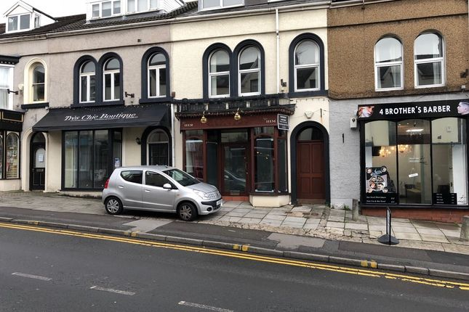
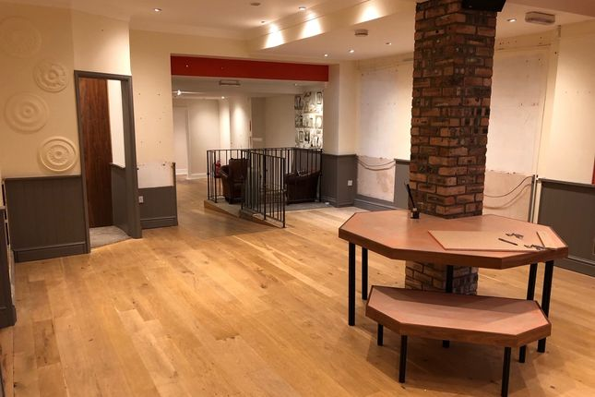
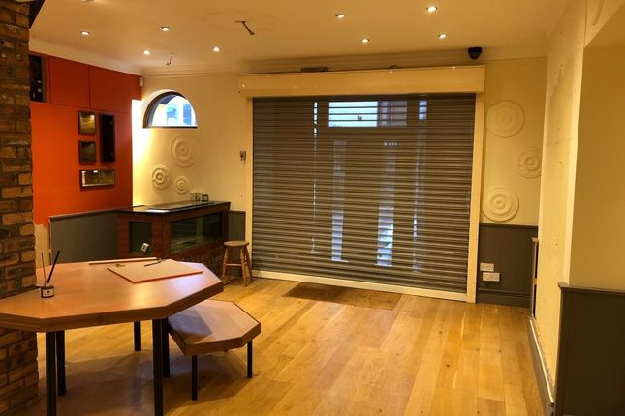
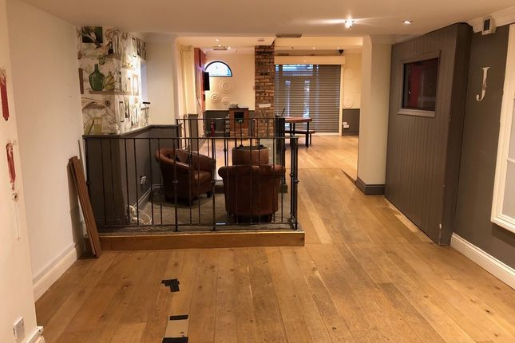

Online questionnaire:
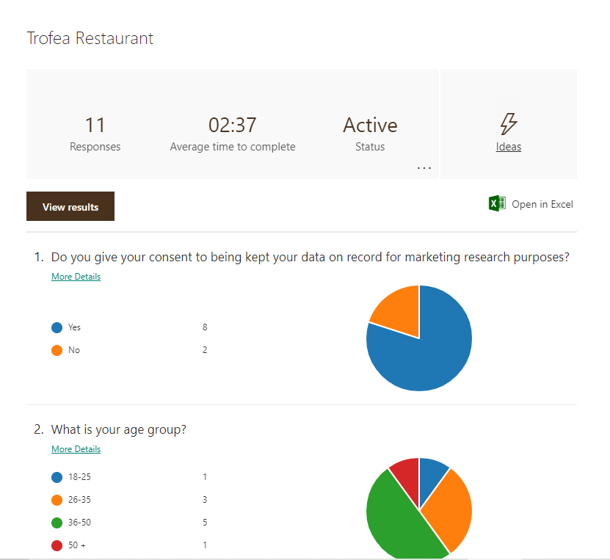
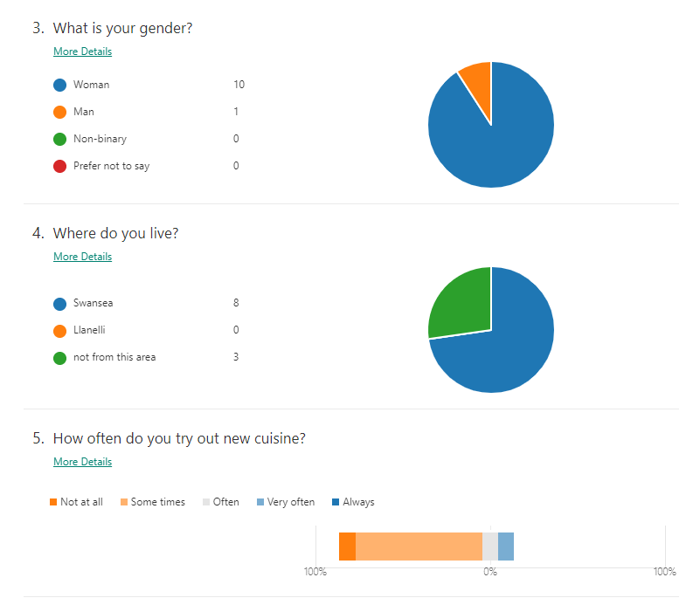
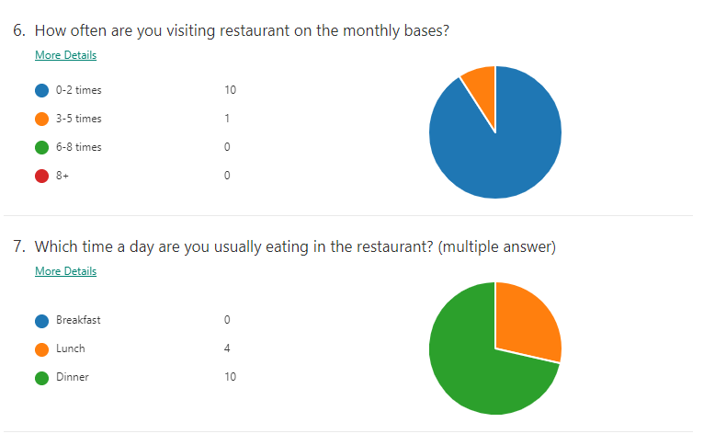
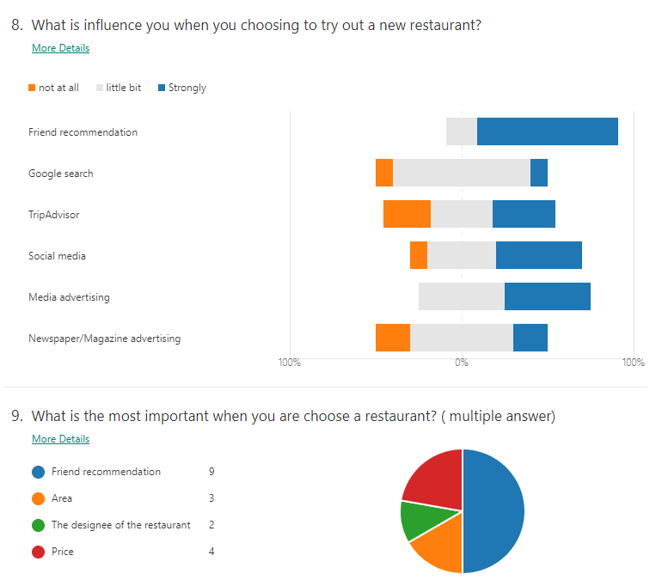
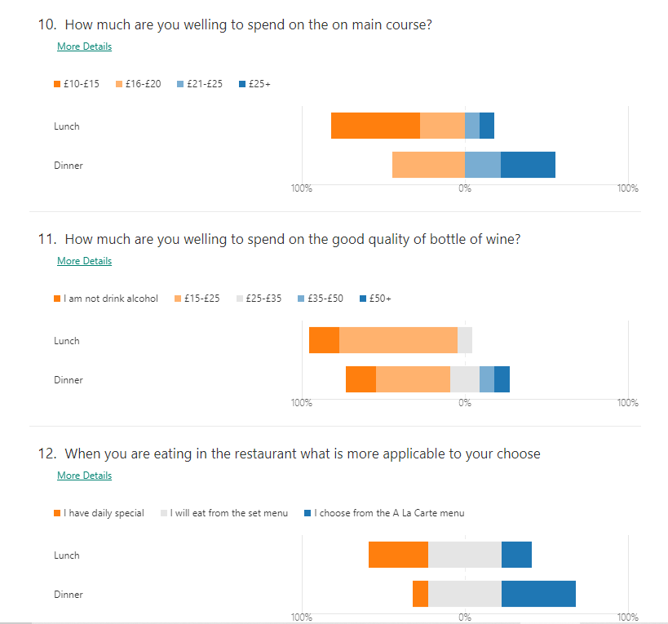

Photos of the equipment, decoration,

References

Banfalvi, C. (2020) Hungarian Chefs Pay Homage to the Classics—with a Twist [www.nationalgeographic.com] Available at: https://www.nationalgeographic.com/travel/destinations/europe/hungary/partner-content-hungarian-chefs/ (Accessed: 16/06/2020)
- Jenkins, T. (2017) How to become a successful Chef [www.finedininglovers.com] Available at: https://www.finedininglovers.com/article/how-become-successful-chef (Accessed: 16/06/2020)

Kenton, W. (2019) Marketing mix [www.investopedia.com] Available at: https://www.investopedia.com/terms/m/marketing-mix.asp (Accessed: 31/05/2020)

Kenton, W. (2019) Target Market [www.investopedia.com] Available at: https://www.investopedia.com/terms/t/target-market.asp ( Accessed at: 31/05/2020)
- Krokida, S. (2020) 23 best Marketing Campaigns of 2019 Fuel Your Inspiration. [www.moosend.com] Available at: https://moosend.com/blog/best-marketing-campaigns/ (accessed 16/06/2020)

Lienard, S. (2020) How to be a professional chef: Nathan Outlaw [www.bbcgoodfood.com] Available at: https://www.bbcgoodfood.com/howto/guide/how-be-professional-chef (Accessed 16/06/2020)

Putnam, J. (2020) What a Unique Selling Proposition Really Means & Why Your Business MUST Have One [www.neilpatel.com] Available at: https://neilpatel.com/blog/unique-selling-proposition/ (Accessed: 16/06/2020)

Tarver, E. (2019) Market Segmentation [www.investopedia.com] Available at: https://www.investopedia.com/terms/m/marketsegmentation.asp (Accessed: 31/05/2020)

Wilkinson, J. (2013) Market Positioning [www.strategiccfo.com] Available at: https://strategiccfo.com/market-positioning/ ( Accessed at: 31/05/2020)

