New Build Dwelling: Technical report with drawings

Prepared for:

G. Traylor

Written by:

S. Williams

Date completed:
2nd May 2023

Table of Contents
Page
Number
1.0 Executive Summary 3

2.0 Findings 3
2.1 Ground floor construction and external wall drawing information. 3 - 5
2.2 U-value calculation of lower brick work wall. 6
2.3 U-Value calculation of higher block work with render. 6 - 7
2.4 U-value calculation of ground floor construction. 7
2.5 Window opening in the external wall drawing information. 7 - 9
2.6 Eaves detailing and roof covering drawing information. 10 - 11
2.7 U-value calculation of roof. 12
2.8 Roof structure drawing information. 12 - 14
2.9 Limitations of the current roof construction. 15
2.10 The advantages of a dormer roof. 15
2.11 The disadvantages of a dormer roof. 16
2.12 What is meant by Offsite Construction? 16
2.13 The four types of Offsite Construction. 16

3.0 Conclusion 17

4.0 References 17

1.0 Executive summary
A technical report that includes drawings with details has been prepared for the client to give them an understanding of how the different building elements in this timber frame construction are put together. U-value calculations are then provided in tables to show how the chosen materials in the different elements of the building fabric comply with building regulations in terms of thermal performance. It then goes on to discuss the limitations of the current roof structure and suggests an alternative solution for a possible attic conversion. Finally, different types of offsite construction are discussed with examples of how each could be applied to the proposed build.
2.0 Findings
2.1 Ground floor construction and external wall drawing information.
Drawing not to scale.
- 18mm smooth render finish applied to block work.
- 103mm concrete block work with 10mm mortar joints
- 103mm stack bonded brick work with 10mm mortar joints.
- Stainless steel cavity wall tie fixed between brick work and timber stud.
- 50mm cavity.
- Breather membrane.
- 9mm OSB chipboard.
- 140mm mineral wool insulation in between timber studs.
- Vapour layer.
- 38mm of phenolic foam insulation within the battened service zone.
- 15mm of gypsum plasterboard.
- Timber sole plate.
- Timber batten.
- DPC 150mm above ground level.
- Cavity fill below ground.
- 300mm layer of hardcore.
- 50mm sand blinding layer.
- Damp proof membrane.
- 150mm layer of phenolic foam insulation.
- 200mm concrete slab.
- 50mm layer of screed.
- Concrete block work.
- Foundation.
- Underfloor heating in the screed.
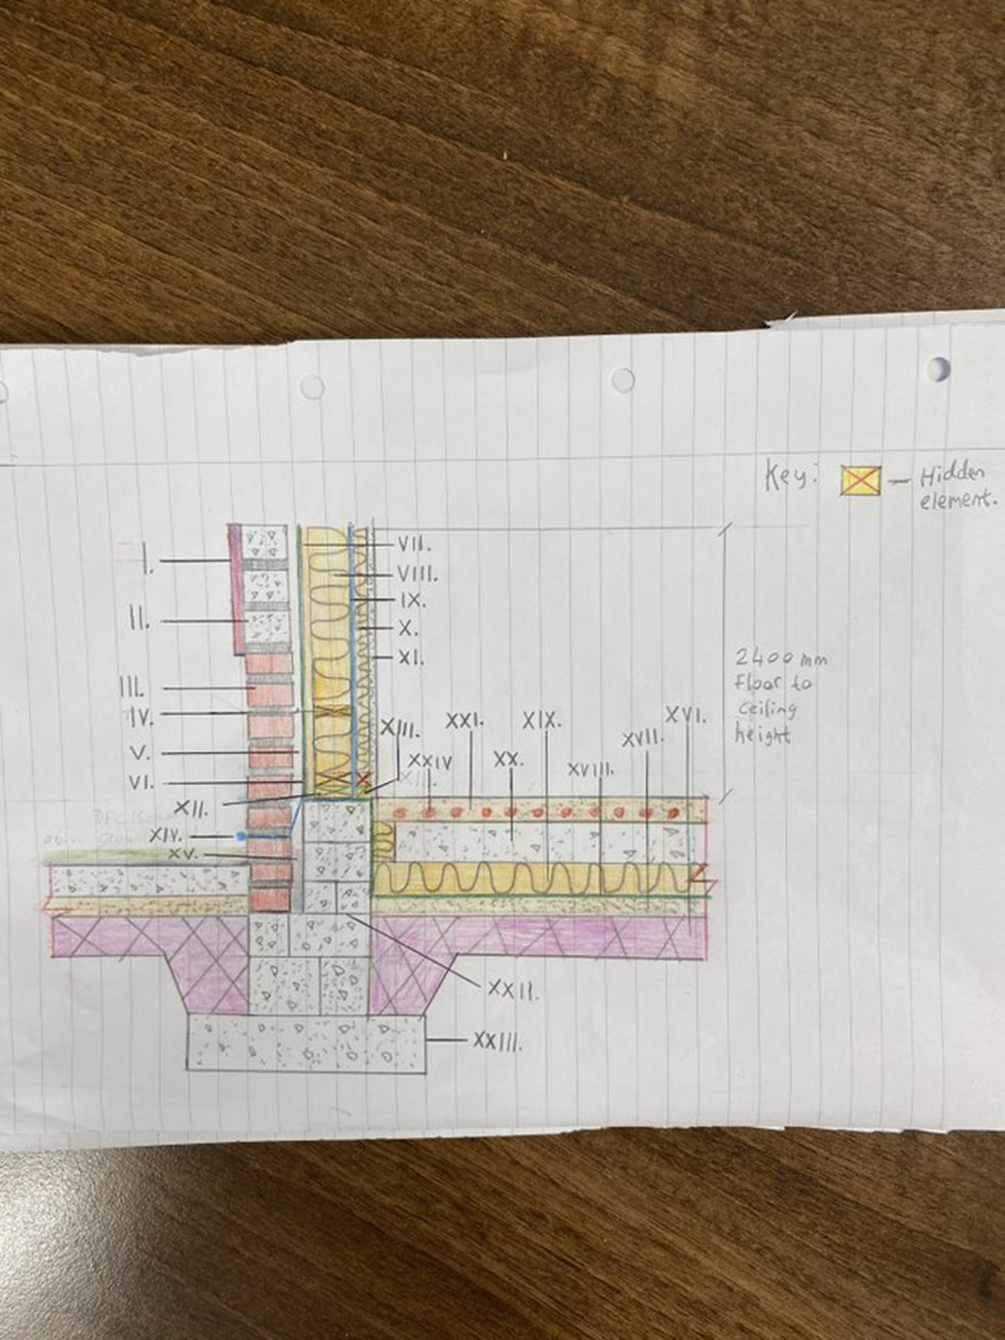
(Roger and Greeno, 2016, p. 412, 420, 490, 491).
2.2 U-value calculation of lower brick work wall.
Layer | Thickness  (m) | K-value  (W/mC) | R-value  ($m^{2}$C/W)
RSI | n/a | n/a | 0.12
Gypsum plasterboard | 0.015 | 0.16 | 0.094
Battened insulation | 0.038 | 0.020 | 1.9
Vapour layer | n/a | n/a | n/a
Stud/insulation | 0.140 | 0.04 | 3.5
OSB chipboard | 0.009 | 0.15 | 0.06
Breather membrane | n/a | n/a | n/a
Cavity | n/a | n/a | 0.18
Brick work | 0.103 | 0.62 | 0.166
RSO | n/a | n/a | 0.06

Total R-value = 6.08 $m^{2}$C/W
1/RT = 1/6.08
U-value = 0.16 W/$m^{2}$C (2 d.p)
2.3 U-value calculation of higher block work with render.
Layer | Thickness  (m) | K-value  (W/mC) | R-value  ($m^{2}C/W$)
RSI | n/a | n/a | 0.12
Gypsum plasterboard | 0.015 | 0.16 | 0.094
Battened insulation | 0.038 | 0.020 | 1.9
Vapour layer | n/a | n/a | n/a
Stud/insulation | 0.140 | 0.04 | 3.5
OSB chipboard | 0.009 | 0.15 | 0.06
Breather membrane | n/a | n/a | n/a
Cavity | n/a | n/a | 0.18
Block work | 0.103 | 0.51 | 0.202
Render | 0.018 | 0.50 | 0.036
RSO | n/a | n/a | 0.06

Total R-value = 6.152
1/RT = 1/6.152
U-value = 0.16 W/$m^{2}$C (2 d.p)

2.4 U-value calculation of ground floor construction
Layer | Thickness  (m) | K-value  (W/mC) | R-value  ($m^{2}C/W$)
RSI | n/a | n/a | 0.14
Screed | 0.050 | 0.41 | 0.122
Concrete slab | 0.200 | 0.16 | 1.25
Insulation | 0.150 | 0.02 | 7.5
Sand blinding | 0.050 | 2.00 | 0.025
Hardcore | 0.300 | 0.96 | 0.313
RSO | n/a | n/a | 0.04

Total R-value = 9.39
1/RT = 1/9.39
U-value = 0.11 W/$m^{2}$C (2 d.p)
The ground floor construction and external wall complies with Wales Approved Document A: Structure and Approved Document L: Conservation of fuel and power. The materials selected and the result of the u-value calculation meets the current requirements.
2.5 Window opening in the external wall drawing information.
Drawing not to scale.
- 3 glazed units in the sealed frame.
- Air filled gaps.
- Glazing bead.
- Synthetic rubber seal.
- Aluminium spacers in between glazed units.
- Top rail.
- Bottom rail.
- Window head.
- Exposed steel lintel.
- Window frame.
- Windowsill.
- Window board.
- Timber lintels 38 x 140mm.
- Remaining void filled with insulation.
- Top of timber rail 140 x 38mm.
- Wall plate 140 x 38mm.
- Red lines indicate DPC’s.
- Cavity barrier.
- 18mm of render applied to external concrete block work.
- 103mm external concrete block work with 10mm mortar joints.
- 50mm cavity.
- Breather membrane.
- 9mm OSB chipboard.
- 140mm mineral wool insulation in between timber studs.
- Vapour layer.
- 38mm of phenolic foam insulation within the battened service zone.
- 15mm of gypsum plasterboard.
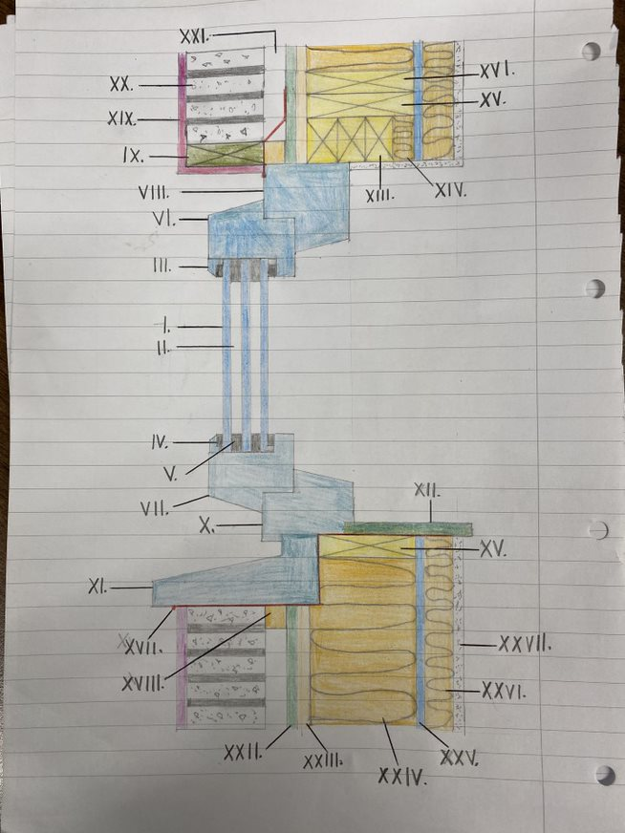
(Roger and Greeno, 2016, p. 464, 470, 471).
(Callanan, 2017).
2.6 Eaves detailing and roof covering drawing information.
Drawing not to scale.
- 15mm of gypsum plasterboard.
- 38mm of phenolic foam insulation within the battened service zone.
- Vapour layer.
- 140mm mineral wool insulation in between timber studs.
- 9mm OSB chipboard.
- Breather membrane.
- 50mm cavity.
- Cavity barrier.
- 103mm external concrete block work with 10mm mortar joints.
- 18mm of render applied to external concrete block work.
- Soffit.
- Fascia board.
- Gutter.
- Tilting Fillet.
- Breather membrane.
- Timber rafter.
- 350mm of fiberglass insulation.
- Top of timber rail 140 x 38mm.
- Timber wall plate 140 x 38mm.
- Eaves ventilator.
- 50 x 25mm timber roof battens.
- 18mm OSB sheathing boards.
- Felt moisture barrier.
- 7mm of steel roof sheeting coverings.
- Steel bolts are to be fitted into the timber battens where metal sheets overlap.
- Dimension lines indicate where lapping has taken place between the two metal sheets.
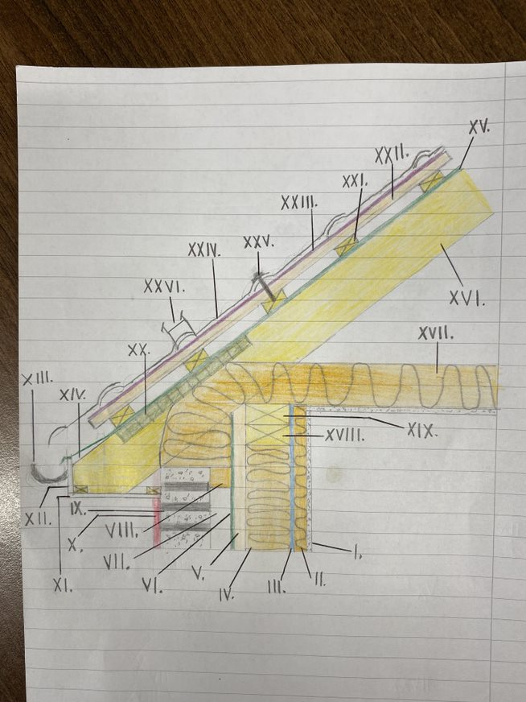

(Roger and Greeno, 2016, p. 591, 705).
(Thomas, 2022).

2.7 U-value calculation of roof.
Layer | Thickness  (m) | K-value  (W/mC) | R-value  ($m^{2}C/W$)
RSI | n/a | n/a | 0.10
Plasterboard | 0.015 | 0.16 | 0.094
Fiberglass insulation | 0.350 | 0.04 | 8.75
Cavity | n/a | n/a | 0.14
OSB chipboard | 0.018 | 0.15 | 0.12
Metal sheeting | 0.007 | 60.00 | 0.00001
RSO | n/a | n/a | 0.04

Total R-value = 9.244
1/RT = 1/9.244
U-value = 0.11 W/$m^{2}$C (2 d.p)
2.8 Roof structure drawing information.
Drawing not to scale.
- King post.
- Strut.
- Ceiling tie.
- Rafter.
- Wall plate.
- Truss plate connectors made from galvanised steel that are fixed onto timber members.
- Outline of building fabric.
- Soffit.
- Fascia.
- Sprocket to reduce the velocity of rainwater running down the slope.

The materials selected for the u-value calculation and its result complies with Wales Approved Document L: Conservation of fuel and power.

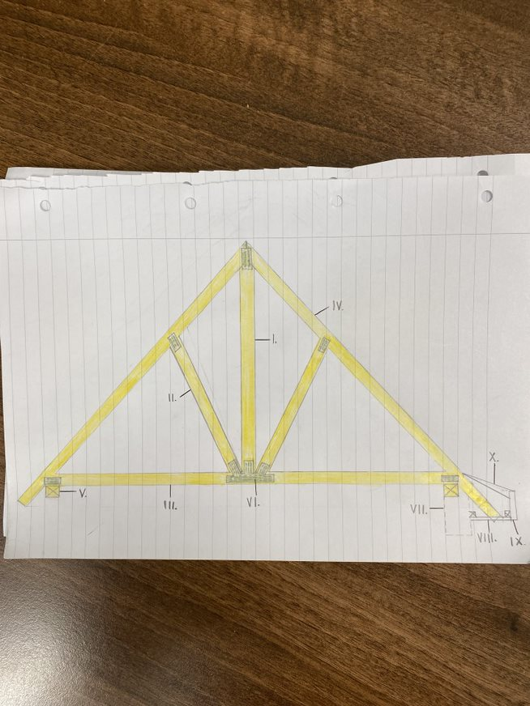
(Roger and Greeno, 2016, p. 515, 516).
2.9 Limitations of the current roof construction
Even though the existing gable roof design can be a desirable choice for this build as it possesses distinctive qualities in terms of affordability while providing an extra amount of roof space for storage. It’s also affected by certain restrictions that could potentially limit the client’s needs for an attic conversion. These restrictions are:
Wind damage: Where gable roofs have a steeper incline compared to other designs, it may not be a suitable choice for areas affected by strong winds as it will eventually cause damage to the structure and peel off its materials leading to expensive repairs.
Limited living space: Due to the steeper pitch of the roof design, the client will not be able to maximise the space already available for an attic conversion.
Installation & Technique: In order to prevent the possibility of the gable roof from collapsing, the framing technique and its installation must be carried out by competent construction personnel (LONG HOME PRODUCTS, 2023).

As indicated in the specification, the installation of metal roofing sheets on the exterior will be an effective solution to withstand strong winds and prevent any potential damage to the structure. The remaining issue to now combat is how the planned roof structure can be converted into a habitable space. An alternative suggestion would be to add an additional structure in the form of a dormer roof to the existing gable roof as this will open up the space.
2.10 The advantages of a dormer roof
Improved aesthetics: Adding one or several dormers to the roof structure will not only enhance the architectural value of the building as a whole, but the investment will be more appealing to future buyers if the client decided to sell the property.
Better ventilation: Heat that has risen through the attic floor overtime will gradually reduce the air quality whereas the access to a dormer window can prevent this by allowing fresh air to flow around the space.
Improved lighting: A dormer window in the attic provides an opportunity for natural light to enter the space during daylight hours and could reduce the reliance on using artificial lighting indefinitely.
Increased room: A dormer roof transforms the entire attic into a usable space where extra ceiling height allows for furniture to be added and the user can walk around freely.
2.11 The disadvantages of a dormer roof
Increase in cost: The construction cost of a dormer roof will be significantly higher as they require additional time and materials for it to be successfully built.
Risk of leakage: If an incompetent roofing contractor does not install the dormer roof correctly, the risk of water leaking in through the roof or window increases (Roofing Calculator Inc, 2021).

2.12 What is meant by Offsite Construction?
This refers to a combination of pre-assembled building elements or components that are manufactured in a controlled environment such as a factory where they will then be transported and erected on site (Designing Buildings Ltd, 2022).
2.13 The four types of Offsite Construction.
Volumetric systems: This modern method of construction can be achieved in a number of ways although it mainly involves the manufacturing of three-dimensional structural building components that will then be assembled to create a fully finished enclosure. Non-structural modules in the form of bathrooms can also be designed where internal finishes are also applied and could be incorporated into the proposed house (Foot Anstey, 2020).

Hybrid systems: The purpose of this construction method is to create finished buildings with the combination of both volumetric and panellised systems. Initially, highly utilised areas such as bathrooms or kitchens are constructed as a volumetric module and then panels are used to assist its completion.
Panellised systems: This method commonly involves using flat panel units to create structural building elements such as floors, walls, and roof panes. They can either be transported to a site as part of an already built module or be fitted into an existing structure. They also can act as non-load bearing elements such as windows and doors.
Sub-assemblies and components: Smaller building elements are pre-manufactured off site and then transported on site where they will be fixed in place. A wide variety of elements can be built such as staircases, doors, windows, structural beams or columns and materials (The Constructor, 2020).

3.0 Conclusion
Even though the materials used for the u-value calculations provides adequate thermal performance for the different parts of the building and meets the current requirements of the building regulations. It is possible to improve this by increasing the thickness of the building fabric or using better quality materials. Although, this will depend on the clients needs and if it falls within the budget.

4.0 References
LONG HOME PRODUCTS (2023) Advantages and Disadvantages of Gable Roofs. Available at: Advantages & Disadvantages of Gable Roofs | Long Roofing (longhomeproducts.com) (Accessed: 20 April 2023).
Roofing Calculator Inc (2021) Top 10 Roof Dormer Types, Plus Costs and Pros & Cons. Available at: Top 10 Roof Dormer Types, Plus Costs and Pros & Cons (roofingcalc.com) (Accessed: 22 April 2023).
Designing Buildings Ltd (2022) Off-site construction. Available at: Off-site construction - Designing Buildings (Accessed: 23 April 2023).
Foot Anstey (2020) What is volumetric construction? Available at: What is volumetric construction? | Foot Anstey (Accessed: 24 April 2023).
The Constructor (2020) What is Offsite Construction? Available at: What is Offsite Construction? - The Constructor (Accessed: 25 April 2023).
Chudley, R. and Greeno, R. (2016) BUILDING CONSTRUCTION HANDBOOK. 11th edn. 2 Park Square, Milton Park, Abingdon, Oxon, 0X14 4RN: Routledge.
Thomas (2022) Fully supported single skin metal roofs. Available at: Fully supported single skin metal roofs (labcwarranty.co.uk) (Accessed: 28 April 2023).
Callanan (2017) Passive Timber Frame Wall Openings (Triple Glazed Windows) Notes. Available at: Passive Timber-Frame - Scoilnet (Accessed: 28th April 2023).

