How can we improve engagement through the use of teacher modelling in a primary setting?

Appendices

Appendix A: - Peter Dudley’s lesson cycle process
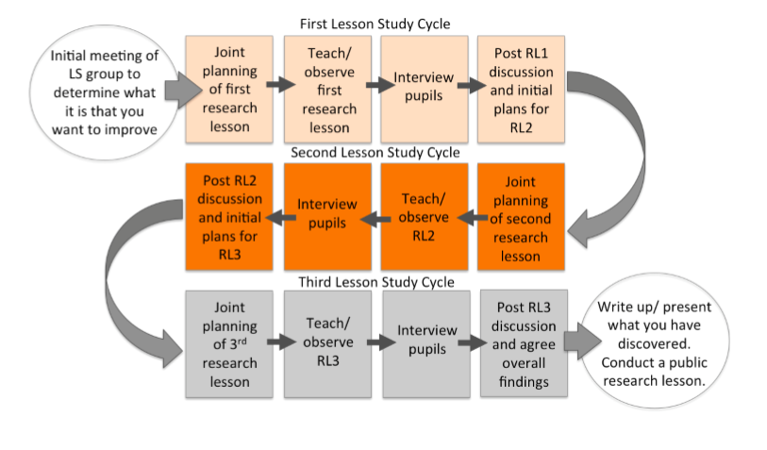

Appendix B: - Interview Questions

Interview Questions

- How do you feel the lesson went?
- What did you like best about the lesson?
- What task did you prefer, 1 or 2? Why?
- How do you feel about the modelling techniques used?
- Do you think that the modelling helped you focus on the tasks? How?
- How could I improve the lesson next time?

Appendix C: - Non-participant observation table
Observation table 1 – we adapted Dr. Ferre Laever’s ‘Leuven’s scale’ for involvement to suit our research study for teacher modelling and engagement.
Part A
Name of observer | Jenna Walters
Date of session observed | 21/02/2019
Details of session observed | The lesson took place in a year 5 classroom, located a primary school in West Wales. The lesson was taught in and outside of the classroom.
Agreed aims and objectives of the session | Representing data in a variety of charts, diagrams and graphs and be able to interpret the data.
Specific aspects the trainee teacher wishes the observer to focus on | Teacher modelling and Engagement

Part B
Introduction of the session
Did the trainee teacher…? | 1 | 2 | 3 | 4
- Secure pupils’ attention |  |  |  | X
- Clarify aims |  |  |  | X
- Introduce subject |  |  |  | X
- Provide link to previous session |  |  |  | X
Organisation of the session
Did the trainee teacher…? | 1 | 2 | 3 | 4
- Adopt a structured approach |  |  |  | X
- Emphasis key points |  |  |  | X
- Provide alternative explanations |  |  | X
- Make good use of resources |  |  |  | X
- Introduce/ explain tasks effectively |  |  |  | X
- Vary activities/skills |  |  |  | X
Presentation of the session
Did the trainee teacher…? | 1 | 2 | 3 | 4
1.Pitch the language appropriately |  |  |  | X
2. Make appropriate use of the target language |  |  |  | X
3. Show enthusiasm |  |  |  | X
4.Control pace of delivery |  |  |  | X
5.Control timing |  |  |  | X
6.Speak clearly and concisely |  |  |  | X
- Make eye contact |  |  |  | X
Closing the lesson
Did the trainee teacher…? | 1 | 2 | 3 | 4
- Reiterate and summarise points
- Give clear instruction for follow-up
- Identify link with the following session
- End the session positively and clearly
Modelling of task
 | Task 1 -Venn Diagrams | Task 2 – Tally/ Bar Chart
How many times did the trainee teacher model the task? | Twice | N/A
Student participation and interaction (engagement)
Did the trainee teacher…? | 1 | 2 | 3 | 4
- Employ small group/pair work |  |  |  | X
- Clarify understanding |  |  |  | X
- Handle questions appropriately – N/A
- Keep students involved |  |  |  | X
- Restrain dominant students |  |  |  | X
- Give support and guidance |  |  |  | X
- Monitor students’ progress |  |  |  | X
- Use room layout effectively |  |  |  | X

Observation table 2 – Adapted from the Leuvan Scale.
Name | Engagement (1-5) | 15-minute intervals | 15- minute intervals | 15-minute intervals | 15-minute intervals | Comments
Child 1
(Tay)
Child 2
(Shakira)
Child 3
(Jayden)

Appendix D: - Amended Reflection Table

Reflection Pro-Forma – Adapted from Kolb’s (1984) learning cycle and Gibbs (1988) reflective cycle.
Reflection of experience
Description
What happened?

Concrete Experience/Feelings
What were you thinking and feeling?

Evaluation
What was good and bad about the experience?

Reflective Observation/Analysis
What sense can you make of the situation?

Abstract Conceptualization/ Conclusion
How can you learn from the experience?
What else could you have done in the lesson?

Action Plan
If you taught the lesson again, what would you do?

Active Experimentation
Put the plan into action….

Appendix E: - Lesson 2 Plan
 |  |  |  |  |  |  |  |  |  |  | 1B

Session Plan – Key Stage 2
Name of trainee: |  | Jessica Ainsworth |  |  |  | Session ref: |  |  | 21/02/19(1) Mathematics
Personal target(s) in relation to QTS:
Year group: | 5 |  | No. of learners: |  | 28 |  | ALN: | Adventurers x4
Additional Adults: |  |  | 0
Learning objective(s):  - Year 5: Can you represent data in a variety of charts, diagrams and graphs and be able to interpret them? |  |  |  |  |  |  | Success criteria:  - Activate prior knowledge of representing data  - Categorise your data to complete your chart, diagram or graph  Yn y Pit  - Select your chosen method to calculate the mean, mode and median of your data
Links to previous learning:
- Prior knowledge of representing data. Develop skill of recording data and analysing the information.
Curriculum coverage (range, skills)
LNF: Representing Data

AoLE: Mathematics and Numeracy

Four Purposes:

Ambitious Capable Learners

Literacy (LNF)  - Use terms; data, tally chart, venn diagram, bar graph, mean. mode, median  - Oracy skills – discussion, methods/strategies |  |  |  |  |  | Numeracy (LNF)  - Year 5: Can you represent data in a variety of charts, diagrams and graphs and be able to interpret them?
DCF  - Use of interactive whiteboard  - Take pictures of work |  |  | Thinking  - Mastery Skills  - Higher Order Thinking skills |  |  | ESDGC  N/A |  |  |  | YCC  The Welsh language will be used throughout lesson
Key vocabulary (English/Welsh):

Represent, data, recording, figures, tally chart, venn diagram, bar chart, mean, golygu, mode, modd, median, canolrif, barod, da iawn, bore da, grandewch, bant a chi

Time | Session activities, organisation and management  Mental Maths - 5 minutes  Introduction - 5/10 minutes  Main Activity – 40 minutes  Plenary – 5 minutes | Key questions & Assessment for Learning opportunities
 | Mental Maths:  - Mental maths recap on multiplication  - http://mathszone.co.uk/calculating/mental-addition/daily-10/ |  | MASTERY SKILLS:
Introduction: Whole class - Interactive board PowerPoint presentation

- Introduce ‘representing data’ using the interactive whiteboard
- Show learning intention for today’s lesson
- Question “What is data?” “Can anybody tell me anything they know about data?” “What is it?” What do you use?”
- Display a mini mindmap on board – finish on data can be visualised in many ways. Question: “In what ways can we display data?” “What graphs have you used?” “What diagrams have you used?” “What charts have you used?”
- Next, display the types of data we will be focusing on today: VENN DIAGRAM, TALLY CHART, BAR GRAPH.
- Our first challenge – provide each child with three sticky notes each and complete each tally chart on board as a class.
Venn diagram: Do you have any brothers and sisters?
Tally Chart: What is the first letter of your name?
Bar Graph: Which month is your birthday?
- Once sticky notes have been placed on the board, fully complete VENN DIAGRAM properly with the information collected – whole class. Do the TASK PERFORMANCE AND MODELLING (research study strategy) and explain how to complete the diagram.
- The tally chart and bar graph I will complete one section of each (will measure how engaged they are with one being modelled more than the other).
- Next, introduce mean, median and mode. Ask the children “Do you recognise any of these words?” “Do you know what any of them mean?”
- Play video and get children to feedback a method for each one that they can use – write on whiteboard
- Do practise sums on board (TASK PERFORMANCE AND MODELLING STRATEGY)
- Children to pair up and work out the mean, mode and median in pairs – each table will be selected to work out each different sum.
- Children to feedback calculations
- Introduce group work – outside tasks and groups for children.
Questioning techniques:
What is data?

What does it mean to represent data?

 |  |  | What is it? What do you use?
In what ways can we display data?

What graphs have you used?

What diagrams have you used?

 |  |  | What charts have you used?”
 | Main activities: Whole class – Small group work
- All children to get into small groups
- Follow me up to the Basket Ball Courts
- Each group will be given 3 tasks to complete – venn diagram, tally chart, bar graph.
- The venn diagram will be completed using hula hoops to create the venn diagram – a question will be given with pictures and words for the children to place in the correct place.
- The Tally Chart will be completed using chalk – children will be provided with a question and will tally the answers
- The Outline of the bar graph will be made using sticks, the children will write x and y axis including a title with chalk and create the bar graph using pictures.
- Once the children have completed the tasks in their groups they will use the iPads to take a picture of all their data they have represented.

Yn y Pit
- For each group I will have Mean, Median and Mode questions for them to answer on the data they have recorded.

Resources Needed:
Hula Hoops Ipads Pencils
Chalk ClipBoards Sticky notes
Sticks Questions WhiteBoard/Pens
Pictures
 | Plenary: whole class  Each group will feed back and interpret some data they have found in each diagram they made to the rest of the class. |  | How did you feel your learning went today?
 | Write down 1 thing you learnt today – sticky note! (stick on board)
 |  |  | Did you understand the task?
Did you achieve your learning intention?
How do you know?

