Effective Teamworking and communication
Module BMSW4009
Submission Date: 19.06.2025
Student Name: Mihaela Miculescu (2422449)
Word count: 1030

Contents Page
- Introduction ……………………………………………. 2
- Findings ………………………………………………….2
  - Belbin’s ……………………………………………….2
  - Tuckman’s …………………………………………….3
  - The Thomas Kilmann’s……………………………..4
  - Conflicts…………………………………………….…4
    - Active listening……………………………………...4
    - Efficient Communication ………………………....4
    - Empathy…………………………………………..…..4
    - Compromises …………………………………..……4
    - The implication and motivation…………………...4
- Conclusion ………………………………………………5
- References.……………………………………………....6

- Introduction
1.1 Teamwork represents an activity where the member combines their efforts, resources, and the abilities to reach a common target or objective. Teamwork is a fundamental aspect of organizational success, encompassing the collective effort of individuals working towards shared goals (Mullins & Christy, 2016). In an organization or a work place it needs more than just coordination and proper communication, but also developing the interpersonal relation and being able to sort out any conflicts might come your way.
  - Conflict, when managed well, can lead to innovative solutions; and shared goals align team efforts (Heffernan, 2012). Additionally, emotional intelligence and self-awareness are vital as they influence how individuals relate within teams (Goleman, 1998).
  - As per the Belbin’s Questionnaire and my work experience, I can say my natural role in a team was a Coordinator and a Shaper. I always enjoyed bringing constructive contributions and to maintain harmony into a team, as this is the key to deliver the best service. This tendency aligns with the theories and models we learned in this module, highlighting the importance of knowing your own stiles and to be able to understand the dynamic of a group so you can become an efficient member.

2 Findings (Theories on Team Work)
  - Belbin said that each individual may adopt in a team any of his 8 Team Roles, such as Coordinator, Implementer, Plant, Monitor / Evaluator, Resource Investigator, Team Worker, Shaper, Completer/Finisher (Belbin, 2010) The learning trough out this module has helped me to rediscover myself and understand better the weaknesses and the strength of each individual including myself, both in a group or a team. I came to realize that another role after shaper and coordinator, that describe me is Team worker. As an example, in one of the previous modules we had a group activity, so I engaged and encouraged the quieter team members to share their opinion and ideas, and like this the whole activity became more active, enjoyable and with better results.

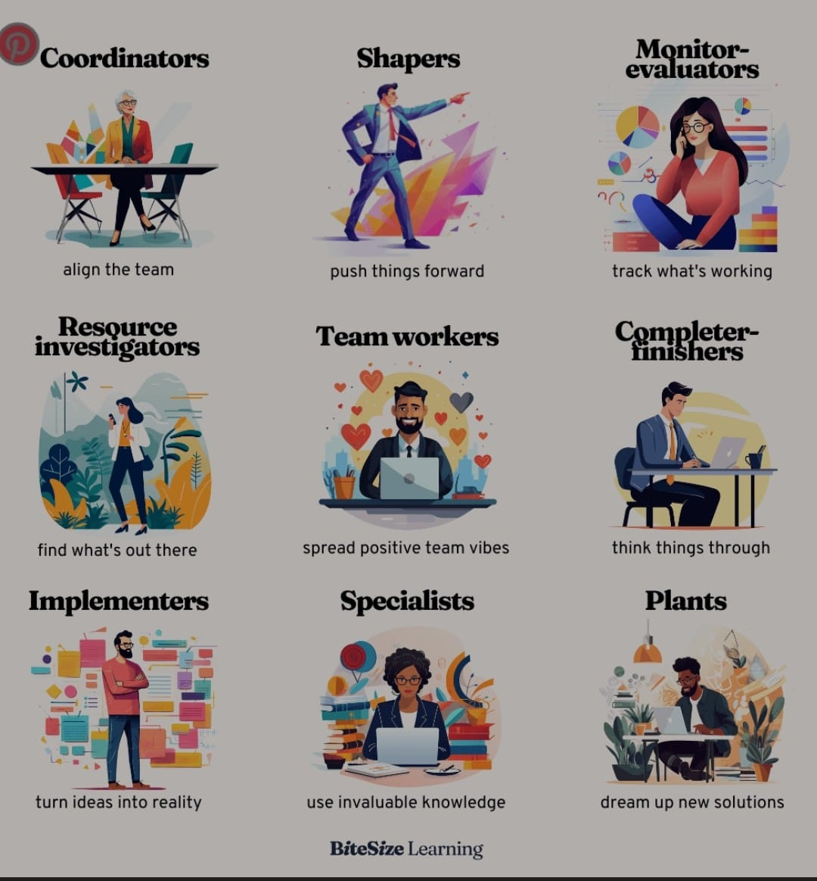

2.2Tuckman’s (2012) model outlines stages of forming, storming, norming, performing, and mourning. This has offered me a clear understanding of the phases we go through in the process of becoming a team. Conflicts sometimes happen, but its normal and you can’t really avoid them, they might as well be beneficial if dealt with in the right manner. In one of the restaurants I was working, the management team we had a different point of view in regards one of the garden’s projects, all of this led to an open discussion. Thanks to the fact that it was dealt in professional manner and with efficient communication techniques, the
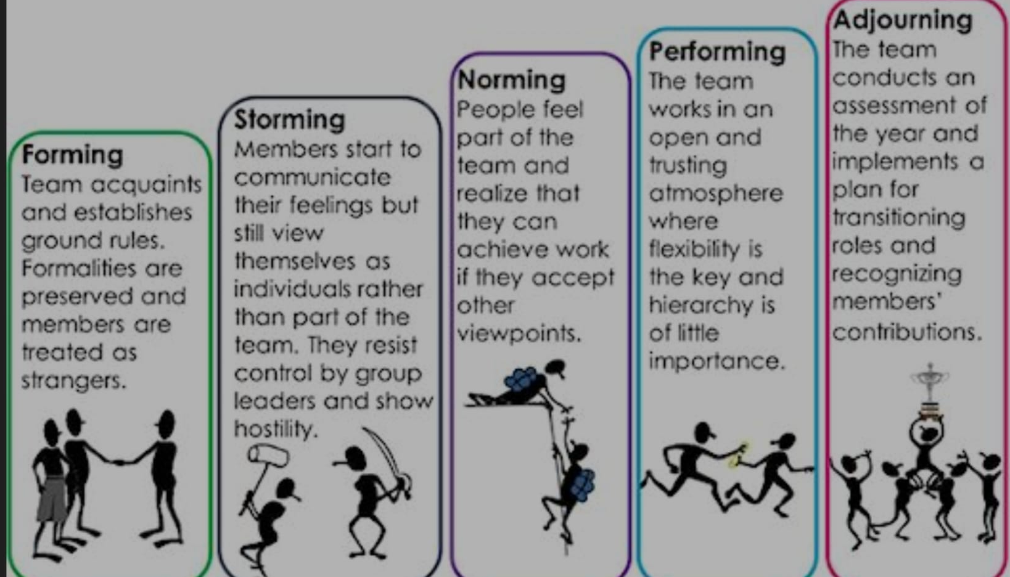

  - The Thomas Kilmann’s conflict model (Thomas & Kilmann, 1974) presents five conflict-handling modes: competing, collaborating, compromising, avoiding, and accommodating which offered me the tools on how to deal and approach the conflicts. By choosing the accommodating and the collaborating style in some situations I managed to avoid some tensions, and I found solutions that are a win-win for all the parts. For example, in prioritizing task conflict, I proposed a session of brainstorming to identify the most important tasks and to organize them together, this has promoted a consent between all the team members and improved the results.

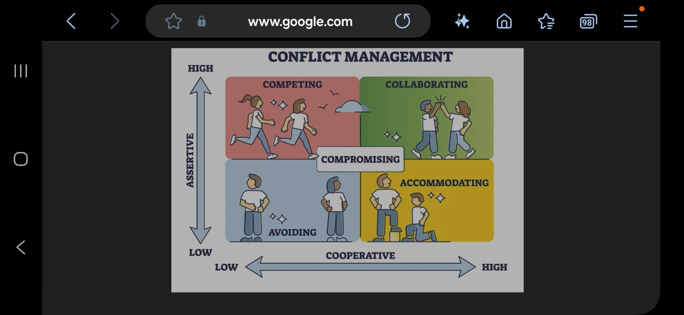

  - Conflicts are sometimes impossible to avoid. Stadler (2019) highlights that conflict is natural and can be constructive if managed properly. Conflicts often appear from various differences between individuals or groups, and its often because of the human diversity. We are all different, so we think, act, behave, different. The acceptance of the fact that the conflicts shouldn’t be avoided, but understood taken in a constructive manner, can lead to better relationships and the progress of the society. For a conflict to become an opportunity, is important to deal with in an adequate manner:
2.4.1 Active listening: It’s a vital ability of communication that goes beyond of simply listening to the words. It involves full implication and understanding of the speaker words.
2.4.2 Efficient communication: Express your point of views in a clear and respected manner
    - Empathy: Try and put yourself in others people shoes
    - Compromises: Look for advantages in both sides when coming up with solutions
    - The implication and motivation of the team are verry important in any business. AS per implication theories Adair, J.E. (2015) the clear communication of the purpose and the recognizing of the individual contribution stimulates the engagement. In one off my supervisor shifts at the restaurant I organized feedback debrief before the starting of a day, where I pointed out the contribution of each team member, which led to a higher motivation and collective responsibility. One critical learning is that strong interpersonal relationships underpin successful teamwork, enabling open communication and trust (Sinek, 2023)
- Conclusion
Reflecting on everything I went through and learned on this module, 3 of them I felt helps me the most: Tuckman, Belbin and the Thomas Kilmann’s conflict model. They offered me a clear perspective over the group dynamic and efficient communication.
- Tuckman: helped me to understand the natural phases of team growing and to deal better with the challenges from each step.
- Belbin: showed me how to value the diversity of the roles and to be able to create balanced teams for a better performance.
- Thomas Kilmann: allowed me to become more aware of my own behaviour and to communicate easier and in an efficient manner with my colleagues, reducing the conflicts and improving collaboration. As well as the stages that a team goes through until they become effective collaborating together.
My main learning is that for a team to be successful it needs open and free communication. I also realized that auto-analyse and continuous adaptability are essential to build solid and efficient relationships.
Plan of action to be a better team player:
- Improve my active communication: by listening more careful my colleagues and offer constructive feedback to avoid misunderstanding.
- Roles distribution: I will propose and accept roles by analysing the weakness and the strength of the team members, to become a balanced team.
- I will monitor and deal with behaviours using the concepts of Transactional Analysis to maintain an open and positive atmosphere in the team

Reference

Adair, J.E., (2015). Effective teambuilding: how to make a winning team (revised. Edition). London: Pan Books
Belbin, R. M. (2010). Team roles at work (2nd ed.). London: Routledge.
Goleman, D. (1998) ‘Working with emotional intelligence’, Globe and mail. Toronto, Ont: The Globe and Mail.
Heffernan, M. (2012) Dare To Disagree https://www.ted.com/talks/margaret_heffernan_dare_to_disagree?utm_campaign=tedspread&utm_medium=referral&utm_source=tedcomshare
Mullins, L. J., & Christy, G. (2016). Management & organizational behaviour (11th ed.). Harlow: Pearson.
Sinek, S. (2023) Trust: the Basis of High Performing Teams https://youtu.be/P8ojeO9za84?si=ZDNualg9hPQ_Y5UU
Stadler, S. (2019) Conflict, Culture and Communication. 1st ed. Milton: Routledge
Thomas, K. W., & Kilmann, R. H. (1974). Thomas-Kilmann Conflict Mode Instrument
Tuckman, B. W., & Harper, B. E. (2012). Conducting educational research (6th ed.). Rowman & Littlefield Publishers.

