  - Network Operating Systems and Services

NOSS Component 2 Worksheet
Jacob Hopkins
2003836
BSc Computing (Computer Networks and Cybersecurity)
Submission Deadline: Friday April 29th

Contents
Network Operating Systems and Services 1
Task 1: Managing and Maintaining Network Resources Using Network Policy and Security Practices 3
Task Brief 3
Understanding NTFS 3
Share Permissions 6
Accessing the File Share/Server Over the Network 9
Configuring User Environment and Computer Environment, ‘Network Group Policy Objects’: 10
Creating New Organizational Unit 10
GPO 1: Moderating Access to the Control Panel 11
GPO 2: Removing Access to the Command Prompt 13
GPO 3: Restricting Access to Removeable Media Devices 15
GPO 4: Restricting Software Installs 17
GPO 5: Enforcing Password Policy in the ‘nosstask.msft’ Domain 20
Task 2: Routing and Packet Filtering Within Core TCP/IP Services and Critical Failover/Redundancy Practices 22
Task Brief 22
Utilizing ARP and Routing Tables 22
Deploy Core Services (FTP Server) 23
Installing and configuring the Routing and Remote Access Service 28
IP Packet Filtering 31
Filter 1: Stopping ‘anyone’ in PrivateNet1 from Pinging the Router Firewall Service 31
Filter 2: Restrict Access to FTP Service running on Server 2 to only hosts in PrivateNet2 32
Filter 3: Only allow specific hosts in PrivateNet1 to access the FTPService running on Server 2 34
Bibliography 44
Appendices 46
Acronyms Table 46
Appendix A [1] 47
Appendix B [3] 48
Appendices C [5] 48
Appendices D [14] 49

References and sources used throughout this report were subject to thorough credibility checks. Academic, institutional, and online sources were each investigated on their validity and reliability to further justify and support their use within this report.

Task 1: Managing and Maintaining Network Resources Using Network Policy and Security Practices
  - Task Brief
In this task, drives, files, and folders will be shared both locally and across networks with the use of NTFS permissions to help manage and maintain each of the resources. Additionally, further management of network environments such as the integration of security policies will be investigated and implemented.

Understanding NTFS
- Within the Client 1 VM, a new folder houses a blank text document that will be used to test basic NTFS permissions.
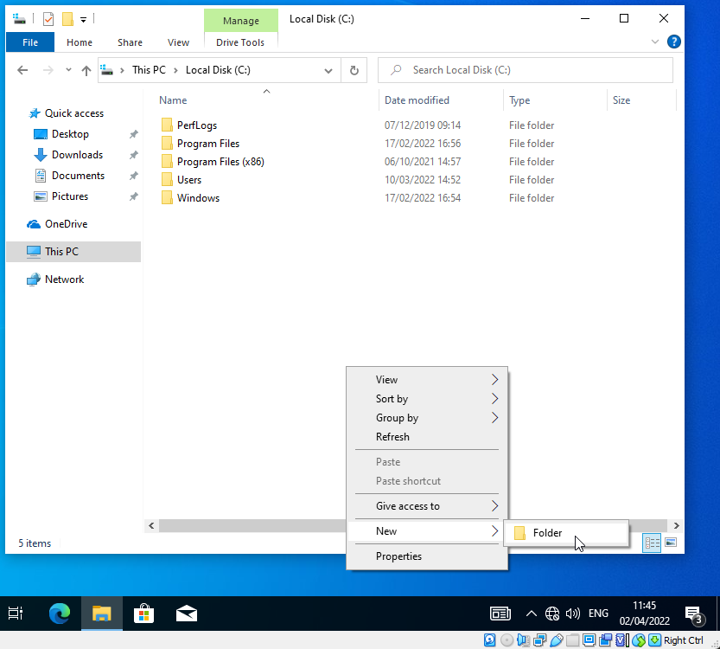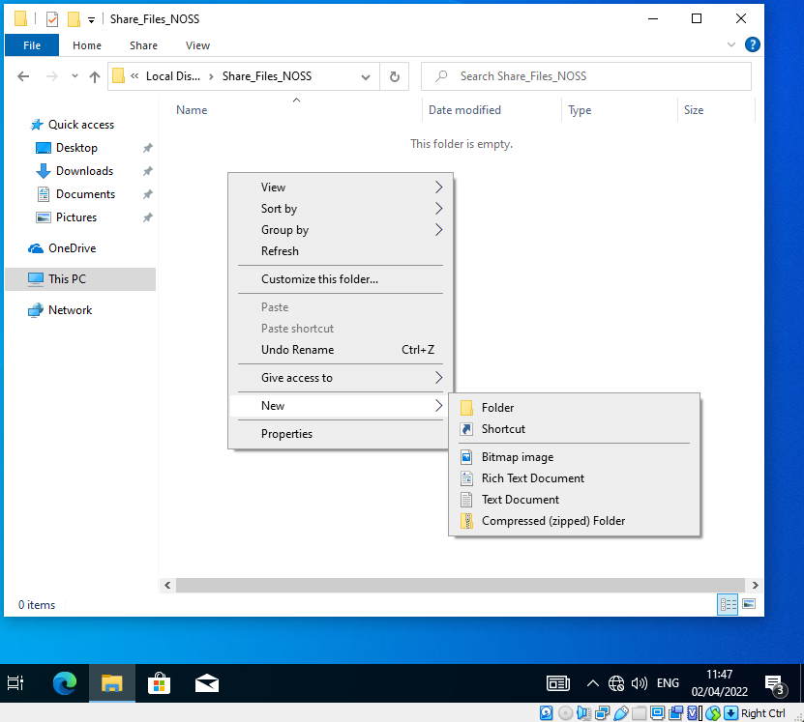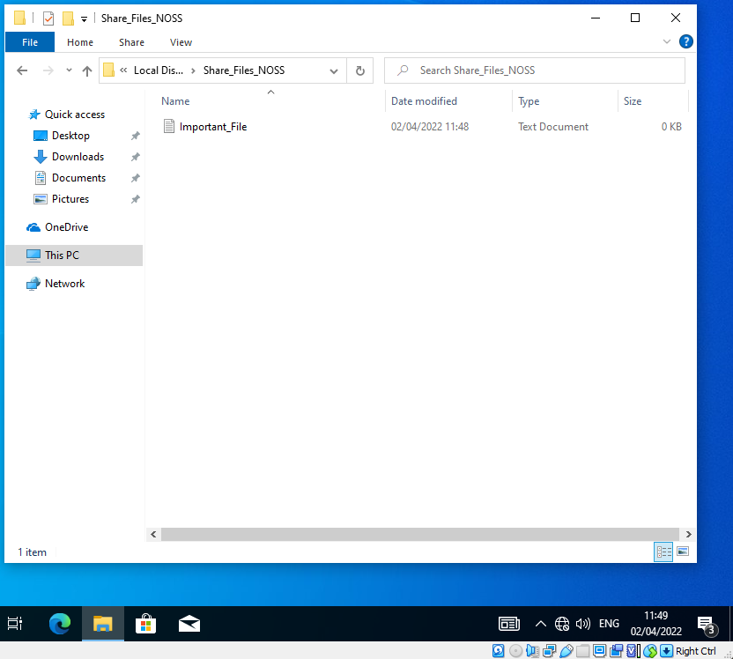

- User folder permissions are accessed through properties. It is essential to disable inherited permissions of the folder to allow for these changes.

Inherited permissions are those propagated from parent objects, in this case the C drive that we want to remove.
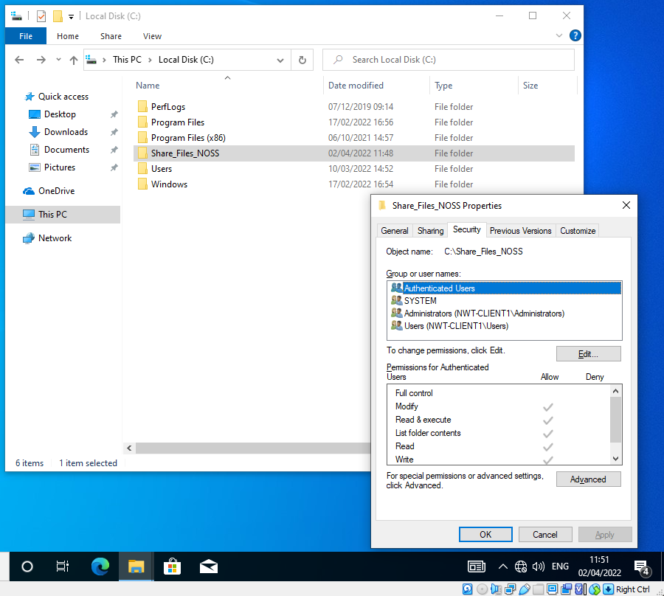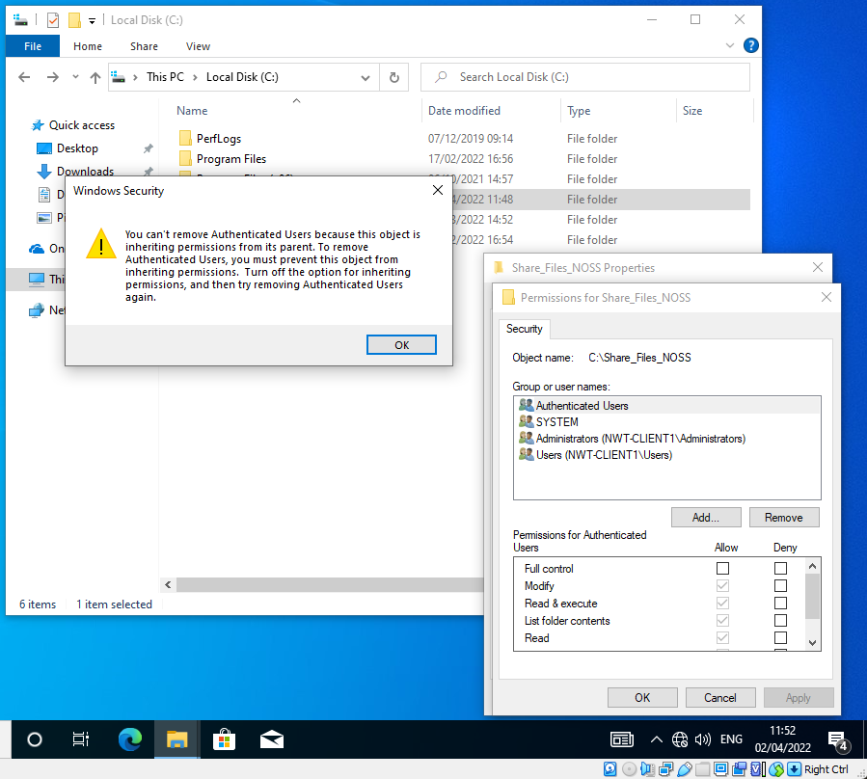

- Inheritance permissions can be disabled through the advanced security properties.
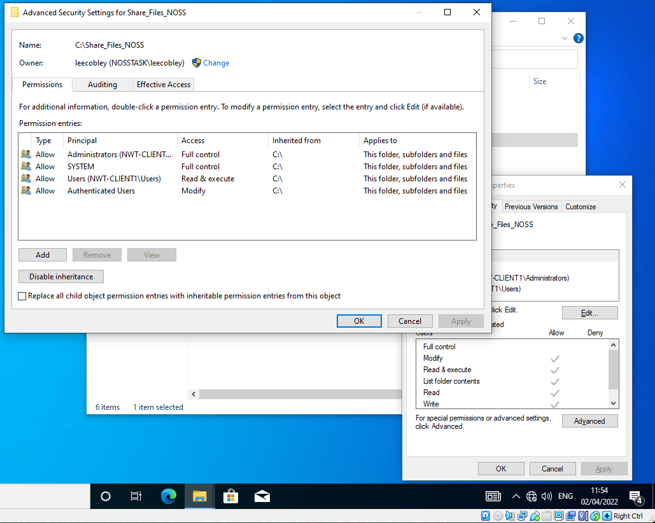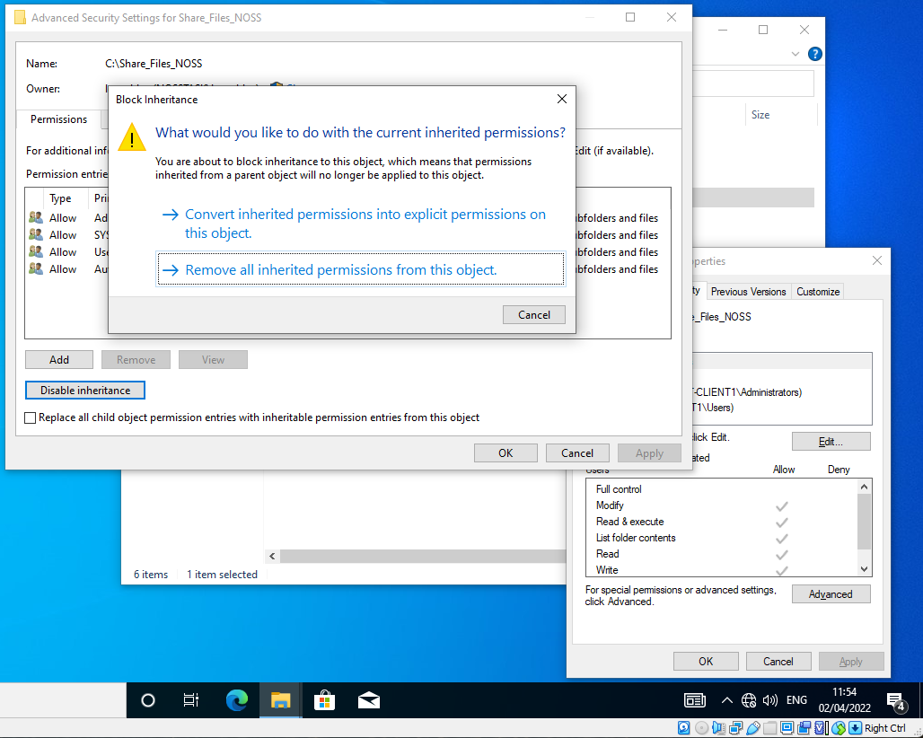
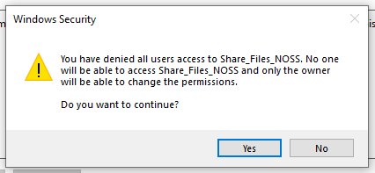

- Removing all previous users, leaving only the current signed-in admin users can help tighten down permissions. Ensure admin has full control over the file share.

Refer to Appendices A for a detailed explanation of permissions within Windows.
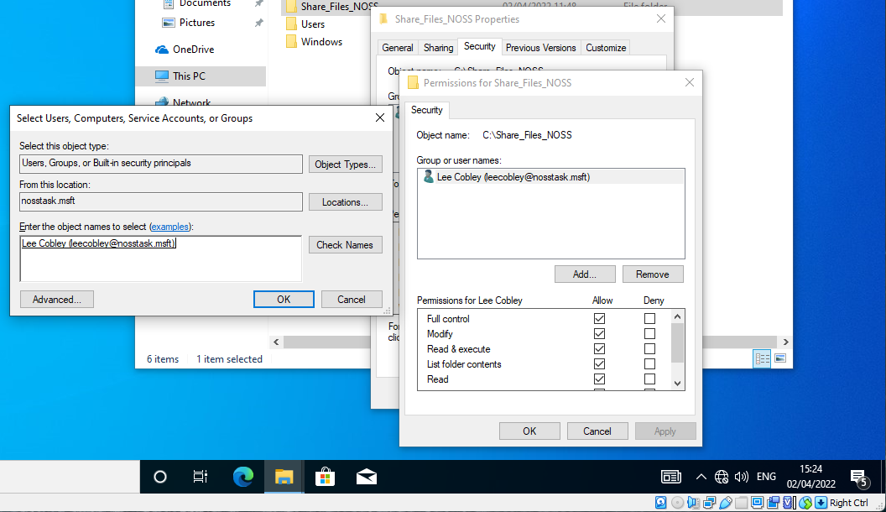
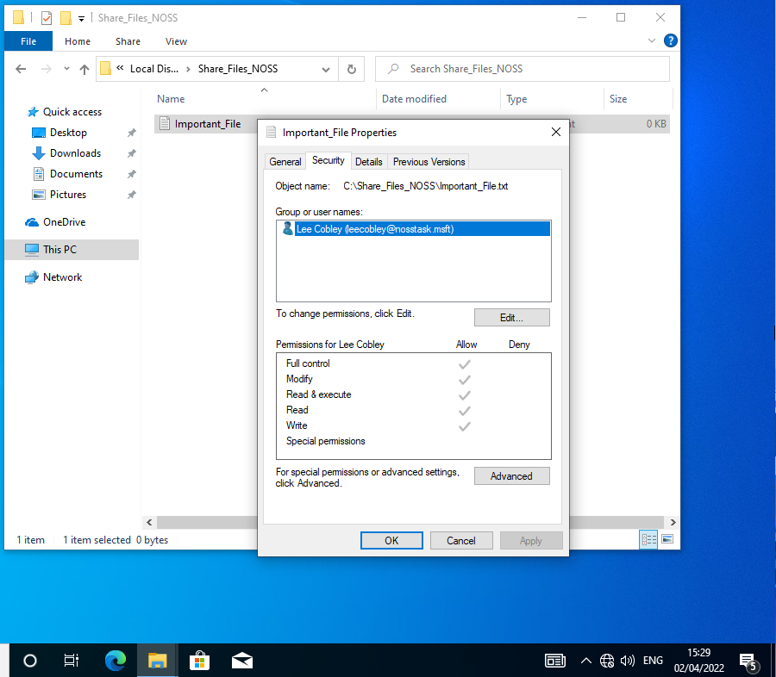

- Add an additional non-admin user and allow all permissions besides modify to test permissions.
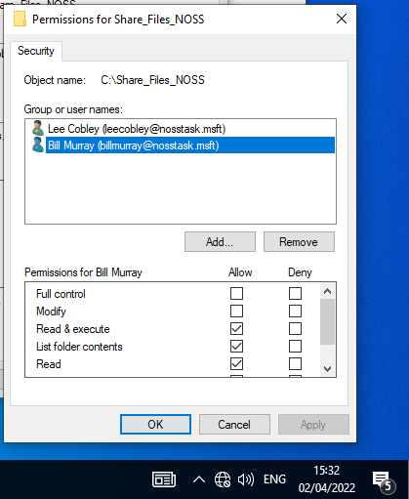
- When attempting to modify and delete the file, administrator credentials are required to override the permission restrictions.
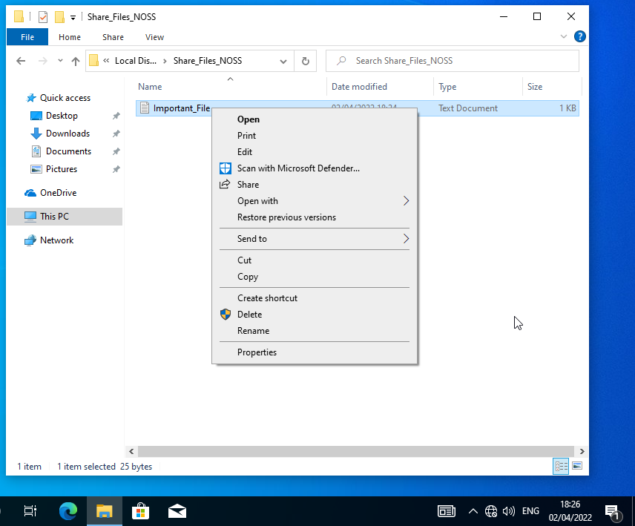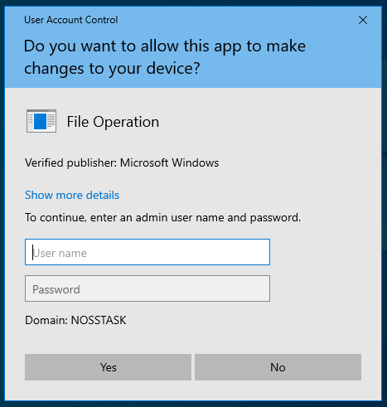

Share Permissions
- A file share can be construct using the share wizard.
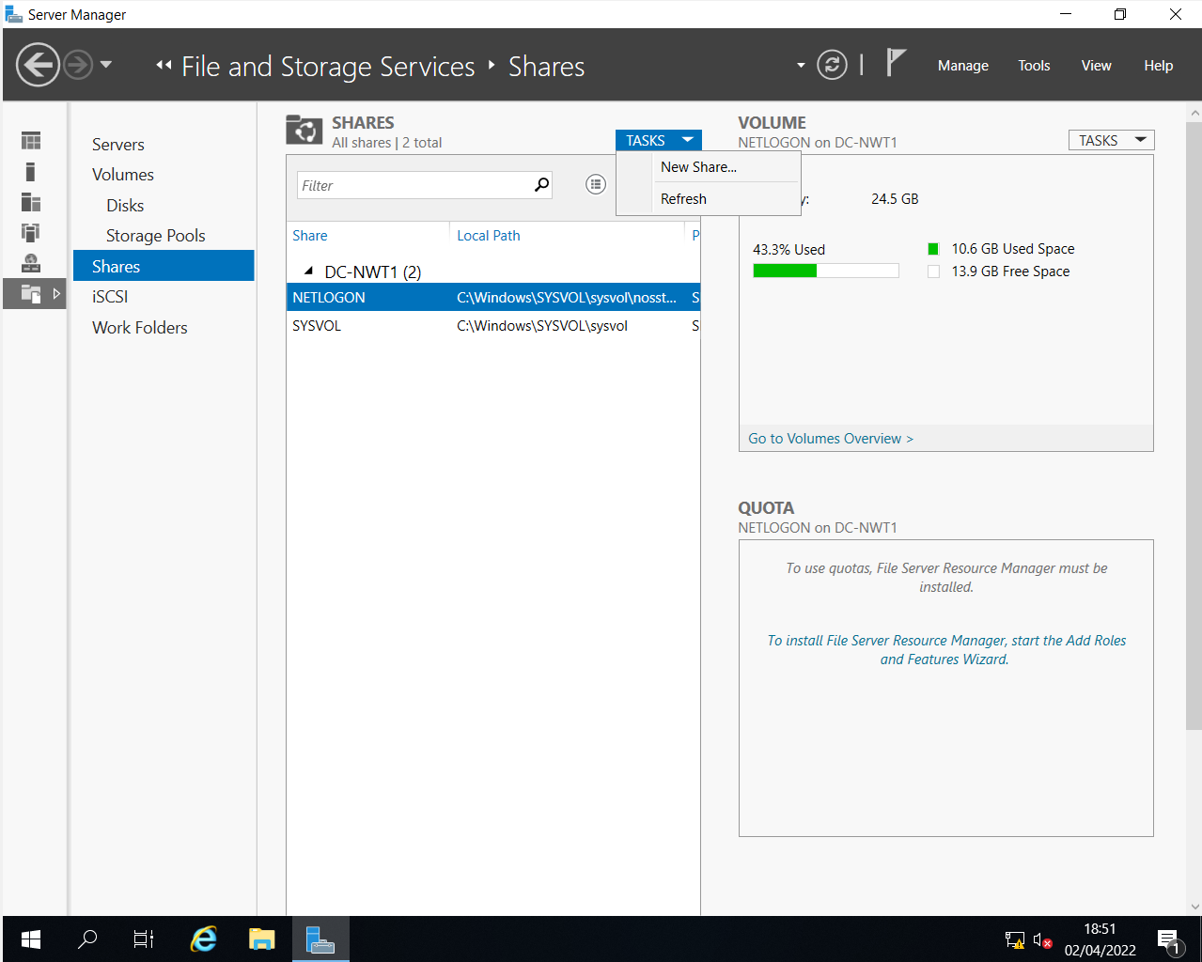

- The SMB Share – Quick profile offers a fast share creation and offers great interoperability for use with other operating systems such as Linux (Samba).
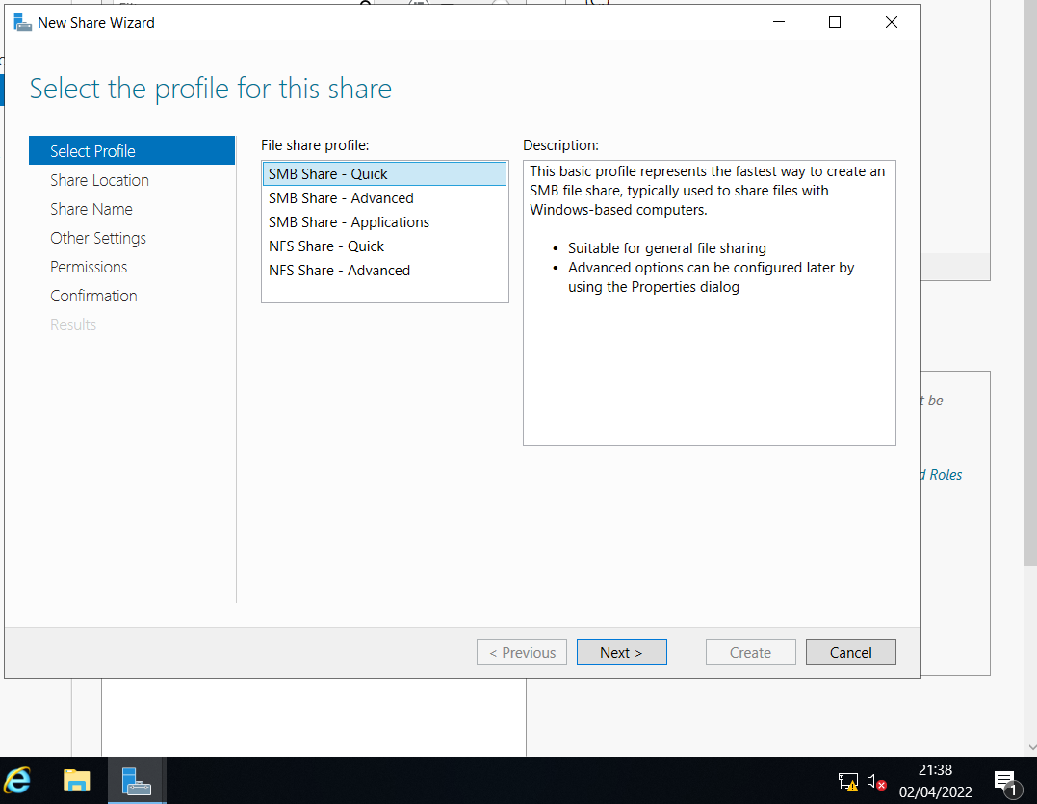

- Name the share Share_Files_NOSS$. Using the ‘$’ after the share name hides the share from casual browers within the network. [2]

Take note of the local path to share as it is used to map network drives and share access to the files within the file server.
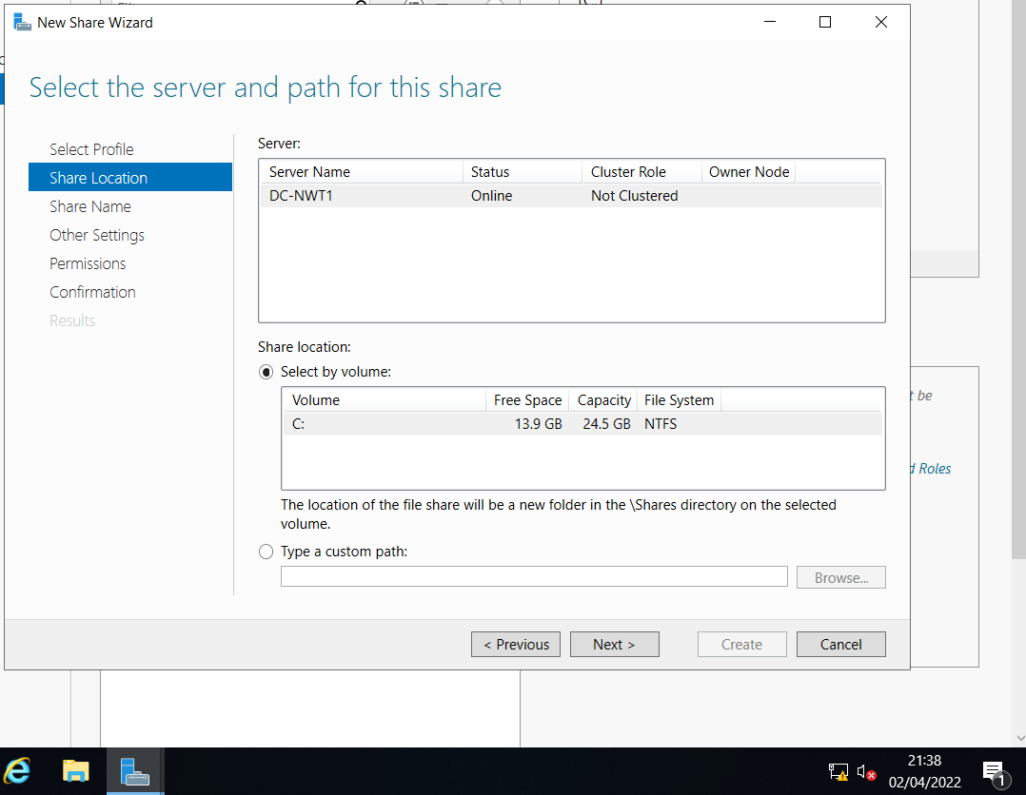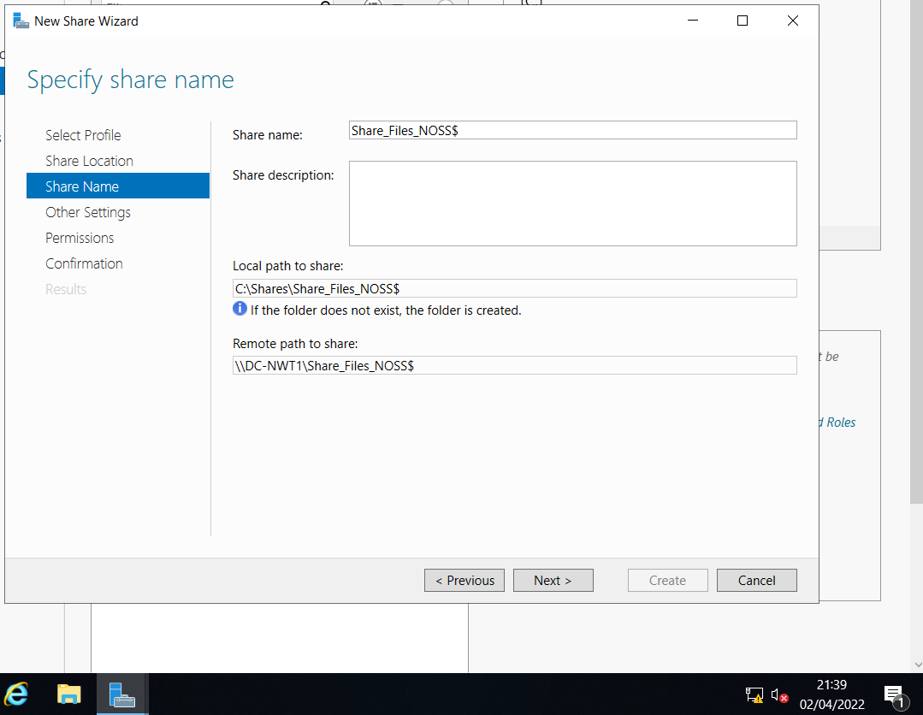

- Enable access-based enumeration.

The file share will grant adminstrators full control, and two members of nosstask.msft read and execute access.
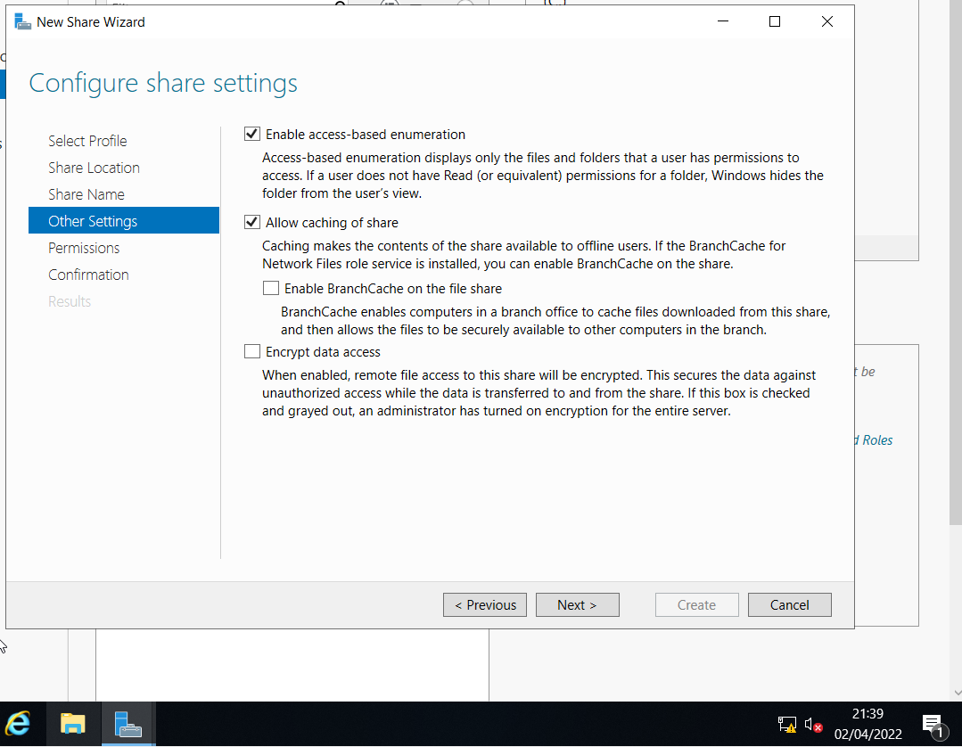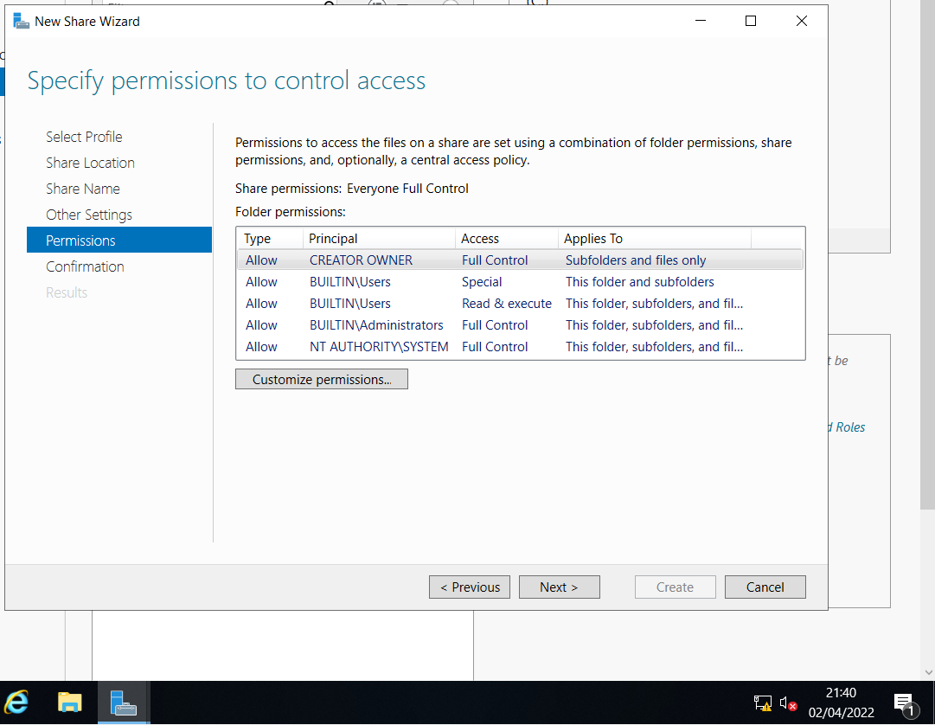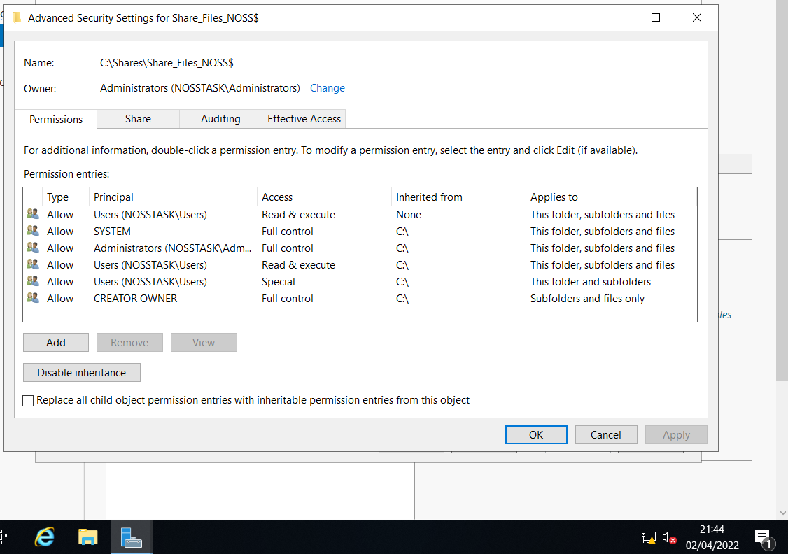

Accessing the File Share/Server Over the Network
- To share the file share/server over the network a network drive must be mapped as the use of the ‘$’ has hidden the share from the network. Refer to Appendices B for further information on access-based enumeration.
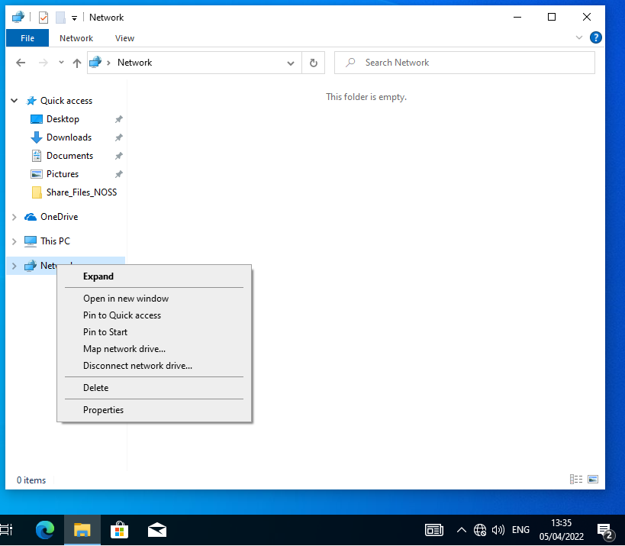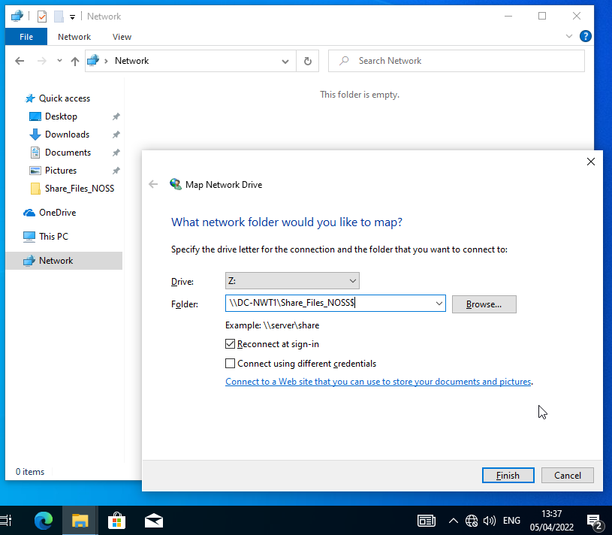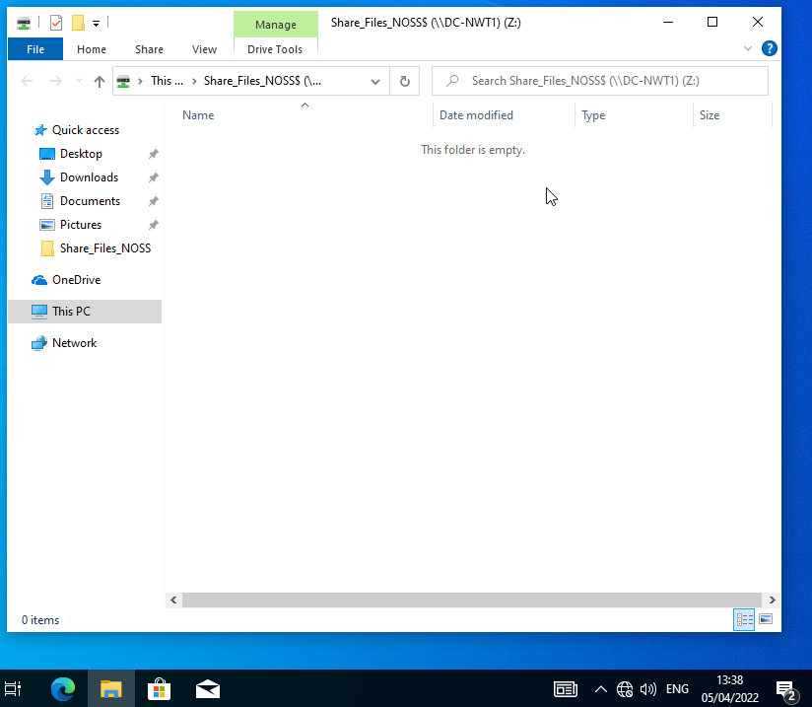

Configuring User Environment and Computer Environment, ‘Network Group Policy Objects’:

Creating New Organizational Unit
- Create a new organizational unit (OU) within the nosstask.msft domain called Non-Admin Users. Within, create a user to test any new policies.
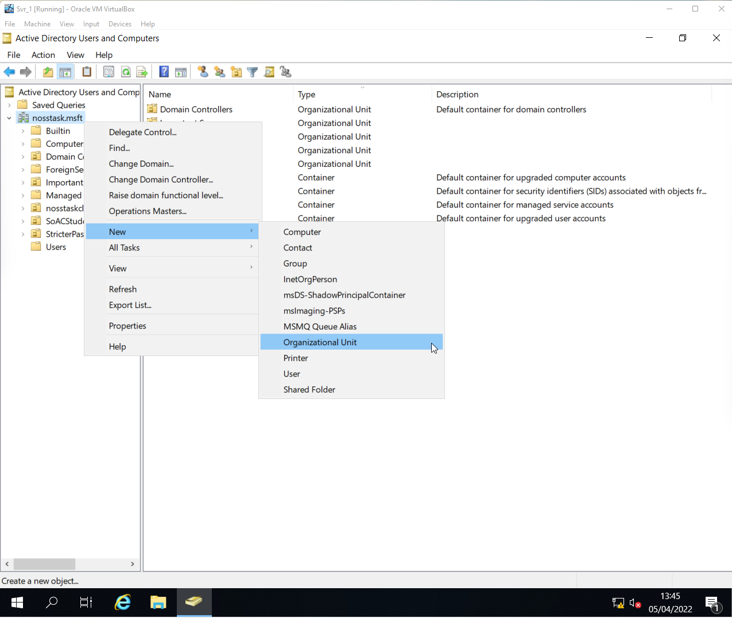
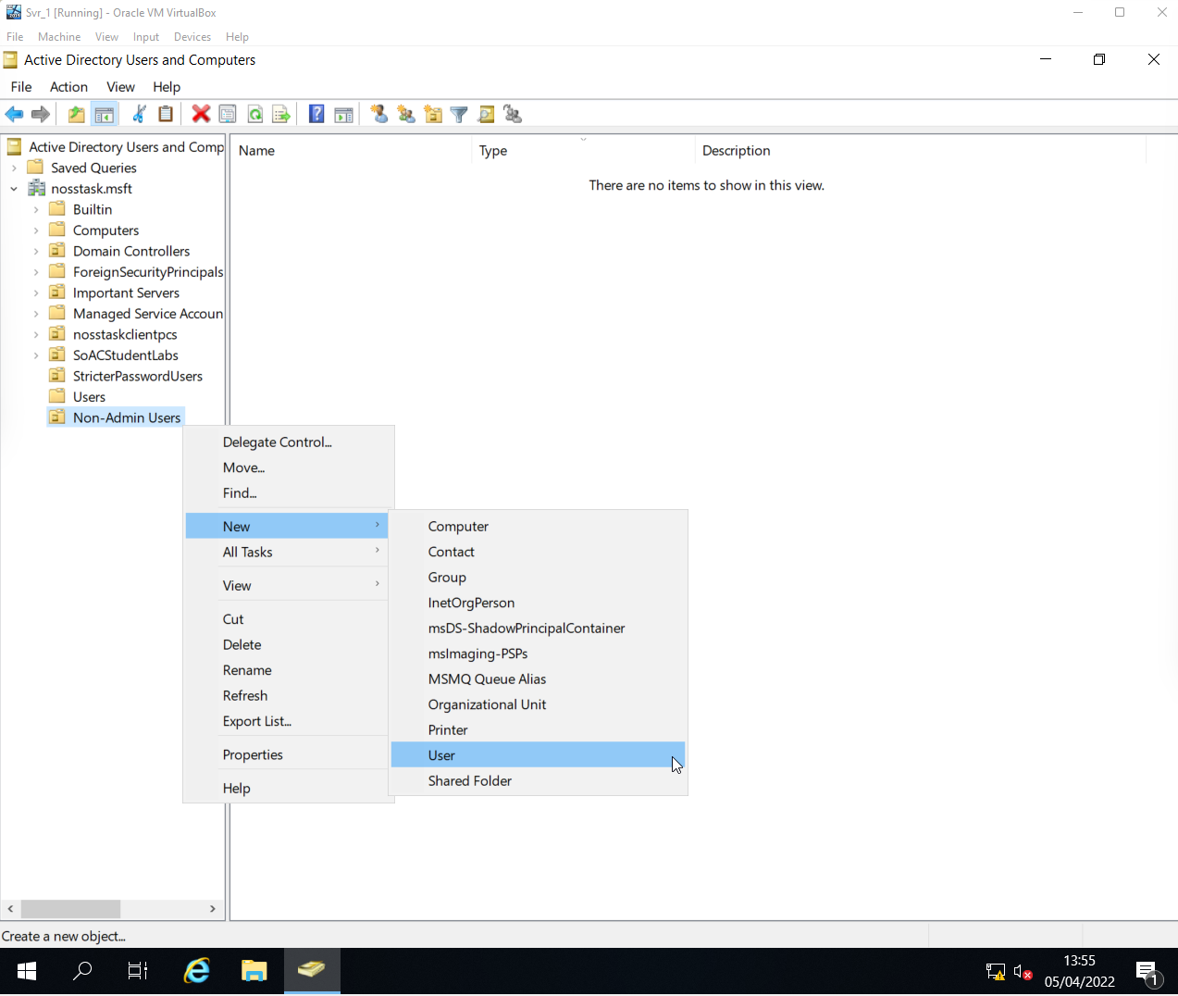
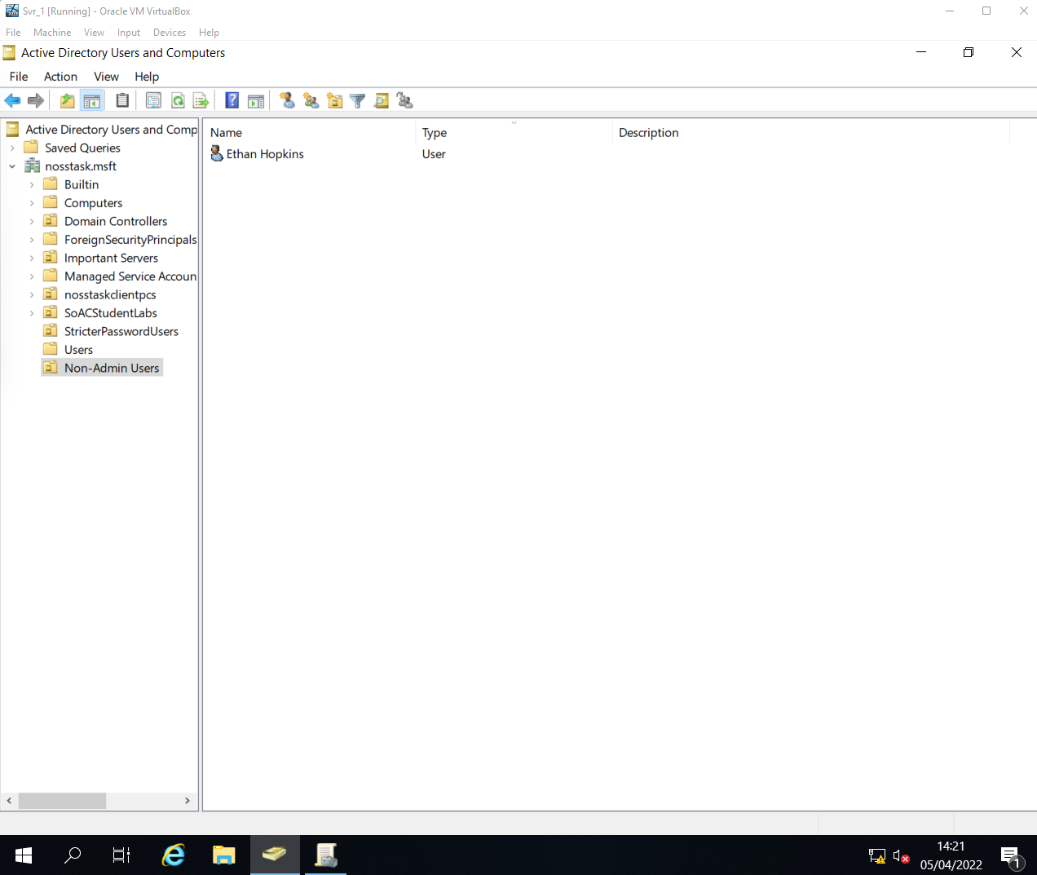

GPO 1: Moderating Access to the Control Panel
- GPO NoCtrlPanAccess created within Non-Admin Users OU.
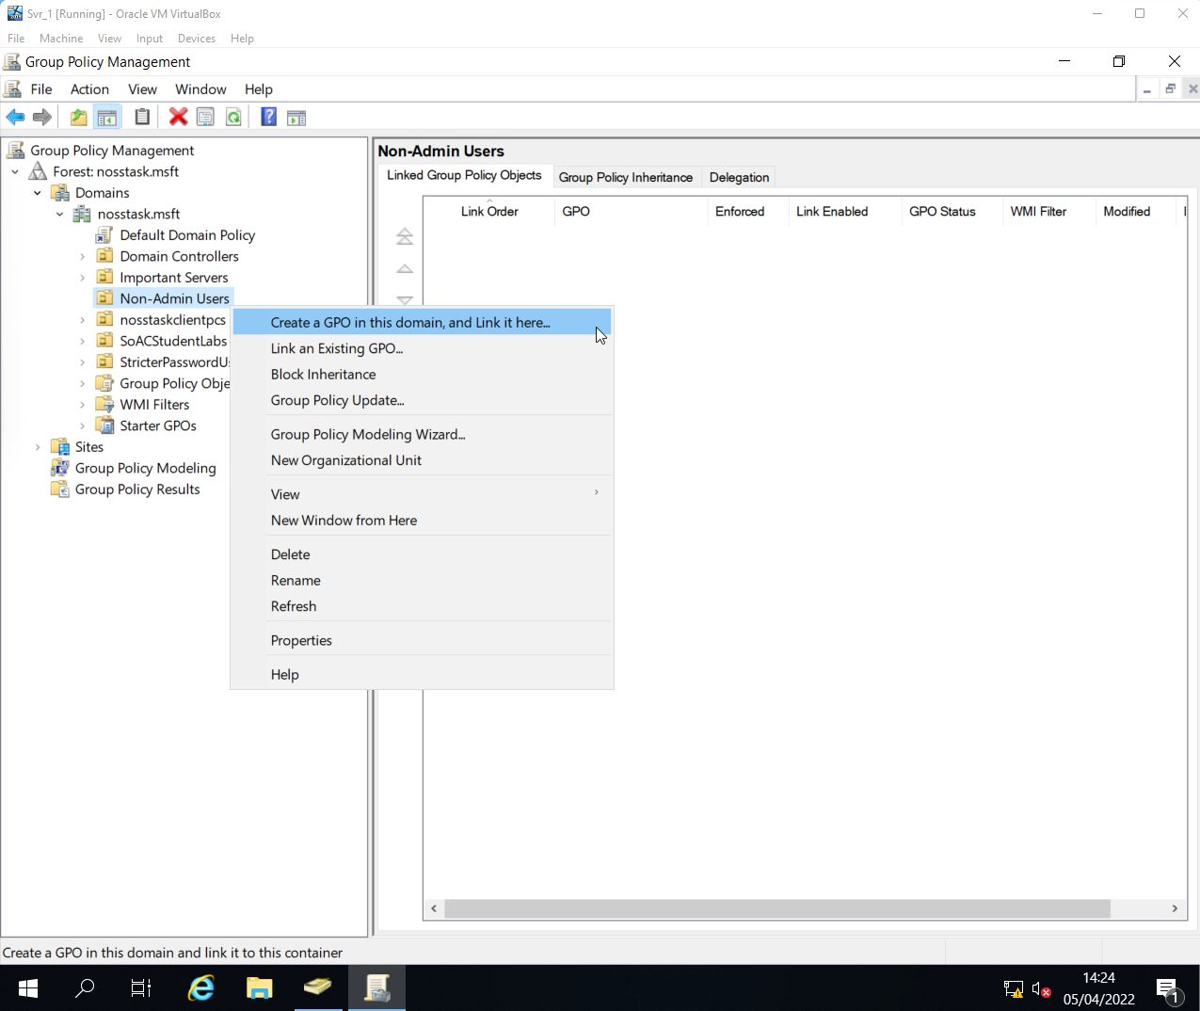

- The policy selected below within the GPO will prevent user access to the control panel.
Restricting Control Panel access can safeguard both users and the network from accidental or malicious administrative changes.
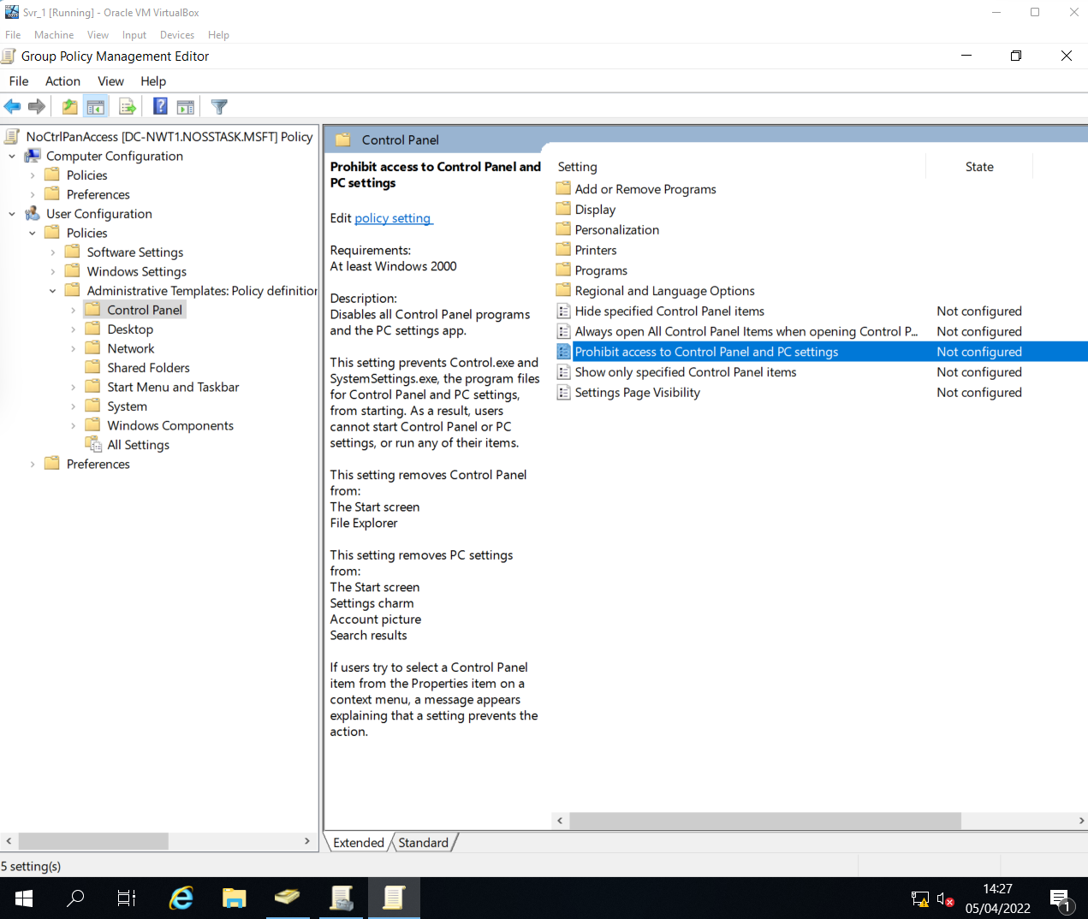
- Using the command gpupdate /force within command prompt will force Active Directory to recognize and apply new settings or policies, this can be useful for testing any new changes.
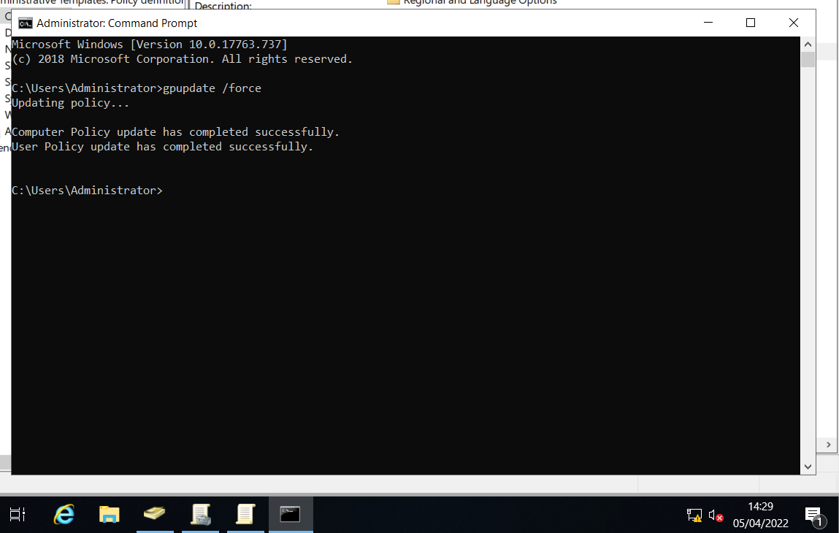

- NoCtrlPanAccess GPO has restricted control panel access.
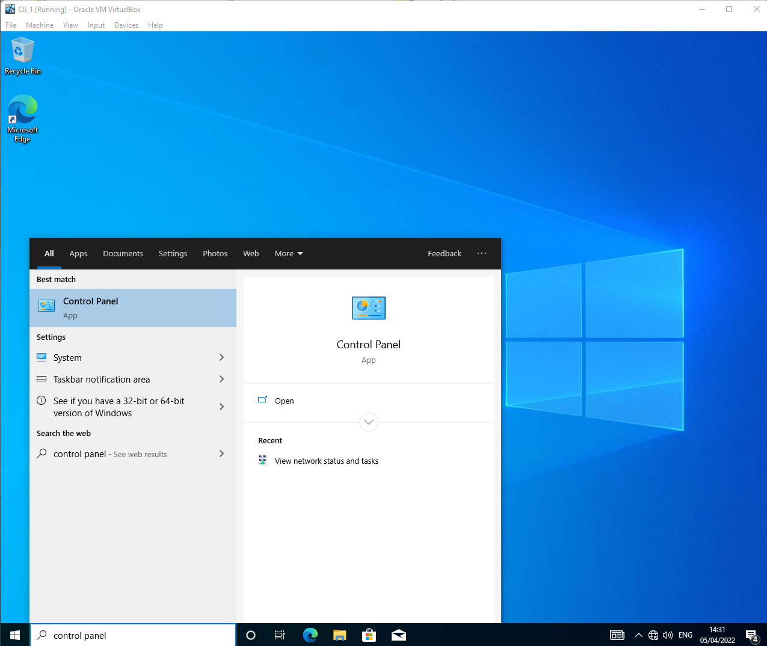
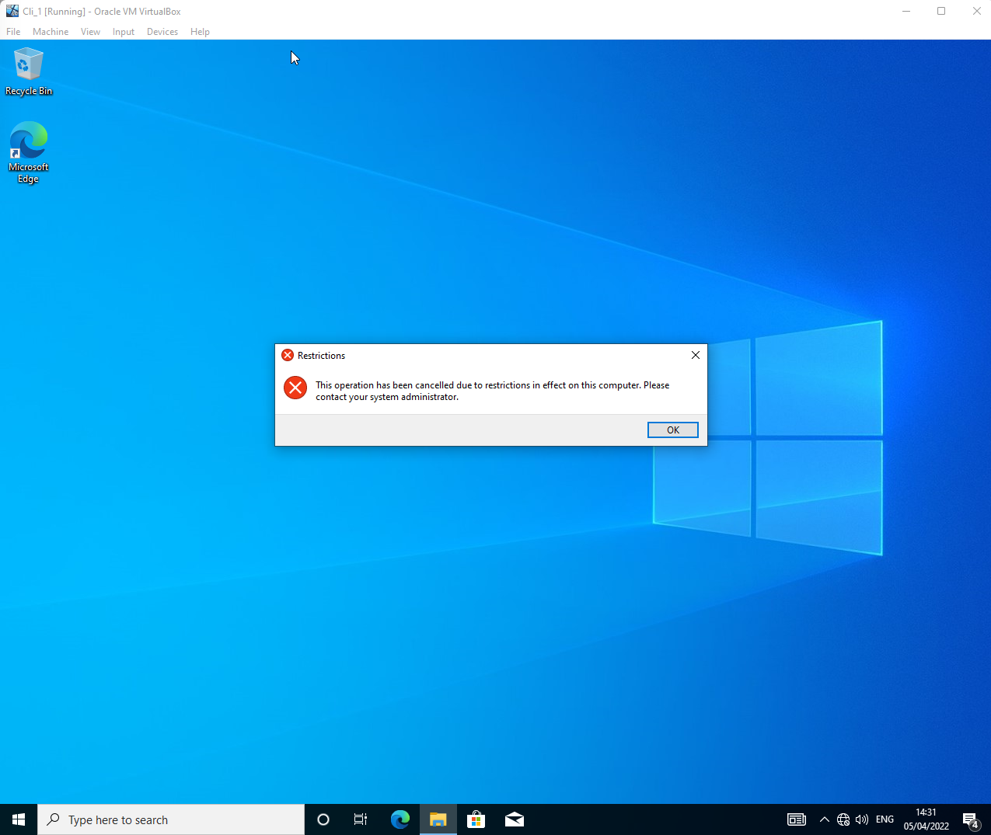

GPO 2: Removing Access to the Command Prompt
- Repeat actions of xiv. through xvi. for all remaining GPOs, providing appropriate name and policy.
Restricting access to Command Prompt can help mitigate potential attacks involving the circumvention of security policies through high-level commands.
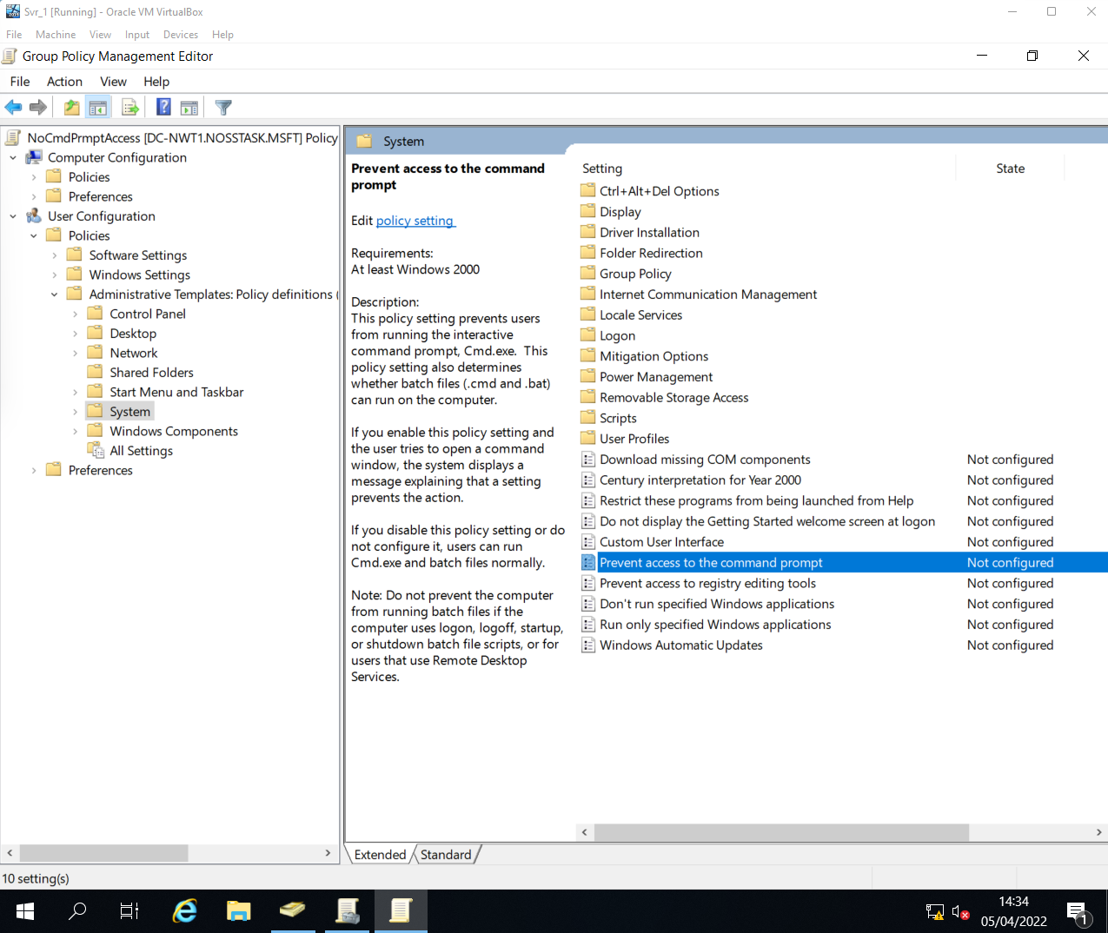
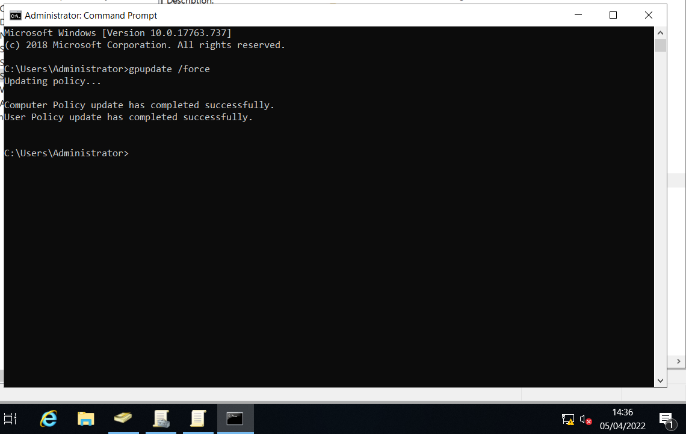

- Validation of NoCmdPrmptAccess policy.
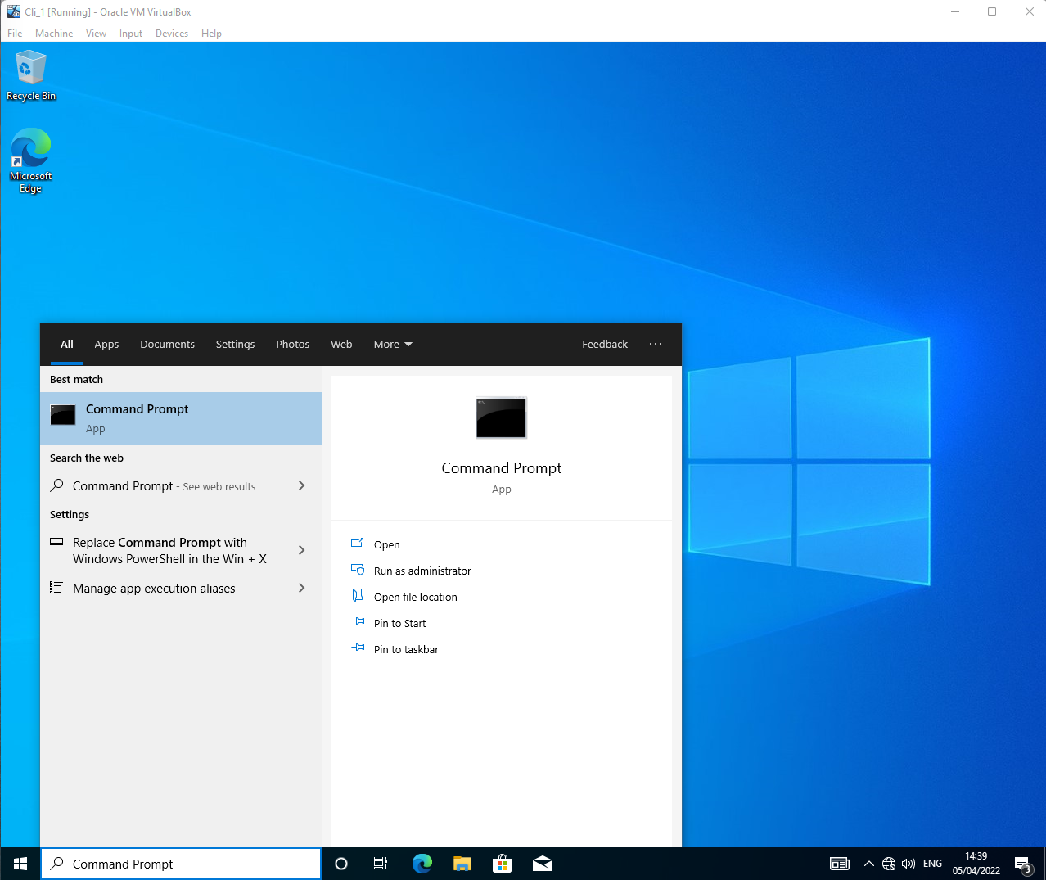
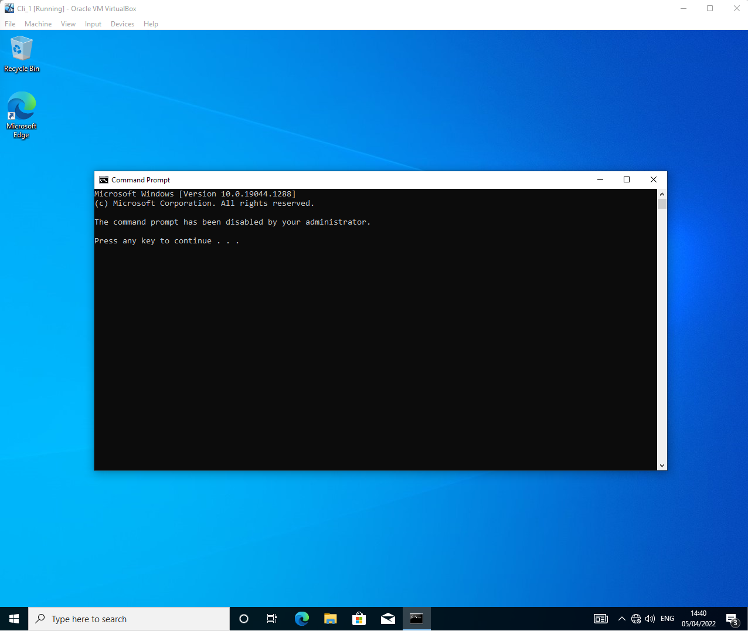

GPO 3: Restricting Access to Removeable Media Devices
- A peer-reviewed article from Computerworld highlights that one in eight malware attacks occurs via a USB drive ^{[3]}. Therefore, restricting removeable media devices can help circumvent the introduction of a virus or malware onto the network directly through hardware.
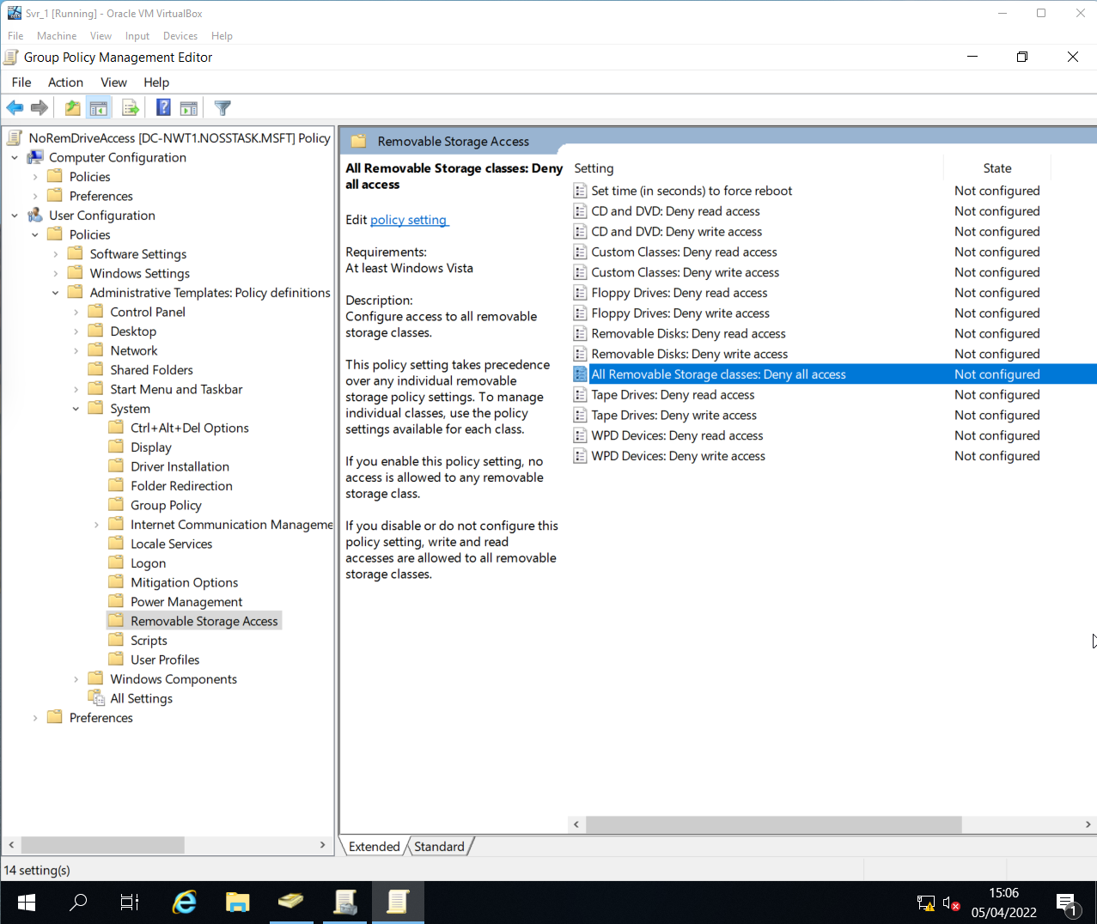
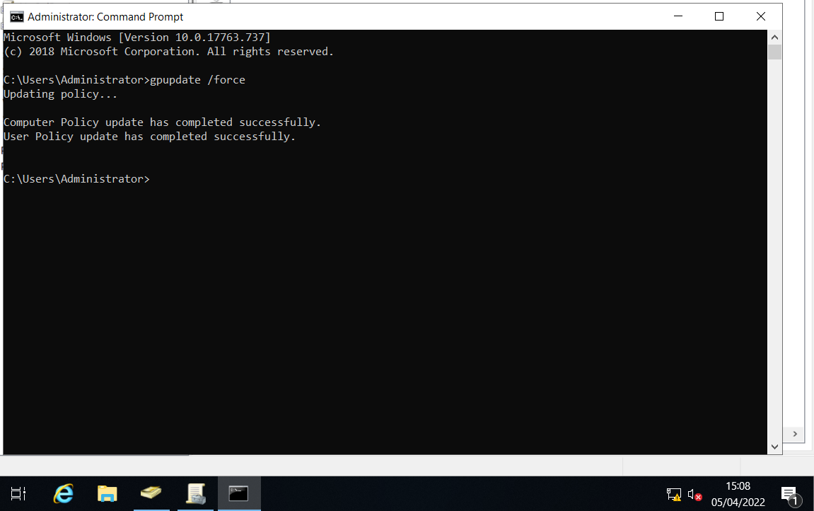

- Validation of NoRemDriveAccess policy.
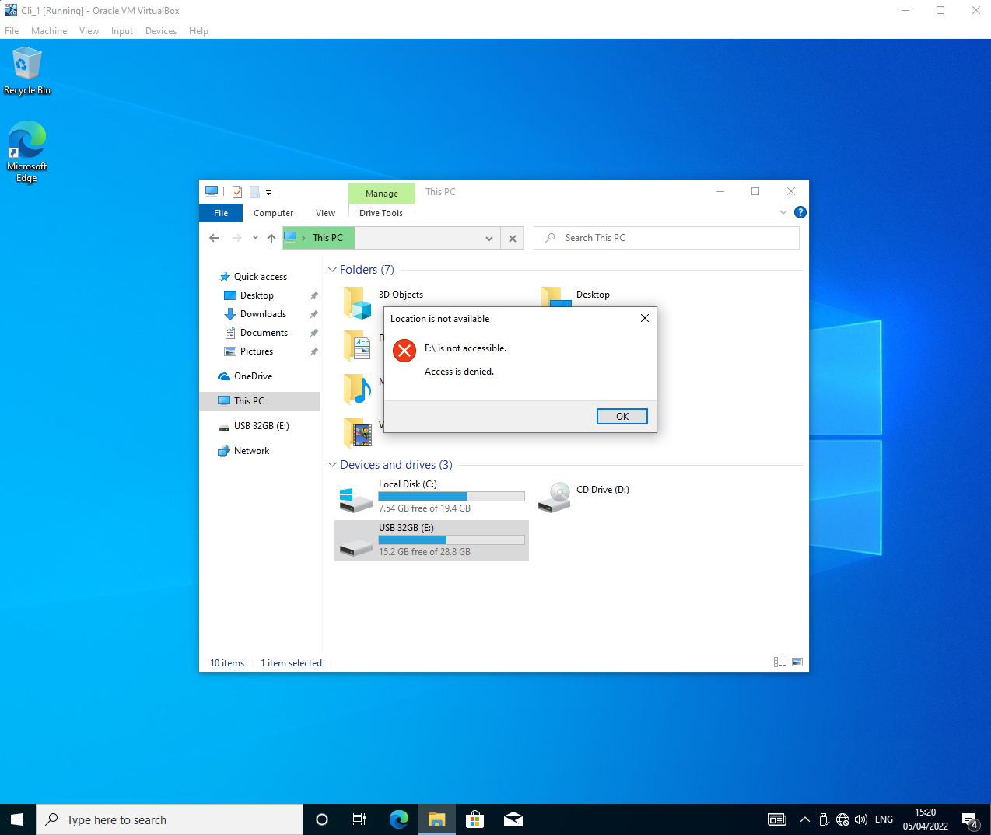

GPO 4: Restricting Software Installs
- GPO is applied to computer object so that it effects all users accessing the system.
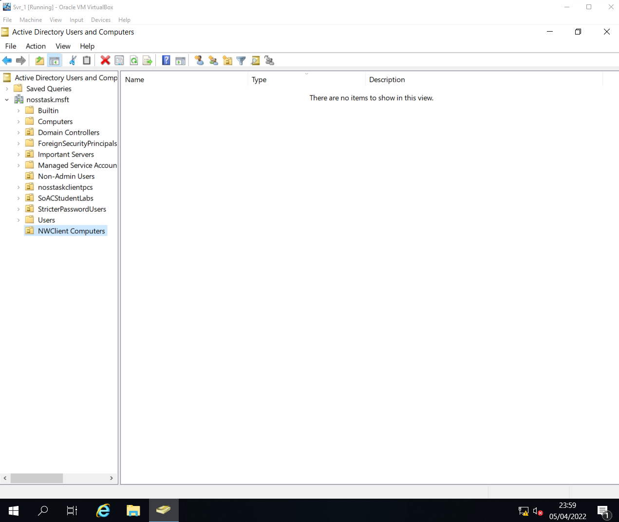
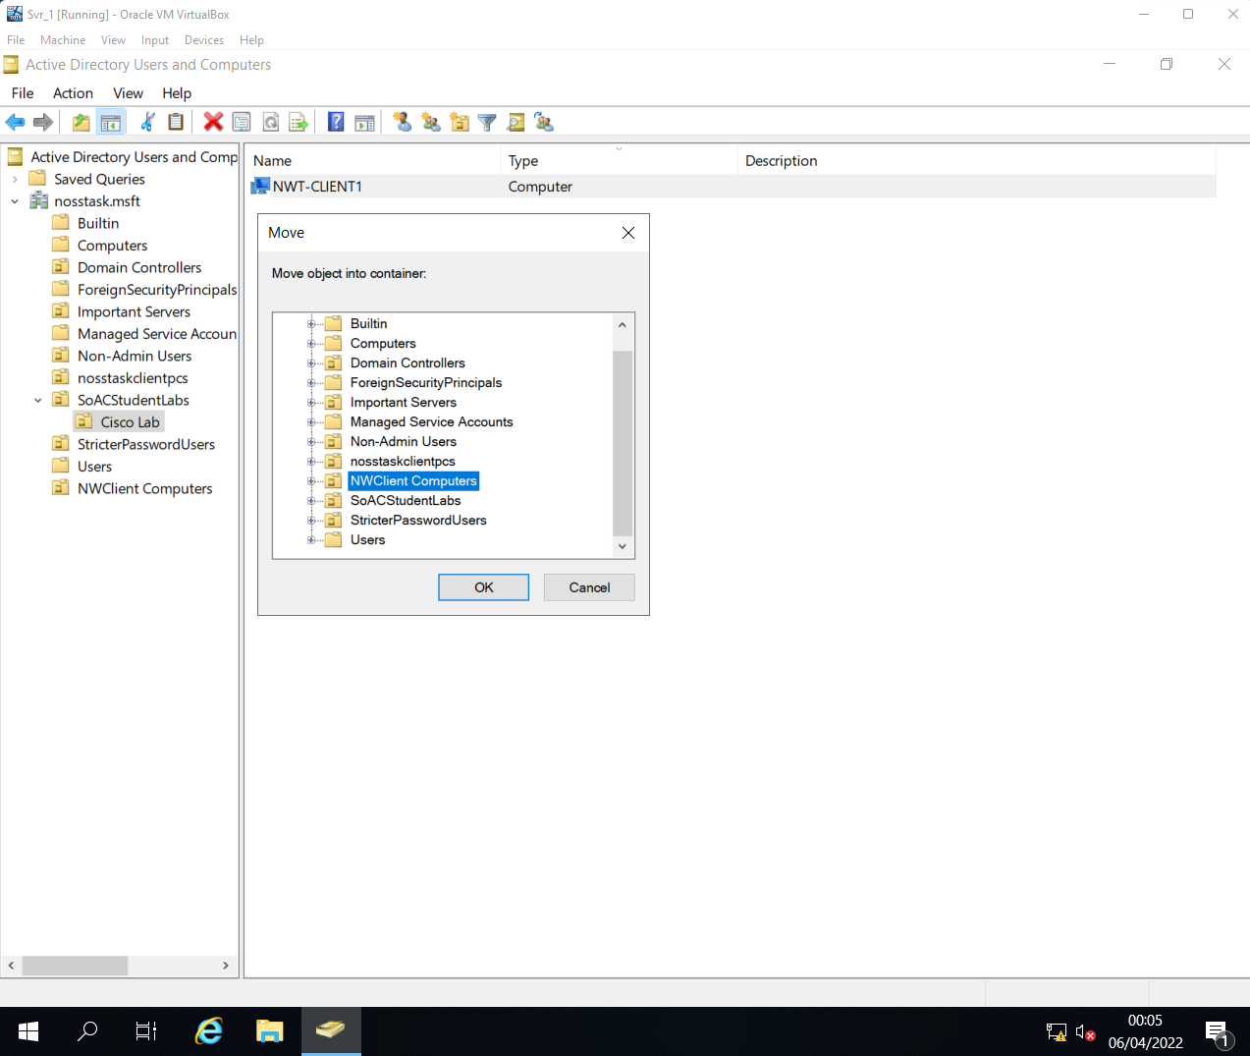

- Repeat actions of xiv. through xvi., providing appropriate name and policy.
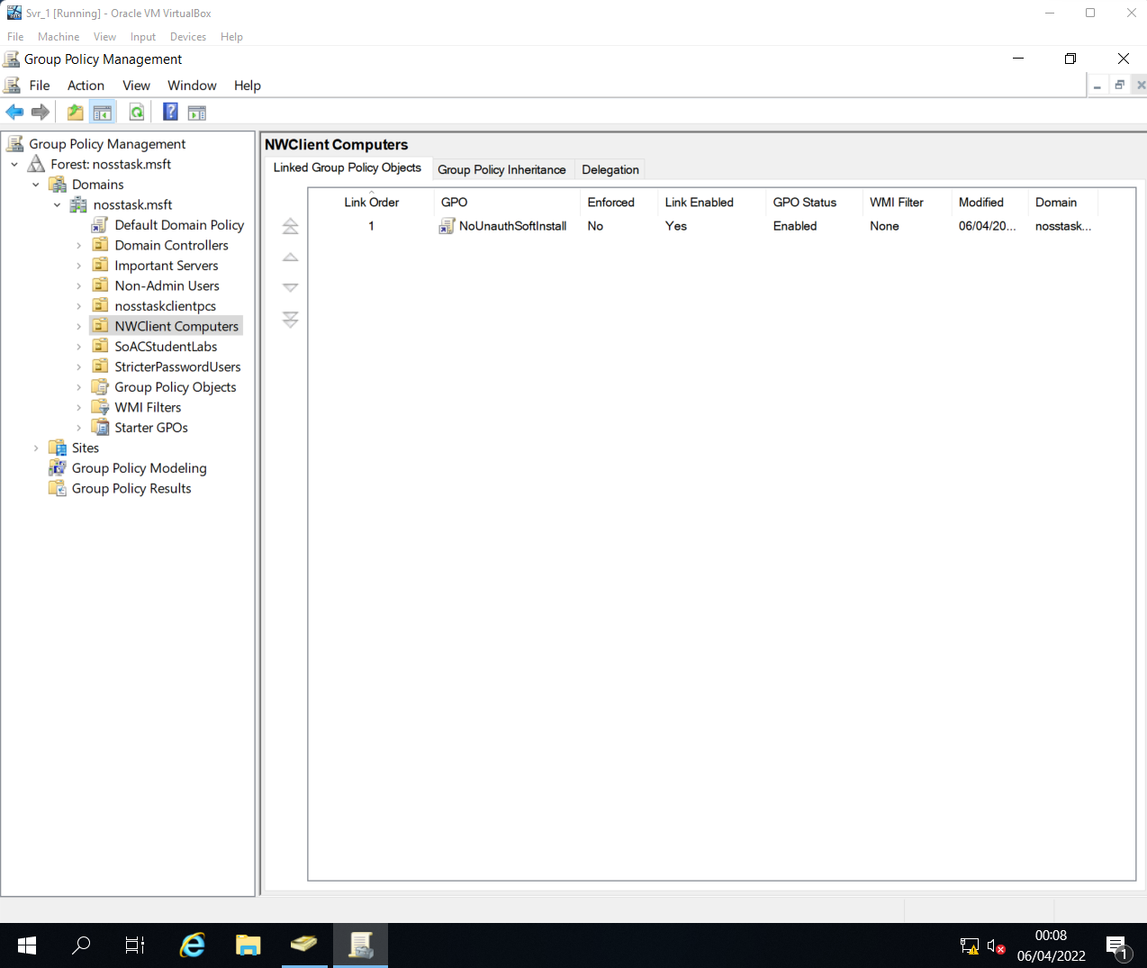
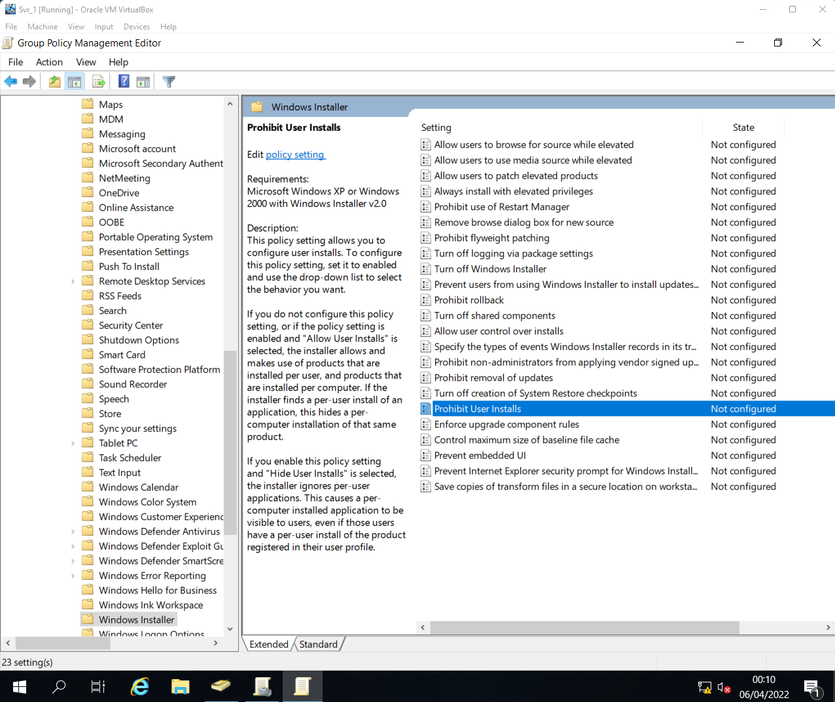
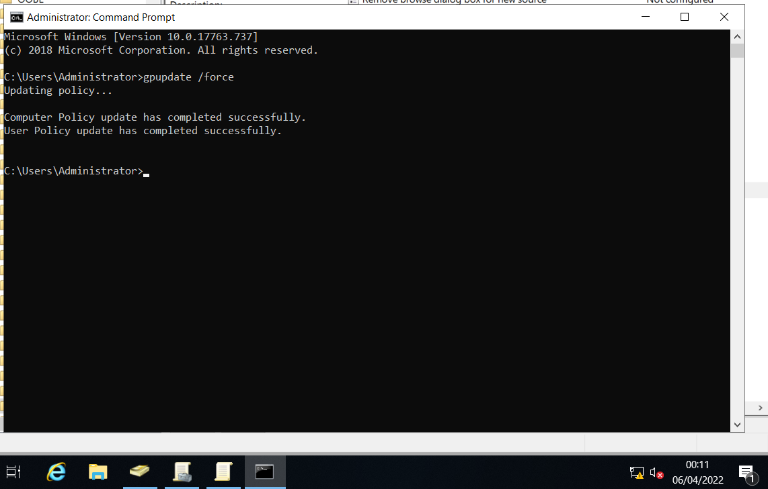
- Validation of NoUnauthSoftInstall policy.
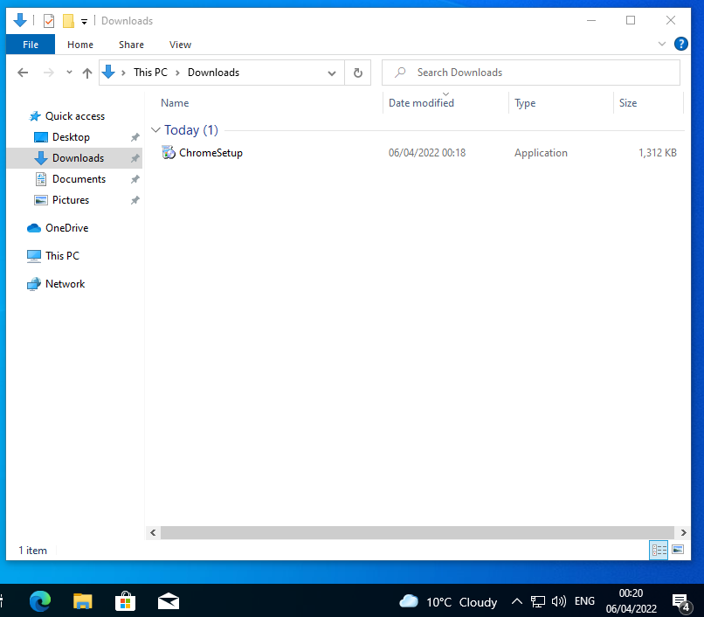
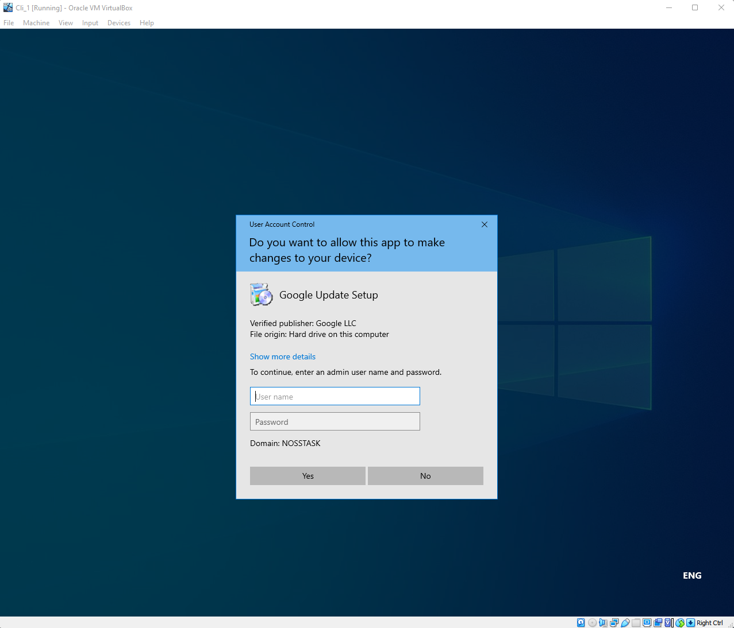

GPO 5: Enforcing Password Policy in the ‘nosstask.msft’ Domain
- Password policies are configured directly within the nosstask.msft domain. Repeat the actions of xv..
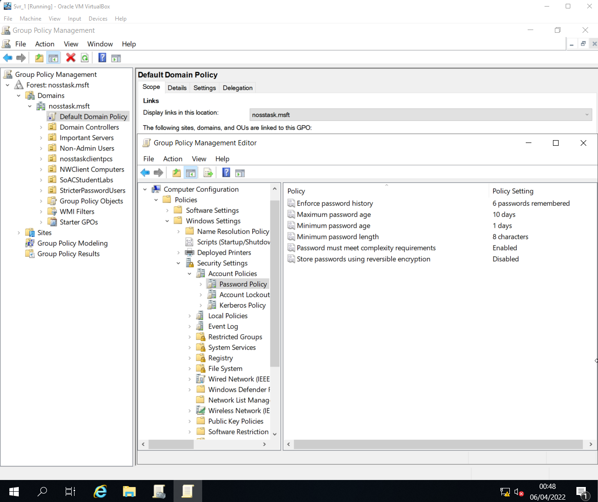
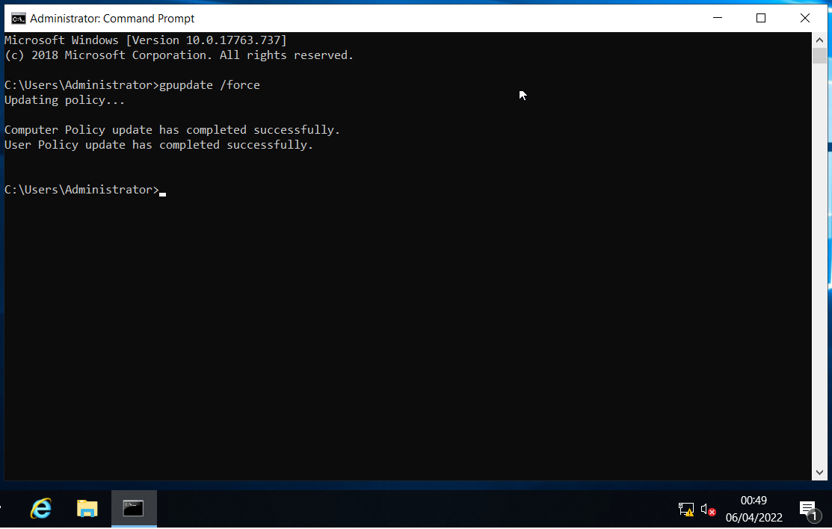

- Validation of password policy implementation.
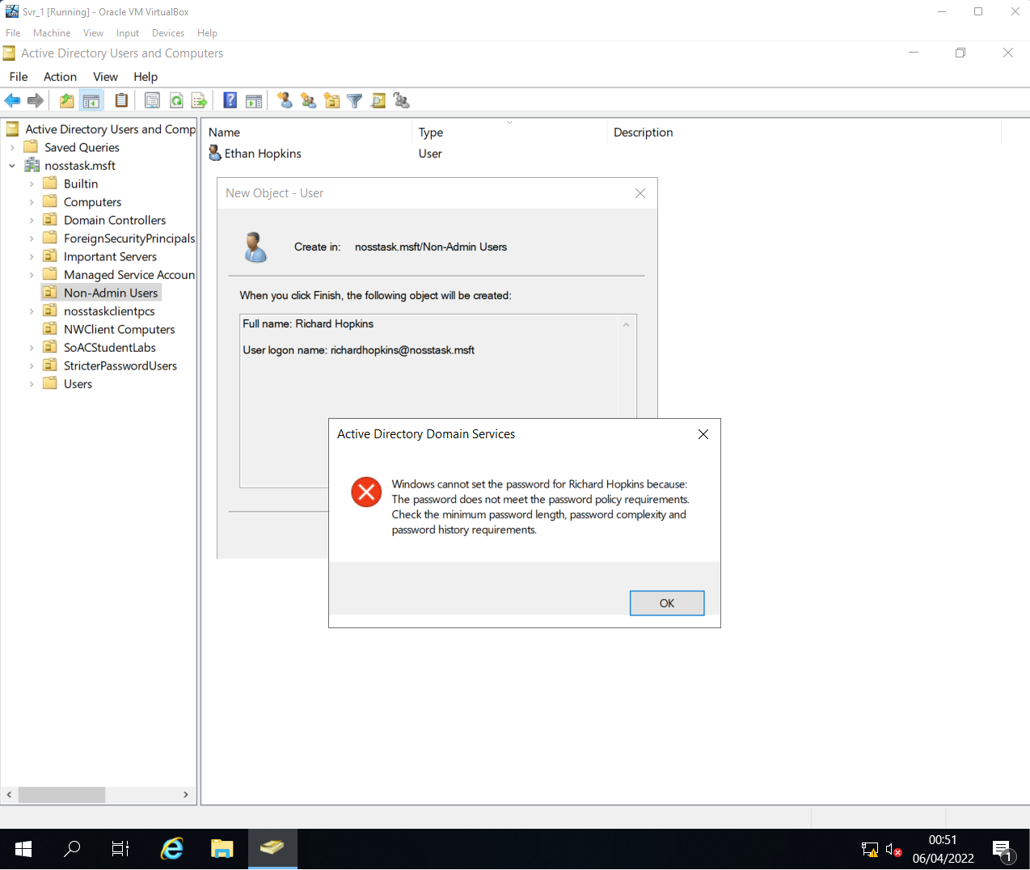

Task 2: Routing and Packet Filtering Within Core TCP/IP Services and Critical Failover/Redundancy Practices
  - Task Brief
In this task, routing and remote access will be incorporated into the network systems. Making use of such tools will require the deployment of core TCP/IP services, including IP packet filtering to manage inbound and outbound traffic within the network to help further enhance security.

Utilizing ARP and Routing Tables
- ARP tables can be viewed within the command prompt by entering ARP -A into the console.
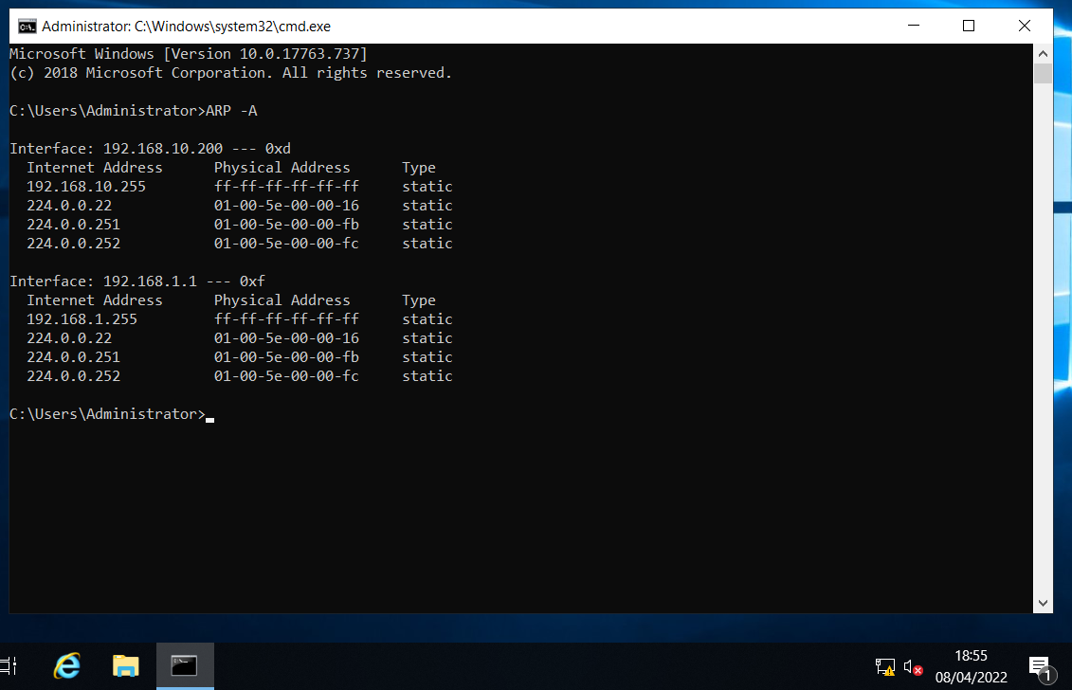

- Pinging machines outside of the presented ARP table will cause the table to update and note down additional connections.
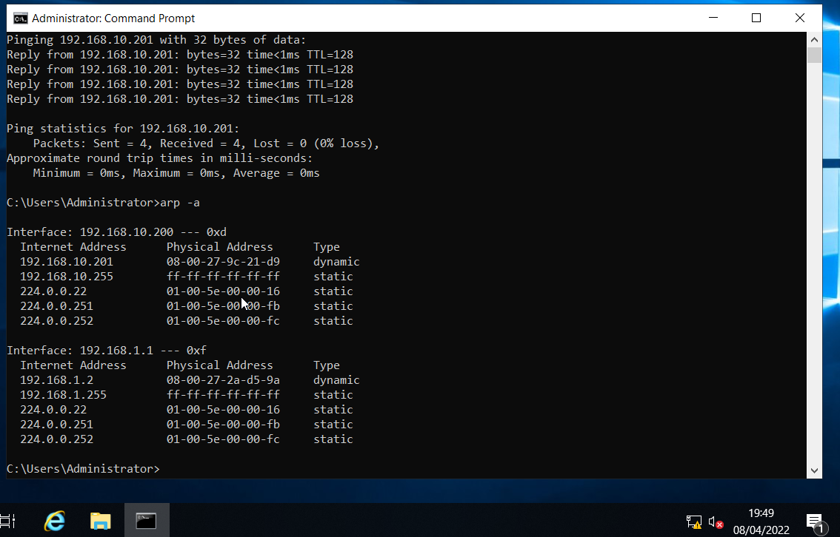

- Route print command prints out the routing table of the OS.
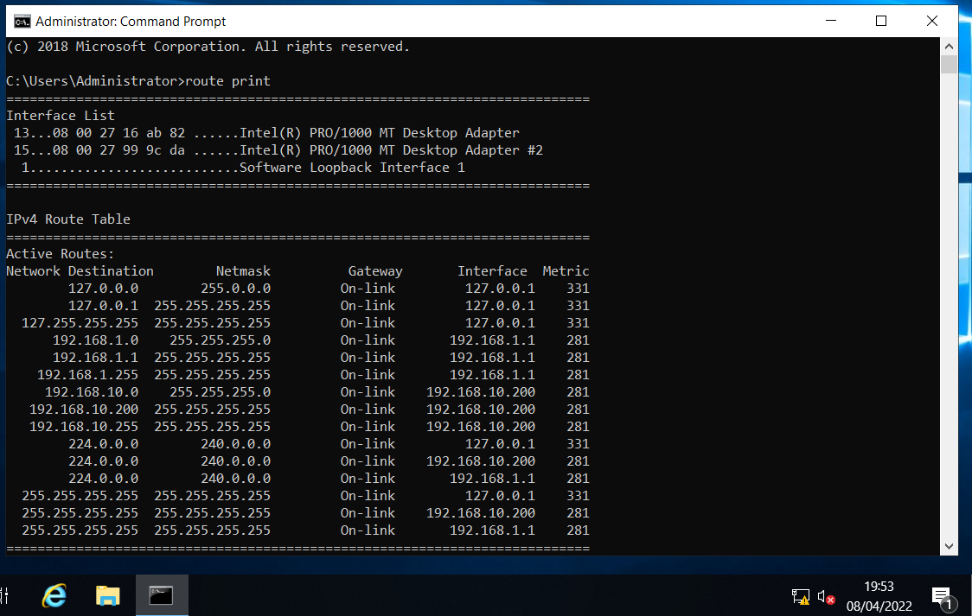

Deploy Core Services (FTP Server)
- Install FTP Server role onto the server using Server Manager. Create user ftpuser22 using Computer Management to assign and test FTP access policies across VM systems through command prompt.
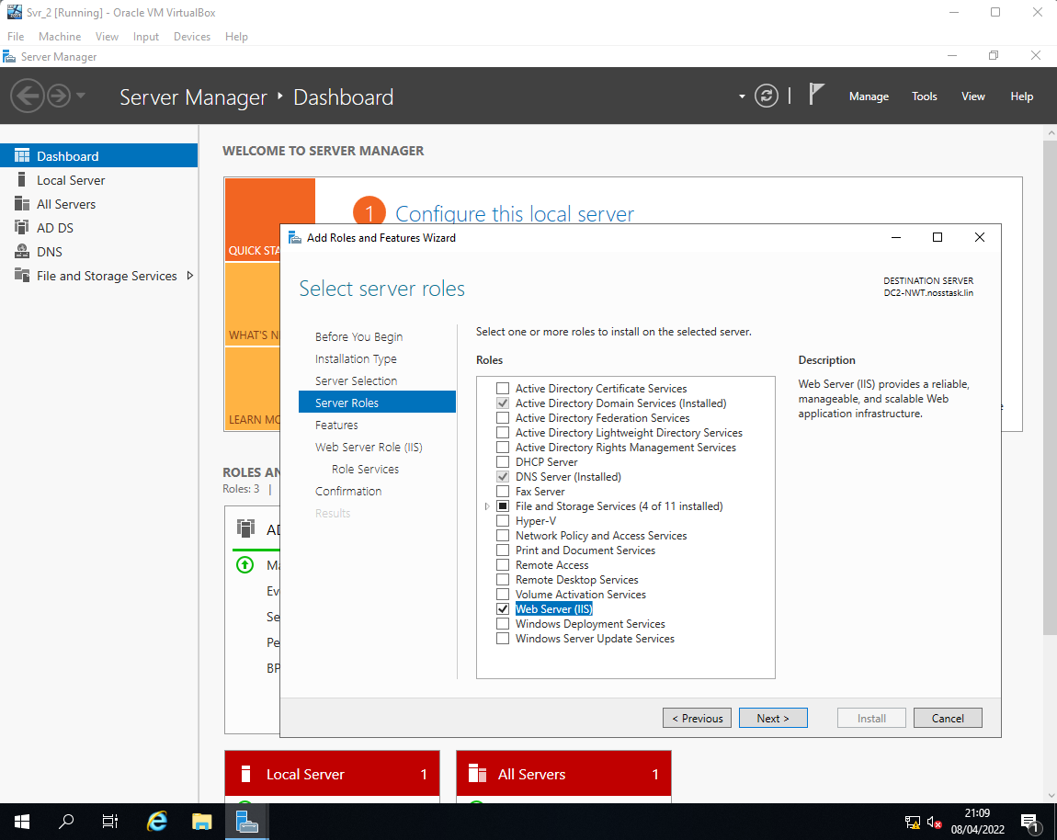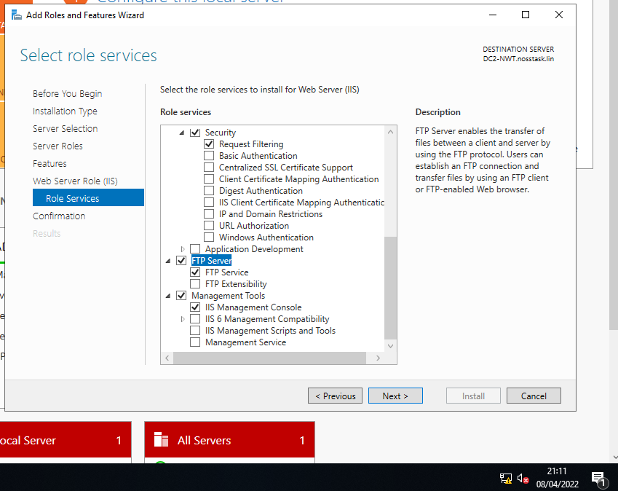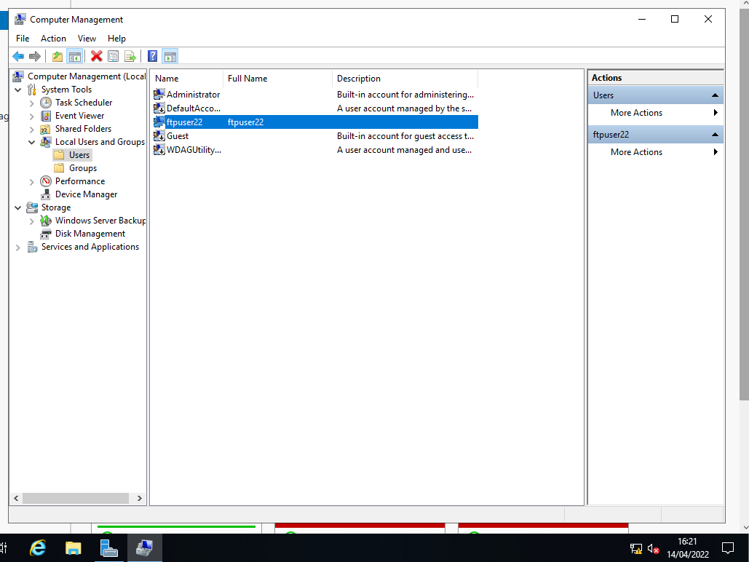

- Create FTP Site using the Internet Information Services (ISS) Manager. The assigned physical path of the FTP site will act as the default read/write directory for data received through the FTP client.

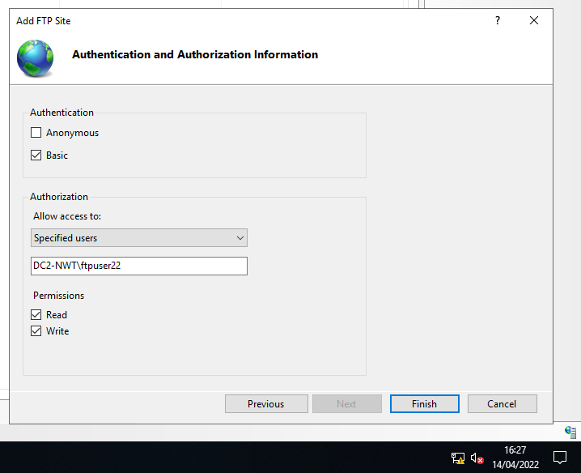

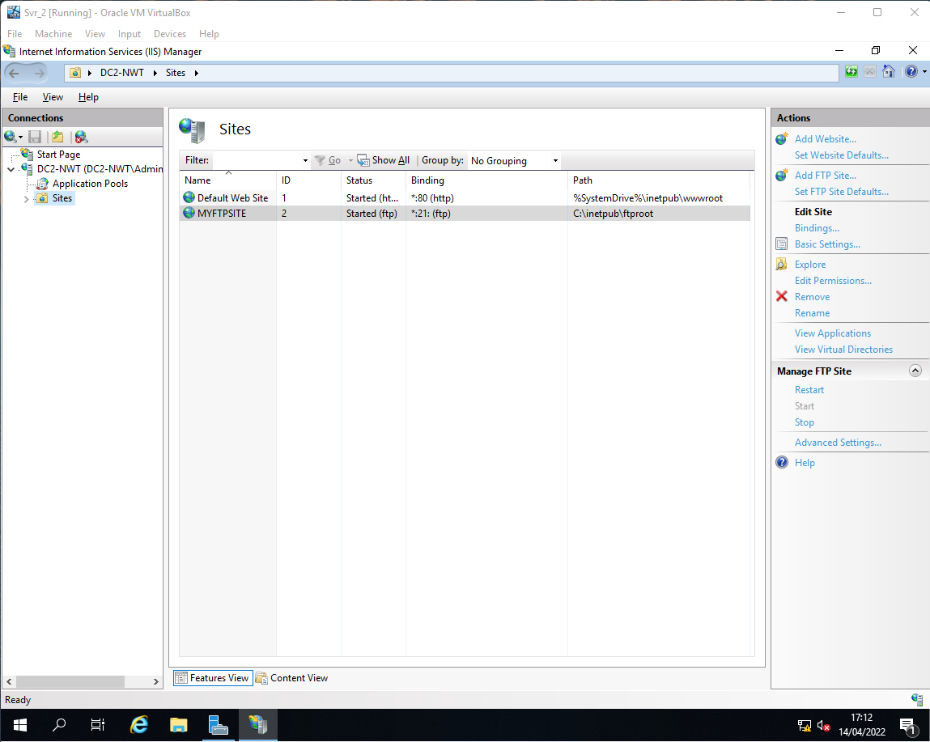

- Creating a banner within the IIS Manager can help inform users of the FTP of the site they are connected to and ensure it is the correct one. Banners can be accessed within FTP messages of MYFTPSITE.
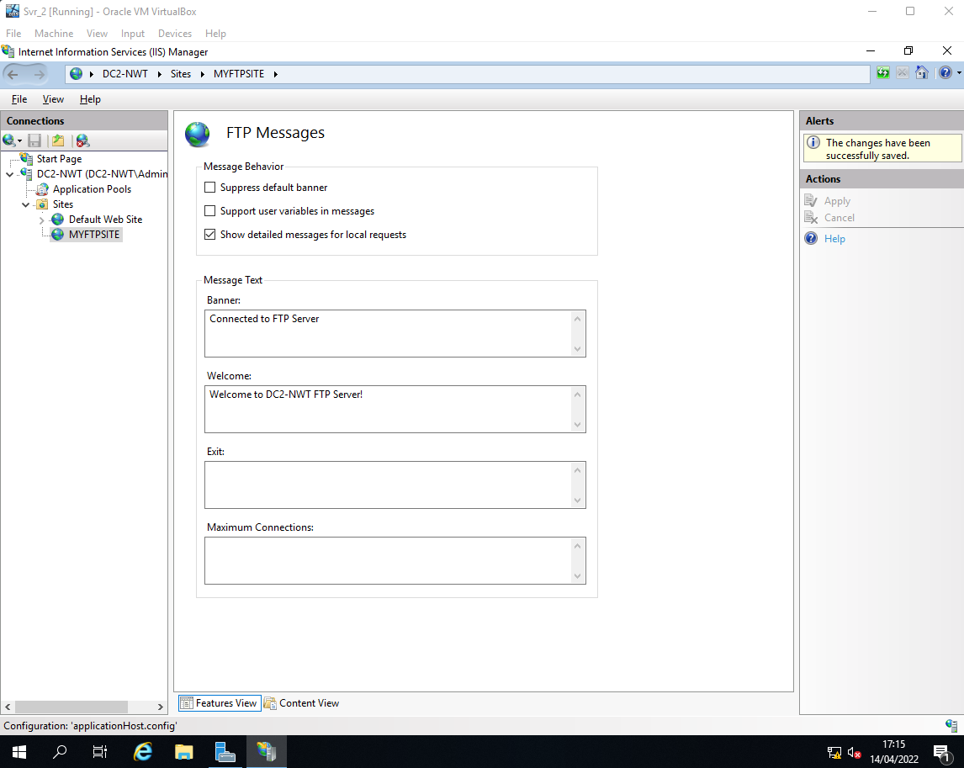

- Assign ftpuser22 further permissions within the FTP root physical path folder, enabling more creative control over the FTP site.
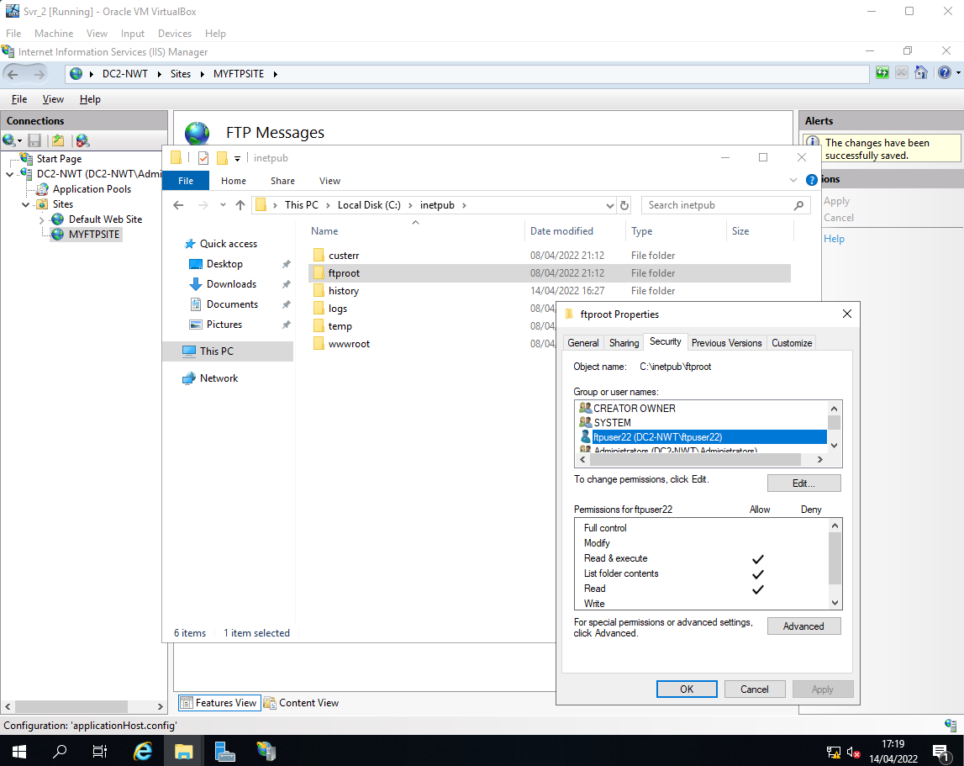

- Create file myftpfile2upload.txt to upload to FTP site. Connect to FTP site using ftp 192.168.11.1 within command prompt. Provide ftpuser22 credentials to login.
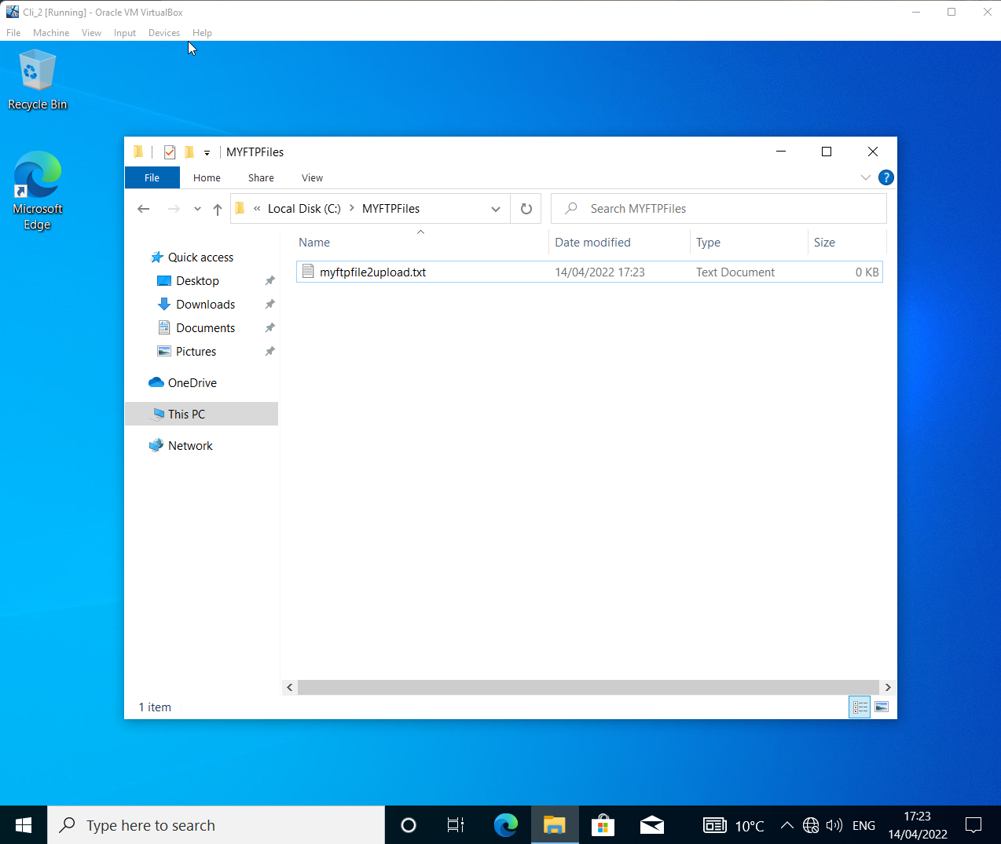
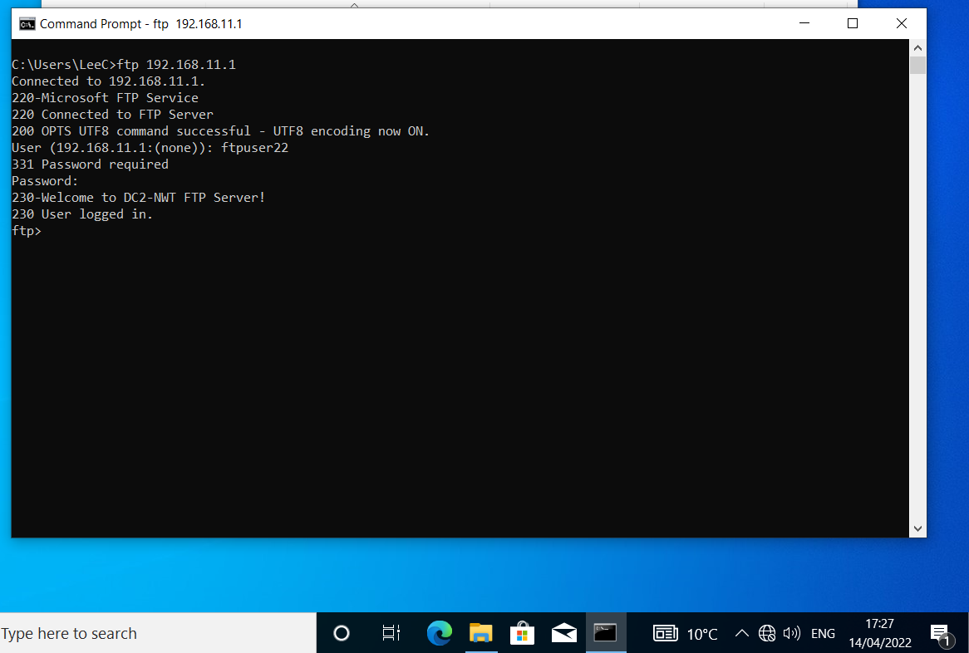

- !dir C:\MYFTPFiles will list the available files within the client machine. Using put C:\MYFTPFiles\myftpfile2upload.txt will transfer the file over FTP from the client machine to the server.
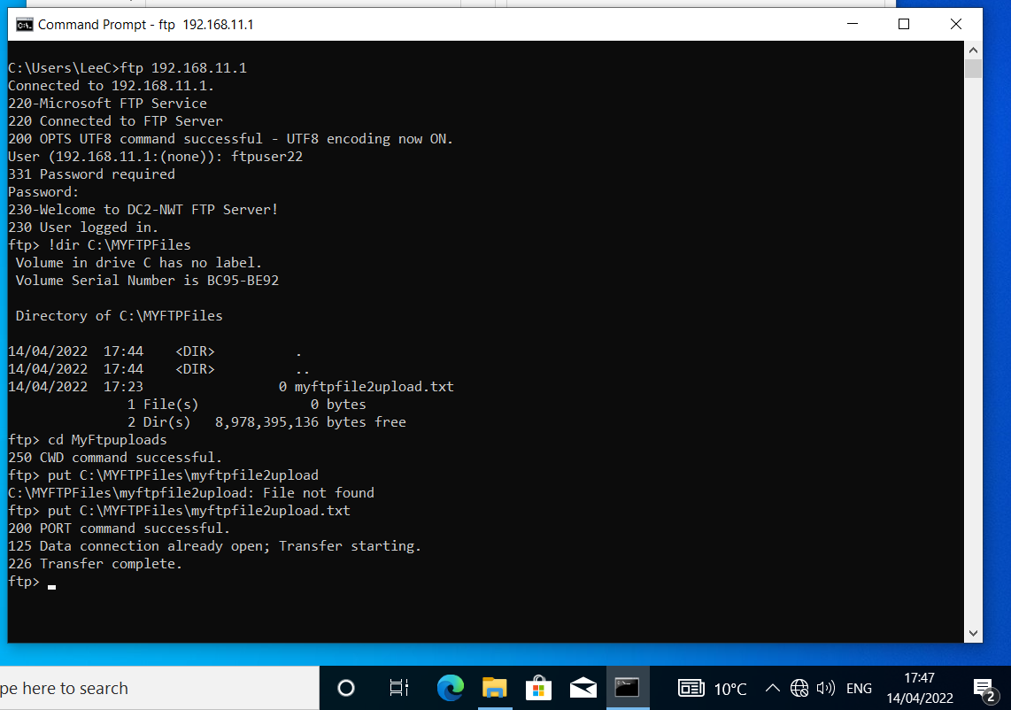
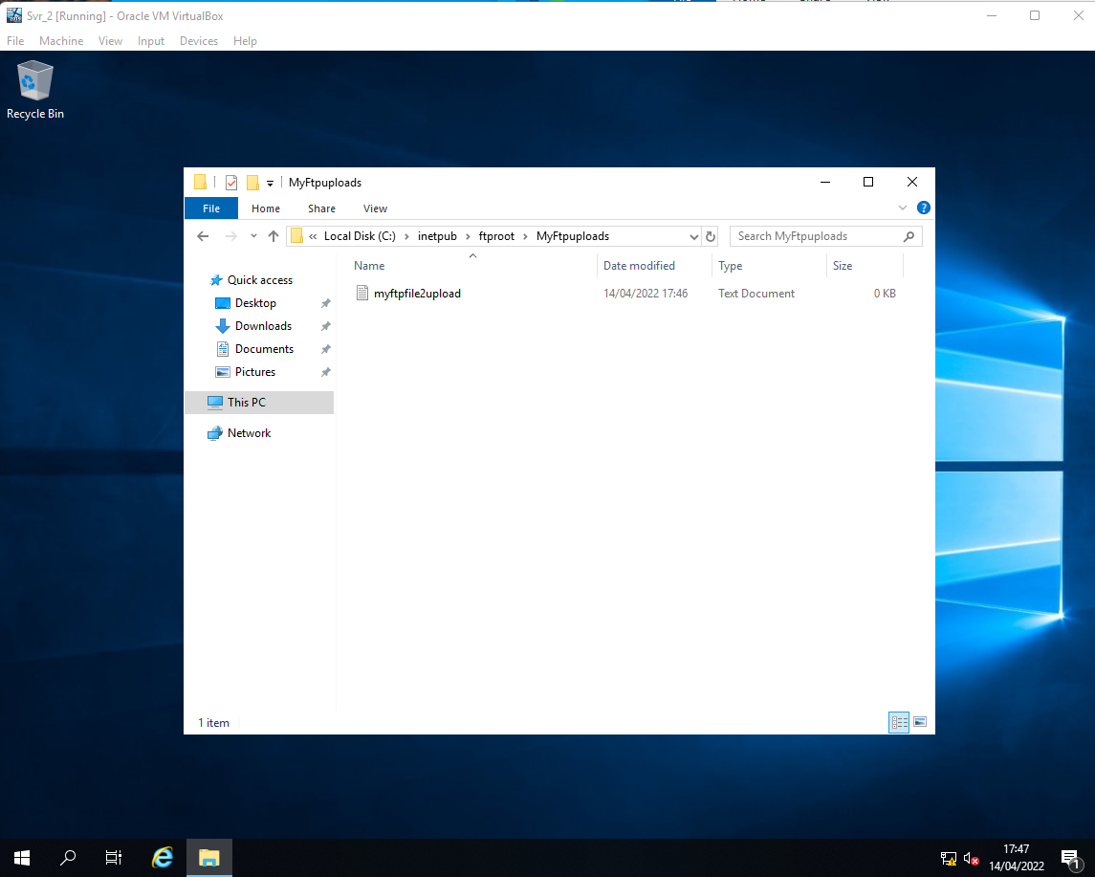

Installing and configuring the Routing and Remote Access Service
- Remote Access brings DirectAccess and VPN and Routing services to be used within LAN routing configurations. These services can deploy crucial routing protocols for the network.
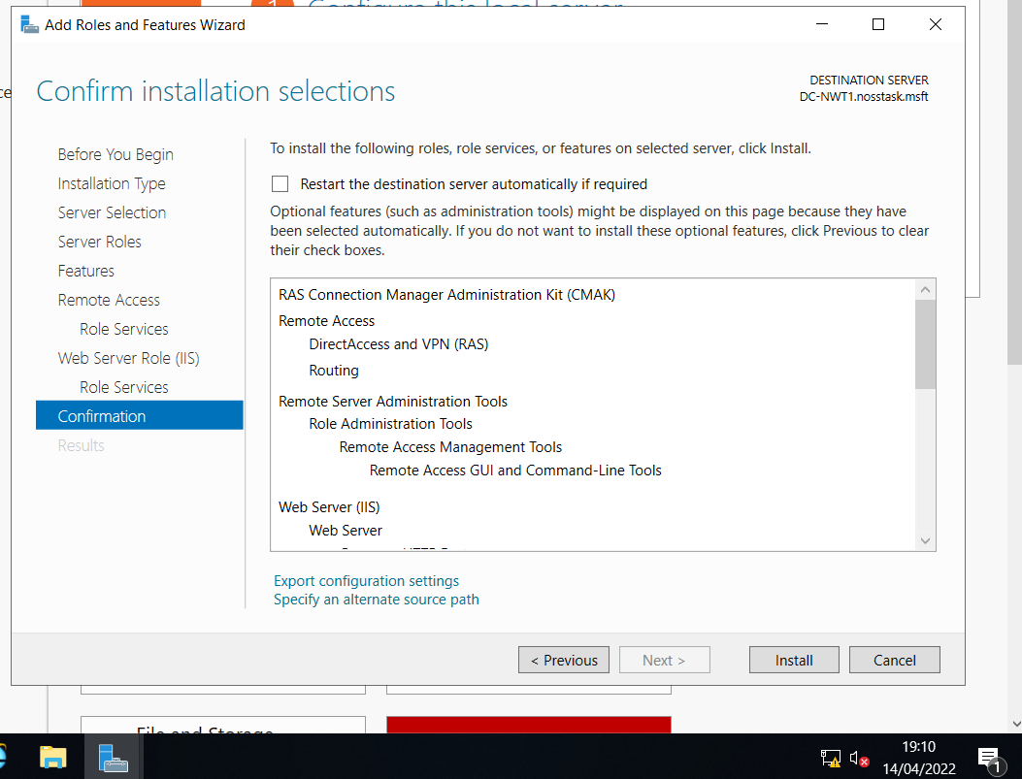
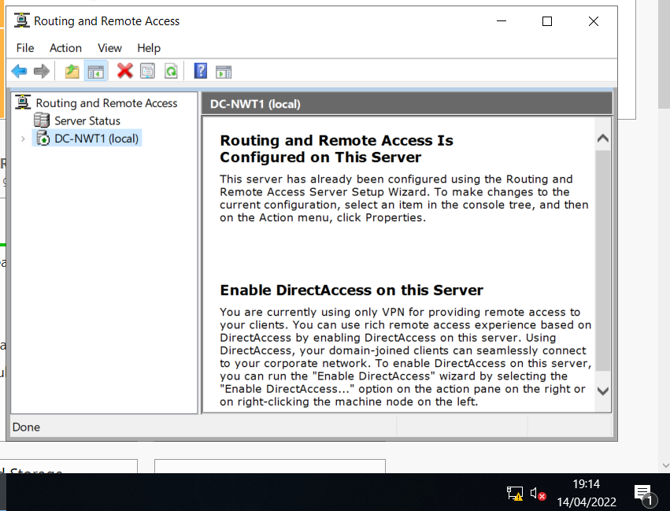

- Described in an article from Chitkara University, Routing Information Protocol (RIP) version 2 is a dynamic routing protocol that helps pave a route between at least two networks. Its classless nature allows it to be more effective at identifying and utilizing the most effective route to a destination while also offering encryption for a secure connection ^{[4]}.
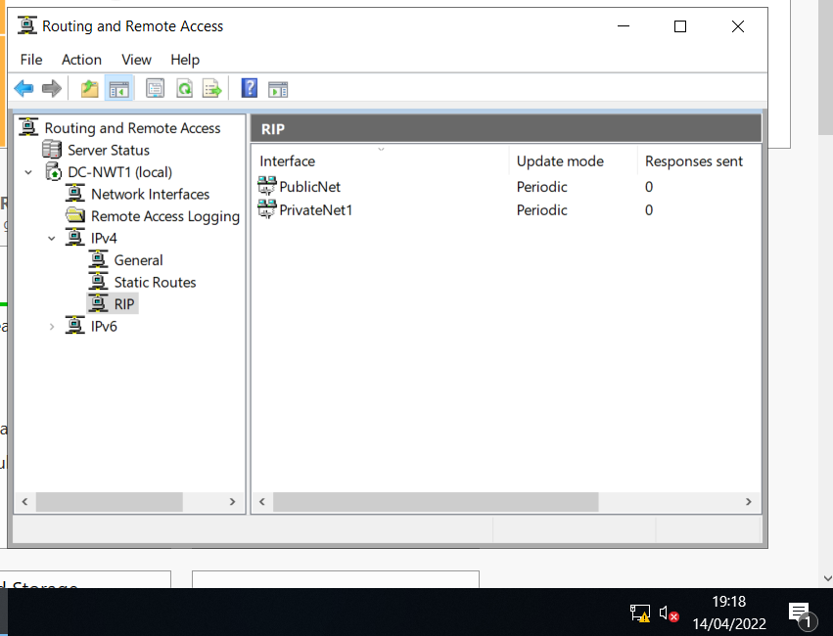

- Repeat the actions of xxxv. through xxxvii. within Server 2, adding each interface to RIPv2 for routing.

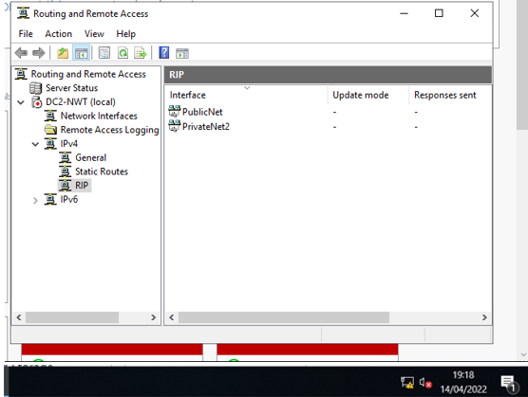

- WAN connectivity test to ensure RIP has been configured and operates appropriately. Successful ICMP ping between both servers and private networks.
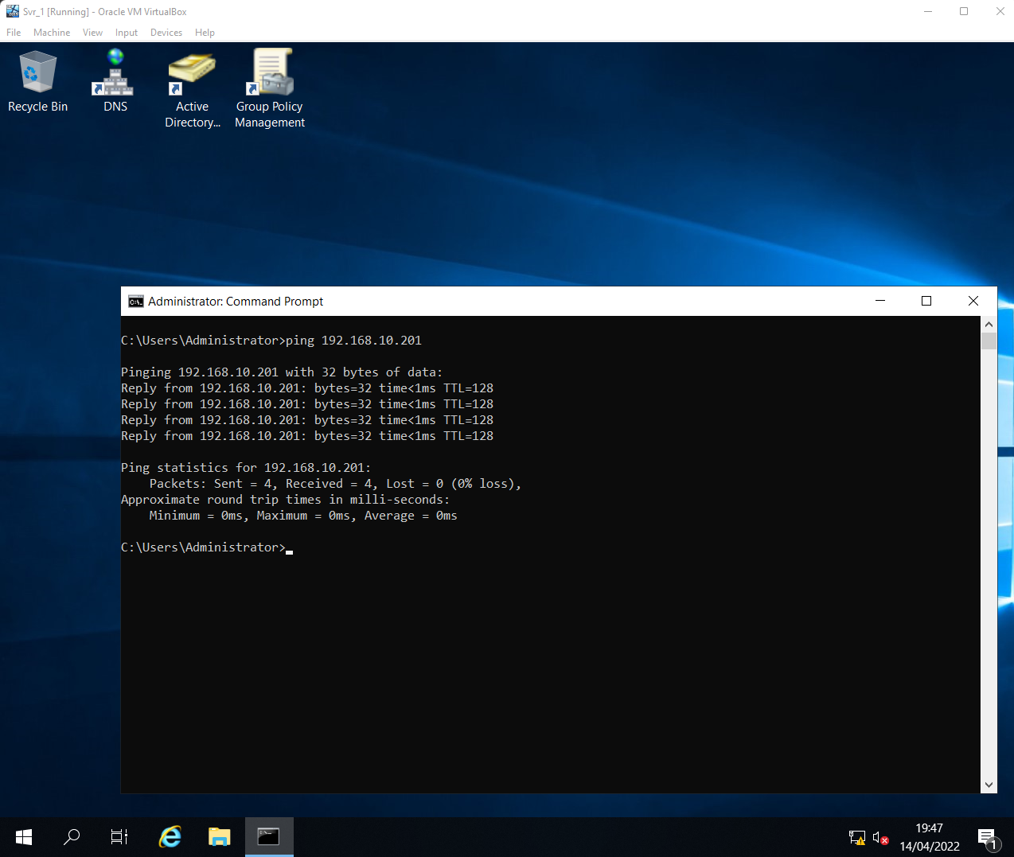
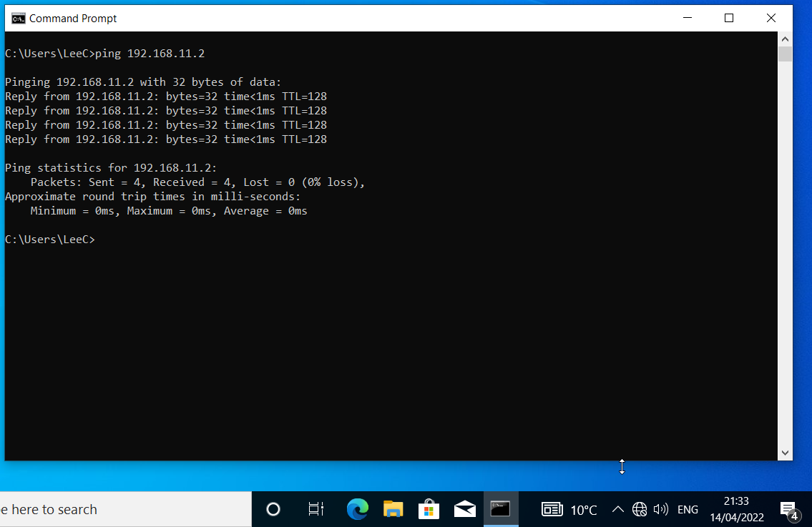

IP Packet Filtering

Filter 1: Stopping ‘anyone’ in PrivateNet1 from Pinging the Router Firewall Service
- Filter receives all packets except inbound ICMP packets from 192.168.1.1 (PrivateNet1) specifically sent to the Server1 PublicNet.
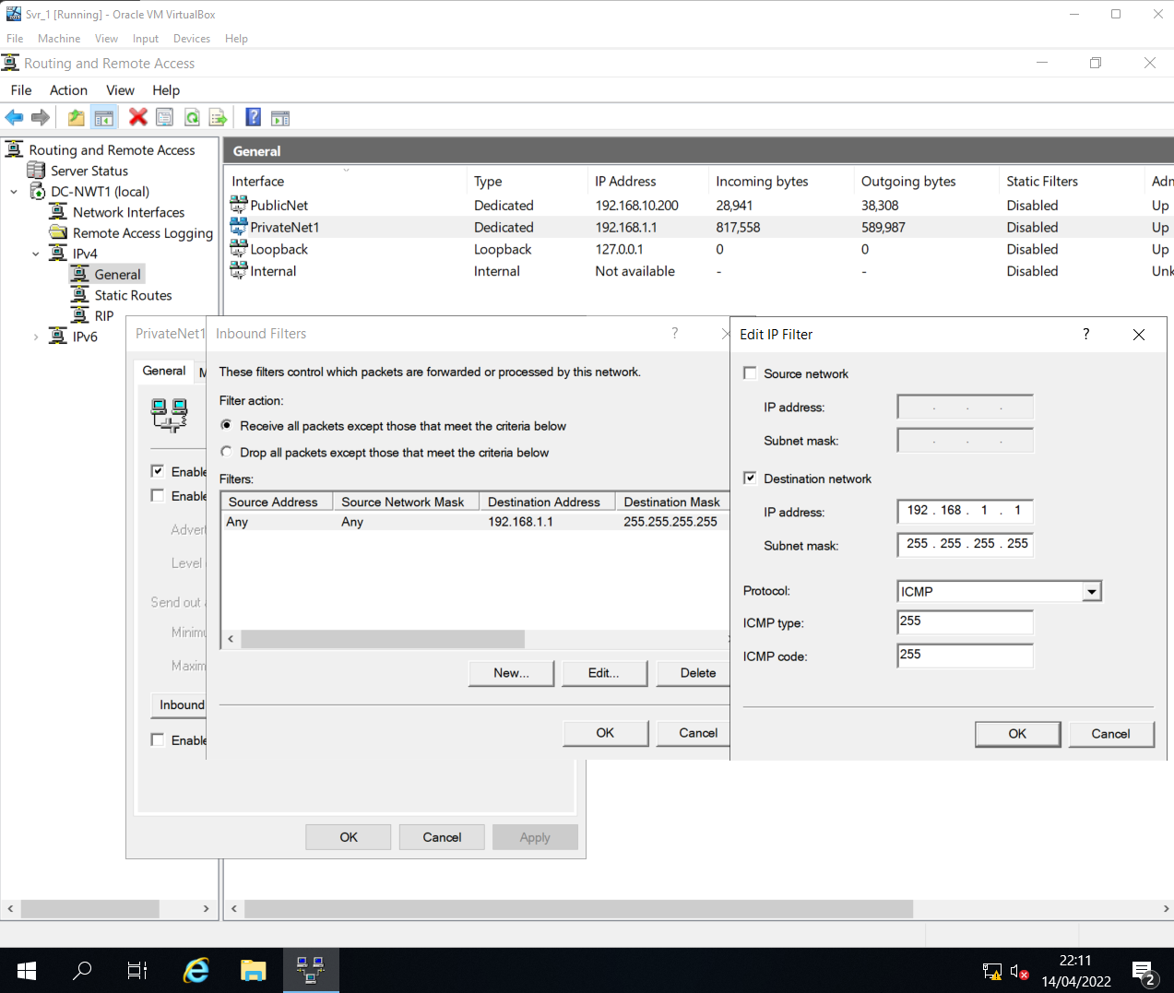
- Leaving the source network blank causes pings from every address within PrivateNet1 to be dropped.
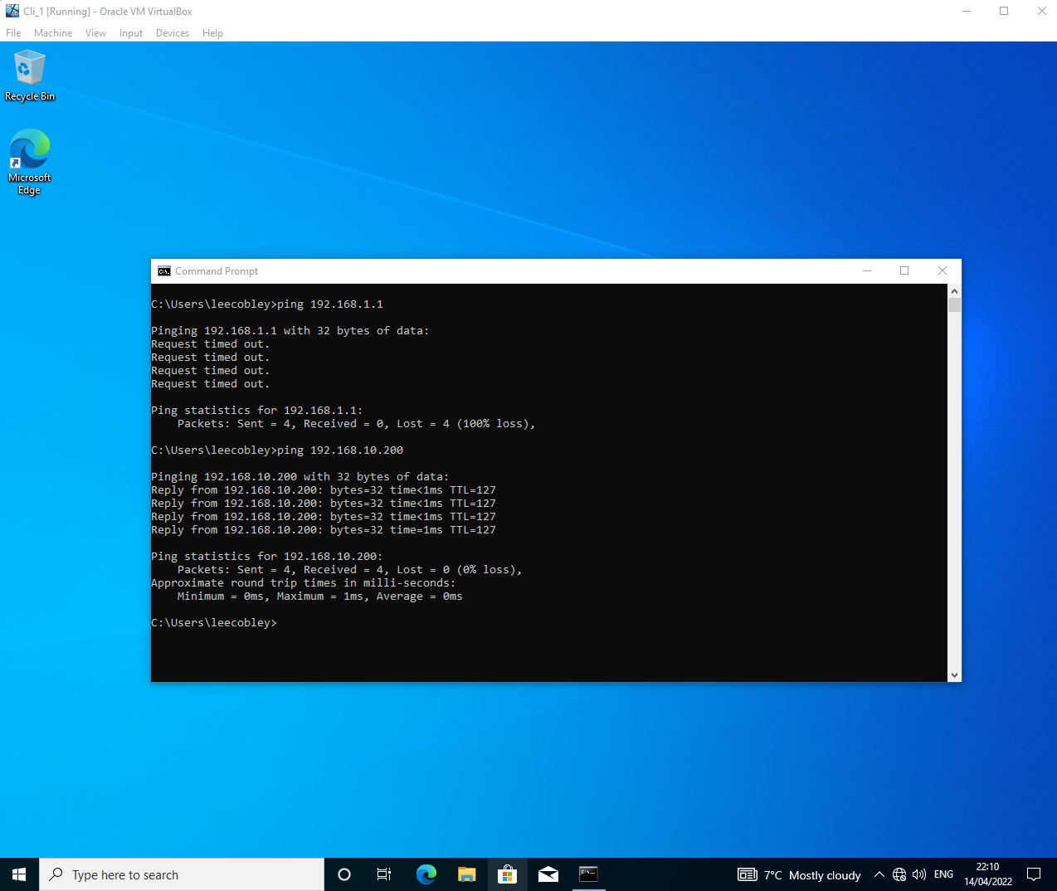

Filter 2: Restrict Access to FTP Service running on Server 2 to only hosts in PrivateNet2
- Filter restricts FTP access by dropping only outbound Server1 PublicNet TCP packets routing towards TCP port 21 of 192.168.10.201 (Server2 PublicNet). Port 21 is reserved for passive FTP. Other network packets are unaffected and can transmit.
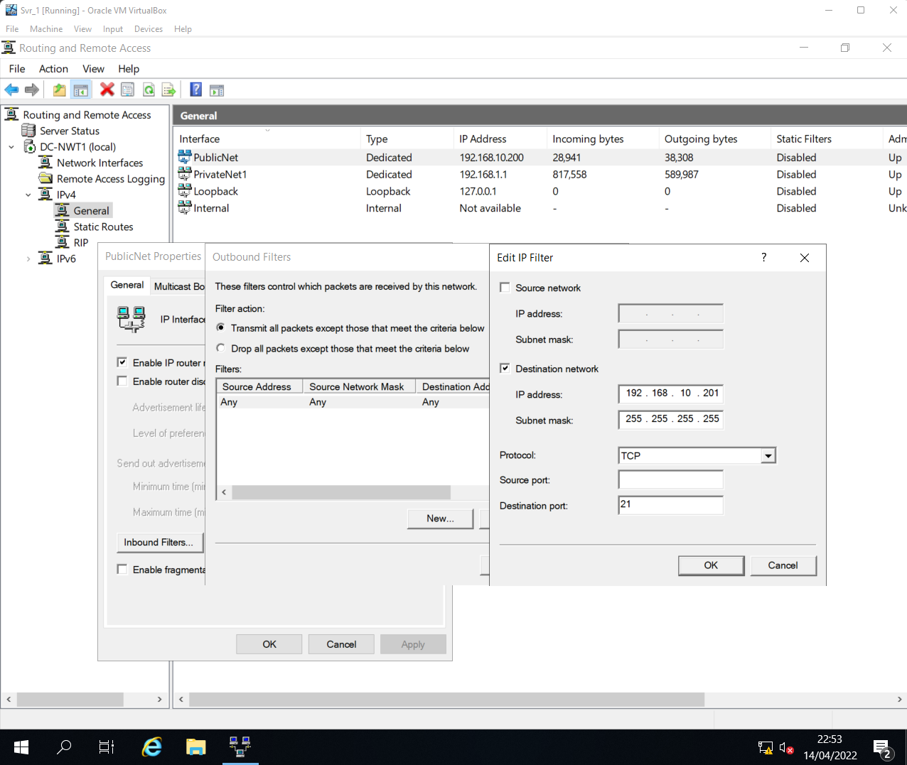
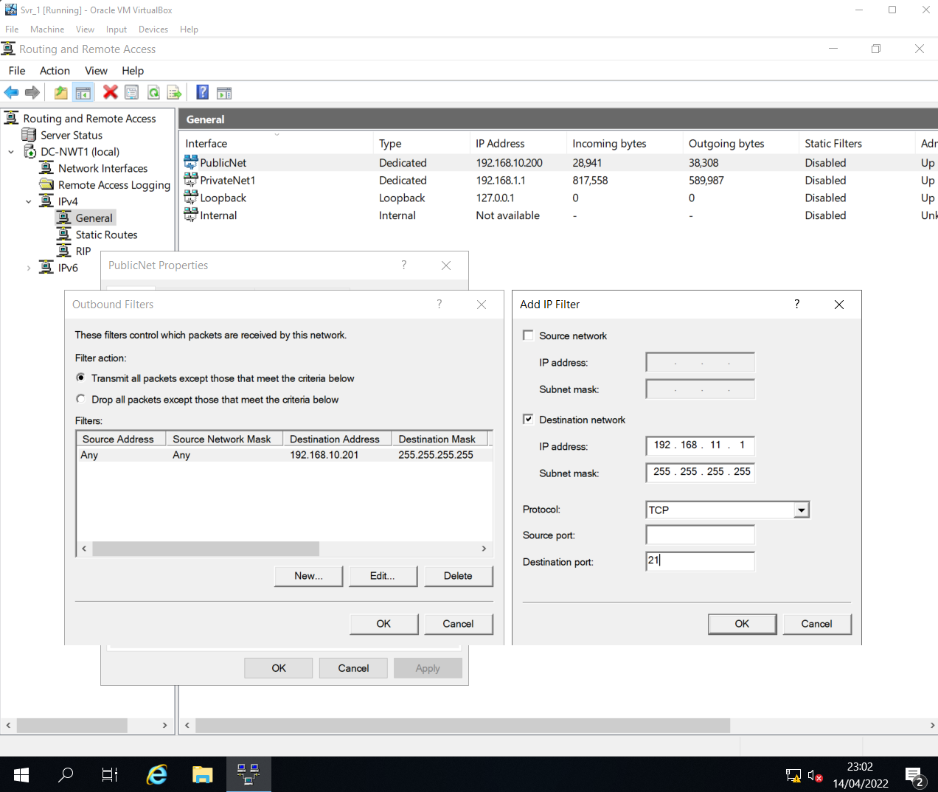

- Filter is required for both Server2 and PrivateNet2 as using only one could allow for a potential bypass. While filter drops Server2 below, users can still connect directly through PrivateNet2. Whereas two filters cover all possible points-of-entry.
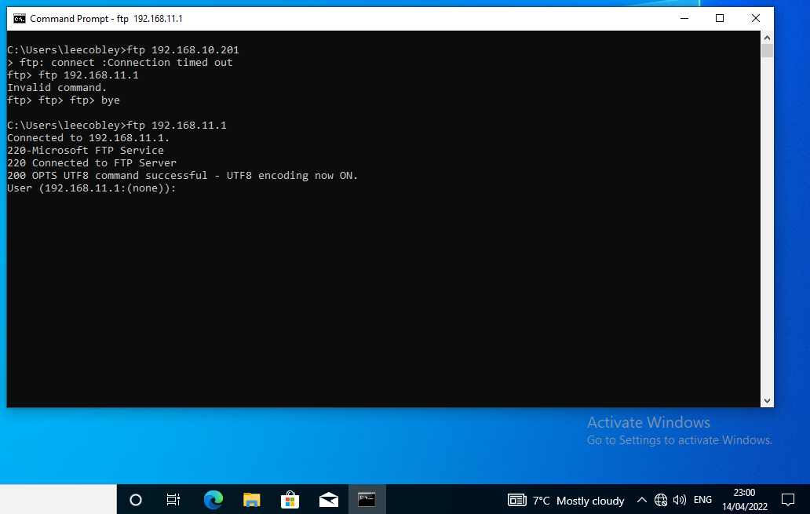
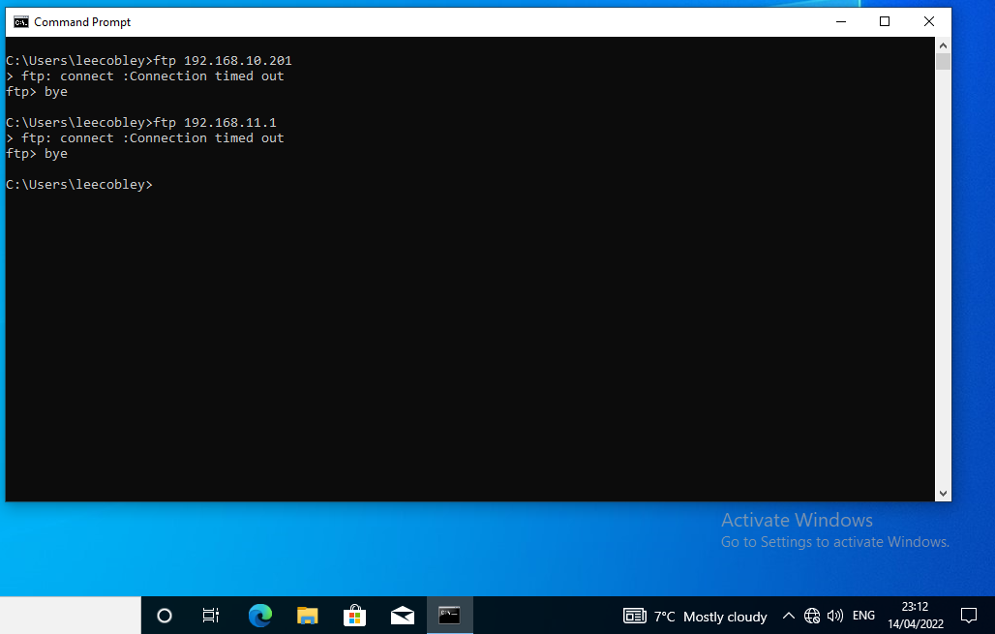

Filter 3: Only allow specific hosts in PrivateNet1 to access the FTPService running on Server 2
- Filter limits access to the FTPService by dropping all packets inbound from PrivateNet1 except those directed towards port 21 of both 192.168.11.1 (PrivateNet2) and 192.168.10.201 (Server2 PublicNet) from IP 192.168.1.2 (Client1).
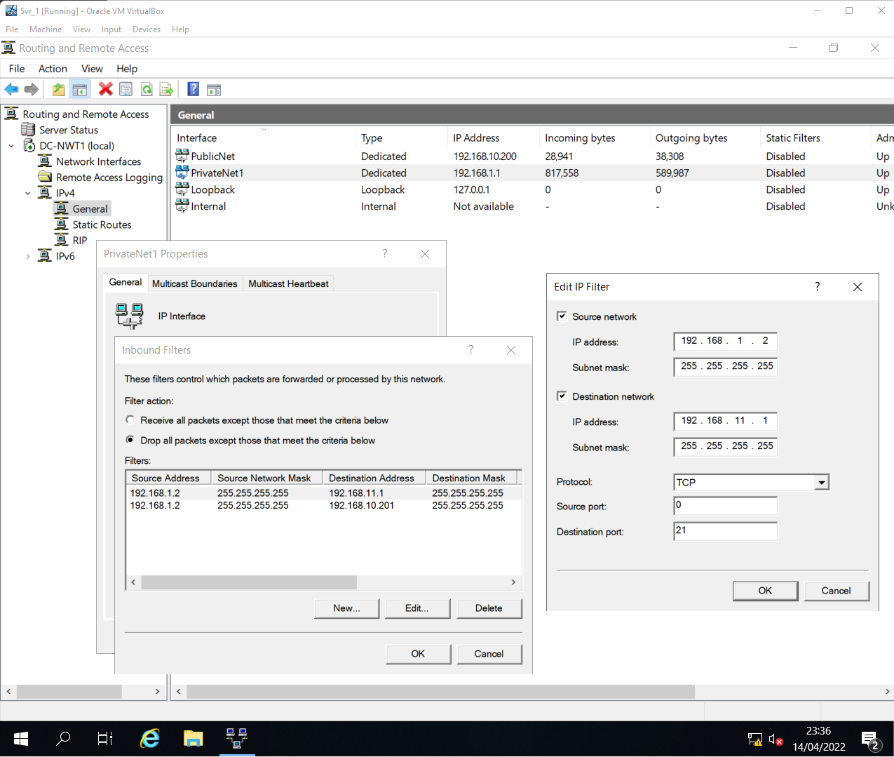
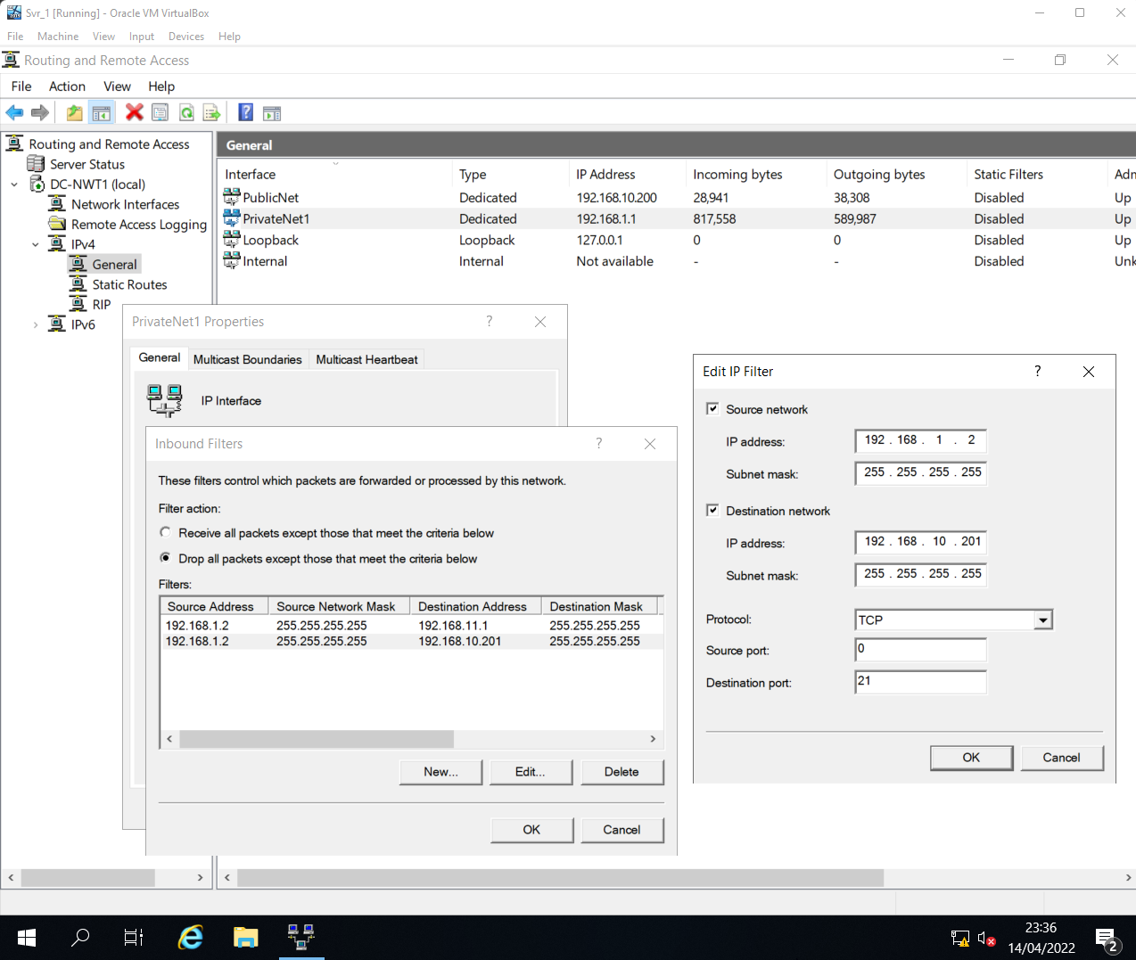
- Note that ICMP packets such as ping are also dropped as the active filter is prompted to drop all packets except FTP requests between 192.168.1.2 (Client1) and the FTPSite.
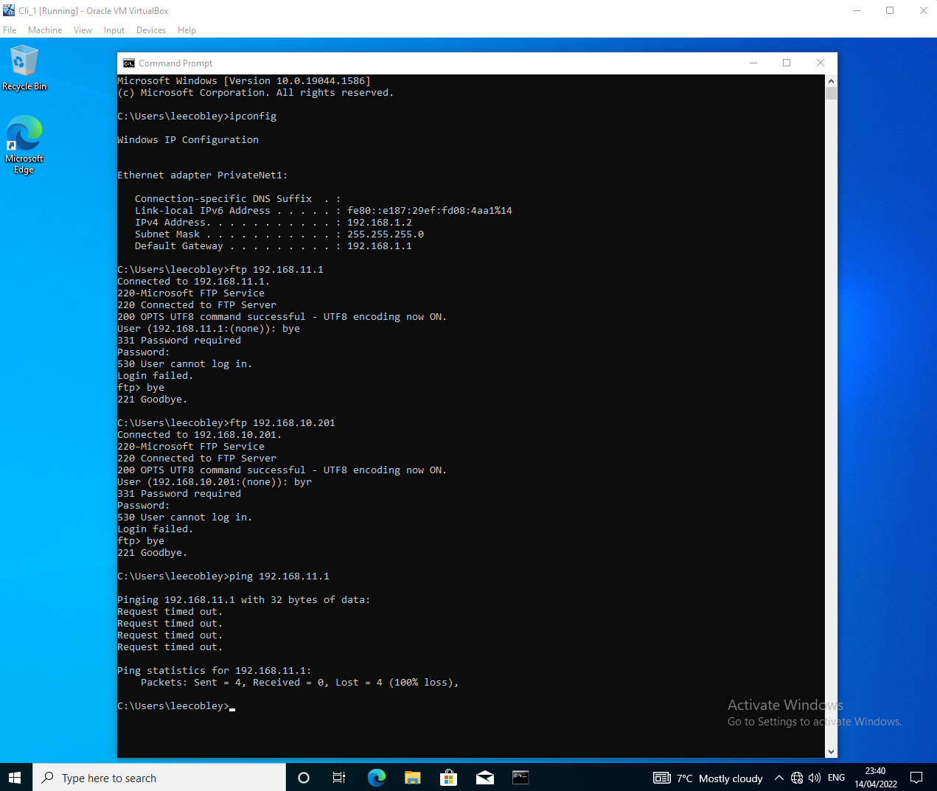

Task 3: Observational Tasks

When dealing with passwords and confidential credentials, it is very important to ensure that sound password principles and policies are set in place to help protect not only user information, but also a reputation. In the past, there have been countless attacks on large network services, most notably the PlayStation Network outage in 2011, where 77 million ^{[5]} accounts were compromised. Details on this attack can be found in Appendices C. In the wake of the attack, new security measures and policies were promised for PSN by Sony, bringing greater levels of data protection and encryption ^{[6]}. However, it wasn’t until nearly 5 years after the attack in 2011 that Sony introduced two-factor authentication to PSN ^{[7]}, which if introduced sooner could have potentially reduced the impact of the attack. In a report published by IT security firm Kaspersky, a robust and sound password policy is said to help reduce the likelihood of an attack by 60% ^{[8]}.
There are many ways in which a modern network could encompass sound password principles and policies to further secure and protect its users and credentials. One example previously mentioned includes two-factor authentication (2FA). Standing as a second line of defense in the case of an attack, 2FA requires users to provide additional verification when logging-in. Whether it’s via text message or through a standalone application on a trusted device, attackers would require access to these trusted devices to confirm the verification in addition to the password, greatly restricting the chances of an attack ^{[9]}. In 2019 a report from Microsoft claimed 2FA blocked 99.9% of automated attack, concluding the multi-factor authentication works ^{[10]}.
Further examples of sound password principles and policies include the adoption of passphrases, a series of words separated by space to create a secure password. Valued and respected source John Wiley & Sons, Inc., claimed passphrases to be the strongest password, a passphrase comprised of 20 characters with various numbers can greatly increase the strength of a password thanks to its length and randomized complexity ^{[9]}. Enforcing further policies such as complexity requirements (use of upper-case/lower-case, numbers, non-alphanumeric symbols) and a minimum length is essential, and collating these policies can significantly strengthen a passphrase, which is not possible with a random 9-character password ^{[11]}.

What could be described as an essential feature within many enterprise networks is high availability (HA). It is the concept of continuous high-level operations of various systems, components, or applications, without intervention for a given period. Its infrastructure is designed and built to handle varying loads and failures while still delivering high-quality performance, all with little to no downtime ^{[12]}. The percentage method is a brilliant approach towards targeting and detailing the downtime of systems, Appendices D helps explain this method in detail. To ensure continuous high availability of their networks, enterprises turn to what are known as high availability clusters (HAC) or failover clusters to manage and support their complex enterprise applications. These software-managed systems are made up of complex hardware infrastructures, built to monitor these important systems and help mitigate failure through seamlessly repairing or relocating data across different nodes whenever necessary, striving for minimal system downtime ^{[13]}. Figure 1, found below, provides a detailed illustration of how a failover cluster comprised of two nodes may look and operate.
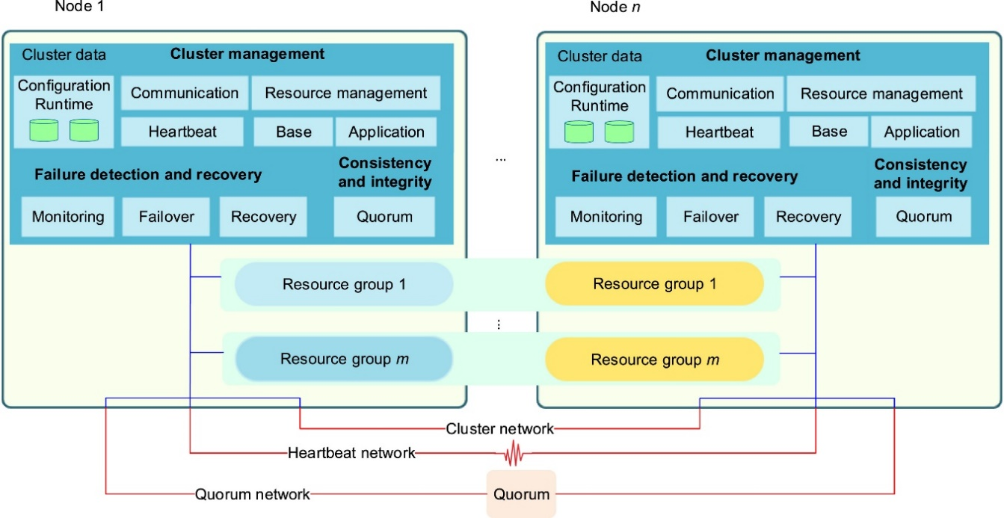^{[13]}
Figure 1
There are various instances and situations where high availability is needed within enterprise. Hospitals, banks, email servers, and active directories, are just a few environments which rely on the constant exchange of data to operate and perform daily tasks. Even in recent years, with the growth of the cloud, many cloud applications and businesses require high availability to provide their services to users. The cloud applications market has an expected valuation of 168.6 billion U.S. dollars by 2025, with an annual growth rate of 4.8% ^{[15]}.
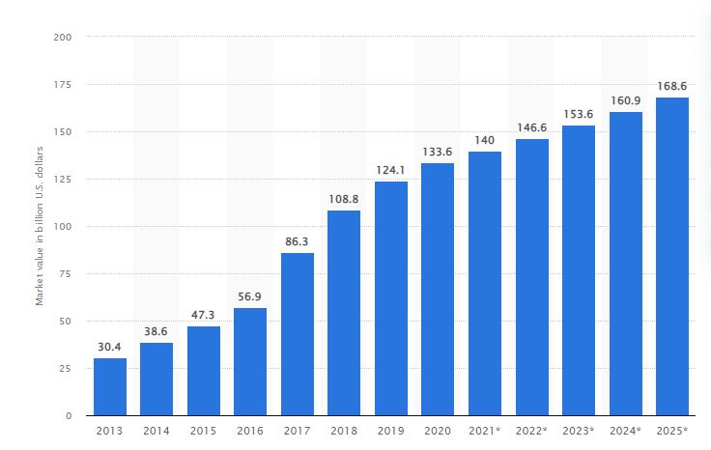^{[16]}
Figure 2
While there are many benefits that may come with the implementation of a failover cluster, there are also some drawbacks to consider. With high availability often comes a high price, as for clustered servers to be reliable they will require quality hardware and design, and therefore managing cost effectiveness is key. Microsoft provide an overview of their pricing and licensing for Windows Server 2022, with the Essentials edition being the cheapest option at $501, and their Datacenter edition costing a staggering $6,155 ^{[16]}. Further areas to consider before deploying a failover cluster would include frequent and consistent monitoring and maintenance of such systems, with increasing hardware comes increased infrastructure.
Failover clusters can be deployed within Windows Server by utilizing tools built right into the operating system. Using the Server Manager application within the OS, administrators can add and install the Failover Clustering feature, which in turn will install the Failover Cluster Manager tool. Note that the failover clustering feature will need to be installed on all systems intended to be used within the cluster network.
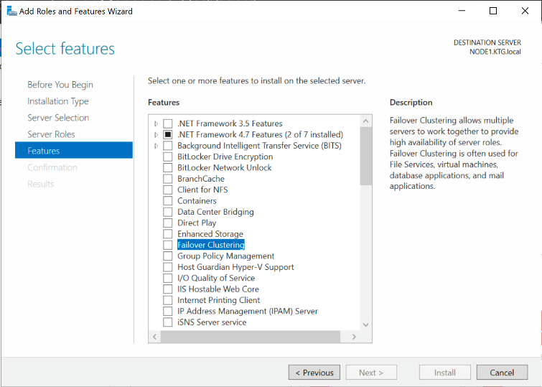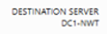
However, before a failover cluster can be implemented within Windows Server, there are some prerequisites that must be put in place. It is important to ensure that all servers within the cluster node are operating on the same Windows Server OS version as to avoid incompatibility or further clashing issues. Also, admins should install appropriate devices controllers and adapters for storage such as storage nodes using iSCSI, a network-based storage standard that links data storage systems within a network. This will provide clustered storage for each server, allowing access to various storage systems to failover to in the event of a failure. Furthermore, the failover systems must all connect to the same AD domain, meaning that a dedicated AD DS must be established by administrators. Finally, it is recommended that admins create a dedicated OU to house the computer accounts for the cluster systems, as this can help manage any group policy settings created for the cluster nodes. It can also help protect against the accidental deletion of nodes within the cluster system ^{[17]}.
Once the necessary prerequisites are in place, admins can begin to build their cluster network. Access to the Failover Cluster Manager can be found within the tools menu of Server Manager. Once open, users must validate their configuration, selecting which systems they wish to include in their cluster network. Systems will be checked by the OS to ensure each selected node meets the requirements of a failover cluster.
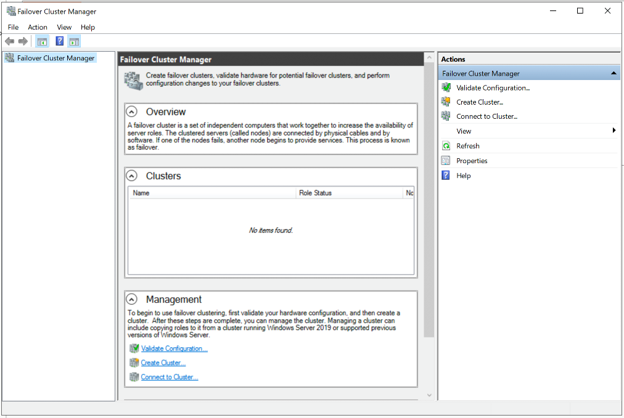
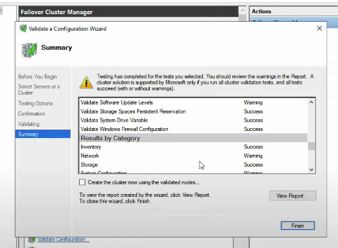
The cluster validation will present users with a detailed report on any errors or warning the software may have encountered in the process. Providing help on how to resolve any issues that may be preventing systems from joining the cluster network.
Now that the cluster nodes are validated and ready for deployment, users can create their cluster within Failover Cluster Manager, selecting the desired nodes and name for the cluster.
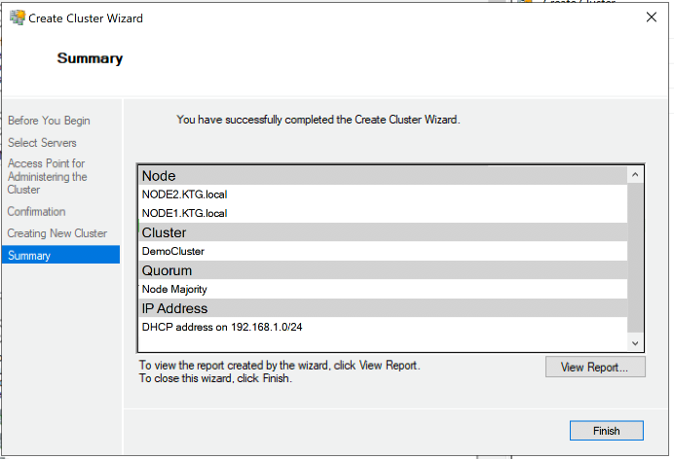
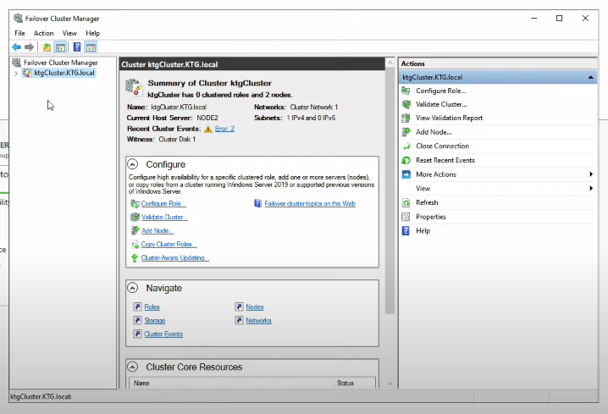
Finally, disks must be allocated to the cluster to handle and manage storage. In this case, virtual disks will be used from the iSCSI target server. Once allocated, the cluster network will be able to operate and provide high availability whilst also protecting the network from failure thanks to the failover cluster created ^{[18]}.
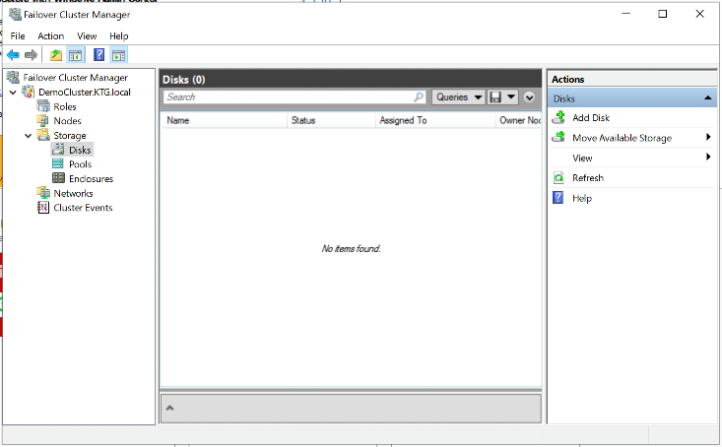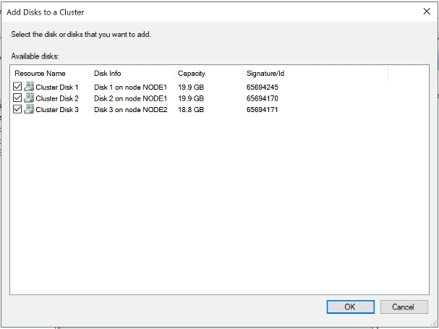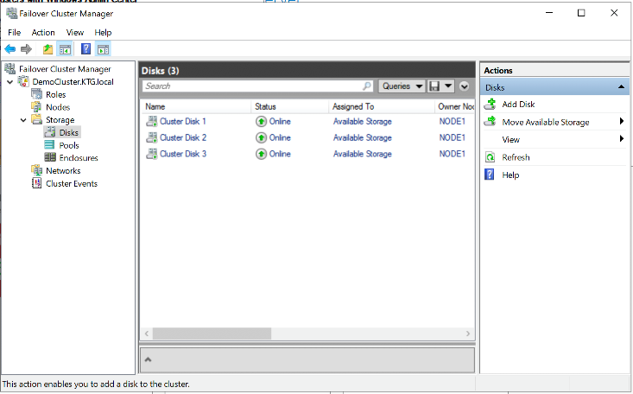

iii.
Network Security Policy
- Introduction
  - This network security policy document applies to all elements and information contained within the network, including users and physical environments.

- Purpose/Scope
  - This document sets out each policy created for the protection of the networks confidentiality, integrity, and availability.
  - Responsibilities for network security are established.
  - This document applies to all users of the network, including temporary users.

- Network Architecture
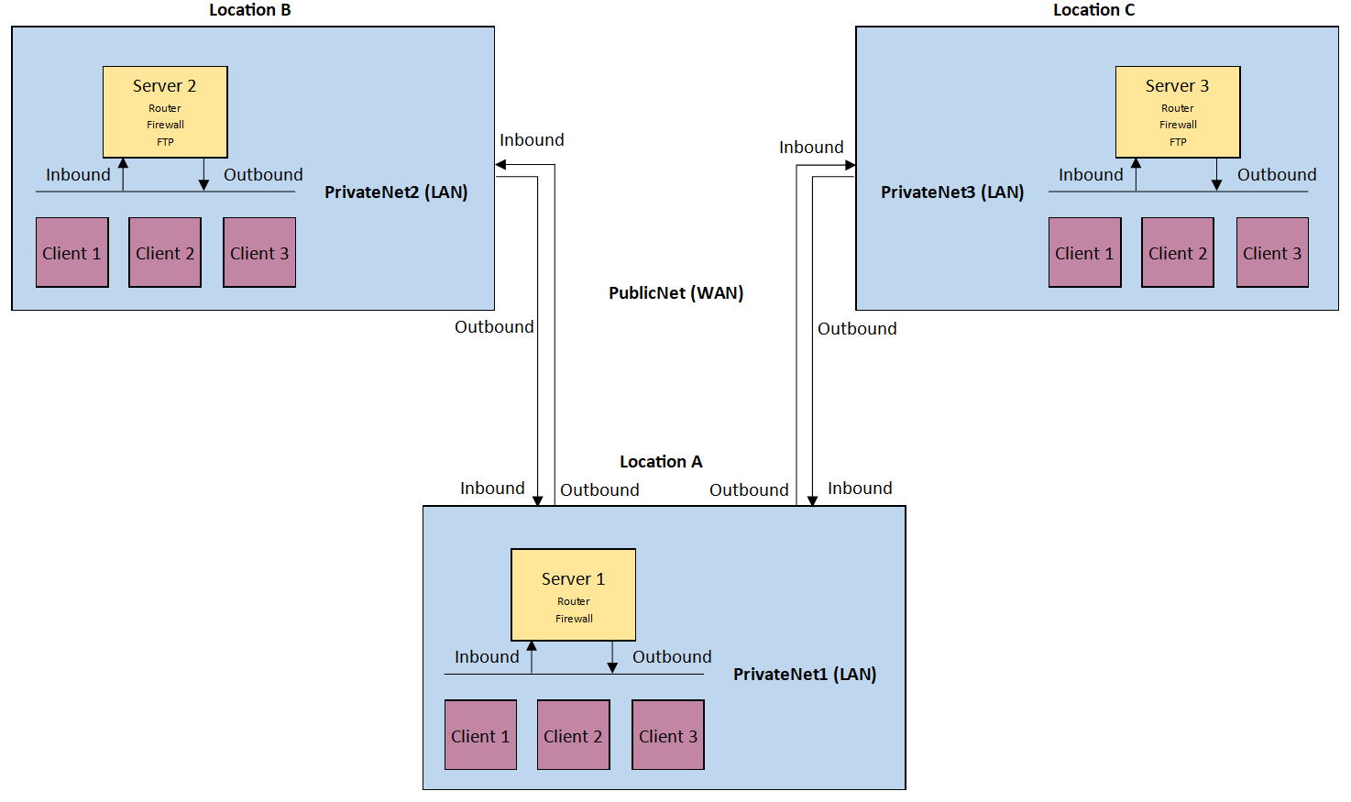
  - Central network domain will be deployed within Server 1 of Location A.
  - Both servers at locations B and C will deploy FTP services for data transfer purposes.
  - Key network personnel manage network access and user permissions. Key personnel include:
    - Administration group users.
    - Privileged group users.

- Network Access
  - Active Directory will be deployed to manage and monitor access to the network.
  - Network administrators will maintain and periodically review access held by privileged users.
  - Access to the network will be through a secure login procedure, users will be required to enter credentials. Factor designed to reduce the possibility for unauthorized users to access the network.
  - Firewalls will actively monitor both incoming and outgoing packets on the network using curated packet filters.

- Security Team
  - Network administrators are responsible for ensuring that the network is appropriately maintained and monitored for potential security breaches. Ensuring to follow and comply with all listed legislations of the policy document.
  - Network administrators hold privileges above all others, allowing for the maintenance of the network.
  - FTP group users can access and distribute data across network FTP server.

- Enforcement of Security Policies
  - Group policies will be appropriately applied.
  - Passwords should be changed regularly and must abide by network password policy regulations:
    - Changed every 30 days.
    - Include special characters (E.g. !, ?, #).
    - Both upper- and lower-case characters.
  - Report all suspected and known breaches to administration.
  - Use of multifactor authentication services to further enhance security of user accounts during login.

- Analysis of Security Risks
  - Risk assessments will be used to identify necessary security countermeasures to protect the network and its users against potential breaches in confidentiality, integrity, and availability.

- Monitoring Security Operations
  - System monitoring software such as Ganglia will operate to maintain network health and security.
  - Administrators will carry out regular system scans to identify any unauthorized harmful hardware/software installed.

- Mitigating Violations
  - Failover clusters will be deployed across all systems to provide high availability in the event of an attack or failure.
  - Systems will undergo regular backups to prevent loss of data in the event of an attack or failure.
  - Critical or sensitive network equipment will be stored within secure protected areas, guarded with appropriate security measures:
    - Locked doors.
    - Security personnel.
    - Secure perimeter.

Bibliography

[1] | University of Wisconsin Eau Claire, "Network: Establishing Windows File and Folder Level Permissions," University of Wisconsin Eau Claire, 27 May 2021. [Online]. Available: https://www.uwec.edu/kb/article/drives-establishing-windows-file-and-folder-level-permissions/. [Accessed 7 April 2022].
[2] | Microsoft, "Deploying Roaming User Profiles," Microsoft, 29 July 2021. [Online]. Available: https://docs.microsoft.com/en-us/windows-server/storage/folder-redirection/deploy-roaming-user-profiles. [Accessed 7 April 2022].
[3] | A. Savvas, "USB Devices Guilty in Many Malware Attacks," Computerworld, vol. 44, (23), pp. 2, 2010. Available: https://www.proquest.com/trade-journals/usb-devices-guilty-many-malware-attacks/docview/817732622/se-2?accountid=130472.
[4] | V. Baggan, A. K. Sahoo, P. K. Sarangi, and S. Priya Chaturvedi, “A comprehensive analysis and experimental evaluation of routing information protocol: An elucidation,” vol. 49, pp. 3040–3045, 2022, doi: https://doi-org.ezproxy.uwtsd.ac.uk/10.1016/j.matpr.2020.10.676. [Online]. Available: https://www-sciencedirect-com.ezproxy.uwtsd.ac.uk/science/article/pii/S2214785320382997.
[5] | PlayStation, "PlayStation Network and Qriocity Outage FAQ," PlayStation, 28 April 2011. [Online]. Available: https://blog.playstation.com/archive/2011/04/28/playstation-network-and-qriocity-outage-faq/. [Accessed 9 April 2022].
[6] | T. Phillips, "Five years ago today, Sony admitted the great PSN hack," Eurogamer, 26 April 2016. [Online]. Available: https://www.eurogamer.net/sony-admitted-the-great-psn-hack-five-years-ago-today. [Accessed 9 April 2022].
[7] | N. Lomas, "Sony finally says it's adding 2FA to PlayStation Network," TechCrunch, 21 April 2016. [Online]. Available: https://techcrunch.com/2016/04/21/sony-finally-says-its-adding-2fa-to-playstation-network/?guccounter=1&guce_referrer=aHR0cHM6Ly93d3cuZ29vZ2xlLmNvbS8&guce_referrer_sig=AQAAAF75TZXEErp5mHMQMEJiX8iJd3SC6YS32RN5fpywlZQC7WIJsVrNy8XSgkBlOUCi8ZfPe2MHEjEBtRDfeAA. [Accessed 9 April 2022].
[8] | Kaspersky, "Incident response analyst report," Kaspersky, Moscow, 2021.
[9] | A. Dennis, A. Durcikova, J. FitzGerald, "Making Strong Passwords," in Business Data Communications and Networking, Wiley, 2020, pp. 330-331.
[10] | E. Bott, "Malti-factor authentication: How to enable 2FA to step up your security," ZDNet, 22 March 2022. [Online]. Available: https://www.zdnet.com/article/better-than-the-best-password-how-to-use-2fa-to-improve-your-security/#:~:text=A%202019%20report%20from%20Microsoft,%2Dbased%20one%2Dtime%20passwords.. [Accessed 9 April 2022].
[11] | J. M. Johansson, "The Great Debates: Pass Phrases vs Passwords. Part 3 of 3," Microsoft, 20 May 2008. [Online]. Available: https://docs.microsoft.com/en-us/previous-versions/tn-archive/cc512624(v=technet.10). [Accessed 9 April 2022].
[12] | Cisco, "What Is High Availability?," Cisco, [Online]. Available: https://www.cisco.com/c/en/us/solutions/hybrid-work/what-is-high-availability.html. [Accessed 12 April 2022].
[13] | R. Calinescu, R. Buyya, P. Somasekaram, "Journal of Systems and Software," High-availability clusters: A texonomy, survey, and future directions, vol. 187, pp. 1-4, 2021.
[14] | C. Oggerino, "The Percentage Method," in High Availability Network Fundamentals, Cisco, 2001, pp. 9-10.
[15] | Statista, "Cloud applications market size worldwide from 2013 to 2025," Statista, 2020. [Online]. Available: https://www.statista.com/statistics/475670/cloud-applications-market-size-worldwide/#:~:text=In%202021%2C%20the%20global%20cloud,growth%20rate%20of%204.8%20percent.. [Accessed 13 April 2022].
[16] | Microsoft, "Pricing and licensing for Windows Server 2022," Microsoft, 2022. [Online]. Available: https://www.microsoft.com/en-us/windows-server/pricing. [Accessed 13 April 2022].
[17] | Microsoft, "Create a failover cluster," Microsoft, 11 February 2022. [Online]. Available: https://docs.microsoft.com/en-us/windows-server/failover-clustering/create-failover-cluster. [Accessed 13 April 2022].
[18] | kindsonthegenius, "Windows Server 2019 Failover Cluster Installation and Setup - Step by Step," Kindson the Genius, 4 October 2020. [Online]. Available: https://www.kindsonthegenius.com/windows-server-2019-failover-cluster-installation-and-setup-step-by-step/. [Accessed 14 April 2022].

Appendices

Acronyms Table
Throughout this literature there are numerous network acronyms used. This table highlights the ones mentioned through this report.
Acronym | Stands for…
NTFS | New Technology File System
ICMP | Internet Control Message Protocol
VM | Virtual Machine
SMB | Server Message Block
OU | Organizational Unit
GPO | Group Policy Object
USB | Universal Serial Bus
TCP | Transmission Control Protocol
IP | Internet Protocol
ARP | Address Resolution Protocol
OS | Operating System
FTP | File Transfer Protocol
VPN | Virtual Private Network
LAN | Local Area Network
WAN | Wide Area Network
RIP | Routing Information Protocol
2FA | Two-Factor Authentication
HA | High Availability
HAC | High Availability Clusters
iSCSI | Internet Small Computer Systems Interface
AD | Active Directory
AD DS | Active Directory Domain System

  - Appendix A [1]
The following table represents the available standard permission types.
Permission | Description
Full Control | Permits the user(s) to:  - view file name and subfolders.  - navigate to subfolders.  - view data in the folder's files.  - add files and subfolders to the folder.  - change the folder's files.  - delete the folder and its files.  - change permissions.  - take ownership of the folder and its files.
Modify | Permits the user(s) to:  - view the file names and subfolders.  - navigate to subfolders.  - view data in the folder's files.  - add files and subfolders to the folder.  - change the folder's files.  - delete the folder and its files.  - open and change files.
Read & Execute | Permits the user(s) to:  - view file names and subfolder names.  - navigate to subfolders.  - view data in the folder's files.  - run applications.
List Folder Contents | Permits the user(s) to:  - view the file names and subfolder names.  - navigate to subfolders.  - view folders.  - does not permit access to the folder's files.
Read | Permits the user(s) to:  - view the file names and subfolder names.  - navigate to subfolders.  - open files.  - copy and view data in the folder's files.
Write | The Read permissions, plus permits the user(s) to:  - create folders.  - add new files.  - delete files.

  - Appendix B [3]
Access-based enumeration hides files and folders that users do not have permissions to access. By default, this feature is not enabled for DFS namespaces. You can enable access-based enumeration of DFS folders by using DFS Management. To control access-based enumeration of files and folders in folder targets, you must enable access-based enumeration on each shared folder by using Share and Storage Management.
Access-based enumeration does not prevent users from getting a referral to a folder target if they already know the DFS path. Only the share permissions or the NTFS file system permissions of the folder target (shared folder) itself can prevent users from accessing a folder target. DFS folder permissions are used only for displaying or hiding DFS folders, not for controlling access, making Read access the only relevant permission at the DFS folder level. For more information, see Using Inherited Permissions with Access-Based Enumeration

  - Appendices C [5]
Q: Was my personal data encrypted?
A: All of the data was protected, and access was restricted both physically and through the perimeter and security of the network. The entire credit card table was encrypted and we have no evidence that credit card data was taken. The personal data table, which is a separate data set, was not encrypted, but was, of course, behind a very sophisticated security system that was breached in a malicious attack.
Q: When or how can I change my PlayStation Network password?
A: We are working on a new system software update that will require all users to change their password once PlayStation Network is restored. We will provide more details about the new update shortly.
Q: What steps is Sony taking to protect my personal data in the future?
A: We’ve taken several immediate steps to add protections for your personal data. First, we temporarily turned off PlayStation Network and Qriocity services and, second, we are enhancing security and strengthening our network infrastructure. Moving forward, we are initiating several measures that will significantly enhance all aspects of PlayStation Network’s security and your personal data, including moving our network infrastructure and data center to a new, more secure location, which is already underway. We will provide additional information on these measures shortly.
Q: Has Sony identified the party or parties responsible for the PlayStation Network hack and subsequent theft of personal information?
A: We are currently conducting a thorough investigation of the situation and are working closely with a recognised technology security firm in order to find those responsible for this criminal act, no matter where in the world they might be located.

  - Appendices D [14]
The Percentage Method


