Heritage Practice Placement at Weston Park, Staffordshire, England.
Harriet Barber, 1703736, Level 5, HPHE5004

Introduction: about the house
The house is a private trust. It was a setup by Margaret Thatcher in order of preserving the heritage of such a grand and fabulous house rather than losing it through the family being unable to fund the death duties, it was set up in 1986 and has been running ever since. Bringing to life the stories such significant people around the surrounding Shropshire lands, including those that lived in the house who were royalists! (Weston Park, 2019)
Which is understood that there is no government funding that the organization simply relies on money from the public as well as corporate events that are hosted in the house or around the park which bring in revenue to help support the conservation work that is done by staff members or volunteers. There are many external events which are displayed within the house and grounds of Weston park, many of the events I was able to hear about in passing conversation during my time as a volunteer over the summer.
The granary which is the restaurant or the cafe has recently been done up by a catering company that works for Weston, for a heritage attraction the restaurants etc are crucial part of generating income for the Park by having sufficient amounts of food and beverages for the visitors enjoy allows them to relax a lot more after they have paid for tickets to enter the grounds and the house.
Celebrating 30 years of the foundation being up and running for the public to glance at and learn the heritage of, in 2017 there was an event set up by the architectural editor of country life with other guests including those of ™ Lighting , Sibyl Colefax and John Fowler who discussed the modern and latest ways of preserving and conserving the famous art collections around the house ensuring that none of them are damaged, as well as this they get a chance to combine thoughts on curatoring techniques and presentable ways of preserving the interior design ideas (Country Life, 2017).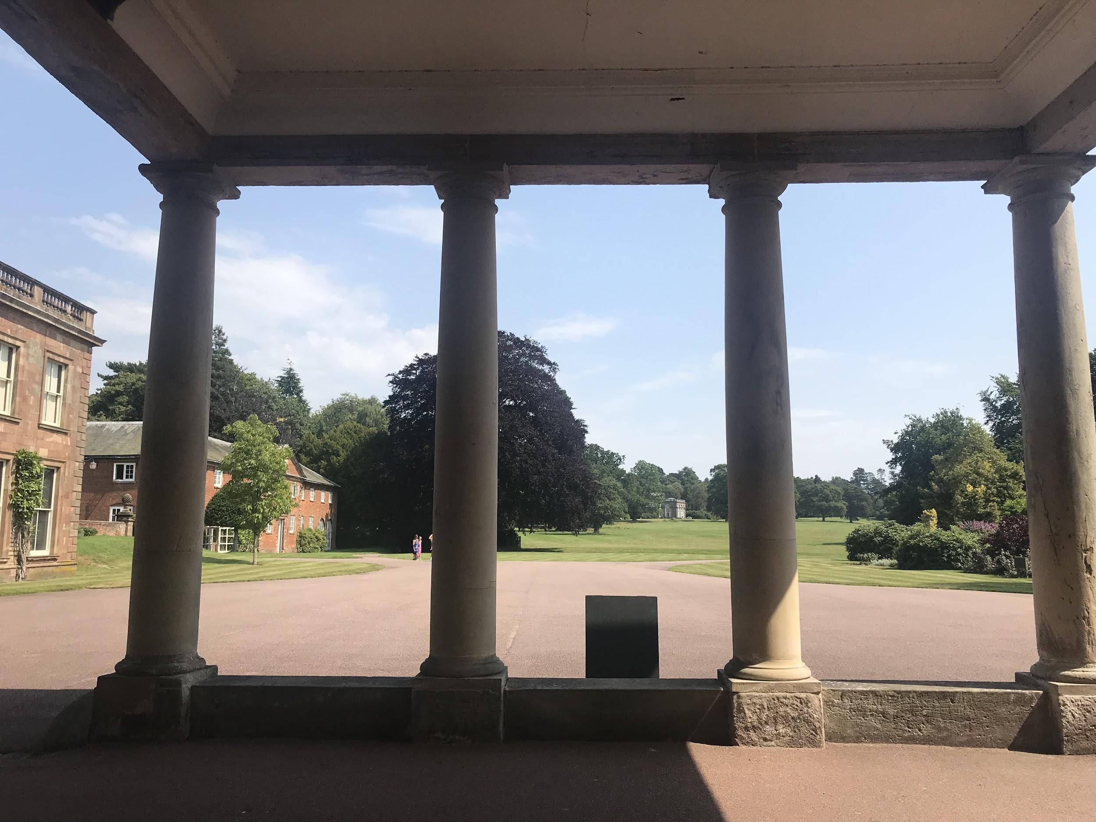
Fig1, Outside at Entrance of house, Barber 2019

Interview;
Tuesday 18th June 2019, 10am-11am. I Had attended an interview with the volunteering organizer Katherine Dowd who already had a bit of information from myself via emails that we had been exchanging. I had already informed her that I was a current student at UWTSD studying BA Heritage Studies and was looking forward to exploring this work environment.
As a heritage attraction Katherine mentioned that Weston Park were not government funded, however they were still a charity and they earned money through those paying customers who wanted weddings, corporate events, breaks away, visits to the house and guided tours in the house which I was to become a follow guide on Tuesday, Wednesday and Thursday. I also had the opportunity to venture into other departments and further my experience.
I got given a brief tour on the day of the interview and was given the underlying information of how everything would be run throughout my days of volunteering.
Katherine also told me information about the design of the house standing from the entrance hall facing towards the pillars at the entrance of the house see Figure 1.
I got given a booklet which had all of the information for volunteers which included the mileage forms to claim back expenses to the company, all of the different parts of security within the house and grounds, just all of the underlying information which volunteers would be required to know before they take on the role.

After the interview, Kathrine and I discussed over email the dates in which I would work. My first date is on 25th June&26th June, then following days of 2nd July, 4th July as well as the weeks commencing 8th July &15th July.
The hours 12:45pm-4/5pm, which the house is open for guided tours then last admission is at 4pm.

Tuesday 2nd July 2019:
At 1:00 the first tour that had started and I followed onto the end of, was very interesting learning about. Through the duration of the tour, I gained knowledge about the history of the house and the interior of houses, for example; the paintings, the library (there are about 3000 within the house) and the wall pieces. eg. the 1960’s interpretation of the georgian period features. See figure 2&3.
There is a carpet in the dining room which was replicated for the National Trust property Dudmaston Hall.
Many of the visitors that arrived on my first day were quite local, a couple were staying in the temple of Diana which is across the field overlooking the grounds which helps to fund all of the conservation work for the house.
On the tour Brian mentioned that the University of Cambridge Karr Institute, who come every February for about 5 days and volunteer to help clean all of the paintings which are on display in the house, that they have managed to clean all of the paintings in the library clean enough that all of the soot, smoke, water, and moisture damage over the 200 years that the house has been standing had been removed and the paintings seem almost brand new.
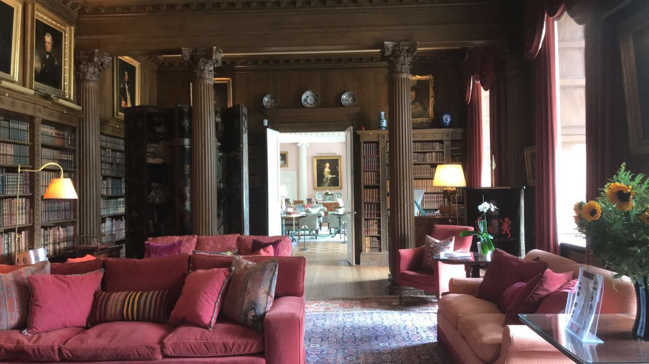
Figure 2, Library facing towards dining room, 2019, Barber.
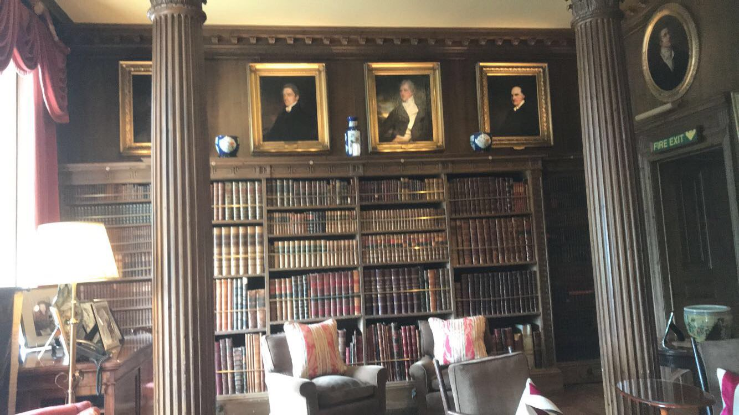
Figure 3, Library towards dining room, 2019, Barber.
Thursday 4th July 2019:
The day before on the 3rd July there was an event at the house which was going on from the morning of the 3rd continuing into the Thursday 4th July which is how the organization makes their extra money.
There was an event in the conference room that had a meeting early in the morning.
There were also many groups which had been pre booked at admissions or online, many groups brought guide books which are also a way that the house makes money as they are sold separately at £2.00 each.
The weekend of the 6th July there was the Camper Jam, which was an event where campervans from around the UK or abroad got together in one area and stayed overnight in them. The event was on for 5th-7th July, welcoming families to view the vans. The prices for the tickets on the Saturday were; Adults: £20, Children 5-16: £15, under 5’s: free and on the Sunday were: Adults: £15, children: £5, under 5’s: free.
About 20,000 people turned up for the weekend event bringing in a huge amount of revenue to help the organization with costs that might be needed to be paid.
An event that brought at least 20,000 people into the grounds and buying their L tickets, whether that be on the day or prepaid they were bringing a significant amount of money.
Tuesday 9th July 2019:
Starting the placement, there were tours at 1:00,1:45,3:15PM. I followed one of the tours at 1:45 with Pat Lowe, who is a really good tour guide keeping the visitors involved and entertained.
There were three groups all going on at the same time, which was tricky to manage.
For the weekend of this week, the 13th July there was an event being hosted for Saturday evening Classic Ibiza there were about 6 thousand tickets sold and the house was rented out by the couples who had bed&breakfast , picnic champagne basket with nibbles tor the event itself and an overnight stay was included in the price which was £299 for the pair. The tickets were £35 if bought ahead of the event and £40 if bought on the day.

Wednesday 10th July 2019:
I worked on the ticket desk for this afternoon at 1PM. There were 5 people on the tour with one follow guide which is Wendy and the tour guide which is Clive, counting in the people was really easy, we just had to use a clicker that already has the numbers written down on it.
The cash flow was £50, and we hadn’t sold any guide books when the visitors arrived.

There were a couple who were being guided around the house which included all of the upstairs rooms as well as the downstairs room, more than likely for an event like a wedding anniversary as the couple were of an older age range.

There was no one booked in for the rest of the afternoon, so it was just a waiting game in which we would get a phone call from the admissions desk if there were people who had bought tickets for the nearest tours. Many of the days were like this during the start of the summer days when the children were still at school.

Tuesday 16th July 2019:
Today is one of the days where the organization faces issues with making money as there were only 4 people on the 1PM tour around the house, the tickets were already prepaid and at the start of the tour, no one bought a guide book.
Private conferences happen a lot more whilst the schools are slowly breaking up for school, there are people walking around the house due to there being a conference on in the music room who have all paid for the food that is being served as a ‘picnic’ dinner with free range of the grounds outside.
The organizers stayed in the Temple of Diana which overlooked the venue close enough to sit in the temple and watch the event.
They left the temple at early lunchtime 12PM, there is a couple now staying for the week in the Temple who had a guided tour early on in the afternoon.

Thursday 25th July 2019
There were tours on from the moment we opened the house to the public at 1PM,1:45PM all these tickets were bought at the admissions desk at the main entrance, there were 11 people on the 1:45PM tour.
For the 2:30PM tour there were 49 booked in from a coach party, they were being split up into different groups with different guides who were Katherine and Brian.
Brian didn’t finish his tour until 3:45, in which the tour started at 2:30PM. Most of the visitors on the guided tour needed to have a break and sit down, there was a woman who had hearing issues which meant that she struggled with hearing a lot of the information being given. To help her and me, another guide gave her indications where there are pieces of information which has parts of the paintings details for her to read, and we allowed her to borrow the short guide booklet to read on her way around rather than struggling.

Tuesday 31st July 2019:
The 1PM tour had 9 people on this guided tour, a woman on during this had a particular interest in Tong and everything that was associated with the house and Tong. Naturally I helped her out when she was struggling to find some information about a photo of Tong Castle which the M54 runs through. This woman was part of the Tong church fundraising, and wanted to find more information about the little town as a way of raising money for a new roof; which recently had been stolen. Brian was great with reacting to those that are hard of hearing because he interacted with her more after I mentioned she was unable to hear him throughout the tour, I did the same when she spoke to me at the start of the tour assisting her and informing her of details she could have missed.

Wednesday 7th August
There was a group on the 1PM tour which also included a couple of children who were given the wildlife trail pointing certain animals in each room. Clive who was taking this tour was still in the morning room at 1:25PM there was anxiety about clashing with Clives tour and the lack of interest that the children on his tour could have if Clive tells the visitors all of the information that he knows after the decade amount of time he has been volunteering. In this case, this did happen as a couple with two children came back through to the entrance with their completed trails complaining not in such a negative way, but more of an apologetic response about the children’s concentration couldn’t last the length of Clive’s tour, as there was too much to take in at such a slow pace.
The tour which I was following was the 1:45PM tour, they were the Lestershire ladies group who had been already around the gardens and had lunch in the cafe before coming on the house tour, there were 26 of them and they were all interested in the tour and their concentration levels were focused on Pat (the tour guide), Clive’s tour had just finished at 2PM whilst my tour was in the morning room. They were an enthusiastic group who interacted with the guide Pat asking her questions about pieces in the room as well as making comments to me about wanting to know more about items and history of the house.
I helped one woman who wanted to know about some of the objects that are in the display case to the left of the display of the robes in the main passageways, see figure 4 to view the placement of the objects.
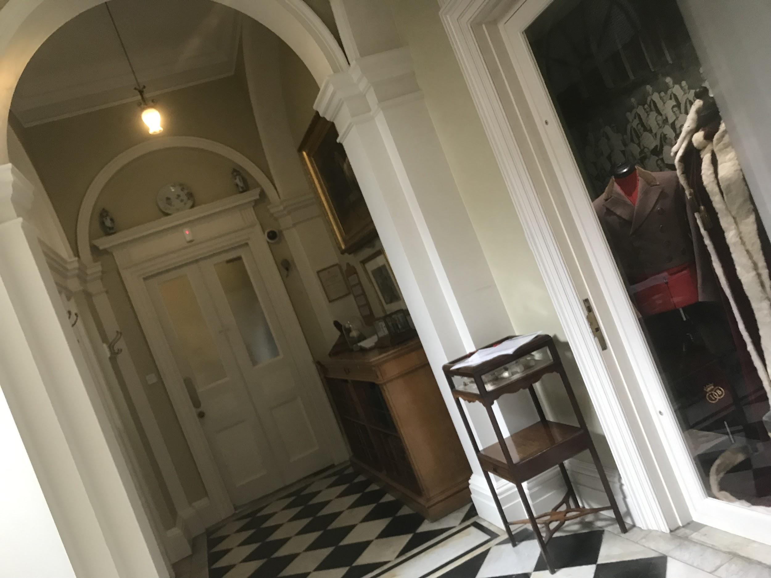
Figure 4, Passageway, Barber 2019

Thursday 8th August
There were 11 people on the 1PM tour who were guided by Brian; he is a different tour guide as he gives a long tour to each of the guides and especially with older visitors and children their concentration is not on the information throughout the duration of each tour. Thankfully on the 1.45Pm tour there were only a few children who had their clipboard with the animal summer trail and they rarely asked me questions, however a few of their parents did, just wanted to know further information about the paintings in the morning room and whether they were the person that they had assumed they were from recognising the features. I searched for in the black books which are situated in every room with extra information about each room with general history about the house and its emergency contact numbers, I found the painting, meaning that these visitors were correct about their assumptions of this person in the frame. Who happened to be Lady Diana Russell as a baby with her rattle in the box underneath the painting of her seen below in figure 5.
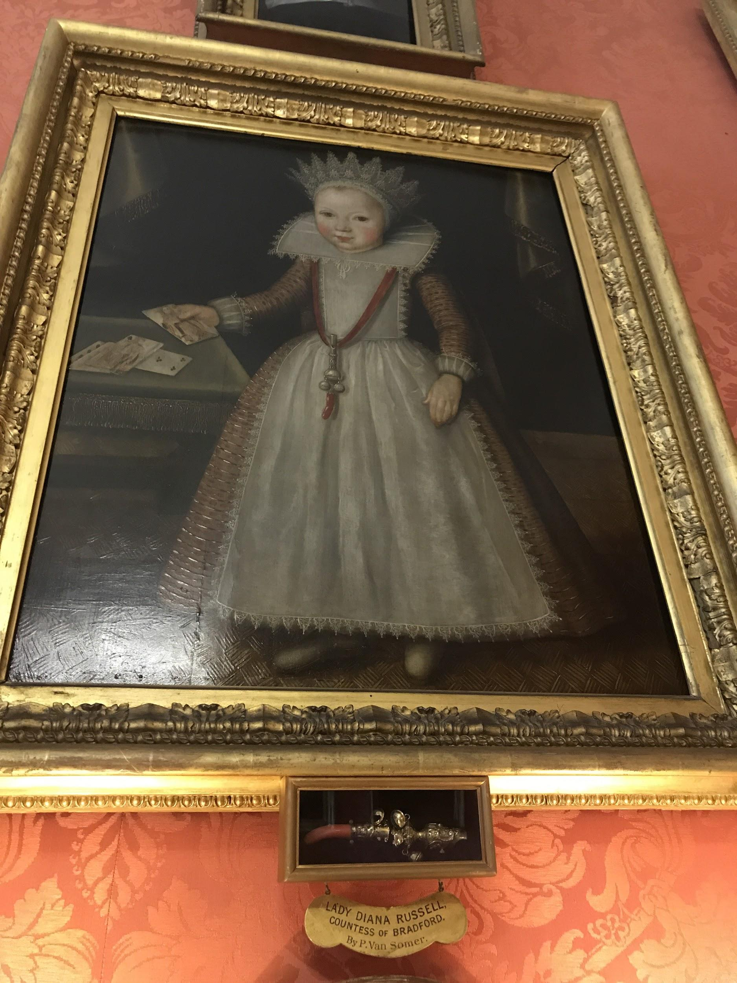
(Figure 5, Lady Diana, Countess of Bradford, P.Van Somer, Barber 2019)
Wednesday 14th August
Upon arrival of attempting to make it into my work experience this day, there was trenchirial rain which meant that there it has not stopped raining for the past 2 days. On the back lanes driving up to my work experience there were floods of water sweeping across the roads from the fields and dips that the water droplets had fallen into causing the speed of the vehicle to be extremely slow.
The main entrance leading up to the A5 Junction had been completely closed off for the past 2 days, I was unaware of this and it came to a bit of a surprise when I was not able to make it into my placement venue on this day. Quickly emailing Katherine to inform her that there was no possible way that me or anyone else would be able to make it into the park today.

Wednesday 21st August:
For the 1PM tour, there were 24 people including 6 children who I sorted out for with Gill, for the booked in Group tour there were 32 which was split into two groups making that 16&16 between both groups. Katherine was doing one of the tours& Pat was doing the other tour, I was a follow guide for Pat helping her around with this large number of guests.
There is a laboratory system in the public toilets which are in the same design as it would’ve during the 1800’s with their modern laboratory system, this has display been maintained in the downstairs. This decor really amazed me as not many working toilets within other organizations are styled in the original decor of the estates. To further my information I watched a documentary on modern decor of laboratory throughout the years that the idea has been circling, it was extremely insightful and surprising there was information beginning with the Romans and the stick to the tudors emptying the waste into the streets.
This was a popular day, where there were about 90-100 guests in total that visited the house on guided tours which included children. Recently Katherine has on Facebook
See figure 5,6,7
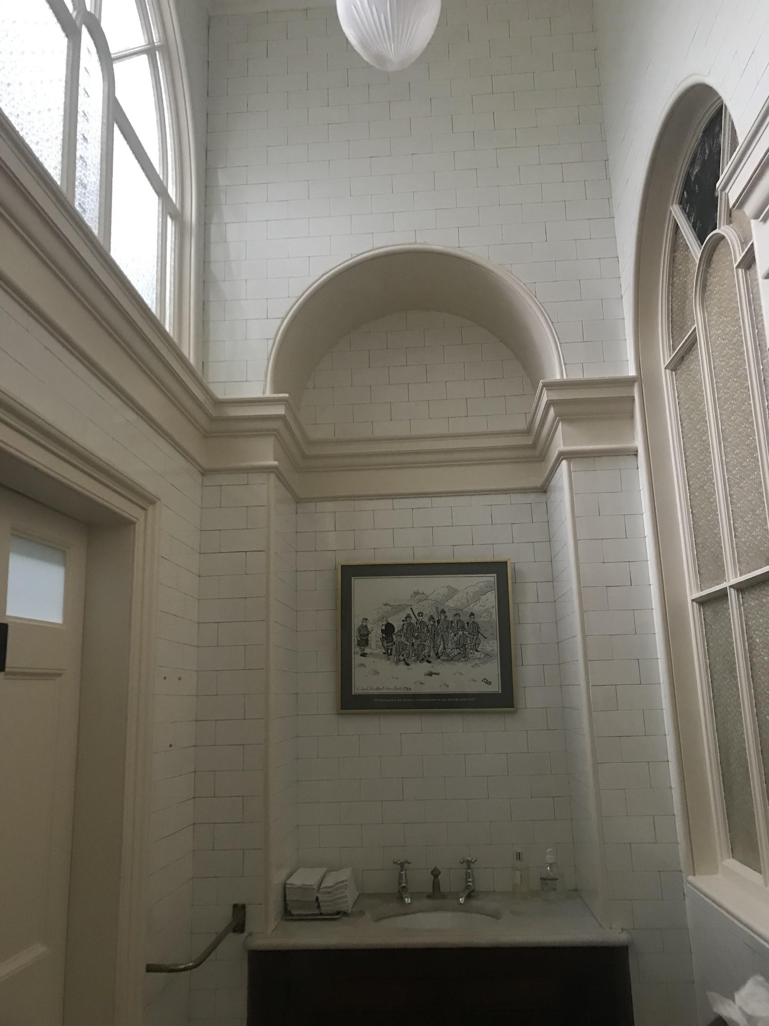
Figure 6, sink in the female/male bathroom, Barber 2019)
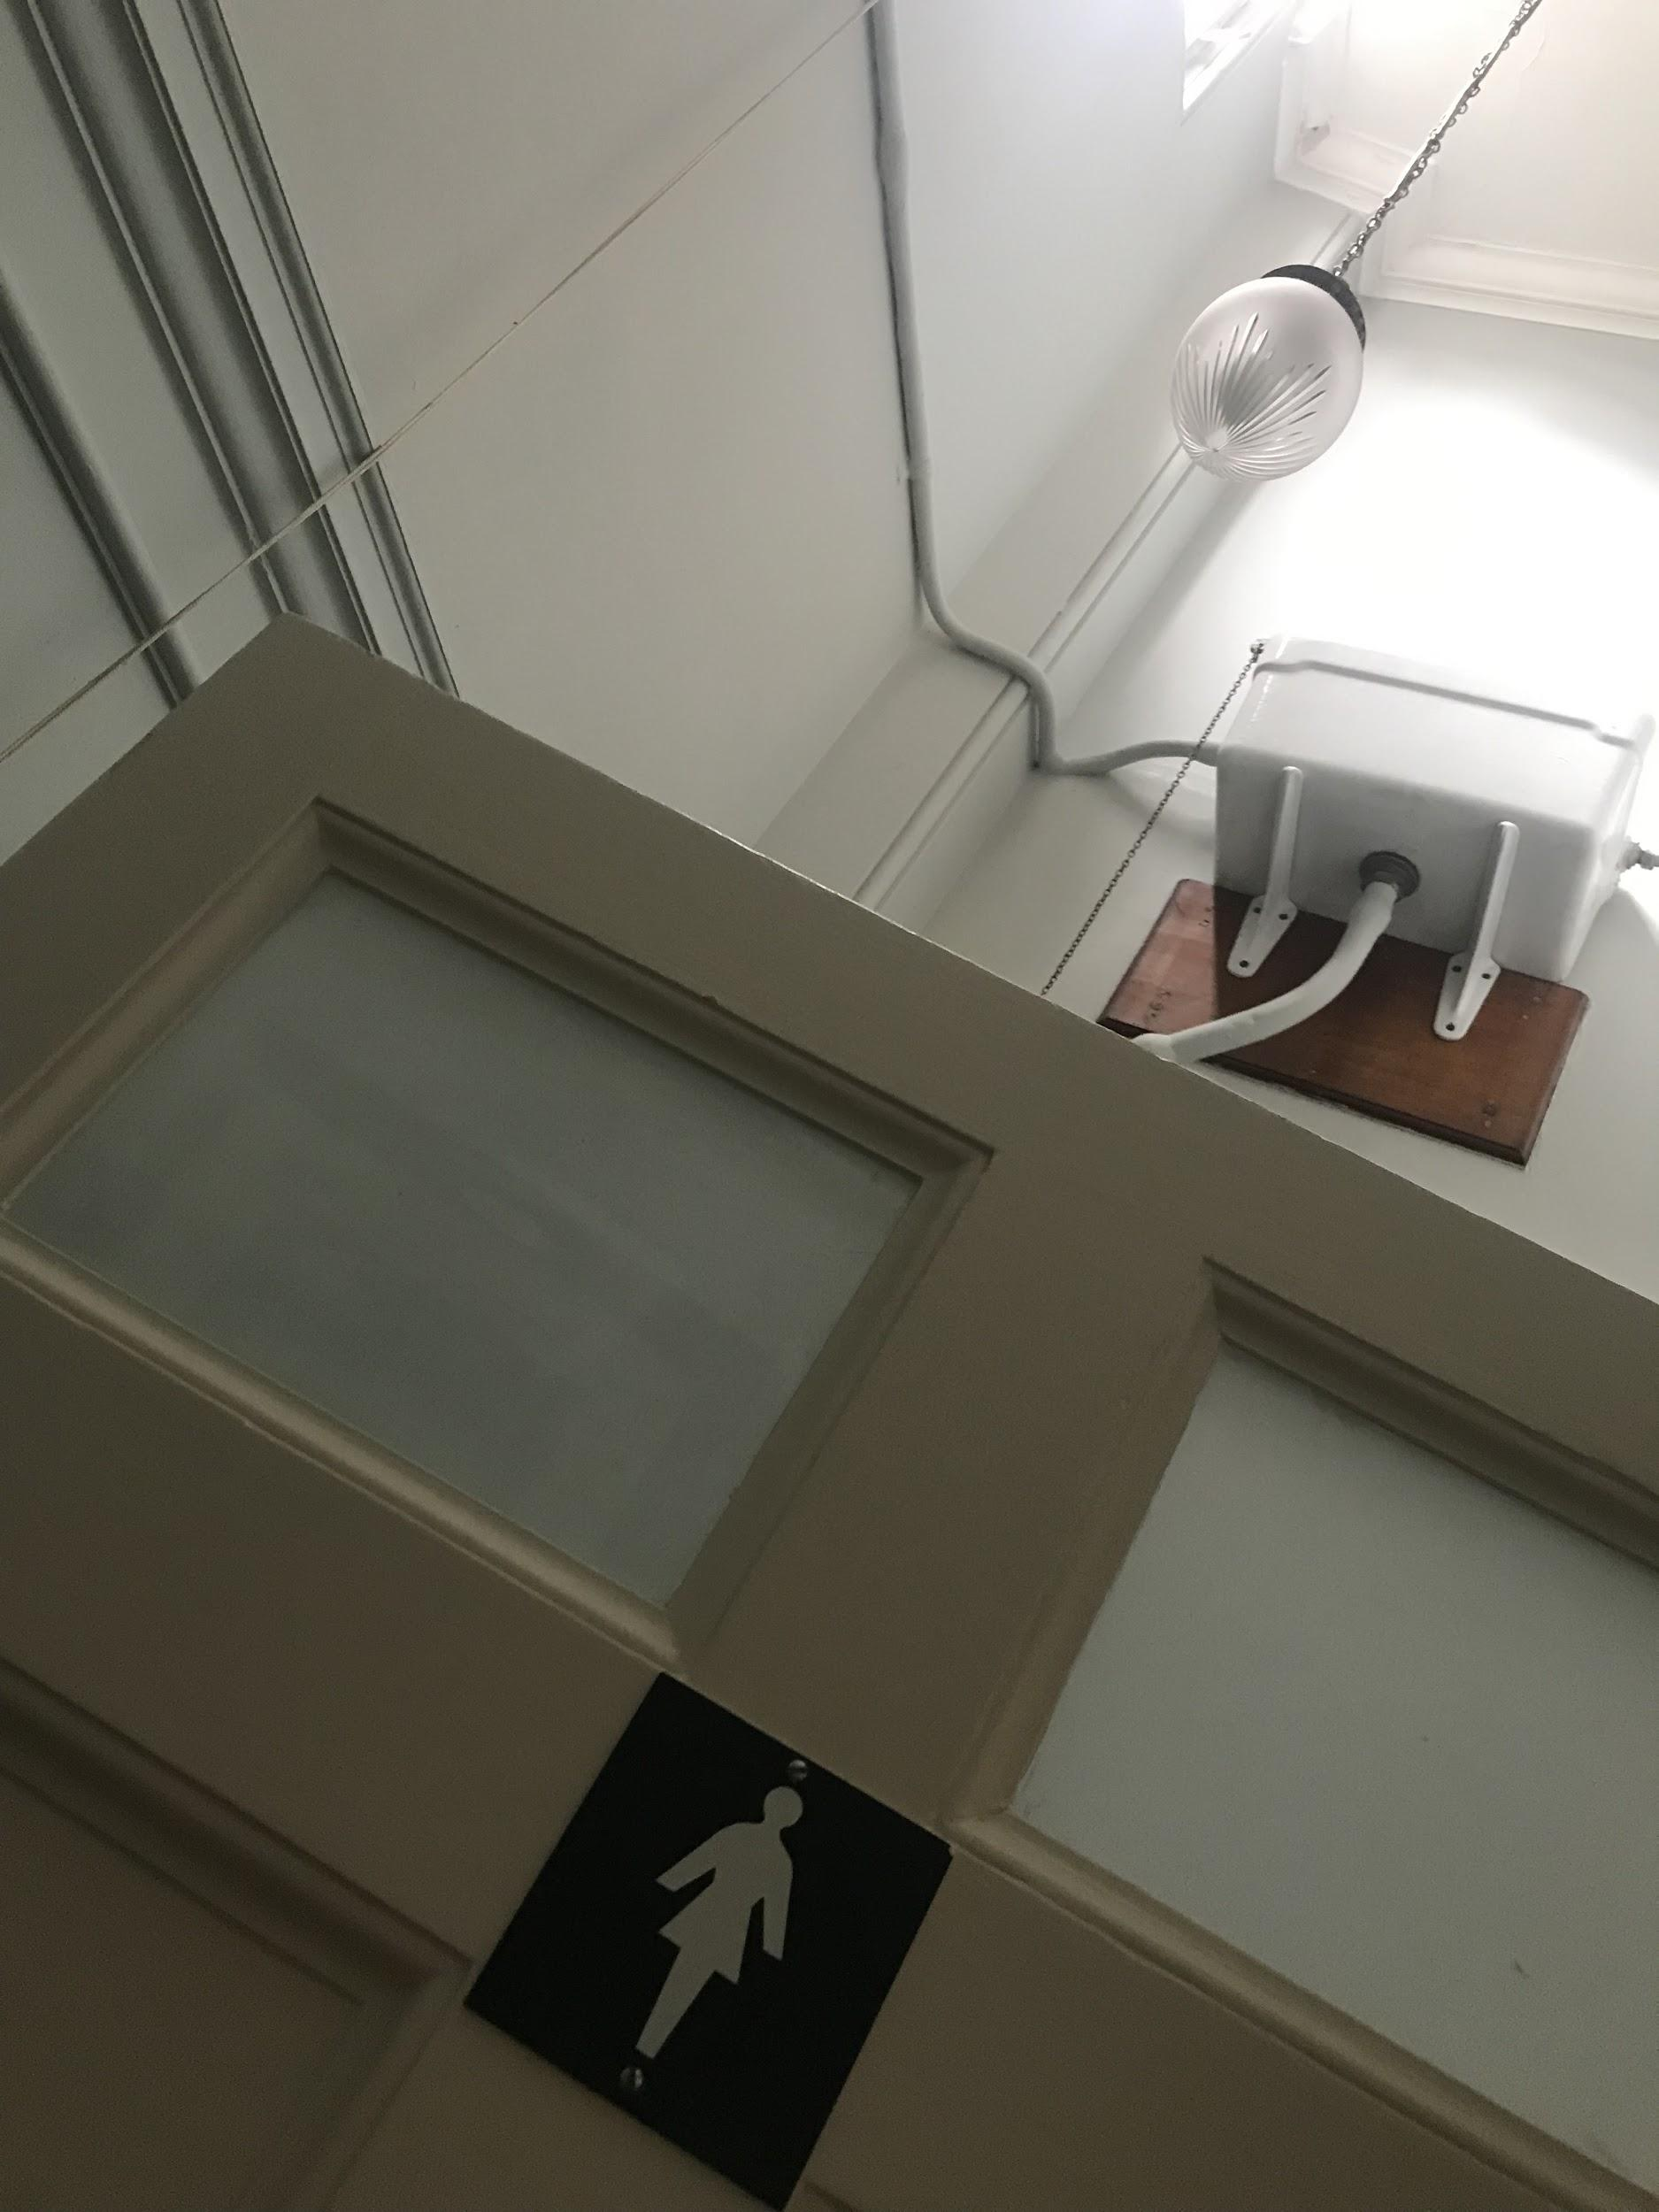
(Figure 7, entrance&working 1800’s toilet, Barber 2019)
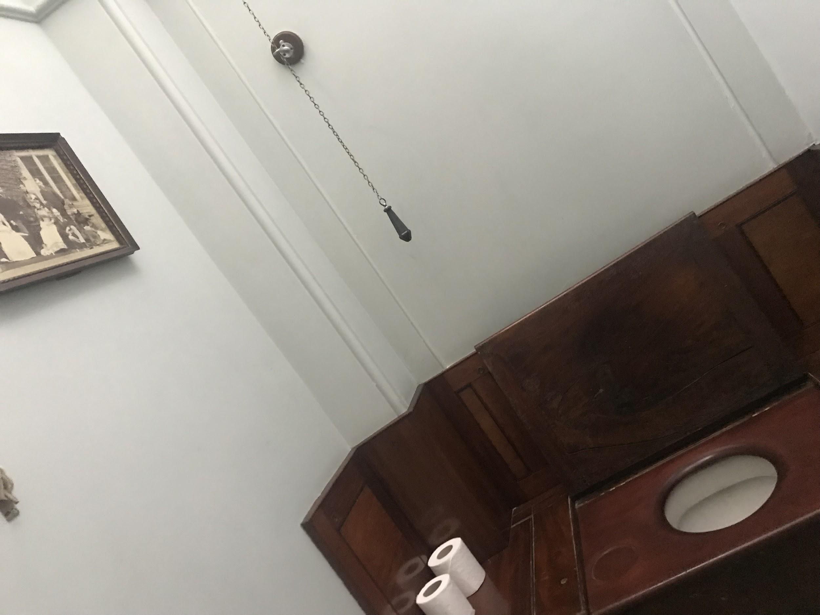
(Figure 8, 1800’s working toilet, Barber 2019)

Thursday 22nd August:
Today I went on two tours with Pat, I helped with her and follow guided for her.
There were a lot of people on these tours, I helped her more with the 2:30PM tour as there was a woman who was in a mobility scooter she claimed to be a descent of the family of the 4th Earl of Bradford who owned this house during the 1800's. There was nothing in terms of documentation to prove she was a descent, there were lots of family names which weren’t the Bridgeman side of the family the part which she claimed she was from.
There was a lovely Australia/ New Zealanders who took an interest in the tour, found the heritage of the estate extremely interesting.
I spoke to them a lot during their 2:30PM tour, answering their questions which they asked about the 7th Earl Of Bradford and where he had ended up since the house was given to the Nation in the 1980’s.
In the dining there is a painting of Malt Davis who was a mistress of Charles II in the painting she is playing the note F sharp which I pointed out to Pat and she clarified to the group that I knew information about guitars as I’m the guitar player. I discussed this painting and the guitar in further detail with the Australian/New Zealand couple who explained to me the extra details of the painting.
See Figures ,9,10.11
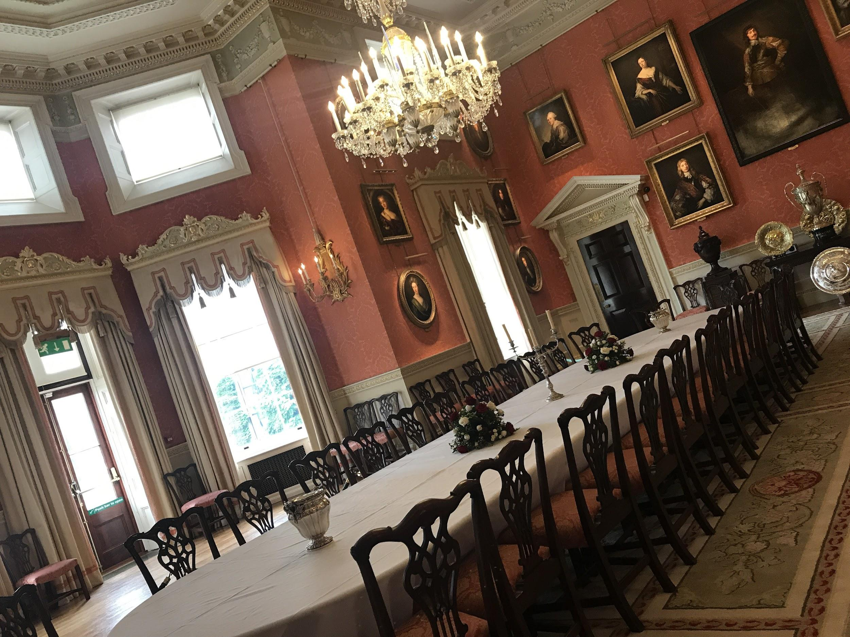
(Figure 9, dining room table with chandelier, Barber 2019)
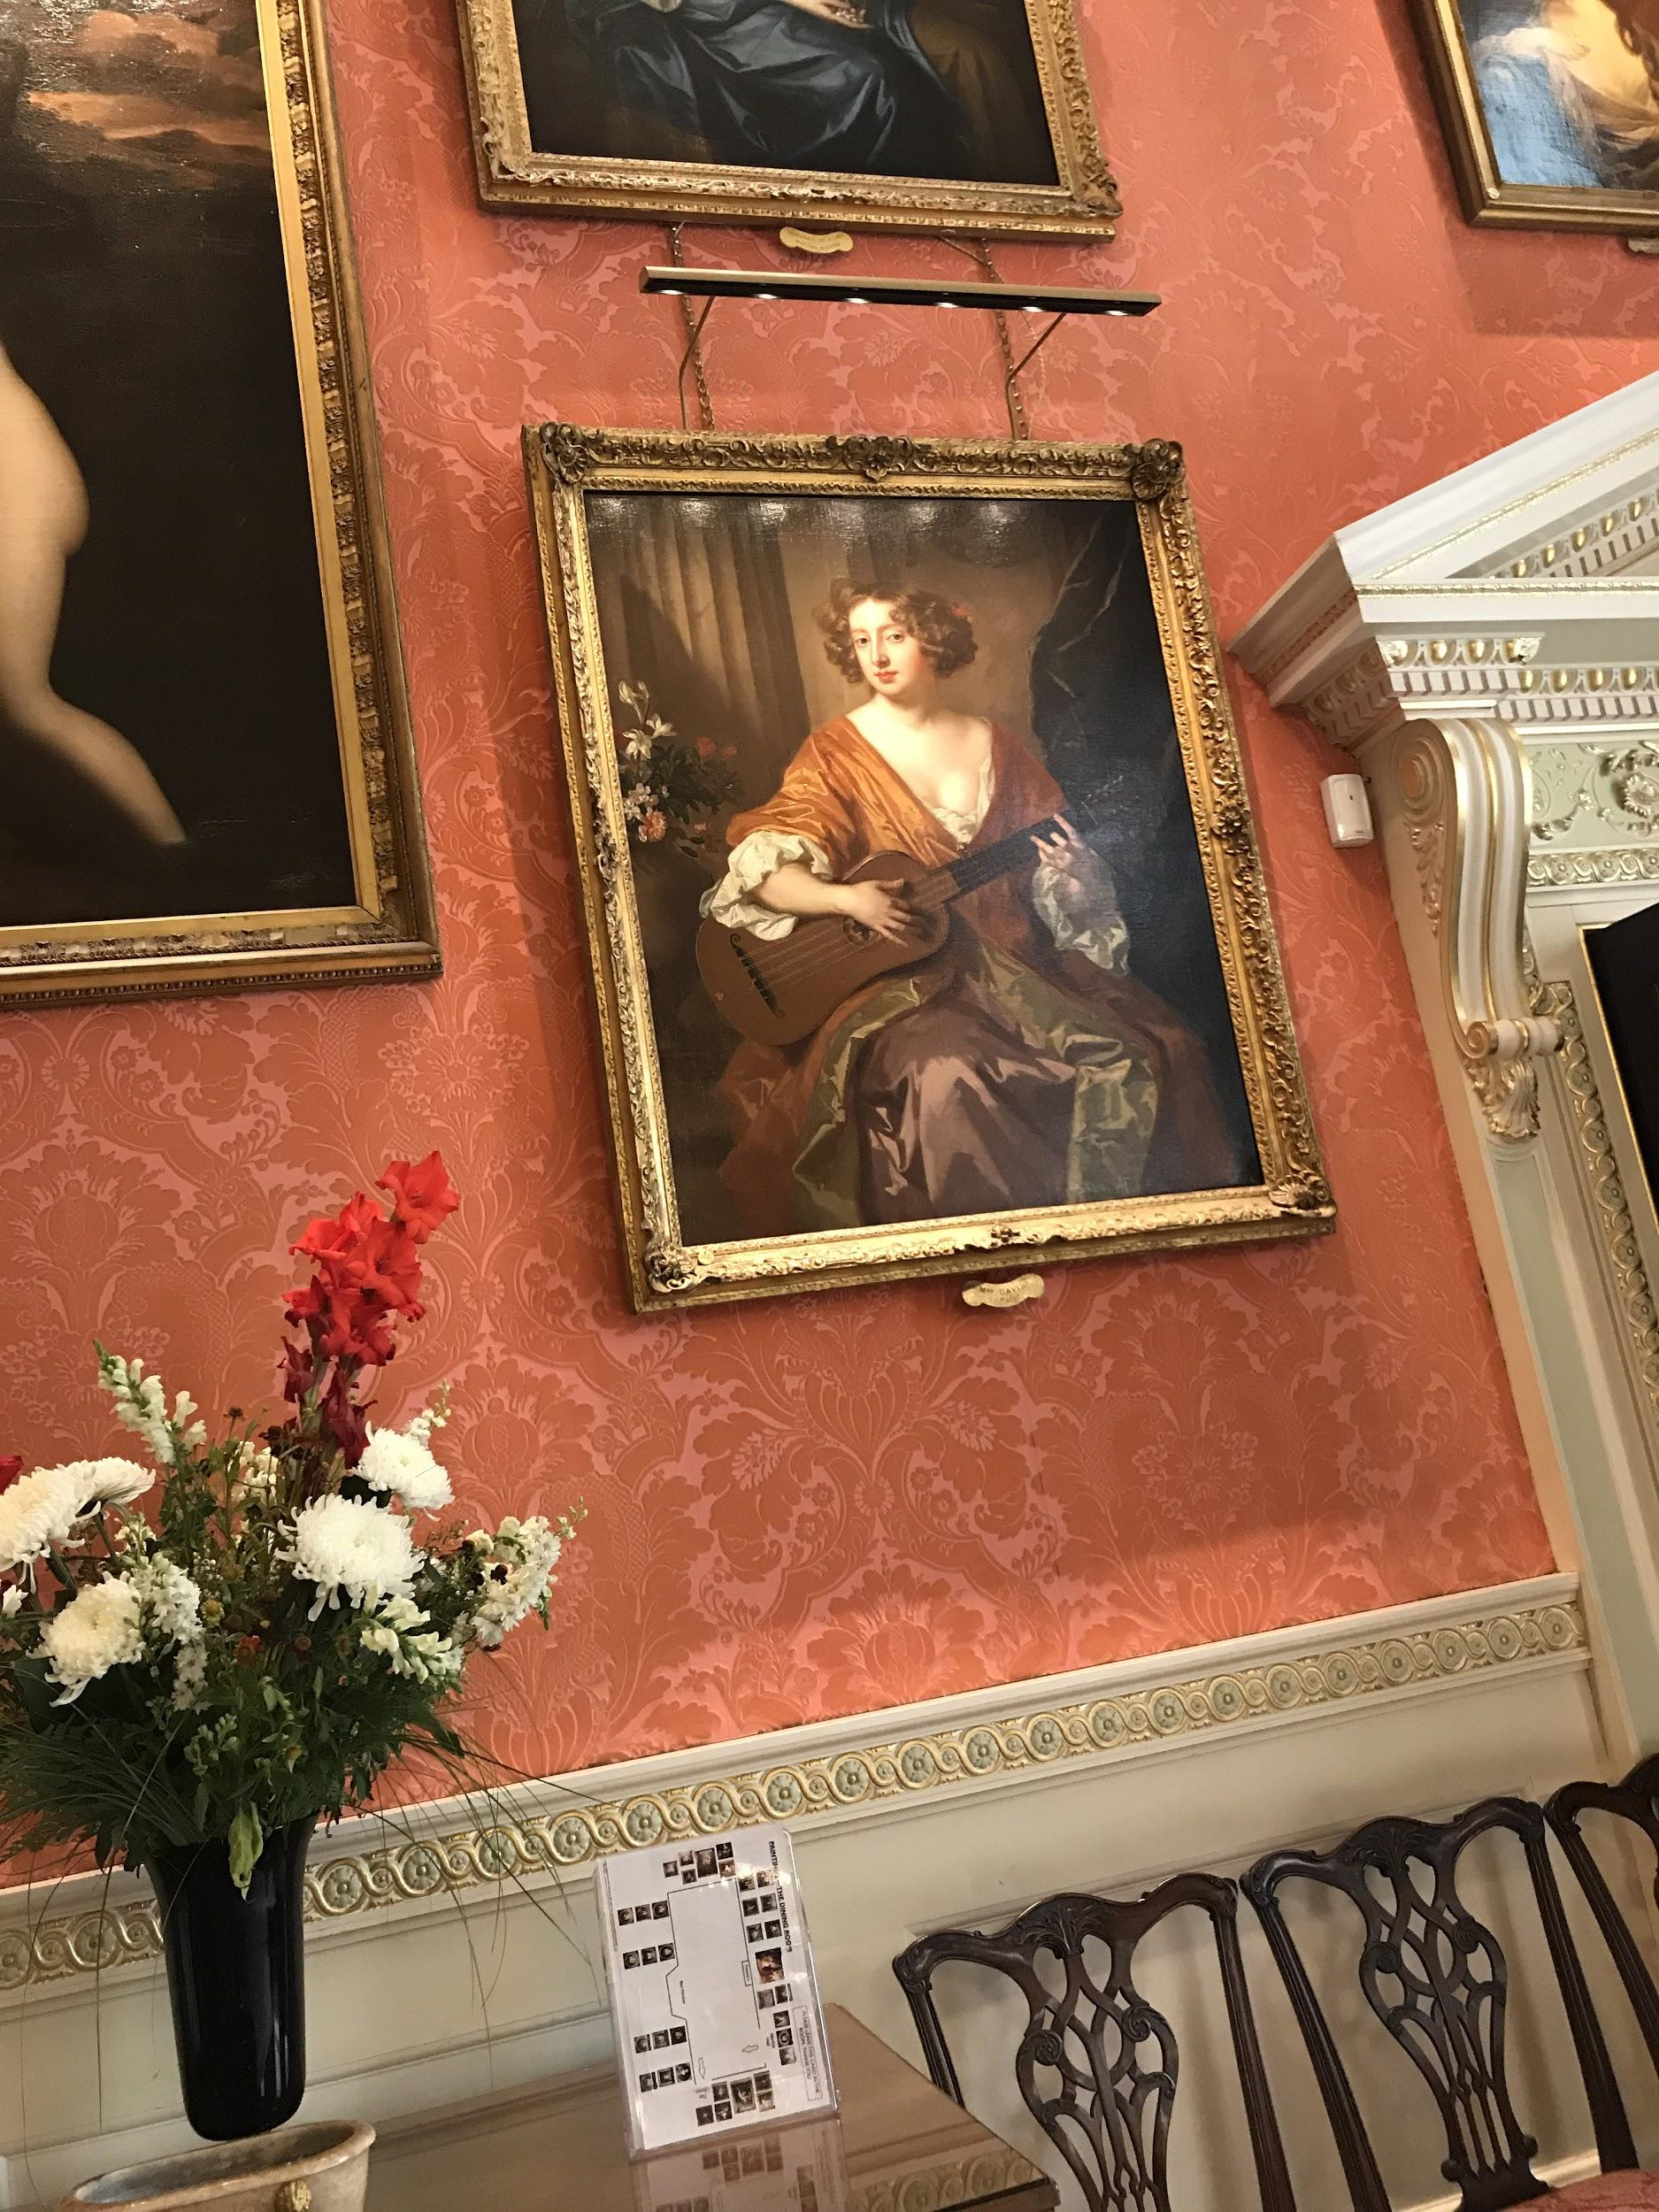
Figure 10, Mrs Davis, Sir Peter Lely, Barber 2019)
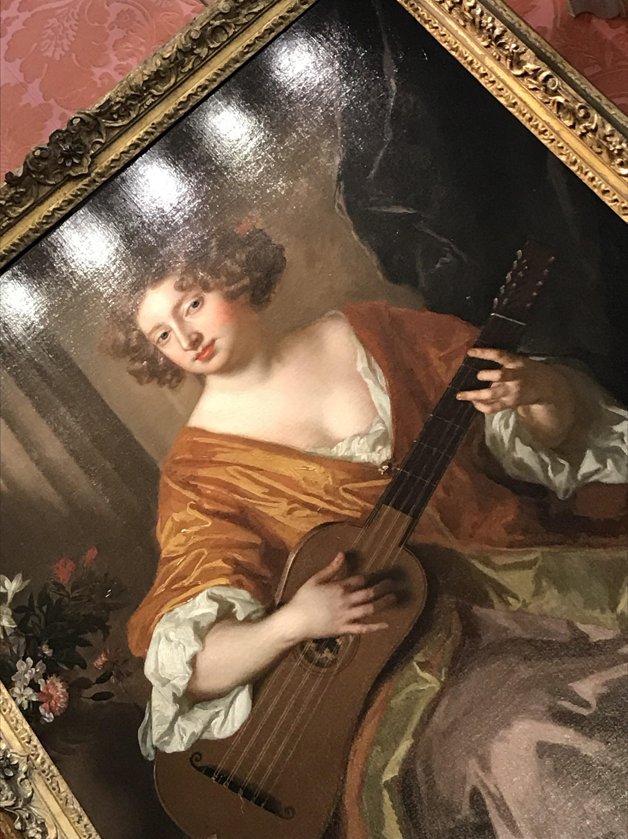
Figure 11, Moll Davis playing F sharp chord, Barber 2019)
Katherine suggested to me that she take photographs of me with the guests and the tour guiding, doing a social experiment in the stance as if I was welcoming the guests into the 2nd Saloon. She wanted to take photos of me as I’m a younger guide volunteering in the house this season compared to the other guides who are ranging from different ages much older than me. As well as this she wanted to notify the nation and people who are interested in heritage that there are younger people who are interested in volunteering as there is a stereotypical type of idea that volunteers are of the older ages when in fact that is untrue.

Conclusion: After the placement.
There were a few things that I took away from my experience each day of being a follow guide, each day is never the same as it was quite unpredictable in terms of whether or not people wanted tours. Some days there were only a few groups of people who turned up whereas on other days there were at least 2 groups booked into the later tours meaning that all 49 visitors were taken on split tours with different guides in order to accommodate them all in the best way for them all to experience the house at the same time. I have mentioned this above in my diary of the day to day activity from the work placement, I have also noted down the amount of guests that the house has received on each of the days which has impacted how the house staff and volunteers deal with no guests and days that are extremely busy.
As the house is relying on payments from the general public whether that be booked groups or people walking into the house spontaneously this has a huge affect on the sales of the organisation and how it is run on a day to day basis in order to help preserve the past and heritage of this famous venue.
There were many archives to backup the information that were appearing around the house for example Weston Park Foundation have set up online a staff and volunteers archives which allows them to log into the site and research about servants who worked at the house throughout the years that the house was in use by those that owned it (Weston Park, 2019)
Throughout my placement I have gained an understanding of how an organisation such as Weston Park is run on a day to day basis whether that be through communication of the security team, the conservation team and lending a hand in that department or in the main department that I specialised in during the summer. The experience has helped me gain a lot more skills and confidence in understanding how these heritage attractions that is so popular to the public across the globe.

Bibliography:
Websites:
Search-proquest-com.ezproxy.uwtsd.ac.uk. (2017). [online] Available at: https://search-proquest-com.ezproxy.uwtsd.ac.uk/docview/1863562074?accountid=130472&rfr_id=info%3Axri%2Fsid%3Aprimo [Accessed 14 Aug. 2019].

Limited, W. (2019). Weston Park Shropshire. Events, wedding venue, meetings. [online] Weston Park. Available at: https://www.weston-park.com/ [Accessed 14 Aug. 2019].

Photography:
Figure 1, Entrance of the house facing the arches, Barber 2019
Figure 2, Library facing towards drawing room, Barber 2019
Figure 3, Library facing the dining room, Barber 2019
Figure 4, Passageway into the second saloon, Barber 2019
Figure 5, Lady Diana Russell, Countess Bradford . P.Van Somer, Barber 2019
Figure 6, Sink in the female/male bathroom, Barber 2019
Figure 7, entrance of working 1800’s toilet, Barber 2019
Figure 8, 1800’s working toilet seat, Barber 2019
Figure 9, Dining room table with chandelier in view, Barber 2019
Figure 10, Mrs Davis, Sir Peter Lely, Barber 2019
Figure 11, Moll Davis, playing F sharp, Sir Peter Lely, Barber 2019

