Quality tools and root cause analysis

Matthew Preece
Student Number 1809102
April 2019
Introduction
This report is intended to provide a root cause analysis and suggest a corrective action plan to address the defect rates and improve the quality of the free standing pillar drill.
The report analyses the defect data of two operatives, Operator A and Operator B who are involved in the production of the castings and Operator C and D who finish the component. In analysing their defect rate, it is assumed that they make the same number of products. It has also been assumed that they work 8 hours per day and the same shift pattern over the 6 day working week.
It is also assumed that A and B and C and D operations are the same and that A and B cannot be interchanged with C and D. It is assumed that A and B both make the mould and cast.
It is assumed that both sets of operators have the same equipment as each other, that is that there is no difference in the equipment supplied to operator A as to Operator B and that both sets of pairs have the same basic training.
The defect data has only been analysed for 1 week and it is assumed that this is a typical week and that there is nothing unusual about this number of defects and that this week would be the same as any other. Further it is assumed that the defective products identified are rejected so defective products from operation 1 do not go through to the finishing process.
A “root cause analysis helps identify what, how and why something happened thus preventing recurrence” (Rooney and Vanden Heuvel 2004). In order to develop a corrective action plan to address the problems of defects in the products in this process it is first important to identify what are the probable reasons for the problem. However it is also vital to understand why the problem occurred in order to prevent it reoccurring. A root cause analysis does both of these things.
Rooney and Vanden Heuvel (2004) also suggest a four step model for undertaking a RCA
- Data Collection
- Causal Factor Charting
- Root Cause Identification
- Recommendation generation and implementation
This is similar to the “The Seven Step Problem Solving Model” (Westcott, 2016) which provides a framework for undertaking a RCA. This report is using the guidance offered by both of these model.

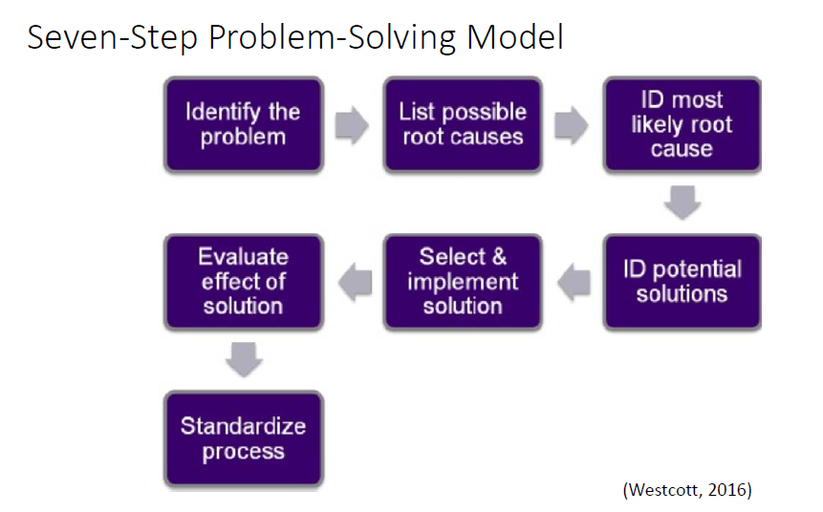

Step 1 Identify the Problem

In order to identify the problem a Pareto diagram has been created. This helps to identify the most important issue to focus on. This will also be referred to again when identifying potential solutions. From this it can be seen that surface finishing defects account for the majority of the defects and sit within the 80% cumulative frequency, with blow hole defects being the second priority. According to Pareto principles then these are the defects that should be given the most focus to address.

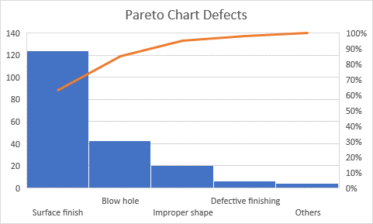
Operation 1 Sand Casting Process

The graph below shows the different defects by both operators. From this it can be seen that both operators have a larger number of surface finishing defects than any other type of defect. Operator B has significantly more surface finishing defects than operator A. Both operators have similar number of other defects.

The number of defects occurring on each shift for both operators A and B was also analysed.
This analysis can be seen in the two graphs below.

Operator A has more defects on Wednesday am and pm shifts and on Thursday morning shift.

Operator B shows a more even spread of defects throughout the week although like operator A he has more defects on Wednesday, particularly Wednesday morning. He also has more defects on Saturday afternoon than operator A. Although Operator A also shows an increase in defects on Saturday afternoon.
Both graphs indicate a spike in defects on Wednesday.
Operation 2 Finishing
The graphs below show the defects by each operator C and D.

This graph shows that operator D has more defects than operator C. Both operators have significantly more surface finish defects than any other defects.
The graphs below show the number of defects on each shift over the 6 day week.
Operator C has an even spread of defects across the week but shows a spike on Wednesday particularly Wednesday pm.

Operator D also has more defects on Wednesday than any other day and he has the most defects on a Wednesday afternoon than on any of his other shifts.

Step 2 Possible Root Causes

The second step in both the models offered by Rooney et al and Westcott suggest that there should be an assessment of all the possible root causes. To support this step an Ishikawa diagram has been constructed. It is recognised that this is better done as a brainstorming session. Doggett (2005) suggests that an Ishikawa or cause and effect diagram is a useful tool in RCA although this does not identify a “particular root cause once complete” and so step 3 of the Westcott (2016) seven step model will also be used.
The “Fishbone” diagram below groups the possible root causes into the 6 Ms as can be seen.

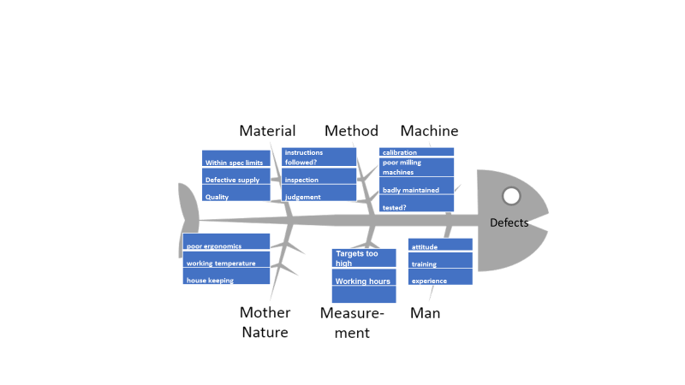

Materials refer to the material needed to produce the product. From the analysis some of the possible causes in this group include
- the quality of the raw materials. The defects maybe caused by the raw materials not being of good quality
- The materials being supplied may not be in the specification ordered particularly if it is only recently that the defects are being seen
- The raw material supplier may have changed and this is causing the problem
Method refers to how the process is performed and the specific requirements. Some possible causes in this category are
- Whether or not there are standard operating procedures (SOP) for the two process
- If there are SOPs are these being followed in full or if only partly being followed is that contributing to the defect rate
- Is there sufficient inspection or quality control in each part of the process. If there is no quality control it could be that the defect is caused in one stage of the process and then passes into another. As an example if there is no quality control at stage 1 when the sand cast moulds are being made any problems could cause the defects in the casting process. Another example is with the blow hole defects which are reported in both the first and second process but it might be that the blow holes are actually bigger than reported in the casting process as they are only found in the milling or finishing process.
- There might be an increase in the judgement of the defects or the customer may have increased their specification and will no longer accept products that have any defect. This will increase the number of products rejected.
Machine includes the equipment and tools required to do the job. Some defects caused by the machine include
- The defects may have increased if the machines being used have gone out of calibration
- The machines may be worn or new ones may have been purchased that are sub standard
- The machines may not be being properly maintained or the maintenance schedule may have been reduced
- There may be a reduction in the testing of machines to see if they are still within specification
Mother Nature refers to the environment this is the conditions in which the process operates. Issues that could be causing defects include
- Ergonomics – is the process poorly designed to suit the workers and this makes the manufacturing difficult
- Is the working environment too hot or too cold and this causes the workers to be uncomfortable and leads to mistakes.
- The number of defects increases on Wednesday for both processes. Does something happen on a Wednesday from a working environment that causes these problems
- Housekeeping issues. Is the area around the working area clean and tidy or does an untidy or dirty area contribute to the defects

Measurement includes how the performance of the process is evaluated. Some considerations in this area include
- Are the production targets too high and is this causing the workforce to make mistakes or cut corners
- Are the shift patterns too long or are the workers working too many hours. They are working six days a week so are they having sufficient rest or are they tired and is this causing them to make mistakes
Man is anyone who is involved in the process. Issues that could be causing the defects in this area are
- Are they well trained on the process or do they need additional training
- Worker B makes significantly more defective products than the others. Does he lack training or is he less experienced
- Attitude - Have the workforce become demoralised or complacent
The analysis above shows a number of potential cause but as Doggett (2005) commented this method does not identify the most likely cause. The Pareto Principle or the 80/20 rule suggests that to get the best results in an improvement the focus should be on the 20% that really matters. It is vital then that this long list of possible causes is reduced to a shorter list of the most likely causes and then potential solutions and a corrective action plan can be produced.

Step 3 Identify the Most Likely Cause
The Pareto diagram showed that the area that should receive the greatest consideration is correcting the surface finishing defects as these account for the majority of the defects.
The analysis showed that Worker B makes the most defects and 150% more than worker A. it is also thought that many of the defects reported in the milling process are actually caused by the casting process. So correcting worker B’s defects will have the biggest impact.
It can also be seen that there is a spike in defects on Wednesday.
To find out what the most likely causes are of these key issues the 5 Whys technique is used. This technique is part of the Six Sigma process (isixsigma.com).
Surface Finishing Defects
Why 1 | Why are there more surface finishing defects | This is a labour intensive job and he is working independently
Why 2 | Why is he working independently | Because this is the current practice in the department
Why 3 | Why is this current practice | There has been no recognition that this is causing a problem
Why 4 | Why has there been no recognition that this is causing a problem | Because other workers are working independently and they are not making the same number of errors
Why 5 | Whys is worker B making more errors | The next set of whys answer this

Worker B

Why 1 | Why does worker B have more defects | He is not following standard operating procedures
Why 2 | Why is he not following SOPs | He does not know about them or does not understand them
Why 3 | Why doesn’t he understand them | He has not had sufficient training
Why 4 | Why has that happened | He has not had proper supervision
Why 5 | Why has that occurred | He is very new and his line manager has not put the proper processes in place

More Defects on Wednesdays
Why 1 | Why are there more defects on Wednesday | This is difficult to answer with the limited data
Why 2 | Why is there limited data | Because only 1 week was measured
Why 3 | Why was only 1 week measured | Not sure but more data is required to draw any conclusions
Why 4 | Why can’t conclusions be drawn from this data | Because it might just be an anomaly and unusual
Why 5 | Why is this important | Because actions need to be specific to the problem. More data is required to be sure there is a problem.

Step 4 Potential Solutions - Corrective Action Plan
The corrective action plan below takes the main issues identified in the analysis and the most likely causes from the 5 Whys and suggests some corrective actions to address the problems.

 | Finding/observation | Corrective action | Responsible person | Target completion date
Priority one | The casting process makes the most defects out of the two processes. Surface finishes are the majority. | Use high quality materials when casting.  Use higher quality sand when making moulds.  Use higher quality iron when casting. | Finance department to look for better materials and to look at cost benefits. | Two months.
Priority one |  | More training required or refresher courses. | Training department | one week
Priority one |  | Regular checks on equipment.  Equipment to be tested and calibrated. | Engineering department | Every month
Priority one |  | Implement a Standard operating procedure. | Management | One month
Priority one |  | Put in extra quality controls measures sooner in the processes to pick up defects earlier | Management | One month
Priority one |  | Better ergonomics and working conditions | Management | Three months
Priority one |  | Targets and incentives for the workers to work towards | management | Four months
Priority two | Worker B makes approximately 150% more defects than worker A | Provide extra training | Training department | One week
Priority two | Worker B makes approximately 150% more defects than worker A | Have extra supervision | management | Supervise for one month then checks every two months of six months
Priority two | Worker B makes approximately 150% more defects than worker A | Implement a Standard operating procedure. | Management | One month
Priority two | Worker B makes approximately 150% more defects than worker A | Put in extra quality controls measures sooner in the processes to pick up defects earlier | Management | One month
Priority three | There is a high number of defects on Wednesday | Investigate what happened on that particular Wednesday | management | One week
 |  | Collect another months data to see if it was just a one off or if something is happening on Wednesdays to cause these high number defects on Wednesdays | management | One month
 |  | If still bad after one month further investigation into the issue will be required | management | Extra three months if needed
Conclusions and Recommendations
A root cause analysis has been undertaken on the data provided using a range of techniques. However the limitations of this are acknowledged. In particular that this has been undertake by a single analyst and a group may have provided better solutions.
The data is very limited and it has only been collected for one week.
The analyst only has a limited understanding of the process.
The recommendations for action are provided in the corrective action plan. The main actions recommended include
- Collecting more data
- Developing Standard Operating Procedures
- Improving training
- Improving or reviewing quality assurance processes
- Improving equipment

References

Doggett M (January 2006) Root Cause Analysis: A Framework for Tool Selection Quality Management Journal 12 (4)
Isixsigma.com
Rooney James J and Vanden Heuvel Lee N (July 2004) Root Cause Analysis for Beginners Quality Progress
Westcott, R.T. (2006). The certified manager of quality/organizational excellence handbook (3rd Edition) WI:ASQ

