

Electronics (Diodes and Amplifiers)
Module Code: PCEE4006
Learner Name & Number: Luke O’Sullivan 176776
Lecturer Name: Neil Roberts

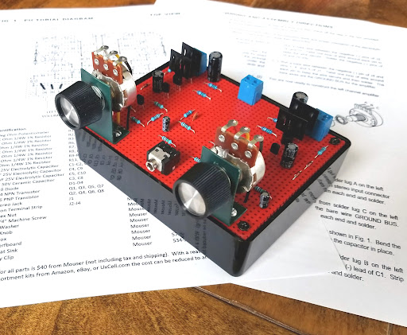

Table of Contents
Task 1 – Diodes and Power Supply Unit 3
Task 2 – Transistor Amplifier Design and Performance Measurement 12
Task 3 – Non-Inverting Operational Amplifier 28
References 39
Bibliography 40

Task 1 – Diodes and Power Supply Unit
- “A diode is a two-terminal unidirectional power electronics device” (Electrical Technology, 2020). The most common material used to construct a diode is silicon; other semiconductor materials such as germanium or germanium arsenide are used. There are two types of semiconductor material that are used in the construction of a diode. An intrinsic and Extrinsic semiconductor. The intrinsic semiconductor is a pure semiconductor in which holes and electrons are available at room temperature. In extrinsic semiconductors, impurities are added to increase the number of holes or number of electrons. The impurities are usually trivalent, such as boron, indium or aluminium or pentavalent, such as arsenic, antimony and phosphorus.

A semiconductor diode has two layers, one is a P-Type semiconductor and the second is made from an N-type semiconductor layer. Adding trivalent impurities in silicon or germanium creates more holes which is a positive charge and therefore it is known as a P-Type layer.

Adding pentavalent impurities in silicon or germanium, creates a greater number of electrons and creates a negative charge, therefore is known as the N-Type layer.

“The diode is formed by joining both N-type and P-type semiconductors together. This device is a combination of P-type and N-type semiconductor material hence it is also known as PN Junction Diode” (Electrical Technology, 2020)

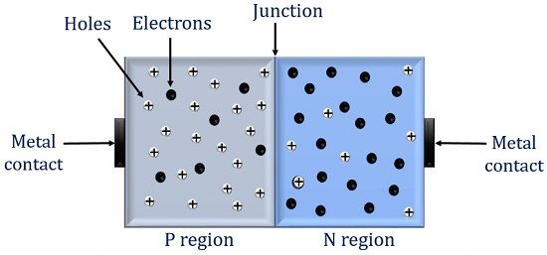

Figure 1 – Construction of a PN Junction Diode.

A PN Junction within semiconductor devices, exhibits different behaviours when under forward and reverse bias, these behaviours are essential in the operation of diodes and other electronics. A forward bias PN junction must be under the condition that the Positive terminal of the battery is connected to the P-Type and the negative terminal is connected to the N-Type. The functionality of the forward bias PN junction has the external voltage reducing the built-in potential barrier of the junction, “If this external voltage becomes greater than the value of the potential barrier, approx. 0.7 volts for silicon and 0.3 volts for germanium, the potential barriers opposition will be overcome and current will start to flow” (Storr, 2013). Holes from the P-Type and electrons from the N-Type are pushed towards the junction. “This results in a characteristics curve of zero current flowing up to this voltage point, called the “knee” on the static curves and then a high current flow through the diode with little increase in the external voltage” (Storr, 2013). Therefore, current flows easily through the junction and it will act like a closed switch.

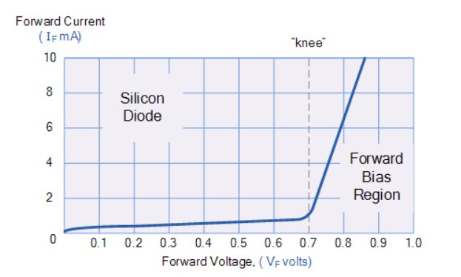

Figure 2 – Forward Characteristics Curve for Junction Diode.

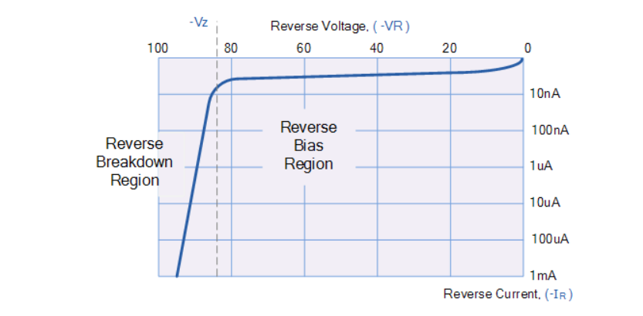
Different to the forward bias, the reverse biased PN junction must be under the condition of the positive terminal on the battery connecting to the N-Type and the negative terminal connecting to the P-Type. The functionality of this has the external voltage increasing the width of the depletion region and raising the potential barrier, majority carriers are pulled away from the junction and there are no major current flows. “If the reverse bias voltage Vr applied to the diode is increased to a sufficiently high enough value, it will cause the diode’s PN junction to overheat and fail due to the avalanche effect around the junction” (Storr, 2013). This causes the diode to become shortened and will result in the flow of maximum circuit current.

Figure 3 – Reverse Characteristics for Junction Diode.

- Task 1b requires the design of a power supply unit that contains a full-wave bridge rectifier, this is designed through a series of calculations which also adheres to the following specifications:
- Input voltage: 230Vrms at 50Hz
- Output voltage: 18V dc $±$10%
- Ripple factor (max): 4.00%
- Load current (max): 150mA.

The first calculation carried out was to discover the ripple frequency:

Ripple Frequency = $2 ×Input Frequency$
= $2 ×50=100Hz$

For the value of Resistor 1 (R1) the calculation of load is carried out:

RL = $\frac{V}{IMax ×{10}^{-3}}$ = $\frac{18}{150 ×{10}^{-3}}=120Ω$

Next, the Ripple Voltage (V) is calculated:

Ripple Voltage = Vr = $r ×Vo$
= $4\% ×18$
= $0.04 ×18$
= 0.72V
Following this the transformer calculations were carried out:
Vin = 230Vrms
Vp(In) = $\sqrt{2} ×Vin$
$$\sqrt{2} ×230=325.3V$$

The next step was to carry out calculations to find results for the peak output voltage from secondary winding:

Voltage drop across the diode = 0.7V
2 Diodes in each direction = 1.4V
Required Vout = 18V
Vp(Out) = Vp (Sec) – 1.4
Vp(Sec) = Vp(Out) + 1.4
= 18 + 1.4 = 19.4V

Next, calculations were carried out for the turn’s ratio within the transformer:
Vin = 325.3V
Vout = 19.4V
Np = No. of turns on primary
Ns = No. of turns on secondary
$$\frac{Np}{Ns}= \frac{Vin}{Vout}$$
$$\frac{Np}{Ns}= \frac{325.3}{19.4}=16.8$$
Approximately 17 Turns.
From here smoothing capacitor calculations are carried out:
Vr = $\frac{1}{FR1C} ×Vout$
Vr = 0.72V
F = 100Hz
R1 = 120Ω
C = Smoothing Capacitor
Vout = 18V
Rearrange =>
C = $\frac{Vout}{Vr ×F×R1}$
C = $\frac{18}{0.72×100×120}$
= 2083 uF

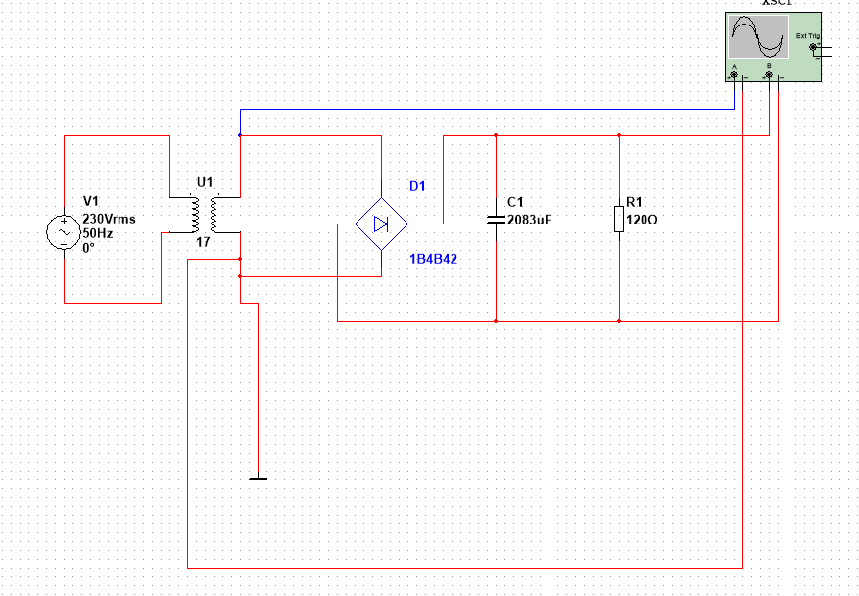
c) Use Multisim to simulate and test the developed circuit.

Figure 4 – Developed circuit from calculations
In figure 4 the developed circuit created on multisim is shown, the components in the circuit were chosen based on calculations carried out in task 1b). This is shown firstly through U1 which is the transformer and its approximate amount of turns which is 17. The smoothing capacitor labelled C1 is rated at 2083uF, and R1 with a resistance of 120Ω. The circuit is then connected to an oscilloscope to take readings.
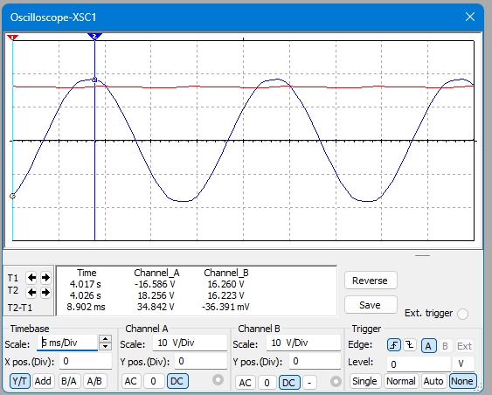
Figure 5 – Oscilloscope showing ripple voltage.
Figure 5 shows the power supply unit oscilloscope readings, in this figure, the red reading (channel 2) represents a ripple voltage reading. A ripple voltage refers to an unwanted AC Voltage, that has fluctuations that superimposes on the DC Voltage. The smoothing capacitor in this circuit is used to give the ripple voltage the smoothest possible reading and filter out voltage fluctuations, however figure 5 shows how it has a slight ‘ripple’ along the reading.

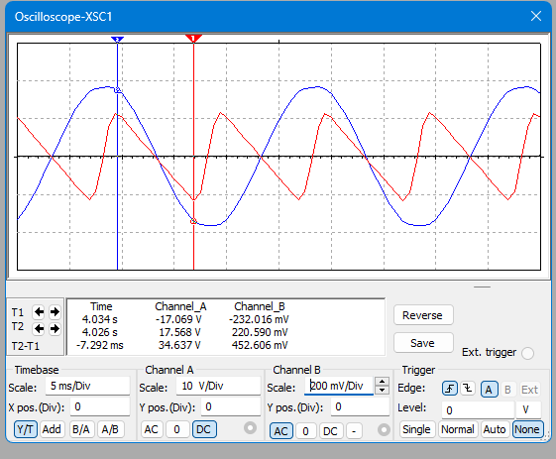
Figure 6 – Ripple voltage reading with no DC Signal shown.
From figure 6, there is visualisation that the ripple voltage is less than half a volt, this is shown in channel B, with a reading of 452.606mV. The reading, is visualised without the DC part of the signal and the ripple is clear in figure 6 due to the scale being adjusted to 200mV/Div.
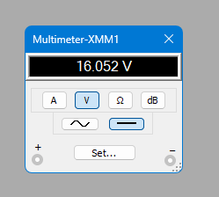

Figure 7 – DC Output Voltage from circuit

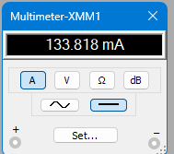

Figure 8 – Current through the circuit which is below the 150mA maximum.

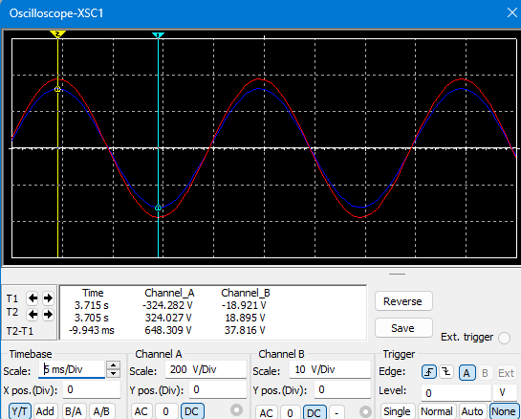
Figure 9 – Oscilloscope reading with no capacitor or diode.
Figure 9 shows an oscilloscope reading from the circuit, where no smoothing capacitor or diode is connected, to collect readings from the transformer. From these results the readings show that the output is approximately 20x smaller than the input, this gives an approximate ratio of 20:1 on the windings of the transformer.

Task 2 – Transistor Amplifier Design and Performance Measurement
- Class A and Class B amplifiers are both commonly used power amplifiers, with each of them having different operational characteristics. The main difference in the amplifiers is how the output devices connected conduct current. Within a Class A amplifier, the output device conducts for the full cycle of the input signal. This means that the output device (such as a transistor) is always “ON”, this means there is minimal distortion, and a maximum amplitude of output signal is produced. Whereas, a Class B amplifier will use two transistors, with each one conducting only half a cycle. One transistor will amplify the positive half and the other amplifying the negative half.

Due to the two amplifiers having a difference in conduction, efficiency changes significantly between the two, Class A amplifiers are commonly inefficient, carrying an average efficiency of 20-30% and a theoretical maximum of 50%. Within the Class A amplifier, large amounts of power are lost through heat, even when there is no signal. A Class B amplifier performs substantially better than the Class A, with a theoretical maximum efficiency of 79%. Power is only consumed when amplifying a signal. Making a Class B amplifier more suitable in battery powered or heat-sensitive applications.

The benefit of having the simplicity and linearity of the Class A amplifier is outweighed by its high-power consumption and heat losses. However, whilst Class B amplifiers are more efficient, they suffer from crossover distortion, which is a non-linear behaviour that occurs at the point where the signal transitions between resistors. This distortion can particularly effect audio quality, especially at low signal levels.

Aesthetically, the Class A amplifier can be considered better due to its simplicity and are often used in high-fidelity audio applications where the signal purity is key. The design of a Class B amplifier is complex, this is due to the requirement of matching the transistors to minimise the distortion. Despite this, they are often used in applications where audio quality isn’t critical.

Overall, Class A amplifiers offer a greater signal fidelity but are inefficient due to their heat production, only making then suitable for high end audio applications. Class B amplifiers, however, offer greater efficiency, with the baggage of distortion, making them useful for general purpose amplification, where power saving is a priority compared to signal purity.

b.) Design a Class A common emitter amplifier using a suitable transistor (see sheet) that has a h_{fe} value between 100 to 800 (value to be checked using datasheets and multimeter). A suitable voltage supply is to be selected, the decoupling capacitor will be 100μF and coupling capacitors will be 10μF.

As shown in Appendix A, the datasheet for a BC550 transistor is shown, from this datasheet a set of values were taken to aid the calculations and circuit design, the values can be found below:
- VBE = 1.1V
- Current Gain (hFE) = 514
- Vs/VCC = 12V
- Ic = 1mA
The first calculation completed was for the Collector Resistor (Rc):
$Rc= \frac{VCC}{2 ×Ic}$
$Rc= \frac{12}{2 ×{10}^{-3} }=6000$
Rc = 6000 Ω
Next, is the calculations for the Emitter Resistor (Re):
Ie = Ic = 1mA
Ve = 10% to 15% of VCC
Ve = 12% x 12
Ve = 1.44
$$Re= \frac{VE}{IE}$$
$$Re= \frac{1.44}{1×{10}^{-3}}=1440$$
Re = 1440 Ω
Below is the estimated value for the Base Current (IB):
$$hfe= \frac{Ic}{IB}$$
$$IB = \frac{Ic}{hfe}$$
$$IB = \frac{1 ×{10}^{-3}}{514}= {1.95 ×10}^{-6} A$$
Next, the Base Voltage (VB) is determined:
The base voltage should be around the VBE value (1.1V as shown in Appendix A) higher than VE to ensure that the input signal is biased on the linear part of the transistor input characteristic.
VB = VE + VBE
VB = 1.44 + 1.1
VB = 2.54 V

Represented below is the DC bias network current:
To ensure adequate bias stability, the current flowing through R1 and R2 should be about 10 times greater than the base current IB so the current flowing through R1 and R2 will be simply IB × 10.
DC bias network current = IB x 10
$${1.95×10}^{-6 }×10= {1.95 ×10}^{-5}$$

Next, the calculations have been calculated for the Resistance for R2:
$$R2= \frac{VB}{10 ×IB}$$
$$R2= \frac{2.54}{{1.95 ×10}^{-5}}=130, 256 Ω$$
R2 = 130k Ω

Lastly, the calculations for the resistance of R1 are shown below:
$$R1= \frac{VCC-VB}{11 ×IB }$$
$$R1= \frac{12-2.54}{11 ×{1.95 ×10}^{-5}}=441,024$$
R1 = 441k Ω

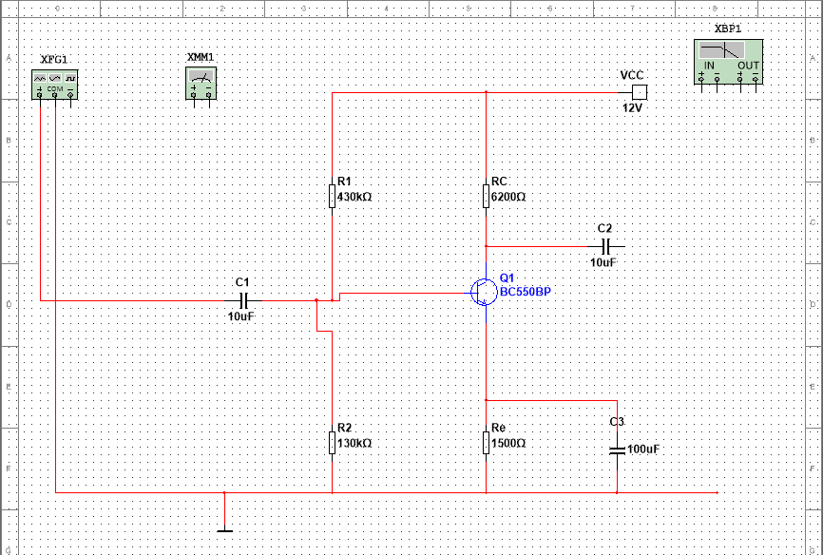
Figure 10 – Circuit design with Multimeter connected in VBE connections
From this circuit a series of readings were taken on the multimeter to gather results for connections across the base, collector and emitter. The table below shows the results gathered.
VB | Ground & Base connection (2.06V)
VE | Ground & Emitter Connection (1.42V)
VC | Ground & Collector Connection (6.16V)
VBE | Base & Emitter Connection (632.1mV)
VCE | Collector and Emitter Connection (4.73V)
Table A

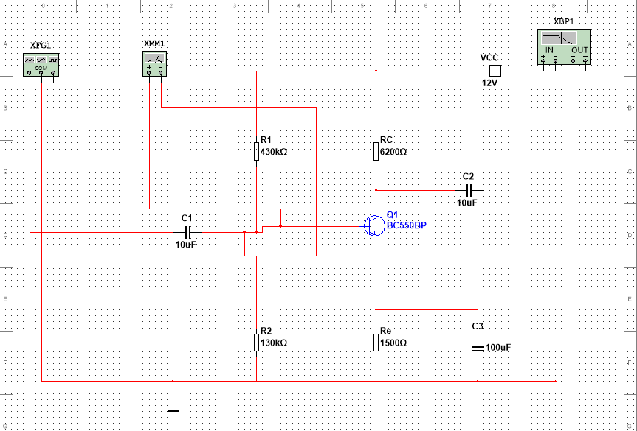

Figure 11 – Example of circuit connected to multimeter for readings (connected in VBE)

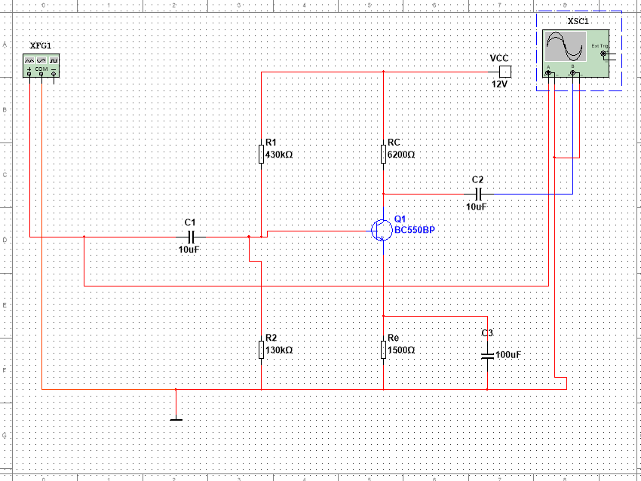
From the results taken, it can be seen that the results relate, the correlation is in the difference of values, where VB and VE are at readings of 2.06V and 1.42V, the reading of VBE which is 632.1mV is the approximate difference between the readings. This correlation is also seen between VC and VE, where the readings have a similar difference in values to the reading of VCE. It should also be noted that the RC component within the circuit has its value through calculations carried out, these calculations are in place so that the RC value is approximately half supply voltage at VC, this is evidenced in the readings due to VS being 12V and VC reading at 6.16V.
Figure 12 – Circuit connected to oscilloscope

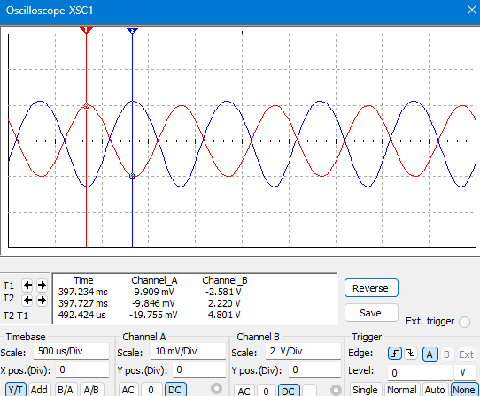

Figure 13 – Oscilloscope first output reading.

Figure 13 demonstrates the first output signal reading, the reading for this should be approximately 10mV as that is set from the function generator, this is shown in the results for Channel A above, in the readings for Channel B, it is shown that the output voltage is 2.2V This value for output voltage is then converted in to mV which makes it 2200mV, this is converted to calculate the gain.

Oscilioscope Results:

Vin = 10mV
Vout = 2.2V
Gain = 20 x Log (Vout/Vin)
Gain = 20 x Log (2200/10)
Gain = 47 dB

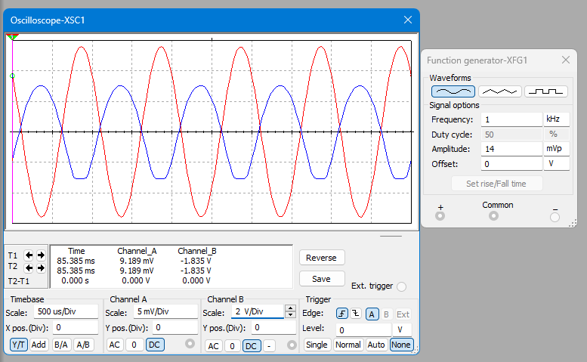
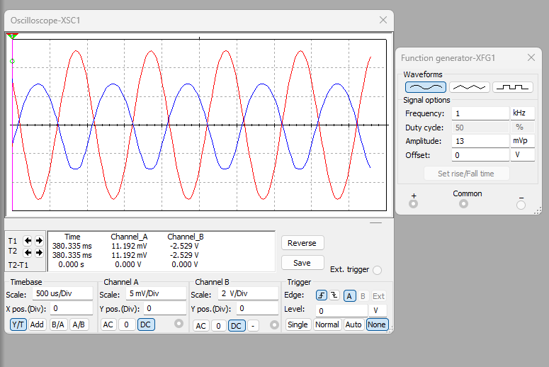
Figure 14 – Oscilloscope reading at 13 mVp, no clipping and nice representation of waves.
Figure 15 – Oscilloscope reading at 14 mVp, clipping now appearing which is a poor representation.

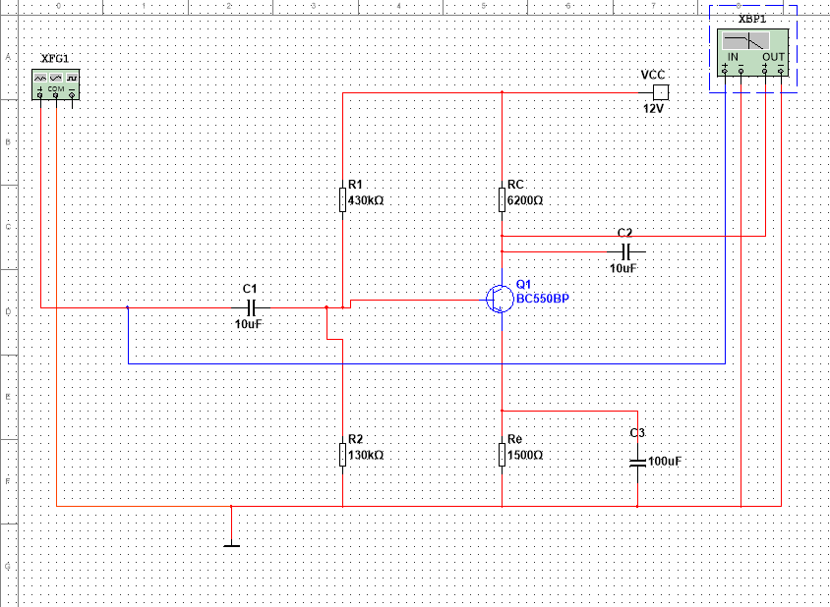
Figure 16 – Circuit connected to Bode Plotter.

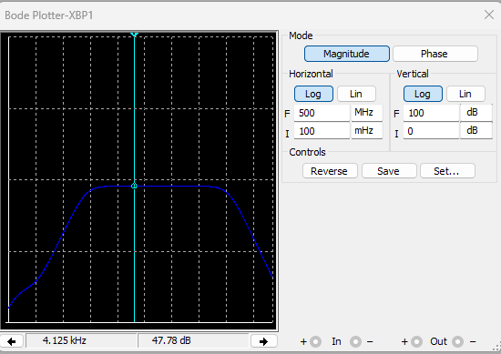

Figure 17 – Peak Gain Bode Plotter reading
Figure 17 demonstrates the Peak Gain value taken from the Bode plotter connected to the circuit. The reading taken (47.78dB) matches the calculations taken from the oscilloscope readings. The essential use of the Bode plotter is that it takes the frequency, and changes/calculates it into a gain value automatically, where a graph is then produced.

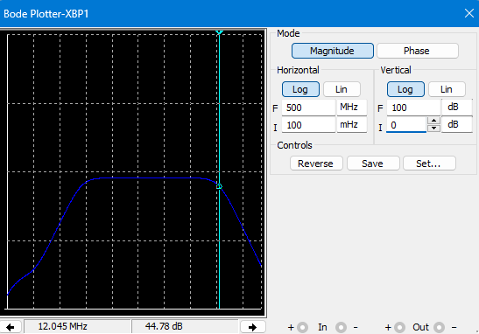
Figure 18 – Bode Plotter representing upper cut off frequency.
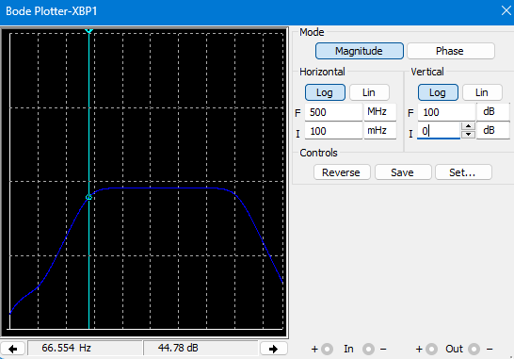
From this bode plotter reading, it is visible that the upper cut off frequency is at 12.045 Mhz or 12045000Hz, this is also known as the half power point where the output power has dropped approximately 3dB.

Figure – 19 Bode Plotter representing lower cut off frequency.
The bode plotter here is taking the lower cut off frequency reading, where a much lower reading of 66.554Hz has been taken, on this graph the reading has also been taken at approximately 3dB lower output power.
Lower Cut off frequency = 66.554Hz
These two results are used to calculate the Bandwidth from the circuit, this result is calculated through subtracting the Lower Cut off frequency from the Upper Cut off frequency.

Bandwidth Calculations = Upper Cut off - Lower Cut off
= 12045000 – 66 = 12044944Mhz

Next, a physical circuit is built and a set of results are produced, similarly to the simulated circuit.
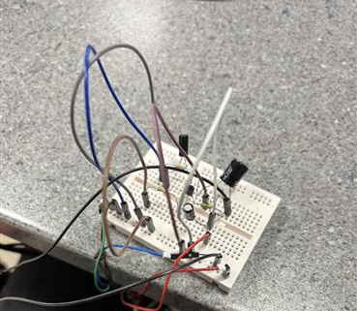

Figure 20 – Physical Transistor Amplifier Circuit

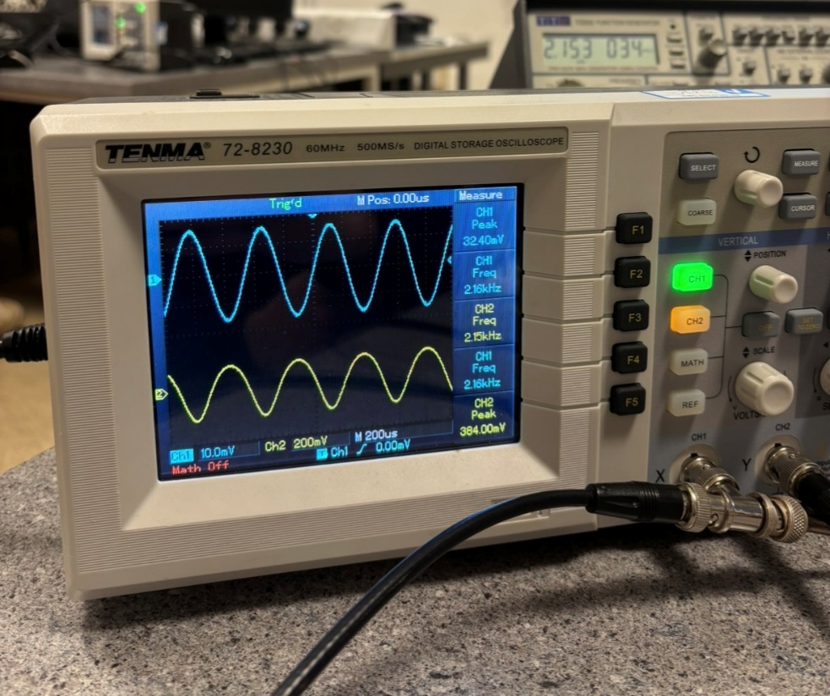

Figure 21 – Oscilloscope Connected to physical circuit, representing smooth waveform.
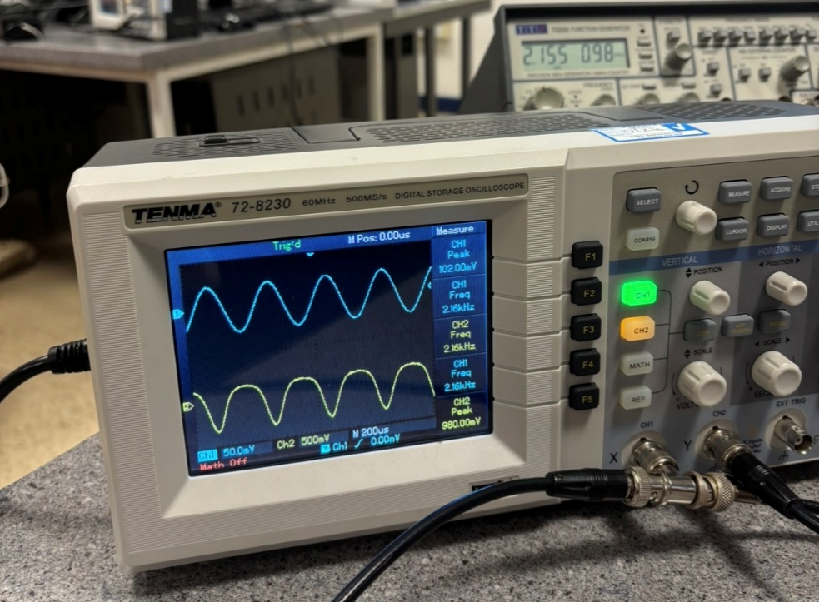

Figure 22 – Oscilloscope connected to physical circuit, representing clipping within the waveform.

Figure 20 represents the physical circuit built of the Transistor amplifier, the circuit was built using the following equipment:
- Solderless Breadboard
- Male to Male wires
- 2 x 10uF Capacitors
- 100uF Capacitor
- 430kΩ Resistor
- 130kΩ Resistor
- 1500Ω Resistor
- 6200Ω Resistor
- BC550BP Transistor
- Power supply
Following the building of the circuit, both components and testing equipment were required to be checked to ensure of fair and accurate results. Equipment was checked through a series of tests. For the oscilloscope, a calibration check can be performed to verify that the display is accurate and that the time base and voltage scales are correct. The multimeter can be checked through testing the other measurements on the circuit, this could be through a continuity check between known connection points, a voltage check from the power supply, a resistance measurement checking each resistor or testing the auto ranging on the oscilloscope. The function generator can be verified through connecting the output to the oscilloscope and checking the waveform type, looking at the frequency and amplitude readings and ensure that the impedance is correct to the input it is driving. As mentioned previously the breadboard, components and wires can be tested when the multimeter is run through tests.
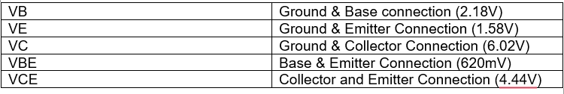
After these tests were carried out, the first set of results were obtained, like the simulated circuit, results were gathered for voltage readings across ground, the base, emitter and collector. The table below presents these results.
Table B
From the results gathered in the table above, it is evident that the data from the physical circuit are reliable, as they fall within a reading of 0.3V from the simulated circuit. Also the correlation between VB, VE & VBE as well as the correlation between VC, VE & VCE also applies to these set of results.
Next a set of results were taken for Vin, Vout and Frequency changes, these were then used to calculate Gain values.

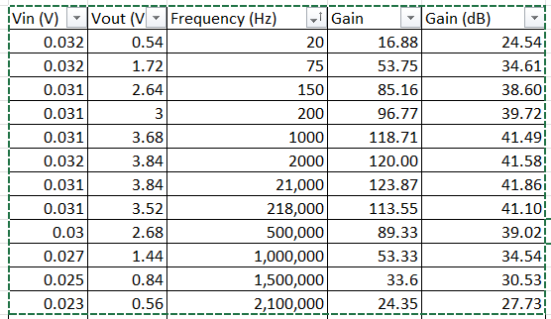
The table above represents the results taken from the physical circuit, results for Vin and Vout are taken from connecting the oscilloscope directly to the circuit, whilst the frequency levels are taken from the input from the function generator. Results for the gain are taken from a simple calculation that is Vout/Vin. The accurate gain value measured in decibels is then calculated through the formula of 20 x Log (Gain). From the table above, it is visible that the peak gain of 41.86dB is like the peak gain of the simulated circuit which was at a reading of 47.78dB.

Similar to the simulated circuit, a clipping limit was tested on this circuit, this is achieved through changing the amplitude on the function generator. Figures 21 & 22 demonstrate this.
The table above was then used to produce Frequency response curve, which plots a graph of the gain against the frequency, this curve is similar to the bode plotter seen from the simulated circuit.

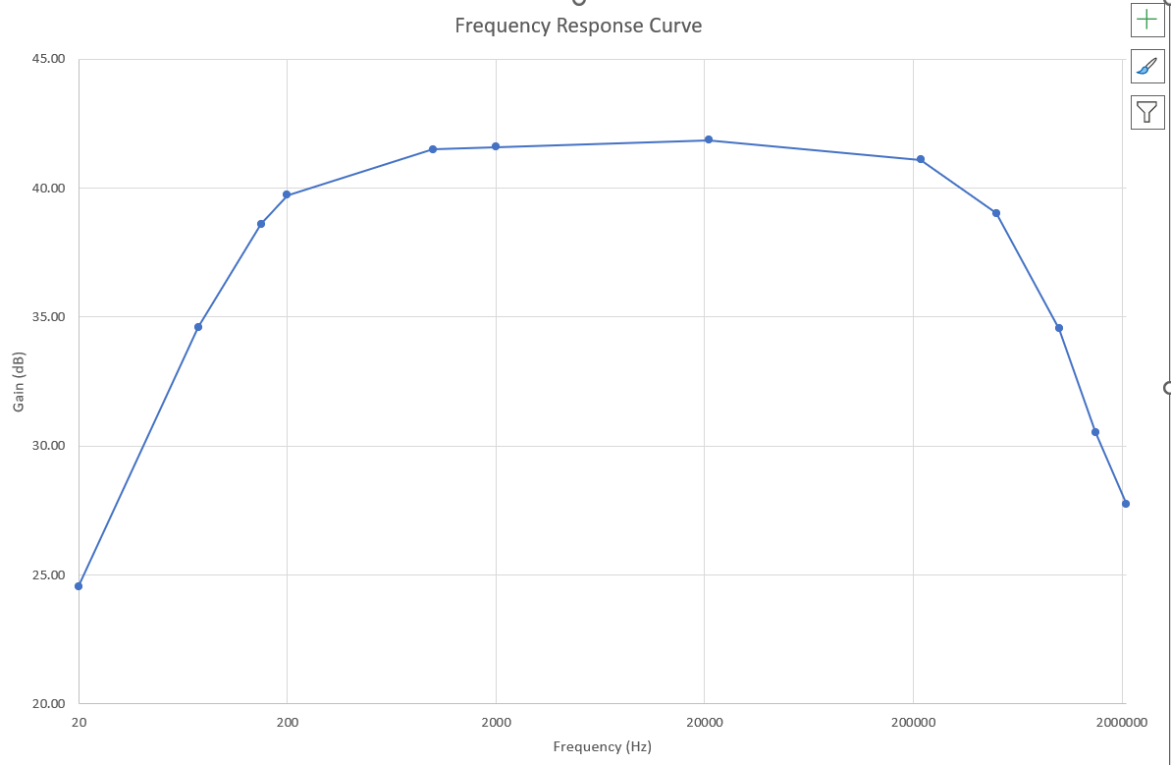
Figure 23 – Frequency Response Curve

Comparison of results:
A variation of results can be seen between Table A and Table B, as well as the differences in gain calculations. One of the main factors in the variating results is the tolerances of the equipment used within the practical. Most of the equipment and components used have a rough tolerance of ± 5-10% which can cause a difference in results. Another factor that can affect the practical results is human error. Human error can be errors such as connecting equipment loosely, taking results at inaccurate times or having wires/components touching. Considering the external factors that are affecting the practical circuit, the results are in a suitable region compared to the simulated results. The simulated results are accurate readings with no external factors implicated.

Task 3 – Non-Inverting Operational Amplifier

The criteria for task 3 is to design and look at the functionality of a non-inverting operational amplifier. Within the circuit a 741 Op-amp is being used in the construction of the circuit. The op-amp is a voltage amplifier that produces a high gain factor within the circuit. An op-amp is also a linear integrated chip that includes multiple terminals. An op-amp is designed to feedback components such as resistors in this circuit, the various legs on the op-amp have various functions. These functions include but are not limited to, non-inverting inputs, inverting input and positive/negative connections. Depending on the value of the supply input, the gain factor will variate and depend on the feedback value as well as the input resistor. The voltage gain will be determined by the open-loop gain of the op-amp. The figure below demonstrates a schematic of a 741 Op-amp.
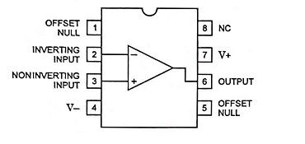

Figure 24 - Schematic of 741 Op-Amp
Construction of a non-inverting amplifier
A non-inverting amplifier is an op-amp circuit with a specific configuration which will produce an amplified output signal with a 0° phase shift. With a non-inverting amplifier, the non-inverting terminal is connected to ground. Due to this the inverting terminal needs to be brought back to ground level. This is to avoid any voltage difference in between the two input terminals. This is achieved through the virtual earth. The virtual earth causes the resistors to form a potential divider. As the inverting terminal is at ground this means the two resistors in the circuit need to also be at ground level. The gain of a non-inverting amplifier can be determined through the following.

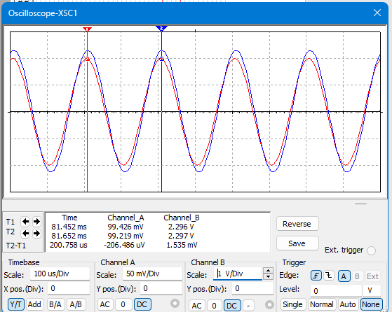
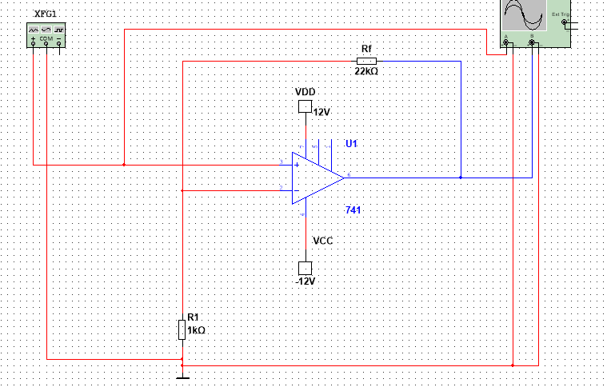
Figure 25 – Non Inverting Op Amp Circuit design from Multisim
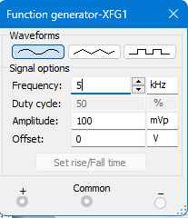

Figure 26 – Oscilloscope reading and Function generator set up for Non Op-Amp circuit.

Figure 25 demonstrates the circuit designed for the non-op-amp circuit, the design consists of the 741 op-amp chip, a 12V power supply as well as a 1kΩ resistor and a 22kΩ resistor. The oscilloscope reading in figure 26 shows the operation of the circuit working with the Waveforms following each other, this is also known as the signals being “in phase”.
The function generator can be described as “a piece of electronic test software or equipment that is used for the purpose of generating various kinds of electrical waveforms over a broad range of frequencies” (Rigol.com, 2021). It is a signal source for the circuit and supplies a known waveform, this is to test how the circuit responds. In circuits that are digital or have switching characteristics, the function generator can produce square waveforms to simulate clock signals or digital inputs. In this circuit the function generator is critical to observe the wave rectification and output voltage characteristics.
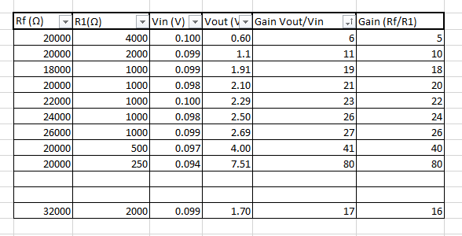
Next a table was created taking various results from the simulated circuit to experiment the effects on the gain.
The table above shows the results taken from the simulated circuit, throughout the experiment, values of R1 and Rf were changed to gather a range of results for the gain. Through taking the range of results, it was discovered that the value for gain can be calculated through the formula of (Rf/R1)+1, this can be seen as an easier alternative to taking values for Vin and Vout as it requires no measurements, using solely resistor values.
The last part of this experiment was to find a gain of 17, this was achieved through performing trial and error tests with different values and using mathematics to calculate that 32,000/2000 = 16, then 16+1 = 17 which was the desired gain. This was achieved by changing the resistors to a 15kΩ and 2x 1kΩ resistors.

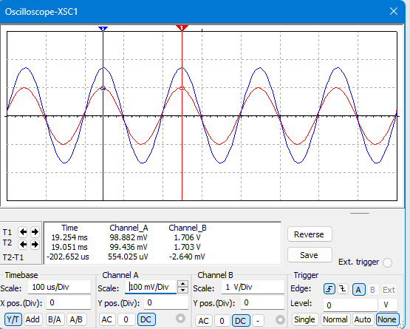
Figure 27 – Oscilloscope representing Gain readings.
From Figure 27, we can see the efficient gain calculation values in Channel A and B. Below is the calculations to confirm the values integrity.
Gain = 17
Gain = (Rf/R1)+1
17-1 = Rf/R1
16 = Rf/R1.

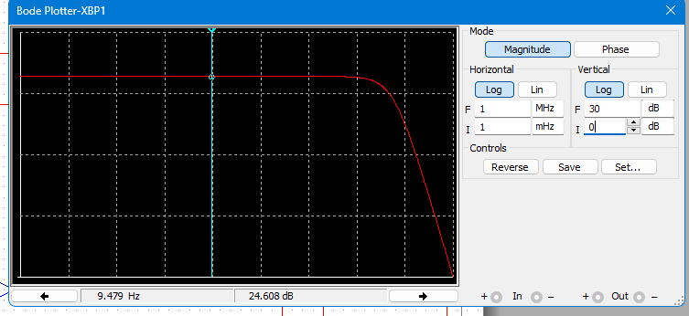
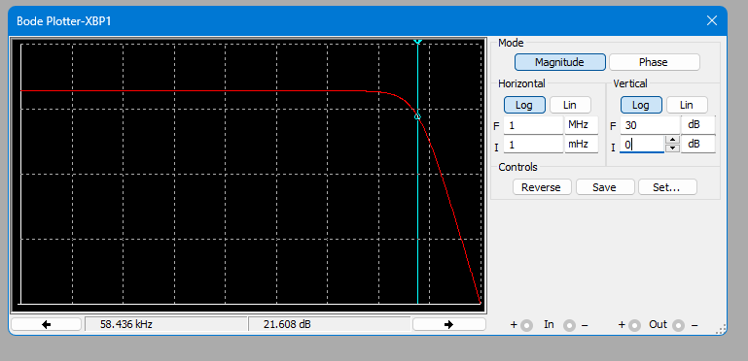
Figure 28 – Bode plotter set up to generate frequency response curve
Figure 29 – Bode plotter set up for Cut off frequency.
In figure 29, the bode plotter is set up at a value 3dB lower than the peak, giving a reading of 58.4kHz for the cut off frequency.
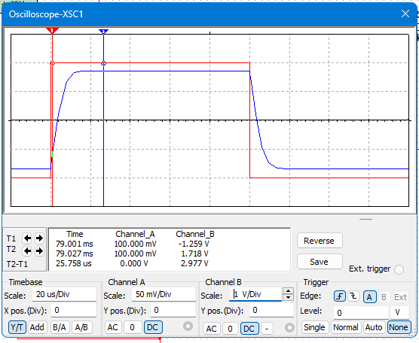
Figure 30 – Oscilloscope reading representing Slew rate.
Figure 30 demonstrates a slew rate within the circuit, this is where the output takes time to follow the input, showing a delay in the waveforms, this is achieved with a frequency of 5kHz. This occurs in the circuit due to the amplifier not being able to respond instantly to the change in input. A good slew rate is key for a functioning amplifier that has quick response times. “The slew rate of an op amp is the maximum rate of change of output voltage following a step input voltage. It causes the output voltage to change at a slower rate that the input. Such that the output waveform is a distortion of the input waveform. 0.5V/µs is a typical value for the slew rate” (Bird, 2007). In our circuit using the 741 chip, the slew rate is at a desired value of 0.5V/uS.
The slew rate is measured in V/µs. It can also be calculated from the equation of
$$Slew Rate=2 x π x Frequency x peak output Voltage$$

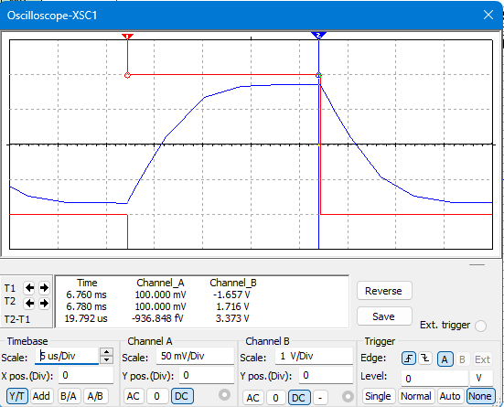
Figure 31 – Slew rate at 25kHz
Figure 31 represents the slew rate more noticeably; this is due to the frequency being at 25kHz.

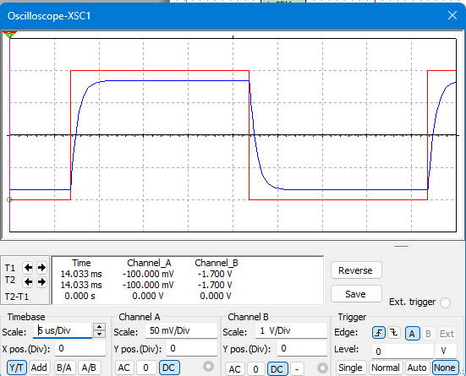

Figure 32 – Slew rate using TL-081 Chip
For experimental purposes, on our designed circuit the chip was changed from a 741 op amp to a TL-081 chip. From this change it there is a change in slew rate from 0.5V/uS to near 13V/uS.
Next a circuit was built to gain various results and test the amplification in relation to the developed circuit.
From creating the circuit, the table below was generating from recording various results, whilst changing the frequency to gather different results for the Gain.
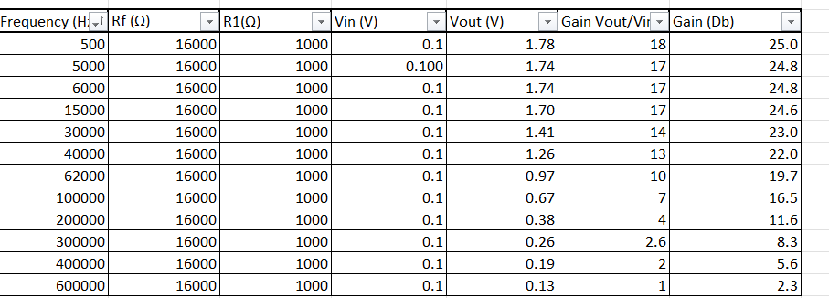
Table presenting results taken from practical circuit.

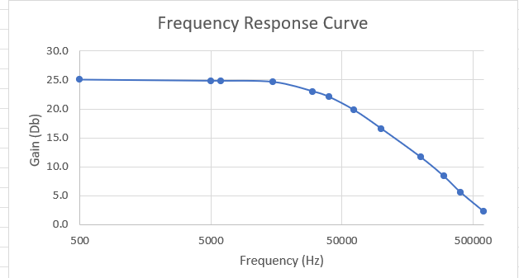

Figure 33 – Frequency response Curve generated from Practical, similar to Bode plotter results.

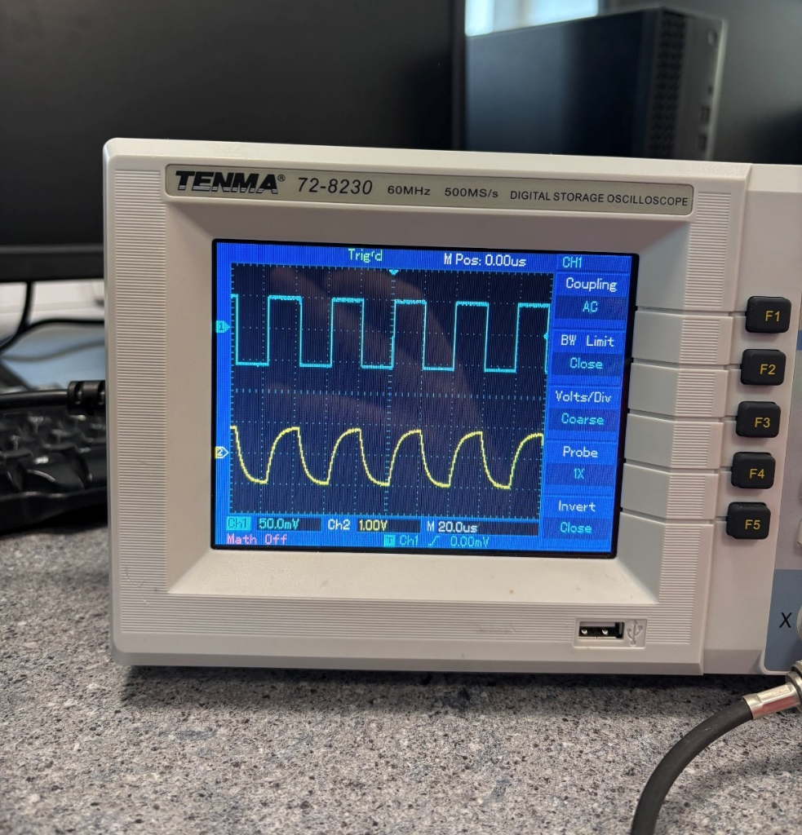
Figure 34 – Oscilloscope connected to physical circuit representing slew rate.

Conclusion of results:
The comparison between the physical and simulated circuit shows the external factors that has a minor impact on the circuit’s performance. In both circuits the trend of the circuits gain decreasing as the input frequency increases aligns and is correct. The practical results closely follow the behaviour predicted by the simulation, providing a reasonable level of validation for the physical circuit's performance.
However, small deviations between the simulated and measured results are expected and can be attributed to several key factors. The components used in the physical circuit typically have tolerances ranging from ±5% to ±10%, introducing variability in resistance, capacitance, and other properties that directly affect circuit behaviour. Additionally, human error during setup and measurement, such as loose connections, timing inaccuracies when recording results, or unintended contact between components this can also impact the accuracy of the results.
Despite these limitations, the practical outcomes fall within an acceptable range of the simulated values, demonstrating that the circuit performs reliably under realistic conditions. In contrast, the simulation provides idealized results, free from manufacturing tolerances, environmental noise, and handling errors. This reinforces the usefulness of simulation tools in the design phase, while also underlining the importance of accounting for real-world imperfections during practical implementation.


Appendix A BC550C Transistor Datasheet

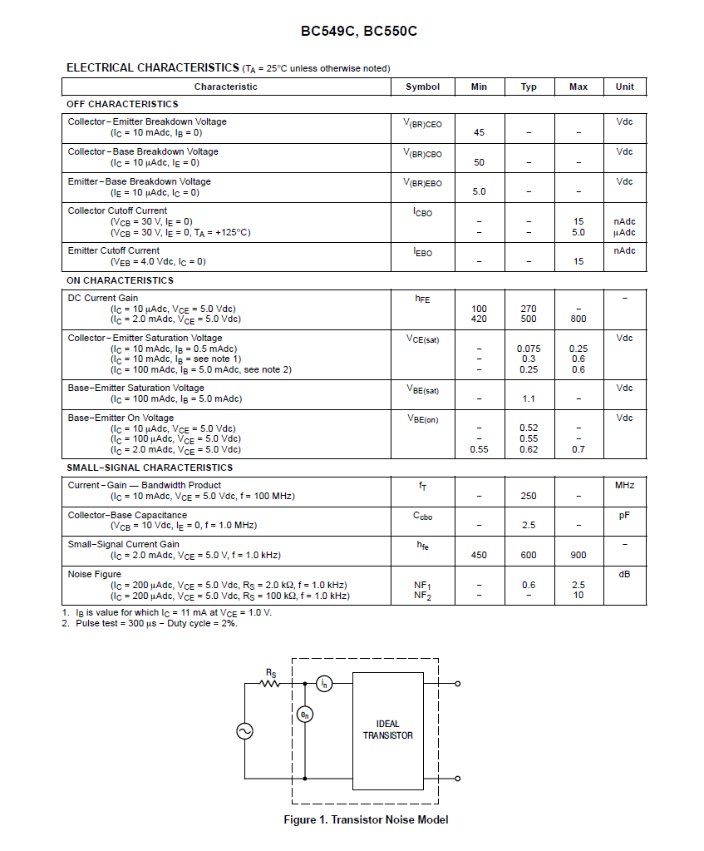

References
- Electrical Technology (2020). What is Diode? Construction & Working of PN Junction Diode. [online] ELECTRICAL TECHNOLOGY. Available at: https://www.electricaltechnology.org/2020/06/diode.html [Accessed 6 May 2025].

- Storr, W. (2013). PN Junction Diode and Diode Characteristics. [online] Basic Electronics Tutorials. Available at: https://www.electronics-tutorials.ws/diode/diode_3.html [Accessed 7 May 2025].

- eeeguide (2022). Op Amp IC 741 Pin Diagram and its Working - EEEGUIDE.COM. [online] EEEGUIDE.COM. Available at: https://www.eeeguide.com/op-amp-ic-741-pin-diagram-and-its-working/ [Accessed 16 May 2025].

- ‌ Rigol.com. (2021). What does a function generator do?-RIGOL Technologies, Co. Ltd. [online] Available at: https://int.rigol.com/news/blog/117#:~:text=This%20is%20a%20piece%20of,square%20wave%2C%20and%20sine%20wave. [Accessed 16 May 2025].
- ‌
- John Bird (2007). Electrical and Electronic Principles Third Edition. Elsevier Ltd. [Accessed: 14/01/2021]

Bibliography

- Electrical Technology (2020). What is Diode? Construction & Working of PN Junction Diode. [online] ELECTRICAL TECHNOLOGY. Available at: https://www.electricaltechnology.org/2020/06/diode.html [Accessed 6 May 2025].

- ‌ R. Rajeswari, Venugopal, D., George, A. and Raj, A.D. (2020). Design, construction and performance of P-N junction diode prepared with FeTiO2 thin films. Materials Letters, [online] 281, pp.128604–128604. doi:https://doi.org/10.1016/j.matlet.2020.128604.

- ‌CADENCE PCB Solutions. (2025). PN Junction Reverse Bias versus Forward Bias and Their Functional Characteristics. [Online]. Resources - PCB CADENCE. Available at: https://resources.pcb.cadence.com/blog/2020-pn-junction-reverse-bias-versus-forward-bias-and-their-f [Accessed 7 May 2025].

- Storr, W. (2013). PN Junction Diode and Diode Characteristics. [online] Basic Electronics Tutorials. Available at: https://www.electronics-tutorials.ws/diode/diode_3.html [Accessed 7 May 2025].

- Sproul, A. (n.d.). Understanding the p-n Junction. [online] Available at: https://cmapspublic.ihmc.us/rid=1N205BSVD-V7C7GN-4LV0/UNSW_Understanding_the_p-n_Junction.pdf.

- ‌ Rigol.com. (2021). What does a function generator do?-RIGOL Technologies, Co. Ltd. [online] Available at: https://int.rigol.com/news/blog/117#:~:text=This%20is%20a%20piece%20of,square%20wave%2C%20and%20sine%20wave. [Accessed 16 May 2025].
- ‌
- John Bird (2007). Electrical and Electronic Principles Third Edition. Elsevier Ltd. [Accessed: 14/01/2021]

- ‌

