

Programme: Certificate of Higher Education Employability Skills
Module: Academic Skills for the Digital Era (BMSW4013)
Part 2

Name: Tomas Bagi
Student Number: 2322589
Total word count: 1500
Gibbs’ reflective cycle
One well-liked paradigm for introspection is Gibbs' reflective cycle. The paradigm, which is outlined below and is referenced in Dye (2011, p. 230), consists of six stages of reflection.
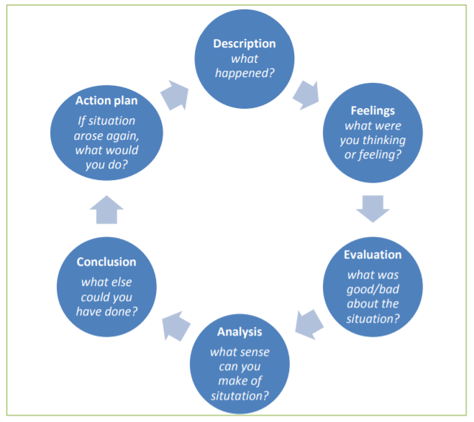
Dye, V. (2011) ‘Reflection, Reflection, Reflection. I’m thinking all the time, why do I need a theory or model of reflection?’, in McGregor, D. and Cartwright, L. (ed.) Developing Reflective Practice: A guide for beginning teachers. Maidenhead: McGraw-Hill Education (pp. 217-234).

Description
The reflection focuses on a challenging incident that occurred during the first few weeks of my employment as a warehouse supervisor. The situation involved an escalating conflict with a colleague, which ultimately resulted in a physical altercation. The tension escalated when the colleague openly challenged my decisions in front of the team, leading to a heated argument. The conflict intensified, resulting in a physical confrontation that disrupted the workflow and affected team morale. Early in my tenure at the company, I encountered a colleague who consistently undermined my authority and was openly disrespectful. This behaviour manifested in various forms, including dismissive comments, refusal to follow instructions, and deliberate attempts to sabotage my efforts to streamline warehouse operations. Despite my attempts to address the situation through calm and constructive dialogue, the colleague's behaviour did not improve.

Feelings
At the Time:
Initially, I felt a mix of anxiety and frustration when the colleague began undermining my authority. Being new to the role, I was eager to establish myself as an effective leader and maintain a positive work environment. The colleague’s persistent disrespect challenged my confidence and created a significant amount of stress. During the heated argument, I experienced a surge of anger and helplessness as the situation escalated beyond verbal conflict. The physical altercation compounded my feelings of inadequacy and embarrassment, as I felt that I had failed to manage the situation professionally.
Immediate Thoughts:
In the moment, I was preoccupied with how to defend my position and regain control of the situation. I focused on asserting my authority, which, in hindsight, may have intensified the conflict rather than resolving it. My immediate thoughts were centred on how to quickly address the disruptive behaviour and restore order in the workplace. I was concerned about the impact of the incident on my reputation and the team's perception of my leadership abilities.
Afterwards:
Reflecting on the situation after the fact, I recognized that my approach to handling the conflict was not as effective as it could have been. I realized that my initial reaction to assert authority and engage in confrontation may have contributed to the escalation of the situation. I felt regretful and disappointed, not only about the physical altercation but also about the way I managed the conflict

Evaluation
My initial reaction to the conflict, marked by an aggressive assertion of authority, proved ineffective and counterproductive. Conflict resolution theories indicate that such an approach typically escalates disputes rather than resolving them (Thomas, 2006). Fisher and Ury (1981) note that confrontational methods can intensify antagonism, which was apparent as hostility escalated.
The physical altercation created a hostile environment, disrupting team cohesion and reducing morale. Tuckman’s stages of group development (1965) suggest that such conflicts can obstruct the "norming" and "performing" stages, adversely affecting team productivity and relationships.
On the positive side, the incident underscored the need for a more measured approach to conflict management. It highlighted the significance of professionalism and emotional intelligence, as discussed by Goleman (1995). This realization has led me to adopt more constructive techniques, such as active listening and empathetic engagement.
Conversely, the escalation to physical conflict damaged team morale and my professional credibility. The failure to manage the conflict non-confrontationally underscored the need for improved conflict resolution skills, aligning with Rahim’s (2011) view that effective conflict management requires balancing assertiveness with cooperativeness.
The unresolved tension and ongoing issues emphasize the importance of proactive conflict management strategies for maintaining a productive work environment (Deutsch, 1973).

Analysis

In reflecting on the conflict, several factors that both hindered and helped the situation emerge clearly. Initially, my reactive approach to the conflict significantly hindered resolution. According to Thomas (2006), reactive responses often escalate tensions rather than addressing the root causes. My aggressive assertion of authority, without first seeking to understand the colleague's perspective or attempting mediation, contributed to the escalation rather than mitigating it.
Additionally, the lack of effective communication was a significant hindrance. Fisher and Ury (1981) stress the importance of clear, respectful dialogue in conflict resolution. My communication, marked by frustration and defensiveness, likely aggravated the situation rather than fostering constructive dialogue. This ineffective communication approach further impeded the resolution process.
Another hindrance was my inadequate conflict resolution skills. Rahim (2011) emphasizes the need for a balance between assertiveness and cooperativeness. My failure to apply these strategies effectively limited the resolution process, leading to a negative outcome.
On the positive side, the experience highlighted the importance of emotional intelligence. Goleman (1995) argues that self-awareness and self-regulation are crucial for managing conflicts. This realization prompted me to focus on maintaining composure and empathy in similar situations, improving my conflict management approach.
Furthermore, the incident underscored the critical role of leadership in managing team dynamics. Tuckman’s stages of group development (1965) highlight the importance of effective leadership in guiding a team through the "storming" phase. The experience provided valuable insights into how leadership impacts team cohesion and productivity, offering lessons for future practice.
Comparing my experience with the literature reveals that a collaborative approach is often most effective in resolving conflicts (Deutsch, 1973). My confrontational approach, characterized by dominance and aggression, did not align with this theory. Adopting a more collaborative style involving negotiation and compromise could have fostered a more positive outcome. Additionally, Goleman’s (1995) work on emotional intelligence emphasizes managing one’s emotions in conflict situations, contrasting with my initial failure to manage emotions effectively. Lastly, Thomas (2006) advocates for a proactive approach to conflict management, including early intervention and preventive strategies. My reactive responses, rather than proactive measures, contributed to the conflict's escalation, highlighting the need for a more proactive conflict management approach.

Conclusion
Reflecting on the incident reveals several key areas for improvement. Initially, my reactive and confrontational approach was ineffective in resolving the conflict. A more strategic method, including early intervention, clear communication, and mediation, could have prevented the escalation and led to a more positive resolution. According to Thomas (2006), a proactive conflict management strategy that focuses on understanding and addressing the root causes through collaboration is crucial. Adopting such strategies might have mitigated the negative outcomes.
The experience highlighted the importance of emotional intelligence and effective communication in conflict resolution. Maintaining composure, actively listening, and addressing underlying issues are essential for resolving conflicts constructively, aligning with Goleman’s (1995) emphasis on emotional intelligence. The need for stronger conflict resolution skills and a more collaborative approach to leadership became evident.
Had I approached the situation with a focus on mediation and collaboration instead of confrontation, the outcome could have been more favorable. Utilizing conflict resolution frameworks and involving a neutral third party might have facilitated a more constructive dialogue, adhering to Rahim’s (2011) principles of balancing assertiveness with cooperativeness.
To prevent similar issues in the future, I plan to develop proactive conflict management strategies, enhance communication skills through training, and attend conflict resolution workshops as recommended by Stewart (2023).

Action Plan
1. Acquire Conflict Management Training:

To enhance my conflict resolution skills, I will enroll in conflict management workshops and online courses. These programs will provide practical techniques for addressing disputes constructively. Additionally, I will consult with my mentor or supervisor to identify recommended training resources tailored to my needs. I plan to complete this training within the next 3 months.

2. Develop Emotional Intelligence:

Improving my emotional intelligence is crucial for managing conflicts and understanding others' perspectives. I will attend seminars focused on emotional intelligence and engage with literature such as Goleman’s Emotional Intelligence: Why It Can Matter More Than IQ (1995). Regular self-reflection will help me manage my emotions and enhance empathy. I aim to start this process immediately and continue it over the next 6 months.

3. Improve Communication Skills:

Effective communication is vital for resolving conflicts. I will participate in workshops to refine my communication skills, including active listening and providing constructive feedback. I will also practice these skills in daily interactions and seek feedback from colleagues and supervisors to identify areas for improvement. Initial workshops will be completed within 3 months, with ongoing practice.

4. Develop Proactive Conflict Management Strategies:

I will create a conflict management plan that includes early identification of potential conflicts, mediation methods, and resolution steps. Setting up regular team meetings will help address issues proactively before they escalate. I plan to develop this plan within 2 months and implement it immediately thereafter.

5. Seek Regular Feedback and Support:

Regular feedback from my supervisor and joining professional networks will provide guidance and support. I will schedule monthly meetings with my supervisor to discuss progress and challenges, and actively engage in professional groups for additional insights. These activities will commence within the next month.

By following this action plan, I aim to improve my conflict management abilities, enhance emotional intelligence, and foster a more positive work environment.

References
Dye, V. (2011) ‘Reflection, Reflection, Reflection. I’m thinking all the time, why do I need a theory or model of reflection?’, in McGregor, D. and Cartwright, L. (eds.) Developing Reflective Practice: A guide for beginning teachers. Maidenhead: McGraw-Hill Education, pp. 217-234.
Deutsch, M. (1973) The Resolution of Conflict: Constructive and Destructive Processes. New Haven: Yale University Press.
Fisher, R. and Ury, W. (1981) Getting to Yes: Negotiating Agreement Without Giving In. New York: Penguin Books.
Goleman, D. (1995) Emotional Intelligence: Why It Can Matter More Than IQ. New York: Bantam Books.
Rahim, M.A. (2011) Managing Conflict in Organizations. New Brunswick: Transaction Publishers.
Thomas, K.W. (2006) Conflict and Conflict Management: Reflections and Update. Journal of Organizational Behavior, 27(3), pp. 269-285.
Tuckman, B.W. (1965) ‘Developmental Sequence in Small Groups’, Psychological Bulletin, 63(6), pp. 384-399.
Stewart, J. (2023) Personal Development for Professional Growth. London: Sage Publications.
Stewart, J. (2023) Effective Communication and Leadership Development. New York: McGraw-Hill Education.

