

The Court System: Public Perception on Sentencing, is it impacting upon community trust?

Ashleigh Bourne
Learner Number – 2236404
January 2025
BSc (Hons) Professional Policing Practice
Word Count – 7, 529

Acknowledgements

I would like to express my gratitude to my colleagues, whose insights, encouragement, and collaboration have greatly enriched my research and professional growth. Their willingness to share ideas, challenge me and provide constructive feedback has been invaluable throughout this journey.
I am also thankful to my friends, who have supported me with patience, humour and understanding during the most demanding stages of my career and academic studies. Your encouragement outside of academia has been constant and a source of strength and perspective.
Finally, I owe my greatest thanks to my nearest and dearest, my family. Your unwavering love, sacrifice and belief in me have been second to none. Without your constant support none of this would have been possible.

Declaration
This work has not previously been accepted in substance for any degree and is not being concurrently submitted in candidature for any degree.
Signed: A.Bourne
Date: 10/01/2025

STATEMENT 1
This dissertation is being submitted in partial fulfilment of the requirements for the degree of BA.
Signed: A.Bourne
Date: 10/01/2025

STATEMENT 2
This dissertation is the result of my own independent work/investigation, except where otherwise stated.
Other sources are acknowledged by footnotes giving explicit references. A bibliography is appended.
Signed: A.Bourne
Date: 10/01/2025

STATEMENT 3
I hereby give consent for my dissertation, if accepted, to be available for photocopying and for interlibrary loan, and for the title and summary to be made available to outside organisations.
Signed: A.Bourne
Date: 10/01/2025

STATEMENT 4
I hereby give consent for my dissertation, if accepted, to be available on the university’s IT system to those who have consent to use the system.
Signed: A.Bourne
Date: 10/01/2025

Abstract

This dissertation investigates how the public views sentencing in the legal system and whether or not these views have an impact on community trust levels. Public debate has historically centred on sentencing, which is frequently influenced by political rhetoric, media coverage, and personal encounters with the legal system. This study examines how the public perceives the consistency, fairness, and openness of sentencing decisions using both qualitative and quantitative data. According to the findings, opinions about how severe or lenient a case is can have a big impact on people's trust in the legal system, which can have wider repercussions for societal cohesiveness and legitimacy. This study adds to current debates over accountability, transparency, and the function of courts in preserving public faith in the legal system by highlighting important elements that influence public trust.
Table of Contents
Acknowledgements 2
Declaration 2
Abstract 3
Chapter One : Introduction 5
Chapter Two : Literature Review 6
2.1 Public Understanding and Misconceptions of Sentencing 6
2.2 To explore the Public Perception on Sentencing within the Courts 7
2.3 To Explore Public Perception on Sentencing and Sentencing Within the Courts 8
2.4 To Identify if Public Perception on Sentencing is Impacting Upon Community Trust Towards the Police 9
2.5 Ways to improve the public perception on sentencing and the link to police and their trust within 10
2.6 Summary 12
Chapter Three : Methodology 13
3.1 Introduction 13
3.2 Research Method 13
3.3 Ethical Practice 14
3.4 Informed Consent 15
3.5 Sampling 15
3.6 Limitations 15
Chapter Four : Analysis of Results 16
4.1 Introduction 16
4.2 Questionnaire Results 16
Chapter Five : Findings and Conclusions 22
5.1 Introduction 22
5.2 Objective 1: Public Perception on Sentencing within the Courts 23
5.3 Objective 2: Public Perception of Sentencing and Community Trust in the Police 24
5.3 Objective 3: Improving Public Perception of Sentencing and Trust in the Police 25
Chapter Six : Recommendations 26
6.1 Recommendation One: Enhance transparency of sentencing 26
6.2 Recommendation Two: Expand public education initiatives 26
6.3 Recommendation Three: Ensure greater consistency and fairness 26
6.4 Recommendation Four: Align police and court communication 26
Chapter Seven : Bibliography 27
Chapter Eight : Appendix 31
8.1 Questionnaire 31
8.2 Ethics Form 35
8.3 Research Proposal 51

Chapter One : Introduction

The purpose of this essay will be to discuss and investigate the court systems and what the public perception is on the sentencing that is set out and how that has an impact of the public trust within the Criminal Justice system.
The Criminal justice system is critical in preserving the rule of law, keeping and tackling public order and delivering justice. At the centre of this system is the sentencing, the procedure by which the court assess the sentencing that is reasonable for each offender. However, the public view of sentencing judgements has grown, with questions being raised as to whether the sentences that are being given are seen as fair, consistent and reflective of the community ideals (Roberts, 2003). The perceived validity of sentencing method can considerably influence levels of public faith in the justice system overall (Tyler, 2006).
According to research, public trust is essential for an effective and lawful justice system (Hough and Sato, 2011). When the public sentencing judgements as being unduly lenient or excessively harsh, it can diminish the trust in the system’s ability to provide justice and safeguarded society (Craig, Gannon and Dixon, 2013). This is especially apparent in media representations and political debate, which frequently reinforce popular displeasure and encourage a punitive approach, independent of real sentencing trends (Cunneen, Goldson and Russell, 2017).
This dissertation investigates the link between public perceptions of sentencing and public faith in the criminal justice system. It will look to explore the public perception on sentencing within the courts and to identify if public perception on sentencing is impacting on community trust towards the police, I will look to identify ways that can improve the public perception on sentencing and the link to police and their trust within.

Chapter Two : Literature Review

The goal of this chapter is to analyse how the public view sentencing in the legal system and how it affects the community trust. This section will then address the following objectives:
- To explore the public perception on sentencing within the courts
- To identify if public perception on sentencing is impacting upon community trust towards the police
- To identify ways to improve the public perception on sentencing and the link to police and their trust within.
Any criminal justice systems legitimacy depends on both its capacity to uphold the law and the level of public faith within it. As a very evident representation of justice, sentencing is crucial in establishing that trust. The literature shows that how sentencing judgements are seen, especially regarding fairness, transparency and proportionality, affects the public trust in the systems and the police service. The scholarly debate about how the public views sentencing and how these views affect legitimacy in institutions and public trust is examined in this section.

2.1 Public Understanding and Misconceptions of Sentencing

The discrepancy between the public beliefs and the actual sentencing methods is highlighted in a large body of literature. According to Roberts and Stalans (2019), the majority of people have little to no knowledge of sentencing guidelines, frequently as a result of relying more on the media that on factual information. According to research by Gelb and Sentencing (2006), when the public is polled regarding sentencing in an abstract way, they frequently think that punishments are too light; yet when given thorough case studies, they are more likely to support the judges’ rulings. This highlights that the public don’t have an understanding of the Criminal justice system nor how sentencing works. This research could be considered as outdated as however there is no current research that undermines or contradicts this, therefore still making it relevant.
A recent study shows from (Justice Committee, 2022) shows that the public biassed and inadequate understanding of sentencing trends is demonstrated by the systematic underestimating of the harshness of existing practices. Based on this study it shows that the sentences are too light. Misconceptions about the typical prison term then influence sentencing and sentencing opinions. The Sentencing academy poll (2021) found that respondents who believed that sentencing was “much too lenient” were much less accurate in estimating sentencing practices than those who believed that sentencing was about appropriate. In particular, supporters of harsher penalties tended to under vale the current usage of imprisonment (Roberts et al., 2022).
In 2021, respondents to a survey conducted by (Roberts et al., 2022) were asked if they thought sentencing was appropriate, too light or too harsh. About two – thirds (65%) of those surveyed agreed that the penalty was too light, Excluding the ‘don’t know’ responses increase the percentage of respondents who chose this perspective to 76%; these results are largely consistent with the British crime survey from 1966. According to a survey conducted by (Clark, 2020), these results are consistent as 70% of the public believe that sentencing is not harsh enough.
The above research outlines that the general public do not have an understanding of how sentencing works and the majority believe the sentences provided to defendants aren’t harsh enough.

2.2 To explore the Public Perception on Sentencing within the Courts

The perception that the public have on the courts is crucial to the legitimacy and effectiveness in the prevention of crime. Surveys indicate that how the public trust in the judicial system is relatively high, but there are worries about sentencing leniency and inconsistency (Hough and Roberts, 2005). The media and social platforms frequently have an influence on the public perceptions towards the court. Sensationalised coverage of high-profile cases can give the impression that sentencing is excessively lenient, despite evidence that courts normally impose adequate punishments (Marsh and Melville, 2014). The sentencing council have worked to increase transparency by publishing the guidelines and communicating with the public so that they have an idea as to what the advice is when sentencing for offences (Sentencing Council, 2022).
In addition, it could be argued that the language or wording used in sentencing is unclear. Although many people think they understand phrases like “life sentence” and “on license”, qualitive discussions show that real comprehension is frequently lacking. This discrepancy emphasis how important it is to communicate sentencing guidelines and results more clearly. The same as people do not understand what probation is and how this has an influence on sentencing and prison times.
The public’s perspective of the court system’s effectiveness is an important aspect in determining its legitimacy and authority. A study that examined data from the Crime survey for England and Wales (CSEW) investigated how demographic factors and person experience with crime influence the trust that people have in the system. The findings indicate that perceptions of fairness and success range among population groups, empathising the necessity for the justice system to address these disparities to preserve public trust (Morales-Gomez and Associate, 2020).
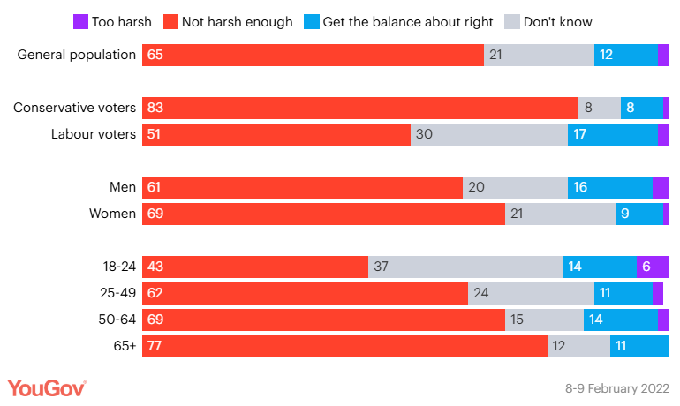
A recent survey from Kirk (2022) shows that most of the public being 65% believe that the sentencing for criminals is “not harsh enough” whereas 2% believe it is “too harsh”. This impression influences political and judicial policy, with a preference for harsher punishments over evidence-based rehabilitative strategies.
Table 1 - (Kirk, 2022)

2.3 To Explore Public Perception on Sentencing and Sentencing Within the Courts

Instead of firsthand experience, the public's perception of sentencing is frequently influenced by incomplete facts and media narratives. There is a persistent disparity between sentence facts and public perceptions, according to research. According to Ashworth and Roberts (2013), a lot of people think that judges' punishments are too light, especially when they involve violent offences. However, the public's preferences for sentence more closely resemble judges' when they are given complete facts of actual cases (Gelb and Sentencing, 2006).
One of the main problems is that the public is unaware of the process used to determine sentences. According to Wood and Gannon (2011), the general public does not fully comprehend sentencing guidelines, complex legal reasoning, or aggravating or mitigating factors. When sentences are perceived to deviate from public expectations or media representations, this information gap exacerbates feelings of injustice or contradiction. It is impossible to ignore how the media shape’s public opinion. Morgan, Reiner and Maguire (2012) contend that a distorted perception of court leniency can result from the mass media's frequent framing of sentencing decisions as insufficient, particularly in high-profile criminal cases. Public pressure for harsher penalties and a decline in confidence in judicial discretion can result from this "penal populism" (Pratt, 2007).

2.4 To Identify if Public Perception on Sentencing is Impacting Upon Community Trust Towards the Police

Although the judiciary makes sentencing choices, the police is the first step in a larger justice process. Since the police are frequently viewed as the face of justice, opinions about them may change if people believe that the courts are unfair, especially when it comes to sentencing (Bradford, 2017). Police trust is significantly impacted by how the public views sentencing. The public's trust in law enforcement's capacity to uphold order may be weakened if they perceive the legal system to be forgiving. According to the Justice (2013), members of the public’s experiences of crime and interactions with the police were important indicators of confidence in the CJS and the police.
Furthermore, the Justice Committee's report (2022), made clear that public perception of punishment has an impact on trust in the Criminal justice system. The study underlined that increased openness and communication regarding sentencing may boost public confidence. Demographic groupings differ in how they view sentence and police trust. According to a 2022, study by the Sentencing Council, Asian adults and adults under the age of 54 were more likely to believe that the Criminal justice system was effective.
However, compared to women and Black adults, men and White and Asian adults were more likely to believe it was fair. These variances show that cultural, societal, and personal experiences influence perceptions and trust levels. Comprehending these distinctions is essential for formulating focused tactics to enhance public trust in the legal system and law enforcement Rice and White (2010) contend that there is a reciprocal relationship between faith in legal authorities like the courts and the perception of the police as being unjust, particularly in neighbourhoods where there are longstanding grievances. This is particularly true in ethnic minority and marginalised communities, where experiences of under protection and over policing can exacerbate mistrust (Bowling and Phillips, 2002; Lammy, 2017).
Beliefs that the entire system, from the police to the courts, is biassed are strengthened by perceived sentencing inequalities, such as harsher terms for minority criminals. According to procedural justice theory, perceived fairness of procedures as well as results are key components of trust in institutions (Tyler, 2006). The public may believe that the system, including the police, lacks legitimacy and fairness if they believe that the courts are not producing just results, whether because of perceived leniency or severity (Jackson et al., 2012). There are connections between the different elements of the Criminal Justice System (CJS) and trust. Trust in law enforcement may suffer as a result of unfavourable opinions about sentencing. When communities regard the courts as lenient or inconsistent, they may question the efficacy of police initiatives, leading to decreasing collaboration and involvement.
Only 40% of English citizens trust their police force, according to a 2024 survey, with the Metropolitan Police scoring the lowest. Between July 2022 and September 2023, the study, which was published in the journal Policing and Society, polled more than 8,000 people in nine different districts of England. It was discovered that trust was especially low in London, where public confidence has been damaged by high-profile scandals involving the Metropolitan Police, and among ethnic minorities. (Dodd, 2024).

2.5 Ways to improve the public perception on sentencing and the link to police and their trust within

A report conducted by the Ministry Of Justice (2013), they highlight that transparent communication about sentence decisions should be a top priority for the criminal justice organisations and judicial organisations. Sentencing procedures can be made more understandable by interacting with communities through open forums, educational resources, and candid discussions. This kind of openness can clear up misunderstandings and increase confidence among the public, the legal system, and law enforcement.
It is essential to increase public awareness of sentencing procedures. The knowledge gap can be closed through educational activities including adding sentencing education to school curricula and making resources easily accessible online. Justice Committee (2022) suggests creating initiatives that educate people about sentencing in order to promote educated public debate and boost confidence in the legal system
Hewson (2025) states that by requiring an annual statutory report on sentencing, Parliament and the government are held more accountable for the resource consequences of the sentencing policies they propose or implement and enhance the Sentencing Council's mandate to increase public knowledge of sentencing.
Resource-related issues might be the first to be addressed. Although no organisational reform is free, it is not always costly to improve the quality of relationships in interactions with the general public. The use of good leadership is more effective in bringing about changes in policing and justice delivery methods than either training or re-engineering formal procedures. Police chiefs and court administrators must make it very evident to their staff that upholding procedural justice is a fundamental aspect of their jobs. Making sure that internal management genuinely commands legitimacy in the eyes of the workforce is a crucial component of this communication process. Police and Crime Commissioners may play a significant role in making sure that system legitimacy and procedural justice receive enough attention.
It is crucial to take steps to remedy perceived inequities in sentencing, such as applying uniform criteria and taking mitigating circumstances into account. The legitimacy of the legal system can be improved by making sure that sentencing procedures are fair and representative of society's values. Moreover, admitting and addressing cases where punishment may have been influenced by biases can reinforce public confidence (Justice Committee, 2022b).
Police personnel frequently voice their dissatisfaction with the results of sentence, particularly when repeat criminals are involved. When expressed publicly, these opinions have the power to sway public opinion. Aligning police communication with judicial message can be achieved by pushing police officials to advocate for transparency and provide justifications for punishment (Reiner, 2016).
Engaging local communities through citizens’ sentencing panels or public forums can enhance perceptions of inclusiveness and accountability (Marder, 2016). These initiatives promote dialogue and reduce the distance between judicial authorities and the communities they serve.

2.6 Summary

The important connection between public opinion of punishment and police trust has been examined in this literature review, emphasising how these interrelated factors influence public trust in the criminal justice system. Public discontent with sentencing, which is exacerbated by perceived structural injustices, a lack of transparency, and media misrepresentation, leads to a deterioration in public confidence in both the legal system and law enforcement.
Therefore, efforts to change public opinion must be multifaceted. The public must be educated about sentencing procedures, structural inequities must be addressed, and transparency must be increased through easily accessible information and open justice efforts. Promoting alternatives to jail time, such visible community-based sanctions and restorative justice, can also help to match justice objectives with public expectations.
Most significantly, re-establishing confidence necessitates a collaborative approach that bridges the gap between courts and law enforcement. When both institutions communicate effectively and act publicly within a framework of fairness, accountability, and inclusiveness, the public perceives them as having a shared legitimacy. Finally, boosting public knowledge and confidence in sentencing is not merely a judicial concern—it is fundamental to restoring long-term trust in the entire criminal justice system.
Some of the academia founded within this section is notably old. This is because of there not being any current and up to date research in this area.

Chapter Three : Methodology

3.1 Introduction

This chapter describes the approach taken to look into the connection between public trust in the criminal justice system and how the public views sentencing. The chapter discusses ethical issues and possible constraints, provides an overview of the data gathering and analysis procedures, and defends the selected study design. The main goal is to collect empirical data on public perceptions of sentencing decisions and whether these perceptions have a quantifiable impact on public confidence in the legal system.
The research addresses the following objectives:
- To explore the public perception on sentencing within the courts
- To identity if public perception on sentencing is impacting upon community trust towards the police
- To identify ways to improve public perception on sentencing and the link to police and their trust within.

3.2 Research Method

A cross-sectional, quantitative survey design was chosen in order to capture numerical data at one particular moment in time. Large-scale views and opinions can be examined with this method, which makes statistical analysis easier to investigate trends and connections (Saunders, Lewis & Thornhill, 2019). The selection of questionnaires was based on their usefulness, affordability, and capacity to reach many people with little interviewer bias.
As part of my research, questionnaires are the main tool used to collect data. They are generally accepted as effective instruments for collecting information from sizeable groups, and they are particularly helpful in gauging attitudes, beliefs, and opinions (De Vaus, 2014). Additionally, the anonymity of questionnaires promotes truthful answers, especially when discussing delicate subjects like opinions on criminal justice.
Questionnaires are easily accessible, and participants can complete this at a time that is suitable and comfortable for them. This will achieve the best evidence and allow the participant to complete the survey anonymously and they can share their opinion without having to worry that the reader can link it back to them. Both open-ended and closed-ended questions are used in questionnaires, which can be advantageous because it yields both quantitative and qualitative data. Whereas a closed-ended question can only be answered with a yes, no, or don't know response, an open-ended question demands additional consideration (Kuphanga, 2024).
The goal of quantitative research is to explain phenomena by collecting numerical data that are analysed using mathematically based methods, in particular statistics (Lim, 2024). It uses sampling techniques and online surveys, polls, and questionnaires to collect data from current or potential clients; the results can be expressed as numerical data (Fleetwood, 2023).
Compared to qualitative data, information is collected from a broader population and is much more structured. This type of research reveals various attitudes, beliefs, and actions, and by comparing them, it is possible to determine the answer to the question. Results from a questionnaire will be discussed using quantitative research. Tables and graphs comparing responses to each question will be included with the data.

3.3 Ethical Practice

When conducting my research, It was ensured that the research did not deviate away from the ethical standards required. Ethical permission is necessary before any study can begin to guarantee that cany research involving human participants conforms with the demanding rules and guidelines that are in place (Research Ethics Committee, 2016). This is granted through an ethical form which is put before a committee to review and assess before the study commences. The ethical consent form detailed how the study would be carried out. This would entail questionnaires, the location of the study, who and why I am engaging certain participants, how the data is going to be stored and how confidentially is going to be maintained. It is the researcher’s duty to always conduct research with the highest integrity and transparency (Antes and Maggi, 2021).
Participants first received an information sheet and consent form before accessing the questionnaire through a link. Anonymity was guaranteed, and participation was entirely optional (Cleave, 2021).

3.4 Informed Consent

To ensure all ethical guidelines are adhered to, at the beginning of my survey there was a disclaimer which informed participants about how their responses will be stored (Central Digital and Data Office, 2020). Participants were cautioned by the survey and the disclaimer stating they could only participant if they were over the age of 18. They were also provided with a disclaimer at the start of the survey and they were informed that they could leave anytime. They were told the aim of the study and how their responses were stored on a password protected device to avoid any leaks in the information.

3.5 Sampling

Participants of the survey will be general members of the public. To get a variety of viewpoints and create a solid analysis of the findings, I want to gain 30 members of the community to complete my questionnaire. This will ensure that my results are from a variety of people who may have been involved in the criminal justice system and people who don’t have as much knowledge of the criminal justice system or are not involved in any way.

3.6 Limitations

I've given considerable thought to the restrictions or difficulties I might face whilst handing out my questionnaire. Participants may believe they are pressed for time, which could affect how much information I am able to collect. Time restrictions, which most police officers struggle to find, because of the demands of their jobs today, they may struggle to find a convenient time to answer the questionnaire and answer it well. An additional disadvantage of employing a questionnaire is that participants may be less likely to provide truthful answers to open-ended questions, both because of time limits and because they don't want to be perceived as different. As this question is going to be handed out to general members of the public, it bears the risk that people won’t answer the survey truthfully as it doesn’t mean anything to them, and it isn’t going to change anything whether they provide their opinion or not.
Digitally disconnected people may not be able to participate in an online approach, but this issue was lessened by offering physical copies of the questionnaire in police stations around the force which were readily available for people who are less accustomed to the online world.

Chapter Four : Analysis of Results

4.1 Introduction

This chapter will look at the results collected by the primary research that was conducted, being a questionnaire, and compare it to the research that is already available and that has been conducted and tested.
A significant proportion participant was between the ages of 18 and 44, representing a wide demographic sample. A balanced gender perspective was provided by the representation of both male and female participants. This is important as it reflects the opinions, needs and experiences of everyone and avoids bias.

4.2 Questionnaire Results

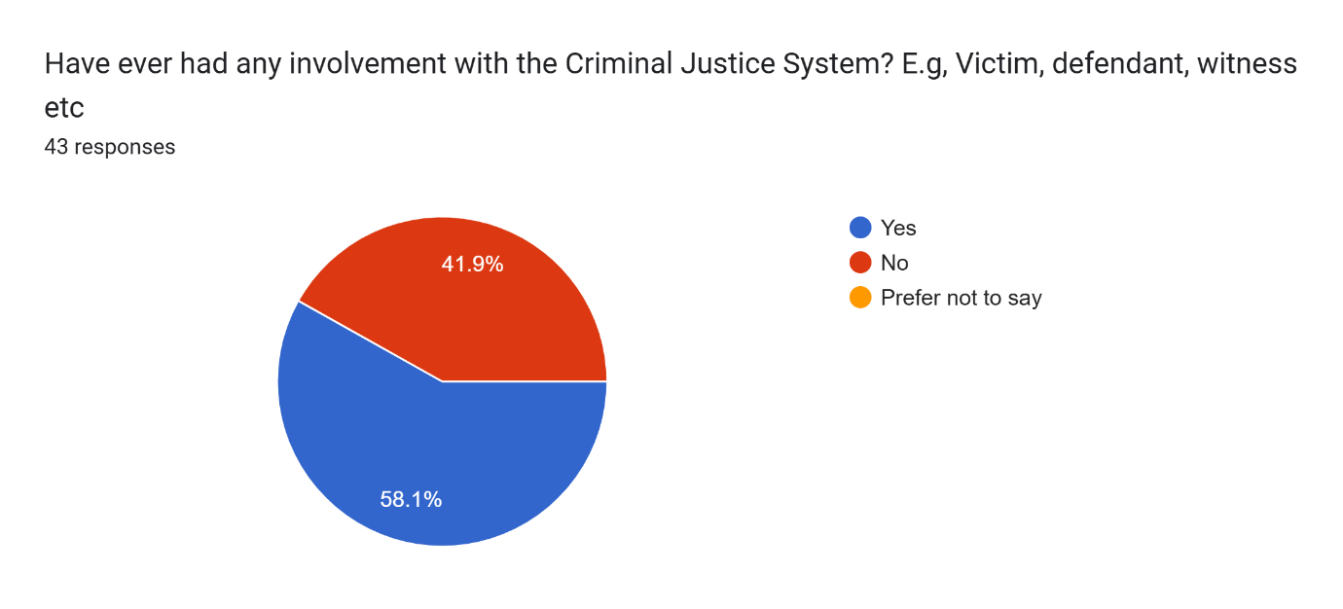
Question: “Have you ever had any involvement with the Criminal Justice System?”
58.1% of respondents had prior criminal justice system experience, while others did not (41.9%). Experience frequently coincides with more critical appraisals, which makes this divide significant. According to Roberts and Stalans (2019), and the Justice Committee (2022), people who have direct experience are more prone to doubt the fairness of the system, whilst others rely their opinions on secondary sources such as the media. This divide is reflected in the findings from the survey, which show that respondents with experience were more likely to openly discuss perceived injustice or leniency in sentencing. This is consistent with research on how scepticism is influenced by experiential knowledge.

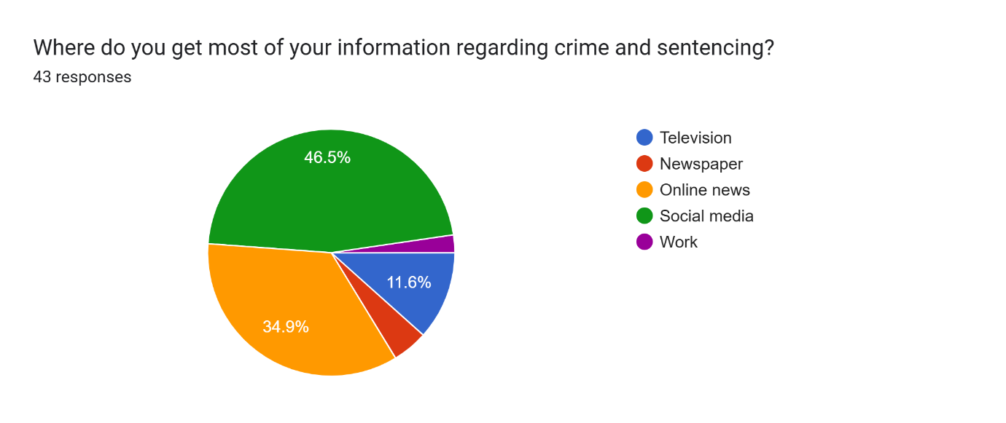
Question: “Where do you get most of your information regarding crime and sentencing?”
Social media and internet news were the most frequently mentioned primary sources (46.5%) by respondents. This supports a common theme in the literature that media narratives, not factual knowledge, have a significant impact on popular understanding. According to Marsh and Melville (2014) and Roberts and Stalans (2019), the public's perception of sentencing is distorted by this reliance on the media. Pratt (2007) also presents the idea of "penal populism," in which sensationalist reporting encourages calls for more severe punishment irrespective of the facts presented by the courts.
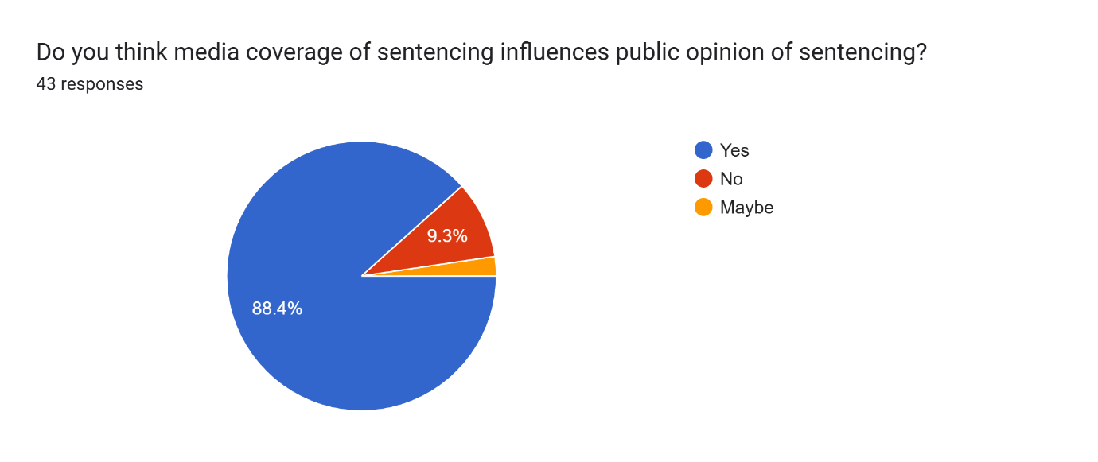
Question: “Do you think media coverage of sentencing influence’s public opinion of sentencing?”
A vast majority of the respondents (88.4%) indicated that they were aware of the media's ability to shape public opinion. This is in line with Sentencing Advisory Council studies (Gelb and Sentencing, 2006), which discovered that when the public is given media soundbites instead of the complete legal background, their attitude becomes harsher. Although it is encouraging that respondents are conscious of the impact of the media, there is a chance that, despite acknowledging bias, their opinions would still be influenced by such narratives. This finding supports the Ministry of Justice's (2013) recommendation that public legal education is necessary. Given that respondents acknowledged media influence while also expressing strongly held opinions influenced by it, the current research lends credence to this tendency.

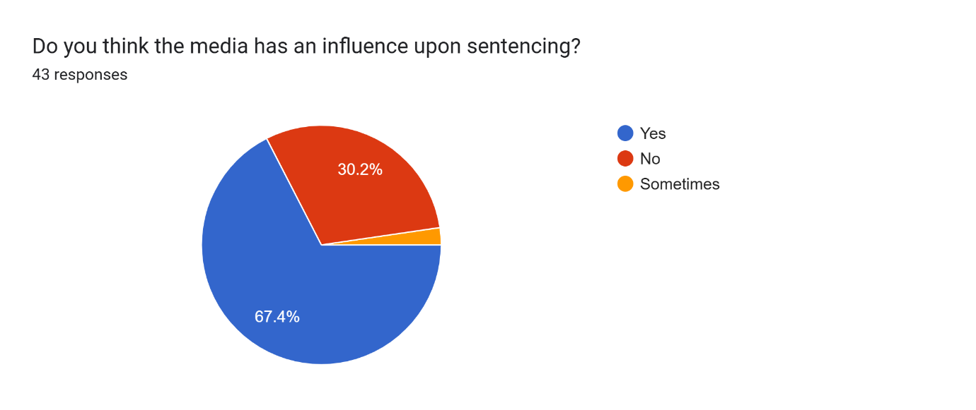
Question: “Do you think the media has an influence upon sentencing?”
Over two thirds (67.4%) believed that media pressure can affect court judgements, albeit not all of them agreed. This supports the worries expressed by Morgan, Reiner, and Maguire (2012), who warn that strong media attention, especially in high-profile cases, can impact the perception of the courts' independence. Additionally, this opinion aligns with the concept of punitive populism (Pratt, 2007), which holds that institutional and political forces indirectly influence sentencing policy. The apparent erosion of judicial integrity is probably a factor in the lack of trust that is seen in the further survey questions.

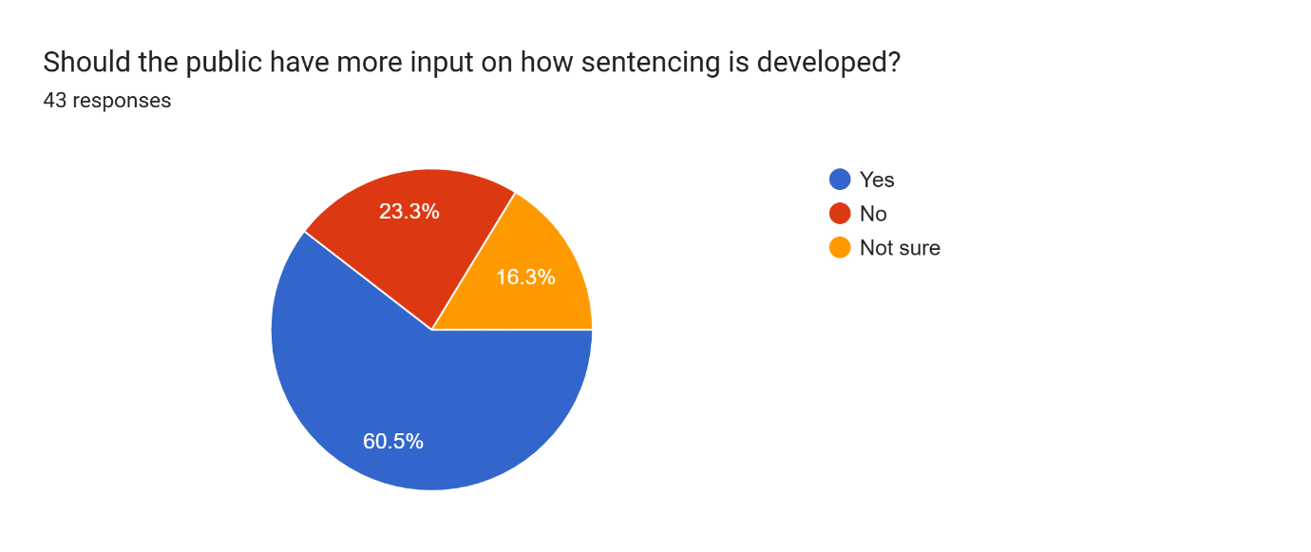
Question: “Should the public have more input on how sentencing is developed?”

The majority's affirmative response indicates that demand for participatory justice is rising. This type of public involvement could strengthen legitimacy without compromising judicial expertise, claims Marder (2016). But the literature also cautions against populism gone too far. To guarantee that the courts uphold consistency and legal integrity, Hough and Roberts (2005) argue that public involvement should be advisory rather than prescriptive. The survey's open-text responses show that the public prefers greater representation and transparency to control.
Question: “How much trust do you have in the criminal justice system?”
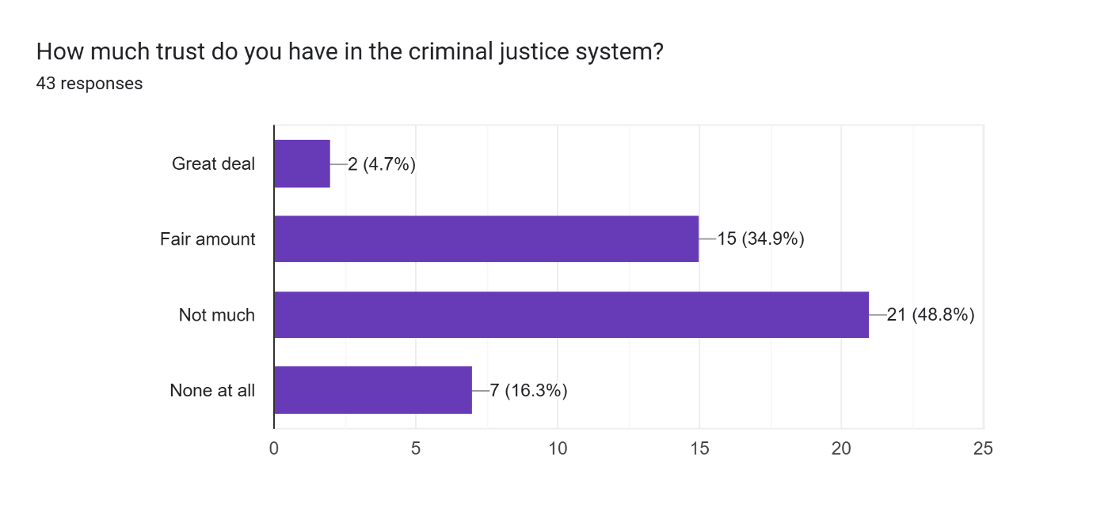
The majority of those surveyed chose "fair amount," "not much," or "none at all." These results demonstrate a weak foundation of trust, which is consistent with more general national data from the CSEW and Dodd (2024) that indicates a decline in public confidence, particularly among ethnic minorities and in metropolitan areas.

Question: “Does the way sentencing is handled affect your level of trust in the justice system?”
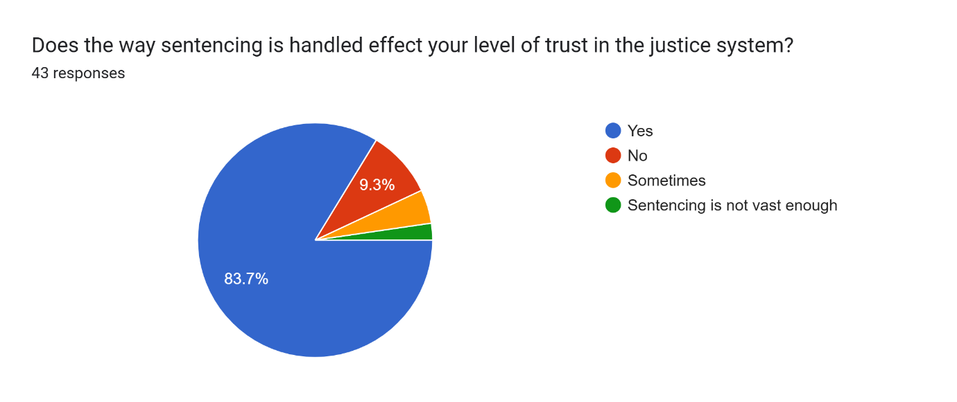
Almost everyone (88.4%) who responded said "yes" or "sometimes." This demonstrates that sentencing is a symbol of justice as well as a legal procedure. Jackson et al. (2012) contends that broader institutional trust, such as in the government and police, is impacted by how fair sentencing is regarded. This relates directly to the community trust, which demonstrates that lenient or inconsistent sentencing impair public confidence in law enforcement and criminal justice results in general (Bradford, 2017; Lammy, 2017).

Question: “Would more transparency in sentencing decisions increase your trust in the criminal justice system?”
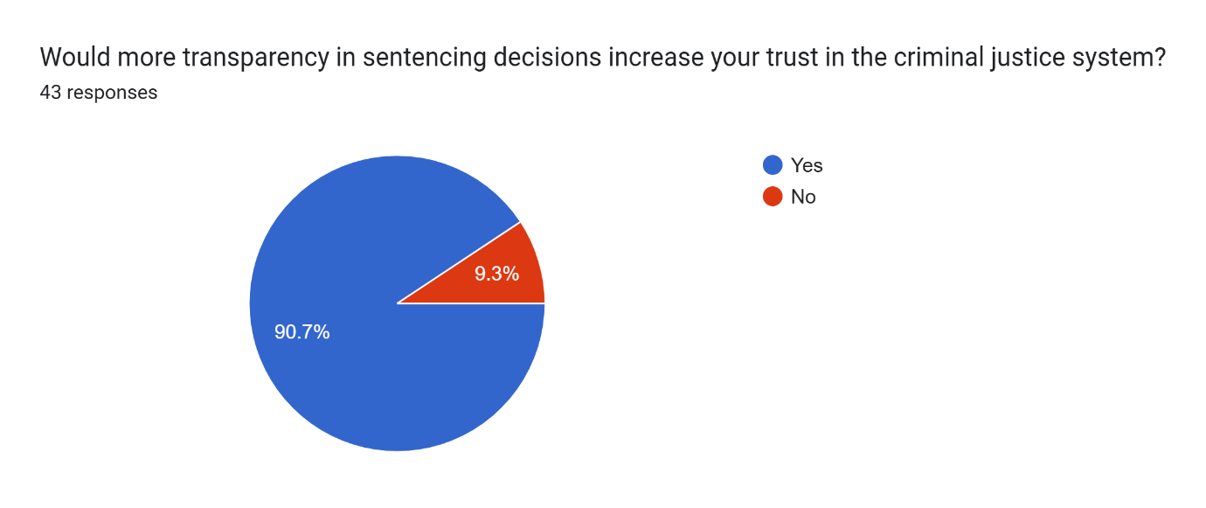
The resounding "yes" answer supports the public's demand for responsibility and clarity. According to Wood and Gannon (2011), the public frequently misunderstands legal terminology and procedures, leaving a gap that is populated by media interpretations. Several sources within the literature review section emphasised transparency, such as the punishment Council (2022) and the Justice Committee (2022), which both advocate for publicly accessible justifications of punishment to foster confidence.

Question: “What changes would help improve public trust in sentencing and the justice system overall?”
This question highlighted some reoccurring answers from the public, people suggested stricter punishments, clearer guidelines, public consultation and judicial consistency. These reaffirm the issues raised in your evaluation. According to Clark (2020), 70% of British citizens thought that sentences were too light, and your results support that conclusion. The sentence Council shares the respondents' desire for clear accountability and proportionality in sentence through the revisions to its guidelines. Additionally, requests for consultation are consistent with Marder's (2016) support of local justice forums and citizens' sentencing panels.

Question: “What are the biggest issues with how sentencing is handled today?”
When this question was answered, there were common themes throughout. The key issues identified by respondents were lack of consistency, overly lenient sentences, media influence and Unclear terminology. These answers mirror academic findings. Roberts et al. (2022) and Ashworth & Roberts (2013) both note that public opinion often exaggerates leniency due to misunderstanding and selective information. Wood and Gannon (2011) stress that confusion about terms like “on licence” or “life sentence” fuels scepticism. These responses call for education, reform, and clear communication, reflecting recommendations across the research.
The research, which shows a recurring discrepancy between popular views and court realities, substantially supports the conclusions.

Chapter Five : Findings and Conclusions

5.1 Introduction

This dissertation set out to investigate how public perceptions of sentencing influence community trust, with a particular focus on the courts and the police. This was sought by analysing existing literature alongside primary data collected through surveys, the study has sought to assess whether perceived leniency, inconsistency, or lack of transparency in sentencing undermines confidence in the criminal justice system. The research also examined whether distrust of sentencing decisions extends beyond the judiciary to affect wider trust in the police as representatives of law and order. Finally, it aimed to identify actionable ways to improve public understanding and confidence in sentencing, thereby strengthening legitimacy across the justice system.
The study pursued three core objectives:
1. To explore the public perception on sentencing within the courts.
2. To identify if public perception on sentencing is impacting upon community trust towards the police.
3. To identify ways to improve public perception on sentencing and the link to police and their trust within.

Every objective has been examined in light of both empirical data and scholarly research, and it is evident that they are intricately related. Taken together, they suggest a justice system where trust is brittle and readily swayed by perceived injustices, media framing, and insufficient information.

5.2 Objective 1: Public Perception on Sentencing within the Courts

The results consistently show that, even in cases where sentencing statistics does not support the public's impression of sentence as being excessively lenient. A long-standing disparity between the public's perception of sentencing and its actual implementation was uncovered by the literature research. When queried in general terms, members of the public usually believe that punishments are too mild, but when given case-specific information, they frequently agree with court rulings, as demonstrated by Roberts and Stalans (2019) and Gelb (2006). This implies that views of leniency are less a product of critical analysis and more a reflection of generalised views.
This trend is supported by the survey results, which show that respondents overwhelmingly felt sentences were too soft, with many citing inconsistency and lack of clarity as their main frustrations. The prevalence of media reliance, which nearly half of participants reported, highlights how sensationalist reporting reinforces narratives of “lenient justice.” The majority of respondents (88.4%) acknowledged the media’s influence on public opinion, but many continued to accept media portrayals as truth, illustrating the paradox that being aware of bias does not prevent it.
This highlights a major issue facing courts: the discrepancy between sentencing perceptions and facts. Although the Sentencing Council has published guidelines in an attempt to increase transparency, this research indicates that the issue is more with the information's accessibility and clarity than with its availability. Many respondents said they had trouble understanding terms used in sentencing, such "life sentence" and "on licence." Misunderstandings undermine trust in the justice system's efficacy and fairness and contribute to a narrative of leniency.

5.3 Objective 2: Public Perception of Sentencing and Community Trust in the Police

The second goal was to determine whether popular discontent with punishment influences public trust in the police. Empirical data and literature both attest to the connection between the two. Although they are not in charge of determining sentences, police officers act as the public face of the legal system. By association, the power of the police is undermined when courts are seen as being overly forgiving or contradictory.
According to the literature, general views of justice and fairness are strongly correlated with public trust in the police. Procedural justice theory highlights that legitimacy is based on views of impartiality, fairness, and openness (Bradford, 2017; Tyler, 2006). Judgements concerning policing are influenced by the notion that sentencing decisions are unfair.
This trend was evident in the survey results. Almost 90% of participants said that their trust in the legal system is impacted by the way sentencing is handled. Respondents frequently linked their dissatisfaction with sentence to their faith in law enforcement, pointing out that lenient decisions eroded their belief that police work had a long-lasting impact. This is consistent with the Justice Committee's (2022) conclusions, which found that confidence in the police is inextricably linked to confidence in the legal system and sentencing decisions.
Variations in demographics are also important. Due to lived experiences of discrimination and institutional injustices, minority populations frequently express lower levels of faith in the police and courts, as the research has documented (Bowling & Phillips, 2002; Lammy, 2017). This was somewhat mirrored in the study, where respondents frequently mentioned bias and inconsistencies. The idea that punishments differ not only by crime but also by the traits of the offender contributes to larger narratives of unfairness, which erode the credibility of the police.
The study's findings ultimately show that sentence perceptions are inextricably linked to police legitimacy. The police's credibility is harmed if the public thinks the system is "soft on crime," even if they have no say in sentencing decisions. This demonstrates how justice systems are interdependent and how better coordinated communication tactics are required.

5.3 Objective 3: Improving Public Perception of Sentencing and Trust in the Police

The final objective explored ways to rebuild confidence in sentencing and, by extension, in the police. Both the literature and survey findings converge on several strategies: enhancing transparency, improving public education, increasing consistency, and fostering community engagement.
Clearer disclosure of sentence judgements was strongly welcomed by respondents. Almost everyone thought that more openness would boost their faith in the legal system. This implies that there is an urgent need for sentencing committees and courts to explain sentences in simple terms. Although there are previously established norms, they are sometimes written in technical terms that laypeople cannot understand. Alongside sentence announcements, courts ought to think about providing succinct, publicly accessible summaries that provide context for the judgement as well as the reasoning behind it.
Enhancing the public's comprehension of punishment is necessary for longer-term reform. According to the Justice Committee (2022), integrating sentencing education into school curricula could aid in clearing up misconceptions before they become entrenched. Campaigns that engage the public, like those for jury duty or anti-crime programs, may also help change the way that sentencing is portrayed. The study's respondents specifically demanded "clearer guidelines" and "public consultation," indicating a strong desire for increased participation and instruction.
Inconsistency was one of the most important issues brought up by the literature and survey respondents. Mistrust is fuelled by sentences that seem arbitrary or that differ significantly for similar acts. This impression might be dispelled by enforcing stricter sentencing criteria and making sure that deviations are more transparent. Furthermore, restoring confidence in marginalised communities requires recognising and resolving differences in sentencing results across ethnic and demographic groupings.
Despite their separate functions, the public views the police and judiciary as having similar legitimacy. When police officers publicly convey their unhappiness with sentence decisions, especially when dealing with repeat criminals, it can have an impact on public opinion. According to Reiner (2016), coordinating police and court messages may lessen the impression of institutional division. In order to strengthen a cohesive message of justice and accountability, police chiefs should be urged to support sentencing transparency.

Chapter Six : Recommendations

Based on the findings of this research, the following recommendations are proposed:

6.1 Recommendation One: Enhance transparency of sentencing

Courts should issue plain-language explanations of sentences, either through written summaries or short public statements.

6.2 Recommendation Two: Expand public education initiatives

Introduce sentencing education into school curricula and run public campaigns to correct common misconceptions.

6.3 Recommendation Three: Ensure greater consistency and fairness

Strengthen adherence to sentencing guidelines and address disparities in sentencing outcomes.

6.4 Recommendation Four: Align police and court communication

Encourage coordinated messaging that emphasises shared goals of justice, fairness, and accountability

Chapter Seven : Bibliography

Antes, A.L. and Maggi, L.B. (2021). How to Conduct Responsible Research: A Guide for Graduate Students. Current Protocols, 1(3). doi:https://doi.org/10.1002/cpz1.87.
Ashworth, A. and Roberts, J.V. (2013). Sentencing guidelines : exploring the English model. Oxford, United Kingdom: Oxford University Press.
Bowling, B. and Phillips, C. (2002). Racism, crime and justice. Harlow ; New York: Longman.
Bradford, B. (2017). Stop and Search and Police Legitimacy. Routledge.
Central Digital and Data Office (2020). Data Ethics Framework. [online] GOV.UK. Available at: https://www.gov.uk/government/publications/data-ethics-framework/data-ethics-framework-2020 [Accessed 27 Jul. 2025].
Clark, D. (2020). Opinion: prison sentence harshness in Britain 2019. [online] Statista. Available at: https://www.statista.com/statistics/1100694/opinion-on-prison-sentences-in-britain/ [Accessed 27 May 2025].
Cleave, P. (2021). The Benefits of Anonymous Surveys. [online] SmartSurvey. Available at: https://www.smartsurvey.co.uk/blog/the-benefits-of-anonymous-surveys [Accessed 25 Jul. 2025].
Craig, L.A., Gannon, T.A. and Dixon, L. (2013). What Works in Offender Rehabilitation. John Wiley & Sons.
Cunneen, C., Goldson, B. and Russell, S. (2017). Human rights and youth justice reform in England and Wales: A systemic analysis. Criminology & Criminal Justice, [online] 18(4), pp.405–430. doi:https://doi.org/10.1177/1748895817721957.
DeVaus, D. (2014). Surveys in Social Research. 6th ed. Sydney Allen & Unwin.
Dodd, V. (2024). Only 40% of people in England trust their police force, research reveals. [online] the Guardian. Available at: https://www.theguardian.com/uk-news/2024/apr/18/only-40-of-people-in-england-trust-their-police-force-research-reveals?utm [Accessed 3 May 2025].
Fleetwood, D. (2023). Quantitative Research: Definition, Methods, Types and Examples. [online] QuestionPro. Available at: https://www.questionpro.com/blog/quantitative-research/ [Accessed 27 Jul. 2025].
Fulham, L., Blais, J., Rugge, T. and Schultheis, E.H. (2023). The effectiveness of restorative justice programs: A meta-analysis of recidivism and other relevant outcomes. Criminology & Criminal Justice. [online] doi:https://doi.org/10.1177/17488958231215228.
Gelb, K. and Sentencing, Victoria. (2006). Myths and misconceptions : public opinion versus public judgment about sentencing. Melbourne: Sentencing Advisory Council.
Hewson, A. (2025). PRT calls for fundamental reform of sentencing to address prison capacity crisis | Prison Reform Trust. [online] Prison Reform Trust. Available at: https://prisonreformtrust.org.uk/prt-calls-for-fundamental-reform-of-sentencing-to-address-prison-capacity-crisis/ [Accessed 7 Sep. 2025].
Hough, M & Sato, M 2011, Trust in Justice: Why It Is Important for Criminal Policy, and How It Can Be Measured. 1st edn, HEUNI, Helsinki Finland. <https://heuni.fi/documents/47074104/49491250/HEUNI-Report-70-Trust-in-justice.pdf/8c65a6b9-0a55-08cb-6f6f-bb16a2f79617/HEUNI-Report-70-Trust-in-justice.pdf?t=1607458053425>
Hough, M. and Roberts, J. (2005). Understanding Public Attitudes to Criminal Justice. McGraw-Hill Education (UK).
Jackson, J., Bradford, B., Hough, M., Myhill, A., Quinton, P. and Tyler, T.R. (2012). Why do People Comply with the Law?: Legitimacy and the Influence of Legal Institutions. British Journal of Criminology, 52(6), pp.1051–1071. doi:https://doi.org/10.1093/bjc/azs032.
Joyce, P. (2012). Criminal justice : an introduction to crime and the criminal justice system. London: Routledge.
Justice Committee (2022a). Public Opinion and Understanding of Sentencing - Justice Committee. [online] Parliament.uk. Available at: https://publications.parliament.uk/pa/cm5803/cmselect/cmjust/305/report.html [Accessed 25 May 2025].
Justice Committee (2022b). Public opinion and understanding of sentencing: Government and Sentencing Council response to the Committee’s Tenth Report of Session 2022–23 - Justice Committee. [online] Parliament.uk. Available at: https://publications.parliament.uk/pa/cm5804/cmselect/cmjust/442/report.html [Accessed 23 Jun. 2025].
Justice, M. of (2013). The public’s understanding and views of sentencing and the criminal justice system. [online] GOV.UK. Available at: https://www.gov.uk/government/publications/the-publics-understanding-and-views-of-sentencing-and-the-criminal-justice-system?utm [Accessed 3 May 2025].
Kirk, I. (2022). Criminal Sentencing Is Too soft, Say two-thirds of Britons | YouGov. [online] yougov.co.uk. Available at: https://yougov.co.uk/politics/articles/41641-criminal-sentencing-too-soft-say-two-thirds-briton?redirect_from=%2Ftopics%2Fpolitics%2Farticles-reports%2F2022%2F03%2F30%2Fcriminal-sentencing-too-soft-say-two-thirds-briton [Accessed 24 May 2025].
Kuphanga, D. (2024). Questionnaires in Research: Their Role, Advantages, and Main Aspects. [online] ResearchGate. Available at: https://www.researchgate.net/publication/378868278_Questionnaires_in_Research_Their_Role_Advantages_and_Main_Aspects [Accessed 16 Sep. 2025].
Lammy, D. (2017). The Lammy Review. [online] GOV.UK. Available at: https://assets.publishing.service.gov.uk/media/5a82009040f0b62305b91f49/lammy-review-final-report.pdf [Accessed 23 May 2025].
Lim, W.M. (2024). What Is Qualitative research? an Overview and Guidelines. Australasian Marketing Journal (AMJ), [online] 33(2), pp.199–229. doi:https://doi.org/10.1177/14413582241264619.
Marder, I.D. (2016). Communicating and collaborating across nations, professions and disciplines in restorative justice. Restorative Justice, 4(2), pp.237–246. doi:https://doi.org/10.1080/20504721.2016.1197529.
Marsh, I. and Melville, G. (2014). Crime, Justice and the Media. New York: Routledge.
Marsh, N., Mckay, E., Pelly, C. and Cereda, S. (2019). PUBLIC KNOWLEDGE OF AND CONFIDENCE IN THE CRIMINAL JUSTICE SYSTEM AND SENTENCING A REPORT FOR THE SENTENCING COUNCIL. [online] Available at: https://www.sentencingcouncil.org.uk/wp-content/uploads/Public-Knowledge-of-and-Confidence-in-the-Criminal-Justice-System-and-Sentencing.pdf [Accessed 27 May 2025].
Ministry Of Justice (2013). Revision to Attitudes to Sentencing and Trust in Justice: Exploring Trends from the Crime Survey for. [online] Available at: https://assets.publishing.service.gov.uk/media/5a7c1b00ed915d210ade19d0/Attitudes_to_Sentencing_and_Trust_in_Justice__web_.pdf [Accessed 25 Jun. 2025].
Ministry of Justice (2023). Prison Reforms Will Cut Reoffending and Put Worst Offenders behind Bars for Longer. [online] GOV.UK. Available at: https://www.gov.uk/government/news/prison-reforms-will-cut-reoffending-and-put-worst-offenders-behind-bars-for-longer [Accessed 27 Apr. 2025].
Morales-Gomez, A. and Associate, R. (2020). Analysing perception of the effectiveness of the Criminal Justice System using CSEW. [online] Available at: https://ukdataservice.ac.uk/app/uploads/3analysingcsew.pdf [Accessed 27 May 2025].
Morgan, R., Reiner, R. and Maguire, M. (2012). The Oxford handbook of criminology. 5th ed. Oxford: Oxford University Press.
Penal Reform International (2023). Overcrowding. [online] Penal Reform International. Available at: https://www.penalreform.org/issues/prison-conditions/key-facts/overcrowding/ [Accessed 27 Apr. 2025].
Pratt, J. (2007). Penal Populism: Key Ideas in Criminology. London ; New York: Routledge, Taylor & Francis Group.
Reiner, R. (2016). Policing, popular culture and political economy : towards a social democratic criminology. London: Routledge.
Research Ethics Committee (2016). The Main Reasons Why Ethical Approval Is Required. [online] Ucl.ac.uk. Available at: https://ethics.grad.ucl.ac.uk/why-is-ethical-approval-required.php [Accessed 27 Aug. 2025].
Rice, S.K. and White, M.D. (2010). Race, Ethnicity, and Policing New and Essential Readings. [online] New York Nyu Press. Available at: http://muse.jhu.edu/chapter/366862 [Accessed 27 Jun. 2025].
Roberts, J. and Stalans, L. (2019). Public Opinion, Crime, And Criminal Justice. S.L.: Routledge.
Roberts, J., Bild, J., Pina-Sánchez, J. and Hough, M. (2022). Public Knowledge of Sentencing Practice and Trends Research Report. [online] Available at: https://sentencingacademy.org.uk/wp-content/uploads/2023/08/Public-Knowledge-of-Sentencing-Practice-and-Trends.pdf [Accessed 27 Jun. 2025].
Roberts, J.V. (2003). Penal populism and public opinion : lessons from five countries. Oxford ; New York: Oxford University Press.
Saunders, M., Lewis, P., Thornhill, A. and Bristow, A. (2019). ‘Research Methods for Business students’ Chapter 4: Understanding Research Philosophy and Approaches to Theory Development. [online] Researchgate. Available at: https://www.researchgate.net/publication/330760964_Research_Methods_for_Business_Students_Chapter_4_Understanding_research_philosophy_and_approaches_to_theory_development [Accessed 27 Jul. 2025].
Sentencing Council (2022). Public confidence in sentencing and the criminal justice system: 2022 – Sentencing. [online] Sentencing Council. Available at: https://www.sentencingcouncil.org.uk/publications/item/public-confidence-in-sentencing-and-the-criminal-justice-system-2022/ [Accessed 27 May 2025].
Tyler, T.R. (2006). Why people obey the law. Princenton New Jersey: Princeton University Press.
Wood, J.L. and Gannon, T.A. (2011). Public opinion and criminal justice. London: Routledge

Chapter Eight : Appendix

8.1 Questionnaire

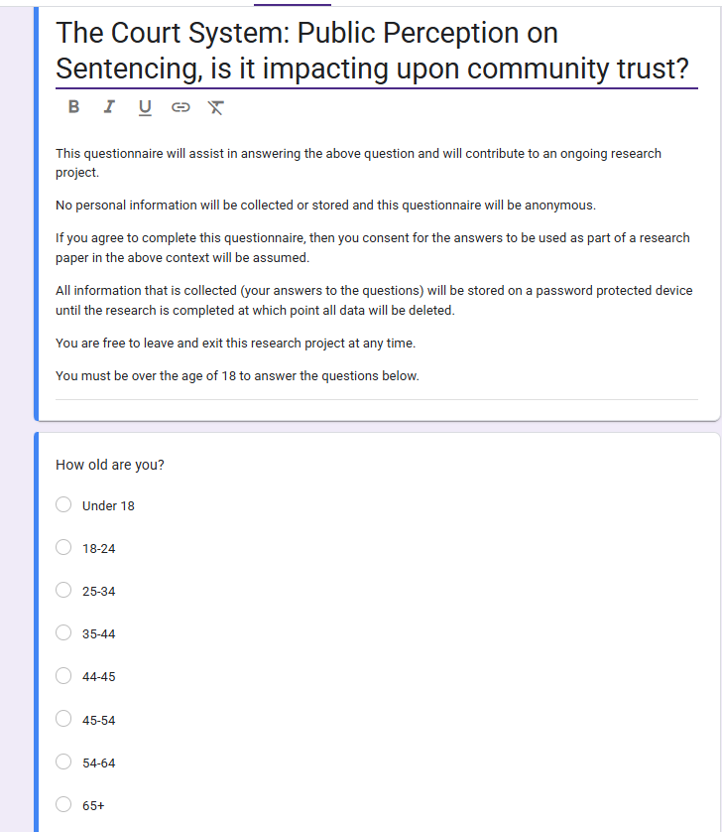

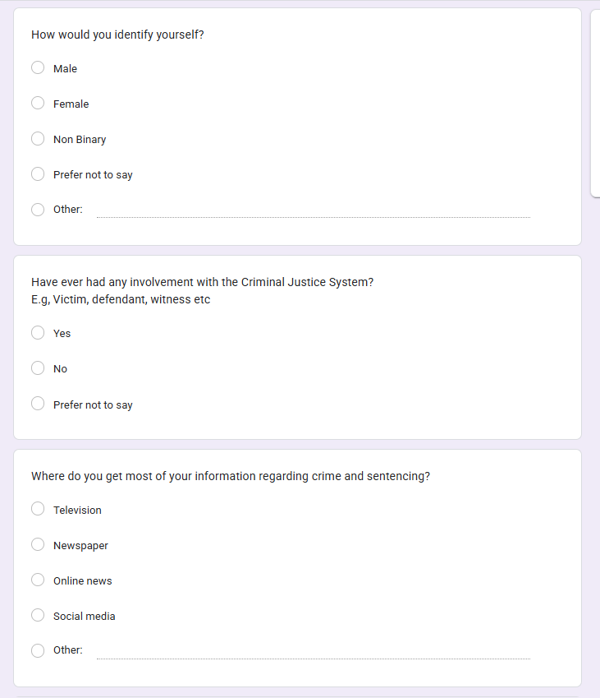

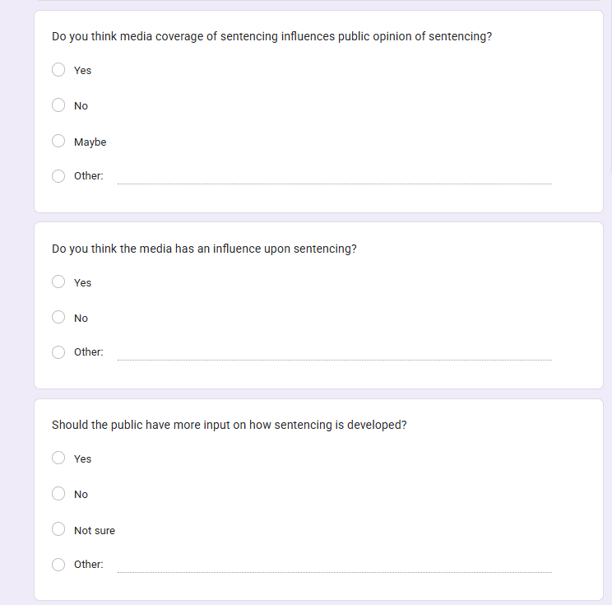

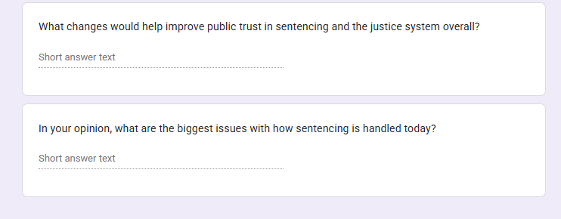
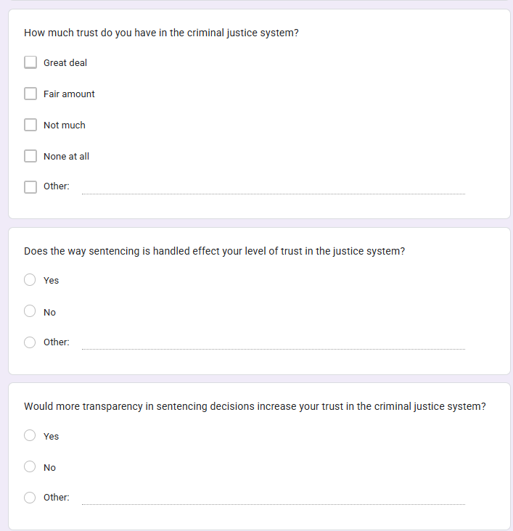

8.2 Ethics Form
APPLICATION FOR ETHICAL APPROVAL

RESEARCH STUDENTS
This form is to be completed by the student within SIX months for full-time students and TWELVE months for part time students, after the commencement of the research degree or following progression to Part Two of your course.

Once complete, submit this form via the MyTSD Doctoral College Portal at (https://mytsd.uwtsd.ac.uk).

This document is also available in Welsh.

RESEARCH STAFF ONLY
All communications relating to this application during its processing must be in writing and emailed to pgresearch@uwtsd.ac.uk , with the title ‘Ethical Approval’ followed by your name.

STUDENTS ON UNDERGRADUATE OR TAUGHT MASTERS PROGRAMMES should submit this form (and receive the outcome) via systems explained to you by the supervisor/module leader.

In order for research to result in benefit and minimise risk of harm, it must be conducted ethically. A researcher may not be covered by the University’s insurance if ethical approval has not been obtained prior to commencement.

The University follows the OECD Frascati manual definition of research activity: “creative work undertaken on a systematic basis in order to increase the stock of knowledge, including knowledge of man, culture and society, and the use of this stock of knowledge to devise new applications”. As such this covers activities undertaken by members of staff, postgraduate research students, and both taught postgraduate and undergraduate students working on dissertations/projects.

The individual undertaking the research activity is known as the “principal researcher”.

Ethical approval is not required for routine audits, performance reviews, quality assurance studies, testing within normal educational requirements, and literary or artistic criticism.

Please read the notes for guidance before completing ALL sections of the form.

This form must be completed and approved prior to undertaking any research activity. Please see Checklist for details of process for different categories of application.

SECTION A: About You (Principal Researcher)
1 | Full Name: |  | Ashleigh Bourne
2 | Tick all boxes that apply: |  | Member of staff: | ☐ | Honorary research fellow: | ☐
 | Undergraduate Student | ☒ | Taught Postgraduate Student | ☐ | Postgraduate Research Student | ☐

3 | Institute/Academic Discipline/Centre: | UWTSD- Institute of Management and Health (Swansea)
4 | Campus: | UWTSD- Institute of Management and Health (Swansea)
5 | E-mail address: | 2236404@student.uwtsd.ac.uk
6 | Contact Telephone Number:
 | For students:
7 | Student Number: | 2236404
8 | Programme of Study: | BSc Honours Professional Policing Practice
9 | Director of Studies/Supervisor: | Jane Davies

SECTION B: Approval for Research Activity
1 | Has the research activity received approval in principle?  (please check the Guidance Notes as to the appropriate approval process for different levels of research by different categories of individual) |  | YES | ☒ | NO | ☐
 |  |  |  |  | Date
2 | If Yes, please indicate source of approval (and date where known): Approval in principle must be obtained from the relevant source prior to seeking ethical approval | Research Degrees Committee |  | ☐
2 |  | Institute Research Committee |  | ☐
2 |  | Other (write in) Jane Davies |  | ☒

SECTION C: Internal and External Ethical Guidance Materials
 | Please list the core ethical guidance documents that have been referred to during the completion of this form (including any discipline-specific codes of research ethics, location-specific codes of research ethics, and also any specific ethical guidance relating to the proposed methodology). Please tick to confirm that your research proposal adheres to these codes and guidelines. You may add rows to this table if needed.
1 | UWTSD Research Ethics & Integrity Code of Practice | ☒
2 | UWTSD Research Data Management Policy | ☒
3 | [List any other relevant documents here] | ☐

SECTION D: External Collaborative Research Activity
If there are external collaborators then you should gain consent from the contact persons to share their personal data with the university. If there are no external collaborators then leave this section blank and continue to section E.
1 | Institution
2 | Contact person name
3 | Contact person e-mail address
4 | Is your research externally funded? |  | YES | ☐ | NO |  | ☐
5 | Are you in receipt of a KESS scholarship? |  | YES | ☐ | NO |  | ☐
6 | Are you specifically employed to undertake this research in either a paid or voluntary capacity? | Voluntary | YES | ☐ | NO | ☐
7 |  | Employed | YES | ☐ | NO | ☐
8 | Is the research being undertaken within an existing UWTSD Athrofa Professional Learning Partnership (APLP)? | If YES then the permission question below does not need to be answered. | YES | ☐ | NO |  | ☐
9 | Has permission to undertake the research has been provided by the partner organisation? | (If YES attach copy)  If NO the application cannot continue | YES | ☐ | NO |  | ☐

Where research activity is carried out in collaboration with an external organisation
10 | Does this organisation have its own ethics approval system? | YES | ☐ | NO | ☐
 | If Yes, please attach a copy of any final approval (or interim approval) from the organisation (this may be a copy of an email if appropriate).

SECTION E: Details of Research Activity
1 | Indicative title: | Are the Court systems doing enough in the UK to curb crime?
2 | Proposed start date: | 30/12/2024 | Proposed end date: | 06/10/2025
Introduction to the Research (maximum 300 words per section)
Ensure that you write for a Non-Specialist Audience when outlining your response to the points below:
- Purpose of Research Activity
- Proposed Research Question
- Aims of Research Activity
- Objectives of Research Activity
Demonstrate, briefly, how Existing Research has informed the proposed activity and explain
- What the research activity will add to the body of knowledge
- How it addresses an area of importance.
3 | Purpose of Research Activity  As part of my Year 3 Dissertation for the BSc Honours Professional Policing Practice, I will conduct research on this topic and share my results and findings throughout the project.
4 | Research Question  Are the Court Systems doing enough in UK to curb crime?
5 | Aims of Research Activity  This study will aim to assess the effectiveness of the UK court system in reducing crime and to propose potential improvements to enhance its performance in crime prevention and reoffending.  My current research shows that throughout the UK in the current climate there is a significant backlog of criminal court cases and articles that talk about how this is affecting victims. There seems to be a lack of research into the success and value that the criminal justice system is providing to the public and what impression they are giving. There is also a lack of research into what the court systems are doing to tackle crime and how they can play their part as the corner stone of the criminal justice system.  One of my aims is to analyse the sentencing policies and their impact on the crime rates and reoffending and to investigate the systematic inefficiencies such as court delays and resource constraints. I am looking to explore alternative sentencing practices such as probation services and rehabilitation courses.  (this box should expand as you type)
6 | Objectives of Research Activity  The aim of this research is to:  - Critically evaluate the effectiveness of the UK judicial system in decreasing crime and preventing recidivism.  - Investigate the relationship between sentencing policies and rehabilitation programmes and their effects of reoffending.  - Identify systemic issues in the UK court systems such as delays, resource constraints, and sentence inequities that may impede their ability to combat crime.  - Determine the effectiveness of alternative justice techniques such as restorative justice and community- based sentencing in reducing crime.  (this box should expand as you type)
Proposed methods (maximum 600 words)
Provide a brief summary of all the methods that may be used in the research activity, making it clear what specific techniques may be used. If methods other than those listed in this section are deemed appropriate later, additional ethical approval for those methods will be needed. You do not need to justify the methods here, but should instead describe how you intend to collect the data necessary for you to complete your project.
7 | My aim is to engage in online publicly available articles and statistics to provide me with the facts and figures to back up my research project. I will research via trustworthy websites and ensure that the authors are reliable and relevant. I aim to use literature that is already produced on my chosen topic and will analyse the data statistics based on my findings.  I will form my research activity upon a questionnaire that I have created which will be specific to my subject and research objectives that are documented above. The questions will allow participants to answer openly and give their honest opinion.  This questionnaire will not be paper based, my aim is to provide an online questionnaire that will be distributed to all participants, and this can be completed at their own leisure and will automatically be submitted back to myself as the author and organiser. This will save time and means that people don’t feel under pressure to answer in a particular way or provide a certain answer.  These questionnaires will be anonymous. This will allow participants to provide an opinion that isn’t going to be judged due to their rank, experience, or job role. I intend to ask a variety of different participants to engage in my questionnaire of all different job roles, ranks and members of the public which will provide a wide range of opinions. I will then aim to compare them and provide a summary of my findings and relate it to my project.  This method comes with ethical issues that I have identified through my research.  My questionnaire will be completed completely consensual, and all participants will be provided with a question allowing them to withdraw at any stage. All participants will complete the questionnaire of their own accord and in their own time. I do not intend for my questionnaire to hinder with any participants personal or work commitments.  As mentioned above, the distribution of my questionnaire will be electronic which will automatically protect the confidentially of all participants as there will be no name required on the document and I will have no way of knowing who has responded. All responses that will be used within the project will be rephrased and no direct answers will be used.  Given the topic I have chosen I am not expecting for my participants to be affected by my questions however, should this occur I will ensure that there are options to withdraw at any time throughout the questionnaire and encourage the participants to seek the relevant support that they feel they require.  (this box should expand as you type)
Location of research activity
Identify all locations where research activity will take place.
8 | Gwent.  (this box should expand as you type)
Research activity outside of the UK
If research activity will take place overseas, you are responsible for ensuring that local ethical considerations are complied with and that the relevant permissions are sought. Specify any local guidelines (e.g. from local professional associations/learned societies/universities) that exist and whether these involve any ethical stipulations beyond those usual in the UK (provide details of any licenses or permissions required). Also specify whether there are any specific ethical issues raised by the local context in which the research activity is taking place, for example, particular cultural and/or legal sensitivities or vulnerabilities of participants. If you live in the country where you will do the research then please state this.
9 | None of my research will take place outside of the UK.  (this box should expand as you type)

10 | Use of documentation not in the public domain: Are any documents NOT publicly available? | NO | ☒
10 |  | YES | ☐
11 | If Yes, please provide details here of how you will gain access to specific documentation that is not in the public domain and that this is in accordance with the current data protection law of the country in question and that of England and Wales.  (this box should expand as you type)

 | Does your research relate to one or more of the seven aims of the Well-being of Future Generations (Wales) Act 2015? | YES | NO
12 | A prosperous Wales | ☐ | ☐
13 | A resilient Wales | ☐ | ☐
14 | A healthier Wales | ☐ | ☐
15 | A more equal Wales | ☐ | ☐
16 | A Wales of cohesive communities | ☐ | ☐
17 | A Wales of vibrant culture and thriving Welsh language | ☐ | ☐
18 | A globally responsible Wales | ☐ | ☐
19 | If YES to any of the above, please give details:
 | (this box should expand as you type)

SECTION F: Scope of Research Activity
 | Will the research activity include: | YES | NO
1 | Use of a questionnaire or similar research instrument? | ☒ | ☐
2 | Use of interviews? | ☐ | ☒
3 | Use of focus groups? | ☐ | ☒
4 | Use of participant diaries? | ☐ | ☒
5 | Use of video or audio recording? | ☐ | ☒
6 | Use of computer-generated log files? | ☐ | ☒
7 | Participant observation with their knowledge? | ☐ | ☒
8 | Participant observation without their knowledge? | ☐ | ☒
9 | Access to personal or confidential information without the participants’ specific consent? | ☐ | ☒
10 | Administration of any questions, test stimuli, presentation that may be experienced as physically, mentally or emotionally harmful / offensive? | ☐ | ☒
11 | Performance of any acts which may cause embarrassment or affect self-esteem? | ☐ | ☒
12 | Investigation of participants involved in illegal activities? | ☐ | ☒
13 | Use of procedures that involve deception? | ☐ | ☒
14 | Administration of any substance, agent or placebo? | ☐ | ☒
15 | Working with live vertebrate animals? | ☐ | ☒
16 | Procedures that may have a negative impact on the environment? | ☐ | ☒
17 | Other primary data collection methods. Please indicate the type of data collection method(s) below. | ☐ | ☒
 | Details of any other primary data collection method:  (this box should expand as you type) | ☐ | ☒
If NO to every question, then the research activity is (ethically) low risk and may be exempt from some of the following sections (please refer to Guidance Notes).

If YES to any question, then no research activity should be undertaken until full ethical approval has been obtained.

SECTION G: Intended Participants
If there are no participants then do not complete this section, but go directly to section H.

 | Who are the intended participants: | YES | NO
1 | Students or staff at the University? | ☒ | ☐
2 | Adults (over the age of 18 and competent to give consent)? | ☒ | ☐
3 | Vulnerable adults? | ☐ | ☒
4 | Children and Young People under the age of 18? (Consent from Parent, Carer or Guardian will be required) | ☐ | ☒
5 | Prisoners? | ☐ | ☒
6 | Young offenders? | ☐ | ☒
7 | Those who could be considered to have a particularly dependent relationship with the investigator or a gatekeeper? | ☐ | ☒
8 | People engaged in illegal activities? | ☐ | ☒
9 | Others. Please indicate the participants below, and specifically any group who may be unable to give consent. | ☐ | ☒
 | Details of any other participant groups:  (this box should expand as you type) | ☐ | ☒

Participant numbers and source
Provide an estimate of the expected number of participants. How will you identify participants and how will they be recruited?
10 | How many participants are expected? | 20  (this box should expand as you type)
11 | Who will the participants be? | Members of the public  Police officers  Colleagues  Members of the Criminal Justice Systems (eg. Solicitors and magistrates)  (this box should expand as you type)
12 | How will you identify the participants? | Through my Job  Via the University  Face to Face  Social Media  (this box should expand as you type)

 | Information for participants: | YES | NO | N/A
13 | Will you describe the main research procedures to participants in advance, so that they are informed about what to expect? | ☒ | ☐ | ☐
14 | Will you tell participants that their participation is voluntary? | ☒ | ☐ | ☐
15 | Will you obtain written consent for participation? | ☐ | ☒ | ☐
16 | Will you explain to participants that refusal to participate in the research will not affect their treatment or education (if relevant)? | ☐ | ☐ | ☒
17 | If the research is observational, will you ask participants for their consent to being observed? | ☐ | ☐ | ☒
18 | Will you tell participants that they may withdraw from the research at any time and for any reason? | ☒ | ☐ | ☐
19 | With questionnaires, will you give participants the option of omitting questions they do not want to answer? | ☒ | ☐ | ☐
20 | Will you tell participants that their data will be treated with full confidentiality and that, if published, it will not be identifiable as theirs? | ☒ | ☐ | ☐
21 | Will you debrief participants at the end of their participation, in a way appropriate to the type of research undertaken? | ☒ | ☐ | ☐
22 | If NO to any of above questions, please give an explanation
Written consent will not be obtained but there will be a tick box question explaining that they do not have to participate if they do not so wish too. All participants will be over the legal age.

(this box should expand as you type)

 | Information for participants: | YES | NO | N/A
24 | Will participants be paid? | ☐ | ☒ | ☐
25 | Is specialist electrical or other equipment to be used with participants? | ☐ | ☒ | ☐
26 | Are there any financial or other interests to the investigator or University arising from this study? | ☐ | ☒ | ☐
27 | Will the research activity involve deliberately misleading participants in any way, or the partial or full concealment of the specific study aims? | ☐ | ☒ | ☐
28 | If YES to any question, please provide full details
 | (this box should expand as you type)

SECTION H: Anticipated Risks

Outline any anticipated risks that may adversely affect any of the participants, the researchers and/or the University, and the steps that will be taken to address them.

If you have completed a full risk assessment (for example as required by a laboratory, or external research collaborator) you may append that to this form.
1 | Full risk assessment completed and appended? |  | Yes | ☒
1 |  |  | No | ☐
2 | Risks to participants  For example: sector-specific health & safety, emotional distress, financial disclosure, physical harm, transfer of personal data, sensitive organisational information
 | Risk to participants:  (this box should expand as you type) | How you will mitigate the risk to participants:  (this box should expand as you type)
3 | If research activity may include sensitive, embarrassing or upsetting topics (e.g. sexual activity, drug use) or issues likely to disclose information requiring further action (e.g. criminal activity), give details of the procedures to deal with these issues, including any support/advice (e.g. helpline numbers) to be offered to participants. Note that where applicable, consent procedures should make it clear that if something potentially or actually illegal is discovered in the course of a project, it may need to be disclosed to the proper authorities
 | (this box should expand as you type)
4 | Risks to the investigator  For example: personal health & safety, physical harm, emotional distress, risk of accusation of harm/impropriety, conflict of interest
 | Risk to the investigator:  (this box should expand as you type) | How you will mitigate the risk to the investigator:  (this box should expand as you type)
5 | University/institutional risks  For example: adverse publicity, financial loss, data protection
 | Risk to the University:  (this box should expand as you type) | How you will mitigate the risk to the University:  (this box should expand as you type)
6 | Environmental risks  For example: accidental spillage of pollutants, damage to local ecosystems
 | Risk to the environment:  (this box should expand as you type) | How you will mitigate the risk to environment:  (this box should expand as you type)

 | Disclosure and Barring Service
 | If the research activity involves children or vulnerable adults, a Disclosure and Barring Service (DBS) certificate must be obtained before any contact with such participants. | YES | NO | N/A
7 | Does your research require you to hold a current DBS Certificate? | ☐ | ☐ | ☒
8 | If YES, please give the certificate number. If the certificate number is not available please write “Pending”; in this case any ethical approval will be subject to providing the appropriate certificate number.

SECTION I: Feedback, Consent and Confidentiality

1 | Feedback  What de-briefing and feedback will be provided to participants, how will this be done and when?
At the beginning of my questionnaire there will be a small paragraph explaining to participants what my research is going to be used for and how their data will be used.

(this box should expand as you type)
2 | Informed consent  Describe the arrangements to inform potential participants, before providing consent, of what is involved in participating. Describe the arrangements for participants to provide full consent before data collection begins. If gaining consent in this way is inappropriate, explain how consent will be obtained and recorded in accordance with prevailing data protection legislation.
All participants are going to be over the legal age of 18 and will be consensually completing my questionnaire. At the beginning of my questionnaire the paragraph will highlight that they are free to withdraw from the questionnaire at any time.

(this box should expand as you type)
3 | Confidentiality / Anonymity  Set out how anonymity of participants and confidentiality will be ensured in any outputs. If anonymity is not being offered, explain why this is the case.
No confidential data is going to be gathered or required. This is protecting all participants.

(this box should expand as you type)

SECTION J: Data Protection and Storage

 | Does the research activity involve personal data (as defined by the General Data Protection Regulation 2016 “GDPR” and the Data Protection Act 2018 “DPA”)? | YES | NO
1 | “Personal data” means any information relating to an identified or identifiable natural person (‘data subject’). An identifiable natural person is one who can be identified, directly or indirectly, in particular by reference to an identifier such as a name, an identification number, location data, an online identifier or to one or more factors specific to the physical, physiological, genetic, mental, economic, cultural or social identity of that natural person. Any video or audio recordings of participants is considered to be personal data. | ☐ | X
 | If YES, provide a description of the data and explain why this data needs to be collected:
2 | (this box should expand as you type)
 | Does it involve special category data (as defined by the GDPR)? | YES | NO
3 | “Special category data” means sensitive personal data consisting of information as to the data subjects’ –  (a) racial or ethnic origin,  (b) political opinions,  (c ) religious beliefs or other beliefs of a similar nature,  (d) membership of a trade union (within the meaning of the Trade Union and Labour Relations (Consolidation) Act 1992),  (e) physical or mental health or condition,  (f) sexual life,  (g) genetics,  (h) biometric data (as used for ID purposes), | ☐ | X
 | If YES, provide a description of the special category data and explain why this data needs to be collected:
4 | (this box should expand as you type)

 | Will data from the research activity (collected data, drafts of the thesis, or materials for publication) be stored in any of the following ways? | YES | NO
5 | Manual files (i.e. in paper form)? | ☐ | ☒
6 | University computers? | ☐ | ☒
7 | Private company computers? | ☐ | ☒
8 | Home or other personal computers? | ☒ | ☐
9 | Laptop computers/ CDs/ Portable disk-drives/ memory sticks? | ☒ | ☐
10 | “Cloud” storage or websites? | ☐ | ☒
11 | Other – specify: | ☐ | ☒
12 | For all stored data, explain the measures in place to ensure the security of the data collected, data confidentiality, including details of backup procedures, password protection, encryption, anonymisation and pseudonymisation:
The laptop that will be used to store this data is password protected and is only assessed by myself as the researcher.

There is no one else who has access to the laptop and only I know the password.

(this box should expand as you type)

 | Data Protection
 | Will the research activity involve any of the following activities: | YES | NO
13 | Electronic transfer of data in any form? | ☐ | ☒
14 | Sharing of data with others at the University outside of the immediate research team? | ☐ | ☒
15 | Sharing of data with other organisations? | ☐ | ☒
16 | Export of data outside the UK or importing of data from outside the UK? | ☐ | ☒
17 | Use of personal addresses, postcodes, faxes, emails or telephone numbers? | ☐ | ☒
18 | Publication of data that might allow identification of individuals? | ☐ | ☒
19 | Use of data management system? | ☐ | ☒
20 | Data archiving? | ☐ | ☒
21 | If YES to any question, please provide full details, explaining how this will be conducted in accordance with the GDPR and Data Protection Act (2018) (and any international equivalents, where appropriate):
 | (this box should expand as you type)
22 | List all who will have access to the data generated by the research activity:
 | (this box should expand as you type)
23 | List who will have control of, and act as custodian(s) for, data generated by the research activity:
 | (this box should expand as you type)
24 | Give details of data storage arrangements, including security measures in place to protect the data, where data will be stored, how long for, and in what form. Will data be archived – if so how and if not why not.
 | (this box should expand as you type)
25 | Please indicate if your data will be stored in the UWTSD Research Data Repository (see https://researchdata.uwtsd.ac.uk/ ). If so please explain. (Most relevant to academic staff)
 | (this box should expand as you type)
26 | Confirm that you have read the UWTSD guidance on data management (see https://www.uwtsd.ac.uk/library/research-data-management/) | YES | ☒
27 | Confirm that you are aware that you need to keep all data until after your research has completed or the end of your funding | YES | ☒

SECTION K: Declaration
The information which I have provided is correct and complete to the best of my knowledge. I have attempted to identify any risks and issues related to the research activity and acknowledge my obligations and the rights of the participants.

In submitting this application I hereby confirm that I undertake to ensure that the above named research activity will meet the University’s Research Ethics and Integrity Code of Practice which is published on the website: https://www.uwtsd.ac.uk/research/research-ethics/
1 | Signature of applicant: | A.Bourne | Date: 23/01/2025

For STUDENT Submissions:
2 | Director of Studies/Supervisor: |  | Date:
3 | Signature: |  | Date:

For STAFF Submissions:
4 | Academic Director/ Assistant Dean: |  | Date:
5 | Signature: |  | Date:

Checklist: Please complete the checklist below to ensure that you have completed the form according to the guidelines and attached any required documentation:
☒ | I have read the guidance notes supplied before completing the form.
☒ | I have completed ALL RELEVANT sections of the form in full.
☒ | I confirm that the research activity has received approval in principle
☐ | I have attached a copy of final/interim approval from external organisation (where appropriate)
☐ | I have attached a full risk assessment (where appropriate) ONLY TICK IF YOU HAVE ATTACHED A FULL RISK ASSESSMENT
☒ | I understand that it is my responsibility to ensure that the above named research activity will meet the University’s Research Ethics and Integrity Code of Practice.
☒ | I understand that before commencing data collection all documents aimed at respondents (including information sheets, consent forms, questionnaires, interview schedules etc.) must be confirmed by the DoS/Supervisor, module tutor or Academic Director.

RESEARCH STUDENTS ONLY
Once complete, submit this form via the MyTSD Doctoral College Portal at (https://mytsd.uwtsd.ac.uk).

RESEARCH STAFF ONLY
All communications relating to this application during its processing must be in writing and emailed to pgresearch@uwtsd.ac.uk , with the title ‘Ethical Approval’ followed by your name.

STUDENTS ON UNDERGRADUATE OR TAUGHT MASTERS PROGRAMMES should submit this form (and receive the outcome) via systems explained to you by the supervisor/module leader.

8.3 Research Proposal



UNDERGRADUATE DISSERTATION
RESEARCH PROPOSAL FORM

Please complete the following research proposal and submit it to Turnitin.

Which project option are you taking? Please tick:

8,000 word project X
OR
4,000 word project and presentation:

NAME: Ashleigh Bourne | STUDENT ID No: 2236404
DRAFT RESEARCH TITLE QUESTION:

An Investigation into the Court Systems and their responsibilities for Crime: Are the Court Systems doing enough to curb crime in the UK?

INTRODUCTION:

The court system’s role in preventing and combatting crime has long been up for debate in the criminology and public policy. The court system in the United Kingdom, as part of the larger criminal justice framework, is responsible for not only administering justice through punishment, but also for preventing future criminal behaviour, rehabilitating criminals, and encouraging social reintegration. With increased worries about reoffending rates, court delays, and sentencing inequities, it is becoming increasingly unclear if the UK’s currently judicial system is capable of effectively reducing and playing its part in tackling crime. This study will critically assess the efficiency and the UK court systems in decreasing crime through the difference purposes, some including deterrence, rehabilitation, and sentencing policies.

The concept of curbing crime through the legal system is multi-dimensional. Traditional criminological theories, such as deterrence theory and rehabilitation theory, place emphasis on various components of the legal process. While deterrence employs the prospect of punishment to prevent future crime, rehabilitation seeks to address the underlaying reasons of criminal behaviour. This duality underpins much of the argument about the court system’s effectiveness in decreasing crime.

It is clear and well known that the current prisons in the UK have no space for offenders and they are overcrowded. Over 118 countries’ prisons have exceeded their maximum occupancy rate, with 11 national jail systems operating at more than double their capacity (Penal Reform International, 2023). This highlights that the prison and court systems are not in sync, and they are not adequately equipped to manage the amount of criminality and offenders that are being pushed through the system. This topic still has unanswered questions as to whether the current system is balanced and if they are set up in such a way to manage expectations of the public and the perceptions of justice.

SUMMARY OF RESEARCH OBJECTIVES:

My aim throughout this research project is to hand out devised questionnaires to members of the public along with police officers which will target the 4/5 points covered below.

- Critically evaluate the effectiveness of the UK judicial system in decreasing crime and preventing recidivism.
- Investigate the relationship between sentencing policies and rehabilitation programmes and their effects of reoffending.
- Identify systemic issues in the UK court systems such as delays, resource constraints, and sentence inequities that may impede their ability to combat crime.
- Determine the effectiveness of alternative justice techniques such as restorative justice and community- based sentencing in reducing crime.

LITERATURE REVIEW:
There are key literature sources that have assist throughout the research phase. One book that has been alluded to is (Joyce, 2012) who gives a background into the Criminal Justice system and includes the role that the courts play in addressing crime. I have also researched via journals and (Fulham et al., 2023) allows me to analyse and review the empirical studies that have been devised on the sentencing practices and their impact on the crime rates.

The courts are overrun, and the backlog within the criminal justice system is extreme. There is no capacity to keep offenders behind bars and this is having an impact on the reoffending rates. (Ministry of Justice, 2023) states that offenders that have served time for less than 12 months have a significantly greater recidivism rate, as do those in prison for less than 6 months. While the national reoffending rate is 25%, the percentage for those who have served less than 12 months in prison is more than 50%. This increases to 58% for those who have served for 6 months or less. This is also significantly higher than the 23% for a suspended sentence with requirements, 38% without requirements.

According to studies, the courts have an important role in delivering proportionate sentences and promoting rehabilitation. However, issues like as court procedure delays, sentencing anomalies, and resource constraints are well documented. Restorative justice and problem-solving courts are emerging areas of study that show potential for lowering recidivism rates.

There has clearly been some substantive work and research carried out on how effective the sentencing and court interventions but there is still some outstanding areas of work like understanding the systematic barriers that hinder the courts. Some of these that I have highlighted are the long-term impact of alternative methods of punishment on reoffending, the role of the court efficiency in especially delays in the public confidence and deterrence. One huge gap in the research that I have identified is the current use of modern technology in speeding up the court processes and receiving outcome quicker.

SUMMARY OF RESEARCH –SURVEY METHOD:

I will form my research activity upon a questionnaire that I have created which will be specific to my subject and research objectives that are documented above. The questions will allow participants to answer openly and give their honest opinion.

This questionnaire will not be paper based, my aim is to provide an online questionnaire that will be distributed to all participants, and this can be completed at their own leisure and will automatically be submitted back to myself as the author and organiser.

SUMMARY OF SAMPLING FRAMEWORK:

I intend to ask members of the public and police officers in my different areas.
I aim to ask 20 overall and gather the results. I believe this will collect a wide range of opinions and the results will be a true representation of the greater public.

ETHICAL ISSUES:

My questionnaire will be completed completely consensual, and all participants will be provided with a question allowing them to withdraw at any stage. All participants will complete the questionnaire of their own accord and in their own time. I do not intend for my questionnaire to hinder with any participants personal or work commitments.

As mentioned above, the distribution of my questionnaire will be electronic which will automatically protect the confidentially of all participants as there will be no name required on the document and I will have no way of knowing who has responded. All responses that will be used within the project will be rephrased and no direct answers will be used.

Given the topic I have chosen I am not expecting for my participants to be affected by my questions, however, should this occur, I will ensure that there are options to withdraw at any time throughout the questionnaire and encourage the participants to seek the relevant support that they feel they require.

TIME SCALE:
For my research I need to adhere to the following time scales:

Literature review – Due date of 5th May 2025

Research and Data gathering– Due date of 16th June 2025

Analysis of data – Due date of 4th August 2025

Write up collected data – Due date of 8th September 2025.

Final draft submission – Due date of 6th October 2025
REFERENCE LIST:

Fulham, L., Blais, J., Rugge, T. and Schultheis, E.H. (2023). The effectiveness of restorative justice programs: A meta-analysis of recidivism and other relevant outcomes. Criminology & Criminal Justice. [online] doi:https://doi.org/10.1177/17488958231215228.

Joyce, P. (2012). Criminal justice : an introduction to crime and the criminal justice system. London: Routledge.

Ministry of Justice (2023). Prison Reforms Will Cut Reoffending and Put Worst Offenders behind Bars for Longer. [online] GOV.UK. Available at: https://www.gov.uk/government/news/prison-reforms-will-cut-reoffending-and-put-worst-offenders-behind-bars-for-longer.

Penal Reform International (2023). Overcrowding. [online] Penal Reform International. Available at: https://www.penalreform.org/issues/prison-conditions/key-facts/overcrowding/.

Word Count – 1,097

