
University of Wales Trinity Saint David
School of Computing
Application Development
Kieran John Ayres (P149775)
23/03/2020
Database Management Systems/ACCA5014

Contents
Introduction 1
1. Performance Tuning 2
2. Distributed Database Solutions. 4
3. Conclusion 5
References 6
Bibliography 6

Introduction
The focal point of this document is to be a formal report to document the implementation of the Shape Up Gym Database. This will be shown through the implementation along with the performance tuning method, this will be done through adding indexes. Then there will be a report on the proposed method of fragmentation and how the fragmented database may look to the user.

Project Initiation Document

Performance Tuning
This section of the document is to explain the performance tuning of the database, this is done through the use, of indexes. “Indexing is an effective way to tune your SQL database that is often neglected during development” [1] This is a method that developers follow so that the database can bring the data together using queries, this can group data together to sometime get meaningful conclusions. When using indexes, they can use the SQL Server to monitor the performance. This can be used to tell the speed of how fast the query can build, this happens in milliseconds in the case of the queries below. As they are of a much significantly smaller size query as the dataset was not large enough to bring meaningful results, they did compile much slower. However, if the dataset was of a much larger size then there may be a longer time to compile. The ones below compiled in milliseconds. A developer could also use the “dynamic management views” [2] They can provide things such as query stats.
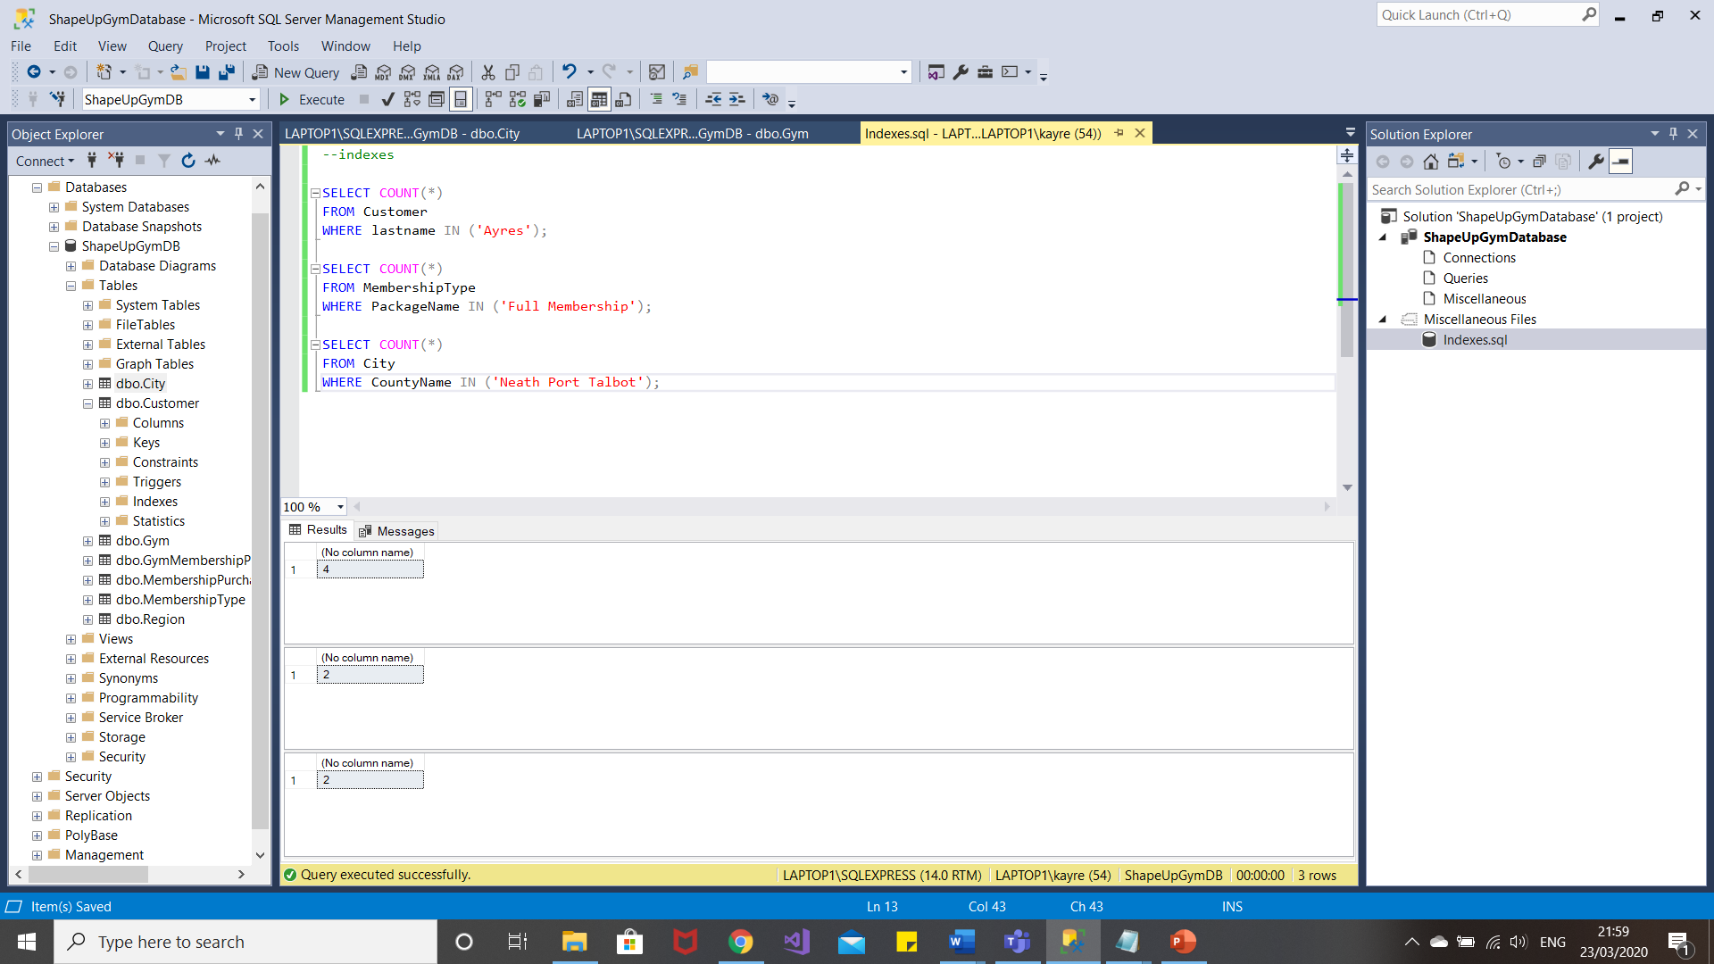
Figure 1
The first query was chosen as there was a couple of more data entries in there than the other tables so there was more to perform the indexes. This did this in a very quick and efficient time and is a quick and easy way to see how many instances in the database there are of people with the last name of “Ayres”, in this case 4. The next query was performed in milliseconds and was a good way to see how many cases there are in the database with the full membership, it is good to be able to look at this one as the employees can see how many people may be classed as regulars at the gym but this also lets them see how many instances of the higher band of payment is being paid. The last one can see where the most popular branch is, this one executed in a very quick time. This helps them to see that there are more people using the Neath Port Talbot Branch.

Distributed Database Solutions.
The next part of the report is based on fragmentation. Fragmentation is the “process of dividing the database” [3] into smaller subsets, these may get placed between the branches, this may help it be more readable as it is in smaller sections. There are three methods of data fragmentation, they are; horizontal data fragmentation, vertical fragmentation and hybrid fragmentation.

Conclusion
In conclusion, this has been a challenging assignment, the developer has learnt how to successfully connect a database using SQL Server and then creating tables while including constraints, such as not allowing the user to type over the eleven numbers needed in someone’s phone number. Also the development has learnt about fragmentation of a database.

References

[1] | K. Bloch, “SQL Database Performance Tuning for Developers,” toptal, [Online]. Available: https://www.toptal.com/sql-server/sql-database-tuning-for-developers. [Accessed 23 March 2020].
[2] | M. Watson, “SQL Performance Tuning: 7 Practical Tips for Developers,” Stackify, 6 September 2019. [Online]. Available: https://stackify.com/performance-tuning-in-sql-server-find-slow-queries/. [Accessed 23 March 2020].
[3] | TutorialRide, “Fragmentation in Distributed System,” TutorialRide, N/A N/A N/A. [Online]. Available: https://www.tutorialride.com/distributed-databases/fragmentation-in-distributed-system.htm. [Accessed 23 March 2020].
[4] | W3Schools, “SQL Alter Table,” W3Schools, N/A N/A N/A. [Online]. Available: https://www.w3schools.com/sql/sql_alter.asp. [Accessed 23 March 2020].

Bibliography

[1] | K. Bloch, “SQL Database Performance Tuning for Developers,” toptal, [Online]. Available: https://www.toptal.com/sql-server/sql-database-tuning-for-developers. [Accessed 23 March 2020].
[2] | M. Watson, “SQL Performance Tuning: 7 Practical Tips for Developers,” Stackify, 6 September 2019. [Online]. Available: https://stackify.com/performance-tuning-in-sql-server-find-slow-queries/. [Accessed 23 March 2020].
[3] | TutorialRide, “Fragmentation in Distributed System,” TutorialRide, N/A N/A N/A. [Online]. Available: https://www.tutorialride.com/distributed-databases/fragmentation-in-distributed-system.htm. [Accessed 23 March 2020].
[4] | W3Schools, “SQL Alter Table,” W3Schools, N/A N/A N/A. [Online]. Available: https://www.w3schools.com/sql/sql_alter.asp. [Accessed 23 March 2020].

