Name: HAKEEM UTHMAN
Student ID: 1913888
Module Title: Effective Team Working and Communication
Assignments Title: Communication Skills
Lecturer: Afzal Sayed Munna

Communication Skills and Effective Team Working
Communication is the process of exchange of information between one and another. It is a process of passing information between people or organizations.
According to TA Sullivan (2016) communication as being able to convey your thoughts to someone else. It doesn’t matter whether it’s a through pictures, sing language, words numbers or colours. If you can convey what you wish to express and have someone else clean your meaning, then that’s communication.
Therefore, many people disagree on the definition of commutation because people describe and define communication in different ways, but they all agree in their definitions that communication is passing on information or idea to others in different ways.
In my opinion, I think that is the general belief that communication is very vital and important for teams to work effectively in any organization and this is why in any employment or job interview it is always required because it plays a very strong part in an employee ability to show and demonstrate his or her capability and understanding of the job requirements, effective communication defines a person as a good employee because to build a good relationship with colleague and clients at work and even with friends and family you need to have good communication skills.
Some writers and dictionaries also define communication as a form of passing on information in the form of speaking or writing which is very important and useful especially in a business or workplace because according to some writers without good communication skills a good manager cannot manage properly, a good manager needs good communication skills to be able to manage properly because with good communication skills he can get his message across perfectly to his staff in regards to what and how things should be done.
Clear and effective communication is very essential in all our daily life’s because without a clear and effective communication we may not be able to get across to the receiver. With good and effective communication, we will be able to let people get and understand our message clearly.
Berlo and Shannon Theories Models
Communication:
The theory definition of communication by Berlo and Shannon but Berlo’s (1960) models consist of four models which are the source, message, Chanel and receiver. While the Shannon consists of three models which are the sender, message and receiver. There are different theory and definition of communication and communication can be made in different ways. The Shannon model talks about the sender which is the producer of the message and the message itself which is what we are trying to put across it also talk about the channels which are the platform through which the message is been Chanel through and lastly the receiver which is the person the message is been sent to.
We had an in-class lecture where we discussed different models, we discussed about how and ways communication can be done in modern ways including use of modern technology we discussed the Shannon weaver and Berlos models which shows different ways communication can be done. It can be done in different ways like writing, emailing, or advertising. Communication consists mainly of three parts which are the Sender, the Message and the Receiver.

There are few channels of communication which are usually the platform or the way the message is been sent and this can be in different forms, but the model of communication consists three main parts, the message, the channels and the receiver.
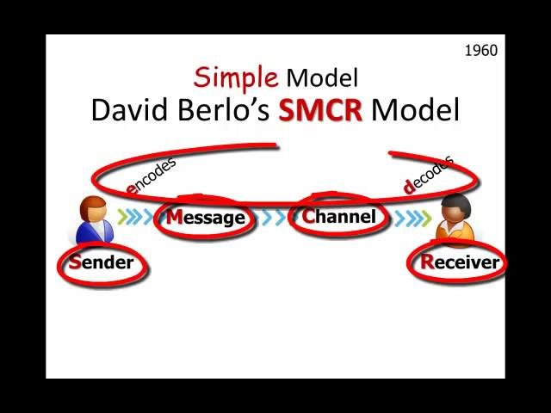
The sender is the person trying to convey a message to someone or people this is usually who generates the content or what is been communicated and sometimes can be referred to as the originator.
The message is what is been sent or information that is been passed it can usually be in the form of writing, email, or advertisement, the channels are the way or the platform on which the information is been passed it can be indifferent form, like telephone, email, Radio verbal, letter, or advertisement.
The receiver is the person or people that the message is been sent to. This can usually be an individual or sets of people and this is the people person the message is for and are required to decode or try to understand what the message is. And according to some other scholars
Communication is a transfer of information from one person to another, whether it elicits confidence. But the information transferred must be understandable to the receiver. G.G. Brown (2013) theory.
If you can convey what you wish to express and have someone else clean your meaning, then that’s communication T A Sullivan (2016) this is another definition of communication by this writer. Communication is the continual ongoing sending and receiving of messages through channels i.e. verbal, nonverbal, media, technology, affected by noise, sound, thoughts, smell, temp and coloured by context Deirdre Fitzgibbons(2018 ) communication is fulfilling the readers desire, whether it be for information or entertainment.as an author I communicate by delivering what my audience expects if I promise to deliver fiction by way of romance novels, that is what I must deliver.

Theories Models of Communication (Karen Cogen, Shannon and Weavers)
Karen Cogan (1978) many scholars define communication in many ways but it all agrees that it is an act or process of passing information from one person to another however everybody seems to agree that communication is very important in any organization because it helps in the function and coordination of tasks. Good communication in an organization also reduces chances of conflicts and misunderstanding in organizations because when there is good communication between two parties they understand each other better communication can be done in different ways in an organization but it is mostly done in three common ways which are verbal, nonverbal, and written but in any way it is done its aim and objective are always the same which is to get a message across or to pass on information however there are some barriers to effective communication and it can be in different forms like language barriers, not been able to send or get the message clearly it can also be noise, not paying enough attention this is why it is very important to always try to make your message very clear and be mindful of your language when you are communicating there are different types of models of communication in business which is considered as been one-sided because it does not show the response of the receiver but the Shannon and weavers(1948) models show that the receiver received the message clearly which is very vital because if the receiver dose not receive the message clearly and accurately it can cause very serious issues because it will be misleading and wrong information and this is why people should always be clear and accurate in sending messages and also have their audience or receiver in mind to make sure that they understand their language ,sing or signal.

Formal Communication
We communicate every time formally which means we communicate without even knowing that we are communicating but the most common form of communication is verbal which is referred to the interchange of information officially. Formal communication is controlled and is a deliberate effort. This makes it possible for the information to reach the desired place without any hindrance, at a little cost and in a proper way of we speak for people to hear and that is defined as oral communication. verbal or oral communication forms the most part of our day to day activity. Sometimes we even communicate by referring to as formal because it’s not informed of what we speak but can be in any other form like gesturing, signalling, or through our body language. This type communication is mostly used by people because it’s very easy and commonly used as legal texts such as contracts, property leases, real estate deeds, court-related documents e.g., indictments, divorce papers, lawsuits, civil and criminal litigation, and court proceedings in general and formal communication in the workplace is the most known by written, such as emails or posters. Formal communication also passes through predefined channels of communication throughout the organization

Informal Communication
We can communicate in writing or by advertising through messages or verbally. Informal communication refers to the form of communication which flows in every direction, it moves freely in the organization. For instance, I work with the NHS in a hospital environment as a porter and we communicate in different ways. And it depends on what the message is or who and what the message is about. As a porter, I usually communicate with so many people at work but in different ways and indifferent form. The main communication for me at work is usually with my manager and supervisor and sometimes with colleagues at work or with the clients. My manager will communicate with me in writing by email or letters whenever there is any information, he needs to pass to me. But my supervisor usually communicates with me through the radio transmitters that we use at the workplace. And I communicate with colleagues and clients verbally.
At my workplace, the radio communication is the most common and easiest way to give information and instructions to staff which is why everyone on duty always has one on every time they are on duty because with the radio you can be contacted wherever you are on the premises and information can be passed to you at any given time for you to carry out a task or when your attention is required.

Advantages.
- It is very easy to use in communicating with people because all you need to do is just to operate it the way it should be and say whatever message you wish to send and call the attention of who you want to receive the message.
- It is also effective and cost savings because the company doesn’t have to pay for the user each time it is used unlike some other communication gadgets
- It is also very safe and easy to use because it has no hazards effects.

Disadvantages
- It is not ideal for some people with hearing difficulties because sometimes it’s very difficult to hear the message on the radio.
- It’s also not conducive to use where there is a lot of noise in the background because it can let the receiver get the wrong message.

Effective communication
Effective communication is very essential in any organization because without effective communication any organisation cannot function effectively.
Effective Communication is very important in achieving any organization goal and this is why successful organization all over the world take effective communication very seriously, most organizations expand their business through good publicity which requires very good and vibrant communication and communication is even more important internally in a workplace because with good communication at work it will boost input and productivity at workplace and this is why it is very important at the workplace I define communication has been able to convey your thoughts to someone else. It doesn’t matter whether it’s through pictures, sing language, words, numbers, or colours.

References
Berlo, David (1960). The process of communication. New York: Rinehart, &Winston
Brown, G. G. (2013) Definition of communication. Available
Deirdre Fitzgibbons (2018) Communications Bridgewater State University
http://communicationtheory.org/definition-Of-communications Accessed April 2020
Karen Cogan (1978) Communications B.S Education and Psychology University of Houston
Shannon and Warren Weaver (1948) The Mathematical Theory of Communication. University of Illinois
T A Sullivan, Author, (2017) Technical Writer/Editor – UX Designer

