
What is Dementia
Dementia is a general term, not a specific disease. It is an impairment that hinders brain functions. It affects memory, making decisions and participating in daily activities (CDCP,2019). Dementia can also affect emotions and behaviours (NHS, 2020). In the UK 850,000 people are currently living with Dementia (OHD,2022)
Types of Dementia
Dementia is an umbrella term for over 100 mental disorders (Keith Bradley-Adams, 2020). The 4 main forms of Dementia in the UK are-
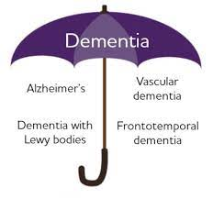(Alzheimer's Association, 2019)
Alzheimer’s disease gradually demolishes memory and all cognitive functions. Six in every ten people are diagnosed with Alzheimer’s (Alzheimer’s Research UK, no date).
Vascular dementia is the second most common form of dementia

ALL YOU NEED TO KNOW ABOUT DEMENTIA
"How your loved one may change”

Treatments
Presently there is no cure for dementia, like many mental disorders it can only be managed. Treatment varies from prescribed drugs, cognitive stimulation rehabilitation and alternative therapies these treatments may help or slow down the progression of dementia.
In the UK, four main prescribed drugs are available, they consist of donepezil, rivastigmine, galantamine and memantine. The main purpose of these drugs is to help with symptoms that affect memory and symptoms that effect mood and behaviour. It is important to note these are only prescribed by a doctor who specialises in dementia also that these drugs only work for 6-12 months and may not work for everyone.
Cognitive stimulation therapy involves group activities and exercises it is meant to help improve memory, language ability and problem-solving. Research suggests cognitive stimulation therapy helps people who are living with mild to moderate dementia (National Health Service, 2020).
Alternative therapies:
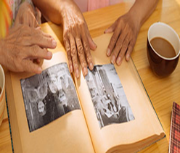
Alternative therapies such as music therapy, reminiscence work and animal assisted therapy all help people living with dementia. In Alzheimer’s disease music memories are often unspoilt because that part of the brain has been relatively untouched by the disease (Mayo Clinic,2021).

dementia in the UK following Alzheimer’s. It is when the brain gets damaged due to the lack of blood supply to the brain (AgeUk,2022).
Dementia with Lewy bodies is a rarity compared to Alzheimer’s and Vascular dementia. Dementia with Lewy bodies is caused when clumps of protein are formed in the brain cells (NIH,2021).
Frontotemporal dementia is another uncommon form of dementia. This form of dementia is caused by abnormal proteins building inside the brain cells, the build-up of these abnormal proteins is at the frontal and temporal lobes of the brain (NHS,2022).
Stages of Dementia
All forms of dementia are progressive which means it takes over several years to go through the stages of dementia however depending on which type of dementia it can progress more quickly than others. These stages are mild dementia, moderate dementia and severe dementia, each stage displays different symptoms. It is very important to remember dementia is different for everyone so the symptoms can vary and overlap in the stages (Alzheimer’s Society, 2020).
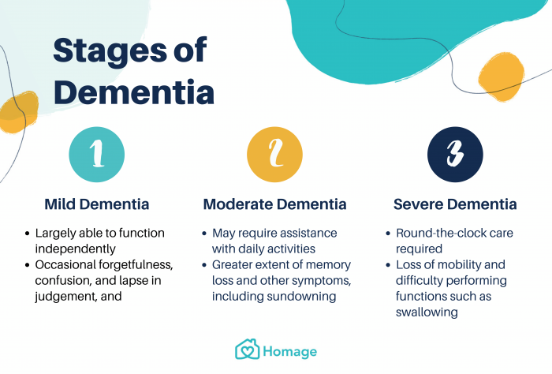
(Homage, no date)

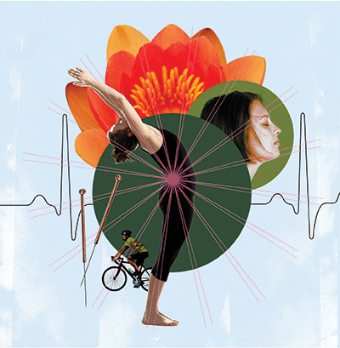
Increased research shows non-pharmacological approach should be used as a first-line approach and a pharmacological as a second although it varies from person to person.
Assistive Technology and Artificial Intelligence
Numerous devices are being created to help people maintain an independent life. Within the dementia world, three types of assistive technology have been developed for daily living, safety and telecare. Daily living devices consist of whiteboards, a kettle tipper and a timer to remind them to check the oven or hob. Safety devices are tracker key ring, smart locks and door alarms stop from wandering. Telecare devices vary from fall detectors, pressure mats and bed or chair occupancy sensors.
Introducing these devices to your loved one's home can be used to support safe walking, speech, hearing and sight. Artificial intelligence devices like Alexa can help with reminders, light settings around the home and can be used as a medical alert as well.
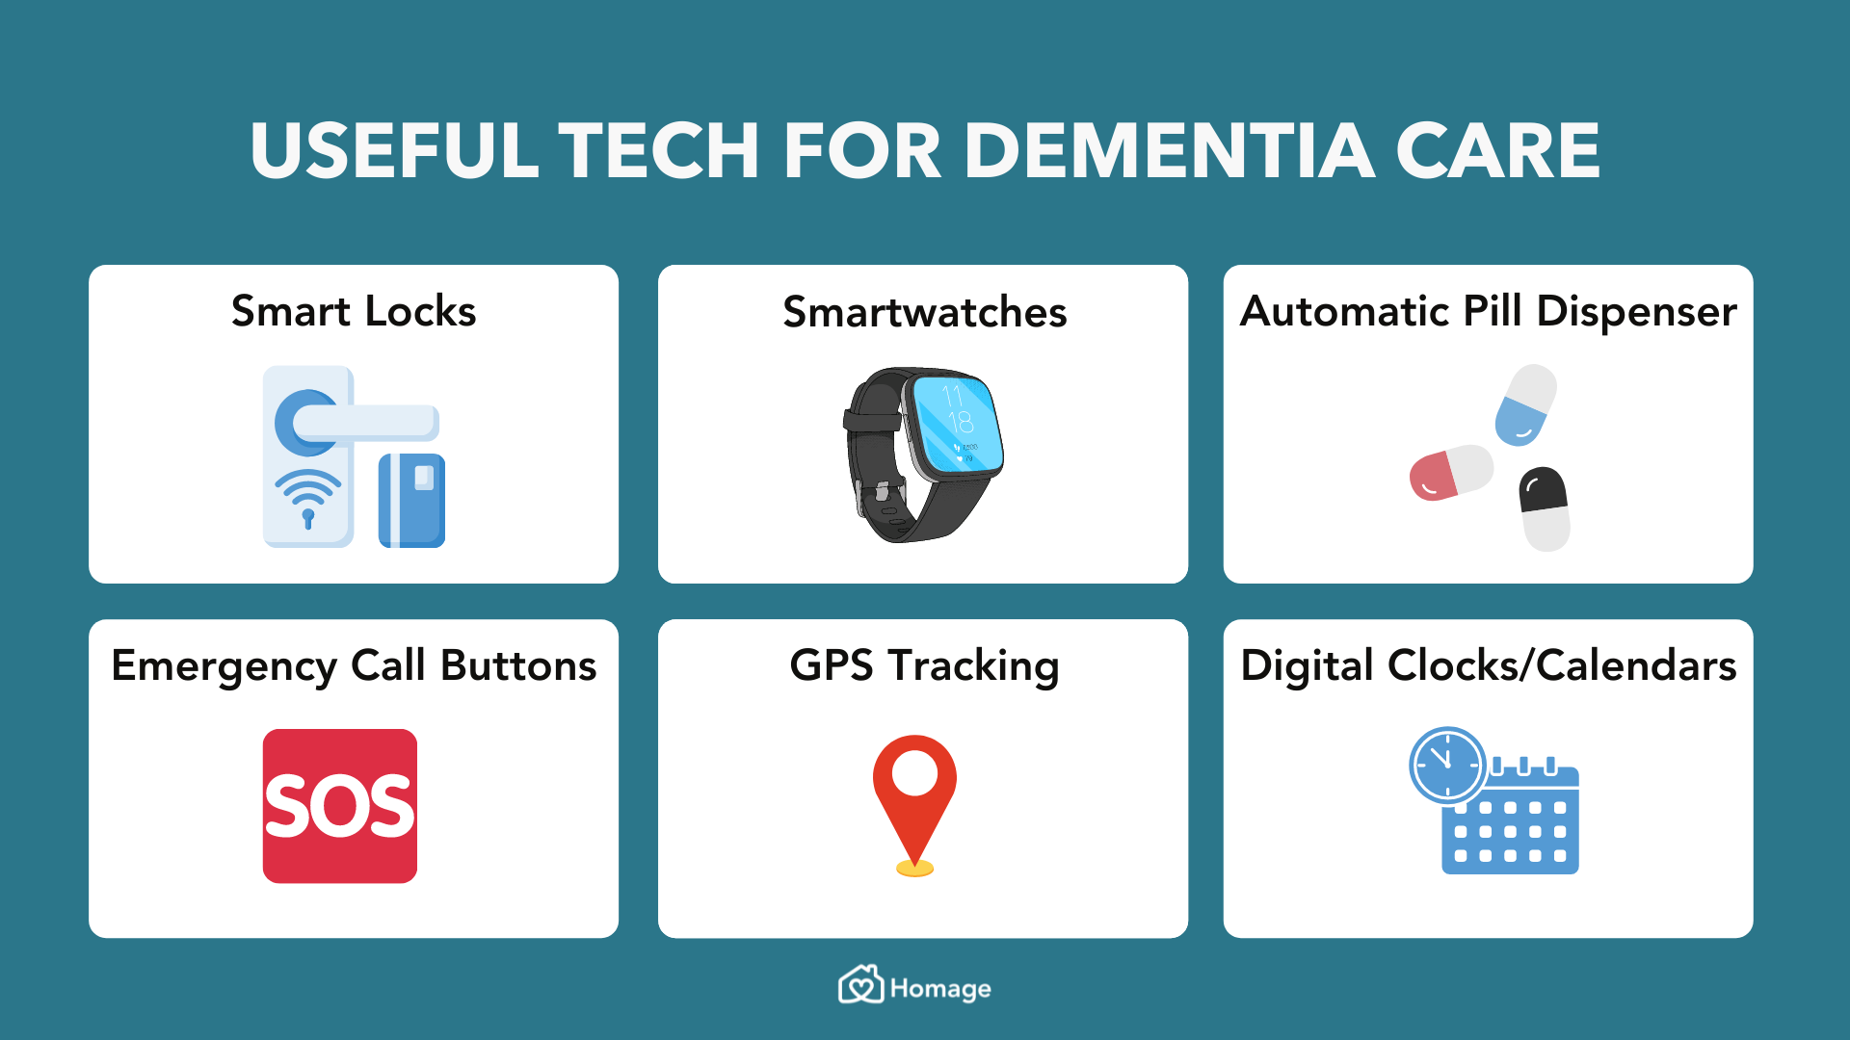
.

Reminiscence work uses all our senses touch, sight, smell, taste and sound by using objects through activities it helps them recall memories (Elder Care Alliance, 2017). Animal assisted therapy promotes independence and quality of life it also improves confidence and self-esteem (Alzheimer’s Society 2019). CBD oil, transcutaneous electrical stimulation and light are other alternative therapy. It helps some people with sleep problems, agitation and behaviour but more research is needed to see how effective it may be
Potential Needs and Requirements
Dementia will bring many changes to both the carer and the person diagnosed with dementia. As a carer or friend of a person living with dementia, you can help them to have autonomy in their own lives for as long as possible. Continue to see them as a person of sound mind who can participate in a conversation and give their opinions. When the time arises help them with hobbies and interest. Helping your loved one to continue to live their life as normal as possible will help with their battle with dementia When they have reached the third stage of dementia your loved one will require further care from round the clock care assistance, mobility and assistive technology.
Interventions
Interventions are important for people living with dementia, as it allows access to important resources and information. Having an early diagnosis allows your loved one to grasp what is happening and how they want to live their life. Early inventions can also help slow down the progression of the disease, it also paves way for your loved one to decide on the intervention available to them at that present time. Interventions consist of Pharmacological (drugs) or non-Pharmacological (non-use of drugs). The latter includes environmental and behaviour adjustments such as change of routine and helping with behaviour.

memories on the bottom shelf and your present-day memories on the top shelf. Over the years you have learnt many skills, gathered memories and accumulated a wealth of knowledge. Now imagine your bookcase has been rocked side to side by a strong gale of wind, what do you think will happen? Your books will fall, most likely from the top and some from the lower shelves. So short-term memories will fall first while childhood memories may still be unmoved. Once the gale of wind stops a person may try to put the books back on the shelf but the top shelf may be hard to reach, so many memories, skills and knowledge may never return. A person's memory may have disappeared but the way an experience has made a person feel does not vanish, this is why sensations such as taste, smell, sound/music are very important to help bring back memories for a person living with dementia.
Caring for someone can be rewarding but it can be emotionally draining, you may find yourself experience compassionate fatigue this is why support is available for carers. Please refer to sources of support for financial and emotional support.
Sources of support
Alzheimer's Society's Dementia Connect support line on 0333 150 3456.
Age UK Advice Line on 0800 678 1602 (free)
Independent Age Helpline on 0800 319 6789 (free)
Dementia UK's Admiral Nurse Dementia Helpline on 0800 888 6678 (free)
Carers Direct helpline on 0300 123 1053 (free) contact to get information for carer allowance and respite care.
Roni Akhtar 2006645

As a family/carer of a person with dementia, assistive technology and artificial intelligence would benefit both parties. It will help them to have healthy, productive and dignified lives and most importantly improve their independence, safety and well-being. It will give you the reassurance that your loved one is safe and has the means to contact you when necessary.
Legislations
The mental Capacity Act 2005 protects people who suffer from dementia, it protects people who may no longer have the capacity to make decisions. This legislation outlines who can and should decide on their behalf. A person’s financial affairs, private property and health and social care are all covered under the Mental Capacity Act 2005 (Alzheimer’s Society, no date).
Insight into a dementia
A great way to understand how your loved one’s mind now works is the bookcase analogy.
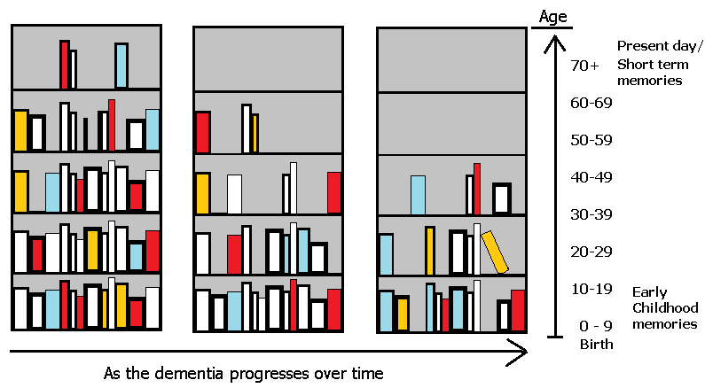
(Greensleeves care, no date)
Envision this bookcase as your brain has all your early childhood

Reference List
Age UK (2022) Understanding Dementia. Available at: https://www.ageuk.org.uk/information-advice/health-wellbeing/conditions-illnesses/dementia/understanding-dementia/
(Accessed: 11 October 2022).
Alzheimer’s Association (2019) Understanding Alzheimer’s and Dementia.
Available at: https://justiceinaging.org/wp-content/uploads/2021/06/Handout-from-Alzheimers-Association.pdf
(Accessed: 11 October 2022).
Alzheimer’s Research UK (no date) Alzheimer’s Disease. Available at: https://www.alzheimersresearchuk.org/dementia-information/types-of-dementia/alzheimers-disease/
(Accessed: 11 October 2022).
Alzheimer’s Society (2020a) The progression and stages of dementia. Available at: https://www.alzheimers.org.uk/sites/default/files/pdf/factsheet_the_progression_of_alzheimers_disease_and_other_dementias.pdf
(Accessed: 11 October 2022).
Alzheimer’s Society (2020b) Dementia and the Mental Capacity Act 2005. Available at: https://www.alzheimers.org.uk/get-support/legal-financial/dementia-mental-capacity-act
(Accessed: 12 October 2022).
Alzheimer’s Society (2019) Can Caring for a pet help a person with dementia. Available at: https://www.alzheimers.org.uk/blog/can-caring-for-a-pet-help-a-person-with-dementia#:~:text=Animal%2Dassisted%20interventions%20can%20often,part%20of%20a%20person's%20day.
(Accessed: 15 October 2022).
Bradley-Adams, K. (2020)’Determinants of Poor Mental Health and the Road to Recovery’, in Edwards, DJ and Best, B. (ed.) The textbook of Health and Social Care. London: Sage.
Centers for Disease Control and Prevention (2019) Alzheimer’s Disease and Healthy Aging. Available at:
https://www.cdc.gov/aging/dementia/index.html#:~:text=Dementia%20is%20not%20a%20specific,a%20part%20of%20normal%20aging
(Accessed: 07 October 2022).
Elder Care Alliance (2017) Benefits of Reminiscence Therapy. Available at: https://eldercarealliance.org/blog/benefits-reminiscence-therapy/#:~:text=Reminiscence%20therapy%20is%20a%20treatment,individuals%20with%20recall%20of%20memories.
(Accessed: 15 October 2022).
Greensleeves Care (no date) Dementia Bookshelf analogy. Available at: https://www.greensleeves.org.uk/knowledge-centre/dementia-like-a-bookshelf/
(Accessed: 12 October 2022).
Homage (no date) Dementia 101: Symptoms, Types, Stages, Treatment and Prevention. Available at: https://www.homage.com.au/health/dementia/ (Accessed: 11 October 2022).
Mayo Clinic (2021) Can music help someone with Alzheimer’s. Available at: https://www.mayoclinic.org/diseases-conditions/alzheimers-disease/expert-answers/music-and-alzheimers/faq-20058173

National Health Service (2020a) About Dementia. Available at: https://www.nhs.uk/conditions/dementia/about/
(Accessed: 07 October 2022).
National Health Service (2020b) Frontotemporal dementia. Available at: https://www.nhs.uk/conditions/frontotemporal-dementia/#:~:text=Frontotemporal%20dementia%20is%20an%20uncommon,the%20frontal%20and%20temporal%20lobes
(Accessed: 11 October 2022).
National Health Service (2020c) What are the treatments for Dementia. Available at: https://www.nhs.uk/conditions/dementia/treatment/#:~:text=Acetylcholinesterase%20inhibitors&text=Donepezil%20(also%20known%20as%20Aricept,mild%20to%20moderate%20Alzheimer's%20disease
(Accessed: 12 October 2022).
National Institute of Health (2021) What Is Lewy Body Dementia? Causes, Symptoms, and Treatments. Available at: https://www.nia.nih.gov/health/what-lewy-body-dementia-causes-symptoms-and-treatments#:~:text=Lewy%20body%20dementia%20(LBD)%20is,movement%2C%20behavior%2C%20and%20mood.
(Accessed: 11 October 2022).
Office for Health Improvement & Disparities (2022) Dementia: applying All Our Health. Available at: https://www.gov.uk/government/publications/dementia-applying-all-our-health/dementia-applying-all-our-health
(Accessed: 07 October 2022).

