Module name: Project Management
Module code: LCLM5003
Student name: Mariana Sherenha
Student ID: 2424533
Lecturer name: Sukhpreet Grewal
a Project portfolio

Part A – Poster 2
Part B – Reflection 3
Part C – Project Management Plan. Redevelopment of the Central Transport Hub 5
1. Introduction 5
2. Project Description 6
3. Project Scope 7
4. Work Breakdown Structure (WBS) 9
5. Quad Chart 11
6. Gantt Chart and Project Schedule 12
7. Stakeholders’ Involvement 13
8. Allocation of Resources 15
9. Risk Analysis 16
Conclusion 18
References 19

Part A – Poster

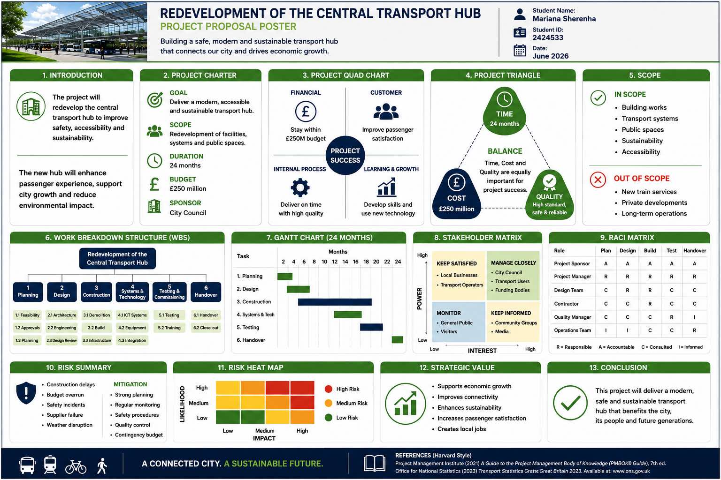

Part B – Reflection

The feedback received from my tutor and peers was valuable because it helped me recognise both the strengths of my project proposal and the areas that require further development. Overall, the response to my poster and presentation was positive. In particular, my tutor highlighted the effectiveness of my introduction, the clear organisation of the poster and the inclusion of all the required project management components. However, the feedback also made me realise that, while I had successfully covered all the required areas, some elements lacked the level of detail expected.

One of the strongest aspects of my presentation was the way I introduced the project. Rather than immediately describing the Central Transport Hub redevelopment, I began by asking the audience to imagine waking up the next morning and discovering that all transport had stopped. This scenario was intended to demonstrate how strongly people and cities depend on transport infrastructure in everyday life. My tutor responded particularly positively to this opening because it immediately attracted attention and created a clear context for the project. Reflecting on this, I realised that using a practical example can make a project proposal more engaging and help stakeholders understand its relevance before technical information is introduced.

Another strength identified in the feedback was that my poster incorporated all the components required by the assessment brief. These included the Project Charter, Quad Chart, Project Triangle, Scope, Work Breakdown Structure (WBS), Gantt Chart, Stakeholder Matrix, RACI Matrix, risk assessment and strategic value. I considered this a significant strength because it demonstrated my understanding of the different tools and structures used within project management. The overall poster was also considered organised, visually clear and professional.

However, this strength also contributed to the main weakness of my work. I focused heavily on ensuring that every required component was included. Due to the limited space available on the poster, I reduced the size and complexity of individual sections in order to make everything fit. As a result, several project management tools were presented too simply and did not demonstrate sufficient analytical depth. This was particularly evident in the risk assessment, WBS and Gantt Chart.

For example, the risk section identified important risks such as construction delays, budget overruns, safety incidents, supplier failure and weather disruption, but these were presented only at a high level. A more developed risk assessment should evaluate likelihood and impact, establish priorities, identify risk owners and provide specific mitigation and contingency actions. Similarly, the WBS should provide a more detailed decomposition of project activities and deliverables. The Gantt Chart should also demonstrate more clearly the sequencing, duration, dependencies and relationships between project activities rather than only providing a simplified project timeline.

This feedback will have a direct influence on my final Project Management Plan. I will retain the clear structure and comprehensive coverage that were recognised as strengths, but I will focus much more on depth and justification. Instead of simply demonstrating that each project management tool has been included, I will explain how and why it supports the successful delivery of the project. Overall, the feedback helped me understand that effective project management is not demonstrated by the number of tools included, but by how appropriately and thoroughly those tools are applied.

Part C – Project Management Plan. Redevelopment of the Central Transport Hub

1. Introduction

Transport infrastructure plays a fundamental role in supporting economic activity, social mobility and access to employment and public services. In the project scenario, the closure of a major Central Transport Hub has created significant disruption to commuter journeys, freight logistics, local businesses and the wider urban economy. The existing facility, constructed more than 40 years ago, no longer meets contemporary requirements for safety, accessibility and operational performance. Its redevelopment is therefore necessary not only to restore transport capacity but also to provide infrastructure capable of supporting the city’s longer-term economic, environmental and social objectives.

This Project Management Plan proposes the redevelopment of the Central Transport Hub as a 24-month infrastructure project with an approved budget of £250 million. The City Council will act as project sponsor, while successful delivery will require coordination between the project management team, designers, contractors, transport operators, technology specialists, regulators, funding bodies, local businesses and the wider community.

Professional project management requires more than completing a project within traditional time and cost constraints. Project success can also incorporate quality, stakeholder satisfaction, strategic value and achievement of intended outcomes (Atkinson, 1999; Serrador and Turner, 2015). Consequently, this plan integrates scope management, a Work Breakdown Structure (WBS), scheduling, stakeholder management, resource allocation and structured risk management.

The plan also responds directly to the feedback received following the Part A project proposal. Although the original poster successfully incorporated the required project management components, the WBS, Gantt Chart and risk assessment were presented at a relatively high level. These areas are therefore developed in greater analytical depth within the final Project Management Plan.

2. Project Description

The purpose of the project is to redevelop the existing Central Transport Hub into a modern, safe, accessible, technologically integrated and environmentally sustainable transport interchange. The redevelopment will restore essential transport capacity while improving passenger circulation, public spaces and connections between different transport modes.

The principal objective is to complete the redevelopment within the approved £250 million budget and 24-month programme while achieving the required standards of safety, accessibility and quality. Additional objectives include integrating modern passenger information and ICT systems, incorporating sustainable design principles, improving passenger experience and creating infrastructure capable of supporting future transport demand.

The project will progress through six principal phases: planning and project preparation; design; construction; systems and technology; testing and commissioning; and handover and close-out. A structured lifecycle provides greater management control because key deliverables can be reviewed before the project progresses into increasingly expensive and complex stages. APM (2019) similarly emphasises management across the complete project lifecycle rather than treating delivery activities independently.

Project success will not be assessed solely by adherence to time and cost. Mir and Pinnington (2014) demonstrate a relationship between project management performance and broader project success, while Serrador and Turner (2015) distinguish project efficiency from overall project outcomes. For the Central Transport Hub, successful delivery therefore requires operational reliability, accessibility, safety, stakeholder acceptance and long-term value alongside compliance with the £250 million budget and 24-month programme.
The relationship between the principal project constraints is illustrated in Figure 1.
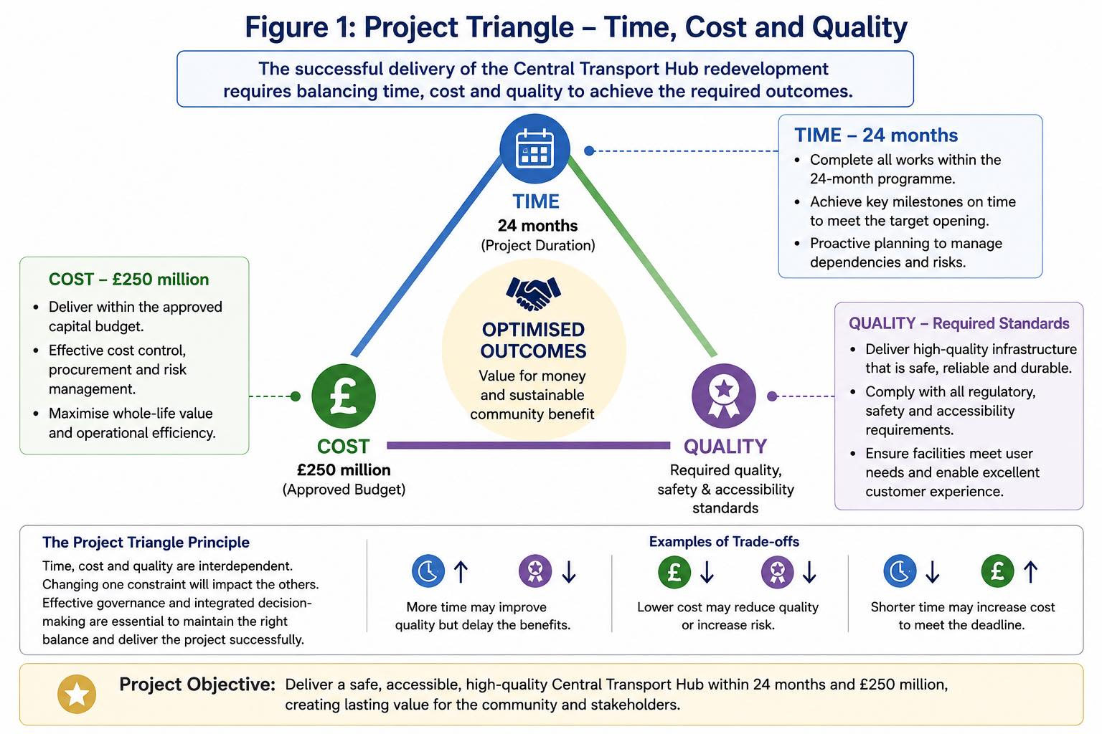

The project triangle demonstrates that time, cost and quality are interdependent. Accelerating construction may require additional resources and increase cost, whereas excessive cost reduction could compromise quality or increase delivery risk. Decisions should therefore consider the combined effect on the three constraints rather than optimising one dimension in isolation (Atkinson, 1999).

3. Project Scope

Effective scope management establishes clear boundaries concerning what the project will and will not deliver. This is particularly important for a major infrastructure project because uncontrolled changes can affect programme duration, expenditure, resource requirements and overall risk exposure.

The redevelopment includes demolition and enabling works, construction and refurbishment of transport facilities, passenger circulation and public spaces, mechanical and electrical infrastructure, ICT and passenger information systems, security systems, accessibility improvements, sustainability measures, testing and commissioning, staff training and operational handover.

Accessibility represents an important requirement. The redeveloped hub will incorporate step-free routes, accessible passenger information, appropriate wayfinding and inclusive public spaces. Sustainability will similarly influence design and construction through energy efficiency, responsible material selection, waste reduction and consideration of whole-life environmental performance.

The project excludes the introduction of new train services, unrelated private developments surrounding the hub, wider expansion of the rail network and long-term operation of the facility following handover. These boundaries prevent the project from expanding into activities that would require separate funding, governance and business cases.

Table 1

In Scope  Building and redevelopment works  Demolition and enabling works  Transport systems  ICT and passenger information systems  Public and passenger spaces  Accessibility improvements  Sustainability measures  Testing and commissioning  Staff training and handover | Out of Scope  New train services  Private developments  Long-term hub operations  Wider rail-network expansion  Unrelated city transport projects  Future transport service expansion  Long-term maintenance contracts  Developments outside the project boundary

Any proposed scope change will be documented and assessed for its effects on cost, schedule, quality, resources, benefits and risk before approval. Significant changes affecting the approved baseline will require sponsor authorisation. This formal change-control approach protects the £250 million budget and 24-month target while reducing the potential for uncontrolled scope creep (PMI, 2025).

4. Work Breakdown Structure (WBS)

The WBS decomposes the overall project into progressively smaller and more manageable deliverables and work packages. It provides a foundation for scheduling, resource allocation, cost estimation and accountability. In response to the feedback received on Part A, the WBS has been expanded considerably beyond the simplified structure presented on the original poster.

The project is decomposed into six major workstreams: planning and preparation; design; construction; systems and technology; testing and commissioning; and handover and close-out.
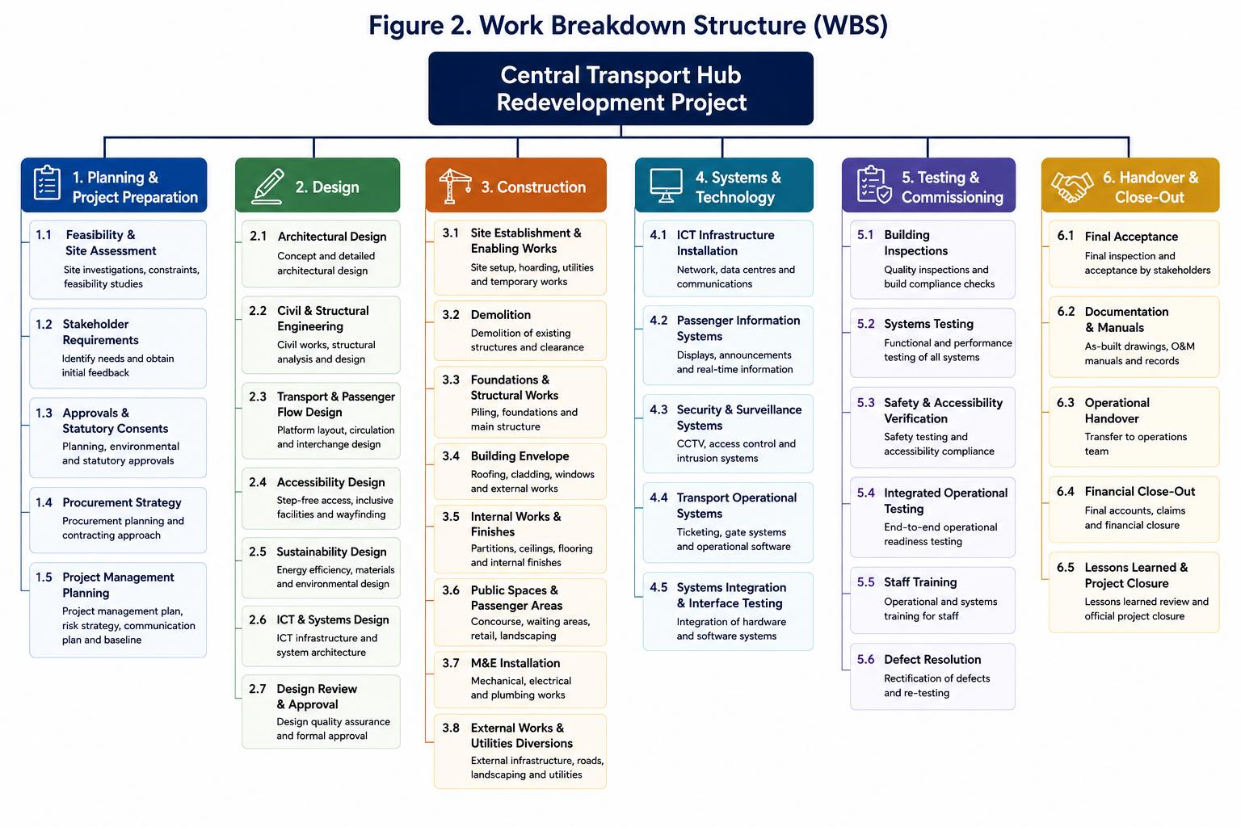

Planning includes feasibility assessment, stakeholder requirements, statutory approvals, procurement strategy and project management planning. Design incorporates architectural, structural, transport-flow, accessibility, sustainability and ICT requirements. Construction is further decomposed into enabling works, demolition, structural works, building envelope, internal works, passenger areas and mechanical and electrical installation.

Systems and technology are treated as a distinct workstream because successful operation depends upon integration between physical infrastructure and ICT, passenger information, security and operational transport systems. Testing and commissioning subsequently verify building quality, system performance, safety, accessibility and operational readiness before final handover.

The expanded WBS strengthens project control because individual work packages can be assigned specific owners, resources, costs and durations. It also creates a direct relationship between project scope and the programme presented in the Gantt Chart.

5. Quad Chart

The Quad Chart provides a concise strategic overview of project requirements across financial, customer/stakeholder, internal-process and learning-and-growth perspectives.
Project Quad Chart

Table 2

Perspective | Project Requirement
Financial | Deliver within the £250 million budget and maintain effective forecasting, cost control and contingency management.
Customer/Stakeholder | Improve passenger safety, accessibility, reliability and satisfaction while managing construction disruption.
Internal Process | Deliver within 24 months while meeting quality, safety, regulatory and operational requirements.
Learning and Growth | Develop digital capability, integrated working, knowledge transfer and effective use of modern technology.

The Quad Chart reinforces the principle that project success extends beyond financial performance. A transport hub completed within budget would still represent an unsuccessful outcome if the facility were unsafe, inaccessible or operationally ineffective. This broader interpretation is consistent with research demonstrating that project efficiency contributes to success but does not represent its complete definition (Serrador and Turner, 2015).

6. Gantt Chart and Project Schedule

Scheduling translates the WBS into a time-based delivery programme. The project will be delivered over 24 months, with selected activities overlapping where technically feasible. Dependencies are incorporated to prevent activities from progressing before the necessary predecessor work has reached an appropriate level of completion.

The detailed programme is presented in Figure 3.

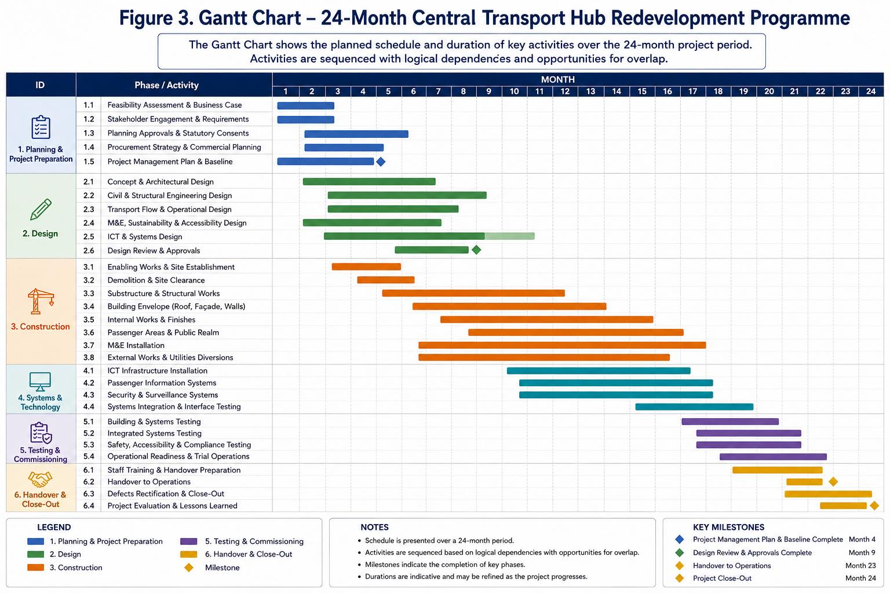
The programme begins with feasibility assessment, stakeholder requirements, planning approvals and establishment of the project baseline. Design activities commence during the planning period and progressively develop architectural, structural, operational, sustainability and systems requirements. Procurement and enabling activities can overlap with later design work once sufficient information has been approved.

Main construction represents the most resource-intensive stage and includes demolition, structural works, building-envelope activities, internal works, passenger areas, mechanical and electrical systems and external infrastructure. ICT installation follows sufficient completion of relevant construction areas, after which system integration can proceed.

Testing and commissioning depend upon both physical construction and technology installation. Operational training overlaps with later commissioning activities so that staff are familiar with the new facility before final acceptance and handover.

Schedule dependencies require particular management attention because delays can propagate through subsequent work packages. Research concerning transport infrastructure demonstrates that extended implementation periods can increase exposure to cost escalation (Flyvbjerg, Holm and Buhl, 2004). Schedule management therefore also contributes directly to financial control.

7. Stakeholders’ Involvement

Major infrastructure projects involve stakeholders with different levels of power, interest and expectations. Stakeholder involvement must therefore continue throughout the project lifecycle rather than being limited to consultation at project initiation.

Olander (2007) argues that construction stakeholder analysis should consider stakeholder influence and attitudes toward the project. Aaltonen and Kujala (2010) additionally demonstrate that stakeholder influence strategies may change throughout different phases of a project’s lifecycle. Consequently, the engagement strategy for the Central Transport Hub must remain responsive as stakeholder requirements and project impacts evolve.

The primary stakeholders are positioned according to their relative power and interest in Figure 4.

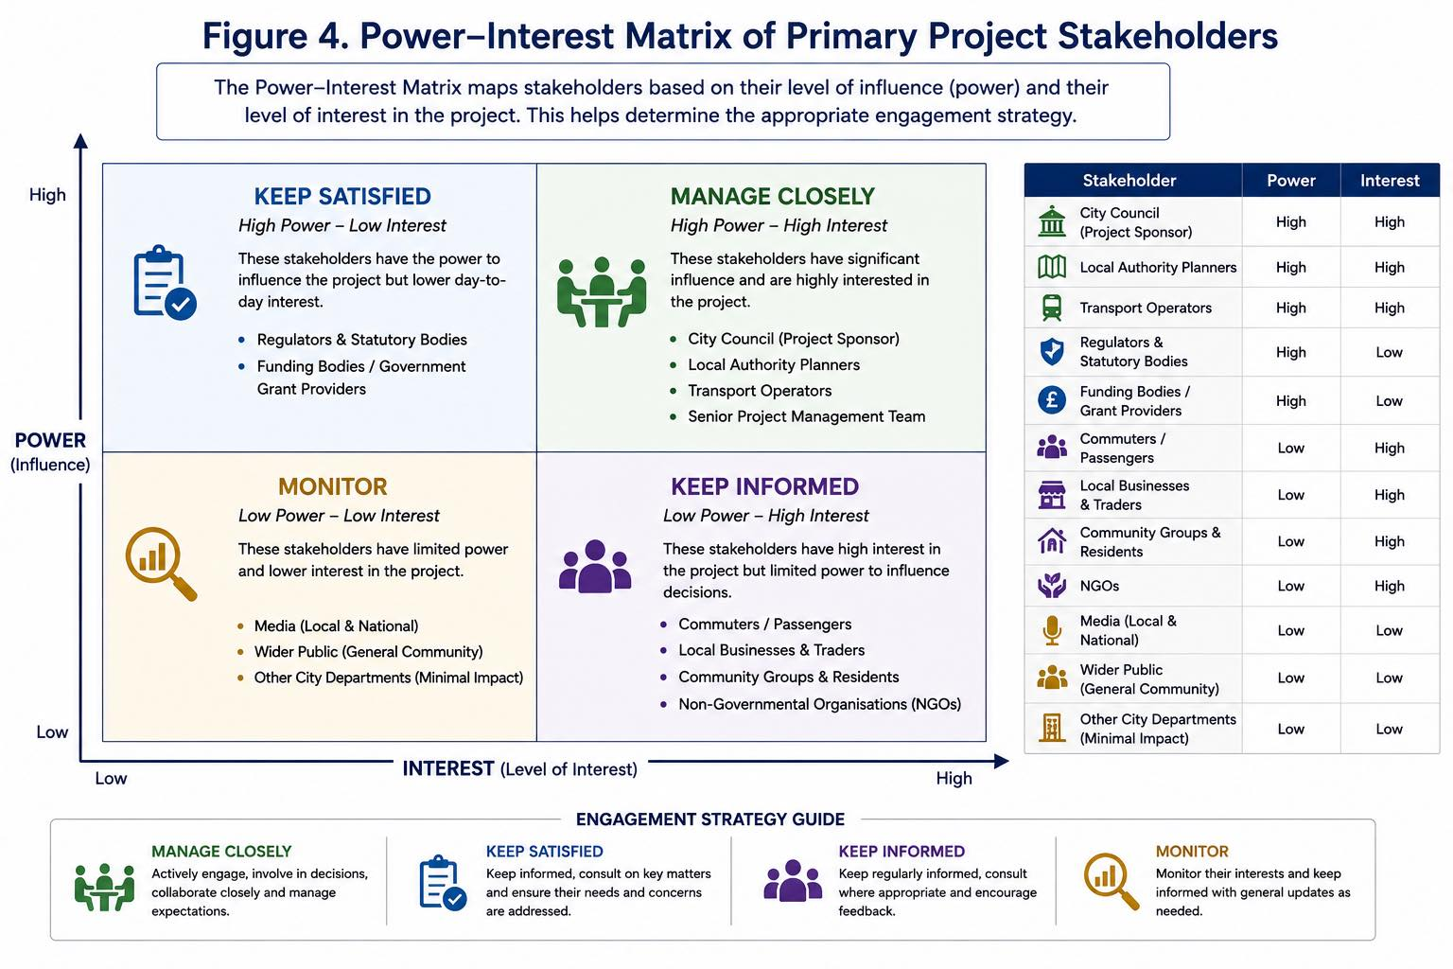
Effective stakeholder involvement is particularly important in public infrastructure because technical feasibility alone does not guarantee stakeholder acceptance. Bryson (2004) demonstrates how systematic stakeholder analysis can support decisions that are technically feasible and politically acceptable. Engagement mechanisms for this project will therefore include governance meetings, stakeholder workshops, public consultation, surveys, project updates and formal issue management.

8. Allocation of Resources

Successful delivery requires coordinated allocation of human, financial, physical and technological resources. Resource requirements will change significantly throughout the 24-month lifecycle and should therefore be aligned directly with the WBS and project schedule.

During the early phases, project management, planning, architectural and engineering specialists will represent the principal human-resource requirement. Construction labour and specialist trades will increase substantially during enabling and structural works. Mechanical and electrical requirements will increase during the middle stages of construction, while ICT specialists become increasingly important during systems installation and integration.

Testing, quality assurance, health and safety and operational resources become increasingly significant as completion approaches. Operations and training personnel are introduced before final handover to support operational readiness and knowledge transfer.

The changing resource profile is illustrated in Figure 5.

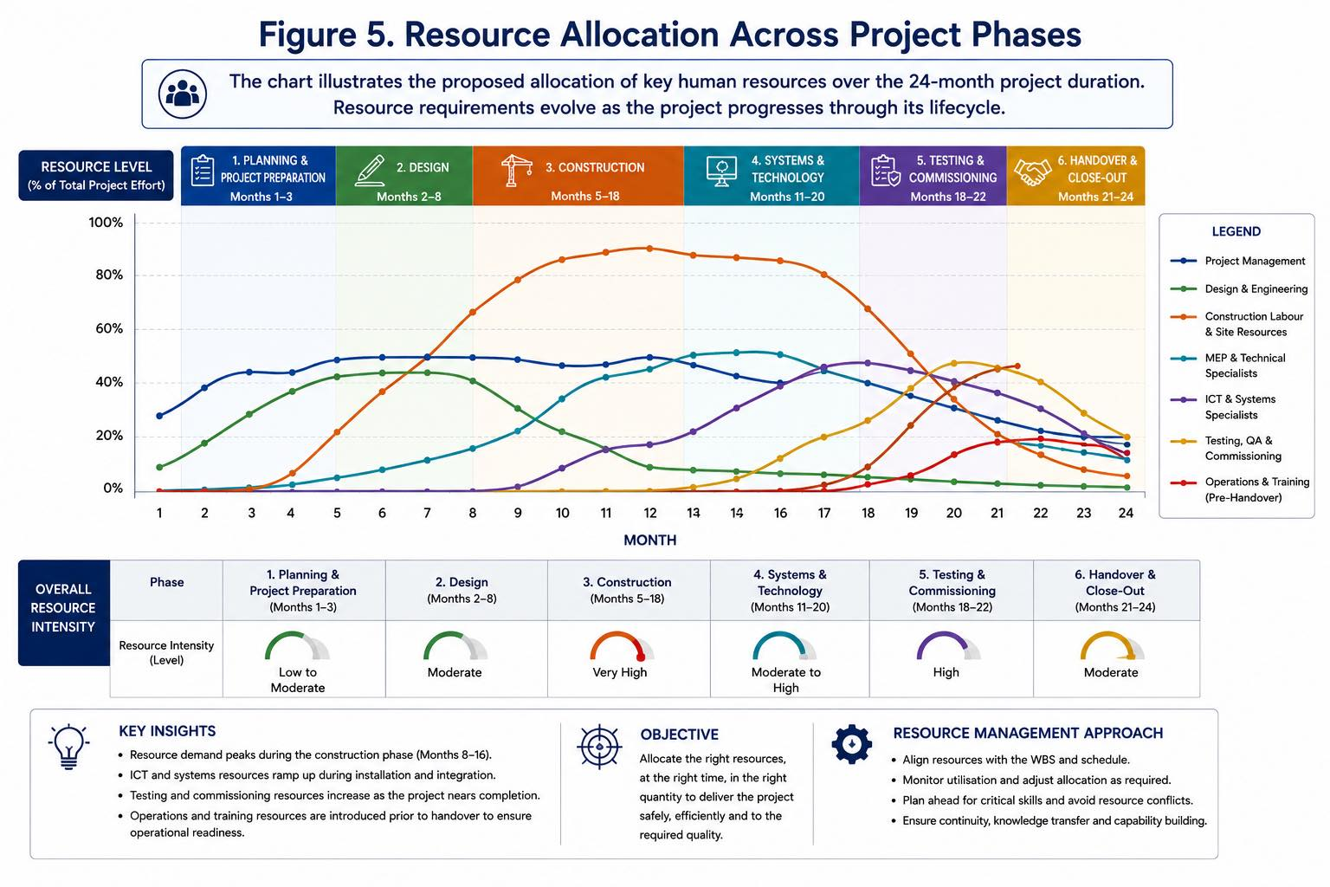
Cost control is particularly important in major infrastructure delivery. Flyvbjerg (2014) identifies cost and schedule overruns as recurring challenges associated with megaprojects. Regular forecasting, variance analysis, contingency control and formal change management will therefore be applied rather than relying exclusively on the original budget baseline.

UK public-sector construction guidance similarly emphasises early planning, appropriate commercial arrangements, effective risk allocation and consideration of whole-life value when delivering public works (Cabinet Office, 2022).

9. Risk Analysis

Risk management represents one of the areas most significantly strengthened following feedback on Part A. The original poster identified construction delays, budget overruns, safety incidents, supplier failure and weather disruption but did not sufficiently establish probability, impact, ownership or detailed response actions.

ISO 31000 provides principles and guidance for integrating risk management into organisational decision-making and emphasises that the approach should be appropriate to the relevant context (ISO, 2018). A live risk register will therefore be maintained throughout the Central Transport Hub project.
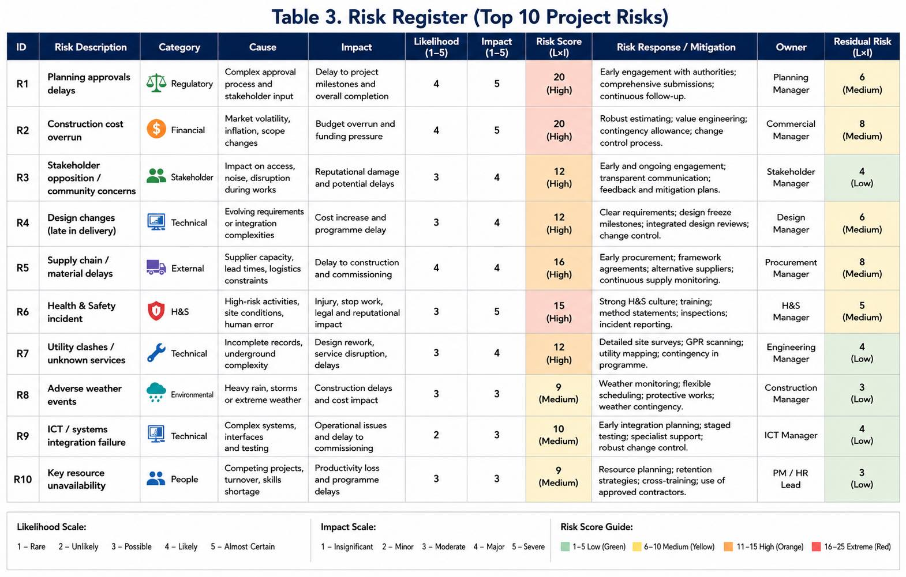
Table 3 identifies the ten principal project risks and evaluates their likelihood, impact, mitigation measures and ownership. The highest-priority risks relate to planning approvals, cost overruns, supply-chain disruption and health and safety. Each risk is assigned to a responsible owner and supported by mitigation measures designed to reduce its likelihood or impact. Residual risk is assessed following mitigation, enabling the project team to prioritise monitoring and response throughout the project lifecycle.

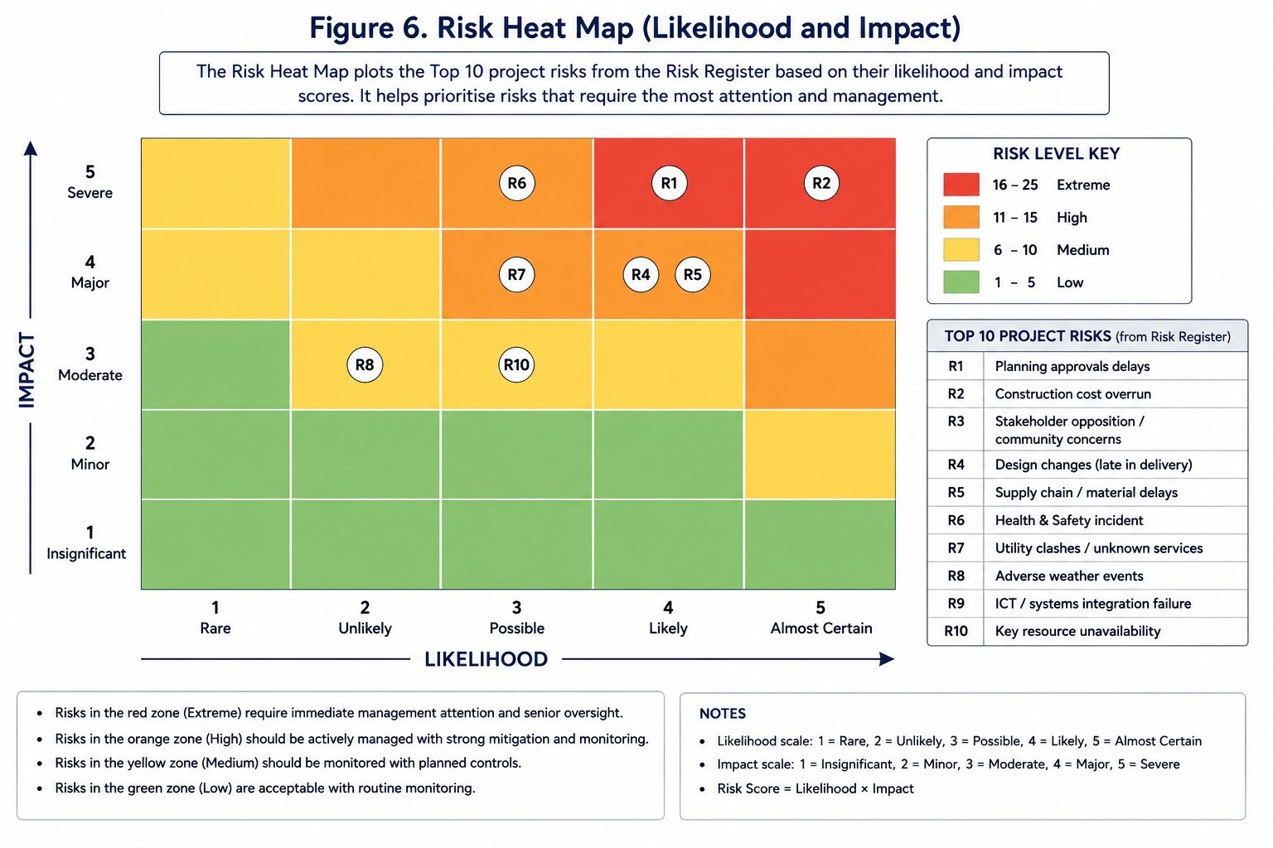
Figure 6 illustrates the likelihood and impact of the key project risks. Risks in the high and extreme zones require priority management and regular monitoring, while medium and low risks remain subject to appropriate controls. The heat map supports effective prioritisation and enables the project team to focus resources on the most significant threats to successful delivery.

Conclusion

The redevelopment of the Central Transport Hub is a complex infrastructure project requiring effective management of time, cost, quality, stakeholders, resources and risk. This Project Management Plan provides a structured approach to delivering the project within the 24-month programme and £250 million budget while meeting safety, accessibility and sustainability requirements. The application of the WBS, Gantt Chart, stakeholder analysis, resource planning and risk management supports effective project control and informed decision-making. Overall, successful delivery will depend on continuous monitoring, stakeholder collaboration and appropriate management of project risks throughout the lifecycle.

References

Aaltonen, K. and Kujala, J. (2010) ‘A project lifecycle perspective on stakeholder influence strategies in global projects’, Scandinavian Journal of Management, 26(4), pp. 381–397. doi: 10.1016/j.scaman.2010.09.001.

Association for Project Management (APM) (2019) APM Body of Knowledge. 7th edn. Princes Risborough: Association for Project Management.

Atkinson, R. (1999) ‘Project management: cost, time and quality, two best guesses and a phenomenon, its time to accept other success criteria’, International Journal of Project Management, 17(6), pp. 337–342. doi: 10.1016/S0263-7863(98)00069-6.

Bryson, J.M. (2004) ‘What to do when stakeholders matter: stakeholder identification and analysis techniques’, Public Management Review, 6(1), pp. 21–53. doi: 10.1080/14719030410001675722.

Cabinet Office (2022) The Construction Playbook: Government Guidance on Sourcing and Contracting Public Works Projects and Programmes. Version 1.1. London: HM Government.

Flyvbjerg, B. (2014) ‘What you should know about megaprojects and why: an overview’, Project Management Journal, 45(2), pp. 6–19. doi: 10.1002/pmj.21409.

Flyvbjerg, B., Holm, M.S. and Buhl, S. (2004) ‘What causes cost overrun in transport infrastructure projects?’, Transport Reviews, 24(1), pp. 3–18. doi: 10.1080/0144164032000080494a.

International Organization for Standardization (ISO) (2018) ISO 31000:2018 Risk Management – Guidelines. Geneva: International Organization for Standardization.

Mir, F.A. and Pinnington, A.H. (2014) ‘Exploring the value of project management: linking project management performance and project success’, International Journal of Project Management, 32(2), pp. 202–217. doi: 10.1016/j.ijproman.2013.05.012.

Olander, S. (2007) ‘Stakeholder impact analysis in construction project management’, Construction Management and Economics, 25(3), pp. 277–287. doi: 10.1080/01446190600879125.

Project Management Institute (PMI) (2025) A Guide to the Project Management Body of Knowledge (PMBOK Guide) and The Standard for Project Management. 8th edn. Newtown Square, PA: Project Management Institute.

Serrador, P. and Turner, R. (2015) ‘The relationship between project success and project efficiency’, Project Management Journal, 46(1), pp. 30–39. doi: 10.1002/pmj.21468.

