Managing Hotel Administration at Novotel Liverpool Centre
Sales and Reservations

Module: BMIH6004 Managing Hotel Administration
Student: Monica Roman
Student id: 2128507
Lecturer: Ben Chong

AI aknowledgement: I confirm that I have not used any AI tools in the research and creation of this assignment. I confirm that I have not presented any AI generated materials as my own work. I confirm I have copies of my drafts, notes and other resources I used, which I may be asked to provide in evidence.

While undertaking my 10 weeks placement at the Novotel Liverpoool Central as part of my academic schedule, I was able to observe how most of the departments work, but also to shadow the respective managers and staff, learn from and help them with daily duties. This placement, but also the previous one in Level four and my prevoius Food and beverage experience in a hotel, enabled me to gain a clearer view and appreciation of how big hotels function. One of the departments that has a great contribution to the success of a hotel, but is working from behind closed doors is the Sales and reservations department. They are part of the Back office, and are not customer facing roles, but deal directly with guests through phone calls and reservation emails. The main business objective of a hotel is to sell its rooms (Prosper, 2024), therefore o good sales department is essential to boosting the revenue, creating lasting and fruitful relationships with major companies that will book at corporate level. Gibbs’ Reflective Cycle (Gibbs, 1988) was used to structure my reflection upon my experince in the sales department, and it includes the description, feelings, evaluation, analysis, conclusions, and an action plan. The reflection critically examines how my experience contributed to both my personal and professional development, highlighting the success and challenges I encountered, and emphasising how theoretical knowledge and prior academic experience have formed my practical skills during the placement.
According to different studies, students who undertake placements during their academic journey are more dedicated, and more engaged in their studies after returning from placement (Aston University, 2017) and „appear to be more driven to succeed”. Blackwell et al. (2002) conclude that, when students are asked by the University to reflect on their learning, placements are more successful.
An accurate forecasting of hotel occupancy rates and reservations is important in basically all areas of the hotel operations (Green and Weaver, 2008). Understanding the concept of managing the Sales and Reservations department was a great exposure and helped me broaden my vision as to what hotel administration entails. Firstly, I realised how important active listening and communication is in the hotel setting where, for instance, the reservations person takes special requests from a guest, regarding food allergies, room requirements, disability access, a special event during the stay. These details must then be forwarded to the entire team at reception, housekeeping and food&beverage. All the information is added to the guest profile, so upon arrival and check-in all staff are aware of the circumstances. This creates a first positive impression, contributes to a great guest experience and enhances the overall satisfaction. Observing these communications also provided insight into the fact that coherence needs to be upheld in order to minimise disruptions to operations. According to Accor (2024) their „sales teams drive revenue and growth, ensure the business attracts and retains clients, and maintains high standards of guest satisfaction.” Marija, the sales manager at Novotel Liverpool describes herself as a reactive sales manager, not exactly what the company would want. According to her, Accor prefers pro-active sales managers, people who are actively looking to create more business connections that would bring corporate bookings and repeat custom. Marija used to work in the front office when she was given the opportunity to progress, and take on the sales manager position. She looks after two main cathegories of guests: groups and corporate clients. Corporate guests are a big part of the hotel’s revenue; some contracts are signed by head-office Accor with Government agencies and multi-national companies, while other corporate contracts are negotiated and signed locally (Fig.2). Corporate rates can be static or dynamic and are offered depending on client and the number of rooms being contracted per year. These rates are reviewed every year and past customers get different incentives. The sales’ team job is to maintain good relations with all these clients, ensure contracts are respected and fulfilled, ensuring future growth in revenue and increase brand awareness (LinkedIn, 2024). A thorough market and competitor analysis help Marija and her team attract new clients and negotiate better rates. Every week the sales department attends a revenue meeting with the financial officer from head-office, where the performance of the hotel is reviewed and analysed, comparing it to the competitors (Fig.1 ). Participating in one of these meetings made me realise that I would not like to work in the sales department. It is all about numbers, increase sales and market analysis and is not something I would enjoy, I am a social, people person.
One day, during my placement, Marjia received a call from a lady from the Isle of Mann. She belongs to a group of fifty women from the island who come to Liverpool every year for their Christmas shopping. They have been staying at the Novotel since the opening in 2016. Being loyal guests, Marjia offers them a preferential rate as the group comes mid-week, before the peak season. Listening to the call, I realised there is more than a professional relationship with this group, Marjia was talking to the lady as if to a friend. Because they are a small, individual group and they have been coming for years, Marjia knows what to offer them and keep them happy to return next year. But not all clients are so easy to deal with. At the beginning of my placement, The Labour Party National Convention took place in Liverpool. It was a major event, with hundreds of participants staying at different hotels in Liverpool. In case of major political, sport or cultural events, there are third parties in charge of organising these and distributing guests to all hotels that have signed up (Trust reservations, 2024). Novotel Liverpool had a different pre-booked group of forty rooms that overlapped with the Labour Conference. Due to a mistake in reservations department, the details of these booking were not checked properly and it resulted in a situation that could have damaged the hotel’s reputation. The group of forty rooms had to be outbooked to a different hotel for one night, on the expence of Novotel Liverpool. Fortunately the guests who had to move were understanding, and the situation was solved quickly. I realised after this incident, how much responsibility is involved when dealing with reservations, especially for big groups. Hotels tend to overbook their rooms, to maximise revenue and have a back-up for particular circumstances (Siteminder,2024), but never for so many rooms. If there had been no availability at another hotel for the forty room group, Novotel’s reputation and relationship with the corporate client would have suffered. Attention to detail and communication are crucial skills in sales and reservations, to make sure every request is looked into, confirmed and passed on to front office and the other departments involved (food&beverage for catering needs and housekeeping for rooming). And, as always, especially in hospitality it comes down to team work: the group effort of all departments to create a seamless and memorable guest experience (Jung, Lee and Lim, 2023) for both leisure and business guests.
My sales department experience was more an observational one as compared to the other departments, where I could get hands-on, and actually help and learn. It takes a different set of skills for sales which I realise I do not have, but I have learned that you can sell all the hotel’s rooms, but without the front-line staff to turn the stay into a memorable experience it is just a business transaction.
Action plan:
- Sales department should have a handover file for big group details, to be accesible to all staff in the department, to avoid mistakes like the one presented above.
- Sales manager should try and be pro-actively looking for local and regional corporate clients, establish new connections with local and national travel agencies to fill rooms in low season.
- Sales department should sell conference rooms for other events (celebrations) to diversify offering and increase revenue.
- F&B staff (not only managers) should get a detailed event memo – including room set-up, coffee break/meals included in package - for conference groups not just brief notes.

References:
Accor Group (2024) Novotel Liverpool Centre. Available at: https://all.accor.com/hotel/6495/index.en.shtml?utm_campaign=seo+maps&utm_medium=seo+maps&utm_source=google+Maps (Accessed: 09 November 2024).
Accor Group (2024) Discover exciting sales jobs at Accor [blog]. Available at: https://careers.accor.com/global/en/blogs/2024-8/discover-exciting-sales-jobs-at-accor (Accessed: 07 November 2024).
Aston University (2017) Do work placements improve final year academic performance? Available at: https://publications.aston.ac.uk/id/eprint/26297/1/Work_placements_improving_final_year_academic_performance.pdf (Accessed: 07 November 2024).
Blackwell, A. et al. (2001) Transforming Work Experience in Higher Education. British Educational Research Journal 27, no. 3: 269- 285 , https://doi.org/10.1080/01411920120048304 (Accessed: 09 November 2024).
Cannon, D. F. (1999) Career Dynamics of Hotel Sales and Marketing Professionals. Journal of Hospitality & Tourism Education, 11(4), 40–44. https://doi.org/10.1080/10963758.1999.10685256 (Accessed: 06 November 2024).
De Jong, S. and Del Junco, C. (2023) How do professional staff influence academic knowledge development? A literature review and research agenda’, Studies in Higher Education, 49(6), pp. 1042–1065. doi: 10.1080/03075079.2023.2258155 (Accessed: 07 November 2024).
Department for Business, Innovation & Skills (2012) Following up the Wilson Review of Business-University Collaboration. London: Department for Business, Innovation & Skills.
Gibbs, G. (1988) Learning by doing: A guide to teaching and learning methods [pdf]. Oxford: Further Education Unit, Oxford Brooks University. Available at: https://stephenp.net/wp-content/uploads/2015/12/learning-by-doing-graham-gibbs.pdf (Accessed: 12 October 2024).
Jung, H. J., Lee, S. H., Lim, S.G. (2023) Enhancing teamwork in the hospitality industry: The importance of empathy. International Journal of Hospitality Management,
Vol. 114. https://doi.org/10.1016/j.ijhm.2023.103557 (Accessed: 09 November 2024).
Kross, E., Ong, M. and Ayduk, O. (2023) 'Self-Reflection at work: why it matters and how to harness its potential and avoid its pitfalls,' Annual Review of Organizational Psychology and Organizational Behavior, 10(1), pp. 441–464. Available at: https://doi.org/10.1146/annurev-orgpsych-031921-024406 (Accessed: 06 November 2024).
LinkedIn (2024) Driving success: The importance of the sales team in a hotel. Available at: https://www.linkedin.com/pulse/driving-success-importance-sales-team-hotel-wilson-panneerselvam-utjbc (Accessed: 05 November 2024).
Prosper (2024) https://www.prosperhotels.com/blog/hotel-sales-management/ Accessed: 05 November 2024).
Siteminder (2024) Hotel overbooking: strategy, solutions and policies. Available at: https://www.siteminder.com/r/hotel-overbookings-pros-and-cons-strategy/ (Accessed: 10 November 2024).
Trust Reservations (2024) Labour Party Conference Liverpool 2024. Available at: https://www.trustreservations.com/labour2024 (Accessed: 10 November 2024).
Vallen, G. and Vallen, J. (2013) Check-In Check-Out: Managing Hotel Operations . Harlow: Pearson New International Edition, Pearson Education, Limited. Available from: ProQuest Ebook Central https://ebookcentral.proquest.com/lib/trinity/reader.action?docID=5173949 (Accessed: 06 November 2024).
.

Appendix:
- Fig. 1 Revenue management meeting slide
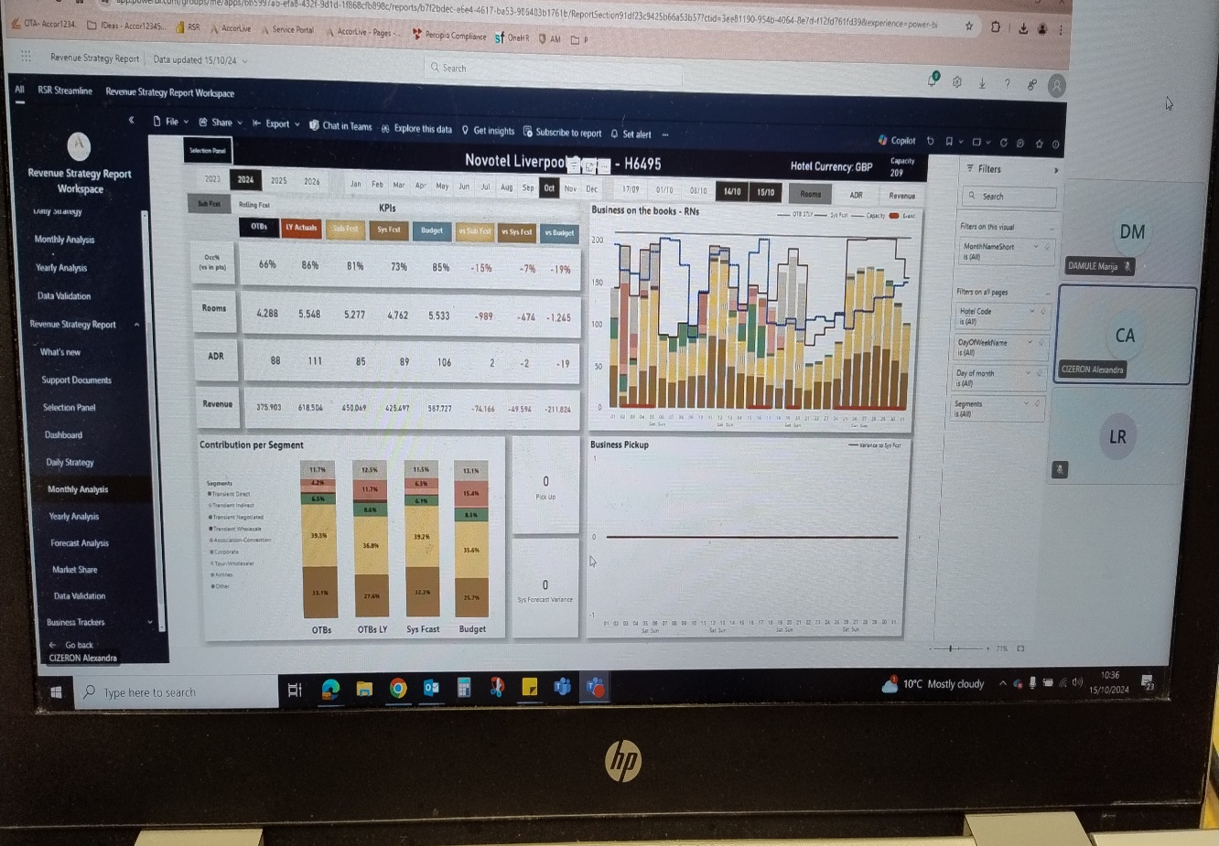

- Fig.2 Group and events list for 23.10.2024 to 10.11.2024

