

Student name -Elena Goranova
Student number -2122365
Module code-LCBB6000

TO UNDERSTAND BARRIERS AND SUCCESS FACTORS OF WOMAN ENTREPRENEURS IN EUROPE

Table of Contents
Chapter 1: Introduction 2
1.1. Research Background 2
1.2. Research Significance 2
1.3. Research Purpose 2
1.4. Research Aim, Objective, and Question 2
Chapter 2: Literature Review 3
2.1. Contribution of women entrepreneur in Europe 3
2.2. Success factors of women entrepreneurs in Europe 4
2.3. Barriers or challenges that women entrepreneurs experience in Europe 4
2.4 Theoretical implementation 5
Chapter 3: Research methods and methodology 6
3.1. Research philosophy 6
3.2. Research paradigm 7
3.3. Research Approach 7
3.4. Research methodology 7
3.5. Research Strategy 8
3.6. Sampling method 8
3.7. Data collection method 8
3.8. Data interpretation 8
3.9. Timeline 9
3.10. Ethical consideration 9
Chapter 4: Conclusion 9
References 11

Chapter 1: Introduction

1.1. Research Background
The increasing rate of Women entrepreneurship eliminates gender-based barriers within Europe. Women entrepreneurs contribute positively to bringing innovation and economic development to Europe. Such entrepreneurs also experience diverse challenges such as a lack of a supportive environment, mentorship challenges, issues in work-life balance, and more. Despite that, technological development, educational facilities, an inclusive environment, and adaptability nature provide benefits to women entrepreneurs in Europe (Kamberidou, 2020). The women's entrepreneurship network within Europe supports the development of such entrepreneurship.

1.2. Research Significance
The present research is significant to gain a clear insight into the contribution of women entrepreneurs in innovation and economic growth within Europe. Hence, a report shows that 31% of women in Europe are working as start-up entrepreneurs and 34.4% are self-employed (Europa. EU, 2024). Hence, the research is going to be significant to analyse the success factor of such women entrepreneurs and their impact on European society. It is also significant to understand the way women entrepreneurs are reshaping the business ecosystem.

1.3. Research Purpose
The primary purpose of the current research is to determine the success factors and the barriers related to women's entrepreneurship in Europe. It also serves the purpose of determining the sociocultural influence, European policies, and best practices that contribute to the development of women's entrepreneurship. Besides that, the research is going to make a comprehensive analysis of the support that the women entrepreneurs receive within Europe to reduce their performance barriers.

1.4. Research Aim, Objective, and Question
Aim
The research aims to analyse the success factors and barriers of women entrepreneurs in Europe.
Objective
- To determine the impact of women entrepreneurship in Europe
- To evaluate the success factors among women entrepreneurs in Europe
- To defect the barriers or challenges faced by women entrepreneurs in Europe
- To understand the strategies to improve women's entrepreneurship in Europe
Research question
- How do women entrepreneurs impact the European market?
- What factors contribute to successful women entrepreneurs in Europe?
- What barriers or challenges are faced by women entrepreneurs in Europe?
- What strategies can be adopted to improve women's entrepreneurship in Europe?

Chapter 2: Literature Review

2.1. Contribution of women entrepreneur in Europe
The European Commission strongly promotes women's entrepreneurship and women's economic empowerment. It also encourages exchanges of good initiatives and practices so that women build confidence and uplift their abilities (Europa. EU, 2024b). Hence, in Europe, women entrepreneurs bring cultural diversity and enhance the growth of creative industries such as entertainment, arts, fashion, media, and more. The 'Enterprise Europe Network’ or EEN contains dedicated experts who promote women's entrepreneurship in different European countries (Europa. EU, 2024b). According to a report, advancing women's equality across countries is going to contribute $12 trillion by 2025 to the global economy (Rafi, 2020). After that, women entrepreneurs in Europe contribute to social development, enhance gender equality and uplift sustainable practices. Based on the below-mentioned figure, a report shows that 18.2% of women from Latvia, a European country involved in early-stage entrepreneurial activity are followed by the Netherlands with a 15.5% engagement rate (McEvoy, 2024).
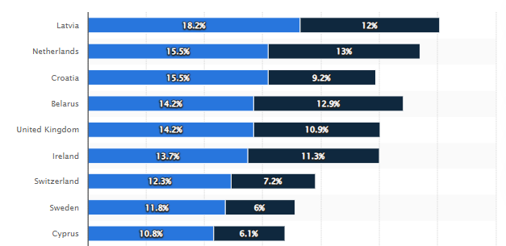
Figure 1: Percentage of women entrepreneurs in different European countries
(Source: McEvoy, 2024)

2.2. Success factors of women entrepreneurs in Europe
There are various success factors that influence women entrepreneurs in Europe such as self-confidence, risk-taking abilities, socio-cultural factors, external factors such as economic factors and more. According to a report, the European Government or the European Innovation Council (EIC) ensures that 25% of women-led companies are funded by them and they have invested nearly €850m within such organisations which works as another key success factor (Drumm, 2024). After that, the report also shows that in Europe 11% of venture funding for startups was led by women which worked as a motivator for women entrepreneurs (Drumm, 2024). Besides that, the training and educational fatalities related to leadership, management, marketing, and so on within Europe work as a success factor for women entrepreneurship. Nonetheless, mentorship programs, professional networks, and a supportive European ecosystem play a crucial role in women's entrepreneurship within the country.

2.3. Barriers or challenges that women entrepreneurs experience in Europe
Women entrepreneurs experience challenges in Europe due to a lack of technological knowledge, lower financial literacy, and limited availability of entrepreneurship networks within the country. It has been noted that the lack of quality and affordable childcare facilities within Europe creates a burden for women to maintain professional work and balance their personal lives which generates barriers to women's entrepreneurship (Bjerde, 2022). Henceforth, gender discrimination, payment gap, and lack of a supportive environment generate barriers in the case of women entrepreneurship in Europe. After that, lack of experience and financial challenges also generate barriers to women entrepreneurship in Europe (Abdulla and Ahmad, 2023). Hence, higher market competition in the European market is another factor that generates barriers to the development of women's entrepreneurship within the country. After that, male male-dominated environment in some entrepreneurial sectors generates barriers for female entrepreneurs to enter the market.

2.4 Theoretical implementation
Social capital theory: Such a theory can be implemented to develop social relationships and manage resources to bring the development of human capital (Swanson et al. 2020). Such a theory can be implemented with the study to eliminate the barriers that women entrepreneurs experience in the European market to ensure growth and development. Through the use of such theory success factors related to women's entrepreneurship can be improved. It will uplift some success factors such as mentorship facilities, social capital, business environment, and more. Despite that, such a theory will be beneficial to improve social networks as per the requirement of women entrepreneurship.
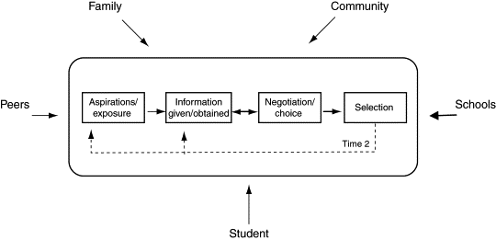
Figure 2: Social capital
(Source: Swanson et al. 2020)
Resource-Based View Theory (RBV): Such theory helps to gain competitive advantage through the use of diverse resources which are costly to imitate, valuable, rare, and exploitable (Davis and DeWitt, 2021). Moreover, through the implication of such theory, women entrepreneurs in Europe can detect a 'strategic fit' between their capabilities and available resources to gain success. After that, it will help the entrepreneurs to eliminate barriers to adopting valuable resources which will also work as their success factor.
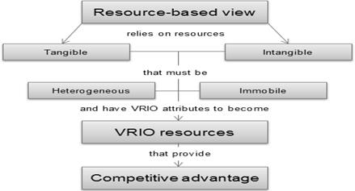
Figure 3: Resource-Based View
(Source: Davis and DeWitt, 2021)

Chapter 3: Research methods and methodology

3.1. Research philosophy
The research will be based on Epistemology research philosophy which will help to understand individuals' opinions related to the challenges and success factors of European women entrepreneurs. According to the research of Uscinski et al. (2024), Epistemology research will improve the validity of the study by determining truth factors related to the information and eliminating misinformation. Moreover, such research philosophy will be selected to find relevant information related to the research objectives and improve the quality of the research outcome. Besides that, it will help to gain clear and new information related to European women entrepreneurs.

3.2. Research paradigm
The study will be based on the Interpretation or interpretivism Paradigm which will help to construct knowledge and interpret information based on the success factors and barriers of women entrepreneurs from Europe. As illustrated in the study of Alharahsheh and Pius (2020), the interpretivism Paradigm will help to gain in-depth insight and experience related to particular research contexts. Besides that, such a paradigm will be more effective in malaise research variables related to the context by considering different circumstances and social realities (Alharahsheh and Pius, 2020). Moreover, it will help to gain a good understanding of the challenges as well as the success factors of women's entrepreneurship.

3.3. Research Approach
The Inductive approach will be used within the research to gain a holistic point of view from the collected data on the success cars of European women entrepreneurs along with the barriers. It has been noted in the research of Proudfoot (2022), that the inductive approach will help to gain a deeper understanding of research phenomenon and collected information. Moreover, such a research approach will be beneficial to generate theoretical rigour and investigate research problems significantly (Proudfoot, 2022). Moreover, an inductive approach will help to maintain research flexibility by ensuring authentic findings on the success factors and challenges of entrepreneurs in Europe.

3.4. Research methodology
Research methodology is a way through which the entire research process is carried out in a systematic and logical way. The present study will use the Secondary data collection method and qualitative Data Analysis method to complete the research. The research of Renjith et al. (2021), indicates that qualitative secondary research methodology will help to complete the study in a cost-effective way with ample information availability. Hence, such methodology will help to complete the study from ample available information on the factors that contribute to women entrepreneurs' success in Europe.

3.5. Research Strategy
An authentic and verified data set will be used to complete the study to ensure the accuracy of the research outcome. All the secondary resources will be collected from books, journals, articles, websites, magazines, newspapers, and so on.

3.6. Sampling method
The study will be completed by using secondary data sources where information is available easily with open access. Hence, the research will not require any sampling method to collect information on the key factors that bring barriers and success for European women entrepreneurs.

3.7. Data collection method
The present research will use a secondary data collection method to collect information regarding the success and challenging factors of women European entrepreneurs. The study of Renjith et al. (2021), represents that the method of secondary data collection will ensure cost effectiveness, maintain time efficiency, and provide access to a larger database. Such data collection methods will be used to gain a diverse perspective of different authors on the research objectives. It will help to collect resources related to objectives and research questions from credible sources which will make the research outcome more reliable and authentic.

3.8. Data interpretation
The present study will use a Qualitative research method to interpret all the collected information on the success factors and barriers related to the entrepreneurship of women in Europe. After that, a qualitative data analysis method will be used to ensure proper data interpretation and data display based on research objectives (Mezmir, 2020). Despite that, such data interpretation methods will encourage openness, flexibility, and creative illustration of the collected data. Through the use of the qualitative data interpretation method a detailed picture of the key success factors that contribute to the positive outcome of women entrepreneurship in Europe.

3.9. Timeline
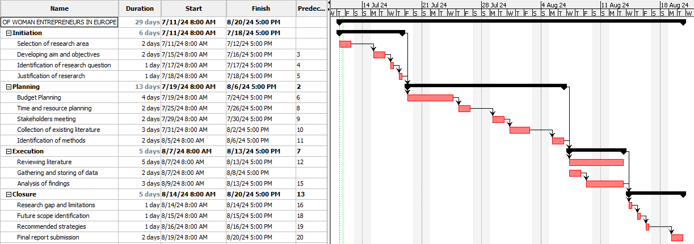
Figure 4: Gantt Chart
(Source: Self-created)

3.10. Ethical consideration
During the data collection process, all the resources will be collected from authentic and ethical sources. No biassed activity will be allowed with the collected information. After completion of the project, all the collected data will be destroyed securely. Therefore, no collected information will be used for any business purpose. After that, all the collected data will be protected through the UK "Data Protection Act 2018" to follow data protection principles (GOV.UK, 2024). Moreover, any negative gesture will not be presented against a research paper of data sources. All the collected resources will be handled with respect and any author related to the sources will not receive any harm.

Chapter 4: Conclusion
It can be summarised through the entire study that the popularity of women's entrepreneurship in Europe is increasing day by day. The European government also supports the development of women's entrepreneurship by providing financial assistance. After that, social support, financial assistance, mentorship facilities, and so on are working as success factors of women entrepreneurship within the selected country. In contrast, lack of proper work-life balance, childcare facilities, higher competition, and male domination create barriers to women's entrepreneurship as well. Therefore, the implementation of Social capital theory and Resource View theory will be effective in improving success factors related to women's entrepreneurship and eliminating its barriers. Nonetheless, the secondary data collection method and qualitative data analysis method will help the study to collect data in less time in a cost-effective manner. Hence, proper ethical activity related to the data collection and implementation process will be maintained throughout the entire study.

References
Abdulla, F.S. and Ahmad, A., (2023). Challenges Faced by Women Entrepreneurs of 21st Century: Literature Review. Journal of Management & Science, 21(1), pp.16-16. https://www.researchgate.net/profile/Ahmad-Albattat/publication/372446624_Challenges_Faced_by_Women_Entrepreneurs_of_21_st_Century_Literature_Review
Alharahsheh, H. and Pius, A. (2020). A Review of Key paradigms: Positivism Vs Interpretivism. Global Academic Journal of Humanities and Social Sciences, 2(3), pp.39–43.
Bjerde, A. (2022). Europe and Central Asia Economies Need More Women Entrepreneurs and Business Leaders. [online] World Bank. Available at: https://www.worldbank.org/en/news/opinion/2022/03/08/europe-and-central-asia-economies-need-more-women-entrepreneurs-and-business-leaders.
Davis, G.F. and DeWitt, T. (2021). Organization Theory and the Resource-Based View of the Firm: The Great Divide. Journal of Management, [online] 47(7), pp.1684–1697. doi:https://doi.org/10.1177/0149206320982650.
Drumm, S., (2024). The role of governments in supporting women entrepreneurs. [online]. Available at: https://sifted.eu/articles/government-women-entrepreneurs-brnd
Europa. EU (2024). Women Entrepreneurship and Leadership | EIT. [online] eit.europa.eu. Available at: https://eit.europa.eu/women-entrepreneurship-and-leadership#:~:text=Representation%20of%20women%20in%20entrepreneurship [Accessed 11 Jul. 2024].
Europa. EU (2024b). Women entrepreneurs - European Commission. [online] single-market-economy.ec.europa.eu. Available at: https://single-market-economy.ec.europa.eu/smes/continuity-and-exit/women-entrepreneurs_en [Accessed 11 Jul. 2024].
GOV.UK (2024). Data Protection. [online] Gov.UK. Available at: https://www.gov.uk/data-protection#:~:text=The%20Data%20Protection%20Act%202018%20is%20the%20UK.
Kamberidou, I. (2020). ‘Distinguished’ Women Entrepreneurs in the Digital Economy and the Multitasking Whirlpool. Journal of Innovation and Entrepreneurship, [online] 9(1), pp.1–26. doi:https://doi.org/10.1186/s13731-020-0114-y.
McEvoy, O. (2024). Gender distribution of early-stage entrepreneurs in Europe by country 2019. [online] Statista. Available at: https://www.statista.com/statistics/315773/gender-distribution-of-early-stage-entrepreneurs-in-europe/.
Mezmir, E.A. (2020). Qualitative Data Analysis: An Overview of Data Reduction, Data Display and Interpretation. Research on Humanities and Social Sciences, [online] 10(21), pp.15–27. Available at: https://core.ac.uk/download/pdf/356684456.pdf.
Proudfoot, K. (2022). Inductive/Deductive Hybrid Thematic Analysis in Mixed Methods Research. Journal of Mixed Methods Research, [online] 17(3), pp.308–326. doi:https://doi.org/10.1177/15586898221126816.
Rafi, T. (2020). Council Post: Why Women Entrepreneurs Are Critical To Economic Growth. [online] Forbes. Available at: https://www.forbes.com/sites/forbesbusinesscouncil/2020/05/18/why-women-entrepreneurs-are-critical-to-economic-growth/.
Renjith, V., Yesodharan, R., Noronha, J., Ladd, E. and George, A. (2021). Qualitative Methods in Health Care Research. International Journal of Preventive Medicine, [online] 12(1), p.20. doi:https://doi.org/10.4103/ijpvm.IJPVM_321_19.
Swanson, E., Kim, S., Lee, S.-M., Yang, J.-J. and Lee, Y.-K. (2020). The effect of leader competencies on knowledge sharing and job performance: Social capital theory. Journal of Hospitality and Tourism Management, 42(1), pp.88–96.
Uscinski, J., Littrell, S. and Klofstad, C. (2024). The Importance of Epistemology for the Study of Misinformation. Current Opinion in Psychology, 57, pp.101789–101789. doi:https://doi.org/10.1016/j.copsyc.2024.101789.

