Dissertation – M6X01791

Exploring Stitch as a Language of Feminism; Using Historical Samplers and Modern Artworks as Reference.

Tiffany Dyke
P144796
Surface Pattern Design
Ainsley Hillard
Word Count 5,896

Contents

Introduction Page 3

Chapter One Page 5

Chapter Two Page 13

Conclusion Page 23

Image List Page 26

Bibliography Page 27
This essay will explore various pieces of stitch, from historical samplers to contemporary artworks, and analyse them making links to the feminist sphere, referencing haptic theory and also touch upon the theories in regards to body hair on the female and relating the findings back to the evolution of feminism and how the female gender has changed from the early eighteenth century to modern day.
Chapter one will be comparing and contrasting historical samplers, focusing on one example that has been researched in depth via an appointment at the Gold Hill Museum with local archivist Sheena Commons, with that of the well-known para-suicidal stitchings of Elizabeth Parker, using factual historical research and texts such as “Elizabeth Parker’s ‘Sampler’: Memory, Suicide and the Presence of the Artist” (1999) by Nigel Llewellyn to fully explore the meaning of Parker’s piece and the relevance of this within the social context in reference to the time period it was created. Emotion and authorship will be explored thoroughly, making reference to the samplers and the individuals who created them.
In order to fully research historical samplers in a generalised view a series of archival visits were undertaken, including the Victoria and Albert Museum archives at the Clothworkers’ Centre for the Study and Conservation of Textiles and Fashion in London, The Goodhart Sampler Collection at Montecute House in Somerset and Gold Hill Museum in Shaftesbury. During these visits meetings were undertaken with archivists who specialise in the preservation of historical textile pieces to gain more insight to the societal backgrounds during the time period in which these pieces were created. This primary research helped to widen the knowledge of samplers needed to correctly analyse these historical pieces, and has informed the assumptions and deductions on historical artworks in the following writing.
Chapter two will discuss contemporary textile artists such as Allison Cooke Brown, Eliza Bennett and Anne Wilson, in addition to visual and performance artist Ann Hamilton. This chapter will also explore the art of stitch from multiple angles, not only that of the finished pieces but also the art of the process and how this effects the audience. The contemporary artists work will be compared and contrasted to the traditional use of stitch in samplers, and the personality and emotion within the unconventional work of Parker.
Overall this essay will aim to investigate the connotations and stereotypes of stitch and female textile artists within the art world, making connections between historical pieces and the traditional use of samplers with contemporary textile art created by female artists, commenting on how all stitched art may have had an impact on the feminist movement, and the evolution of how women are portrayed in society throughout history.

The dictionary definition of a sampler is as follows:
“Sampler
- A piece of embroidery worked in various stitches as a specimen of skill, typically containing the alphabet and some mottoes.
- A representative collection or example of something ‘a sampler of rock plants’.”
The term sampler references the activity of stitch to produce a specimen of skill, this was traditionally used as a beginners exercise in embroidery. “Originally they offered samples of stitches and patterns and were sufficiently valued for complex specimens to be mentioned in bequests and passed on from generation to generation.” (Llewellyn, 1999, page 63), samplers were quite often kept within families as an heirloom and as Llewellyn states “passed on from generation to generation” as an item that holds a significant amount of sentimental value.

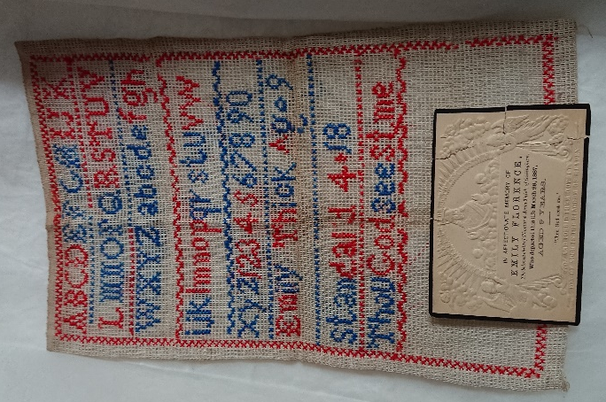

Figure 1 Sampler by Emily Thick (1800's)
The first sampler, see figure one, is a piece by Emily Florence Thick, this individual was a young girl living in the town of Gillingham, Dorset in the South of England. Her sampler was passed down through her family, before being donated to the Gold Hill Museum, located in Shaftesbury, Dorset. She lived during the nineteenth century and passed away at the age of nine according to her funeral placard, which was also included in the donation to the museum archives. This sampler is a typical example of the traditional use of samplers, as it culminates the different aspects of the English alphabet as well as the name of the individual who created the sampler, with the addition of a religious quote. The sampler is a simple cross stitched piece, in red and blue, which states the alphabet in lower and upper case with a series of numbers followed by the girl’s name and a quote from the bible reading “Thou God seest me”. This piece is very concise and unemotional, without any real creativity from the young girl herself, showing that these samplers were typically used for practice of technical skill in a variety of stitch work - often non pictorial they depicted letters in this case the alphabet, numbers and a chosen religious quote.
We can assume that the colours of the thread are insignificant within this piece, as samplers were not created to be viewed as art, but rather an example of skill and dedication to the craft. The backing is a white cloth, similar to a plain cotton, which again is not relevant to analyse in depth as this was likely what was available to be used at the time due to the age of the creator and the time period the work was created within.
Most samplers were void of any personal details bar the name of the creator, however the use of the names within the samplers could claim ownership of the stitched pieces, making the samplers have a small amount of individuality. The use of the religious quote is also interesting to analyse as the text is also used on Thick’s funeral placard, which was also donated to the Gold Hill Museum, alongside the sampler. The text “Thou God seest me” originates from Genesis 16:13 and is used in a scene where a girl is speaking directly to her God, and this is translated from the King James Bible into the English Standard Version as “Truly here I have seen him who looks after me”, this could show that Thick believed she was being cared for and watched over by God. Religion was quite clearly an important part of her life and her beliefs, and the inclusion of a Bible quote within her sampler shows an injection of personality and ownership of the piece and the fact that this same extract was used on Thick’s funeral placard shows that the extract was important to her, or her family.
The young age of the girl shows that creating samplers was a very common thing and was used as a way to improve one’s skills in embroidery and stitch. The sampler itself does not have an exact date of the making, however Emily Thick passed away aged nine in 1887, so we can assume the sampler was created between 1878 and 1887. The age of the creator is necessary to take into account when examining the piece as we can assume that Emily Thick was instructed to create the sampler, as a part of her education or schooling, rather than a conscious decision of her own. The sampler is generic in terms of the content, bar the specific Bible verse and author’s name.
In contrast, the sampler created by Elizabeth Parker differs hugely from the traditional conventions of the sampler throughout history. Parker’s sampler was created in 1830, this woman stitched her sampler of her own accord, not for any other purpose than to show emotion, perhaps even record her feelings almost as a diary entry, this is hugely different to the sampler created by Thick due to the unconventional contents. The traditional use of samplers was to simply practice skill rather than to create a piece that shows so much of the author’s personality.
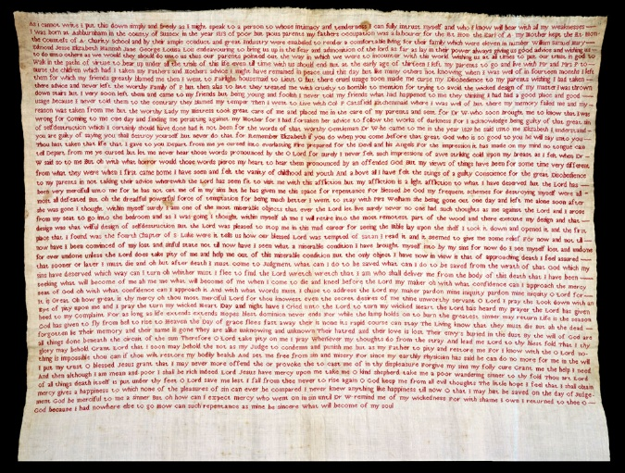

Figure 2 Sampler by Elizabeth Parker (1830)

Parker used the creation of her sampler as a way to convey her own thoughts and feelings and tell a story of her struggles throughout her lifetime, whilst possibly using the stitching process as a form of therapy or a way to clear her mind. The act of stitch is time consuming, and would have been planned and executed over a long amount of time, which is significant when discussing Parker’s sampler as it is a large paragraph of writing which would have taken Parker a long time to create. Due to the nature of embroidery and stitching, we can deduce that these thoughts were not fleeting or temporary, they were something that Parker would have likely held close to her as a constant within her life. Parker states “till now have I seen what a miserable condition I have brought myself into by my sins for now do I see myself lost and undone”, this quote references Parker’s descent into unhappiness with her deteriorating mental wellbeing and shows her admitting to her current state of being “lost and undone” showing her perhaps at her lowest in life so far, which may have been what sparked her need to express her emotions through her handiwork.
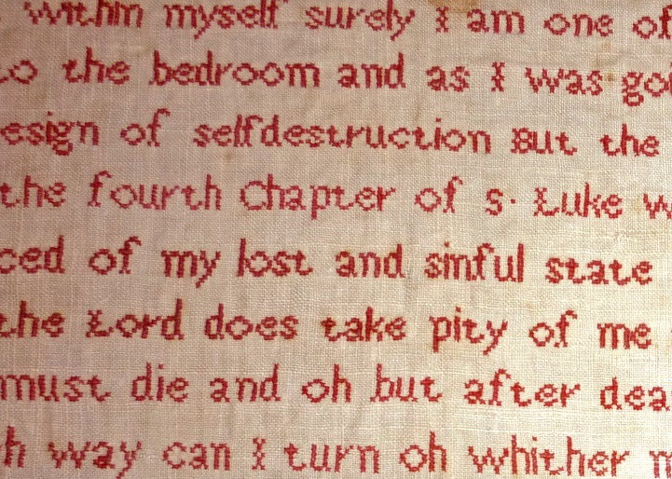

Figure 3 Sampler by Elizabeth Parker (1830)

The thread she has used throughout the whole piece is a deep red, this could have been specifically chosen to signify blood to show personality within the stitch. When analysing the piece we could use colour theory and link the red colour with feelings of anger “Red remains a colour full of majesty and distinction. But it is also, now as ever, a vibrant, stimulating, even aggressive colour” (Pastoureau, 2017, online article). Perhaps this anger could have been directed towards herself as she often negatively mentions her actions within the piece. The colour could be a hidden meaning within the piece, but we also have to remember that samplers were not used as artworks in this time period. They would usually be an exercise to show proficiency with a certain skillset, with no other purpose than to occupy women and girls whilst they were at home, as they were not often educated and would take up occupations within the home such as housemaids or nannies, if they worked at all. So it could be that the use of the colour red in coincidental in matching with the theme of Parker’s words as it could have been by chance that she had an abundance of this colour thread.
We need to remember that this piece was never supposed to have a viewer or audience, it was a private piece. Parker uses phrases such as “What can I do to be saved?” and “God who is so good” which reference a strong religious undercurrent, linking to the idea that Parker believes she has sinned of disappointed her God in some way, perhaps this piece could be in place of a confessional to clear her conscience of wrongdoing. The time taken to create the piece shows dedication, and would have been physically draining for Parker which could show the sampler as a self-inflicted punishment. The extracts “…acknowledge being guilty of that great sin…” and “curse my Disobedience” again shows the religious importance of the piece but also reinforces that idea of self-punishment. This could relate to her self-worth and how she may not value herself, as the gender imbalance would have been a lot wider between men and women during the nineteenth century as men had significantly more rights than women during this era. “The ideology of Separate Spheres rested on a definition of the ‘natural’ characteristics of women and men. Women were considered physically weaker yet morally superior to men, which meant that they were best suited to the domestic sphere” (Hughes, 2014, online article.) due to the separation of the genders into their assigned spheres before the creation of Parker’s sampler we can assume that these stereotypes would have affected Parker.
The piece finishes with a short sentence from Parker reading “what will become of my soul”, the words then cease and a large amount of the fabric is left completely blank. She does not sign off or date the piece, which again reinforces the theory that this piece was created to be private. The continuation of Parker’s life is not clear from this ending, however the outpour of emotion and lack of self-belief is articulates a low point within Parker’s life and perhaps conveys an inclination of the piece being a sort of suicide note to explain her life and her reasoning for anyone who may have read it. The following extract from the sampler documents a doctor speaking directly to Elizabeth and urging her not to “destroy herself” which we could link to the theory of her suicidal thoughts. She also comments on her plans to go to “the remotest part of the wood and … execute my design and that design was that wilful design of self destruction”, we can assume that the phrase of self-destruction is synonymous with the intent to commit suicide. Parker uses religion as a self-saviour, to save herself from her thoughts of suicide and comments on the advancement of death itself and the comfort that brings her; “But the only object I have now in view is that of approaching death I feel assured that sooner or later I must die”, this gives identity to the piece and a much more personal voice to the stitched words which is as far from the traditional use of samplers as a piece can get.
“he said unto me Elizabeth I understand you are guilty of saying you shall destroy yourself but never do that for Remember Elizabeth if you do when you come before that great God who is so good to you he will say unto you Thou hast taken that life that I gave to you Depart from me ye cursed but let me never hear those words pronounced by the O Lord for surely I never felt such impressions of awe striking cold upon my breast as I felt when Dr W said so to me”
Another aspect we can analyse in relation to the Parker sampler is the assumed female behaviour in public contrasting to their behaviour in private in this time period. During the nineteenth century women were often uneducated unless they were in the upper class due to their lower position in society, therefore writing copious amounts was fairly uncommon, the traditional alphabetical samplers were more conventional amongst women. “Rather than attracting a husband through their domestic abilities, middle-class girls were coached in what were known as ‘accomplishments’. These would be learned either at boarding school or from a resident governess… it was important for a well-educated girl to soften her erudition with a graceful and feminine manner” (Hughes, 2014, online article) the skills needed to become worthy of a husband would have included embroidery, as it showed the women’s skill in dainty and time consuming work, which again the daintiness would have been considered a desirable trait. This worthiness that drew upon women’s abilities in these craft spheres was generally more important than a woman having a successful career, which is shown within Parker’s own words where she describes two domestic based jobs she had undertaken, “at the early age of thirteen I left my parents to go and live with Mr and Mrs P to nurse the children” and “I went to Fairlight housemaid”, as seen in the transcript of her sampler. In addition to this women were often held in a lower class than men and did not have the vocal stance that men held within society as a result of this, this era predates women being given the vote which serves as evidence to show women’s lower place in society. The activity of samplers often became synonymous with images of “social acceptability, domestic values, female discipline and modest piety.” (Llewellyn, 1999, page 64) which again enforces the idea that this activity was a very female led scene.
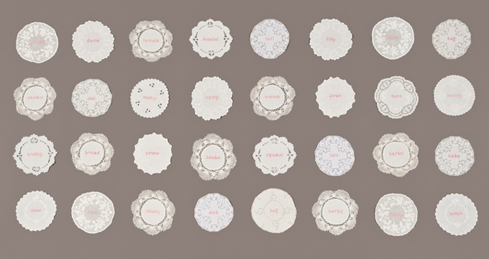
“Within craft production the tighter regulations and increasingly hierarchical organisations worked to exclude women from positions of responsibility and prestige” The Subversive Stitch: Embroidery and the Making of the Feminine, Rozsika Parker (The Domestication of Embroidery, page 60/61). The act of stitch was almost becoming a prison for women during this time, trapping them into spending their time creating these intricate embroidered pieces to preoccupy them from trying to rebel against the patriarchy or hierarchy of the genders. This is significant when analysing Parker’s sampler, as it seems she feels as though she is trapped and this could be the reason she is seeking escape from her seemingly para-suicidal depression in the direction of self-destruction. We can compare and contrast Parker’s rebellion with that of modern day stitch artists, working against the stigmatised view of stitch.
Figure 4 “Her Doilies” by Allison Cooke Brown 2009
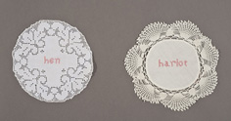
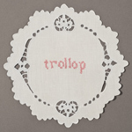
Figure 5 “Her Doilies” by Allison Cooke Brown 2009

The use of stitch in modern day is more of a reclaiming of the act, and is more often used to create artworks rather than to practice the traditional use of the activity, which would have been to produce a specimen of skill. An artist who uses this more modern definition would be Allison Cooke Brown, who created a series of embroidered doilies with words used as slurs against women in the middle of the lace. As seen in figure five, Brown uses pink threads to stitch the text, this creates a juxtaposition in itself due to the connotations behind the colour. Pink is often thought of as the colour for girls, as quoted by Kassia St Clair in her book “The Secret Lives of Colour”, “Pink is for girls and blue is for boys; the evidence is everywhere… All the little girls sit marooned in identically pink seas.” (St Clair, 2016, page 115). Pink is also related to themes of love, but Brown contrasts these assumptions with the words themselves being crude and vulgar. She uses words such as “witch”, “harlot” and “bimbo”, which are well known names forced upon women by catcalling. The artist uses stitch in this series of artworks to reclaim the act of stitch, and perhaps even to mock the act of insulting women as a way of reducing the harshness of these insults. Brown could have created this series of artworks as a way to bring awareness to the issue of unnecessary aggression towards women, as the doilies clearly highlight the slurs in a traditionally feminine field, creating the discussion between the different audience members.
Contrasting to the traditional creation of samplers, these pieces display personality, the artist has expressed herself and her story into each doily. This in itself is a way of rebelling against the preconceived assumptions of stitch, stitch was not initially an art, and it was more of a craft. Socio-historical context comes into effect here, as activities such as watercolour, stitch and embroidery were often regarded as activities for the feminine, whereas oil paintings and other creation methods were regarded as male dominated due to their heightened importance in the art world. The word craft here is being used to show the creation of a product, rather than the definition of an art, which would be the expression or application of human creative skill and imagination, producing works to be appreciated primarily for their beauty or emotional power. Both Brown and Parker are bending the assumption of stitch being a craft and are turning it into a form of art, with their expression of emotion and personality.
We can analyse the use of the lace and pink thread against the words used within the artworks even further by thinking about the two images of women. There is the traditional, caring and sweet woman who is adored by her male counterparts; against the harsh and uncaring woman, who gets called these names and is looked down upon for it. The delicate, pretty lace can be a symbol for the traditional idealistic image of the woman, and the words a symbol for the woman who rebels against this stereotype. The words could even portray a sort of branding on the women, which leads to the abuse of women in society and the hierarchy of gender that is still a problem in modern day society. Brown’s work could highlight the fact that catcalling/ verbal abuse towards women is still very much rampant in society and is damaging to their self-worth, hence the angry slurs stitched into the lace doilies.
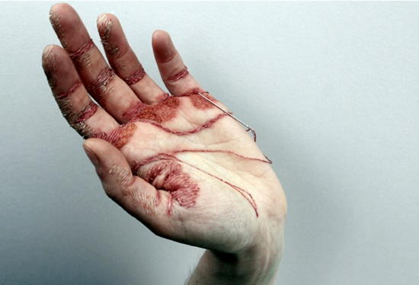

Figure 6 “A Woman’s Work is never done” Eliza Bennett 2012

Eliza Bennett created a piece of artwork called “A Women’s Work is never done” which depicts a series of stitches done using her own hand in the place of cloth. The importance of the use of skin in her work could represent the metaphorical toil of being a woman, or the hardships women have had to face as they raised their gender to that of men, creating a more equal society. It could also represent the physical strain of the act of stitch, and show the difficulty of creating embroidered artworks. The stitches could illustrate the process of skin turning callous over time, due to heavy labour and working. The development of the soft palms and fingertips to the toughened and hard skin can be symbolic in the way that women were, and still often are, seen as gentle creatures and were regularly referred to as the daintier of the sexes whereas now in modern day society, with the feminist movement, are toughening themselves and are growing to stand in defence of their own rights.
We can use Bennett’s piece to understand how laboured Elizabeth Parker’s sampler was to create. The act of sewing into one’s own skin could be a painful process, this physical pain that Bennett could have endured could represent the difficulty of stitch itself or could be a nod to the suffering of what she references as “Women’s Work” this potential pain is almost a feeling given to the viewer, the meanings and sharing of emotion from the artist to the viewer is a strong sensation. This sensation can be referred to as haptic visuality. This term, coined by art historian Alois Riegl, defines the sense of feeling an emotion or sensation purely through an image. This haptic visuality affects the audience, and encourages them to think as though they are feeling the potential pain that Bennett felt whilst creating this piece.
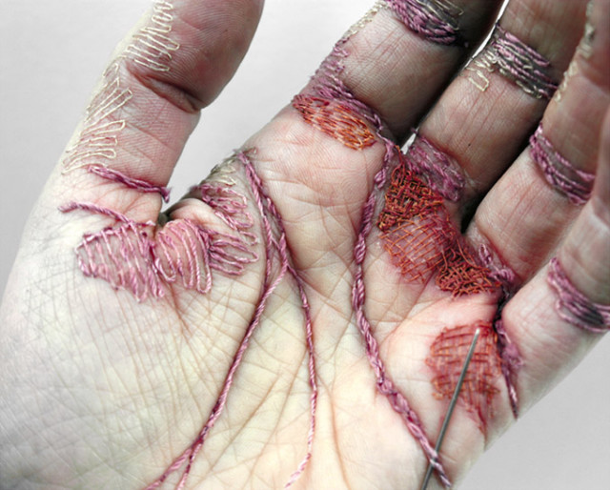

Figure 7 “A Woman’s Work is never done” Eliza Bennett 2012

The use of reds, pinks and purples in Bennett’s piece could symbolise flesh, which could be a relation to the human body being used in stitch, and the act of putting yourself into your work physically, or perhaps the heat of the colours could represent anger from the artist, this along with title could exemplify the frustration of the artist towards the disproportionate equality between the genders. This could be compared to the use of red thread in Parker’s sampler, the warm, dark colours give a feeling of anger to the viewer, and this feeling goes hand in hand with the rebellion that these women are embarking upon creating despite the very different time periods that the separate pieces were made.
“The skin is the vulnerable, unreliable boundary between inner and outer conditions and the proof of their frightening, fascinating intimate contiguity… The skin has become intensely vulnerable and thoroughly unreliable in its combined incapacity to resist external threats and its tendency to harbour (but then to release) internal threats.” Book of Skin, Steven Connor.
Bennett shows the delicate nature of the skin by penetrating and breaking the surface of her palms to achieve the stitches. The vulnerability is significant within the discussion of the relation between Bennett’s work and the conventional female due to the assumed emotional sensitivity of the female gender against that of the male. The comparison of skin as a boundary shows Bennett as breaking this border and therefore revealing herself and her own private sphere to the audience through the process of stitch.
The fact that Bennett’s piece consists of just the photographs of the stitching rather than video or any type of performance art excludes the audience from the creation of the work. This could again strengthen the force of the haptic visuality, as the viewer is unaware of the mistakes the artist could have made, the injuries she could have sustained, and the time taken to complete the stitching. This makes the audience think for themselves, and imagine the sensations of their own hands being stitched into for a long amount of time, almost projecting the senses of the artist onto themselves to fully understand the piece of work.
Another artist who uses haptic visuality to immerse the audience within her artwork is Ann Hamilton, Hamilton is a visual artist who has created a multitude of textile and video based art. Her piece “draw” is performance art in the form of video and sound, the piece implicates the viewer and draws them in to become part of the art from their reactions. The visuals show the process of Hamilton creating stiches, through a piece of silk organza, with a thick red piece of thread. The use of the red thread is significant, and links with the work of Parker and Bennett, symbolising emotions of anger or frustration along with the suggestive links to the body as the red also alludes to the colour of blood. The red thread itself, weaving in and out of the silk organza, conjures imagery of veins in the body, and the light coloured, thin and delicate fabric shows as a skin for the veins to intertwine with and navigate through. The addition of sound to this video projection allows the audience to feel connected to Hamilton as she sews, as it gives the feeling of inclusion in the act. The sound of the needle puncturing the cloth repeatedly could make the audience unsettled, as it procures the idea of breaking the material and creating holes, just as Bennett’s stitches break the skin, this creates a haptic visuality of pain. Hamilton’s video focuses on the sensory angle of performance art, making the audience feel a certain way.
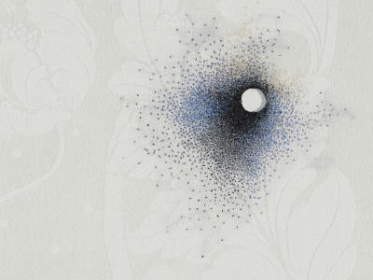
The way the threads weave through the organza, over and over, show the process and the exertion of energy from the artist needed to create the abundance of stitches in both modern embroidered artworks as well as historical samplers. We can use Hamilton’s video piece as reference to the toil that Parker would have endured to create her self-expressive sampler.

Figure 8 “Dispersions” Anne Wilson 2013

Another current artist who reclaims stitch is Anne Wilson. Wilson uses white cloth, often with a floral pattern embossed into it, as a backdrop for her stitch work. Contrasting to Brown, Wilson does not opt to use text but instead creates circles of textured areas around holes, as a way of mending the fabrics. The interesting aspect of Wilsons work is that the artist stiches hair into the cloth in addition to threads. The artist is literally putting herself into her work, much like the theoretical merging of Parker and her sampler.
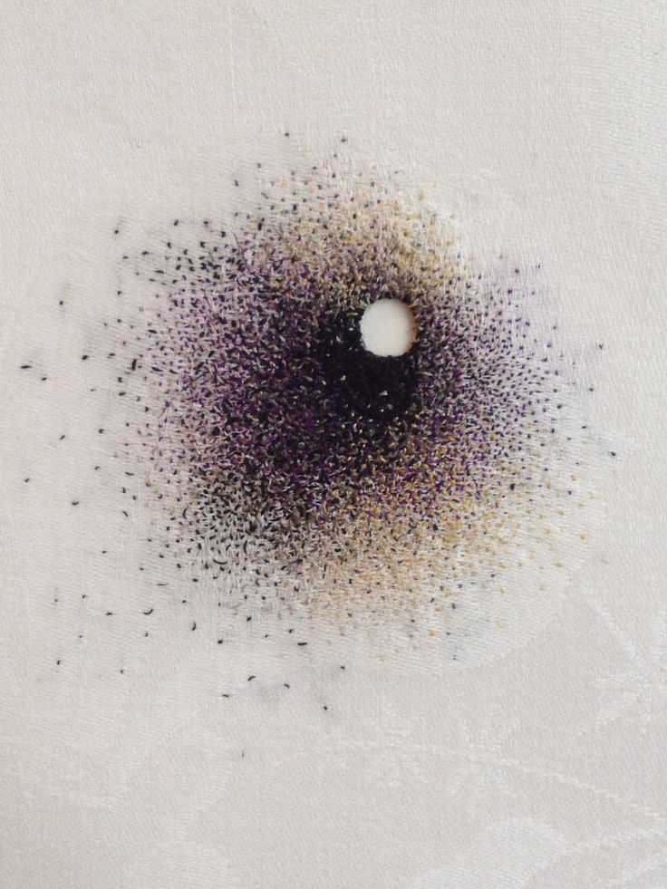

Figure 9 “Dispersions” Anne Wilson 2013

These artworks show stitch as evolving from being something seen as very clean and perfect to something dirty and repulsive to the audience. This could be seen as a reclamation of stitch by changing the traditional view of the act, or perhaps making the stitch less traditionally female. This is also enforces by the use of the white cloth as a backdrop to her work, the white is often thought of alongside imagery of cleanliness and purity which contrasts to the use of hair, as this is assumed as being dirty, we could see the artworks as a way in which Wilson is rebelling from the norm, and reclaiming stitch as a result of this. We can comment on the modern views on female body hair within this topic, and the negative connotations often given to female body hair. Body hair on women is so often seen as a repulsive thing, this is due to the normalizing of the ideal female body, which stems from images of women as far back as the idealistic, smooth and hairless female body in the Birth of Venus painted by Sandro Botticelli in the mid 1480’s. This negativity against body hair has evolved over time, and now includes an abundance of areas on women’s bodies but the initial implication that it is repulsive and/or disgusting still stands today. The way that Wilson incorporates human hair into her work quite cleverly merges the separate imagery of the dainty and pretty floral patterned white cloth with the scattered gradients of threads and hair, so the use of hair isn’t immediately visible to the viewer. The feeling may change as the viewer learns more about the pieces, from appreciation of the intricate stitching to repulsion of the material.
Body hair on women has been removed due to aesthetic purposes as early as the sixteenth century, “Research has uncovered ‘Books of Secrets’ which were used during the sixteenth century. These contained hair removal recipes akin to an old-fashioned take on Veet. Instead of a spray can though, sixteenth century women used a paste that apparently melted hair from the skin’s surface.” (Catalogue Magazine, 2014, online article)
Hair could be linked with the idea of secrecy or privacy consequently the use of Wilson’s own hair within her stitched pieces could give the artworks a sense of intimacy between to artist and audience. The showing of the hair gives the audience a glimpse into the personality of the artist, this act of showing something that is regarded as private is again an act of rebellion against the supposed normality of society. This could be compared to Parker showing herself through her writings, baring her soul and opening up within the piece, she almost discards her own privacy through the creation of her sampler which is similar to this display of personality from the use of hair in Wilson’s work. The display of the private could suggest something entirely more intimate from the artist. Perhaps the pores of the skin, relating to hair, can symbolise an entrance to the inner of a human being, whether this is meant in a scientific way or a figurative way in unclear however we can explore both of these ideas in reference to Wilson’s work. The scientific pathway suggests that the pores of the hair are holes or entrance points into the body, leading to internal organs and blood. The significance of this with Wilson’s work is the insertion of the author into the work, claiming ownership by using her own self. Hair itself is something produced by the body, and the act of collecting the hair and processing it to be suitable to be used in the place of thread would have been a very intimate and exclusive process. The holes in Wilson’s work could allude to the puncturing of the skin, or the creation of a window through or into the body, similar to the visual artwork of Hamilton, the needle penetrates the surface of the silk creating new breaches in the cloth, which is again similar to the work of Bennett, who punctures her own skin to create her artworks. The figurative use of the pores and holes within the body could link to the holes Wilson uses within her pieces. The holes could represent a sexual link, the use of hair and holes as an entrance point conjure imagery within the audience of a more intimate nature. This sharing of the personal that Wilson is partaking in merges the spheres of the private and the public, which is a clear statement of defiance in what would be considered as normality for women in terms of the stereotypical. The creation of holes is of high importance when discussing these artists, and when discussing stitch itself. The breaking of the cloth and skin to create a new piece symbolises the destruction of oneself in terms of martyrdom, to sacrifice or suffer for the betterment of their beliefs which in this case is the evolution of feminism.
In conclusion we can see that stitch has been a powerful tool in the evolution of feminism, from originally being an action placed upon girls and women as a time consuming activity throughout history, often linked with the domestic sphere “By the nineteenth century, samplers had become universally identified with social acceptability, domestic values, female discipline and modest piety” (Llewellyn, 1999, page 64), classed as a craft yet not an art form as the pieces were created by females and not males, to evolve into an activity that has been reclaimed by female textile artists to rebel against the assumed stereotypes placed upon the female gender.
Contemporary female textile artists have claimed the act of stitch and are showing conscious and proud ownership of the activity as an act of rebellion against the historical stereotyping of women sewing and mending textile articles.
Women such as Elizabeth Parker have unknowingly sparked a growing confidence of stitch being recognised in the art world as a fine art practice, not just a hobby or craft, and have given assurance and courage to contemporary textile artists to be able to bare themselves and show their own personalities and intimate or private thoughts, feelings and emotions with an audience who recognises their worth as artists over their gender. This newfound tenacity from female textile artists, reclaiming their history and rebelling against the norm, has aided the progression of the feminist movement and the evolution of society. Allison Cooke Brown and Anne Wilson use white doilies and linens as the backing cloths to their artworks, both of which are commonly associated with the domestic space, the kitchen or dining room within the home, and use derogatory and offensive terms and hair as threads to subvert the meanings behind the cloth and overthrow the audience by affixing a new meaning to the materials.
The poesis, or the process of making, is a significant angle to analyse Ann Hamilton’s work. The audience awareness is quite obvious, the creation of the stitchings is blatantly shown to the viewer from the video and audio, making the labour visible and therefore understandable to the audience, whereas the labour behind Parker’s piece is not obvious, and so adds another aspect of the suffering both behind the creation and behind her mental wellbeing and the expulsion of privacy within her sampler. The importance of considering the poesis of a stitched textile artwork alongside the finished piece itself is strong due to the nature of creation. A drawing or painting or photograph will have had varying degrees of planning and process behind them, yet a stitched piece is known to be time consuming and does require extensive planning before embarking on the actual creation of the pieces, especially when planning to stitch text such as Elizabeth Parker and Allison Cooke Brown. The time behind the formation of these artworks adds to the insertion of the artist’s personality into the pieces, and therefore makes each piece more individual and thought over.
Poesis in terms of the feminist movement, in reference to textile art, shows the dedication of female artists to their art and to their cause. The significance of using a reclaimed historical art form to show a new and exciting take on the assumed conventions of women and female artists.

Image List

Figure 1 Sampler by Emily Thick. Backing fabric, embroidery thread and funeral placard. Primary research, sourced from Gold Hill Museum, Shaftesbury, Dorset.
Figure 2 Sampler by Elizabeth Parker. Cotton backing fabric, red embroidery thread. Primary research, sourced from the Victoria and Albert archives at The Clothworkers’ Centre for the Study and Conservation of Textiles and Fashion, London.
Figure 3 Sampler by Elizabeth Parker. Cotton backing fabric, red embroidery thread. Primary research, sourced from the Victoria and Albert archives, London.
Figure 4 “Her Doilies” by Allison Cooke Brown, 2009. Doilies as backing fabric, pink embroidery thread. Sourced via artist website.
Figure 5 “Her Doilies” by Allison Cooke Brown, 2009. Doilies as backing fabric, pink embroidery thread. Sourced via artist website.
Figure 6 “A Woman’s Work is Never Done” by Eliza Bennett, 2012. Human hand, assorted colour embroidery thread, needle. Sourced via artist website.
Figure 7 “A Woman’s Work is Never Done” by Eliza Bennett, 2012. Human hand, assorted colour embroidery thread, needle. Sourced via artist website.
Figure 8 “Dispersions” by Anne Wilson, 2013. Backing cloth, embroidery thread, hair. Sourced via artist website.
Figure 9 “Dispersions” by Anne Wilson, 2013. Backing cloth, embroidery thread, hair. Sourced via artist website.

Bibliography
Books:
Perry, G. Gender and Art (Yale University Press, New Haven & London, 1999)
Butler, J. Undoing Gender (Routledge, 2004)
Berger, M. Wallace, B. Watson, S. Constructing Masculinity (Routledge, 1995)
Butler, J. Gender Trouble; Feminism and the Subversion of Identity (Routledge, 1990)
Jefferies, J. Reinventing Textiles; Gender and Identity (Telos Art Publishing, 2001)
Gatens, M. Imaginary Bodies: Ethics, Power and Corporeality (Routledge, 1996)
Kuryluk, E. Veronica and Her Cloth: History, Symbolism, and Structure of a True Image (Blackwell Pub, 1991)
Parker, R. The Subversive Stitch (I B Tauris & Co Ltd, 2012)
Breward, C. Material Memories, Design and Evocation (1999)
Betterton, R. An Intimate Distance: Women, Artists and the Body (Routledge 1996)
Connor, S. The Book of Skin (Cornell University Press 2003)
Pastoureau, M. Red: The History of a Colour (Princeton University Press, 2016)
Bucklow, S. Red: The Art and Science of a Colour (Reaktion Books, 2016)
St Clair, K. The Secret Lives of Colour (John Murray, 2016)
Gage, J. Color and Meaning: Art, Science and Symbolism (University of California Press, 2000)
Classen, C. The Deepest Sense: A Cultural History of Touch (Studies in Sensory History) (University of Illinois Press, 2012)
Howes, D. Empire of the Senses: The Sensual Culture Reader (Berg Publishers, 2004)
Phillips, P.C. Ann Hamilton: Habitus (Prestel, 2017)
Hamilton, A. Ann Hamilton: Present – Past 1984 – 1997 (Skira-Berenice, 1999)
Llewellyn, N. Elizabeth Parker’s ‘Sampler’: Memory, Suicide and the Presence of the Artist (Berg, 1999)

Websites:
V&A website Elizabeth Parker http://www.vam.ac.uk/content/articles/s/sampler/
Hamilton, Ann “draw” 2003 http://www.annhamiltonstudio.com/videosound/draw.html
Bennet, Eliza. Artist website. http://www.elizabennett.co.uk/a-womans-work-is-never-done-text/
Brown, Allison Cooke. Artist website. http://www.allisoncookebrown.com/herDoilies.html

Articles:
Morris, William “Useful Work versus Useless Toil” https://www.marxists.org/archive/morris/works/1884/useful.htm
Langellier, Kristin M (Jan, 1994) “Human Studies” Vol. 17, No. 1, “Appreciating Phenomenology and Feminism: Researching Quiltmaking and Communication”, Springer http://www.jstor.org.ezproxy.uwtsd.ac.uk/stable/20011029
Konau, Britta (Spring, 2011) “Stitching Her Way Out”, Surface Design Journal https://www.meca.edu/uploads/files/stitching-her-way-out-sdaj-spring-2011.pdf
Oliver, Kelly (Summer, 1993) “Julia Kriseva’s Feminist Revoloutions” Wiley, Hypatia, Inc. http://www.jstor.org/stable/3810407
Totaro, Donato (2000) “The Skin of the Film: Intercultural Cinema, Embodiment, and the Senses by Laura U. Marks” Durham and London: Duke University http://www.filmstudies.ca/journal/pdf/cj-film-studies101_Marks_intercultural.pdf
Parker, Elizabeth, Sampler Transcript https://victorianpersistence.files.wordpress.com/2015/04/transcript-of-elizabeth-parkers-sampler.pdf
Trinkwon, Mary Lou (2006) “When This You See Remember Me: Sampler Making as a Material Practice of Identity and Selfhood” http://digitalcommons.unl.edu/cgi/viewcontent.cgi?article=1295&context=tsaconf
Pastoureau, Michel (2017) “A history of the colour red – in pictures” https://www.theguardian.com/books/gallery/2017/mar/16/a-history-of-the-colour-red-in-pictures
Hughes, Kathryn (2014) “Gender Roles in the 19th Century” https://www.bl.uk/romantics-and-victorians/articles/gender-roles-in-the-19th-century
Catalogue Magazine (2014) “A Short History of Female Body Hair” https://www.cataloguemagazine.com.au/feature/a-short-history-of-female-body-hair

Primary Research:
Visit and appointment at Gold Hill Museum, Shaftesbury, Dorset with archivist Sheena Commons.
Visit and appointment at the Victoria and Albert archives at the Clothworkers’ Centre for the Study and Conservation of Textiles and Fashion, London with multiple archivists.
Visit to the Goodhart Sampler Collection at Montacute House, National Trust site, Montacute, Somerset.
Own collaborative exhibition titled “Girls” held at Creative Bubble in Swansea, to create and showcase my own embroidery pieces to fully immerse myself in the research and poesis of textile art. Photos of this exhibition can be seen at: https://www.instagram.com/surfacepatterntiffany/?hl=en

