Name: Rick Turner

Student Number: 2520197

WORKSHEET 4 – TESTING (Dice Duel)

- Original code:
import random

#Question A solution

"""

You = 0
Comp = 0

print ("Are you ready to roll your dice? (y/n)")
playing = input()

while playing == "y":

rando1 = random.randint(1,6)
rando2 = random.randint(1,6)
rando3 = random.randint(1,6)

print ("You rolled", rando1, rando2, rando3)

comp1 = random.randint(1,6)
comp2 = random.randint(1,6)
comp3 = random.randint(1,6)

print ("The computer rolled", comp1, comp2, comp3)

userScore = rando1 + rando2 + rando3
compScore = comp1 + comp2 + comp3

print("You rolled", userScore, "and the computer rolled", compScore)

if userScore > compScore:
print ("You won!")
You = You + 1
elif userScore == compScore:
print ("it's a draw")
else:
print ("You lose")
Comp = Comp + 1

print ("Current scores are: You:", You, "Computer:", Comp)

print ("play again? (y/n)")
playing = input()

else:
print ("Bye")

"""
#Question B Solution

You = 0
Comp = 0
print("Are you ready to roll your dice? (y/n)")
playing = input()

if playing == "y":

print("how many rounds would you like to play?")
rounds = int(input())

for counter in range(rounds):
rando1 = random.randint(1, 6)
rando2 = random.randint(1, 6)
rando3 = random.randint(1, 6)

print("You rolled", rando1, rando2, rando3)

comp1 = random.randint(1, 6)
comp2 = random.randint(1, 6)
comp3 = random.randint(1, 6)

print("The computer rolled", comp1, comp2, comp3)

userScore = rando1 + rando2 + rando3
compScore = comp1 + comp2 + comp3

print("You rolled", userScore, "and the computer rolled", compScore)

if userScore > compScore:
print("You won!")
You = You + 1
elif userScore == compScore:
print("it's a draw - no points")
else:
print("You lose!")
Comp = Comp + 1

print("Current scores are: You:", You, "Computer:", Comp)

else:
print ("Final score was: You:", You, "Computer:", Comp)

print("Bye")

- Code Testing
For each test below (i – ix), run your code and show the results of the scenarios below. Present a screenshot of what happened when the programme ran. Did the programme behave correctly or did it do something unexpected, and if so, why?

Part a)
- Computer wins round
- User wins round
- Draw
- “Go again” – enter y
- “Go again” – enter n
- “Go again” – enter Y
- “Go again” – enter b

Part b)
- Show score/score tracking (depending on how you have implemented your program)
- Show an overall win (however this is achieved eg first to 5, best of 12 etc)

Part c)
x. Analyse your code and write a short paragraph commenting on the efficiency of the original code. Could efficiency be improved and if so comment on what is currently inefficient?

Template for tests:
Test:
- Computer wins round

Screenshot(s) of output:
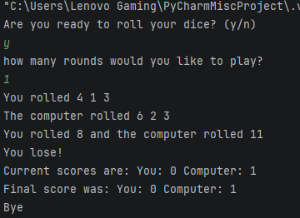
Result: Did the programme behave as expected ie syntactically and logically correct?
YES

The program has provided 3 random numbers for both the user and the computer and has correctly added the numbers of the dice together to produce a total. It has then correctly identified the computer’s total was greater than the users and produced the correct text output while also tracking the score.

Test:
- User wins round

Screenshot(s) of output:
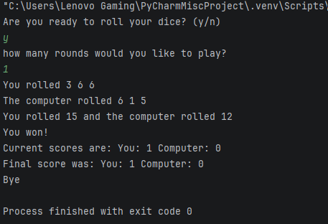
Result: Did the programme behave as expected ie syntactically and logically correct?
YES

The program has provided 3 random numbers for both the user and the computer and has correctly added the numbers of the dice together to produce a total. It has then correctly identified the user’s total was greater than the computers and produced the correct text output while also tracking the score.

Test:
- draw

Screenshot(s) of output:
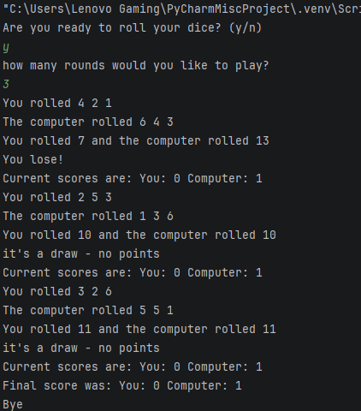
Result: Did the programme behave as expected ie syntactically and logically correct?
YES

The program has provided 3 random numbers for both the user and the computer and has correctly added the numbers of the dice together to produce a total. It has then correctly identified the user’ and computer total were the same and produced the correct text output while also tracking the score.

Test:

- “Go again” – enter y
Screenshot(s) of output:
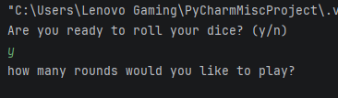
Result: Did the programme behave as expected ie syntactically and logically correct?
YES

The “go again” feature has been written out of the program owing to the user being made to select how many rounds they would like to play at the start of the program.

For the purpose of testing validation, which is the same principle, a test has been conducted on the y/n feature at the start of the program.

The program has accepted “y” as a valid entry and then allows the user to proceed into the dice game as expected. There is no validation in the code as this stage and therefore any entry will be accepted but only a lower case y will allow the user proceed as the code only checks if the variable is equal to y. Further validation will be required to enhance the program.

Test:

- “Go again” – enter n
Screenshot(s) of output:
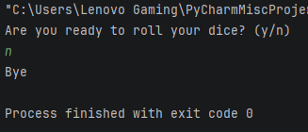
Result: Did the programme behave as expected ie syntactically and logically correct?
YES

The “go again” feature has been written out of the program owing to the user being made to select how many rounds they would like to play at the start of the program.

For the purpose of testing validation, which is the same principle, a test has been conducted on the y/n feature at the start of the program.

The program has accepted “n” as a valid entry and then directs the user to the next text output before exiting the program as expected. There is no validation in the code as this stage and therefore any entry will be accepted and any entry other than a lower-case y will result in the program exiting. Further validation will be required to enhance the program.

Test:

- “Go again” – enter Y
Screenshot(s) of output:
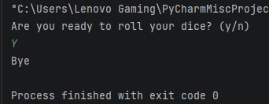
Result: Did the programme behave as expected ie syntactically and logically correct?
YES

The “go again” feature has been written out of the program owing to the user being made to select how many rounds they would like to play at the start of the program.

For the purpose of testing validation, which is the same principle, a test has been conducted on the y/n feature at the start of the program.

The program has accepted “Y” as a valid entry and then directs the user to the next text output before exiting the program as expected. There is no validation in the code as this stage and therefore any entry will be accepted and any entry other than a lower-case y will result in the program exiting. Further validation will be required to enhance the program.

Test:

- “Go again” – enter b
Screenshot(s) of output:
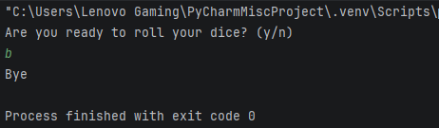
Result: Did the programme behave as expected ie syntactically and logically correct?
YES

The “go again” feature has been written out of the program owing to the user being made to select how many rounds they would like to play at the start of the program.

For the purpose of testing validation, which is the same principle, a test has been conducted on the y/n feature at the start of the program.

The program has accepted “b” as a valid entry and then directs the user to the next text output before exiting the program as expected. There is no validation in the code as this stage and therefore any entry will be accepted and any entry other than a lower-case y will result in the program exiting. Further validation will be required to enhance the program.

Test:
- Show score/score tracking (depending on how you have implemented your program)

Screenshot(s) of output:
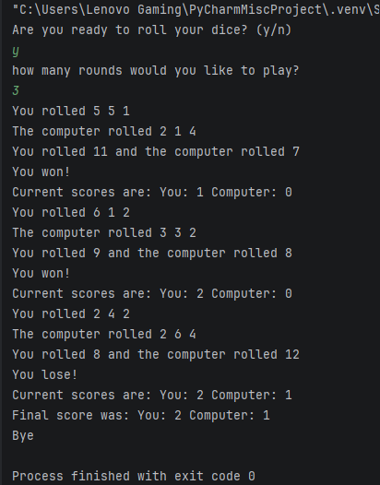
Result: Did the programme behave as expected ie syntactically and logically correct?
YES

After each round the user is informed of the current score. The program has tracked the score correctly by adding a +1 on to the computer or user’s tally dependant on who has won the round.

Test:
- Show an overall win (however this is achieved eg first to 5, best of 12 etc)

Screenshot(s) of output:
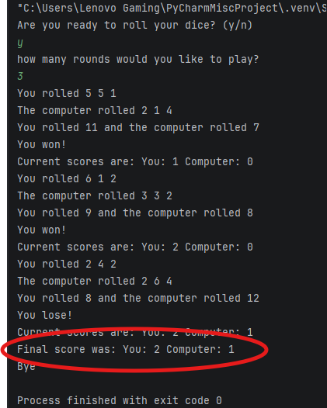
Result: Did the programme behave as expected ie syntactically and logically correct?
YES

The program has delivered a final score based on the current running score at the end of the program. This could be enhanced by providing a clearer text output at the end and this be explored when adjusting the coding.

Test:

- Analyse your code and write a short paragraph commenting on the efficiency of the original code. Could efficiency be improved and if so comment on what is currently inefficient?
Adjustments have already been built into the code to aid with efficiency. The main feature is that the user is required to enter the amount of rounds they would like to play after deciding they want to play at the start of the program. There are various options that could improve the efficiency of the code such as encapsulating the playing feature in a function.

- Consider the results of the above tests and your analysis of program efficiency and revisit your original code in order to address any tests that failed and/or improve code efficiency.

(Note: you may not be able to solve all of the problems that were encountered, but solve as many as you can.)

Paste your full revised code here :

import random

def GameTotal():
print("Are you ready to roll your dice? (y/n)")
#Validation for the y or n question
flag = 0
while flag == 0 :
playing = input().lower()
if playing != "y" and playing != "n":
print ("Please enter either y or n")
else:
flag = 1
#Main game function
def rolling(You, Comp):
print("how many rounds would you like to play?")
flag = 0
while flag == 0 :
try:
rounds = int(input())
if rounds <=0 or rounds > 100:
print ("Please select between 1 and 100 rounds")
else:
flag = 1
except ValueError:
print ("Please enter a number between 1 and 100 ")
for counter in range(rounds):
rando1 = random.randint(1, 6)
rando2 = random.randint(1, 6)
rando3 = random.randint(1, 6)
print("You rolled", rando1, rando2, rando3)
comp1 = random.randint(1, 6)
comp2 = random.randint(1, 6)
comp3 = random.randint(1, 6)
print("The computer rolled", comp1, comp2, comp3)
userScore = rando1 + rando2 + rando3
compScore = comp1 + comp2 + comp3
print("Your dice total was", userScore, "and the computer dice total was", compScore)
if userScore > compScore:
print("You won!")
print("")
You = You + 1
elif userScore == compScore:
print("it's a draw - no points")
print("")
else:
print("You lose!")
print("")
Comp = Comp + 1
print("Current scores are: You:", You, "Computer:", Comp)
print("")
else:
print("")
return You, Comp
#Main
You = 0
Comp = 0
if playing == "y":
You, Comp = rolling(You, Comp)
else:
print("")
print ("Final score was: You:", You, "Computer:", Comp)
if You > Comp:
print("You beat the computer!")
elif You < Comp:
print("The computer wins!")
else:
print("No winners today")
#Play again loop
again = "y"
while again == "y":
GameTotal()
again = input("Play again? y/n: ").lower()
while again != "y" and again != "n":
print("Please enter y/n:")
again = input("Play again? y/n: ").lower()
print("Thanks for playing!")

