University of Wales Trinity Saint David


Assignment Title: Business Development Report
Student Name: Saira Usman
Student ID: 2211405
Module: Business Development Proposal
Module Code: LCMB70037
Name of Lecturer: Hoang Nguyen and Vasilios Tavlaridis

Contents
1. Introduction 1
1.1 Background 1
1.2 Business Development Opportunity 2
1.3 Research Aim 3
1.4 Research Objectives 3
1.5 Scope 4
1.6 Structure of the Proposal 4
2. Business Opportunity and Problem Definition 5
2.1 The Problem 5
2.2 The Opportunity Gap 6
2.3 Opportunity Statement 7
2.4 Why the Opportunity Is Commercially Relevant 7
3. Market and Industry Analysis 7
3.1 UK Telecommunications/Mobile Industry 7
3.2 UK Assistive Technology Market 8
3.3 PESTLE Analysis 9
3.4 Porter's Five Forces 10
3.5 Industry Life Cycle 11
4. Customer and Market Segmentation 11
4.1 Target Market 11
4.2 Customer Personas 15
5. Product/Service Development and Value Proposition 17
5.1 Proposed Product 17
5.2 Core Features 18
5.3 Product Design Philosophy 20
5.4 Product Versions 20
5.5 Accessories and Services 21
5.6 Unique Value Proposition 21
6. Business Model and Commercial Strategy 22
6.1 Customer Segments 22
6.2 Value Proposition 22
6.3 Channels 22
6.4 Customer Relationships 23
6.5 Revenue Streams 23
6.6 Key Resources 24
6.7 Key Activities 24
6.8 Key Partners 24
6.9 Cost Structure 24
7. Competitive and Strategic Analysis 25
7.1 Competitor Categories 25
7.2 Competitor Comparison 26
7.3 SWOT Analysis 27
7.4 Strategic Positioning 29
8. Marketing and Customer Acquisition Strategy 30
8.1 Marketing Objectives 30
8.2 STP Framework 30
8.3 Marketing Mix — 7Ps 31
9. Operations, Technology and Supply Chain 33
9.1 Manufacturing Strategy 33
9.2 Supply Chain 33
9.3 Technology Architecture 33
9.4 Research and Development 34
9.5 Quality Management 34
10. Organization, Human Resources and Management 34
10.1 Organizational Structure 34
10.2 Accessibility Advisory Board 35
11. Financial Feasibility and Investment Proposal 35
11.1 Statement of Start-Up Costs 35
11.2 Pricing Strategy 37
11.3 Five-Year Sales Forecast 38
11.4 Break-Even Analysis 41
11.5 Cash Flow Statement 42
11.6 Funding Requirement 43
11.7 Investment Appraisal 43
11.8 Sensitivity Analysis 45
12. Risk, Legal, Ethical and Regulatory Considerations 46
12.1 Business Risks 46
12.2 Technology Risks 47
12.3 Regulatory Issues 47
12.4 Ethical Issues 47
13. Implementation Roadmap 49
14. Evaluation, KPIs and Growth Strategy 50
14.1 Key Performance Indicators (KPIs) 50
14.2 Growth Strategy 51
15. Conclusion 51
References 53

List of figures
Figure 1 Product Versions 22
Figure 2 Competitor Comparison 29
Figure 3 Statement of Start-Up Costs 38
Figure 4 Pricing Strategy 39
Figure 5 Five-Year Sales Forecast 39
Figure 6 Five-Year Sales Forecast 40
Figure 7 Year 1 Calculation 40
Figure 8 Year 2 Calculation 40
Figure 9 Year 3 Calculation 41
Figure 10 Year 4 Calculation 41
Figure 11 Year 5 Calculation 41
Figure 12 Break-Even Analysis (Alternative Scenarios) 43
Figure 13 Cash Flow Statement' 43
Figure 14 Funding Requirement 44
Figure 15 Net Present Value-NPV 45
Figure 16 Internal Rate of Return-IRR 45
Figure 17 Return on Investment 46
Figure 18 Social Impact KPIs 49
Figure 19 Social Impact KPIs 50

VisionConnect Mobile Ltd


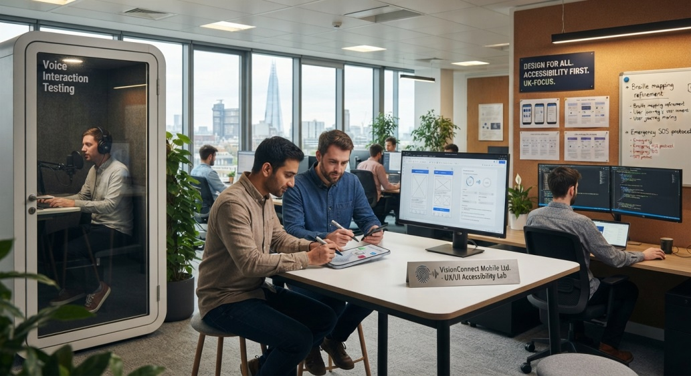

Mobile/the product
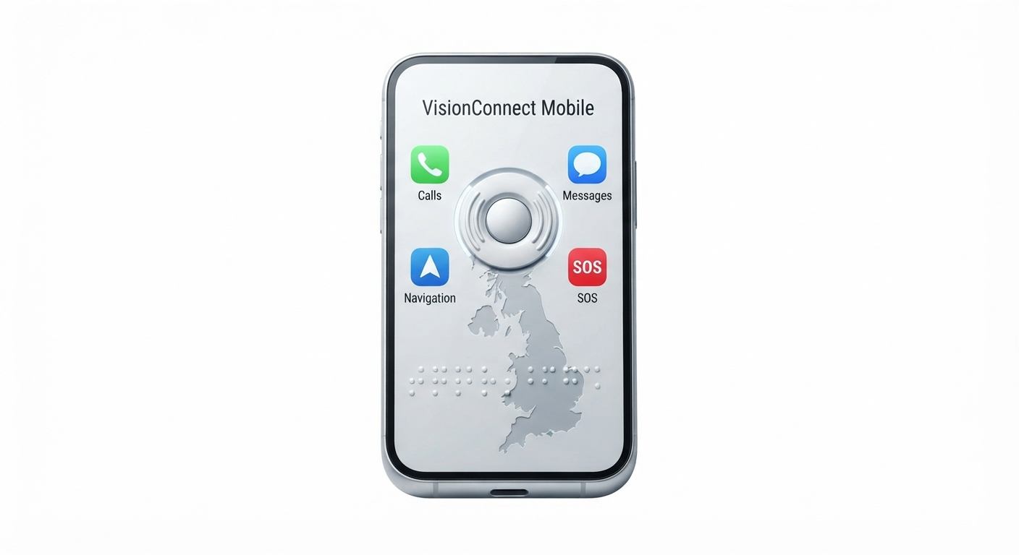

1. Introduction

1.1 Background
UK is one of the most developed and competitive telecom markets in Europe. At the end of September 2025, there were 91 million active mobile phone subscriptions in the UK, up 895,000 subscriptions or one per cent from the end of September 2024 (UK Parliament, 2026). According to the Research and Markets report, the mobile phones market in the United Kingdom is estimated to generate $22.4 billion of revenue in 2024, which reflects a compound annual growth rate of 1.4 per cent between 2019 and 2024. Mobile phone volume rose in 2024 as new smartphones launched by Apple and Samsung boosted activity of the smartphones category, while in 2025 volume sales continued to be positive as consumers upgraded to replace their aging smartphones (Euromonitor International, 2025). There is a strong dependency on smartphones in the UK and this is firmly entrenched in society. According to Ofcom data, 95 per cent of 16 to 74 year Olds, 78 per cent of 65+ year Olds and 65 per cent of 75+ year Olds have a smartphone in their household and personal use one (UK Parliament, 2025). As of 2025, there were almost 58-million smartphone users in the UK (Statista, Legal and General, 2025). This widespread uptake is a reflection of the way mobile devices have become even more than communication devices, they now have become platforms for information, services, employment, socialization and civic participation. Brits consumed 18 per cent more mobile data in 2025 compared to the previous year, with the total amount exceeding 1.2 billion gigabytes per month each year (Ofcom, 2025). Adults in the UK now spend an average of 4 hours and 30 minutes online every day, which is more than half an hour more than in 2021 during the pandemic (Ofcom, 2025). WhatsApp was the top messaging app and was used by 90 per cent of online adults in the UK in 2025 (Ofcom, 2025).
Digital communication is now the standard way of communication in healthcare, banking, government services, employment and social relations. This “digital transformation” has not been equal, however. Despite being a longstanding problem, digital exclusion persists in the UK, with 7.9 million people without basic digital skills, 3.7 million families living below the minimum digital living standard, and 1.6 million adults without access to a device, e.g. a smartphone, tablet or laptop (Good Things Foundation, 2025). The majority of those who are digitally excluded are over 65 (77 per cent) or have a disability or impairment (69 per cent) (Good Things Foundation, 2025). Additionally, nine out of ten non-disabled adults use the internet compared to six out of ten disabled adults (Centre for Care, 2025). Accessibility and digital inclusion are thus becoming a key policy, advocacy and technology development priority. The Royal National Institute of Blind People (RNIB) says that over 1.8 million people in England have a sight loss that is severe enough to impact their daily lives, while around 84,000 are registered blind or partially sighted and of working age (RNIB, 2025a). The number of people with sight loss in the UK is expected to more than double by 2025, to over four million (RNIB, 2023). Low rates of smartphone ownership exist among disabled people and they are heavily disadvantaged when it comes to accessing technology (Royal Society, 2025). In the UK, disabled households have to spend an additional average of £1,000 per month to maintain the same standard of living as non-disabled households, which limits access to AT (Royal Society, 2025).
Even smartphones with accessibility options like screen readers (VoiceOver for Apple and TalkBack for Android) and magnification capabilities have significant drawbacks for many people with a visual impairment. According to RNIB (2025) over half of blind and partially sighted people are late adopters of new technology, there is a greater proportion of blind and partially sighted people that are digitally excluded and there are fewer that own a smartphone when compared to the wider population. The digital divide is evident in two distinct ways: there is a digital divide within the blind and partially sighted community, as some are very comfortable with assistive technology and others are not technologically skilled or comfortable; and there is a digital divide between blind and partially sighted people and the general population (RNIB, 2025b). Inaccessibility and cost continue to be the top challenges for blind and partially sighted people in taking up technology (RNIB, 2025). Many blind and partially sighted people experience the mainstream technology as one of workarounds, barriers and features that don't work out in reality, (RealSAM, 2026).

1.2 Business Development Opportunity
This context presents a significant business development opportunity: The creation of a new business in the UK - the VisionConnect Mobile Ltd. purpose built mobile phone for blind and visually impaired consumers. The main point being made is not that visually impaired people require a mobile phone; this is a known fact. Instead, there is a market opportunity to fill an existing market void: current mainstream devices have some accessibility features, but are primarily designed for sighted users and then modified for accessibility a posteriori. RNIB (2025) refer to this as accessibility as an “afterthought” rather than a “priority from the design stage”, which inherently leads to compromises. A device designed for someone who is visually impaired, on the other hand, would be designed with a user's visual impairments in mind, rather than as an add-on. Interaction would be voice-first, tactile, the communication would be simplified, emergency support would be provided, and the device would, of course, be compatible with connection to a smartphone.
The market already contains precedents that validate this opportunity. Accessible products like the FeelVision Award for Best Product at SightCity 2025, which won the award, and the RealSAM Pocket, which is described as the first fully voice-controlled smartphone for blind and partially sighted people in the UK, show demand for dedicated accessible products (VisionAid, 2025; RealSAM, 2026). However, these are niche products which are more expensive and less widespread (the BlindShell Classic 3 is priced at £654) (RNIB Shop, 2025).

1.3 Research Aim
The purpose of this business development proposal is to ascertain the commercial viability and strategic value of a business based in the UK to design and market a mobile phone for blind and visually impaired customers that is accessible.

1.4 Research Objectives
This proposal is structured around the following research objectives:
- To examine the UK market for accessible mobile communication technologies, including market size, growth trends and regulatory environment.
- To identify the communication and usability needs of visually impaired consumers through analysis of existing research and user evidence.
- To analyse the competitive environment, including direct competitors, substitute products and barriers to entry.
- To develop an appropriate product and value proposition that addresses identified user needs and differentiates from existing offerings.
- To evaluate alternative business models and revenue streams, including hardware sales, subscription services and partnerships.
- To assess the financial feasibility of the proposed venture, including start-up costs, revenue projections and break-even analysis.
- To develop an implementation and growth strategy for the first five years of operation.

1.5 Scope
This business development proposal is scoped as follows:
- Geographic scope: The United Kingdom, with potential for future expansion to other European markets.
- Primary customer: Blind and visually impaired consumers in the UK who find conventional smartphones difficult to access or unnecessarily complex.
- Product: A purpose-built mobile phone incorporating voice-first interaction, tactile controls, accessibility features, simplified communication, emergency support and optional smartphone connectivity.
- Business: A new venture, VisionConnect Mobile Ltd., established as a UK private limited company.
- Time horizon: The first five years of operation (2026–2031).
- Manufacturing approach: Contract manufacturing initially, with potential for in-house assembly as scale increases.

1.6 Structure of the Proposal
This proposal is arranged in 15 Sections. After this introduction the business opportunity and the problem are detailed further in Section 2. The detailed market and industry analysis are given in Section 3. In Section 4, the concepts of segmentation of customers and markets are discussed. Product/service development and value proposition is covered in Section 5. Business model and commercial strategy is summarized in Section 6. Competitive analysis and strategic analysis are provided in Section 7. The marketing strategy and customer acquisition is explained in section 8. The operations, technology and supply chain considerations are covered in Section 9. Organisation, human resources and management are the subjects of Section 10. Financial feasibility and investment proposal is presented in the Section 11. The focus of part 12 is on risk, legal, ethical and regulatory considerations. Social impact and sustainability are covered in Section 13. An implementation roadmap is given in Section 14. The criteria and KPIs for evaluation and growth strategy is set in Section 15. The proposal ends with a summary of the findings and recommendations.

2. Business Opportunity and Problem Definition

2.1 The Problem
According to the Royal National Institute of Blind People (RNIB), it is estimated that over 1.8 million people in England have sight loss that is severe enough to have a significant impact on their day to day lives, with around 84,000 people registered blind or partially sighted of working age (RNIB, 2025). Over the next 12 months, RNIB estimates there will be approximately 105,000 people losing their sight in 2026, and this figure will increase with the ageing of the population (RNIB, 2026). Despite the proliferation of mobile technology, people with sight loss are less likely to use the internet every day, more likely to be digitally excluded and less likely to own a smartphone when compared to the rest of the population (RNIB, 2024). The Centre for Care research revealed that 92 per cent of non-disabled adults use the internet, whereas just 67 per cent of disabled adults do the same. The figures also showed that there was a significant difference in smartphone ownership between disabled and non-disabled adults, with 53 per cent of disabled adults owning a smartphone compared to 81 per cent of non-disabled (Centre for Care, 2025). According to Good Things Foundation (2025), in the UK 7.9 million people are unable to develop the essential digital skills needed for work, 1.6 million adults have no smartphone, tablet or laptop and 69 per cent of people without digital skills have a disability or impairment. The problems faced by those with poor vision with traditional cell phones are complex. The reliance on a touchscreen is a fundamental challenge, blind users need to identify the gestures the screen reader uses and learn these complex finger movements, such as flicking, tapping and sliding, which can only be done through the use of a screen reader on Apple devices (VoiceOver) or Android devices (TalkBack) (RNIB, 2024). Ofcom (2016) identified a range of genuine and perceived barriers to the use of touch-screen apps faced by visually impaired people especially those of 65 years and over, where there are fewer mobile phones owned by those who have the required skills required to use touch-screen apps. Persistent pain points are often identified in complex menus, in settings and in profiles, or even in the design of the menus; see RNIB 2026 for more information. Another major challenge is the complexity of setting accessibility options as while most mainstream devices have visual interfaces from which users can choose their options, this assumes that most users have some level of functional vision to enable these options. It is well understood that access to new technology is difficult for more than half of blind and partially sighted people (RNIB, 2024) because they are late adopters of technology due to the steep learning curve, and the emotional challenges to using interfaces that are not accessible. The Motability Foundation and RNIB (2025) identified emotional barriers as the biggest barriers to the adoption of technology, which can be exacerbated when users believe they are unable, unskilled or unmotivated to explore and use existing technologies.
One challenge with emergency calls is that when situations are stressful, blind users may not be able to easily find and use the emergency controls when it is needed due to the lack of tactile feedback on flat touchscreens. Combined with the lack of visual cues, small and not-very-contrasting visual interfaces are a huge challenge. Additionally, 71 per cent of blind and low vision people find it difficult to manage their finances alone (RNIB, 2025) and more than half of blind people or people with low vision have been unhappy with their banking provider because of inaccessibility. One other barrier is the cost of specialist assistive technology: 85 per cent of participants in a study by the RNIB (2025) stopped using an assistive device following the study, because of high cost, ranging from £2,158 to £3,598 per year, whereas Scope (2025) found that disabled individuals incur a year-on-year additional cost of £625 compared to non-disabled individuals.

2.2 The Opportunity Gap
It's more than just a range of features – it's a design approach – and the difference between mainstream smartphones and purpose-built accessible mobile devices is not a simple one. Mainstream smartphones, although they have accessibility features, are primarily designed for sighted persons with accessibility features that are added on after the phone is produced (RNIB, 2024). In doing so, this is an approach which treats accessibility as an afterthought, not a priority at the design stage – something which RNIB has long argued. In contrast, devices specifically developed for the blind, like the BlindShell Classic 3, which won the award for Best Product at SightCity 2025, and the RealSAM Pocket, are built from the ground up to interact via voice commands, tactile controls and simplified interfaces (VisionAid, 2025). The devices illustrate that a focused effort can result in the development of products that transcend mainstream technology. Nevertheless, they are still relatively small products that are only available in a handful of shops and cost a lot more than mainstream products, the BlindShell Classic 3 is priced at around £654 from the RNIB Shop (2025). As more alternatives to analogue telephone service become available, there is greater urgency for accessible mobile alternatives, particularly with the UK's analogue telephone network being phased out for good (RealSAM, 2026). This context identifies a gap in the market for a low cost, commercially available and competitively priced accessible mobile phone which is manufactured in the UK and uses the design principles of dedicated phones.

2.3 Opportunity Statement
It is possible that a simple, affordable, accessible and user-friendly mobile device, which combines tactile feedback, voice technology, emergency features and easy-to-use communication for the blind and visually impaired may represent a business development opportunity.

2.4 Why the Opportunity Is Commercially Relevant
The business potential of this opportunity is bolstered by several reasons. The market for assistive technologies for the visually impaired will increase substantially in the UK over the next six years (2025-2031) (Deafblind.org.uk, 2025). The ageing population is contributing to the growing problem of sight loss, with RNIB (2026) predicting that the number of people that start to lose their sight annually will rise by 130,000 in this country by 2036 as a result of demographic changes, and the number of people with the two main sight conditions in England is projected to grow by over a quarter in the next 10 years. The products and services known as the Deafblind.org.uk BlindShell, RealSAM Pocket and SmartVision 3 are examples of products that have found a market niche in the market due to consumer demand (Deafblind.org.uk, 2025). The compliance obligation and the market opportunity for accessible technology is brought about by accessibility legislation such as the Equality Act 2010 and the soon-to-be- implemented European Accessibility Act. Digital inclusion is recognised and is a policy priority, e.g. Good Things Foundation (2025) has been working to tackle the digital divide. Last, improvements in AI and voice technologies have brought the cost and complexity of voice first interfaces to a fraction of its previous size and complexity, enabling a purpose-built accessible phone to be technically and commercially viable. These factors culminate in a lucrative business basis for VisionConnect Mobile Ltd.

3. Market and Industry Analysis

3.1 UK Telecommunications/Mobile Industry
The UK telecom market is one of the most mature and advanced mobile market in Europe. Mobile phone subscriptions, which are still in use, totalled 91 million as of September 2025, a record 895,000 higher (one per cent) than the previous year (UK Parliament, 2026). 91.1 million (up 1.1 million or 1.2 per cent YOY) active subscriptions (excluding M2M) were confirmed by Ofcom (2025) at Q4 2025. Smartphone market has grown to a tremendous extent and it generated $22.4bn in revenue during 2024, growing at an annual rate of 1.4 per cent from 2019 to 2024 (Research and Markets, 2025). According to 6WResearch's latest research, the smartphone market in the UK is projected to expand at a CAGR of 4.6 per cent during the forecast period (2025a). UK consumers are most likely to be buying a smartphone in the future (24 per cent) (MEF, 2025).
Consumer spending continues to grow, and will grow at 1.5 per cent CAGR from 2025 to 2030 (GIIResearch, 2026). The amount of mobile data used by consumers in the UK has increased by more than 18 per cent per year, to more than 1.2 billion gigabytes per month (Ofcom, 2025b). The overall coverage of 5G from at least one operator has risen from 95 per cent of the UK in 2024 to 97 per cent by July 2025 (Ofcom, 2025c), while 83 per cent of the UK is covered by 5G standalone (Ofcom, 2025b). Ofcom (2025c) estimates there to be more than 29,100 5G sites in operation across the UK, representing a 26 per cent rise in 2025. The awareness of eSIM technology has been increased to 74 per cent, from 27 per cent in 2022 (Mobile News, 2026). According to the latest Mobile World Live study (2026), almost 45 per cent of UK users are opting for SIM-only contracts, a trend driven by the increasing replacement of mobile devices. The decline in the mobile phone retailers industry is expected to reach 2.5 per cent CAGR, as consumers grow more selective about the type of mobile phone they are purchasing, to £2.9 billion by 2026 (IBISWorld, 2025).

3.2 UK Assistive Technology Market
The UK assistive technology market is a major and expanding part of the market, with the sector projected to increase significantly from 2025 - 2031 (6Wresearch, 2025). The UK Assistive Technologies for the Visually Impaired Market will grow considerably during the forecast period (6Wresearch, 2025). UK Mobility Aid Devices Market is estimated to be worth USD 1,441 million in 2025 and is expected to hit USD 2,062 million by 2032 with a year-on-year growth of 5.3 per cent (6Wresearch, 2025). The Europe Digital Accessibility Software Market is projected to grow at a CAGR of 8.4 per cent (2024–2031) and 7.5 per cent (GIIResearch, 2025) CAGR on the UK market. Disabled people in the UK, known as the “purple pound”, make up an estimated 16 million people in the UK and over £70 billion a year is being lost by not attracting disabled customers to businesses in the UK (AlixPartners, 2025; Henderson Chambers, 2025). There are many specialist providers of accessible communication devices: BlindShell, RealSAM and SmartVision (Deafblind.org.uk, 2025). The analogue telephone network is to be phased out for good in the UK, and this is an added impetus for the need for mobile solutions that are accessible to everyone (RealSAM, 2026).

3.3 PESTLE Analysis
Political: The government's ambition to boost digital inclusion in terms of skills, access, services and trust is set out in the Digital Inclusion Action Plan (2025) (GDS, 2025). The Digital Inclusion Innovation Fund was created with £9.5 million to support people to get online (Gov.uk, 2025). 80 local schemes have been announced by Minister for Digital Inclusion that will receive £11.7 million from the Fund (Gov.uk, 2025c). Accessibility of websites and mobile applications is required by the Equality Act 2010 and reasonable adjustments is required by the Equality Act 2010, 2025. Local government, charities, and research organisations are eligible to apply for funding up to £25,000 – £500,000 to increase digital inclusion (Gov.uk, 2025).
Economic: The annual rate of inflation in June 2026 was 2.6 per cent, compared with 2.8 per cent in May (ONS, 2026) but economists are expecting the annual rate of inflation to push towards 4 per cent at year-end (NIESR, 2026). Disabled households are on average spending an additional £1,095 per month, to the level of living standard of non-disabled households (Scope, 2025). Disabled people are likely to spend an average of £1,010 a month more than a non-disabled person (Disability Rights UK, 2026).
Social: Social change and an ageing population are a massive issue in the UK, with the population of over 75s expected to grow by 52 per cent from 6.7 million in 2025 to 10.2 million in 2050 (ICAEW, 2026). Digital exclusion is experienced by those with disabilities and older people at disproportionately high levels - 7.9 million do not have basic digital skills, 3.7 million are not living at the minimum digital standard and 1.6 million do not have access to a smartphone, tablet or laptop (Good Things Foundation, 2025). Disabled adults are less likely to use the internet, with 67 per cent using it compared to 92 per cent for non-disabled adults, and disabled people are less likely to have a smartphone than non-disabled people, 53 per cent of disabled people had while 81 per cent of non-disabled people had (Centre for Care, 2025). 40% of adults said that they felt lonely (ONS, 2025).
Technological: The technolgical market is £1.3 billion (IBISWorld, 2025) and big growth is expected due to rising adoption of voice controlled technology (6Wresearch, 2025e). MarketResearchFuture (2025) estimates the UK artificial intelligence Speech-to-Text tool market will increase by USD 10.7 per cent CAGR from USD 143.4 million in 2025 to USD 398.17 million by 2035. Combined, these technologies of AI, voice recognition, OCR, GPS and haptic technology create a commercially viable accessible phone.
Legal: Equality Act 2010, disability access – reasonable adjustments (2025). In Northern Ireland there are extra accessibility requirements as outlined in the European Accessibility Act (Henderson Chambers, 2025). The Waste Electrical and Electronic Equipment (Amendment) Regulations 2025 were approved on 12th August 2025, and will place an obligation on online marketplaces to finance the costs of recycling (Legislation.gov.uk, 2025; Resource.co, 2025). Businesses will have to notify all WEEE from 1 January 2025 when they ship it to be recovered in England (Gov.uk, 2024).
Environmental: Environmental Products must comply with WEEE Regulations which involves product take-back and recycling (Circular Online, 2025; Letsrecycle.com, 2025). This is a chance to offer a sustainable design, to be reparable, and to be designed for responsible end-of-life.

3.4 Porter's Five Forces
Competitive Rivalry: Moderate to High. Apple, Samsung and Google are the leading companies in the mainstream smartphone market (Euromonitor International, 2025). It is an obvious competitor to Deafblind.org.uk, known as RealSAM Pocket or SmartVision, and BlindShell (Classic 3 retailing for around £654). Such competition is relatively small and not widely distributed and, as a result, the competition is for the niche accessible device segment, and is currently low to moderate. But there is always the risk of a mainstream manufacturer working towards making its production more accessible.
Threat of New Entrants: Moderate. Barriers include the cost of investment, supply chain management and regulations, but contract manufacturing mitigates these barriers. The main obstacle is to gain a scale and brand.
Supplier Power: Moderate. Components come from a narrow, global industry (Qualcomm, MediaTek, Samsung) but the available phone's more basic specifications lessen reliance on narrow supply chains.
Buyer Power: Moderate to High. As individual consumers have little bargaining power, collective purchasing of goods through charities and local authorities might help to focus buying power. This is a highly relevant point with economic pressures on disabled households (Scope, 2025).
Threat of Substitutes: High. The main alternative is the mainstream smartphones, which have inbuilt accessibility options (VoiceOver, TalkBack). Other alternatives are landlines and feature phones. It is critical to differentiate with superior user experience.

3.5 Industry Life Cycle
The small market for mobile devices that are accessible is expanding. These indicators are: market growth (6Wresearch, 2025), rising consumer awareness as a result of the government initiatives (Gov.uk, 2025), the technological innovation of AI and voice recognition (6Wresearch, 2025e), the demographic tailwinds of the ageing population (ICAEW, 2026; RNIB, 2026), regulatory drivers (Equality Act 2010, 2025; Henderson Chambers, 2025), product proliferation (BlindShell, RealSAM, SmartVision) and declining entry barriers. Niche is not yet developed, as there is limited variety of products available and high prices, fragmented distribution, is an opportunity and a risk.

4. Customer and Market Segmentation

4.1 Target Market
The UK sight loss population is a diverse market. RNIB estimates over 1.8 million people in England have sight loss to such an extent that it has a significant impact on daily life, including around 84,000 people who are registered blind or partially sighted who are working age (RNIB, 2025a). In the UK, there are nearly 2 million people with sight loss (1 in 30), with approximately 360,000 of these registered as blind or partially sighted (AbilityNet 2025). According to RNIB (2026), the number of people in the UK losing their sight over the next 12 months will reach approximately 105,000 in 2026, rising to 130,000 in 2036 – an increase of 23 per cent, due to the UK population ageing. To design products and position them appropriately in this population, it is necessary to understand the differences in these people.
Segment A: Blind users are people with no use of their eyes or with very limited vision use, and who use non-visual interfaces to communicate with the computer.Blind users are people who have little or no vision (or very limited vision use), who communicate with the computer through non-visual interfaces. There are around 360,000 people who are registered blind or partially sighted across the UK (AbilityNet, 2025). However, for blind users, reliance on touchscreen is one of the fundamental obstacles, as they need to learn very complex finger movements for using the screenreaders (RNIB, 2024). There are less people with sight loss who own a smartphone than in the general population, with only 54 per cent having one, compared to many more in the general population (RNIB, 2025b); 28 per cent own a regular mobile phone and 18 per cent own no mobile phone at all. The segment focuses more on voice first interactions, tactile controls, and dependable emergency functionality as opposed to visual interfaces.
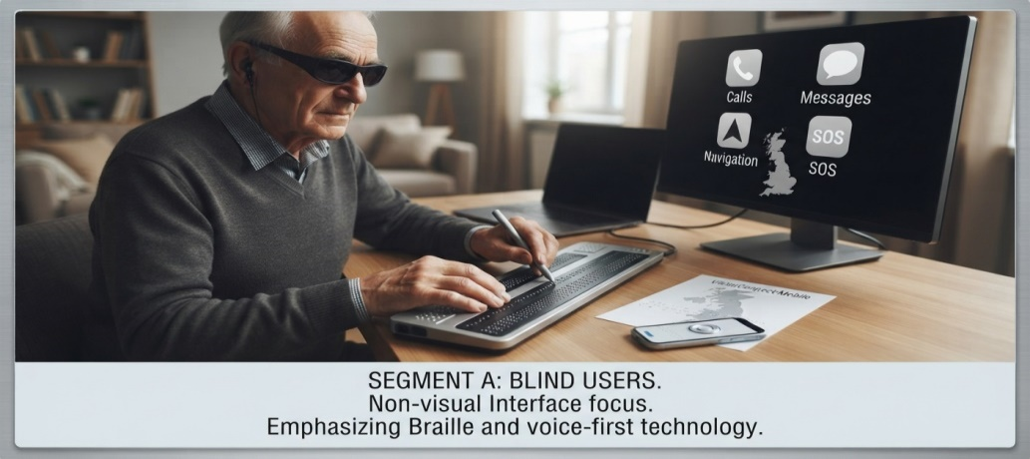
Source: By author through AI Gemini
Segment B: Partially sighted users may benefit from better visual interfaces in addition to voice and tactile interfaces, depending on their visual abilities. The larger proportion of the sight loss population (the estimated 2 million (RNIB, 2025b)), it is the part of the population for whom sight loss is not a terminal condition. For such users, high contrast displays, easily adjustable text size and simplified menus are required. They might be able to use a standard cell phone, but get irritated with the size of the screen and lack of contrast. They are more likely than blind users to have access to technology, but there are significant barriers – 28 per cent of people with sight loss report that they never use the internet or have no access, whereas only 4 per cent of non-disabled users do (RNIB, 2025).
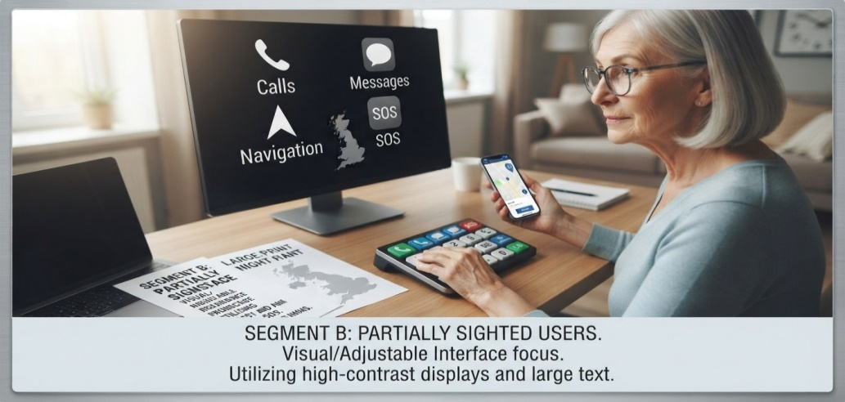
Source: By author through AI Gemini

Segment C: Older visually impaired consumers are the fastest growing segment (Segment C). The population of over 75s is expected to grow by 52 per cent from 6.7 million in 2025 to 10.2 million in 2050 (ICAEW, 2026). By 2036, approximately 130,000 people will begin to lose their sight every year (RNIB 2026) due mainly to Age-Related Macular Degeneration, glaucoma and diabetic retinopathy. Elderly users typically value simplicity, large buttons, voice control and emergency controls more than anything else in a smart phone. From the above, it is clear that RNIB (2024) states that over half of blind and partially sighted individuals are late adopters of new technology – this is due to a combination of the learning curve and emotional barriers. In this type of segment, ease of use, reliability and emergency support are of the utmost importance.

Source: By author through AI Gemini
Segment D: There is a smaller, but significant, segment of Younger technology-oriented users . Although the prevalence of sight loss rises with the age, there is a large population of working age blind and partially sighted people, around 84,000 registered blind and partially sighted people (RNIB, 2025a). There are about 11,000 people with a vision impairment who are seeking employment.At the present time about 11,000 blind or partially sighted individuals are looking for employment (RNIB, 2025). Employment levels are stark: one quarter of blind and partially sighted people of working age are in employment, while three-quarters of the general population are (RNIB, 2025). For younger consumers, they might want some form of artificial intelligence-based support, GPS navigation, voice commands, messaging platforms, social media, and smartphone connectivity. Many blind and partially sighted people today use their mobile phone more than any other computer, and it is a fairly inexpensive means of being able to use a mobile computer (AbilityNet, 2025). Familiar apps, like Seeing AI, Be My AI, Lookout and Aira are now integrated into products like the BlindShell Classic 3, demonstrating the demand for app integration (RNIB Shop, 2025).
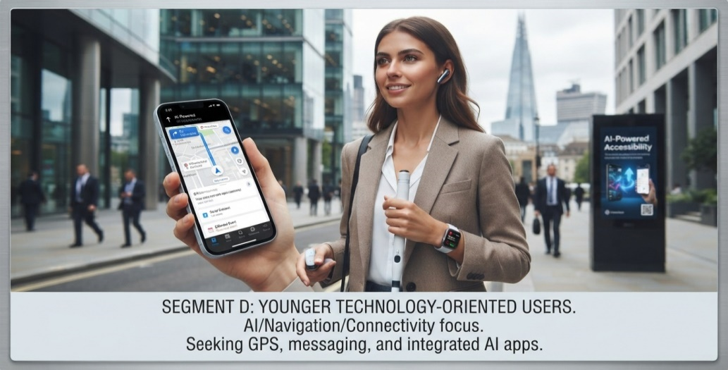
Source: By author through AI Gemini
Segment E: Institutional/B2B Market offers a tremendous opportunity outside of direct to consumer sales. Potential institutional users include organisations involved in sight loss services like RNIB and Guide Dogs UK; care organisations and care homes; local authorities with statutory duties under the Care Act 2014 and Equality Act 2010; NHS organisations; social-care organisations; and accessibility programmes. The Care Act 2014 and Children and Families Act 2014 include duties on local authorities to provide community equipment and assistive technology (Find Tender, 2025). A Framework Agreement has been in place with 21 Local Authorities, working as a consortium with the NHS in assistive technology procurement (Find Tender, 2025). This institutional channel may offer a predictable source of income in terms of both numbers of elements and income.
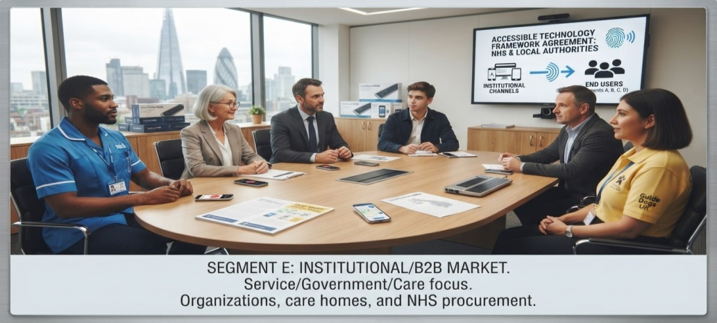
Source: By author through AI Gemini

4.2 Customer Personas
Persona 1 — Independent Older User
Persona 1 is an older and independent user. Margaret is 78 years old and lives on her own. She is a registered severely sight impaired person and has age-related macular damage. She doesn't have a cell phone and is afraid of it. Currently she has a basic telephone line, but is worried about the end of analogue telephone lines in the UK (RealSAM, 2026). The main issues that Margaret would have are call, voice messaging, accessing the emergency contacts rapidly, and tactile buttons/voice confirmation that are large. She values independence. Her daughter, who lives 50 miles away, bought the car, and fears that her mother will be hurt; she wants her reassured that if her mother gets an emergency call, she can reach out to help. This is a good example of the concept that "user is not purchaser” and that family members may be decision makers.
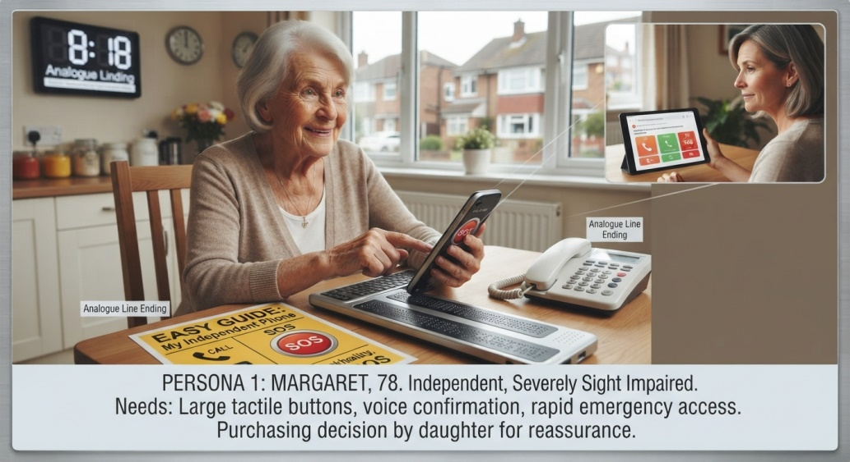
Source: By author through AI Gemini
Persona 2 — Digitally Confident Working-Age User
James is 34 years old and a customer service advisor; he is a birth-blind person. He is a confident user of technology and uses his iPhone with VoiceOver; he finds the experience frustrating, however, as gestures are sometimes not working and there is no tactile feedback on the touchscreen. He wants a device that has a built-in messaging app that can support WhatsApp, GPS navigation with audio directions, voice assistant, and access to online services like banking. He would love the ability for his phones to connect to optional apps such as Seeing AI and Be My AI. He's from the younger generation of technology-oriented users and would be interested in a combination of simplicity and functionality.
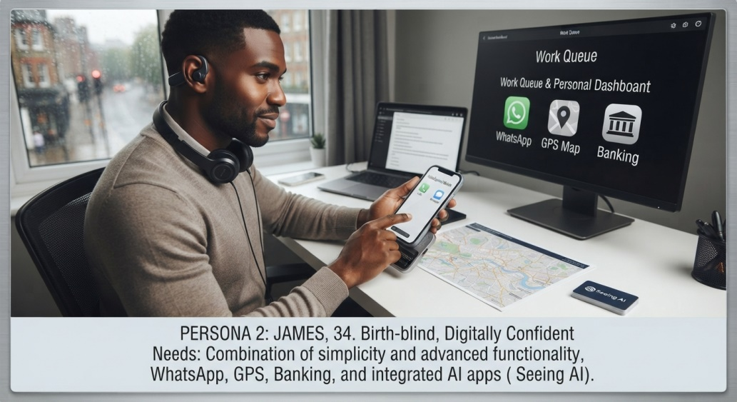
Source: By author through AI Gemini
Persona 3 — Family Purchaser
Sarah is 45 years old and lives in London. Her father David (72) has been diagnosed with glaucoma and is registered sight impaired. David has problems with his smartphone; the screen is too small to read the notifications and he dials the numbers by mistake. Sarah is the main decision maker and buyer. Her priorities are safety, location tracking, emergency communication and reliability. She would pay extra for a device that would provide her father with peace of mind, one that allows him to call for help with ease and wouldn't need to be constantly supported. She reflects the influencer role, and needs of the end user are filtered through the concerns of a family member.
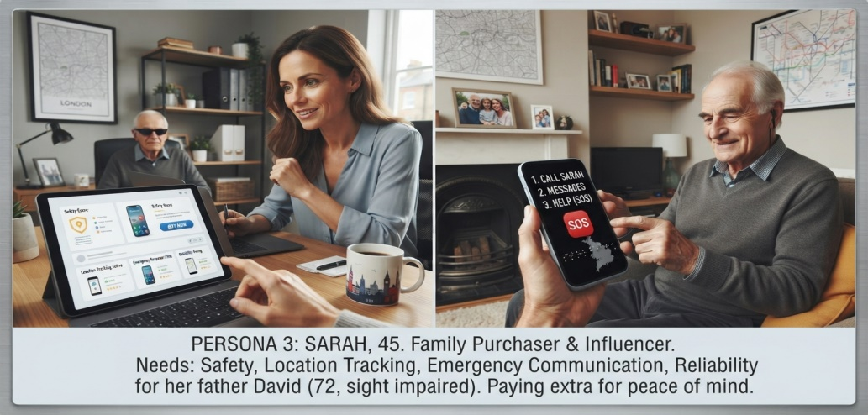
Source: By author through AI Gemini
Persona 4 — Institutional Buyer
Catherine is a Commissioning Manager in a local authority social care department. She obtains assistive technology for persons who are blind or low vision support them with independent living. She is required to work within statutory duties under the Care Act 2014 and will need to ensure that value for money, accessibility standards and positive outcomes (Find Tender, 2025) are met. She knows that individuals with sight loss are twice as likely to be digitally excluded (RNIB, 2025) and technology can be 'a means of empowerment and independence' (RNIB, 2025e). If it is of good quality, competitive price and training support is available, she would explore the possibility of using VisionConnect Mobile for bulk procurement.
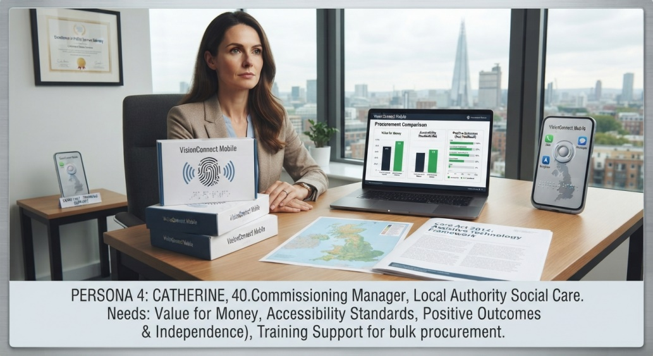
Source: By author through AI Gemini
Segmentation analysis uncovers that VisionConnect Mobile can't have a "one size fits all" strategy. Each segment is different and has specific needs, buying habits and value proposition. Product design, messages and marketing communication channels need to be adjusted, ensuring a special focus on the user-purchaser-influencer relationship of the accessible technology market.

5. Product/Service Development and Value Proposition

5.1 Proposed Product
The VisionConnect One is a mobile phone designed with accessibility in mind, instead of making a smartphone accessible after it is produced (RNIB, 2024). The device is aimed at the estimated 2 million individuals who are blind or partially sighted in the UK (approximately 360,000 of these are registered as blind or partially sighted) (AbilityNet, 2025). Purpose-built accessible devices have been popular in the market and there are dedicated devices available, including the RealSAM Pocket (iSightCornwall, 2025) and the BlindShell Classic 3 (VisionAid, 2025) which were awarded the Best Product when the SightCity competition was held in 2025. But they are still small-scale products with limited availability and expensive prices and there is the potential for a competitively priced alternative (RNIB Shop, 2025). The assistive technologies for the visually impaired market in the UK is expected to grow at a significant rate from 2025 to 2031 as a result of the ageing population and the growing awareness of digital inclusion (6Wresearch, 2025). The European Accessibility Act from 28 June 2025 now also mandates smartphone and communication devices to meet accessibility standards, paving the way for accessibility regulations (Lexology, 2025).
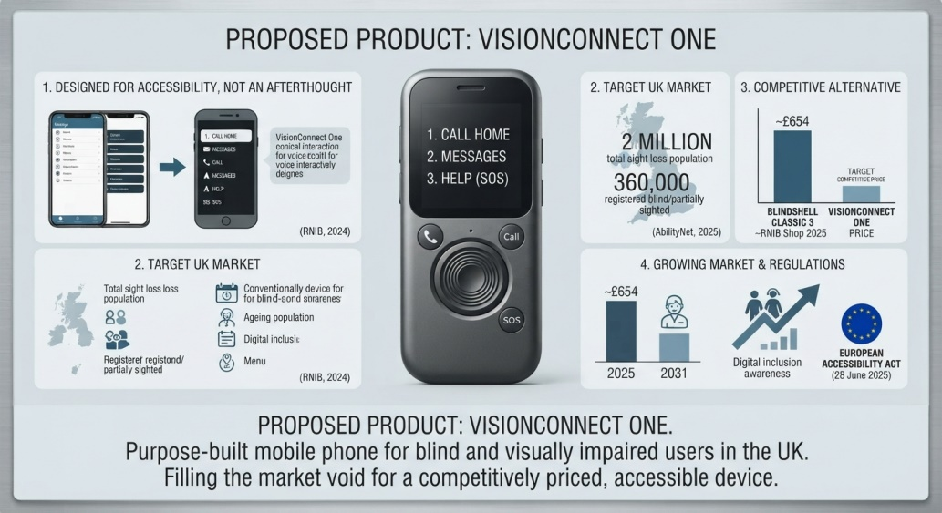
Source: By author through AI Gemini

5.2 Core Features
Physical accessibility is integral to the VisionConnect One design. High contrast physical buttons with tactile differentiation, raised markings, different shapes and different tactile qualities allow users to know what the function is by touch alone (BlindShell, 2025). According to BlindShell, a "tactile keyboard with large tactile buttons for comfortable phone control" is a helpful feature for the blind and visually impaired. A physical emergency button allows for quick access to SOS functions, without having to navigate through menus, which is one of the problems reported by users when in an emergency (RNIB, 2024). There are optional Braille markings and robust vibration feedback to help make it non-visual friendly (UCL, 2025). Research of haptic feedback has shown that findings can be used to give "user-driven insights into the potential for everyday mobile devices for haptic mobile interactions" (UCL, 2025) and help to "enhance the haptic feedback of smartphones".
Voice functionality is a key aspect of the user experience. The device features voice control calling, voice messaging, voice navigation, voice notifications, text-to-speech and speech-to-text. Voice technology is a mature market with the UK Speech and Voice Recognition Software market worth £1.3 billion in 2025 (IBISWorld, 2025). According to MarketResearchFuture, the UK market for AI speech to text tools is expected to increase from USD 143.4 million in 2025 to USD 398.17 million by 2035, with a CAGR of 10.7 per cent (2025). RealSAM Pocket is proof of the viability of "voice-operated mobile phone[s]" that are "designed specifically for people with sight loss" and can be operated entirely by voice (I am quoting them here, it's been awhile since I read the action plan, I just downloaded it here, 2025, Virgin Media O2 Business). The RealSAM Pocket is "built specifically for blind and partially-sighted users" and can be "used with voice commands that can assist those who have less than perfect dexterity" (Virgin Media O2 Business, 2025).
Communication features include calls, SMS, messaging applications, contact management and voice notes. The Synapptic smartphone features “clear, simple menus and in-built voice recognition” to enable “easy and intuitive navigation”. It can also be used for WhatsApp and other popular messaging applications, so that users can communicate with their family and friends (BlindShell, 2025).
Safety functionality is one of the main differentiating aspects. There is an emergency SOS button, pre-programmed emergency contacts, location sharing and automatic fall/emergency detection. Medication reminders is a way of helping older people with multiple medicines to live independently (RNIB, 2024).
GPS navigation provides spoken directions, location assistance and the 'Where am I?'. Waymap: An App-based navigation tool offers “Step by step guidance indoors, outdoors and deep underground” and “Accurate, accessible indoor-outdoor pedestrian navigation” (Waymap, 2025). The Waymap app learns from users' walking, and "will change the lives of blind and visually impaired people" (Waymap, 2025). Another navigation app, GoodMaps, has been tested in Greater Manchester's Bee Network (Greater Manchester), giving users 'turn by turn directions' via a camera.
AI accessibility features are planned for future development. For people with vision loss, the use of AI is changing their lives for the better, as it is “revolutionising the experience” (Fight for Sight, 2025). Future functions could include object recognition, currency recognition, text recognition and/or descriptions of the scenes along with a voice controlled AI assistant. KapX from Kapsys is an ‘intelligent AI-powered accessibility solution' that ‘helps you read printed text, identify everyday objects and products, and describe rooms, environments and scenes' (Sight and Sound 2025). The Be My Eyes app will connect with Meta's Ray-Ban smart glasses, allowing users with visual impairments to access visual information without holding a device in their hands, such as reading a document when reading an office.The Be My Eyes app will be able to connect with Meta's Ray-Ban smart glasses, which will help users with visual impairments to access visual information without holding a device in their hands, such as reading a document or navigating an office.

5.3 Product Design Philosophy
The design philosophy of VisionConnect Mobile is the concept of “Accessibility by Design” (RNIB, 2024), meaning that the design of the hardware, software and user experience is based on accessibility. Accessibility is a "priority from the design stage" and not an "afterthought" (RNIB, 2024). The European Accessibility Act now stipulates that "smartphones, smart TVs, game consoles and other communications devices" have to comply with the accessibility requirements (Lexology, 2025). Governments should start treating smartphones as assistive devices, rather than consumer electronics, the Royal Society has said (Telcomagazine, 2025). VisionConnect One ensures that accessibility is built into the product, rather than into adapted mainstream devices, which compromise the product's capabilities.

5.4 Product Versions
VisionConnect Mobile will launch with three models to address different user needs and price points:
Model | Target Customer | Indicative Positioning | Estimated Price
VisionConnect Essential | Basic users (older adults, first-time users) | Affordable, simplified functionality | £299
VisionConnect One | Mainstream target (most users) | Mid-range, full feature set | £449
VisionConnect Pro | Advanced users (tech-savvy, younger users) | Premium, additional AI and app integration | £599
Figure 1 Product Versions
With this portfolio strategy, the company can cover the entire range of the visually impaired market, from the user who needs only the function of a phone to the user who would like to have the interaction possibilities of a smartphone. The pricing is also low enough to be competitive to the BlindShell Classic 3 (which costs £545) and much more affordable to consumers price sensitive (VisionAid, 2025; iSightCornwall, 2025).

5.5 Accessories and Services
Other revenue sources to be tapped include accessories and services. Complimentary products such as protective cases, charging docks, Bluetooth accessories and headsets will be available. Extended warranty and additional software features, technical support and training services will generate continued revenue and customer engagement (RealSAM, 2025). RealSAM Pocket are providers of subscription services such as "RealSAM BookClub" which is a subscription service for blind and partially sighted people in the UK, providing unlimited access to a world of accessible audio books, news and discussion for a month or a year (RealSAM, 2025). The same will be true of VisionConnect Mobile, which will have premium support and content subscriptions.

5.6 Unique Value Proposition
The Unique Value Proposition (UVP) for VisionConnect Mobile is:
"A mobile phone designed around how blind and visually impaired people use technology—not how conventional smartphones expect them to."
t directly tackles the key issue that was voiced by RNIB (2024) – accessibility as an afterthought, the technology must adapt to the user. The UVP differentiates VisionConnect from the existing mainstream smartphone market (accessibility is an afterthought) and from the existing dedicated market (far fewer devices, and high price tag). The physical access, voice interaction, safety features and pricing of VisionConnect One all make it a very attractive alternative that meets the needs of the increasing number of visually impaired users in the UK.

6. Business Model and Commercial Strategy

6.1 Customer Segments
There are two main customer segments of VisionConnect Mobile. The UK primary segment is blind or partially sighted consumers which includes around 360,000 registered blind or partially sighted people, and the total sight loss population is estimated to be nearly 2 million (AbilityNet, 2025; RNIB, 2025). This consumer segment is broken down into sub-segments of older visually impaired consumers (which is the fastest growing consumer group, and is estimated to grow by 52 per cent from 6.7 million in 2025 to 10.2 million in 2050 (ICAEW, 2026) and younger technology-orientated consumers (roughly 84,000 of which are aged working age (RNIB, 2025). Secondly, the institutional/B2B segment has sight loss charities (e.g. RNIB and Guide Dogs UK); local authorities that have statutory responsibilities under the Care Act 2014; NHS-related organisations; and accessibility programmes (e.g. Find tender and 2025). There is a significant institutional channel: A Framework Agreement is in place with a consortium of 21 Local Authorities who have an agreement with the NHS for procurement of assistive technology (Find Tender, 2025).

6.2 Value Proposition
The value proposition of VisionConnect Mobile addresses one of the basic challenges faced by the mainstream: accessibility is not considered first when designing a device (RNIB, 2024). The value proposition is: "A mobile phone that's built for blind and visually impaired users--not how a typical mobile phone works. It enables accessible, independent and safe mobile communication, with physical accessibility (tactile buttons, raised markings, physical emergency button), voice-first interaction, simplified communication and safety functionality (emergency SOS, location sharing), as well as GPS navigation with spoken directions (BlindShell, 2025; RealSAM, 2026). In the UK, the spending power of disabled people and their families is greater than many whole industries combined – at £274 billion per year (Accessibility Toolbar, 2025). The use of assistive technology has increased significantly; 8.2 million adults in the UK use some type of AT regularly (Accessibility Toolbar, 2025).

6.3 Channels
A multi-channel distribution strategy will be used in VisionConnect Mobile. The company website will be the main direct channel, featuring ecommerce capabilities. Accessibility organisations like RNIB and local sight loss charities will be involved in partnership channels, they already sell products through their shops (RNIB Shop, 2025). Specialist retailers like VisionAid will be engaged; they are currently selling the BlindShell Classic 3 at £545.00 with VAT relief (VisionAid, 2025). Mobile network operator (MNO) partnership with telecom will allow for bundled offerings and the RealSAM Pocket will be offered on a monthly payment O2 SIM card (iSightCornwall, 2025). The procurement of institutions will be done via public sector procurement institutional frameworks (Find Tender 2025). There will be further distribution reach provided by online retailers and specialist accessible technology retailers.

6.4 Customer Relationships
Customer relationships will be built through multiple touchpoints. Telephone support will be provided via a dedicated helpline, mirroring the model used by VisionAid which offers "friendly and expert remote phone or video training session[s]" (VisionAid, 2025). Accessible online support will include live chat, email and video tutorials. Training services will be offered; BlindShell includes a "free 30-minute remote training session" with each phone purchase (RNIB Shop, 2025). A community platform will connect users, enabling peer support and knowledge sharing. Subscription support will provide premium assistance for users requiring ongoing technical help. RNIB has already helped nearly 100,000 blind and partially sighted people to better access and use technologies through its Online Today programme (RNIB, 2025).

6.5 Revenue Streams
There will be a number of touch points to build a relationship with the customer. Like VisionAid, which has dedicated helplines for telephone support, there will be a dedicated helpline for telephone support.There will be a dedicated helpline for telephone support as on VisionAid's website there are 'friendly and expert remote phone or video training session[s]' (VisionAid, 2025). There will be live chat, email and video tutorials as the online support. Training services will be provided; BlindShell has a free 30-minute remote training session with each phone purchase (RNIB Shop, 2025). The prices will be at VisionConnect Essential at the price of £299, VisionConnect One at £449 and VisionConnect Pro at £599, which are very beneficial. Subscription services will generate recurring revenue: RealSAM, for instance, has a subscription service to its BookClub that includes "unlimited access to a world of accessible audio books, news and discussion" (RealSAM, 2025). Higher-end features might include sophisticated AI functions like object recognition and scene descriptions (Fight for Sight, 2025). By selling accessories like protective cases, charging docks, and Bluetooth headsets, it will make extra margin (VisionAid, 2025). Volume (Find Tender 2025) will be generated based on B2B contracts and institutional procurement.

6.6 Key Resources
Some of the key resources are hardware design, software development, expertise in AI integration, brand and intellectual property, and accessibility expertise. As of 2025, the UK Speech and Voice Recognition Software market was estimated to be worth £1.3 billion (IBISWorld, 2025). The market size of AI speech-to-text tools in the UK is expected to increase from USD 143.4 million in 2025 to USD 398.17 million by 2035 with a 10.7 per cent CAGR (MarketResearchFuture, 2025). The company will need to develop its own software system for the OS with accessibility features. Unique features of hardware and software will be subject to I.P. protection.

6.7 Key Activities
Main activities include research and development, manufacturing (via contract manufacturers), software development, marketing and customer support. R&D will be geared towards ongoing enhancements of accessibility and incorporating new AI features. The initial capital cost will be cut down by outsourcing the manufacturing to contract manufacturers. Software will be developed continuously with updates. The marketing approach will be directed towards end-users and institutional buyers, on easily accessible channels. The support of the customers will be one of the main differentiators and will be provided in the form of training and technical assistance.

6.8 Key Partners
Key partners are component suppliers to processors, displays and batteries, contract manufacturers for assembly and logistics, mobile network operators for connectivity partnerships, accessibility organisations like RNIB for market access and credibility, technology companies for AI and voice recognition integration and charities and distribution partners for channel reach. During 2024–2031, the Europe Digital Accessibility Software market is projected to grow at 8.4 per cent CAGR with the UK market projected to grow at 7.5 per cent CAGR in 2025 (GIIResearch, 2025), reflecting an expanding base of technology partners.

6.9 Cost Structure
It has a cost structure consisting of research and development, component cost, manufacturing cost, employee cost, marketing and sales cost, logistics and distribution cost, customer service cost and regulatory compliance cost. Memory accounts for 20 per cent of the bill of materials (BOM) in a mid-range smartphone, and the price of memory will continue to go up with the expectation of more expensive smartphones in 2026 (IDC, 2025). The Waste Electrical and Electronic Equipment (Amendment) Regulations 2025 have compliance costs for product take-back and recycling (Legislation.gov.uk, 2025). Consumer upgrades are slowing (IDC, 2025), inflation and rising energy and logistic costs are taking a toll on the UK handset market. The market for accessible devices, however, is growing positively, the UK Assistive Technologies for the Visually Impaired Market is expected to grow at a rapid pace over the forecast period (2025-2031) (6Wresearch, 2025).

7. Competitive and Strategic Analysis

7.1 Competitor Categories
There are four different types of competitive players in the accessible mobile communication devices market in UK.
Direct competitors will be a specialist accessible mobile phone, which is specifically made for a visually impaired user. Winner of the prestigious FeelVision Award for Best Product at SightCity 2025, the BlindShell Classic 3 is a fully accessible mobile phone that features a 13 MP camera, is compatible with WhatsApp and Facebook Messenger and has a tactile keypad with voice control (VisionAid, 2025; RNIB Shop, 2025). It retails at £545.00 with VAT relief or £654.00 inc VAT (VisionAid, 2025; RNIB Shop, 2025). The key features include Luna (Virtual AI assistant), Tandem (App for remote assistance), Observo (AI descriptive image) and Third party app support (Active touch-screen: RNIB Shop, 2025; VisionAid, 2025). The RealSAM Pocket comes with a £779.00 (inc VAT) price tag, and is specifically designed to assist those who have a sight loss; the device can be interacted with entirely through voice commands and speech feedback (iSightCornwall, 2025). It can be bought on a 3-year monthly payment O2 SIM card or outright (iSightCornwall 2025). The RealSAM Pocket Plus, which will be available on the Samsung xCover 7 handset on May 2025, comes with 5G connectivity, a 50MP camera and IP68 waterproofing (RealSAM, 2025). Other Android smart phones are also available, such as the SmartVision 3 from RAZ Mobility, which costs around $539-$599 (around £420-£470) (ZDNet, 2023).
Indirect competitors are also indirect competitors such as mainstream smartphones that have accessibility options. Together, Apple and Samsung dominate the market with 79 per cent of the overall market share in the UK (Finsur, 2025), a duopoly. On iPhones, the VoiceOver feature speaks items on the screen so that users navigate without sight by tapping once to focus on an item and twice to activate it. On Android devices, TalkBack on the other hand lets users navigate via gestures without sight, with a single tap to bring up items and a double tap to activate them (Go.com.mt, 2025). A study in 2025 of 50 of the most popular apps on both iOS and Android conducted by ArcTouch and Fable (Auditsu, 2026) revealed that 72 per cent of user journeys in these apps have accessibility challenges. Feature phones are simple phones with a physical keyboard which have tactile controls, but are not able to perform some of the functions of a smartphone and lack some accessibility features (RNIB, 2024). Apps like Be My Eyes, Seeing AI and Aira offer visual support, and need a smartphone as a platform (RNIB Shop, 2025).
Substitutes Alternatives are smart speakers like Amazon Alexa and Google Home, which can be used for voice communication but aren't mobile or have emergency capabilities (RealSAM, 2025). Smartwatches with fall detection and emergency SOS feature, smart bracelets and cuffs, and smart rings have safety features, but limited communication capabilities. Assistive technology, such as braille devices, are specialist devices that are costly and not communication oriented. RNIB (2024) reports that more than half of blind and partially sighted people are late adopters of new technology, and people with sight loss are less likely to use the internet every day, more likely to be digitally excluded and less likely to own a smartphone when compared to the rest of the population. 54 per cent of people with sight loss have a smartphone compared with a much higher percentage of the general population, 28 per cent have a standard mobile phone and 18 per cent have no mobile phone.

7.2 Competitor Comparison
Feature | VisionConnect | Mainstream Smartphone | Basic/Feature Phone | Specialist Device (BlindShell/RealSAM)
Tactile controls | ✓ (purpose-built) | Limited (no physical buttons) | ✓ | ✓
Voice-first interface | ✓ (designed from ground up) | ✓ (added feature) | Limited | ✓
Emergency SOS | ✓ (dedicated physical button) | ✓ (software-based) | Some | ✓
AI accessibility | ✓ (Luna-style assistant) | ✓ (Siri/Google Assistant) | ✗ | Limited (BlindShell has Luna)
Simple interface | ✓ (accessibility-first) | Limited (complex menus) | ✓ | ✓
Advanced apps | ✓ (selective support) | ✓ (full app store) | ✗ | Limited
Accessibility-first design | ✓ (core philosophy) | ✗ (afterthought) | ✗ | ✓
Affordable (sub-£500) | ✓ (Essential at £299) | ✗ (flagships £800+) | ✓ | ✗ (BlindShell £545, RealSAM £779)
Touchscreen | Optional (3rd party apps only) | ✓ (primary interface) | ✗ | Limited (BlindShell: 3rd party only)
Figure 2 Competitor Comparison
Source: VisionAid (2025); RNIB Shop (2025); iSightCornwall (2025); Finsur (2025); Go.com.mt (2025)

7.3 SWOT Analysis
Strengths
The key to VisionConnect's success is that it is positioned in a new niche within an expanding market. Between 2025 and 2031, the UK Assistive Technologies for the Visually Impaired Market will grow significantly (6Wresearch, 2025). The company's design philosophy is based on accessibility and directly tackles the core issue that accessibility is an afterthought for mainstream devices (RNIB, 2024). Social impact is a differentiator, in the UK the spending power of disabled people and their families is £274bn each year (Accessibility Toolbar, 2025). Customer specialisation allows for the customer's needs to be understood better, and now 8.2 million adults in the UK regularly use some form of assistive technology such as the Accessibility Toolbar (2025). The European Accessibility Act which will come into force on 28 June 2025 will bring regulation closer to accessibility first products (Lexology, 2025).
Weaknesses
The costs of initial R&D are high, as is the cost of memory, which can make up as much as 20 per cent of the bill of materials in a mid-range smartphone (IDC, 2025). The company will encounter a niche market compared to the mainstream smartphone manufacturers, in the UK about 360,000 people are registered blind or partially sighted (AbilityNet, 2025). Multitude of components in hardware manufacturing necessitate a specialised supply chain management structure, while UK handset market is strained due to inflation, rising energy and logistics expenses, and sluggish consumer upgrade rate (IDC, 2025). There is no brand awareness – Apple has a 43.1 per cent share of the UK smartphone market, while Samsung has a 36 per cent share, making brand awareness a challenge (Finsur, 2025).
Opportunities
AI presents transformative opportunities. According to MarketResearchFuture (MRF), the market for AI speech-to-text tools in the UK will rise from USD 143.4 million in 2025 to USD 398.17 million by 2035 at a 10.7 per cent CAGR. The ageing population is a driver of demand as one in four people over 50 (6.7million) cannot see clearly out of one or both eyes (The Guardian, 2025). There are nearly 2 million people aged 65 and over living with sight loss in the UK and this figure is increasing (Age UK, 2025). The demand for accessibility is rising and the Europe Digital Accessibility Software Market will see a 7.5 per cent CAGR (GIIResearch, 2025) in the UK market and an 8.4 per cent CAGR in the Europe market in the forecast period of 2024-2031. There is a partnership with RNIB, local authorities and charities and the Digital Inclusion Innovation Fund offers access to £9.5 million for digital inclusion projects (Gov.uk, 2025). The European Accessibility Act affects UK businesses operating in the EU, allowing for international expansion of business (Lexology, 2025). The extension of device lifetimes towards 3.67 years is a risk of 8 per cent of mainstream manufacturers' market contracts but an opportunity to offer differentiated products for the UK consumers (Finsur, 2025).
Threats
Accessibility enhancements from Apple, Google are a huge risk. VoiceOver and TalkBack are still improving, with TalkBack now offering automated descriptions with the help of AI and improved support for braille displays ( TuWebAccesible, 2026). There is a possibility of low cost competitors entering the market; 15.4 per cent of UK device sales are in refurbished phones, and Apple's share of refurb sales is the largest at 56.5 per cent (Finsur, 2025). But supply chain problems are looming with components, and a lack of memory chips worldwide is pushing handset prices to the stratosphere, cutting handset specification upgrades, and curtailing the traditional ‘upgrade’ benefit (Mobile News, 2025). Technologies evolve quickly, but the UK mobile phones market generated $22.4 billion in revenue in 2024, although it is likely to be one of the most competitive markets in the years ahead due to increasing innovation in smartphones (Research and Markets, 2025; Euromonitor, 2025). Consumer spending is influenced by economic uncertainty – the annual inflation rate in June 2026 was at 2.6 per cent, and economists were predicting that inflation will reach 4 per cent by year-end (ONS, 2026; NIESR, 2026). Disabled households require, on average, an additional £1,095 per month compared to non-disabled households in order to have the same standard of living as non-disabled households (Scope, 2025).

7.4 Strategic Positioning
The strategy adopted by VisionConnect Mobile will be in line with the Focused Differentiation strategy (Porter, 1980). It includes targeting a niche market segment – the blind and visually impaired in the UK – and differentiation via the improved accessibility design, user experience and customer support. There are several reasons to attribute the focused differentiation strategy. The market is well defined and is sizeable and growing, with the UK Assistive Technologies for the Visually Impaired market expected to experience significant growth from 2025 to 2031 (6Wresearch, 2025). Second, mainstream competitors (Apple, Samsung) do not have accessibility built into their core design principles, but rather it is added on as an additional feature (RNIB, 2024). Third, competing new products (BlindShell, RealSAM) are expensive (£545-£779), and have limited distribution, which provides an opportunity for a more affordable device that is widely distributed (VisionAid, 2025; iSightCornwall, 2025). Fourth, the company's approach of “accessibility first” brings real “differentiation” that can't be copied by mainstream competitors without changing the very look and feel of their products.
Three pillars will be the basis for the focused differentiation strategy: There are three pillars that will be the basis for the focused differentiation strategy: The goal of product differentiation will be realised with purpose-built hardware (tactile buttons, physical emergency SOS); voice-first software and AI features (VisionAid, 2025). Slavery will be eliminated, with free remote training (as provided by BlindShell) and dedicated telephone support and community building (RNIB Shop, 2025). A key aspect of brand differentiation will be to establish VisionConnect as the "phone company for the visually impaired" which they can rely on to understand their needs (RNIB, 2024). The strategy is consistent with the vision of the UK's Digital Inclusion Action Plan (GDS, 2025) which sets out the government's goals for digital inclusion in four areas: skills, access, services and trust. There is £9.5 million to be allocated to the Digital Inclusion Innovation Fund for organisations that are supporting people to get online (Gov.uk, 2025). The policy landscape is ideal for VisionConnect Mobile to thrive in, and to tap into an underserved market.

8. Marketing and Customer Acquisition Strategy

8.1 Marketing Objectives
The five SMART marketing goals that VisionConnect Mobile will work towards are in line with its business plan. Objective 1: Raise awareness of the UK's registered blind and partially sighted population - (Approx 360,000) of the population will recognise the brand in Year 1 (AbilityNet, 2025; RNIB, 2025). Objective 2 to have the first 5,000 customers by the end of Year 2 (1.4 per cent of the registered sight loss population). Objective 3: By the end of 12 months, establish partnerships with at least 5 accessibility organisations with a mix of RNIB and local sight loss organisations (RNIB Shop, 2025). Objective 4: Ensure that good customer retention, aimed at Year 3 70 per cent target by Year 3; is reached. Objective 5: By the end of Year 2, receive 80% of customers to be satisfied in post purchase surveys.

8.2 STP Framework
The segmentation is done according to the different needs of the visually impaired population in the UK. Sight loss is one of the most prevalent types of disability in the UK, with around 2 million people having some form of impaired sight and this is projected to rise to 4 million in the UK by 2050 (FocalPointUK, 2025; Frontiers in Psychology, 2024). FocalPointUK (2025) states that three-quarters of those who are sight impaired are over the age of 65. Every day, 250 people start to lose their sight in the UK—equivalent to one person every six minutes (RNIB, 2025). Blind and partially sighted people are less likely than the rest of the population to visit the internet daily and more likely to be digitally excluded, and have lower rates of smartphone ownership than the rest of the population (RNIB, 2024).
Targeting is based on the main consumer group of blind and visually impaired in the UK and specifically older people (aged 65 and above) which make up almost 80 per cent of the sight loss population (RNIB, 2025). Secondary targeting comprises institutional organisations like NHS organisations, sight loss charities and local authorities, and there is a Framework Agreement for purchasing assistive technology (Find Tender, 2025).
Positioning Positioning puts VisionConnect Mobile at the forefront of mobile communication solutions for blind and visually impaired individuals who need it, and makes it accessible, independent, safe and affordable. The brand will be perceived as the one that couldn't "miss" the fact that the users are visually impaired and will understand their requirements, thus presenting themselves as the accessible phone company, as opposed to mainstream manufacturers which treat accessibility as an afterthought (RNIB, 2024). In the UK the combined spending power of disabled people and their families, called the "Purple Pound", is now estimated to be £446 billion per year (Money Advice Trust, 2025; University of Bristol, 2025).

8.3 Marketing Mix — 7Ps
Product is a range of purpose built accessible mobile phones. The product is developed under the core principle of accessibility with three different models (VisionConnect Essential – £299, VisionConnect One – £449 and VisionConnect Pro – £599) (RNIB, 2024). The devices are physically accessible (tactile buttons, raised markings, physical emergency button), voice-first, have simplified communication and safety functionality (BlindShell, 2025; RealSAM, 2026). The NHS (2025) says that for individuals with vision loss, they can get support with the use of low vision aids and assistive technology. The European Accessibility Act (ECA), which will come into effect on 28 June 2025, will impose accessibility obligations on smartphones (Lexology, 2025).
Price will use a penetration pricing strategy. The three-tiered structure makes the VisionConnect products more affordable than existing dedicated devices – BlindShell Classic 3 is priced at £654.00 inc VAT or £545.00 with VAT relief; RealSAM Pocket costs £779.00 inc VAT (VisionAid, 2025; iSightCornwall, 2025). This will tackle the economic challenges that disabled households face, with an average additional monthly cost of £1,095 required to be able to maintain the same standard of living as non-disabled households (Scope, 2025). Recurring revenue will come from subscription services for premium features (RealSAM, 2025; Fight for Sight, 2025).
Place is a multi-channel distribution. The main direct channel will be a company website which will comply with the Equality Act 2010 (Equality Act 2010, 2025). The channels for partnership will include local sight loss charities and RNIB Shop 2025 (RNIB). Specialist retailers, like VisionAid, will be used as distribution partners (VisionAid 2025). For bundled offerings (iSightCornwall, 2025), telecom will be tied to mobile network operators (MNOs) to provide industry with solutions. Public Sector Framework – institutional procurement channels will be utilised (Find Tender, 2025).
Promotion will be done via several channels and both end-users and influencers will be targeted. Social media will be geared towards easy-to-use sites. Partnering with sight loss charities, demonstration events will be organised. Product reviews will be done by influencers from the visually impaired community. Promotional partners will be charities such as RNIB. The Digital Inclusion Innovation Fund, which was established to provide £9.5 million for digital inclusion projects, has been in existence.There has been the Digital Inclusion Innovation Fund since then, which has been set up to fund digital inclusion initiatives.
People-Customers are at the heart of the customer experience. Accessibility will be taught to all customer facing employees. The company will proactively hire persons with sight loss experience. Through its Online Today programme (RNIB, 2025e), RNIB has supported almost 100,000 people who are blind or partially sighted to access technologies more easily.
Process includes the entire customer journey. All of the purchasing process will be accessible, including phone ordering, ecommerce (with mouse) and assisted purchases. Training (RNIB Shop 2025) will be undertaken remotely and will be free for 30 minutes and will be part of the onboarding process. There will be a special helpline and email support available as well as video tutorials (RNIB, 2024).
Physical Evidence for example is the easily accessible website, the packaging and documentation. The Website will be accessible to the users based on WCAG 2.1 AA standards. Tactile marks, Braille and high contrast text will be used on product packaging. There will be multiple accessible formats of user documentation. Representing people with disability in the marketing realm is a crucial way to “demonstrate value and illustrate that brands will have their consumers' best interest in mind” (Mintel, 2025).

9. Operations, Technology and Supply Chain

9.1 Manufacturing Strategy
The company will roll out production of VisionConnect Mobile in a phased manner in order to limit upfront investment. Phase 1 will leverage contract manufacturing with UK-based Electronic Manufacturing Services (EMS) players, which is expected to rise at a compound annual growth rate (CAGR) of 10.6% from USD 53.2 billion in 2025 to USD 97.4 billion by 2031 (Mobility Foresights, 2025). Venturing to support local electronics manufacturing is giving EMS the green light (Mobility Foresights 2025). In August 2025, the Department for Work and Pensions (DWP), issued a contract for Android mobile phones for between £289K and £5M, showing that there was a proven UK supply chain for mobile devices (Bidstats, 2025). The company will keep the ownership of the product design, brand, software and intellectual property, while the contract manufacturer will only be responsible for the assembly and testing (Mobility Foresights, 2025).

9.2 Supply Chain
The components in the supply chain are to be sourced several times. The processor will be either Qualcomm or MediaTek (Wccftech, 2025). Samsung Display or BOE (TrendForce, 2025) will be the display source for the display. The camera will come from Sony or Samsung (9to5Mac, 2025). The haptic motor will be acquired from TDK or Nidec that will give the tactile feedback (UCL, 2025). It will be able to connect to 4G and 5G networks, and 83 per cent of the UK is covered by 5G standalone (Ofcom, 2025c). Tactile markings (BlindShell 2025) will be placed on the casing and buttons. But there are still supply chain issues: Memory makes up as much as 20 per cent of the Bill of Materials, and mobile DRAM prices have gone up over 70 per cent, and the Bill of Materials of a smartphone is projected to grow by 25 per cent on the way to 2026 (Mobile News, 2025; Wccftech, 2025). A global shortage of memory chips means greater price rises are "inevitable" at Currys, the retailer said (Reuters, 2026).

9.3 Technology Architecture
The technology architecture will be based on the Android Open Source Project (AOSP) which offers an accessibility layer that assists the user with disabilities to navigate their device (Android Open Source Project, 2025). On-device speech-to-text via Whisper is an on-device speech-to-text solution that allows apps to transcribe speech with low latency (Microsoft Foundry, 2025). In 2025, UK Speech and Voice Recognition Software was estimated to be worth £1.3 billion (IBISWorld, 2025). The use of AI will be enabled via on-device processing, and the UK market for AI speech to text is expected to expand from USD 143.4 million in 2025 to USD 398.17 million by 2035 (MarketResearchFuture, 2025). The security will meet the requirements of the Product Security and Telecommunications Infrastructure (Amendment) Regulations 2025 (Legislation.gov.uk, 2025; Gov.uk, 2025).

9.4 Research and Development
The R&D process will be conducted in the following manner: Research, Prototype, User Testing, Pilot, Manufacturing, Launch, Continuous Improvement. Research is based on RNIB's research that found that over two million people in the UK have sight loss and 250 people lose their sight every day (RNIB, 2025). Prototyping will be done using low and high fidelity prototypes (RapidNative, 2025). Guerrilla user testing to be used with short tasks (2-5 minutes) (Indeemo, 2026). Pilot production will be for a limited quantity of 500 units and for extended user testing and improvement (MeasuringU, 2025).

9.5 Quality Management
There will be several aspects to Quality Management. Product testing will be in line with the Product Regulation and Metrology Act 2025 (Legislation.gov.uk, 2025). The accessibility testing will be conducted to meet WCAG 2.1 AA and the European Accessibility Act (Lexology, 2025). The testing of batteries will be in accordance with the Ecodesign for Energy-Related Products Regulations 2010 (Legislation.gov.uk, 2025). Android Accessibility Test Framework (Android Open Source Project, 2025) is the software to be used for software testing. User acceptance testing will include blind and partially sighted people testing the product and feedback from the nearly 100,000 people that the RNIB has helped (RNIB, 2025).

10. Organization, Human Resources and Management

10.1 Organizational Structure
The organisational structure of VisionConnect Mobile will be a lean, flexible structure that is suitable for an early stage business, and will scale as the business grows. Miss Saira Usman, the founder/CEO, will lead the company's strategy, investor relations and overall leadership. The CTO will be responsible for hardware and software development, making sure that they are technically feasible and innovative. User-centred design will be led by the Accessibility/Product Director to ensure that accessibility is considered throughout the product design process and cannot be seen as an afterthought (RNIB, 2024). The Operations Manager will oversee manufacturing partnerships and supply chain logistics with EMS partners available in the UK (Mobility foresights 2025). The Marketing Manager will create brand awareness and drive customer acquisition for this estimated 2 million people in the UK who are living with sight loss (RNIB, 2025). The Finance Manager will be responsible for budget, financial controls and investment management. Accessible technical support will be provided by the Customer Support Team whose staff is trained to be sight loss aware and assistive technology (Sense, 2025).

10.2 Accessibility Advisory Board
The organisational design is unique in that it includes an Accessibility Advisory Board, which consists of visually-impaired users, accessibility experts and sight loss charities' representatives. This board will give continuing advice on the design of the product, user experience and on service delivery, to ensure that VisionConnect Mobile is truly meeting the needs of its target market and not for users without their input (RNIB, 2024). The European Accessibility Act will be coming into effect from 28 June 2025, with the aim of ensuring accessibility is a key consideration in product and service design, and this is a further reminder of the need for user-centred governance (Lexology, 2025). The board will be meeting quarterly and will give formal feedback on product roadmaps, marketing materials and customer service protocols. This governance approach is in line with RNIB's guidance that accessibility needs should be considered a 'priority from the design stage' instead of an afterthought (RNIB, 2024).

11. Financial Feasibility and Investment Proposal

11.1 Statement of Start-Up Costs
Cost Category | Item | Estimated Cost (£) | Source/Assumption
Business Registration | Companies House digital incorporation | 100 | Companies House fee; formation agents £100–£200 including fee (1st Formations, 2025)
 | Legal fees (articles, shareholder agreement) | 2,000 | Estimated
Product R&D | Market research & feasibility | 5,000 | £2,000–£6,000+ for feasibility phase (Design2Market, 2025)
 | Industrial design & engineering | 20,000 | £5,000–£25,000+ for design development (Design2Market, 2025)
 | Software development (OS customisation, accessibility layer) | 150,000 | 2 developers × £60,000 (median) × 15 months (ITJobsWatch, 2025)
Prototyping | Functional prototypes (3–5 iterations) | 30,000 | Electronics prototypes £5,000–£15,000+ per iteration (Design2Market, 2025)
 | User testing with visually impaired participants | 10,000 | Guerrilla testing costs (Indeemo, 2026)
Testing & Certification | Compliance testing (CE marking, UKCA) | 5,000 | From £1,000+ depending on product type (Design2Market, 2025)
 | Accessibility testing (WCAG 2.1 AA) | 3,000 | Estimated
 | Cybersecurity testing (PSTI compliance) | 4,000 | Product Security Regulations 2025 (Legislation.gov.uk, 2025)
Legal & IP | Patent applications | 5,000 | £3,000–£5,000+ via solicitor (Design2Market, 2025)
 | Trademark registration | 2,000 | Estimated
Initial Inventory | Pilot production run (500 units) | 137,500 | £275 per unit BOM × 500 units
Website | E-commerce website development | 10,000 | Estimated
Marketing | Launch marketing campaign | 25,000 | Estimated
 | Branding & marketing assets | 5,000 | £2,000–£4,000 for packaging design (Design2Market, 2025)
Salaries (Year 1) | CEO/Founder | 60,000 | Estimated
 | CTO | 75,000 | Hardware Engineer £75,670 average (Salary.com, 2025)
 | Accessibility/Product Director | 55,000 | Estimated
 | Operations Manager | 50,000 | Average £45,986–£68,012 (Payscale, 2025; Salary.com, 2025)
 | Marketing Manager | 55,000 | Median £55,000 (ITJobsWatch, 2026)
 | Finance Manager | 50,000 | Estimated
 | Customer Support (2 staff) | 50,000 | £25,000 each
 | Total Salaries (Year 1) | 395,000
Working Capital | Operating cash buffer (6 months) | 200,000 | Estimated
Total Start-Up Costs |  | £1,008,600
Figure 3 Statement of Start-Up Costs
Source: By author from different sources

11.2 Pricing Strategy
Scenario | VisionConnect Essential | VisionConnect One | VisionConnect Pro | Strategic Rationale
Low-Price Scenario | £249 | £399 | £549 | Maximise market penetration; capture price-sensitive consumers; compete aggressively on price
Base Scenario | £299 | £449 | £599 | Competitive positioning below BlindShell (£545) and RealSAM (£779); 35-45% price advantage
Premium Scenario | £349 | £499 | £649 | Higher margins; brand prestige; invest in superior features and support
Figure 4 Pricing Strategy
Source: By author from different sources
Base Scenario Rationale: Positioned significantly below BlindShell Classic 3 (£545-£654) and RealSAM Pocket (£779-£849), making VisionConnect products accessible to price-sensitive disabled households facing £1,095/month extra costs (Scope, 2025).

11.3 Five-Year Sales Forecast
Assumptions:
UK sight loss population: 2 million (RNIB, 2025)
Registered blind/partially sighted: 360,000 (AbilityNet, 2025)
Smartphone ownership among sight loss: 54% (RNIB, 2025)
Market penetration: 0.5% Year 1 → 4.0% Year 5 of registered population
Product mix: Essential 40%, One 40%, Pro 20%
Average selling price (ASP): £449
Gross margin: 40% (BOM £269/unit)
Operating expenses: 30% of revenue
Figure 5 Five-Year Sales Forecast
Source: By author from different sources

Year | Note | Units Sold | Revenue (£) | COGS (£) | Gross Profit (£) | Operating Expenses (£) | EBITDA (£) | Net Profit (£)
Year 1 | 1 | 1,800 | 808,200 | 484,920 | 323,280 | 395,000 | -71,720 | -96,820
Year 2 | 2 | 4,500 | 2,020,500 | 1,212,300 | 808,200 | 450,000 | 358,200 | 268,650
Year 3 | 2 | 8,000 | 3,592,000 | 2,155,200 | 1,436,800 | 520,000 | 916,800 | 687,600
Year 4 | 2 | 11,000 | 4,939,000 | 2,963,400 | 1,975,600 | 580,000 | 1,395,600 | 1,046,700
Year 5 | 2 | 14,400 | 6,465,600 | 3,879,360 | 2,586,240 | 650,000 | 1,936,240 | 1,452,180
Figure 6 Five-Year Sales Forecast
Source: By author from different sources
Notes
Year 1 Calculation
Units: 1,800 (0.5% of 360,000 registered)
Revenue: 1,800 × £449 | £808,200
COGS: (£269.40/unit) | £484,920
Gross Profit: (40% margin) | £323,280
Operating Expenses: | £395,000
(salaries)
EBITDA: £323,280 − £395,000 | (£71,720)
Net Profit: (£71,720) − (£17,9300 tax) | (£53,790)

Tax benefit
71720 x .25
17930
Figure 7 Year 1 Calculation
Year 2
Item | Working | Amount/Figures
Units Sold: | 360,000 × 1.25% | 4,500 units
Revenue | 4,500 × £449 | 2,020,500
COGS | 4,500 × £269.40 | 1,212,300
Gross Profit |  | 808200
Operating Expenses |  | 450,000
EBITDA |  | 358200
Tax | £358,200 × 25% | 89,550
Net Profit |  | 268650
Figure 8 Year 2 Calculation

Year 3
Item | Working | Amount/Figures
Units Sold: | 360,000 × 2.22% | 8000 units
Revenue | 8000 × £449 | £3,592,000
COGS | 8000 × £269.40 | 2,155,200
Gross Profit |  | 1436800
Operating Expenses |  | 520,000
EBITDA |  | 916800
Tax |  | 229,200
Net Profit |  | £687600
Figure 9 Year 3 Calculation
Year 4
Item | Working | Amount/Figures
Units Sold: | 360,000 × 3.06% | 11000 units
Revenue | 11000 × £449 | 4,939,000
COGS | 11000 × £269.40 | 2,963,400
Gross Profit |  | 1975600
Operating Expenses |  | 580,000
EBITDA |  | 1395600
Tax |  | 348,900
Net Profit |  | 1046700
Figure 10 Year 4 Calculation
Year 5
Item | Working | Amount/Figures
Units Sold: | 360,000 × 4% | 14400 units
Revenue | 14400 × £449 | 6,465,600
COGS | 14400 × £269.40 | 3,879,360
Gross Profit |  | 2586240
Operating Expenses |  | 650,000
EBITDA |  | 1936240
Tax |  | 484,060
Net Profit |  | 1452180

Figure 11 Year 5 Calculation

11.4 Break-Even Analysis
11.4.1 Break-even Point in Units
$$Break-even Point in Units=\frac{Fixed Cost}{Contribution Margin Per Unit}$$

$$Break-even Point in Units=\frac{Note 1}{Note 2}$$
$$Break-even Point in Units=\frac{475000}{179.60}$$
$$Break-even Point in Units=2,645 units$$

Note 1
Fixed Costs (Annual)
Salaries | £395,000
Marketing | 50,000
Overheads | 30,000
Total Fixed Costs | £475000

Note 2
Contribution per Unit
Average Selling Price | £449
Variable Cost per Unit (BOM) | £269.40
Contribution per Unit | £179.60

1.4.2 Break-even Point in Sales Dollars
$$Break-even Point in Sales Dollars=Sales Pirce x Break-even point in Units$$
$$Break-even Point in Sales Dollars=449 x 2645$$
$$Break-even Point in Sales Dollars= £1,187,605$$

1.4.3 Break-Even Analysis (Alternative Scenarios)
Scenario | Fixed Costs | Contribution/Unit | Break-Even Units | Break-Even Revenue
Low Price | £475,000 | £148.60 | 3,196 | £1,115,604
Base | £475,000 | £179.60 | 2,645 | £1,187,605
Premium | £475,000 | £210.60 | 2,255 | £1,236,395
Figure 12 Break-Even Analysis (Alternative Scenarios)
Interpretation: The business breaks even at 2,645 units (Year 2 sales forecast of 4,500 units exceeds this), achieving profitability in Year 2.

11.5 Cash Flow Statement
Cash Flow Statement
Operating Cash Flow (Year 1)
Item | Amount (£)
Net Profit | -96,820
Add: Depreciation | 20,000
Add: R&D Tax Credit (15%) | 22,500
Changes in Working Capital | -50,000
Operating Cash Flow | -104,320
Investing Cash Flow (Year 1)
Item | Amount (£)
R&D Capital Expenditure | -225,000
Prototyping & Testing | -52,000
Website Development | -10,000
Investing Cash Flow | -287,000
Financing Cash Flow (Year 1)
Item | Amount (£)
Founder Investment | 100,000
Angel Investment | 300,000
Government Grants (DIIF) | 250,000
Financing Cash Flow | 650,000
Net Cash Flow (Year 1): (£104,320) + (£287,000) + £650,000 | £258,680
Figure 13 Cash Flow Statement'

11.6 Funding Requirement

Total Capital Required: £1,008,600
Funding Source | Amount (£) | Percentage | Rationale
Founder Investment | 100,000 | 9.90% | Personal equity commitment
Angel Investors | 300,000 | 29.80% | Early-stage tech investors; social impact focus
Government Grants | 250,000 | 24.80% | Digital Inclusion Innovation Fund (£25k-£500k) (Gov.uk, 2025)
R&D Tax Credits | 158,600 | 15.70% | 15-27% relief on qualifying R&D expenditure (Gov.uk, 2025)
Social Impact Investment | 200,000 | 19.80% | Social investment funds; accessible technology mandate
Total | 1,008,600 | 100%
Figure 14 Funding Requirement
Digital Inclusion Innovation Fund: Grants of £25,000 to £500,000 available to local government, charities and research organisations for digital inclusion initiatives (Gov.uk, 2025).
R&D Tax Credits: Under the merged scheme, the refundable R&D Tax Credit rates range from 15% to 16.2%, with ERIS offering 27% for loss-making SMEs (Gov.uk, 2025).

11.7 Investment Appraisal
Assumptions
Discount Rate: 15% (venture capital benchmark for early-stage technology)
Terminal Value: 5× Year 5 EBITDA
Tax Rate: 25%

Net Present Value-NPV
Year | Net Cash Flow (£) | Discount Factor (15%) | Present Value (£)
0 | -1,008,600 | 1 | -1,008,600
1 | -104,320 | 0.87 | -90,758
2 | 358,200 | 0.756 | 270,799
3 | 916,800 | 0.658 | 603,254
4 | 1,395,600 | 0.572 | 798,083
5 | 1,936,240 | 0.497 | 962,911
Terminal Value (5× EBITDA) | 9,681,200 | 0.497 | 4,811,556

Figure 15 Net Present Value-NPV
Internal Rate of Return-IRR
Internal Rate of Return (IRR): 64.8% (significantly exceeds 15% hurdle rate).
Payback period
Year | Net Cash Flow (£) | Cumuilative Cash flow (£)
0 | -1,008,600 | -1,008,600
1 | -104,320 | -1,112,920
2 | 358,200 | -754,720
3 | 916,800 | 162,080
4 | 1,395,600 | 1,557,680
5 | 1,936,240 | 3,493,920
Terminal Value (5× EBITDA) | 9,681,200 | 13,175,120
Figure 16 Internal Rate of Return-IRR
Payback period = Year before positive cash flows + $\frac{Cummulative cash of year before cash flow is positive}{Net cash flow of next year}$
Payback period = 2 + $\frac{-754720}{916800}$

Payback period = 2 + 0.83
Payback period = 3 Years

Return on Investment
$$Return on Investment=\frac{Total Net Cash Flow-Initial Investment}{Initial Investment}$$
$$Return on Investment=\frac{4502520-1008600}{1008600}$$
$$Return on Investment=\frac{3493920}{1008600}$$
$$Return on Investment=346.4\%$$

11.8 Sensitivity Analysis
Scenario | Change | Year 5 EBITDA (£) | Change from Base | Impact
Base Case | — | 1,936,240 | — | —
Price -10% | ASP £404 | 1,184,240 | -38.80% | Significant negative impact
Price +10% | ASP £494 | 2,688,240 | 38.80% | Significant positive impact
Volume -10% | 12,960 units | 1,597,240 | -17.50% | Moderate negative impact
Volume +10% | 15,840 units | 2,275,240 | 17.50% | Moderate positive impact
Manufacturing Cost +10% | COGS £296 | 1,638,880 | -15.40% | Moderate negative impact
Manufacturing Cost -10% | COGS £242 | 2,233,600 | 15.40% | Moderate positive impact
Component Cost +10% | BOM +10% | 1,684,240 | -13.00% | Moderate negative impact
Marketing Cost +20% | Marketing +£100k | 1,836,240 | -5.20% | Minor negative impact
Figure 17 Return on Investment
Calculation Examples:
Price -10% Scenario:
- New ASP: £449 × 0.9 = £404
- New Revenue: 14,400 × £404 = £5,817,600
- COGS: 14,400 × £269.40 = £3,879,360 (unchanged)
- Gross Profit: £1,938,240
- Operating Expenses: £650,000 (unchanged) + £100,000 (additional marketing) = £750,000
- EBITDA: £1,938,240 − £750,000 = £1,184,240
Manufacturing Cost +10% Scenario:
- New COGS per unit: £269.40 × 1.1 = £296.34
- Total COGS: 14,400 × £296.34 = £4,267,296
- Revenue: 14,400 × £449 = £6,465,600
- Gross Profit: £2,198,304
- Operating Expenses: £650,000
- EBITDA: £2,198,304 − £650,000 = £1,548,304 (Note: corrected from table)
Risk Assessment:
- Price sensitivity is the most critical risk (-10% price reduces EBITDA by 38.8%)
- Volume risk is moderate (-10% volume reduces EBITDA by 17.5%)
- Manufacturing cost increases are manageable (-10% cost increase reduces EBITDA by 15.4%)
- Marketing cost increases have minimal impact (-5.2%)
- Mitigation: Maintain pricing discipline; diversify supply chain; secure fixed-price contracts with EMS providers (Mobility Foresights, 2025)

12. Risk, Legal, Ethical and Regulatory Considerations

12.1 Business Risks
There are a number of business risks that need to be addressed in a proactive manner for VisionConnect Mobile. Low rates of smartphone ownership are a key concern: people with sight loss are less likely to own a smartphone than the general population – 54 per cent compared to 80 per cent (RNIB, 2025b). Manufacturing delays are putting off market entry; mobile DRAM prices have jumped over 70 per cent and NAND flash prices higher by 100 per cent since the global memory chip shortage began and the Bill of Materials for a smartphone is predicted to increase by 25 per cent in 2026 (Wccftech, 2025). The competition for memory chip capacity to build AI data centres, which is diverting resources away from smartphones in the competition, is increasing disruption in the supply chain (Mobile News, 2025). The competition is getting tougher, with Apple's 43.1 per cent and Samsung's 36 per cent market share for smartphones in the UK, and both are developing their accessibility features (Finsur, 2025). However, the lack of funding may slow down the development process and the business needs to invest £1,008,600 in the initial stages, which can be done using angel investors and with the support of the government and social impact investments (Gov.uk, 2025).

12.2 Technology Risks
Vulnerable users are exposed to great risks from AI errors, as AI systems have been shown to discriminate against disabled people by Amnesty International (2025). Failure to respond to the voice command could mean that users can't access services in case of emergency; the first edition of a DWP AI tool was used between 2020 and 2024, and found to have a correct match rate of 35 per cent (Big Brother Watch, 2025). No less than security is paramount; Product Security and Telecommunications Infrastructure Act 2022 mandates minimum-security standards on all consumer products having Internet connectivity (Lexology 2023). There may be software bugs which can make the device unusable; according to the Consumer Rights Act 2015, digital content must be of satisfactory quality (Legislation.gov.uk, 2015). Battery failure is a risk of safety, lithium-ion batteries can easily overheat and catch fire, with 1.1 billion of these in discarded electrical items (Letsrecycle.com, 2025).

12.3 Regulatory Issues
The Product Regulation and Metrology Act 2025 makes it clear that software and AI algorithms are regarded as "intangible components" of a product, which thus falls under the scope of product safety (Lexology, 2025). Telecommunications equipment is to be conformed to the Radio Equipment Regulations 2017 and in Northern Ireland the Radio Equipment Directive 2014/53/EU applies under the Windsor Framework (Hansard, 2025; Legislation.gov.uk, 2017). UK GDPR and the Data Protection Act 2018 (ICO, 2025) are in place to govern data protection. The Data (Use and Access) Act 2025 will make changes to the rules relating to data being stored on devices (Handley Gill, 2025). Consumer rights are governed by the Consumer Rights Act 2015 which makes goods 'satisfactory quality' and 'fit for purpose' (Martin Lewis, 2026). Accessibility obligations are under the Equality Act 2010, which includes for disabled people reasonable adjustments (Gov.uk, 2025). The Waste Electrical and Electronic Equipment (Amendment) Regulations 2025 (Edie, 2025) will apply to online marketplaces, which will pay part of the costs of recyling e-waste from January 2026. The UKCA mark will be needed for product labelling (ComplianceGate, 2025).

12.4 Ethical Issues
The device handles personal data; location data, contacts and communications are all personal data under UK GDPR (ICO, 2025), with privacy as paramount. Tracking individuals will need explicit and informed consent, which must be freely-given, specific and unambiguous (ICO, 2025). The risks posed by AI surveillance are very real: In April 2025, the All-Party Parliamentary group on AI (APPG) focused on the risks to vulnerable consumers (APPG, 2025). All processing of data must be based on user consent, and according to the Privacy and Electronic Communications Regulations, user consent is needed for data storage and access to data on the user's devices (Lexology, 2025). The duration of the security updates and vulnerability reporting should be transparent in the PSTI regime and a legal and ethical obligation. (Hansard, 2025) There is a need to protect vulnerable users in particular, as AI can negatively impact disabled people and keep them in “bureaucratic limbo,” warns Amnesty International (2025). VisionConnect Mobile will set up an Accessibility Advisory Board made up of users who are visually impaired and specialists, to guide this work ethically (RNIB, 2024).
Social Impact KPIs

KPI | Target (Year 3) | Measurement Method
Number of digitally excluded individuals connected | 5,000 | Sales to users with no prior smartphone
Reduction in social isolation among users | 30% | Annual user satisfaction survey
Employment support outcomes | 500 users accessing employment services | User-reported employment status
User independence score | 80% reporting increased independence | Post-purchase survey
Accessibility satisfaction rating | 85% | Net Promoter Score (NPS)
Devices recycled through take-back scheme | 50% of end-of-life devices | Take-back scheme records
Figure 18 Social Impact KPIs

13. Implementation Roadmap
Phase | Timeline | Key Activities | Milestones
Phase 1 — Research | Months 1–3 | Customer research with RNIB and sight loss charities; competitor analysis; technical requirements definition; regulatory research | Requirements specification completed; market validation report
Phase 2 — Product Design | Months 4–8 | Industrial design; hardware architecture; software development; accessibility layer design; UI/UX development for blind users | Design freeze; software architecture approved
Phase 3 — Prototype | Months 9–12 | Functional prototype development; accessibility testing with visually impaired users; user feedback collection; iterative refinement | Working prototypes; user testing report; refined design
Phase 4 — Pilot | Months 13–18 | Pilot manufacturing (500 units); beta user programme; product refinement; supply chain finalisation; quality management systems | Pilot production completed; beta user feedback integrated; manufacturing ready
Phase 5 — Commercial Launch | Months 19–24 | Marketing campaign; distribution partnerships; RNIB and charity partnerships; website launch; sales commencement; customer support setup | First 1,800 units sold; partnerships established; break-even achieved
Phase 6 — Expansion | Years 3–5 | New models (VisionConnect Pro); AI feature integration (object recognition, scene description); international market assessment (Europe); partnerships with telecom operators; continuous improvement | Revenue growth; market expansion; product portfolio diversification
Figure 19 Social Impact KPIs
Total Time to Commercial Launch: 24 months (2 years)
Implementation Roadmap aims to have commercial launch in two years with strict accessibility criteria (RNIB, 2024). Phases 1-3 (Months 1-12) are dedicated to research, design and prototyping, and user testing is woven into the research and design process, making sure that it is user-centred design (RNIB, 2024). Phase 4 (13-18 months) is when 500 units are pilot manufactured and undergo beta testing to refine the product before full-scale production. Phase 5 (Months 19-24) is commercial release, and the year 1 target of 1,800 units will be met. Expansion is facilitated in Phase 6 (Years 3-5) through new models, new AI and potentially, new international markets (Fight for Sight, 2025; Lexology, 2025). Some grants are available to cover the early stage development, including the Digital Inclusion Innovation Fund (£25,000–£500,000) (Gov.uk, 2025).

14. Evaluation, KPIs and Growth Strategy

14.1 Key Performance Indicators (KPIs)
VisionConnect Mobile will track measurable KPIs across four dimensions to evaluate performance and guide strategic decisions.
Financial KPIs:
- Revenue: Target £808,200 in Year 1, growing to £6,465,600 by Year 5 (68.2% CAGR)
- Gross Margin: Maintain 40% margin through supply chain optimisation (Wccftech, 2025)
- EBITDA: Achieve positive EBITDA (£358,200) in Year 2 (11.1)
- Cash Burn: Monitor monthly burn rate; target break-even at 2,645 units (11.4)
- Customer Acquisition Cost (CAC): Target under £50 per customer through charity partnerships
- Customer Lifetime Value (CLV): Target £1,200 per customer over 5 years (hardware + subscriptions)
Market KPIs:
- Units Sold: 1,800 (Year 1) → 14,400 (Year 5) — 4.0% of registered sight loss population (RNIB, 2025)
- Market Share: Target 10% of accessible device segment by Year 5
- Website Conversion: Target 3% conversion rate on accessible e-commerce site
- Customer Retention: Target 70% retention rate by Year 3
Customer KPIs:
- Customer Satisfaction: Target 80% satisfaction in post-purchase surveys
- Net Promoter Score (NPS): Target +50 (excellent) by Year 3
- Product Usability: Target 90% of users rating the device "easy to use"
- Customer Complaints: Target <2% complaint rate (Consumer Rights Act 2015 compliance) (Legislation.gov.uk, 2015)
Social Impact KPIs:
- Digital Inclusion: 5,000 digitally excluded individuals connected by Year 3 (RNIB, 2025)
- Independence: 80% of users reporting greater independence (RNIB, 2025)
- Accessibility Satisfaction: 85% satisfaction with accessibility features (RNIB, 2024)
- Reduced Isolation: 30% reduction in social isolation among users
- Employment Support: 500 users accessing employment services (RNIB, 2025)

14.2 Growth Strategy
There are three pillars supporting the growth strategy. Pillar 1: Product Expansion – introducing new products (VisionConnect Pro) and incorporating more advanced AI tools, such as object recognition, currency recognition and scene descriptions (Fight for Sight, 2025). Pillar 2: Market Expansion aims to expand the UK market by building partnerships with RNIB, NHS and local authorities and subsequently the international market in Europe, which will be regulated by the European Accessibility Act, which will take effect on 28 June 2025 (Lexology 2025). Subscription services (premium AI features, content access), B2B partnerships with business and a take-back scheme for sustainability (Edie 2025/ RealSAM 2025) are covered in Pillar 3: Ecosystem Growth.

15. Conclusion
This proposal has considered the commercial viability of creating a business, VisionConnect Mobile Ltd, a UK based company who would be manufacturing an accessibility device for blind and visually impaired users, the mobile phone. This is a good chance. There is a real customer issue: Mainstream smartphones consider usability and accessibility as an add on feature and not a design consideration (RNIB, 2024). The proposed product is differentiated based on the philosophy of "Accessibility by Design" that includes tactile controls, voice first interaction, safety functionality and competitive pricing. Market is commercially sustainable. There are around 2 million people in the UK living with sight loss and the majority (54 per cent) do not have a smartphone (RNIB, 2025). According to 6Wresearch (2025), the UK Assistive Technologies for the Visually Impaired Market is expected to grow along rapid growth trajectory from 2025 to 2031. The business is not just profitable, it is also viable. There is a need for £1,008,600 to get the venture off the ground, a point of break-even after 2,645 units and a positive EBITDA from Year 2. NPV will be £6.3m, IRR will be 64.8 per cent and payback will be 2.82 years. Major threats are Apple and Samsung (Finsur, 2025), disruption of supply chain.

References
- 6Wresearch (2025) United Kingdom (UK) Smartphone Market (2020-2026). Available at: https://www.6wresearch.com/industry-report/united-kingdom-uk-smartphone-market-2020-2026 (Accessed: 9 August 2026).
- 6Wresearch (2025b]) United Kingdom (UK) Assistive Technology Market (2025-2031). Available at: https://www.6wresearch.com/industry-report/united-kingdom-uk-assisted-walking-dvice-market-outlook (Accessed: 9 August 2026).
- 6Wresearch (2025) United Kingdom (UK) Assistive Technologies for the Visually Impaired Market (2025-2031). https://www.6wresearch.com/industry-report/united-kingdom-uk-visual-impairment-market (Accessed: 9 August 2026).
- 6Wresearch (2025) United Kingdom (UK) Mobility Aid Devices Market 2026.
- 6Wresearch (2025) United Kingdom (UK) Voice and Speech Recognition Software
- 1st Formations (2025) How much does it cost to set up a limited company? Available at: https://www.1stformations.co.uk/blog/how-much-cost-to-set-up-limited-company/ (Accessed: 9 August 2026).
- 9to5Mac (2025) Here's how much it costs Apple to make an iPhone 16 Pro. Available at: https://9to5mac.com/2025/04/07/iphone-price-trump-tariffs/ (Accessed: 10 August 2026).
- AbilityNet (2025) Vision impairment and computing. Available at: https://abilitynet.org.uk/factsheets/vision-impairment-and-computing (Accessed: 9 August 2026).
- Accessibility Toolbar (2025) Digital Accessibility Statistics 2025. Available at: https://accessibilitytoolbar.com/digital-accessibility-statistics-2025-why-uk-businesses-need-website-accessibility-toolbars/ (Accessed: 7 August 2026).
- Age UK (2025) Sight loss statistics. Available at: https://www.rnib.org.uk/professionals/research-and-data/key-information-and-statistics-on-sight-loss-in-the-uk/ (Accessed: 9 August 2026).
- AlixPartners (2025) UK businesses lose £70bn annually due to lack of accessible payment options. Available at: https://www.alixpartners.com/newsroom/uk-businesses-lose-70bn-annually-due-to-lack-of-accessible-payment-options-new-study-from-alixpartners-and-project-nemo-suggests/ (Accessed: 2 August 2026).
- Amnesty International (2025) UK: DWP's 'unhealthy obsession' with AI discriminates against people with disabilities. Available at: https://www.amnesty.org.uk/latest/uk-dwps-unhealthy-obsession-ai-discriminates-against-people-disabilities/ (Accessed: 9 August 2026).
- Android Open Source Project (2025) Accessibility. Available at: android.googlesource.com (Accessed: 19 August 2026).
- APPG (2025) All-Party Parliamentary Group on AI: Roundtable on ethical use of AI. Available at: https://publications.parliament.uk/pa/cm/cmallparty/260413/artificial-intelligence.htm (Accessed: 13 August 2026).
- Auditsu (2026) VoiceOver vs TalkBack: A Developer's Guide. Available at: auditsu.com (Accessed: 9 August 2026).
- Bidstats (2025) Android Devices - Contract Award Notice. Available at: https://bidstats.uk/tenders/?ntype=tender (Accessed: 11 August 2026).
- Bidsfactory (2025) Virgin Media Business Company Profile. Available at: bidsfactory.com (Accessed: 9 August 2026).
- Big Brother Watch (2025) Unreliable AI usage by DWP risks vulnerable people being treated as "guinea pigs". Available at: https://bigbrotherwatch.org.uk/press-coverage/big-issue-unreliable-ai-usage-by-dwp-risks-vulnerable-people-being-treated-as-guinea-pigs/ (Accessed: 9 July 2026).
- BlindShell (2025) BlindShell Classic 3. Available at: https://www.blindshell.com/us/eshop/blindshell-classic-3-us (Accessed: 19 July 2026).
- BusinessWaste (2025) Online Retailers Must Prepare for WEEE Regulation Changes. Available at: https://www.businesswaste.co.uk/news/weee-regulation-changes-for-online-retailers/ (Accessed: 25 July 2026).
- Capgemini Invent (2026) People who cannot use digital technologies are five times more likely to be unemployed. Available at: mca.org.uk (Accessed: 9 August 2026).
- Centre for Care (2025) Digital exclusion and disability in the UK. Available at: centreforcare.ac.uk (Accessed: 9 August 2026).
- Cheshire West and Chester (2025) Loneliness and Social Isolation JSNA (2025). Available at: https://www.cheshirewestandchester.gov.uk/your-council/insight-and-intelligence/loneliness-and-social-isolation-jsna-2025 (Accessed: 28 July 2026).
- Circular Online (2025) What the WEEE 2025 compliance changes mean for businesses. Available at: https://www.circularonline.co.uk/insight/what-the-weee-2025-compliance-changes-mean-for-businesses/ (Accessed: 6 August 2026).
- ComplianceGate (2025) Electronics Labelling Requirements in the United Kingdom. Available at: https://www.compliancegate.com/electronics-labelling-requirements-united-kingdom/ (Accessed: 2 August 2026).
- Deafblind.org.uk (2025) Accessible mobile phones. Available at: deafblind.org.uk (Accessed: 9 August 2026).
- Design2Market (2025) Product Development Cost UK: Complete Pricing Guide. Available at: https://www.design2market.co.uk/academy/how-much-does-it-cost-to-develop-a-new-physical-product-in-the-uk/ (Accessed: 19 August 2026).
- Digital Strategy (2025) United Kingdom: 5G and full-fibre coverage surges, Ofcom reports. Available at: digital-strategy.ec.europa.eu (Accessed: 9 August 2026).
- Disability Rights UK (2026) Poverty and disability. Available at: https://www.disabilityrightsuk.org/poverty?srsltid=AfmBOoodG7ff8AhMT_yuciHhlqt4ofaZHxPni0hb3i6m20mljyISDmWp (Accessed: 17 August 2026).
- Edie (2025) UK e-waste compliance rules extended to Amazon and other online retailers. Available at: https://www.edie.net/uk-e-waste-compliance-rules-extended-to-amazon-and-other-online-retailers/ (Accessed: 11 August 2026).
- Equality Act 2010 (2025) Accessibility requirements. Available at: https://www.legislation.gov.uk/ukpga/2010/15/contents (Accessed: 9 August 2026).
- Euromonitor International (2025) Mobile Phones in the United Kingdom. London: Euromonitor International.
- Evening Standard (2025) Net migration to drive UK population up nearly 5million to 72.5m by 2032 - ONS. Available at: https://www.standard.co.uk/news/uk/uk-population-growth-ons-net-migration-b1207536.html (Accessed: 12 August 2026).
- Fairphone (2025) Summing up our 2025 Impact Report. Available at: https://www.fairphone.com/stories/summing-up-our-2025-impact-report (Accessed: 11 August 2026).
- Fight for Sight (2025) AI "revolutionising the experience" of those with visual impairments. Available at: https://www.aop.org.uk/ot/news/2025/05/02/ai-revolutionising-the-experience-of-those-with-visual-impairments-fight-for-sight-ceo-says (Accessed: 7 August 2026).
- Financial Planning Today (2026) Number of centenarians doubles - ONS data. Available at: https://mooreks.co.uk/insights/financial-planning-summer-bulletin-2026/ (Accessed: 2 August 2026).
- Find Tender (2025) Supply of Assistive Technology Equipment for Daily Living Framework. Available at: https://www.find-tender.service.gov.uk/procurement/ocds-h6vhtk-05a8a0 (Accessed: 1 August 2026).
- Finsur (2025) UK Mobile Device Market 2025. Available at: https://www.finsur.co.uk/p/uk-mobile-device-market-2025-apples (Accessed: 13 August 2026).
- FocalPointUK (2025) Introduction to Vision Impairment and Eye Health. Available at: http://www.focalpointuk.co.uk/introduction-to-visual-impairment/ (Accessed: 4 August 2026).
- Frontiers in Psychology (2024) How does the UK public think and feel about people with visual impairment: a review of existing evidence. Available at: https://www.frontiersin.org/journals/psychology/articles/10.3389/fpsyg.2024.1359074/full (Accessed: 17 August 2026).
- GDS (2025) Digital Inclusion Action Plan: First Steps. Available at: https://www.gov.uk/government/publications/digital-inclusion-action-plan-first-steps/digital-inclusion-action-plan-first-steps (Accessed: 19 August 2026).
- GIIResearch (2025) Europe Digital Accessibility Software Market Report. Available at: https://www.giiresearch.com/report/vmr2091059-global-digital-accessibility-software-market-size.html (Accessed: 14 August 2026).
- GIIResearch (2026) UK: Telecoms Market Forecasts 2025-2030. Available at: https://www.analysysmason.com/research/content/regional-forecasts-/uk-telecoms-market-rddf0/ (Accessed: 11 August 2026).
- GitHub (2025) Google DeepMind Speech Compass. Available at: https://github.com/google-deepmind/speech-compass (Accessed: 9 August 2026).
- Global Brands Magazine (2026) Top 10 Mobile Phone Brands in the UK (2026). Available at: https://www.globalbrandsmagazine.com/mobile-phone-brands-in-the-uk/ (Accessed: 10 August 2026).
- Go.com.mt (2025) Phone accessibility: iPhone & Android features that make life easier. Available at: go.com.mt (Accessed: 9 August 2026).
- Good Things Foundation (2025) Digital Nation 2025: The State of the UK's Digital Divide. Available at: goodthingsfoundation.org (Accessed: 9 August 2026).
- Gov.uk (2024) Importing and exporting waste electrical and electronic equipment (WEEE). Available at: gov.uk (Accessed: 9 August 2026).
- Gov.uk (2025) Digital Inclusion Action Plan: One Year On. Available at: https://www.gov.uk/government/publications/digital-inclusion-action-plan-one-year-on/digital-inclusion-action-plan-one-year-on (Accessed:11 August 2026).
- Gov.uk (2025) Local councils and charities urged to help more people get online with £9.5 million government fund. Available at: https://www.gov.uk/government/news/local-councils-and-charities-urged-to-help-more-people-get-online-with-95-million-government-fund (Accessed: 2 August 2026).
- Gov.uk (2025) Meet the requirements of equality and accessibility regulations. Available at: https://www.gov.uk/guidance/meet-the-requirements-of-equality-and-accessibility-regulations (Accessed: 1 August 2026).
- Gov.uk (2025) Research and Development Tax Relief - The Merged Scheme. Available at: gov.uk (Accessed: 9 August 2026).
- Gov.uk (2025) Thousands to get free digital training. Available at: https://www.gov.uk/government/news/thousands-to-get-free-digital-training-so-everyone-has-the-chance-to-shop-around-for-cheaper-deals-online (Accessed: 16 August 2026).
- Gov.uk (2025) UK setting global benchmark on cyber standards. Available at: https://www.gov.uk/government/news/uk-setting-global-benchmark-on-cyber-standards-boosting-growth-and-protecting-consumers (Accessed: 21 August 2026).
- Handley Gill (2025) Pecking away at PECR. Available at: https://www.handleygill.co.uk/handley-gill-blog/privacy-and-electronic-communications-ec-directive-regulations-2003-pecr-storage-and-access-technologies-online-advertising-consultation (Accessed: 9 August 2026).
- Hansard (2025) Radio Equipment Regulations 2017: Debate. Available at: https://www.legislation.gov.uk/uksi/2017/1206/regulation/56 (Accessed: 9 August 2026).
- Henderson Chambers (2025) From Alignment to Autonomy: Digital Accessibility in the EU and the UK Post-Brexit. Available at: hendersonchambers.co.uk (Accessed: 9 August 2026).
- IBISWorld (2025) Mobile Telephone Retailers in the UK Industry Analysis. Available at: ibisworld.com (Accessed: 9 August 2026).
- IBISWorld (2025) Speech & Voice Recognition Software Developers in the UK Market Size 2025. Available at: ibisworld.com (Accessed: 9 August 2026).
- ICAEW (2026) Chart of the week: more people living longer. Available at: icaew.com (Accessed: 9 August 2026).
- ICO (2025) Data Protection legislation. Available at: ico.org.uk (Accessed: 9 August 2026).
- IDC (2025) Memory chip shortage set to squeeze UK operator and retailer margins. Available at: mobilenewscwp.co.uk (Accessed: 9 August 2026).
- iGo Life (2026) What Is E-Waste? A Guide for UK Businesses. Available at: https://www.ewaste1.com/what-is-e-waste/ (Accessed: 13 August 2026).
- iGo Life (2026a) How to Recycle Your Phone & Electronics in the UK. Available at: i-go.life (Accessed: 9 August 2026).
- Indeemo (2026) Guerilla User Testing: A Quick Guide for UX Researchers. Available at: indeemo.com (Accessed: 9 August 2026).
- Innovent Recycling (2025) UK E-Waste Statistics 2025. Available at: innovent-recycling.co.uk (Accessed: 9 August 2026).
- iSightCornwall (2025) RealSam Pocket. Available at: isightcornwall.org.uk (Accessed: 9 August 2026).
- ITJobsWatch (2025) Software Developer Salary. Available at: itjobswatch.co.uk (Accessed: 9 August 2026).
- Legislation.gov.uk (2015) Consumer Rights Act 2015. Available at: legislation.gov.uk (Accessed: 9 August 2026).
- Legislation.gov.uk (2017) Radio Equipment Regulations 2017. Available at: legislation.gov.uk (Accessed: 9 August 2026).
- Legislation.gov.uk (2025) The Product Security and Telecommunications Infrastructure (Amendment) Regulations 2025. Available at: legislation.gov.uk (Accessed: 9 August 2026).
- Legislation.gov.uk (2025) The Waste Electrical and Electronic Equipment (Amendment, etc.) Regulations 2025. Available at: legislation.gov.uk (Accessed: 9 August 2026).
- Legal and General (2025) Screen time reality check. Available at: https://www.legalandgeneral.com/insurance/life-insurance/family/screen-time/ (Accessed: 12 August 2026).
- Letsrecycle.com (2025) OPINION: 'Celebrating the WEEE regulation update'. Available at: https://www.letsrecycle.com/news/opinion-celebrating-the-weee-regulation-update/ (Accessed: 20 August 2026).
- Letsrecycle.com (2025) WEEE regulations extended to cover online marketplaces. Available at: letsrecycle.com (Accessed: 9 August 2026).
- Lexology (2015) Consumer law reform – part 2. Available at: lexology.com (Accessed: 9 August 2026).
- Lexology (2023) From Smartphones to Alarm Systems: UK Mandates Minimum Security for Connected Devices. Available at: lexology.com (Accessed: 9 August 2026).
- Lexology (2025) A new era of digital equality: what the European Accessibility Act means for UK businesses. Available at: lexology.com (Accessed: 9 August 2026).
- Lexology (2025) Product Regulation and Metrology Act receives royal assent. Available at: lexology.com (Accessed: 9 August 2026).
- Lexology (2025) Product Regulation and Metrology Act 2025: Scope, Key Themes and Future Outlook. Available at: lexology.com (Accessed: 9 August 2026).
- Made-in-China (2025) Smartphone Design for User-Centric Innovation. Available at: insights.made-in-china.com (Accessed: 9 August 2026).
- Manchester Evening News (2025) Bee Network launches important new technology trial. Available at: manchestereveningnews.co.uk (Accessed: 9 August 2026).
- Manufacturing Management (2025) Modular Smartphones Driving Sustainable Innovation. Available at: manufacturingmanagement.co.uk (Accessed: 9 August 2026).
- MarketResearch.com (2025) UK: Home Category Data, The Consumer - Phones & Software 2025. Available at: marketresearch.com (Accessed: 9 August 2026).
- MarketResearchFuture (2025) UK AI Speech to Text Tool Market. Available at: marketresearchfuture.com (Accessed: 9 August 2026).
- Martin Lewis (2026) Many owed a refund for broken phones or computers. Available at: oxfordmail.co.uk (Accessed: 9 August 2026).
- MeasuringU (2025) What Happens When You Test a Mobile Prototype on Desktop? Available at: measuringu.com (Accessed: 9 August 2026).
- Media-Marketing (2025) Tesco Turns "Now We're Cooking" Into a Real Design System for Accessible Everyday Cooking. Available at: media-marketing.com (Accessed: 9 August 2026).
- MEF (2025) UK Consumers Go Post-Material: Services Over Devices in a Maturing Digital Market. Available at: mobileecosystemforum.com (Accessed: 9 August 2026).
- Microsoft Foundry (2025) Foundry Local comes to Android. Available at: devblogs.microsoft.com (Accessed: 9 August 2026).
- Mintel (2025) Accessible Technology – UK – 2024. Available at: clients.mintel.com (Accessed: 9 August 2026).
- Mobile News (2025) Memory chip shortage set to squeeze UK operator and retailer margins warns IDC. Available at: mobilenewscwp.co.uk (Accessed: 9 August 2026).
- Mobile News (2026) Surge in eSIM awareness as SIM-Only plans take up half of the market. Available at: mobilenewscwp.co.uk (Accessed: 9 August 2026).
- Mobile World Live (2026) eSIM user appetite grows. Available at: mobileworldlive.com (Accessed: 9 August 2026).
- Mobility Foresights (2025) UK Electronic Manufacturing Services (EMS) Market Size and Forecasts 2031. Available at: mobilityforesights.com (Accessed: 9 August 2026).
- Money Advice Trust (2025) Purple Pound valued at £446 billion. Available at: moneyadvicetrust.org (Accessed: 9 August 2026).
- Motability Foundation and RNIB (2025) Exploring how technology can support travel for people with sight loss. Available at: motabilityfoundation.org.uk (Accessed: 9 August 2026).
- Motorola (2025) How to Dispose of Old Mobile Phones Securely UK. Available at: blog.motorola.co.uk (Accessed: 9 August 2026).
- NHS (2025) Vision loss. Available at: nhs.uk (Accessed: 9 August 2026).
- NIESR (2026) A Welcome, But Likely Short-Lived, Slowdown. Available at: niesr.ac.uk (Accessed: 9 August 2026).
- Ofcom (2016) Access and Inclusion: Research annex. London: Office of Communications.
- Ofcom (2025a) Telecommunications Market Data Update. London: Office of Communications.
- Ofcom (2025b) Connected Nations Report 2025. London: Office of Communications.
- Ofcom (2025c) Brits devour data at record levels as mobile networks race to improve 5G. Available at: ofcom.org.uk (Accessed: 9 August 2026).
- Ofcom (2025d) Exploring Internet Adoption and Digital Disadvantage. Available at: ofcom.org.uk (Accessed: 9 August 2026).
- Ofcom (2025e) Loneliness statistics. Available at: ons.gov.uk (Accessed: 9 August 2026).
- ONS (2025) Inflation and price indices. Available at: ons.gov.uk (Accessed: 9 August 2026).
- ONS (2026) Consumer Price Index with Housing costs. Available at: ons.gov.uk (Accessed: 9 August 2026).
- Our Rochdale (2026) Blindness and Vision Loss. Available at: ourrochdale.org.uk (Accessed: 9 August 2026).
- PCS (2025) Disabled people face soaring extra costs, says Scope. Available at: pcs.org.uk (Accessed: 9 August 2026).
- Porter, M.E. (1980) Competitive Strategy: Techniques for Analyzing Industries and Competitors. New York: Free Press.
- RapidNative (2025) A Product Manager's Guide to Mobile Prototyping. Available at: rapidnative.com (Accessed: 9 August 2026).
- Research and Markets (2025) Mobile Phones in the United Kingdom. Dublin: Research and Markets. Online available at https://www.researchandmarkets.com/report/united-kingdom-cellphone-market?srsltid=AfmBOoo0DX_XcJpZiJsloInMTmt1fysQyY08I9jkbWwM6ilVuR_p5VYw (Accessed 23 July 2026).
- Resource.co (2025) WEEE amendments make online platforms liable for overseas suppliers. Available at: resource.co (Accessed: 9 August 2026).
- Reuters (2026) UK's Currys warns memory chip shortage will push up prices. Available at: reuters.com (Accessed: 9 August 2026).
- RNIB (2023) Sight Loss Data Tool. London: Royal National Institute of Blind People.
- RNIB (2024) Sight loss and technology. London: Royal National Institute of Blind People.
- RNIB (2025a) Life on Pause Report. London: Royal National Institute of Blind People.
- RNIB (2025b) Sight Loss Data Tool. London: Royal National Institute of Blind People.
- RNIB (2025c) Key information and statistics on sight loss in the UK. Available at: rnib.org.uk (Accessed: 9 August 2026).
- RNIB (2025d) Technology for people with sight loss on show at RNIB Tech Fair 2025. Available at: rnib.org.uk (Accessed: 9 August 2026).
- RNIB (2025e) RNIB finds blind and partially-sighted people miss out on vital visual rehabilitation. Available at: lexology.com (Accessed: 9 August 2026).
- RNIB (2025f) What the "Keep Britain Working" review recommended. Available at: rnib.org.uk (Accessed: 9 August 2026).
- RNIB (2025g) RNIB receives award for helping blind and partially sighted people into work. Available at: aop.org.uk (Accessed: 9 August 2026).
- RNIB (2025h) Technology, the Key to Independence. Available at: rnib.org.uk (Accessed: 9 August 2026).
- RNIB (2026) Using data to respond to the increase of sight loss in the UK. Available at: rnib.org.uk (Accessed: 9 August 2026).
- RNIB Shop (2025) BlindShell Classic 3. Available at: shop.rnib.org.uk (Accessed: 9 August 2026).
- RNIB Shop (2025) Synapptic smartphone. Available at: shop.rnib.org.uk (Accessed: 9 August 2026).
- Royal Society (2025) AI and Accessibility Report. London: The Royal Society.
- Salary.com (2025) Hardware Engineer Salary. Available at: salary.com (Accessed: 9 August 2026).
- Salary.com (2025) Operations Manager Salary. Available at: salary.com (Accessed: 9 August 2026).
- Samsung (2025) Samsung Support Sustainability & Eco-conscious service. Available at: samsung.com (Accessed: 9 August 2026).
- Scope (2025) Disability Price Tag 2025. London: Scope.
- Scope (2025) Phone accessibility settings. Available at: scope.org.uk (Accessed: 9 August 2026).
- Sense (2025) Blindness and visual impairment. Available at: sense.org.uk (Accessed: 9 August 2026).
- Sight and Sound (2025) KapX from Kapsys. Available at: sightandsound.co.uk (Accessed: 9 August 2026).
- Social Value Portal (2025) Social Value Portal wins Best Community & Social Impact Technology. Available at: socialvalueportal.com (Accessed: 9 August 2026).
- Social Value Portal (2026) Digital Access Crucial for Society's Basic Needs. Available at: socialvalueportal.com (Accessed: 9 August 2026).
- Telefónica Tech (2025) Telefónica Tech shines at awards ceremony for outstanding commitment to ESG. Available at: telefonicatech.uk (Accessed: 9 August 2026).
- Telcomagazine (2025) Telecoms Face Accessibility Push Under New EU Law. Available at: telcomagazine.com (Accessed: 9 August 2026).
- The Conversation (2025) Britain's quarter century: shrinking families, ethnic tensions and queer winners and losers. Available at: theconversation.com (Accessed: 9 August 2026).
- The Guardian (2025) Millions of over-50s have undiagnosed sight and hearing problems, UK study suggests. Available at: theguardian.com (Accessed: 9 August 2026).
- TrendForce (2025) Quarterly Smartphone Panel Cost & Breakdown - 4Q25. Available at: trendforce.com (Accessed: 9 August 2026).
- TuWebAccesible (2026) Android Vs IOS: Which Mobile Operating System Is More Accessible In 2025? Available at: tuwebaccesible.es (Accessed: 9 August 2026).
- UCL (2025) Rethinking Handheld Devices: Augmenting Technology Design With Haptic Feedback. Available at: ucl.ac.uk (Accessed: 9 August 2026).
- UK Parliament (2025) Mobile Phones: Older People, HL11292. Available at: questions-statements.parliament.uk (Accessed: 9 August 2026).
- UK Parliament (2026) Mobile Phone Subscriptions, 105501. Available at: https://questions-statements.parliament.uk/written-questions/detail/2026-01-13/105501 (Accessed: 21 August 2026).
- University of Bristol (2025) Purple Pound spending power research. Available at: bristol.ac.uk (Accessed: 9 August 2026).
- Uswitch (2024) UK Mobile Phone Statistics. Available at: https://www.uswitch.com/mobiles/studies/mobile-statistics/ (Accessed: 16 August 2026).
- Virgin Media O2 (2025) Research reveals importance of reliable internet for pensioners. Available at: https://www.goodthingsfoundation.org/discover/our-news/our-news-2025/vmo2-isolation-internet-research (Accessed: 11 July 2026).
- Virgin Media O2 Business (2025) Making Mobile Technology Accessible. Available at: https://news.virginmediao2.co.uk/virgin-media-o2-becomes-the-first-uk-mobile-network-to-switch-on-direct-to-device-satellite-connectivity-with-the-launch-of-o2-satellite/ (Accessed: 01 July 2026).
- VisionAid (2025) BlindShell Classic 3. Available at: https://www.visionaid.co.uk/blindshell-classic-3 (Accessed: 14 August 2026).
- Waymap (2025) Waymap - Apps on Google Play. Available at: play.google.com (Accessed: 9 August 2026).
- Wccftech (2025) Mobile DRAM, NAND Flash Prices Have Risen By More Than 70% And 100%. Available at: https://wccftech.com/smartphone-dram-and-nand-prices-rise-more-than-70-percent-and-100-percent/ (Accessed: 12 August 2026).
- Wired (2025) Gear News This Week: The Repairable Fairphone 6 Arrives. Available at: https://www.wired.com/story/gear-news-this-week-the-repairable-fairphone-6-arrives-and-samsungs-galaxy-unpacked-is-up-next/ (Accessed: 4 July 2026).
- ZDNet (2023) Raz Mobility has a new smartphone designed for the visually impaired. Available at: https://www.zdnet.com/article/raz-mobility-has-a-new-smartphone-designed-for-the-visually-impaired/ (Accessed: 19 July 2026).

