

BA (Hons) Business Management
Student Name: Irina Huides
Student Number: 2412669
Module Name and code: Principles of Human Resource Management - LCBB5012

Contents
PART 1 – JOB DESCRIPTION 3
Job Title 3
Job Purpose 3
Organisation Overview 3
Key Responsibilities 4
Key Duties in Innovation Context 5
Reporting Structure 6
Working Conditions 6
Salary and Benefits 7
PART B – PERSON SPECIFICATION 8
Introduction 8
Education & Qualifications 8
Experience 10
Skills 11
Knowledge & Understanding 12
Personal Attributes 13
Other Requirements 13
References 15

PART 1 – JOB DESCRIPTION

Job Title
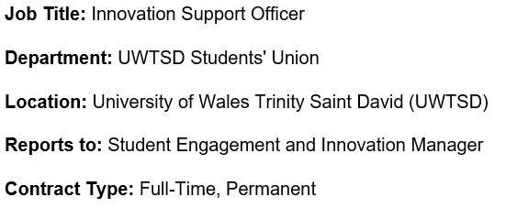

Job Purpose
The Innovation Support Officer will assist in the design, coordination, and execution of innovation initiatives that improve the student experience and align with the strategic goals of the University of Wales Trinity Saint David (UWTSD) Students' Union. The position aims to foster creativity, digital transformation, and ongoing service enhancement by recognising possibilities to transform student services via technology, collaborative efforts, and data-driven decision-making.
The incumbent will collaborate with students, academic departments, external partners, and Students' Union personnel to devise creative projects, enhance stakeholder involvement, and assess the efficacy of innovation initiatives. As higher education institutions progressively adopt digital technologies, artificial intelligence, and automation, organisations necessitate staff that can adapt to technological changes while ensuring high-quality student support (Armstrong and Taylor, 2023). Thus, the Innovation Support Officer will be crucial in fostering a culture of innovation, facilitating organisational change, and ensuring that new projects are congruent with the University's strategic aims.

Organisation Overview
The University of Wales Trinity Saint David (UWTSD) is a contemporary higher education institution dedicated to providing an exceptional student experience via superior teaching, research, innovation, and community involvement. The Students' Union advocates for the interests of students across several campuses and aims to foster an inclusive atmosphere that enables active engagement in academic, social, and personal development opportunities.
Innovation has gained paramount significance in higher education as colleges adapt to shifting student expectations, technology advancements, and transforming labour market requirements. Digital transformation, data-driven decision-making, and collaborative partnerships are acknowledged as vital elements of efficient university management (Bondarouk and Brewster, 2016). The UWTSD Students' Union needs personnel who can provide creative ideas, adopt digital technology, and facilitate ongoing organisational enhancement.
The Innovation Support Officer will aid in achieving these goals by facilitating the creation and execution of innovative projects that enhance student engagement, operational efficiency, and service quality, while also advancing the University's overarching dedication to digital innovation and organisational excellence (Universities UK, 2024).

Key Responsibilities
The Innovation Support Officer is required to:
- Facilitate the planning, execution, and assessment of innovative initiatives within the Students' Union.
- Investigate emerging technology, digital tools, and innovative approaches pertinent to higher education.
- Examine student feedback, survey results, and performance metrics to pinpoint possibilities for ongoing enhancement.
- Facilitate the creation of digital solutions that improve student engagement and service provision.
- Facilitate innovation workshops, focus groups, and collaborative events with students, academic personnel, and external stakeholders.
- Compile reports, presentations, and business cases to facilitate innovation ideas and strategic decision-making.
- Oversee project milestones, budgets, and performance metrics to guarantee effective project completion.
- Foster new thought and ongoing enhancement within the Students' Union.
- Establish effective collaborative ties with internal and external stakeholders.
- Guarantee that all innovation initiatives adhere to University legislation, GDPR stipulations, and policies on equity, diversity, and inclusion.
- Facilitate funding applications and external partnering opportunities as applicable.
These duties include modern human resource approaches that prioritise employee engagement, innovative capacity, and collaborative problem-solving as catalysts for organisational performance (Boxall and Purcell, 2022).

Key Duties in Innovation Context
Innovation constitutes the primary objective of this position. The Innovation Support Officer will play a pivotal role in fostering an organisational culture that promotes innovation, experimentation, and ongoing learning. The chosen candidate will assist the Students' Union in recognising possibilities to enhance services using digital technologies, automation, and data-driven decision-making.
Principal responsibilities of innovation encompass:
- Recognising prospects for digital change within student services.
- Facilitating the use of artificial intelligence and automation as suitable to enhance administrative efficiency.
- Investigating creative methodologies implemented by various universities and student unions.
- Facilitating pilot initiatives aimed at enhancing student happiness and participation.
- Conducting collaborative innovation sessions with students and staff.
- Facilitating ongoing enhancement via systematic assessment of innovative results.
- Promoting interdepartmental information exchange to enhance organisational learning.
- Observing developing technological trends impacting higher education and providing counsel to management accordingly.
These responsibilities acknowledge that innovation extends beyond technology invention to include novel organisational procedures, service enhancements, and collaborative activities that provide value for stakeholders (OECD and Eurostat, 2018). Moreover, digital transformation necessitates individuals that can amalgamate technical advancements with organisational strategy to improve operational effectiveness (Westerman, Bonnet, and McAfee, 2014).

Reporting Structure
The Innovation Support Officer immediately reports to the Student Engagement and Innovation Manager.
The incumbent will collaborate with:
- Chief Executive of the Students' Union
- Team for Student Engagement
- Educational Institutions
- Departments of Professional Services
- Digital Services Division Marketing and Communications Department
- External technology vendors
- Community organisations and industry collaborators
Consistent communication with these stakeholders will guarantee that innovation activities correspond with institutional objectives and student requirements, while fostering collaborative decision-making and organisational learning (CIPD, 2024).

Working Conditions
The role is predominantly located at UWTSD campuses, with options for hybrid work when operationally suitable.
Employment conditions encompass:
- Conventional workweek of 37 hours.
- Intermittent nighttime and weekend employment during student gatherings and innovative initiatives.
- Office-based tasks accompanied by meetings throughout University campuses.
- Consistent utilisation of digital collaboration platforms such as Microsoft Teams, SharePoint, and project management software.
- Obligation to participate at external conferences, networking events, and innovation workshops.
The position necessitates flexibility, adaptability, and a readiness to accept technology advancements in alignment with changing corporate priorities and student expectations (Armstrong and Taylor, 2023).

Salary and Benefits
Salary
£28,000–£33,000 annually (Grade 5), contingent upon qualifications and experience.
Benefits
- Local Government Pension Scheme.
- Ample annual leave allocation in addition to public holidays.
- Opportunities for professional development and subsidised training.
- Hybrid work arrangements when suitable.
- Employee Assistance Program.
- Health and wellness initiatives.
- Access to university athletic and recreational amenities.
- Support for Continuous Professional Development (CPD).
- Opportunities for involvement in national higher education innovation networks.
The benefits package demonstrates UWTSD's dedication to attracting and maintaining skilled personnel who can foster innovation, organisational development, and superior student services. Investment in staff development enhances organisational success, employee engagement, and innovative capacity (Armstrong and Taylor, 2023).

PART B – PERSON SPECIFICATION

Introduction
The Person Specification delineates the credentials, experience, knowledge, abilities, and personal traits necessary for successful performance in the post of Innovation Support Officer at the UWTSD Students' Union. The criteria have been established following best practices in competency-based recruitment, guaranteeing that applicants are evaluated equitably based on the knowledge, skills, and behaviours essential for fostering innovation, digital transformation, and continuous improvement in higher education (Armstrong and Taylor, 2023).
Applicants will be evaluated through the subsequent methods:
A = Application Form / Curriculum Vitae (CV)
I = Interview
T = Test / Practical Task
Candidates must meet all Essential requirements to be deemed appointable. Desirable factors may be employed to differentiate between candidates exhibiting comparable levels of suitability.

Education & Qualifications
Educational qualifications demonstrate that candidates possess the requisite academic knowledge and intellectual capacity to fulfil the duties of the Innovation Support Officer. Universities are increasingly valuing graduates with interdisciplinary expertise in business management, innovation, digital technologies, and organisational development as they invest in innovation and digital transformation (Boxall and Purcell, 2022). Professional certifications and proof of ongoing education further illustrate an individual's dedication to personal growth and continual learning, both of which are vital in a swiftly evolving work environment.

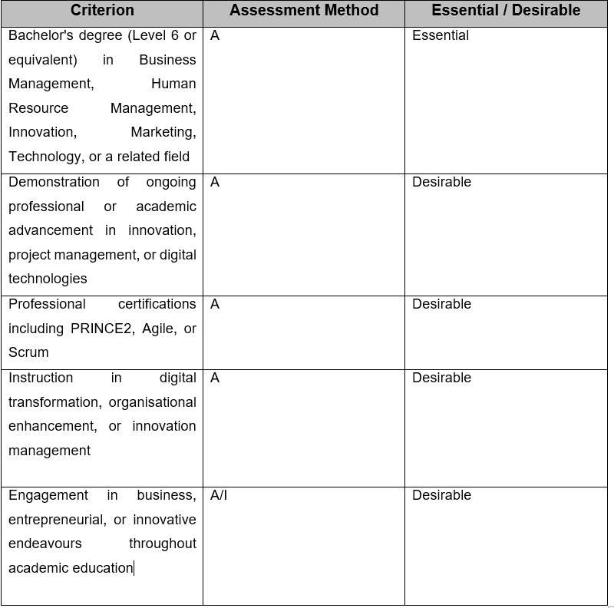

Experience
Relevant job experience illustrates an applicant's capacity to implement academic knowledge in practical organisational contexts. Prior experience in administrative support, project coordination, and stakeholder engagement demonstrates that candidates have the necessary operational competencies to contribute successfully from the beginning. Employers increasingly prioritise candidates who can exhibit transferable experience in project management, event organization, and facilitating organisational change, as these activities are intrinsically linked to innovation and service enhancement (Armstrong and Taylor, 2023).
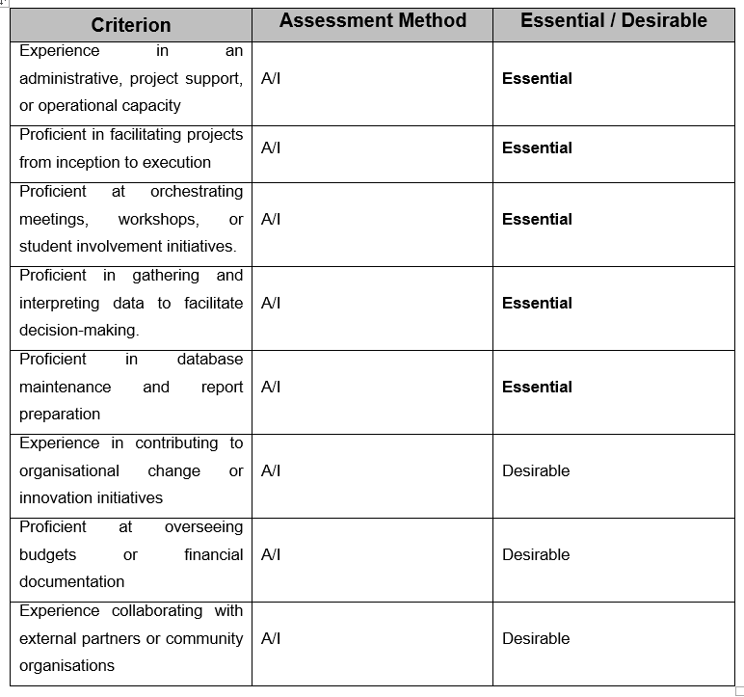

Skills
The Innovation Support Officer necessitates a diverse amalgamation of technical, analytical, and interpersonal competencies to effectively facilitate innovation projects. Effective communication fosters collaboration with students, professors, and external stakeholders, while robust analytical and organisational skills enhance project planning and evidence-based decision-making. Digital competence is crucial as innovation in higher education increasingly relies on technology, data analysis, and digital communication platforms (Bondarouk and Brewster, 2016).
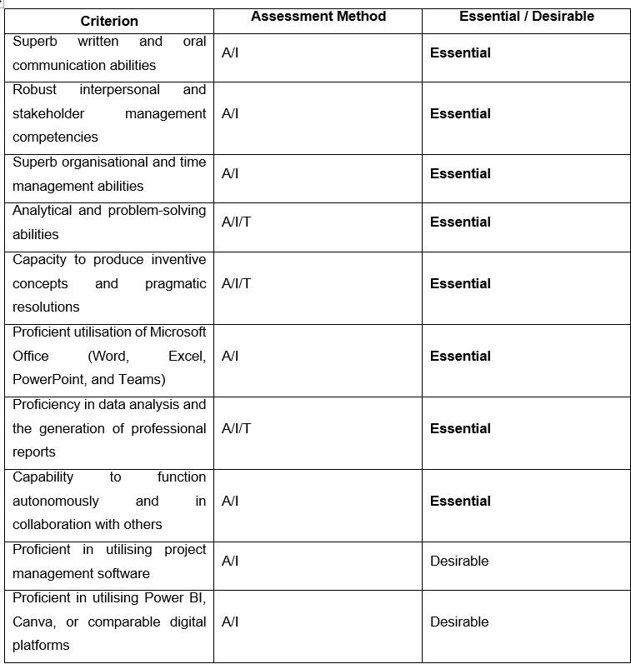

Knowledge & Understanding
Knowledge and comprehension empower individuals to analyse organisational difficulties and make educated decisions that foster innovation and ongoing enhancement. The growing implementation of artificial intelligence, automation, and digital technologies in higher education necessitates personnel who comprehend the impact of technology advancements on organisational performance, student engagement, and service delivery. Moreover, expertise in project management, GDPR, and organisational change empowers employees to contribute efficiently while ensuring legal compliance and professional standards (OECD and Eurostat, 2018).
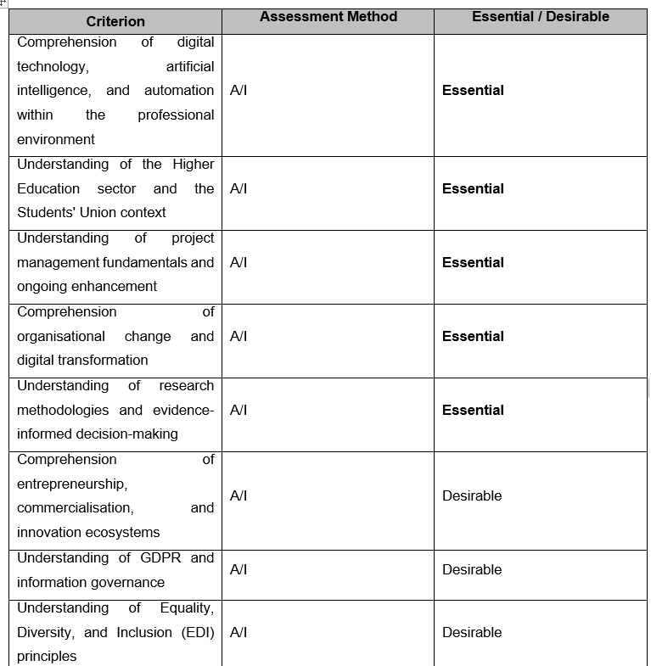

Personal Attributes
Innovation relies not only on technical proficiency but also on the attitudes and behaviours exhibited by individuals. Effective Innovation Support Officers must exhibit inventiveness, resilience, and adaptability, while upholding professionalism and a robust dedication to student service. These traits promote collaborative efforts, organisational learning, and ongoing enhancement, allowing institutions to adapt proficiently to technological advancements and shifting stakeholder expectations (Westerman, Bonnet, and McAfee, 2014).
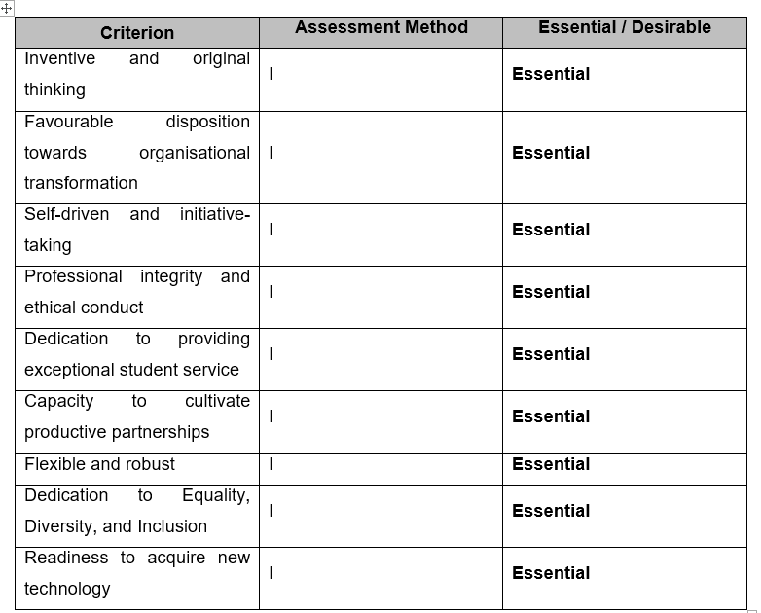

Other Requirements
The supplementary requirements acknowledge the operational characteristics of the position and guarantee that successful candidates comprehend the practical expectations linked to the post. Flexibility, dedication to professional growth, and readiness to assist with activities beyond standard working hours are especially crucial in the Students' Union context. Organisations increasingly anticipate that employees exhibit adaptability and a dedication to lifelong learning in response to technology advancements and evolving organisational priorities (CIPD, 2024).
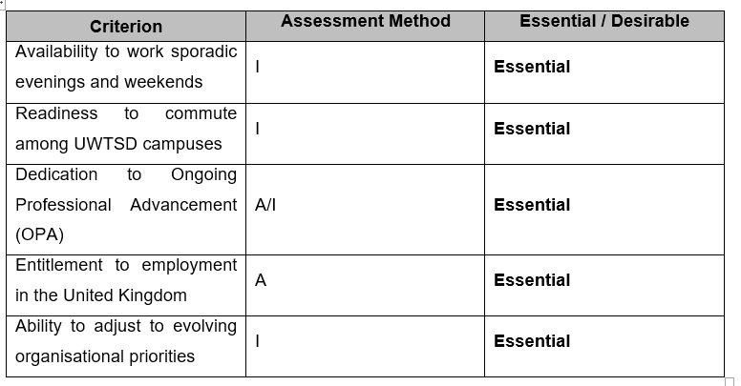

References


