ASSIGNMENT PROJECT REPORT

DATABASE MANAGEMENT SYSTEMS – CASE STUDY

STUDENT NAME: CLAUDIU- STEFAN STELIAN
STUDENT ID: 1815744

LECTURER’S NAME: TERRY WALCOTT

Contents
DATABASE MANAGEMENT SYSTEMS – CASE STUDY 1
Summary Description of Contents: 3
Story: To-Rent Company 3
Tables: 3
• Region 3
• City 3
• Brach 3
• Staff 4
• Client 4
• Owner 4
• Property 4
• Lease 4
Advantages: 5
• Maintenance 5
• User Access to More Than One Person 5
• Privileges 5
Advantages for the To-Rent Company (case study) 5
Example 1: 5
Example 2: 6
Example 4: 6
Disadvantages: 7
• Cost 7
• Abundance of Information 7
• Structured Limits 8
• Isolated Databases 8

Summary Description of Contents:
This Reports presents the database structure of To-Rent real estate company.
The advantages and disadvantages of a new database will be discussed as well.

Story: To-Rent Company
Renting goods and services is very popular today. Services like real estate rubbed the renting lamp. They’ve opened up new horizons, and in the future, we can expect that all kinds of rental services will become even more common.
In this article, we’ll describe a database model that could be used to run an application for renting apartments, rooms, and anything else you can think of.
First, let’s consider a few facts about renting. This information will inform how we build the model.
To-Rent is a real estate business offering renting services to their clients. Due to their successful growth and demand of their service has increased they would like to span their business to different geographical regions in the UK.
In order to keep the track of data flow and see the potential of each area, To Rent, developed a new database. This database will provide all the information needed from the region level to the lease level.

Tables:
Rent database has 8 tables. Connected by foreign keys.
- Region contains the geographical Regions of United Kingdom, where To-Rent company has open branches.

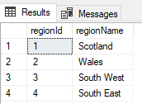
- City table is connected to Region table by the REGIONID (FK). This table will provide a list of cities located in the regions presented above.
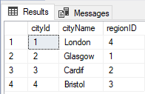
- Brach table is connected to City table by the CITYID (FK). This table stores the branches located in each city
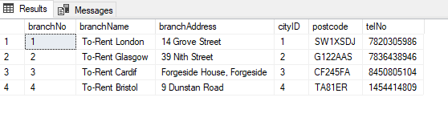
- Staff table is connected to Brach table by the BRACHID (FK). This table has all the staff member information (name, position, salary, etc.)
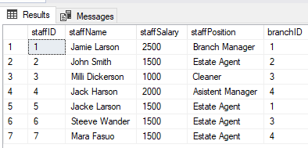
As an example: The database can provide information about each Staff member that is working on To-Rent company. Jack Larson is an Estate Agent that is working in To-Rent London branch in South East Region of UK, in London.
- Client table is connected to the Staff table by STAFFID (FK) and Brach table by BRACHID (FK). This table is holding information about each Client that is renting from To-Rent Company.
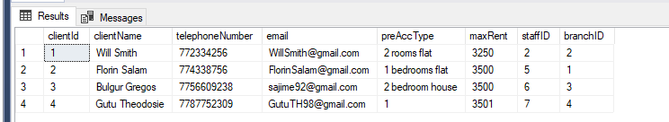
- Owner table is providing information about the people that owns a property.
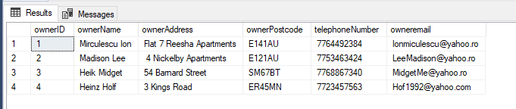
- Property table is connected to the Owner table by OWNERID (FK). It is used to identify the Properties that are being rented from To-Rent company.
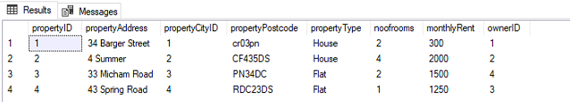
- Lease table is connected to multiple tables: Client table by CLIENTID (FK), Owner table by OWNERID, Property table by PROPERTYID. This table will provide information about clients, owner and properties, method of payment.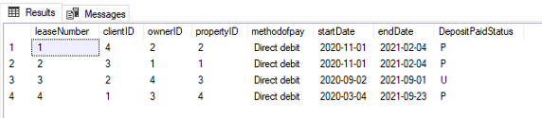

Advantages:
- The main advantage of relational databases is that they enable users to easily categorize and store data that can later be queried and filtered to extract specific information for reports. Relational databases are also easy to extend and aren't reliant on physical organization.

Maintenance
With RDBMS, maintenance is easier as it helps the database admins or technicians to maintain, repair, control, test and even back up the databases that reside within their main system. A built-in automation system or automation tools within the RDBMS on the operating system helps in automating these functions.

User Access to More Than One Person
As already discussed, the user access is multiple. So, more than one user can access one database at the same time. As the data is being updated or changed, users can utilize the built-in locking and transactions management functionality to access the data. This mainly helps in overcoming any possible crashes between more than one user working on the data and prevents users from accessing or using data that has been partially updated.

Privileges
With the authorization and privilege control features in an RDBMS, it is possible for the database administrator to stop any access requested by authorized users. But permissions can be assigned to individual users taking into account the database activities they are intended to handle or undertake. This authorization is determined depending on the remote client IP address, which is combined with user authorization, which restricts access to selected computer systems.

Advantages for the To-Rent Company (case study)
To Rent company saw the advantages of having a database implantation. They needed accurate data in order to identify the new opportunities.

Example 1:
- Database can provide information about the most profitable locations in the system.
To Rent manager needs to know which regions are the most profitable and which ones are not working as expected. This piece of information will contribute at his decision of keeping or remove one of his locations.
select regionName,cityName,monthlyRent,propertyType
from Region a, City b, Property c
where a.regionid = b.regionID
and b.cityId= c.propertyCityID
order by monthlyRent desc
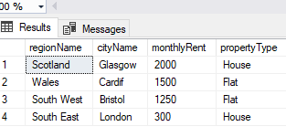
Based on the data in the system, London rent has the lower rent price with a difference of 1700 pounds between Glasgow.

Example 2:
- Database can provide information about the most efficient staff member.
The manager decided to give 10% salary bonus to the top 2 most efficient staff members. He would like to know who they are, the bonus in amounts, and the staff salary after the salary raise (current salary + 10% bonus).
select f.staffName,f.monthlyRent,f.staffSalary, bonus, bonus+f.staffSalary as RaisedSalary from (
select e.staffName,e.monthlyRent,e.staffSalary, 0.1*e.staffSalary as bonus from (
select staffName,sum(monthlyRent) monthlyRent ,staffSalary from property a, staff b, lease c, client d
where a.propertyID=c.propertyID
and a.ownerID=c.ownerID and a.propertyID=c.propertyID
and d.clientId=c.clientID
and d.staffID=b.staffID
group by staffName,staffSalary
)e) f
order by monthlyRent desc
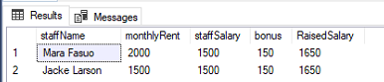
Mara Fasuo and Jacke Larson are the most efficient staff members, they have the same salary of 1500 GBP which will grow to 1650 GBP after the 10% Bonus will be applied.

Example 4:
- Database can provide information about the clients that didn’t payed the deposit.
The manager would need to find the owner's name, staff name (branch, city, region), property name, client name and email address where the deposit status is unpaid.
select c.ownerName, e.staffname, f.branchname, g.cityname, h.regionname, b.propertyaddress, d.clientname, d.email
from lease a inner join property b on a.propertyid= b.propertyid and a.ownerID=b.ownerID
inner join Owner c on c.ownerID = b.ownerID and a.ownerID=c.ownerID
inner join client d on a.clientID = d.clientId
inner join Staff e on d.staffID = e.staffID
inner join Branch f on f.branchno= e.branchID
inner join City g on g.cityId= f.cityID
inner join Region h on h.regionId = g.regionID
where DepositPaidStatus= 'U';
This information will be useful to the manager because he would raise the rent with 10% for the clients that didn’t payed the deposit.
- Database can provide information about the cities with the highest rent prices.
- Database can provide profit and loss information, budgeting information.

Disadvantages:

Cost
One disadvantage of relational databases is the expensive of setting up and maintaining the database system. In order to set up a relational database, To-Rent needed to purchase special software.
It will take time to enter in all the information and set up the program. To-Rent company is large and it will need a more robust database, and hired a programmer to create a relational database using Structured Query Language (SQL) and a database administrator to maintain the database once it is built. Regardless of what data the company will use, it will have to either import it from other data like text files or Excel spreadsheets, or have the data entered at the keyboard. The company store legally confidential or protected information in the database such as personal information it will also have to secure the data against unauthorized access in order to meet regulatory standards.

Abundance of Information
Advances in the complexity of information cause another drawback to relational databases. Relational databases are made for organizing data by common characteristics. Complex images, numbers, designs and multimedia products defy easy categorization leading the way for a new type of database called object-relational database management systems. These systems are designed to handle the more complex applications and have the ability to be scalable.

Structured Limits
Some relational databases have limits on field lengths. When you design the database, you have to specify the amount of data you can fit into a field. Some names or search queries are shorter than the actual, and this can lead to data loss.

Isolated Databases
Complex relational database systems can lead to these databases becoming "islands of information" where the information cannot be shared easily from one large system to another. Often, with big firms or institutions, relational databases grew in separate divisions differently. For example, maybe the company billing department used one database while the company staff department used a different database. Getting those databases to "talk" to each other can be a large, and expensive, undertaking, yet in a complex real estate system, all the databases need to be involved for good client and staff communication.

The model we discussed in this report should be flexible enough to cover renting any building type, but there are many improvements we could make. Some things that come to my mind are storing messages during the negotiation phase; creating and cancelling rental reservations; including item insurance, and adding account and payment details.

