
Skills for the Workplace
Module Assignment Submission
Student Name: | Siobhan Turner
Student Number: | 2115319
Module No: | BMSK4002
Module Title: | Effective Team Work And Communication

Statement of Confirmation of Authenticity
By the act of making this submission, the student declares that this is the work of the student named above. The work has not, in whole or in part, been knowingly presented elsewhere for assessment, or where assessment has been built on a previous assessment, this has been identified. Where materials have been used from other sources it has been properly acknowledged. If this statement is untrue, the student acknowledges that an assessment offence has been committed.
Attention is drawn to the plagiarism and unfair practice policies of both the University and of ILM.
Permission for ILM to use this script
ILM uses learners’ submissions – on an anonymous basis – for assessment standardisation. By submitting, both the centre and the learner agree that ILM may use this script on condition that identifying information is removed. However, if you are unwilling to allow ILM use this script, please refuse by ticking the box: □

Table of Contents
Introduction 3
The communication cycle 3
Noise 3
Section 3 3
Section 4 4
Conclusion 4
References 5
Appendix 1 6
Appendix 2 7

Introduction
Communication is the exchange of thoughts, information and ideas which results in a mutual understanding between two individuals. I will explore the Shannon Weaver communications cycles, examples of communication practice and the barriers of communication. I will add a personal development plan to enable me to improve my own communication skills.

How do we communicate?
There are different forms of communication e.g., face to face, phone or written communication. Encoding and decoding is the concept that we have one sender (encoding the message) and one receiver (decoding the message whether it be the message via speaking, writing or electronically e.g., email. There are Five different elements of communication

- The sender… The sender is the person that starts the communication process
- The idea…. These refer to any ideas that the sender comes up with
- Encoding…This is a huge task in the cycle where they use ideas that the receiver understands. Encoding is creating messages to send over to the receiver. The sender can decode messages like verbal and nonverbal. Verbal languages such as English etc have its own style/grammar that is quite different from other languages. Nonverbal language is more communicated via hand gesture, body movements.
- The message…This is the product that comes after encoding. It can be an opinion, thought that is clearly stated in nonverbal or verbal communication.
- The receiver…The receiver’s responsibility is to receive and decode messages passed on.

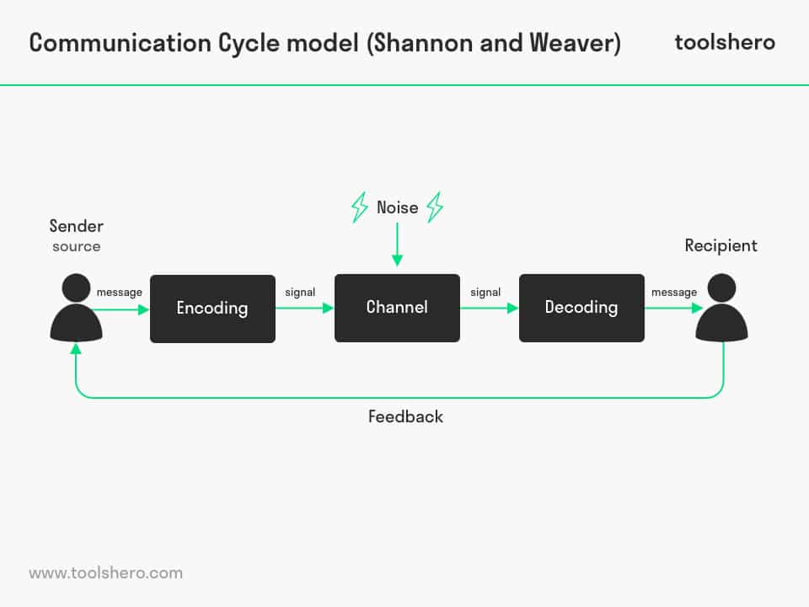

In this section I will be talking about NOISE and how it effects communication.
Noise interferes with communication as it causes distortions of messages sent and then it prevents the message from being understood the way it should be. Noise cant be fixed with technical help, it needs a different solution to be fixed. There have been diagrams and models over the years, but this is an easier breakdown
- You speak
- The listener listens
- The listener then speaks
- You then listen

Noise can be anything to interfere and distract you from communication and it can happen between the speaker(you) or the listener or between both.
There are four types of noise that I will be explaining below
- Physical Noise…could be an external sound that can get in the way of effective communication and can be a disturbance to the environment your in. Physical noise can also be known as environmental noise.
- Physiological Noise…Is usually a barrier from the communicator if they are maybe ill or stressed, it then causes physical noise that becomes an obstacle for effective communication.
- Psychological Noise…Is usually caused by the communicator’s psychological factors e.g., their behaviours attitudes or maybe beliefs. This noise distracts our minds so we can’t concentrate or listen to people, and then people struggle to listen to certain topics as they may find them not interesting.
- Semantic Noise…Is a communication obstruction caused by confusion over the meanings of words. It usually comes from grammatical errors or maybe technical errors in communication. Semantic noise is when different meanings of messages between the sender and receiver occur and then makes the receiver not understand the meaning.
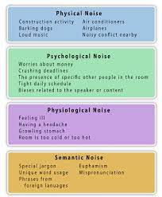
Communication in the workplace
Within my workplace in school kitchens due to being mobile we use what’s app groups to communicate this is our main way to get messages to each other e.g., as I’m a mobile kitchen assistant I can be in a different school daily, so I get told each day were I need to work that day. Also, they use what’s app for what stock in needed and were daily for each school. Whilst in work we use four different types of workplace communication.
- Verbal. We speak to communicate
- Body…Body language is another way we communicate
- Phone. Is our main source out of work to know what school to attend if mobile kitchen assistants like me, or we use phone for sick lines or any complaints or problems.
- Written. We do a lot of written communication in work as we have lots of paperwork as we deal with food and machinery daily.

Communication in the workplace
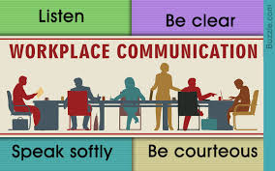

In this section I will speaking about Active Listening
Listening is a very important skill we have and how well we listen has a big impact in the workplace. It can affect how well you perform in your job and on your quality of relationships with work mates.
- We listen to take in information
- We listen to understand things
- We listen for enjoyment
- We listen to learn new things/skills
Research from (Edgar Dale’s) cone of experience states that we only remember between 25 percent and 50 percent of what we hear. So, if you was talking to a work colleague or boss for ten minutes, you would only be paying attention to less than half of that conversation. If someone was to give us instruction to do something we wouldn’t be taking in all the instructions given, due to us only remembering the 25 to 50 percent. Therefor we would be hoping that we remembered the instructions as best as we can to do the job correctly.
Listening is something that everyone can get better with to improve our ability to do well in our jobs and complete daily tasks needed. There are ways to improve listening skills by learning “Active Listening “. To do this you need to really listen, when the person is talking u need to pay attention to not only the word but the message that’s being communicated to you. You need to also not let yourself get board or distracted from the conversation. Mabe try and repeat these words in your head to keep you focused on what they are saying. Try and respond to the speaker so they know you are taking in and listening to everything they are saying.
There are five key techniques to become an effective listener
- 1.Pay attention…look at the speaker directly
Avoid any types of distraction
Listen to the speaker and their body language
- 2.Show that you are listening
Smile
Make sure your looking interested
Nod sometime to show your still paying attention
- 3.Provide feedback
Ask questions to make sure you have understood
Reflect on everything that has been said and then summarise
- 4.Defer judgment
Don’t interrupt the speaker
Wait for the speaker to finish talking before asking question don’t interrupt
- 5.Respond appropriately
Think of your opinions so you don’t offend them
Be honest with your responses
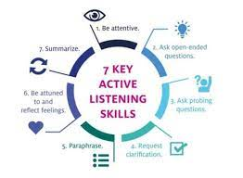

Here are five different listening skills they can be developed at home or in work
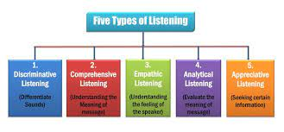

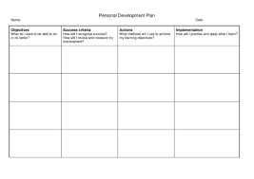
- Discriminative listening…This is the first listening type you are born with, and everybody has it. You use this before u know how to understand words and its used usually by tone of voice or sound changes.
- Comprehensive listening…Comprehensive listen requires language skills. This listening is usually developed in early childhood. Comprehensive listening is used for people to understand what someone is saying when using words.
- Empathetic listening…When you use this type of listening its for you to understand things from someone else’s point of view as they speak. As they speak instead of just focusing on the message, you can use this type of listening to relate as if it’s your own experience.
- Analytical listening…This listening is used to focus on the interpretation and meaning of the sound. Listening to a song and then understanding what mood that song is trying to set out.
- Appreciative listening ...It’s a way of listening were somebody will listen to somebody’s likes and interests, and then actively search for this info that this person may like.
section 2
Assessing own communication skills
To communicate effectively within the workplace, I need to have good communication skills. These skills are needed so I can form some trust and relationships with my work peers. Once the trust is formed, we can then work together as a team. You also need good time keeping skills . Here are some of my strengths and weaknesses these will be things I will always look back on and always try to improve.

Strengths
- I have good time keeping skills
- Work well as a team
- Have good verbal communication
- Know how to speak clearly

Weaknesses
- Gets very nervous when having to do tasks in front of classmates
- Anxiety
- Rushes when producing work out loud
- Can’t make good eye contact

Appendix
Here is a communication questionnaire attached

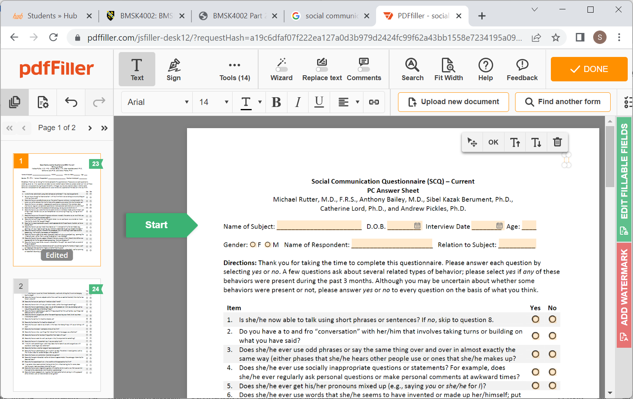
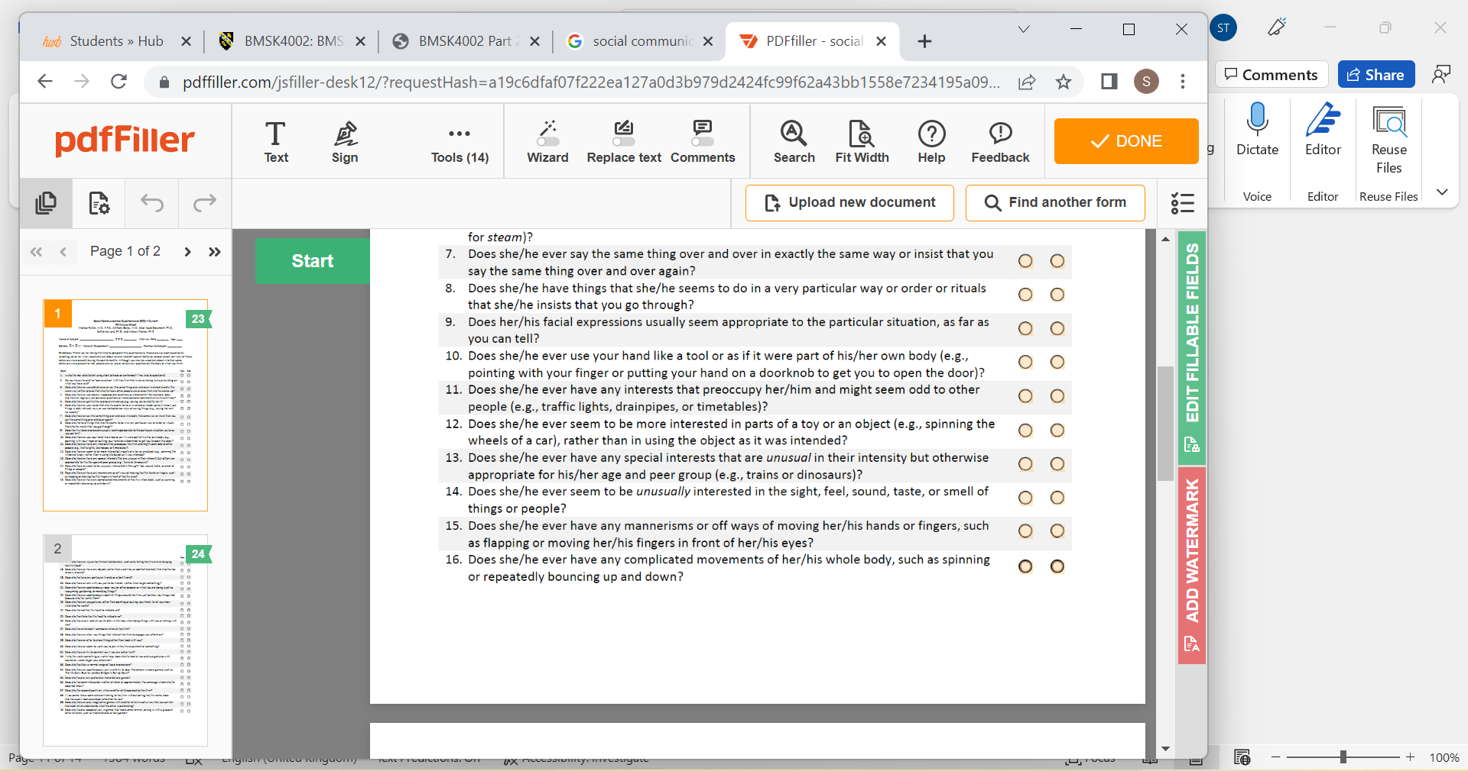

References

Betterup.com
Fictioncommunication.com
Jmcacademy.edu.au
Kell.indstate.edu.com
Mclaughlinsclass.blogspot.com
Mindtools
Newsmoor.com
On the go.fm

Appendix 1

Appendix 2

