Managing Enterprise
~BMSW4011~
~Business plan and reflection~

Lecture name: Melanie Squire

Student name: Marius-Ionel Patrascu
Student id: 2329813
Contents
List of Figures 3
List of Tables 3
Task 1, Part 1 – Business Plan for AlyKo Burger Van 4
1.0 Product Proposition 4
2.0 Name of Business and Type of Ownership 5
3.0 Mission Statement, Aims, Objectives, and USP 6
4.0 Physical Location and Rationale 7
5.0 Human Resources 8
6.0 Marketing Activities 9
7.0 Market Research and Findings 12
8.0 Financials 18
9.0 SWOT Analysis 20
TASK 1, PART 2 – Reflection 22
What? 22
So What? 22
Now What? 22
REFERENCES 23

List of Figures
Figure 1: Business Logo 5
Figure 2: Promotional Pamphlet 7
Figure 3: City Center Area, Cardiff, UK 8
Figure 4: Organisational Structure 8
Figure 5: Facebook Post Poster 11
Figure 6: Poster 12
Figure 7: Survey Result (Q1) 13
Figure 8: Survey Result (Q2) 13
Figure 9: Survey Result (Q3) 13
Figure 10: Survey Result (Q4) 14
Figure 11: Survey Result (Q5) 14
Figure 12: Survey Result (Q6) 14
Figure 13: Survey Result (Q7) 15
Figure 14: Survey Result (Q8) 15
Figure 15: Survey Result (Q9) 15
Figure 16: Survey Result (Q10) 16
Figure 17: Market value of foodservice delivery in the United Kingdom from 2020 to 2022, with forecasts for 2023 and 2026 17
Figure 18: Just Eat just satisfies UK takeaway cravings 17

List of Tables
Table 1: Marketing Mix (7Ps) Analysis 9
Table 2: SWOT ANALYSIS 20

Task 1, Part 1 – Business Plan for AlyKo Burger Van

1.0 Product Proposition
AlyKo Burger Van serves different burgers, crisp fries, and cool beverages with enticing flavours. The food selection focuses on fresh food and has a variety of dishes to cater for everyone with special diets such as the vegetarians and those on gluten-free diets. The business positions itself to offer better flavours to its customers and set out to prioritise the satisfaction that comes from the consumption of burgers (Raposo, 2023).
AlyKo Burger Van targets itself to be the best burger joint which offers quality burger meal, in the covered area. Specifically, compared to traditional fast foods, the van brings freshly prepared and individualised burgers with the spirit of genuine and delicious taste.
This target market covers the working-class clients, the youths, and people who love good foods between the ages of 18- 45 years (Milkman et al., 2020). The food truck targets the sect of people that are residents of the urban areas and the event attendees who are looking forward to grabbing a bite. It will be situated in areas with high traffic areas like business, central business district, and areas where there could be events of many people.

2.0 Name of Business and Type of Ownership
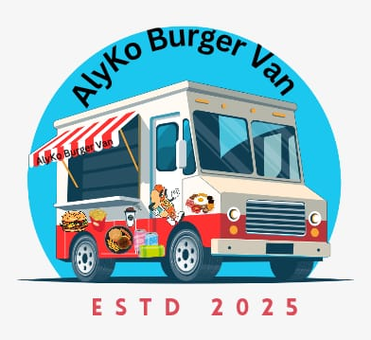
Figure 1: Business Logo

- Business Name: AlyKo Burger Van
- Type of Ownership: Sole Proprietorship
The food truck is called “AlyKo Burger Van” to emphasize on gourmet and customized burgers, creating distinct image of the business. AlyKo Burger Van will be formalised as a business entity in the form of a sole trader. This structure is suitable in a small and volatile enterprise where the owner has full control of the enterprise, menus, and daily activities (Olazabal and Avila, 2022). It also increases flexibility in terms of its funding structure has less paperwork and decreases legal regulations and restrictions. The owner has in mind a review of this structure in the future, particularly when seeking a new stage of expansion, where the company can convert to a partnership, or limited liability partnership (LLP) as needed.

3.0 Mission Statement, Aims, Objectives, and USP
Mission Statement:
AlyKo Burger Van will develop new and distinctive Philippine Street food with great burger options in terms of ingredients, burgers, services, and much more that appeal to present day metro markets to offer fresh and convenient street foods.
Aim:
AlyKo Burger Van’s primary aim is to become a well-known and profitable burger van in the street food business, occupying a popular territory and offering tasty and satisfying dishes to develop a constant customer traffic.
Objectives:
- To achieve target sales of £100,000 in the first year through marketing and customer loyalty.
- To build a concrete customer base and thereby obtain an increase of visits of such loyal prospects within the first year by 25%.
- To establish the second food van in another geographical location within the next 18 months depending on market trends and awareness of the new brand.
USP:
AlyKo Burger Van has adopted differentiation strategy by using high quality burger and new product that are made from fresh ingredients in a gourmet style, serving customized burgers that meets diets of customers met on the streets.

4.0 Physical Location and Rationale
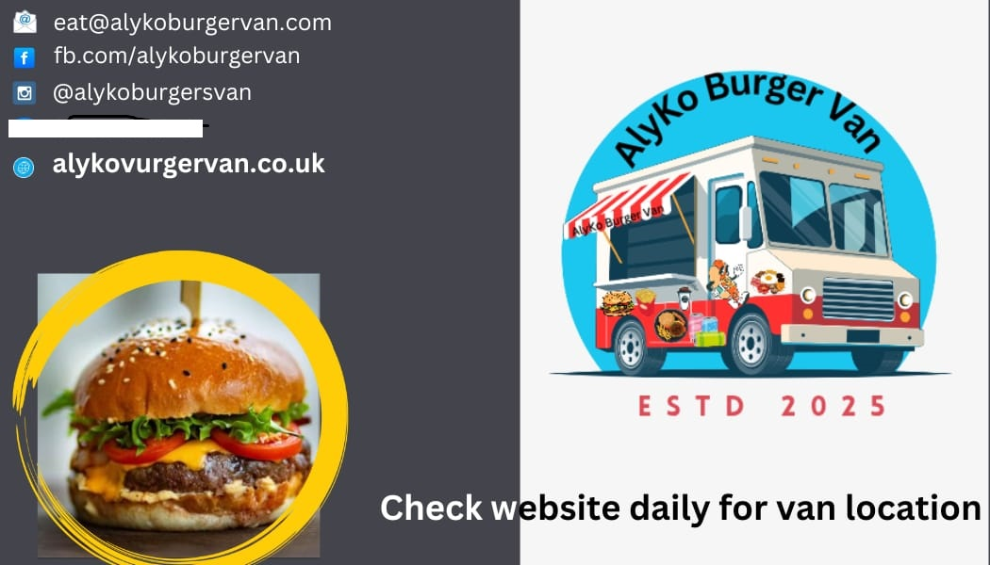
Figure 2: Promotional Pamphlet

AlyKo Burger Van will be situated as close as possible to City Centre, Cardiff to ensure that it is easily accessible by many people passing near the location. This place is situated nearby some attraction sites including The National Museum, Cardiff Castle and learning institutions including the University of Wales and some colleges (Cardiff University, 2019). It will be helpful because it is in an environment with many tourists and students, thus, guaranteeing a constant stream of clients. The establishment’s visibility and accessibility function as a bonus, as it allows for corporate and student populations, as well as tourists, to grab a quick and tasty meal while out during their day or visit.
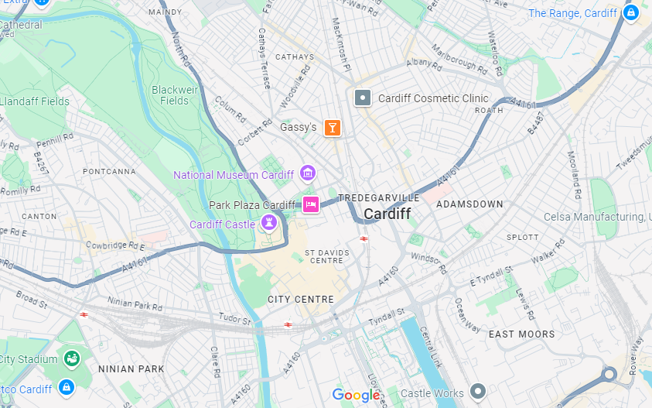
Figure 3: City Center Area, Cardiff, UK
Source: Google Maps

5.0 Human Resources

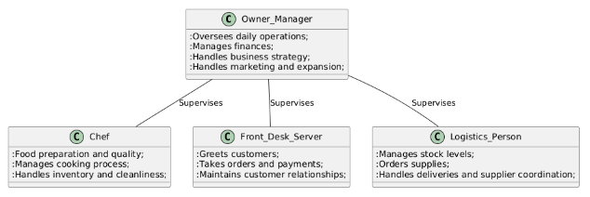
Figure 4: Organisational Structure

Chef
- Maintains cleanliness and food quality to provide meals of high standard and standards (Marinakou and Giousmpasoglou, 2020).
- Supervises the preparation of foods, controls the supplies of foods used in cooking and cleaning of food preparation areas.
Front Desk/Server
- Cooks, solves customers’ queries, and concerns, and takes their orders effectively.
- Accountable to manage payments and customer relationships that consist with the company objectives as well as to ensure customer satisfaction.
Logistics Person
- Controls the stock, order and makes sure that all materials needed in preparation of the food are available (Rushton et al., 2022).
- This entails making sure that the food truck is well stocked and replenished and consulting with suppliers.
Owner/Manager
- Coordinates day-to-day activities, supervises financial issues and origination of work and role of the team.
- Engages in placing strategies for the business, marketing, and growth development.

6.0 Marketing Activities
Marketing Plan
Table 1: Marketing Mix (7Ps) Analysis
7Ps | Details
Product | Tasteful burgers, fries, drinks, and more crafted with market-fresh ingredients. Options to suit a variety of dietary requirements.
Price | Cost-lead with premium yet competitive street food pricing (Chaturvedi, 2021). Customisable options are available.
Place | Strategic position near Cardiff City Centre, museums, and universities, with expansion potential.
Promotion | Flyer distribution in high-traffic areas, Instagram, Facebook, and TikTok advertising, and influencer collaborations (Klaus Solberg Söilen, 2024).
People | Friendly employees or owners that know their clients' demands and provide the greatest service to regular customers.
Process | Speedy order processing, speedy food preparation, and delivery (Johnson, 2024).
Physical Evidence | Catering, food truck branding, high-quality packaging and labelling, vehicle cleanliness.

AlyKo Burger Van's promotional program aims to invest in a suitable location where there is a high traffic flow of people for them to buy meals at a higher price but of excellent quality. Specifically, social media Marketing will ensure social media campaigns, influencer marketing, and an efficient service process will serve to strengthen customer relations with the brand (Ooi et al., 2023). The quality and appearance of the food as well as, the organization of the food truck will enhance the customer experience.

Food Truck's PR Initiatives: AlyKo Burger Van’s PR activities will thus be aimed at awareness creation and credibility. Leveraging regional influencers and food bloggers to review the products through word-of-mouth and creating content for social media platforms. Other promotional strategies include the holding of specific events like the opening days of a store, or special days during the year like World Environment Day.

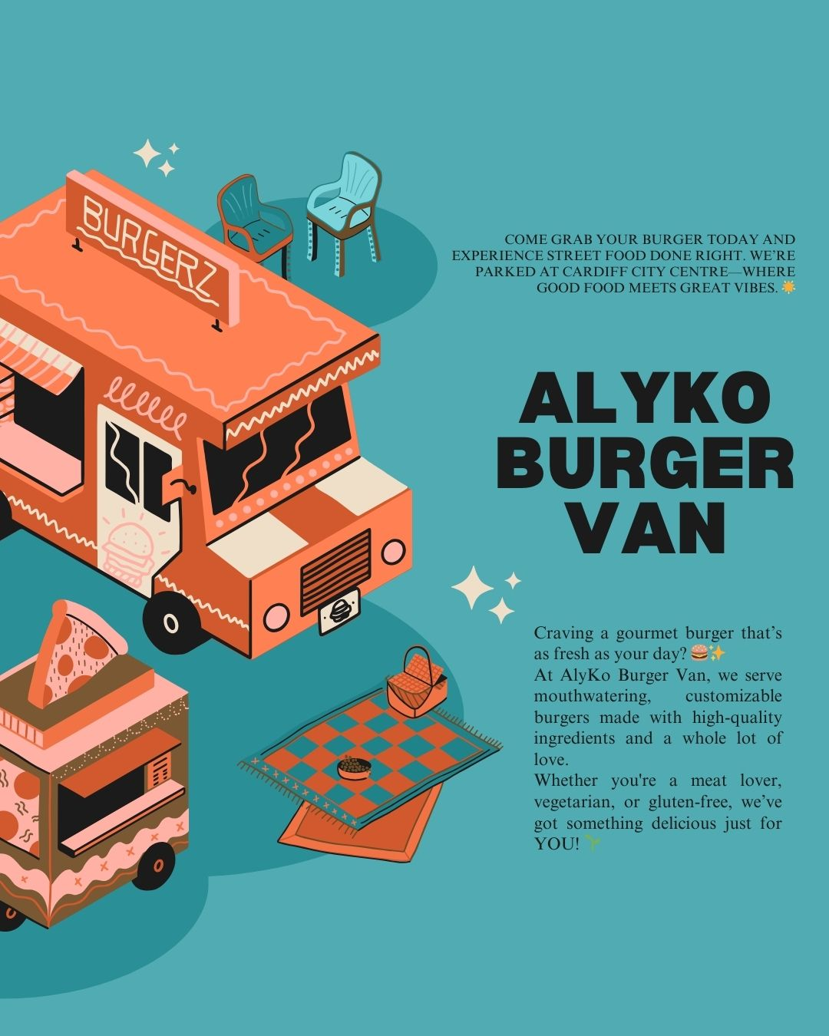
Figure 5: Facebook Post Poster

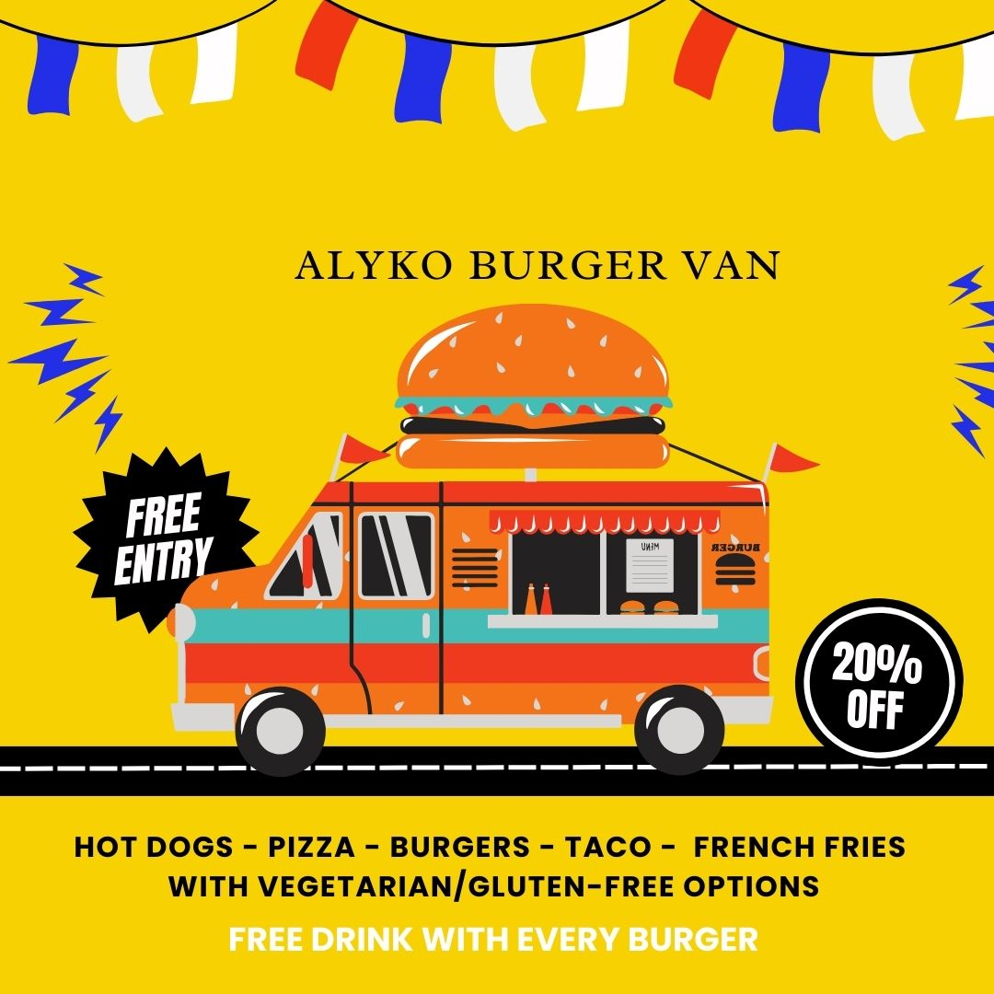
Figure 6: Poster.

7.0 Market Research and Findings
Primary Research
The primary research survey includes the customer preferences as an important parameter. Out of the 13 participants, 11 preferred the gourmet burger, and out of the 10, half of the participants said it tasted ‘very good’ or ‘exceptional’. This survey revealed that customers’ satisfaction level was remarkably high in portion sizes and food quality as well as the speed of service delivery. Moreover, 11 respondents admitted that the prices were equally reasonable, proving that there is a huge potential to serve tasty street food cheap at the same time.

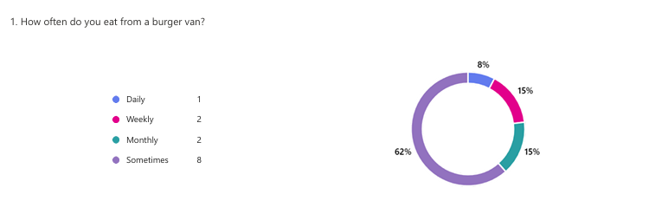
Figure 7: Survey Result (Q1)

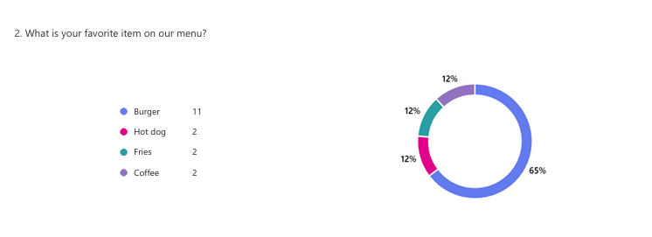
Figure 8: Survey Result (Q2)

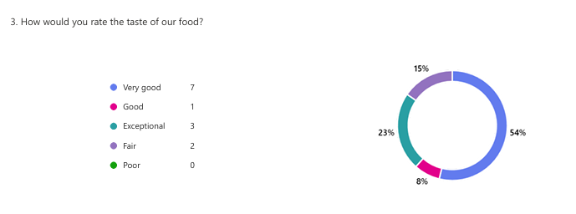
Figure 9: Survey Result (Q3)

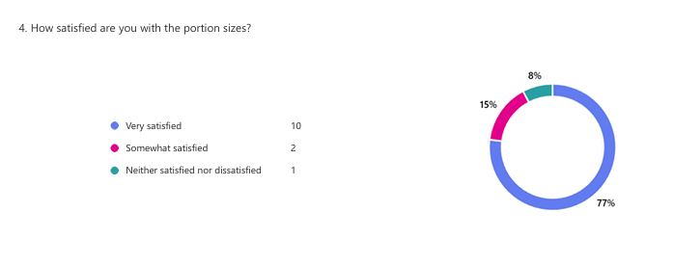
Figure 10: Survey Result (Q4)
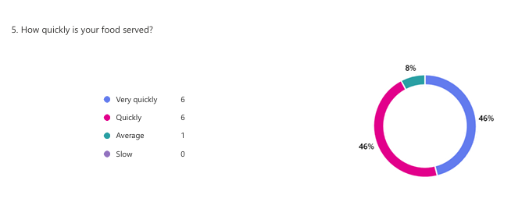
Figure 11: Survey Result (Q5)
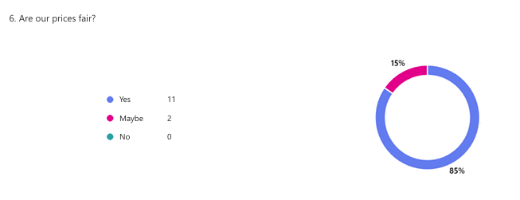
Figure 12: Survey Result (Q6)

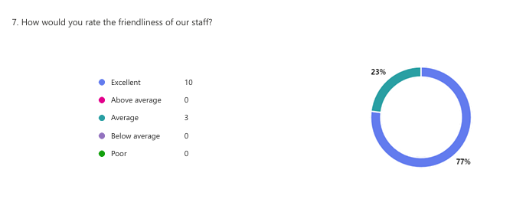
Figure 13: Survey Result (Q7)

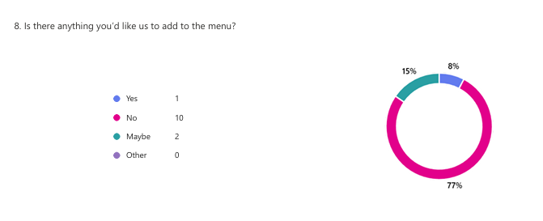
Figure 14: Survey Result (Q8)

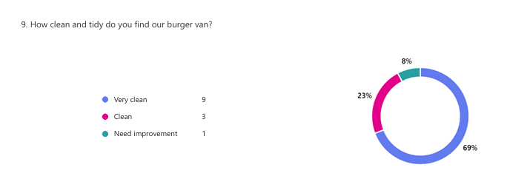
Figure 15: Survey Result (Q9)

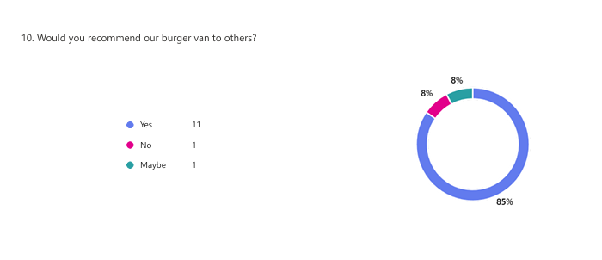
Figure 16: Survey Result (Q10)

Secondary Research
The takeaway market in the United Kingdom has expanded remarkably; this street food market is expected to rise to £1.2 billion by 2025 (Statista, 2024). As stated by Anupama Chirag Dave, (2023), there is a growing trend of consumers opting for quality and customizable ready-to-eat street food. The trend is most popular with employees, students, learners as well as residents of urban areas who require quick meals. The target market for AlyKo Burger Van is ideal as more people are open to consuming street food and they are aware that AlyKo offers only authentic and quality burgers.

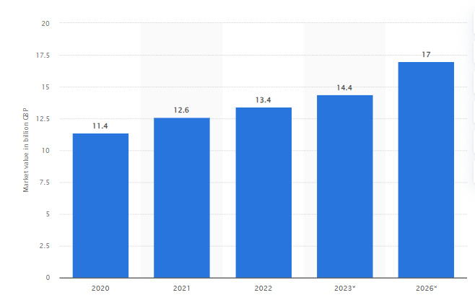
Figure 17: Market value of foodservice delivery in the United Kingdom from 2020 to 2022, with forecasts for 2023 and 2026.
Source: (Statista, 2022)

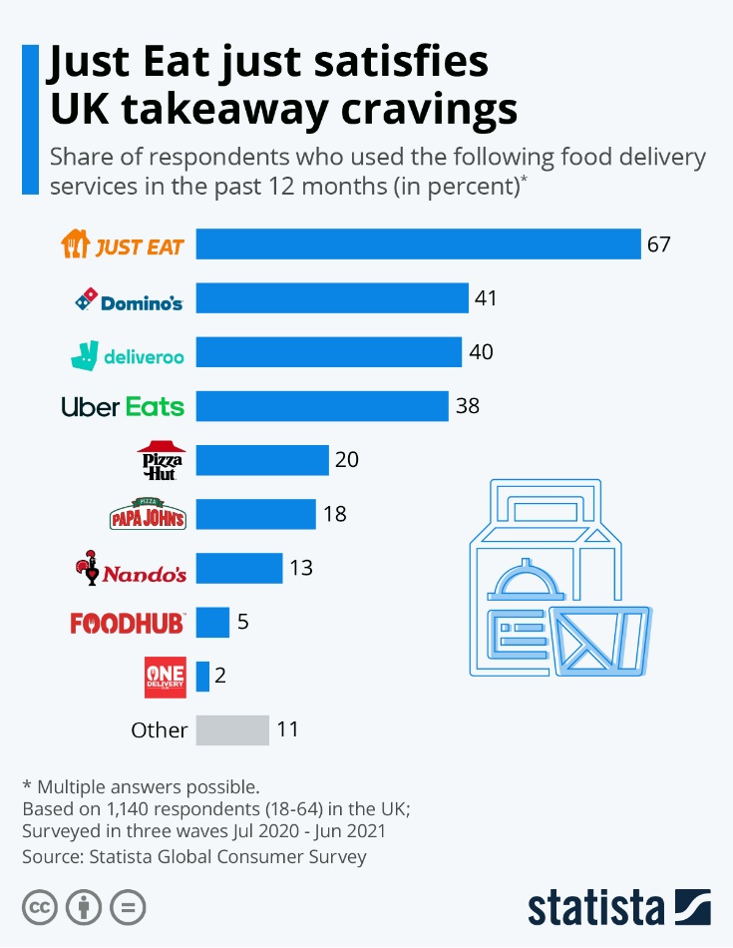
Figure 18: Just Eat just satisfies UK takeaway cravings.
Source: (Zandt, 2021)

8.0 Financials
Costs of Running the Business
Cost Item | Amount per Month (£) | Amount per Year (£)
Food Truck Lease | 550 | 6,600
Licensing and Council Fees | 1,000 | 12,000
Supplies & Ingredients | 2,900 | 34,800
Wages and salaries | 2,200 | 26,400
Insurance expenses | 400 | 4,800
Promotion costs | 900 | 10,800
Utilities bills | 100 | 1,200
Total Monthly Costs | 8,050 | 96,600

Sources of Finance
Source of Finance | Amount (£)
Angel investors | 50,000
Family Contributions | 20,000
Bank Loan | 30,000
Total Finance | 100,000

Expenses
Cost Item | Amount per Month (£) | Amount per Year (£)
Rent | 1000 | 12000
Supplies & Ingredients | 2,900 | 34,800
Wages and salaries | 2,200 | 26,400
Insurance expenses | 400 | 4,800
Promotion costs | 900 | 10,800
Utilities bills | 100 | 1,200
Total Monthly Costs | 6,500 | 90,000

12-Month Cash Flow Forecast

Month | Income (£) | Expenses (£) | Net Cash Flow (£) | Cumulative Cash Flow (£)
January | 8,000 | 6,500 | 1,500 | 1,500
February | 8,000 | 6,500 | 1,500 | 3,000
March | 8,000 | 6,500 | 1,500 | 4,500
April | 8,200 | 6,500 | 1,700 | 6,200
May | 8,300 | 6,500 | 1,800 | 8,000
June | 8,300 | 6,500 | 1,800 | 9,800
July | 8,300 | 6,500 | 1,800 | 11,600
August | 8,300 | 6,500 | 1,800 | 13,400
September | 8,500 | 6,500 | 2,000 | 15,400
October | 8,500 | 6,500 | 2,000 | 17,400
November | 8,800 | 6,500 | 2,300 | 19,700
December | 8,800 | 6,500 | 2,300 | 22,000

The cost of start-up for AlyKo Burger Van are found as per the listed requirements of lease cost, wages and salaries, cost of promotion, supply of goods etc. The total funds investment is sourced from various sources like angel investors, family contributors and bank loan. Major investment contribution is made by angel investors which are at 50%. The above cash flows show a realistic form of analysis about the company earning each month and show regular growth of company in terms of cash flows.

9.0 SWOT Analysis
Table 2: SWOT ANALYSIS
SWOT Category | Details
Strengths | High-quality, gourmet burgers; strong customer satisfaction and loyalty.
Weaknesses | New brand with limited initial recognition; dependence on foot traffic (Hoenink et al., 2024).
Opportunities | Growing street food market in Cardiff; potential for expansion to new locations.
Threats | Such factors as increased competition from other food outlets; altering consumer habits (Daradkeh et al., 2023).

Key Threat and Mitigation Strategy
The main threat is the important level of competition in street food industry. To address this, AlyKo Burger Van will adopt various differentiation strategies including making a specialty of delicious burgers and ensuring a strong brand image. Also, points of customer retention will be reinforced by specialised customer loyalty programs.

TASK 1, PART 2 – Reflection

What?
When developing the business plan for AlyKo Burger Van, I realized that it is crucial to conduct proper market analysis in terms of the tastes of the customers, or the overall trends. The results of the survey were helpful as they helped in articulating the product portfolios and the price plan. Most importantly, the actualization of business requires that the financial plan be well laid including cash flow budgeting (Naji et al., 2024). I also came to understand the importance of a well-defined marketing plan, particularly, in matters concerning the utilisation of social media and public relations activities towards the establishment of brand identity.

So What?
All these have helped improve my skills in entrepreneurship to a great deal. The concept learned from the market was about not guessing but producing well-grounded research findings that can function as a basis for decision-making. When dealing with the financial plan, I was able to see ways how to distribute funds properly and record the progress of the business with profitability. Moreover, learning about a marketing plan has enhanced my skills in strategic thinking on where to market and positioning the business to customers since marketing is key to the growth of any company.

Now What?
In the future, I will further enhance aspects of producing this product learning from the customers and changes in the market. To minimize risks, I will spread marketing across various platforms to avoid putting all my eggs in one basket and will constantly check the financial aspect to ensure the business generates a profit. Further, I would like to continue the growth of its services by increasing the visibility of the food van in new areas within Cardiff and eventually expand to other cities. Focusing on providing enhanced experience and regulating risks, I believe the business will progress and thrive.

REFERENCES
Anupama Chirag Dave (2023). Packaging of ready-to-eat products: a Mix Research Approach for Exploring Aesthetic Element Influence on Brand Preference. British Food Journal, 125(11), pp.4182–4198. doi:https://doi.org/10.1108/bfj-04-2023-0288.
Bassot, B. (2020). Reflective Journal. 3rd ed. London: Palgrave Macmillan, p.31.
Cardiff University (2019). Things to Do in Cardiff during Your Visit. [online] Cardiff University. Available at: https://www.cardiff.ac.uk/visit/things-to-do-during-your-visit.
Chaturvedi, A. (2021). Excessive Competition and Supplier Non‐Performance Risk: Trade‐offs in Reverse Auctions. Production and Operations Management. doi:https://doi.org/10.1111/poms.13418.
Daradkeh, F.M., Hassan, T.H., Palei, T., Helal, M.Y., Mabrouk, S., Saleh, M.I., Salem, A.E. and Elshawarbi, N.N. (2023). Enhancing Digital Presence for Maximizing Customer Value in Fast-Food Restaurants. Sustainability, 15(7), p.5690. doi:https://doi.org/10.3390/su15075690.
Hoenink, J., Cerny, C., Mahoney, C. and Pajda, N. (2024). Fuel us, don’t Fool us: Big Food & Our Communities: Where Are Food Chains expanding? (Out-of-home #1). Cam.ac.uk. doi:https://doi.org/10.17863/CAM.115571.
Johnson, B.K. (2024). Improving Service Quality in the Fast-Food Service Industry. Journal of Service Science and Management, 17(01), pp.55–74. doi:https://doi.org/10.4236/jssm.2024.171002.
Klaus Solberg Söilen (2024). Digital Marketing. Springer texts in business and economics. Springer International Publishing. doi:https://doi.org/10.1007/978-3-031-69518-6.
Marinakou, E. and Giousmpasoglou, C. (2020). Chefs’ competencies: a stakeholder’s Perspective. Journal of Hospitality and Tourism Insights, 5(1), pp.205–229. doi:https://doi.org/10.1108/jhti-06-2020-0101.
Milkman, R., Elliott-Negri, L., Griesbach, K. and Reich, A. (2020). Gender, Class, and the Gig Economy: the Case of Platform-Based Food Delivery. Critical Sociology, 47(3), p.089692052094963. doi:https://doi.org/10.1177/0896920520949631.
Naji, A.H., Hashim, I.S. and Mohammed, H.J. (2024). IMPROVING THE BUDGET PROCESS THROUGH EFFECTIVE BUDGET PLANNING STRATEGY. 04(02), pp.16–28. doi:https://doi.org/10.55640/ijbms-04-02-02.
Olazabal, V.H.N. and Avila, N.M.G. (2022). Dynamic Capabilities in Sole proprietorships: Theoretical Model through Grounded Theory. Journal of International Entrepreneurship, 20(4). doi:https://doi.org/10.1007/s10843-022-00321-2.
Ooi, K.-B., Lee, V.-H., Hew, J.-J., Leong, L.-Y., Tan, G.W.-H. and Lim, A.-F. (2023). Social Media influencers: an Effective Marketing approach? Journal of Business Research, 160(113773), p.113773. doi:https://doi.org/10.1016/j.jbusres.2023.113773.
Raposo, M.C. (2023). Design Thinking and co-creation for the Development of a New plant-based Product. Rcaap.pt.
Rushton, A., Croucher, P. and Baker, P. (2022). The Handbook of Logistics and Distribution Management. 7th ed. London, United Kingdom: Kogan Page.
Statista (2022). UK Takeaway Delivery Market Value 2019. [online] Statista. Available at: https://www.statista.com/statistics/1110682/uk-takeaway-delivery-market-value/.
Statista (2024). UK Fast Food Industry and Takeaway Market Size 2021. [online] Statista. Available at: https://www.statista.com/statistics/1282676/fast-food-and-takeaway-industry-market-size-uk/.
Zandt, F. (2021). Infographic: Just Eat Just Satisfies UK Takeaway Cravings. [online] Statista Infographics. Available at: https://www.statista.com/chart/25532/most-popular-food-delivery-services-in-the-uk/.

