BA (Hons) Leadership and Management Skills in the Workplace

Project Management
LCLM5003

A Project portfolio

Student name: Flavius-Alexandru Baboi
Student ID: 2425413
Lecturer name: Kareem Sani
Table of Contents

Part A: Project proposal poster 3
Part B: Reflection on Feedback Received for the Project Proposal 4
Part C: Project Management Plan 5
Introduction: 5
Project Description 6
Scope: 6
WBS: 7
Quad Chart: 7
Stakeholder Involvement: 9
Allocation of Resources: 11
Risk analysis: 12
Conclusion: 15
References: 16

Part A: Project proposal poster

The project proposal poster has been provided below:

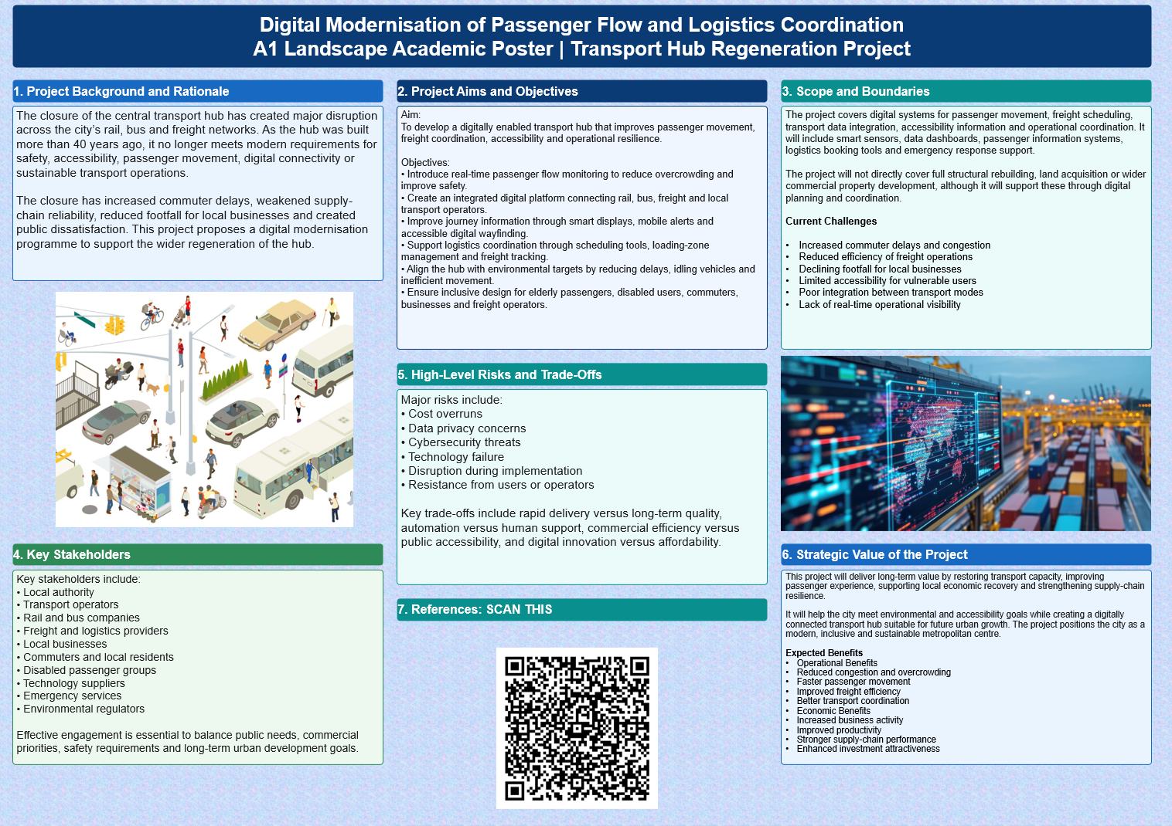

Part B: Reflection on Feedback Received for the Project Proposal

The feedback provided by the tutor and peers was very useful to review my suggested project (Digital Modernisation of Passenger Flow and Logistics Coordination) and understand its pros and cons. Overall, the feedback outlined a number of strengths of the proposal, and some issues that needed further development prior to the final project management plan.
The relevance and strategic importance of the project was one of the key strengths identified. The project was identified as a real and significant urban challenge due to closure of the central transport hub, with agreement from both the tutor and peers (Aarseth et al., 2017). The impact of digital transformation was clearly connected to the broader regeneration agenda, incorporating sustainability, accessibility and operational efficiency. Feedback also highlighted that the project goals were closely tied with the needs of stakeholders and the rationale behind investing in the digital infrastructure was well-documented. Moreover, the major stakeholders identified (transport operators, local authorities, businesses and passengers) were deemed thorough and fitting for this project. There were however some areas which were identified as needing improvement. A frequently proposed recommendation was more information about the scope and scope of the project (Bosona, 2020). The overall vision was set out in the proposal, but some reviewers considered it was lacking in clarity over the distinction between digital modernisation activities and wider infrastructure redevelopment. Feedback further called for an enhancement to the risk analysis section in order to make it more structured, so as to assess potential risks such as cybersecurity, data privacy, delays in implementation and budget constraints. Another area of potential improvement was the incorporation of measurable success criteria to enable stakeholders to assess the project after it was put into operation.
The feedback was very impactful on my end project management plan. As a response, I narrowed the scope of the project by clearly defining what will be done and what will not be done in the project. Additionally, I added more content to the Risk Management section, including risk categories, risk mitigation and risk monitoring mechanisms. In addition, I created a number of key performance indicators (KPIs), including wait times for passengers, logistics efficiency and user satisfaction, among others, to give measurable results. Particular emphasis was placed on stakeholder engagement strategies to help ensure project-related communication and collaboration throughout the project lifecycle. Overall, the feedback process has enhanced the overall quality of the project by assisting me to focus on the areas that needed more details in order to be improved and lessening the gaps on the areas that were already working. Consequently the final project management plan is more realistic, structured and conforms to stakeholder expectations and is therefore more likely to be implemented successfully.

Part C: Project Management Plan

Introduction
The city's main transport hub has been shut down after structural safety problems were identified, causing major disruptions in the movement of people, goods and the local economy. The hub is a key transport node connecting rail, bus and freight, and thus is essential for the flow of people and goods in and out of the city (Carvalho and Rabechini, 2017). As a response, local government has initiated a regeneration programme focused on the rehabilitation of the transport capacity and the fulfilment of contemporary needs of safety, accessibility, sustainability and digital innovation. The task management plan concentrates on the Digital Modernisation of traveller move and logistics co-ordination component of the regeneration plan. The project aims to leverage cutting-edge digital tools, real-time data analysis, and transportation management systems to enhance operational efficiency and user experience. The plan will use recognised project management principles to establish objectives, scope, stakeholders' needs, risks and delivery strategies. The project will be delivered through effective project planning and governance to ensure the transport hub is transformed to become a smart, resilient and future-ready urban infrastructure asset.

Project Description

The Digital Modernisation of Passenger Flow and Logistics Coordination project aims to increase the efficiency, safety and sustainability of transport activities in the redeveloped central transport hub. The project will be integrated with the adoption of digital technologies to enable monitoring and management of movements of passengers, freight activities and transport services in real-time throughout the hub's integrated network (Davis, 2017). The smart passenger flow monitoring systems, digital wayfinding solutions, integrated transport information platforms, logistics scheduling tools and operational data dashboards are key project components. With these technologies, transport operators and local authorities can take decisions based on current data, better coordinate the services and decrease congestion. The project will also promote access, enabling the introduction of navigable and accessible routes and information services for different user groups. The project links digital infrastructure to transport operations to enhance commuter journeys, improve supply-chain resilience, decrease inefficiencies in transport operation and support the broader urban regeneration goals set by local government.

Scope

The project will involve the planning, procurement, implementation and testing of digital systems to enable passenger flow management and logistics coordination within the transport hub. Passenger counting sensors, real-time monitoring, digital information screens, smart wayfinding, freight scheduling and integrated operational dashboards are key core deliverables (Derakhshan, Turner and Mancini, 2019). The project will also include system integration, staff training, stakeholder engagement and performance monitoring activities. The project boundaries are clearly defined, so as to ensure effective resource allocation and project control. The project is part of the wider regeneration programme, but does not encompass large-scale structural rebuilding, building refurbishment, land purchase, commercial development or extending transport infrastructure. These activities will be under separate projects within the overall regeneration project. The emphasis is still on providing digital solutions to enhance operational efficiency, accessibility, passenger experience, logistics performance, long-term sustainability, and urban mobility goals.

WBS
The WBS of the project has been provided below:
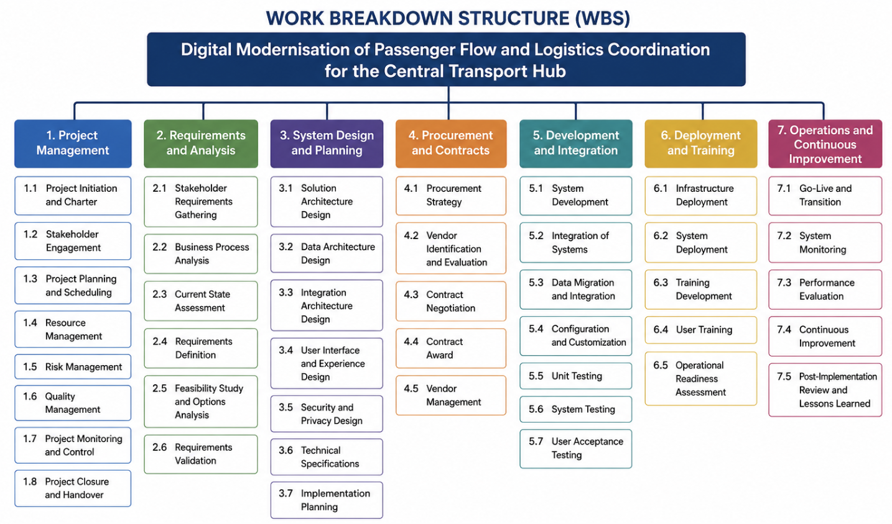

Quad Chart
The Quad Chart gives a brief summary of the Digital Modernisation of Passenger Flow and Logistics Coordination project in four areas: Purpose, Scope, People and Plans. The Purpose section identifies the need to deal with transport disruptions resulting from the closure of the central hub and provides the objectives related to enhancing the flow of passengers and the efficiency and integration of services (Kivilä, Martinsuo and Vuorinen, 2017). The Scope section outlines the expected project outcomes, such as the introduction of smart monitoring systems, a digital information platform, logistics scheduling tools and operational dashboards, and explains activities that are not part of the project. The People section outlines those who are particularly impacted by the project's delivery and governance, including local authorities, transport operators, project team and technology vendors as well as passengers. The Plans section provides a summary of key milestones, budget, success criteria and risks. These four areas allow the stakeholders to have a clear understanding of the project's goals and outcomes, as well as the resources needed and how the project will be run, which will help them make informed decisions and maintain effective project management. The Quad Chart of this project is given below:
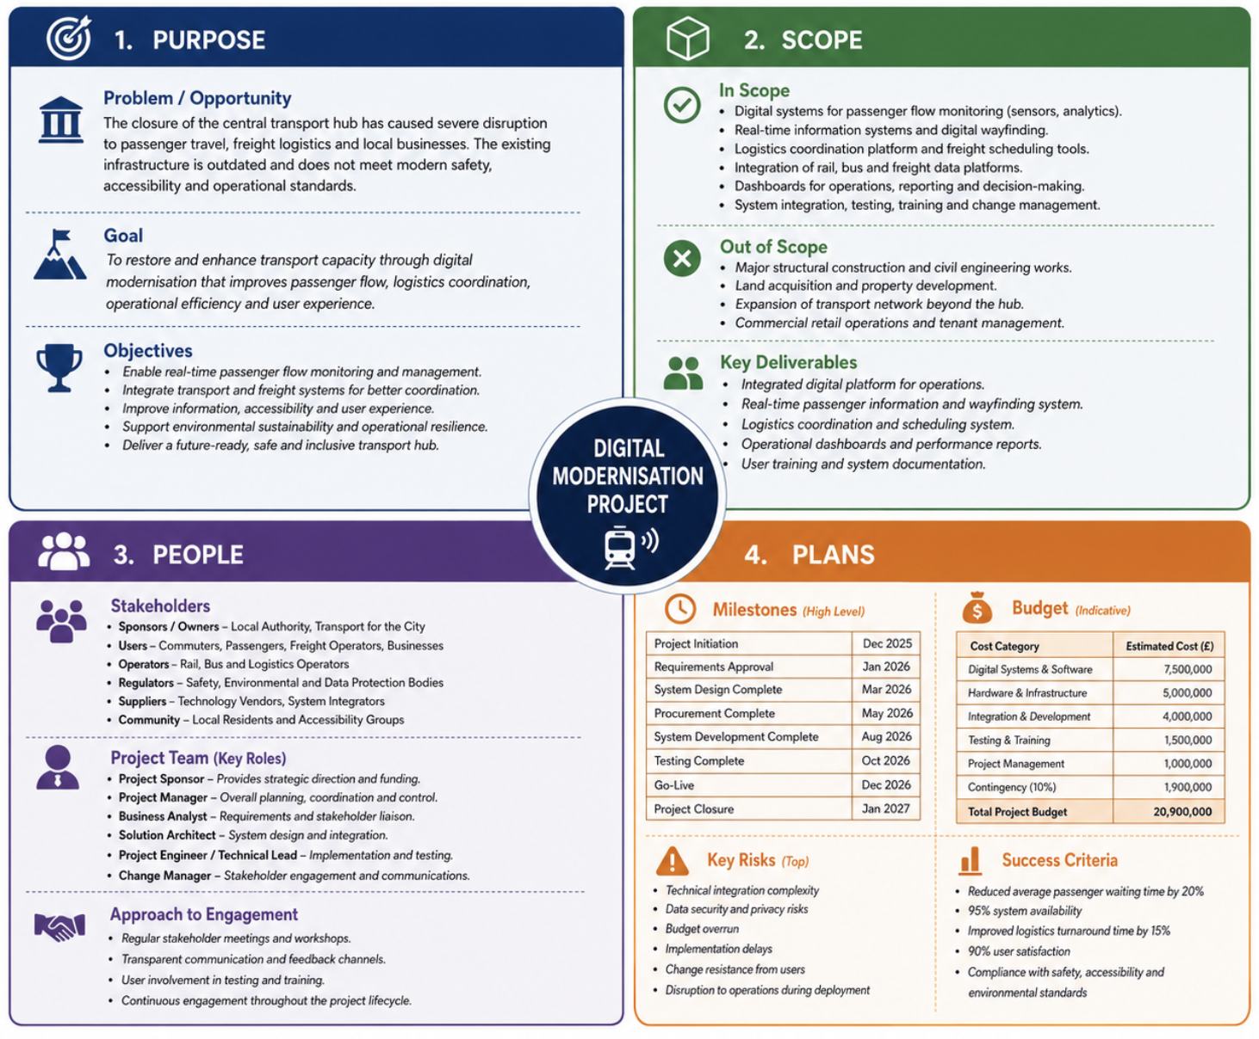

Stakeholder Involvement

The project on Digital Modernisation of Passenger Flow and Logistics Coordination has been successful because of the involvement of stakeholders. The project has an impact on various groups that could shape the results of the project, and on groups that will be affected by the implementation of digital systems. When carried out properly, stakeholder engagement will ensure that project goals are matched with the needs for the operations and the expectations of users as well as wider urban regeneration needs. There will be a need for ongoing communication, consultation and collaboration during the project lifecycle.
Local Authorities and Project Sponsors
Local government acts as the primary project sponsors and also holds strategic directions, fund oversight and governance. They ensure the project is in line with the transport hub regeneration programme and local economic development goals. Their involvement includes approving budgets, monitoring project performance, reviewing progress reports and ensuring compliance with public-sector regulations (Mangiaracina et al., 2017). Sponsors will be able to follow project milestones and aid in decision making if needed, through regular steering committee meetings.
Transport Operators
Transport operators such as rail, bus and freight service providers are important stakeholders, as the digital systems will impact their day-to-day operations. These organisations will offer operational needs, attend system design workshops and assist with testing activities. They will also assist in ensuring that the passenger flow monitoring, logistics scheduling and operational dashboards are fit for their intended use in a practical operational context. Continuous involvement will help to reduce the opposition to change and allow the new technologies to be integrated into current processes.
Passengers and Public Users
Passengers are one of the groups most important stakeholder group as they are the main beneficiaries of the project (Pan et al., 2021). Digital wayfinding systems, real time travel information and accessibility improvements are introduced in an effort to enhance their travel experience. Users' feedback on the functionality, accessibility and usability of the system will be collected through public consultation exercises, survey and user-testing sessions. Users' participation throughout the project allows for a user-centered approach to digital solutions that can meet the needs of various mobility services.
Freight and Logistics Companies
Efficient transport coordination is crucial for freight operators and logistics providers within the hub. They play a crucial role in the development of freight scheduling platforms and logistics management systems, including defining the requirements that are necessary. Stakeholders will be involved in workshops, system testing and performance evaluation to ensure that solutions proposed in the project are efficient for freight movement and to minimize operational delays. They will help build supply-chain resilience and thus enable regional economic activity through their feedback.
Technology Vendors and Contractors
Technology suppliers, software developers and implementation contractors will be responsible for providing the technical solutions for the project. They are employed in the design, support, installation, integration, and testing and maintenance of systems. The technical requirements, quality and delivery dates must be met, which requires a close cooperation between vendors and project managers. Contract management processes will be employed to track vendor performance and project deliverables will be managed effectively.
Project Team and Employees
Project management, IT specialists, operational and support staff are key to project delivery. Staff will participate in the requirements gathering, training, system testing and change implementation processes (Porru et al., 2020). This involvement is crucial as staff competence and acceptance of digital technologies are key to successful implementation. Continuous communication, training workshops will be used and feedback mechanisms will be developed to increase stakeholder commitment and minimise the resistance of organisational change.
Stakeholder Engagement Strategy
An organized stakeholder engagement plan will be followed to ensure there is a strong communication flow throughout the project. The use of engagement methods such as project meetings, workshops, progress reports, consultation sessions and digital communication platforms will vary with the specific needs and influence of the stakeholders. Regular stakeholder engagement will enhance transparency, facilitate sound decision making and increase the chances of a successful project delivery. Collaborative engagement can enable the project to accomplish its goals and provide long-term value to the transport operator, passengers, business and the broader community.

Allocation of Resources
The Digital Modernisation of Passenger Flow and Logistics Coordination project must be implemented and delivered with effective resource allocation.
Human Resources
Human resources are one of the most important resources of a project. The project will be supervised by a dedicated project manager who will be responsible for planning, coordination, monitoring and communicating with the stakeholders throughout the project. Business analysts will collect the stakeholder needs and make sure that the digital solution fits into the operational needs. Information technology specialists, software engineers and systems integration experts will be responsible for designing, configuring and implementing the technological infrastructure (Zhu et al., 2022). The operational personnel of transport operators and logistics providers will engage in system testing and validation to verify the functionality with regard to operational requirements. There will also be a need for training experts to design and conduct user training programs for successful adoption of new systems. Clear role and responsibility matrices will be drafted to enhance role clarity and team effectiveness.
Financial Resources
Financial resources need to be sufficient to support procurement, implementation and continued operation activities. The project funding will be used to purchase passenger monitoring sensors, digital display systems, software licenses, data management platforms and network infrastructure. There will be additional funds available for consultancy services, staff training, stakeholder engagement activities and contingency reserve. A managerial budget process will be used, which aims at controlling costs and avoiding cost overruns. Financial reviews on a regular basis will help project sponsors and management teams determine how resources are being used and will make sure investments will continue to provide value throughout the project life.
Technological Resources
The project heavily depends on advanced technological resources to meet the project goals. The Internet of Things (IoT) sensors for passenger counting, real-time data analytics platforms, integrated transport management software, freight scheduling applications and digital wayfinding systems are key technologies (Carvalho and Rabechini, 2017). Cloud infrastructure will be used to facilitate data storage, scalability, and secure data sharing among stakeholders. Resources will also be allocated to ensure that the operational systems and user data are secure from potential threats through cybersecurity resources. Once implemented, continuous arrangements of technical support and maintenance will ensure the reliability and performance of the system.
Physical Resources and Facilities
Physical resources encompass the office accommodation, training facilities, locations for testing equipment and hardware installation within the transport hub. Servers, network devices, display screens and monitoring sensors will be strategically placed to facilitate operations.
Monitoring and Controlling Resources
Project performance reviews and progress systems will be used to regularly monitor resource utilisation to maximise efficiency. Resource Allocation Plans will be amended as needed, in response to evolving project requirements and/or potential risks. The successful coordination of human, financial, technological and physical resources will help to complete the project in a timely way, optimise the performance of the transport hub and contribute to the successful digitalisation of the transport hub.

Risk analysis

The project has some critical strategic, operational and technical project risks which may impact on the delivery, cost and stakeholders satisfaction. The greatest challenges are those of system integration, cybersecurity and procurement delays caused by dealing with multiple transport modes and digital platforms (Derakhshan, Turner and Mancini, 2019). Risk management will need to be proactive in its approach, engaging stakeholders and having a robust governance framework in place, on-going and monitoring risk. The project can reduce disruption, keep services running smoothly and increase the chances of success in the agreed timeframe and budget, whilst contributing to the overall long-term vision for transport regeneration in the city, through the implementation of the proposed mitigation strategies.

Risk ID | Risk Description | Likelihood | Impact | Mitigation Strategy
R1 | Delays in procurement of digital systems, hardware, or software components may affect project timelines. | Medium | High | Develop detailed procurement schedules, engage suppliers early, and maintain contingency plans for critical components.
R2 | Integration challenges between rail, bus, freight, and digital information systems may reduce operational effectiveness. | High | High | Conduct thorough system compatibility assessments, perform phased integration testing, and involve technical specialists throughout implementation.
R3 | Cybersecurity threats, including data breaches and unauthorized system access, could compromise operations and public trust. | Medium | High | Implement strong cybersecurity controls, regular vulnerability assessments, encryption measures, and staff awareness training.
R4 | Resistance to change from transport operators, employees, or passengers may reduce adoption of new digital solutions. | Medium | Medium | Deliver stakeholder engagement programmes, provide training sessions, and communicate project benefits clearly throughout implementation.
R5 | Budget overruns caused by unforeseen technical requirements or inflationary pressures may impact project delivery. | Medium | High | Establish budget reserves, conduct regular financial reviews, and apply strict cost-control procedures.
R6 | Service disruption during system deployment could affect passenger mobility and logistics operations. | Medium | Medium | Use phased deployment strategies, schedule implementation during off-peak periods, and maintain temporary operational support measures.

Conclusion
The Digital Modernisation of the Coordination of Passenger Flow and Logistics project is a strategic answer to the problems caused by the closure of the city center transport hub. The project seeks to increase the mobility of passengers, optimize logistics coordination, improve operational efficiency and promote sustainable urban development through the use of integrated digital technologies. The project will help meet wider regeneration goals by encouraging access, safety and environmental sustainability and create benefits for the city and its beneficiaries for the long term. The project is managed effectively, with the necessary involvement of stakeholders, risk management, performance monitoring, and implementation in stages, to achieve the desired results within the scope, schedule and budget. Moreover, smart transport solutions will bolster the resilience of transport activities and enhance the experience for users when commuting, working and logistics. Overall, the project creates a future-ready base for urban mobility and is an important step towards the city's aim of developing an innovative, inclusive and digitally connected transport system.

References
Aarseth, W., Ahola, T., Aaltonen, K., Økland, A. and Andersen, B., 2017. Project sustainability strategies: a systematic literature review. International Journal of Project Management, 35(6), pp.1071–1083.
Bosona, T., 2020. Urban freight last mile logistics: challenges and opportunities to improve sustainability. Sustainability, 12(21), pp.1–20.
Carvalho, M.M. and Rabechini, R., 2017. Can project sustainability management impact project success? An empirical study applying a contingent approach. International Journal of Project Management, 35(6), pp.1120–1132.
Davis, K., 2017. An empirical investigation into different stakeholder groups perception of project success. International Journal of Project Management, 35(4), pp.604–617.
Derakhshan, R., Turner, R. and Mancini, M., 2019. Project governance and stakeholders: a literature review. International Journal of Project Management, 37(1), pp.98–116.
Kivilä, J., Martinsuo, M. and Vuorinen, L., 2017. Sustainable project management through project control in infrastructure projects. International Journal of Project Management, 35(6), pp.1167–1183.
Mangiaracina, R., Perego, A., Salvadori, G. and Tumino, A., 2017. A comprehensive view of intelligent transport systems for urban smart mobility. International Journal of Logistics Research and Applications, 20(1), pp.39–52.
Pan, S., Zhou, W., Piramuthu, S., Giannikas, V. and Chen, C., 2021. Smart city for sustainable urban freight logistics. International Journal of Production Research, 59(7), pp.2079–2089.
Porru, S., Misso, F.E., Pani, F.E. and Repetto, C., 2020. Smart mobility and public transport: opportunities and challenges in rural and urban areas. Journal of Traffic and Transportation Engineering, 7(1), pp.88–97.
Zhu, J., Xie, N., Cai, Z., Tang, W. and Chen, X., 2022. A comprehensive review of shared mobility for sustainable transportation systems. International Journal of Sustainable Transportation, pp.1–25.

