Course: BSc (Hons) Health and Social Care
Module: Independent Project (BMHP6020_BIRM)

Component 1: Element 1 - Project Proposal

Student ID: 2325941

Student Name: Sameena shahban

Element 1 - Project Proposal

Title: To what extent does delayed autism diagnosis affect the wellbeing and development of children and their families in the UK?

Aim:
This research aims to critically examine the extent to which delayed autism diagnosis affects the psychological wellbeing and developmental outcomes of children, as well as the impact on their families, within UK health and social care. Through a systematic review of peer-reviewed and policy literature, the study will evaluate the strength of existing evidence and identify gaps for future research.

Objectives:
- To define what constitutes a 'timely' autism diagnosis under NICE guidelines and critically assess current waiting times across UK regions.
- To analyse current literature and evidence on how diagnostic delay affects children's mental health, social development, and educational access, while considering methodological limitations of existing studies.
- To evaluate, through thematic analysis, how delayed diagnosis affects family wellbeing, including parental stress, sibling relationships, and access to support, questioning whether these effects are directly caused by delay or by other factors.
- To provide evidence-based recommendations for reducing diagnostic waiting times and improving post-diagnostic support for families, identifying gaps where further research is needed.

Background/Rationale:
Delayed autism diagnosis is a growing concern in UK health and social care. Families face average waiting times of two to five years for assessment (National Autistic Society, 2023), despite NICE (2017) recommending assessment within three months. This gap between policy and practice raises questions about service capacity.
Factors like milder symptoms and higher cognitive ability are linked to delayed diagnosis, as found by Avlund et al. (2021), though their sample excluded children who never reached diagnostic services. Late diagnosis can lead to faster emotional and behavioural difficulties, as Mandy et al. (2022) noted, with higher levels by age 14. It remains unclear whether earlier diagnosis would have prevented this deterioration.
Despite increasing demand for autism assessments, there remains limited UK research examining the specific impact of delayed diagnosis on child development and family wellbeing. Autism assessment wait times increased by 169% during the pandemic (National Autistic Society, 2023). This includes all ages, so the impact on children and affected groups is unclear. The study will analyse data to evaluate policies and identify gaps, which is crucial for supporting vulnerable families.

Methods:
This research will adopt a secondary analysis approach, including:
- Data Sources: Peer-reviewed journal articles, government reports, NICE guidance, and charity reports.
- Search Terms: The following search terms will be used when searching databases: autism diagnosis, delayed diagnosis, autism assessment, waiting times, child development, family wellbeing, and NICE autism guidance.
- Inclusion Criteria: Peer-reviewed studies published within the last 10 years, focused on children and families in the UK.
- Exclusion Criteria: Non-academic sources, studies outside the UK, or those focused on adult diagnosis without family impact.
- Analysis: A thematic review will identify key patterns. Studies will be critically appraised for methodological quality.
- Ethical Considerations: All sources will be cited in Harvard style. The researcher will actively seek contradictory evidence to avoid confirmation bias.

Resources:
- Databases: PubMed, CINAHL, Google Scholar, NHS Digital, NICE website
- Software: Grammarly, MyBib, MS Word
- Support: Lecturer feedback, UWTSD library, Study Skills Service, Peer support groups
- Referencing Support: UWTSD Quick Referencing Guide (available on Moodle), Cite Them Right Online

Timescale:
The following timeline outlines the key stages of this research project.
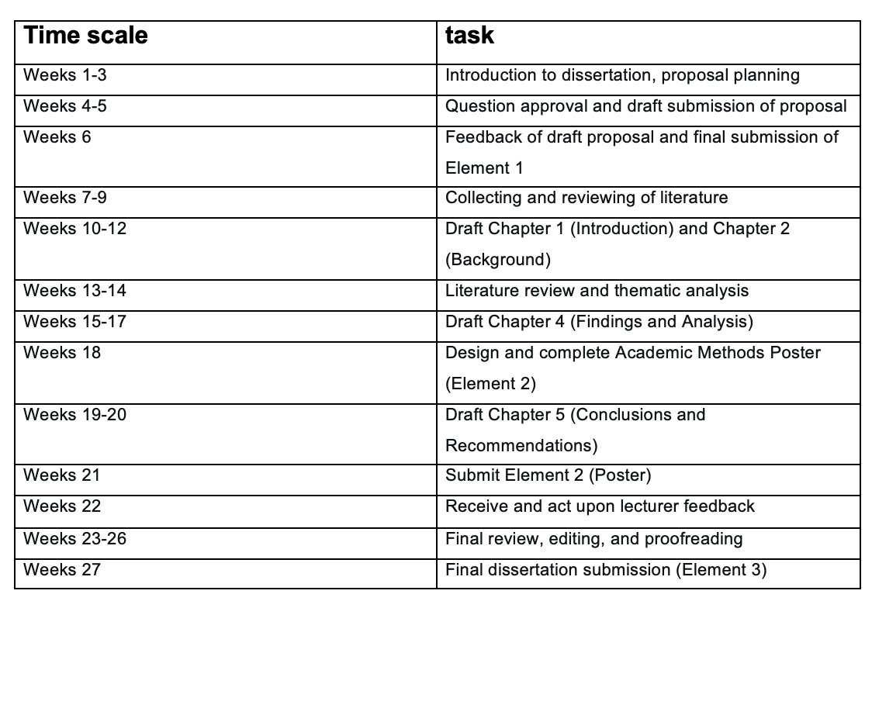Self-reflection as a researcher (any strengths or challenges)
The researcher's strengths include self-awareness, persistence, and a willingness to seek regular feedback from lecturers. However, the researcher struggles with managing time effectively, particularly taking time out to sit down and complete work. To address this, the researcher will set weekly study targets, use structured study schedules, and regularly review progress against the timeline. Using Gibbs' (1988) reflective cycle, the timeline outlined above will help with managing time and staying on track. Seeking regular feedback from lecturers at key stages will also provide accountability and support.

References

Avlund, S.H., Thomsen, P.H., Schendel, D., Jørgensen, M., Carlsen, A.H. and Clausen, L. (2021) 'Factors Associated with a Delayed Autism Spectrum Disorder Diagnosis in Children Previously Assessed on Suspicion of Autism', Journal of Autism and Developmental Disorders, 51(11), pp. 3843–3856. Available at: https://doi.org/10.1007/s10803-020-04849-x
Crane, L., Chester, J.W., Goddard, L., Henry, L.A. and Hill, E.L. (2018) 'Experiences of autism diagnosis: A survey of over 1000 parents in the United Kingdom', Autism, 22(2), pp. 143–152. Available at: https://doi.org/10.1177/1362361315573636
Gibbs, G. (1988) Learning by Doing: A Guide to Teaching and Learning Methods. Oxford: Further Education Unit, Oxford Polytechnic.
Mandy, W., Midouhas, E., Hosozawa, M., Cable, N., Sacker, A. and Flouri, E. (2022) 'Mental health and social difficulties of late-diagnosed autistic children, across childhood and adolescence', Journal of Child Psychology and Psychiatry, 63(11), pp. 1405–1414. Available at: https://doi.org/10.1111/jcpp.13587
National Autistic Society (2023) Autism assessment waiting times. Available at: https://www.autism.org.uk/what-we-do/news/autism-assessment-waiting-times-2023 (Accessed: 18 June 2026).
National Institute for Health and Care Excellence (NICE) (2017) Autism spectrum disorder in under 19s: recognition, referral and diagnosis (CG128). Available at: https://www.nice.org.uk/guidance/cg128 (Accessed: 18 June 2026).
NHS Digital (2023) Autism statistics, April 2022 to March 2023. Available at: https://digital.nhs.uk/data-and-information/publications/statistical/autism-statistics/april-2022-to-march-2023/ (Accessed: 18 June 2026).

