Community Sports Development
Task A – Powerpoint
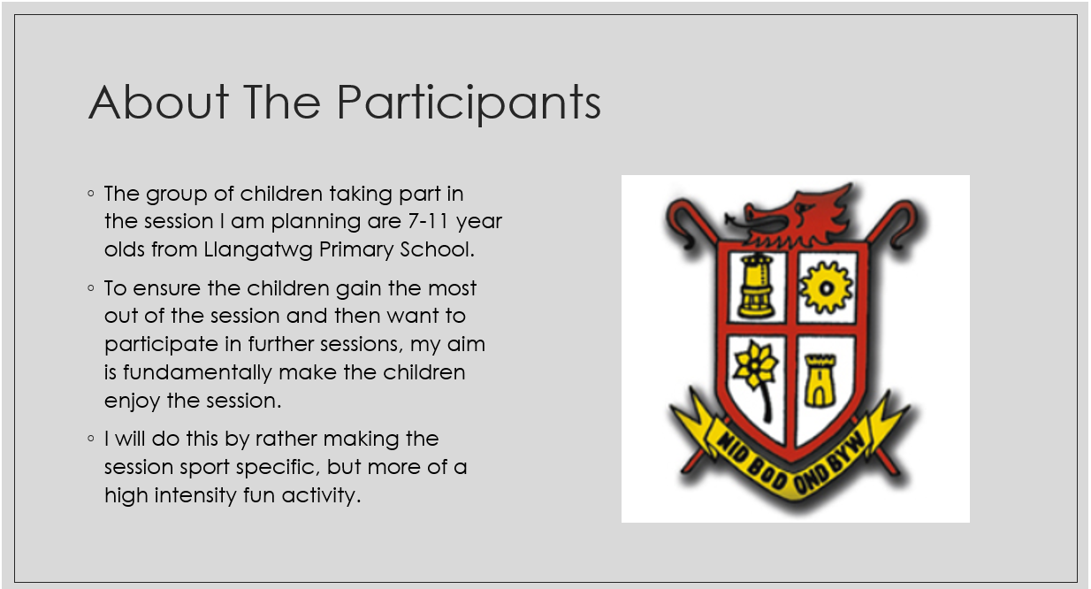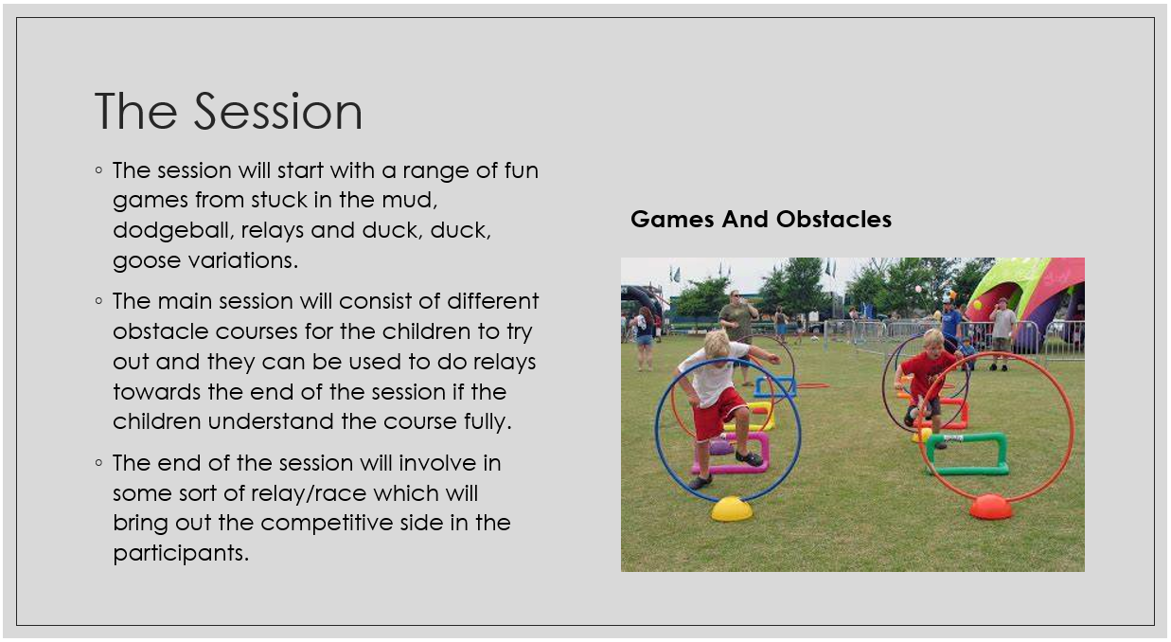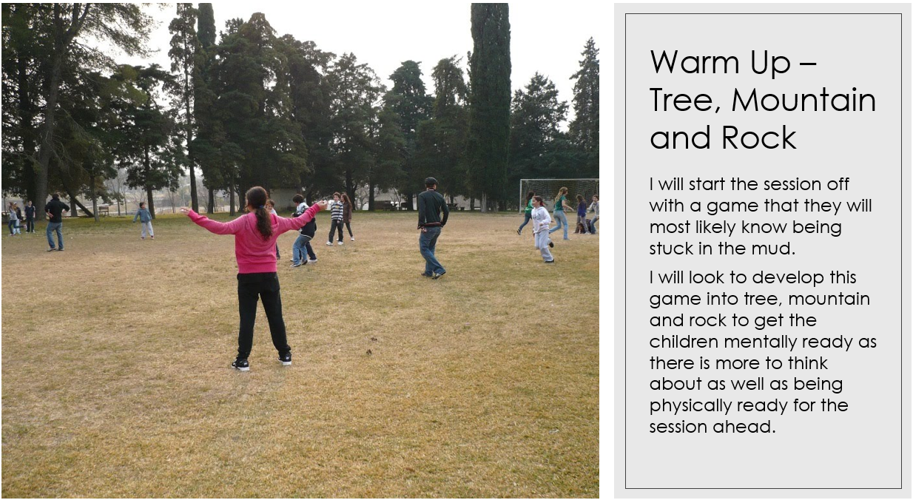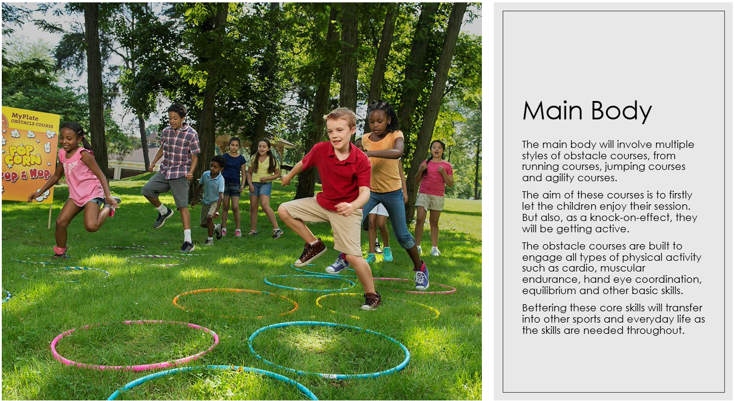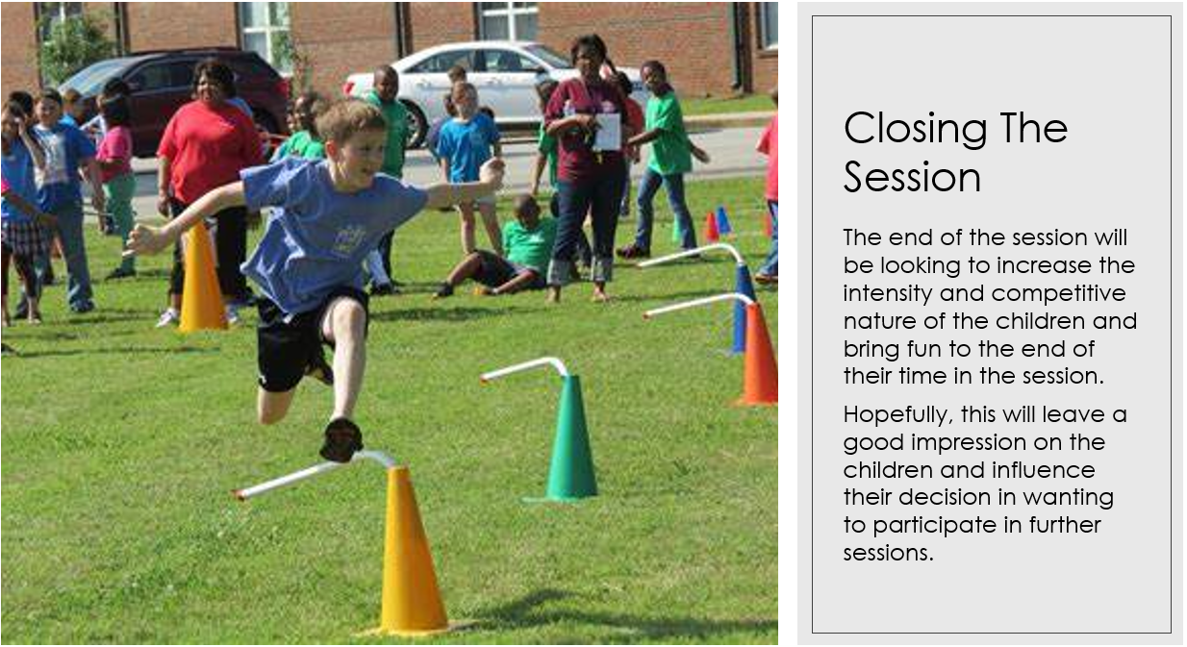

Task B – SWOT Analysis
I will be completing a SWOT analysis on the Physical Activity and Sport Service Neath Port Talbot. By doing this I can outline any strengths and weaknesses of the current work that they are doing, any potential future opportunities and any potential threats to the sports development team.
Strengths
There are many strengths that the development team have going for them. The main one I believe is that there is a big movement throughout the UK and worldwide in trying to get childhood obesity down and make the next generation a more healthy and fitter generation. This means that the governments and local councils are looking to support people who specialise in the development in sport in communities and schools which also takes another level of stress off them. “Funding will also be targeted at groups who have low participation rates to encourage those who do not take part in sport and physical activity to get involved. This includes supporting women, disabled people, those in lower socio-economic groups and older people.” (Department for Digital, culture, media and sport, UK Government, 2015) This statement that has come straight from the government is a perfect example of the push and emphasis that they are putting on sport at the development and grassroots stage. Another strength is the partnership with the Neath Port Talbot council they have. Being partnered with a council means they will have an instant connection with all the local schools, leisure centres, sports facilities and people of young age. This means they can get priority in these facilities and easy access to get the message and movement of exercise and a healthy lifestyle across the district a lot quicker than maybe a private sports development team could.
Weaknesses
In my opinion, I do not believe that there are many weaknesses of the sports development team in Neath Port Talbot. I think this as the work they are doing is genuine and they are looking to better the people of their area physically but also mentally. There are some barriers which can weaken the team though and by pinpointing them out, they will be able to tactically move around the barrier and strive further. Sports development is still rather a new thing in the modern day and age, and this means that professionals in this field become very sought after. For someone to successfully run programmes and projects, they must have a high level of expertise in the field and due to it being a relatively new thing, these professionals can become hard to come by. The; “Average UK salary in 2019 was £30,378” (Careerpilot : Job sectors : Training : Job profiles : Sports development officer) This information shows that even though the average salary of a sports development officer isn’t ridiculously high, it is still a very expensive role to fill within a team of numerous officers and some local authorities may not be able or in the position to pay out that much.
Opportunities
There are many opportunities that come up in everyday life for a sports development team to attack at and ultimately it can be make or break for the team whether they take the opportunities that have arisen. A huge opportunity which is always recurring, and the team can work off is worldwide fitness trends. These trends tend to be the thing that get people involved in sport or exercise in general and when they come around, everyone wants to get involved which can work in the development team’s favour. A huge fitness trend that was almost sparked back up due to the coronavirus is fitness videos and livestreams which consists of following workouts for all ages, abilities and experience working out and this was mainly pushed by Joe Wickes. “Well, we’re not sure about you, but it was evident more than kids were tuning in as the counter passed the 800k mark around 9.20am today.” (Metro News, March 2020) These numbers for sport in general are astronomical and it shows the volume of people who are looking to get involved in sport in the comfort of their own homes. Some people find it hard to go to a gym and workout in that environment and its understandable when a lot of people there are already on their fitness journey whereas you can be at the beginning of yours and not that confident. This means if they feel comfortable after spending some time doing home-workouts and they feel they have made progress, this can encourage them to get out of the house and join a gym, sports club and other sports facilities.
Threats
Right now, globally, there is a massive decrease in government funding and especially in the UK due to the COVID-19 pandemic. Due to so much money being pumped into vaccines and furlough schemes, the government has had to sacrifice a lot of money that was frequently going elsewhere into things such as community projects and development programmes, but now that funding is not available anymore or at least for the time being. This can affect them massively as if there is no funding coming through for projects to get the community involved in sport, then they will need to look elsewhere for funding such as fundraising or sponsors. This approach is usually a lot less effective and can take a considerably longer amount of time to get the money needed to push projects ahead. “Our latest survey of British households pointed to large declines in household income and spending due to Covid-19.” (Bank of England, 25 August 2020) This statistic clearly shows that the economy in a whole has had a massive hit and leave the UK in massive amounts of debt. With the on and off lockdowns enforced by local governments and the UK government, it is difficult to even know if throwing an event, games or even training sessions will be safe and allowed by the rules at that time. It can become unsafe to plan and put money into a project, hoping that it will come through because at times like these, we do not know when we will be coming out of a lockdown and when we are going into one.

References
- https://www.gov.uk/government/news/new-strategy-to-strengthen-sport-from-the-grassroots-to-the-elite
- https://www.careerpilot.org.uk/job-sectors/training/job-profile/sports-development-officer#:~:text=Sports%20development%20officers%20organise%20projects%20and%20training%20to,Statistics)%20Working%20hours%2036%20to%2038%20a%20week
- https://metro.co.uk/2020/03/23/joe-wicks-first-youtube-live-pe-session-12441526/
- https://www.bankofengland.co.uk/bank-overground/2020/how-has-covid-19-affected-the-finances-of-uk-households

