A Strategy Formulation Plan for Honda Company in UK Automotive Sector
Component 2: Strategic Plan – Academic Report

Student Name: Magdalena Vintila

Student ID 2216452

LCBB6015 Strategic Management and Sustainability

Contents
1. Executive Summary 3
2. Introduction 4
3. Company Overview of Honda UK 4
4. Honda UK’s Current Performance in UK Market 5
5. Honda Motor’s Strategic Intent 6
a. Honda’s Vision 6
b. Honda’s Mission 6
c. Honda’s Objectives 6
6. Honda Motor’s Strategy Analysis 6
a. External Environmental Audit 6
i. PESTEL Analysis 6
ii. Honda’s Porter’s Five Forces Analysis 10
b. Internal Environmental Audit 11
i. BCG Matrix of Honda Motor 11
c. SWOT Analysis 12
7. Strategy Formulation 12
8. Conclusion 13
9. Reference List 14

Executive Summary
This report examined Honda’s strategic formulation plan in the UK’s automotive sector. It examined Honda’s strategic analysis of its external and internal environmental audits to identify factors likely to affect its operations. The external environmental audit identified various opportunities and challenges affecting Honda’s operations in the UK. One of the opportunities identified in the external audit analysis is the government’s emission regulations, including ZEV mandate. These regulations together with UK governments’ incentives for EV companies have created a beneficial environment for EV automakers in the UK. Similarly, the analysis identified high competition in the UK’s automotive industry and global economic crises as factors likely to negatively affect Honda’s operations in UK. There are various companies operating in this industry and which compete on price, product quality, and innovations in electric vehicles. Besides, Honda operates under strict UK’s regulatory framework; including the government’s zero emission targets for 2035, which it must comply with to avoid penalty. Besides, the internal environmental audit showed the company’s internal strengths, including strong brand reputation for innovation and reliability and engineering prowess. The report recommended that Honda accelerates the introduction and expansion of electric vehicles and motorcycles to enable it comply with UK’’s strict environmental regulations and increase sales.

Introduction
Managers play an important role in enabling organisations to achieve their long-term goals and objectives. However, as organisations operate in a highly dynamic business environment, managers must become strategic thinkers to enable them make good decisions (Gamble, Peteraf, and Thompson, 2023). Therefore, effective strategic management provides a guide that enable company managers to set long-term goals and align resources to attain them (Gamble, Peteraf, and Thompson, 2023). Strategic management refers to the continuous process of creating and implementing plans to help organisations meet their objectives and goals (Barney and Hesterly, 2015). It is a process that involves environmental audit to identify opportunities and challenges, strategy formulation, resource allocation, monitoring progress, and making necessary adjustments to improve performance and competitive advantage (Barney and Hesterly, 2015). Besides, strategic management helps managers translate their thinking process into action plans that benefit their companies to maintain a competitive edge in the industry (Gamble, Peteraf, and Thompson, 2023). In this regard, strategic management offers organisations and employees clarity of purpose and direction of where they are headed and how they plan to get there. It improves performance by setting clear goals, checking progress, and refining strategies (Barney and Hesterly, 2015). This report focuses on the strategic formulation plan of Honda in the UK’s automotive sector. The report covers strategic analysis of Honda’s business environment to understand market trends, identify opportunities and formulate strategies.

Company Overview of Honda UK
Honda UK serves the European market employing over 3500 people to help build and export vehicles to different countries worldwide (Honda Classics, 2025). This technology seeks to help Honda create a cleaner environment for everyone. Honda offers retail lending, leasing services and financial services to customers and wholesale to dealers (Road Genius, 2024b). The company boasts about 70 retail dealers across the UK (Road Genius, 2024a). As Honda starts to produce electric vehicles, the company decided to restructure its operations by closing its manufacturing plant in Swindon, UK (Road Genius, 2024a). The company aims to produce electric vehicles in Japan, America, and China and export them to the UK market to minimise costs.
- Honda UK’s Current Performance in UK Market
Honda’s financial statement in figure 1 shows a company that continues to perform well, amid high competition in the market. Honda has experienced an ascending growth trend of its sales revenue for the past 5 years (European Media Newsroom, 2025). The company’s positive performance in the UK and Europe has been driven by strong customer demand for its models, especially the newly introduced electric vehicles. Moreover, the demand for Honda CR-V model has helped to improve its UK sales (European Media Newsroom, 2025). Honda plans to introduce electric vehicles in Europe to increase its sales. Despite this increasing revenue, the company’s operating income has continued to reduce year-over-year because of the non-recurring expenses associated with the electric vehicles and tariff impacts 9 Road Genius, 2024a). Furthermore, market-driven factors such as high cost or materials and high competition in the industry have contributed to the reduction in Honda’s profit. Honda plans to introduce direct-to-consumer model through its e-commerce platform to help boost its sales in the UK market
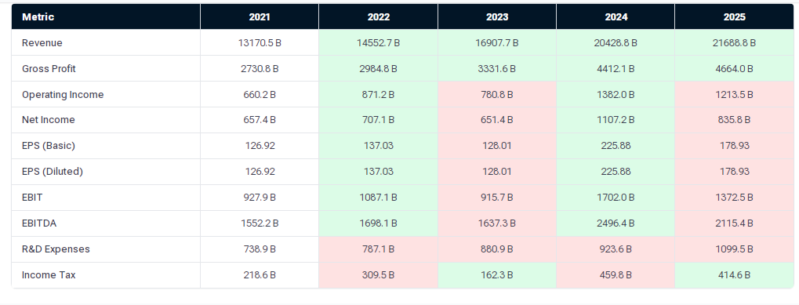
Figure 1: Honda’s Income statement (2021-2025)
Source: DiMarket (2026)

Honda Motor’s Strategic Intent

Honda’s Vision
The company’s vision is “to serve people worldwide with the joy of expanding their life’s potential and to lead the advancement of mobility and enable people worldwide to improve their daily lives” (Honda Classics, 2025). The company’s vision emphasises its commitment to promoting “advancement of mobility” and creation of value for people worldwide (Honda Classics, 2025). In this respect, Honda focuses on offering products and services that bring joy to people and improve their lives.

Honda’s Mission
The company’s mission is “to maintain a global perspective, committed to delivering quality products, at a reasonable price for worldwide customer satisfaction” (Road Genius (2024a).This mission underlines’ Honda’s priorities of delivering top-quality products and services that at affordable prices to improve customer satisfaction (Honda Classics, 2025). The mission statement shows the company’s priority of creating value and ensuring worldwide availability of its products.

Honda’s Objectives
- To achieve 100% electric vehicle sales by 2040 through increased production of EVs in its Japan, China, and US manufacturing plants.
- Continues investment in R&D to promote innovation in the company
- To achieve carbon neutrality by 2050 in all the company’s products and processes to reduce emission.

Honda Motor’s Strategy Analysis

External Environmental Audit

PESTEL Analysis
Political Factors: Honda’s business operations can be affected by various political factors, including government regulations on emissions, tariffs and trade policies, and geopolitical stability (ACEA, 2025). The UK government has committed itself to net-zero emission target, shown in figure 2 below to encourage electrification in the country (Feng, 2025). These strict ZEV timeline are forcing automotive companies like Honda to phase out their traditional ICE vehicles and adopt 100% EVs. Furthermore, Brexit affected Honda’s operations in Europe where it operates through its UK headquarters by introducing new trade tariffs and customs that affected its supply chain (Feng, 2025). Honda can also benefit from the UK government’s incentives for electrification in the country.
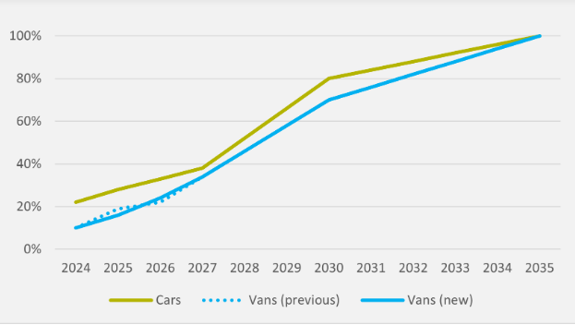
Figure 2: The UK’s Zero Emissions Vehicle (ZEV) mandate
Source: Henning, 2023
Economic Factors: The devaluation of Euro and Japanese Yen affects the company’s importation of components and export of its products. The increasing cost of components is likely to affect the company’s pricing strategy (Feng, 2025). High inflation shown below has led to high cost of living. This has reduced consumer purchasing power, which reduces Honda’s sales (ACEA, 2025).
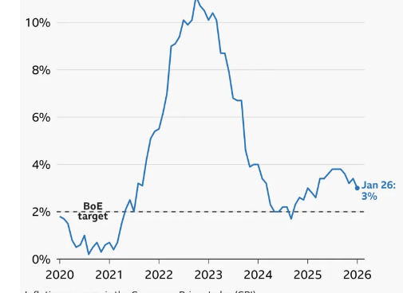
Figure 3: Annual UK inflation rate
Source: BBC (2026)
Social Factors: The UK people tend to strongly believe in their domestic brands, which may affect Honda’s sales in the UK, especially in post-Brexit era (Feng, 2025). Most UK customers have become aware of the effects of climate change in the world, thus prefer eco-friendly products to help minimise emissions (Feng, 2025). UK’s demand for EVs has been growing gradually, as can be seen below.
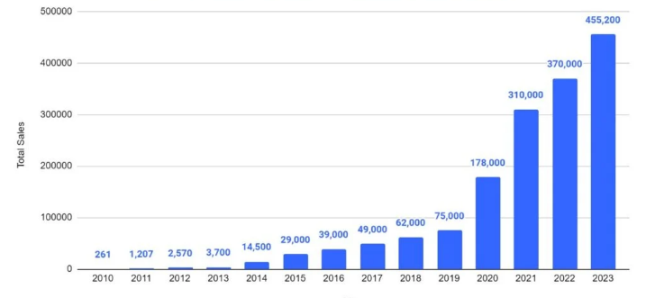
Figure 4: Number of EVs sold in the UK from 2010 to 2023
Source: Road Genius (2024a)
Technological Factors: Developments in charging infrastructures in the UK are another factor that affects Honda’s operations (Feng, 2025). Honda is investing in innovation and new technologies to improve safety and customer driving experience (ACEA, 2025). UK’s charging stations have increased, as shown below. This helps to encourage people to buy EVs in UK.
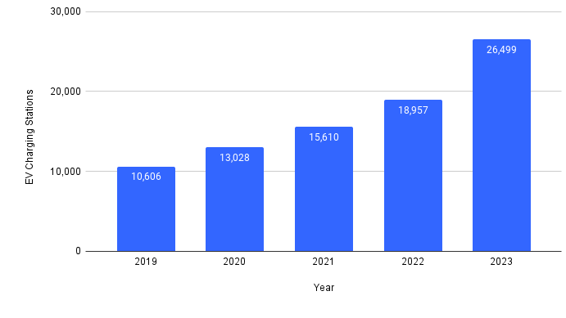
Figure 5: Growth of electric vehicle charging stations in the UK
Source: Road Genius (2024b)
Environmental Factors: Climate change problems have led to new environmental regulations which Honda must comply with to avoid fines (Feng, 2025). UK has emission regulations and policies, like ZEV mandate, which this company must comply with (SMMT, 2026). Furthermore, the government provides financial support to promote production and adoption of EVs.
Legal factors: The UK’s employment laws which require employees to work for eight hours, per day and minimum wages are likely to affect Honda’s production and profitability (SMMT, 2026). Honda must observe the country’s safety regulations in workplaces to avoid fines. More importantly, Honda must comply with UK’s emission regulations to avoid penalties.

Honda’s Porter’s Five Forces Analysis
Porter’s Forces | Low/High /medium | Description
Rivalry among existing competitors | High | There are many automotive companies operating in the UK’s automotive sector, including Tesla, Audi, BMW, and Mercedes. The Chinese low-cost EV companies like BYD and Polestar have also entered the UK market increasing competition (ACEA, 2025).
Threat of new Entrants | Low to Medium | The threat of new entrants is relatively low because of the huge capital that new entrants need to have to successfully enter this industry. However, low-cost EV companies from China are easily entering this market, positing threats to Honda.
Suppliers’ bargaining power | Moderate | Most of the key suppliers of automotive companies are concentrated, which has given them moderate power in the industry to negotiate better terms. Also, the high cost involved in changing suppliers by Honda, gives them moderate power.
Buyers’ bargaining power | High | The cost of switching from automaker to another among UK consumers gives them power to influence prices (ACEA, 2025).
Threat of substitute products | Moderate | Consumers can Uber or public transport

Internal Environmental Audit

BCG Matrix of Honda Motor
Relative Market Share
Star  -CR-V Hybrid  -Civic Hybrid  -HR-V | Question Market  -Honda Prologue EV  -Honda’s new EV models  -Honda electric motorcycles  -Honda o Series EVs
Cash Cow  -Honda accord  -Legacy civic models  -Spare parts | Dog  -Honda clarity  -ICE models
Market growth
Stars: These are products that have high growth potential and high market share. Models in this quadrant like CR-V hybrid have both high market share and growth potential. The company should invest in them to maintain its competitive advantage.
Cash Cow: These are products with high market share but with low growth potential. Products such as Honda Accord, Spare parts, and Legacy civic models are Honda’s cash cow because they have high market share, but low growth potential. Honda should continue milking profits from these products to fund stars and question marks products.
Question Marks: these products have low market share, but with high growth potential in the market. Honda’s electric motorcycles and vehicles are question marks because they have low market share, but with high growth potential in the market (Feng, 2025). Honda should continue investing in these products using cash generated from cash cows to increase its market share and competitive advantage.
Dog: These products hove low growth potential and low market share in the industry. Tesco’s older components and accessories that cost the company money and have no good returns fall into this quadrant (Feng, 2025). Tesco should reposition or divest them to prevent them from continuing to drain the company’s cash. Honda clarity and ICE Models have low growth potential and low market share due to the changing consumer preferences for EVs in UK. The company should eliminate them to allow it redirect all its resources to producing EVs.

SWOT Analysis
Strengths  -Engineering reputation for reliability  -Strong brand image for innovation and quality  -Excellent after-sale service  Diversified product portfolio  -Strong dealer network | Weaknesses  -Product recalls damages its reputation  - High costs of manufacturing and production  -Low market share in the UK and Europe  -Limited product segments
Opportunities  -Increase market share in motorcycle and scooter  -Increase production of EVs to meet the increasing demand for EVs  -Produce fuel-efficient vehicles in line with environmental regulations | Threats  -Intense competition  -Global economic crises  -Rising costs of raw materials  -Supply chain disruptions  -Regulatory pressures

Strategy Formulation
The UK automotive industry contains many established players, including Tesla, Audi, Toyota, BMW, Ford, and Mercedes. Besides, new low cost Chinese electric vehicle companies are also entering the UK industry, further increasing competition (Feng, 2025). In this respect, Honda should focus on differentiating its products by producing quality and reliable electric vehicles to continue attracting more customers in the UK market. Furthermore, Honda can address the challenge of high suppliers’ bargaining power by building strong relationships with key suppliers to get better deals and minimise costs (Barney and Hesterly, 2015). Besides, the company should build close relationships with car dealers to improve customer service and satisfaction at different stages, sales to after-sales and post-sale services. This will improve its competitive advantage in the industry.

Conclusion

This report examined Honda’s strategic formulation plan in the UK’s automotive sector. The report examined Honda’s strategic analysis of its external and internal environmental audits to identify factors likely to affect its operations. The external environmental audit identified various opportunities and challenges likely to affect Honda’s operations in the UK. The government’s emission regulations and ZEV mandate have created a beneficial environment for EV automakers in the UK. Besides, competition is high in this industry, as many established players operate in UK. These companies compete on price, product quality, and innovations in electric vehicles. Similarly, Honda operates under strict regulatory framework; including the UK government’s zero emission targets for 2035, which it must comply with to avoid penalty. The internal environmental audit showed the company’s internal strengths, including strong brand reputation for innovation and reliability and engineering prowess. The company should accelerate the introduction and expansion of electric vehicles and motorcycles to enable it comply with UK’’s strict environmental regulations.

Reference List
ACEA (2025) Economic and market report: Global and EU Auto Industry – full year 2024, ACEA. Available at: https://www.acea.auto/publication/economic-and-market-report-global-and-eu-auto-industry-full-year-2024/ (Accessed: 20 March 2026).
Barney, J. B. and Hesterly, W. S., 2015. Strategic Management and Competitive Advantage: Concepts and Cases. 5 ed. Essex: Pearson Education Limited (Accessed: 21 March 2026).
BBC (2026). Why are UK prices still rising? Available At: https://www.bbc.com/news/articles/c17rgd8e9gjo (Accessed: 20 March 2026).
DiMarket (2026). About Honda Motor Co., Ltd. Available at: https://www.datainsightsmarket.com/companies/7267.T (Accessed: 19 March 2026).
European Media Newsroom (2025). Summary of 2025 Honda Business Briefing – Honda to Realign Automobile Business Strategy to Address Current Business Environment. Available at: https://hondanews.eu/eu/en/corporate/media/pressreleases/534955/summary-of-2025-honda-business-briefing-honda-to-realign-automobile-business-strategy-to-address-cur#:~:text=In%20the%20area%20of%20applying,such%20as%20EVs%20and%20HEVs (Accessed: 19 March 2026).
Feng, X. 2025. ‘A strategic perspective on the UK automotive industry’, SSRN Electronic Journal [Preprint]. Available at: 10.2139/ssrn.5350257 (Accessed: 20 March 2026).
Gamble, J., Peteraf, M.A. and Thompson, A.A. (2023) Essentials of strategic management: The quest for competitive advantage. McGraw-Hill. Available at: 978-1260261547 (Accessed: 18 March 2026).
Gamble, J.E., Thompson, A.A. and Peteraf, M.A., 2013. Essentials of strategic management: The quest for competitive advantage. McGraw-Hill/Irwin. (Accessed: 20 March 2026).
Henning, O.V. (2023) UK Zev Mandate survives with only minor tweaks, EV inFocus. Available at: https://www.evinfocus.com/uk-zev-mandate-survives-with-only-minor-tweaks/ (Accessed: 20 March 2026).
Honda Classics (2025). Honda in the UK. Available at: https://www.honda-classics.co.uk/honda-in-the-uk (Accessed: 21 March 2026).
Road Genius (2024a). UK EV Sales Statistics. Available at: https (Accessed: 20 March 2026).
Road Genius (2024b). EV Charging Stations in the UK. Available at: https (Accessed: 21 March 2026).
SMMT (2026) EV share rises despite contracting market but tax hikes threaten targets. Available at: https://www.smmt.co.uk/ev-share-rises-despite-contracting-market-but-tax-hikes-threaten-targets/ (Accessed: 19 March 2026).

