Lonyé Browne (2114209)
UWTSD
ACBA 6007 STRUCTURAL DESIGN
ASSESSMENT 2 P2

Question 1 Hand Calculations
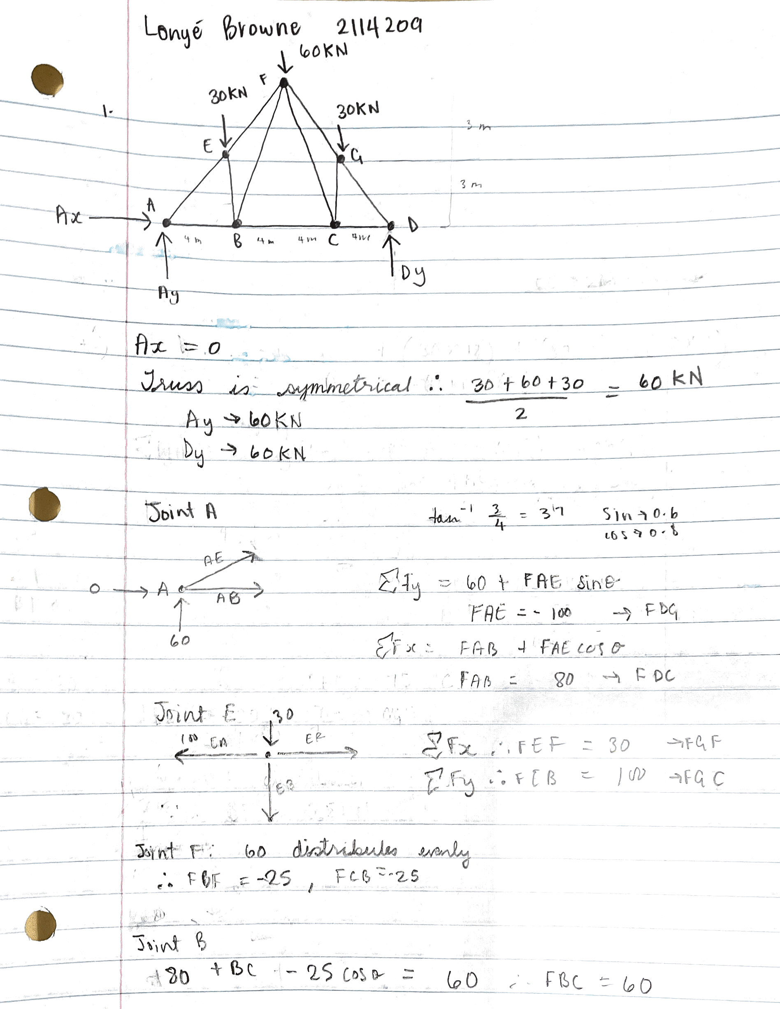

Question 1 Robot Structure
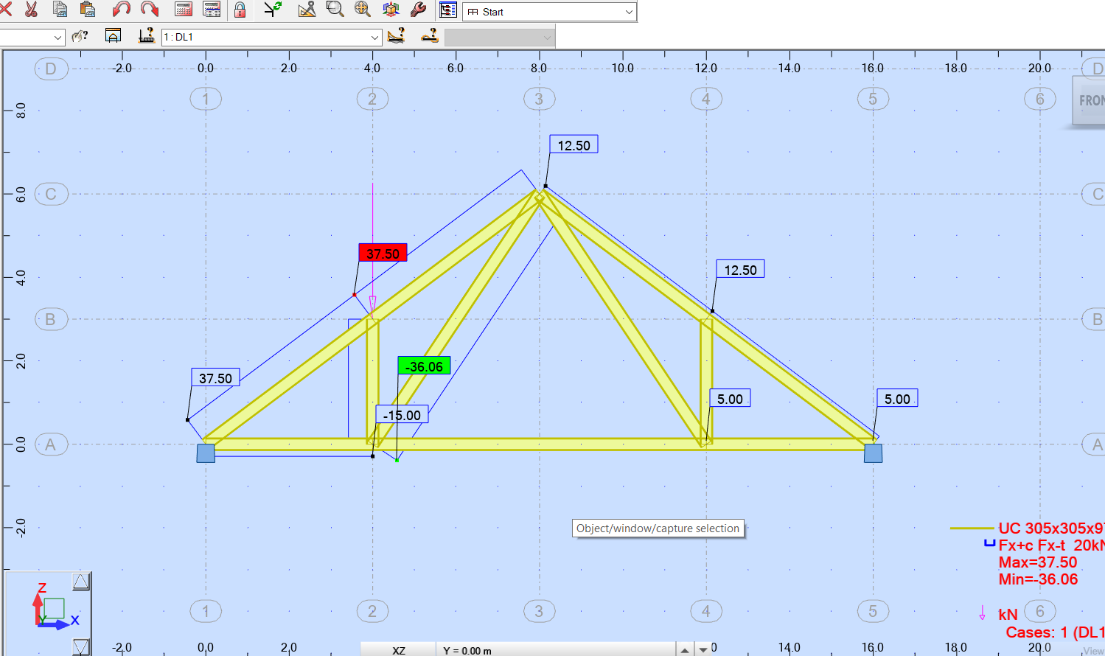

Question 2 Hand Calculations
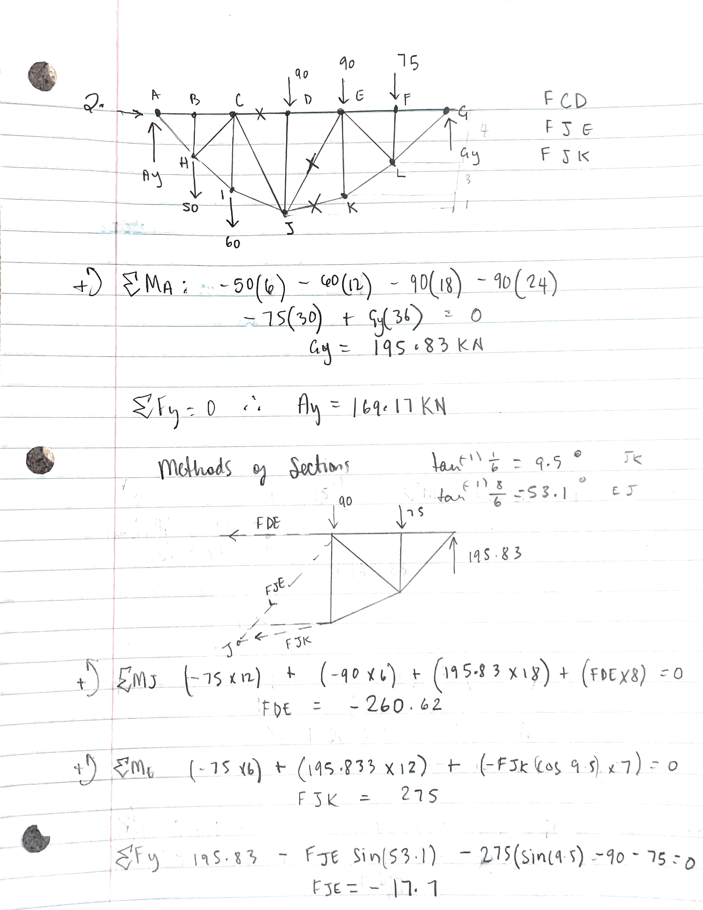

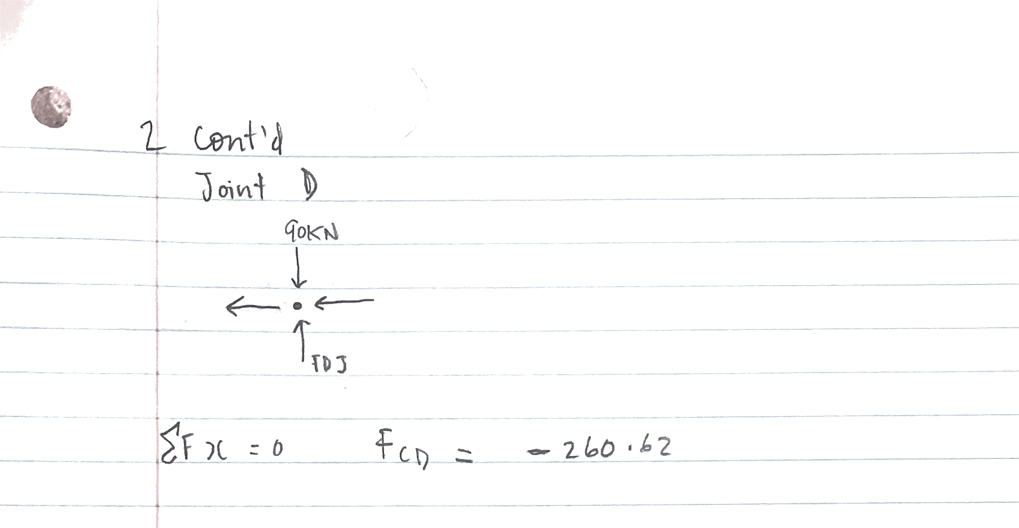

Question 2 Robot Structure
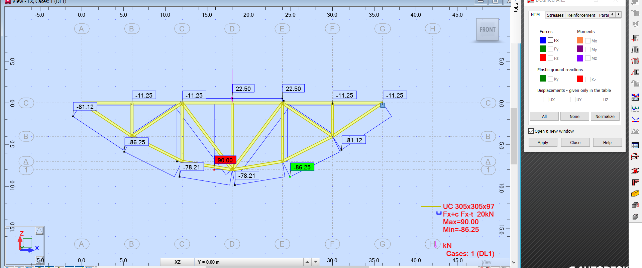

Question 3a Hand Calculations
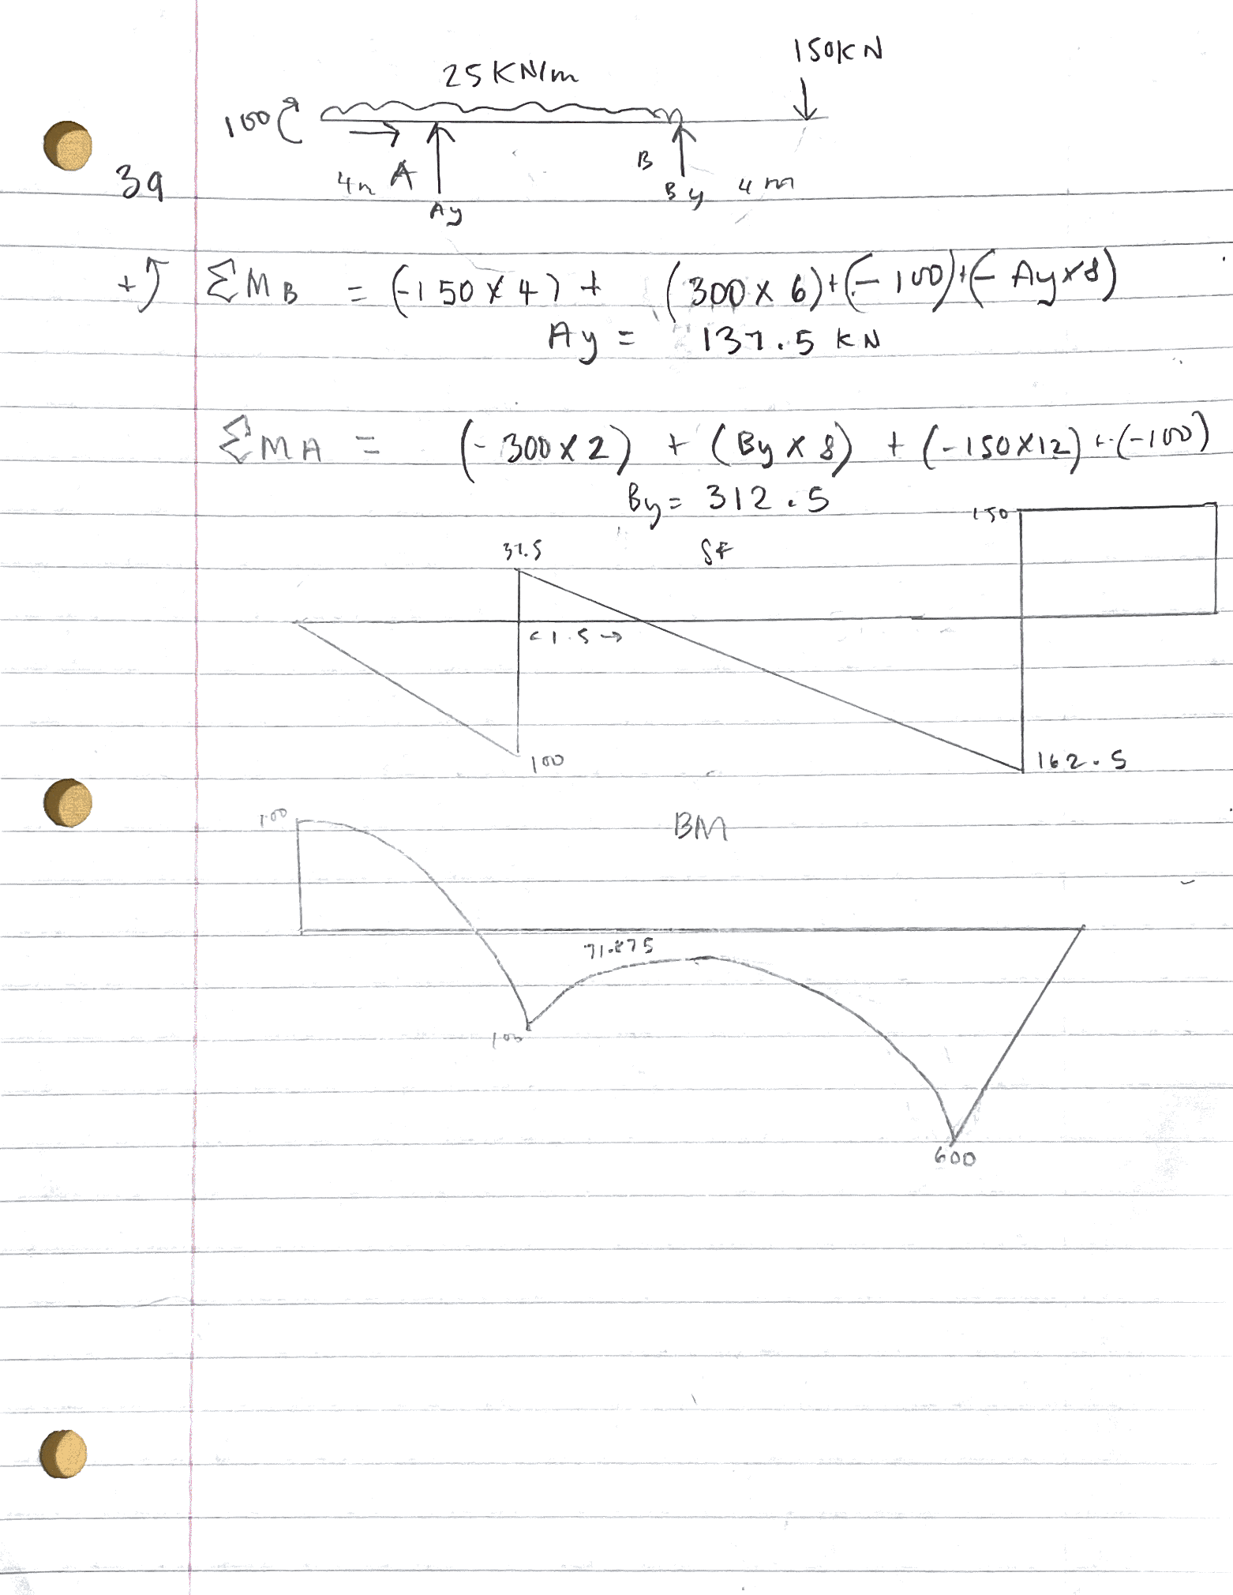
Question 3a Robot Structure
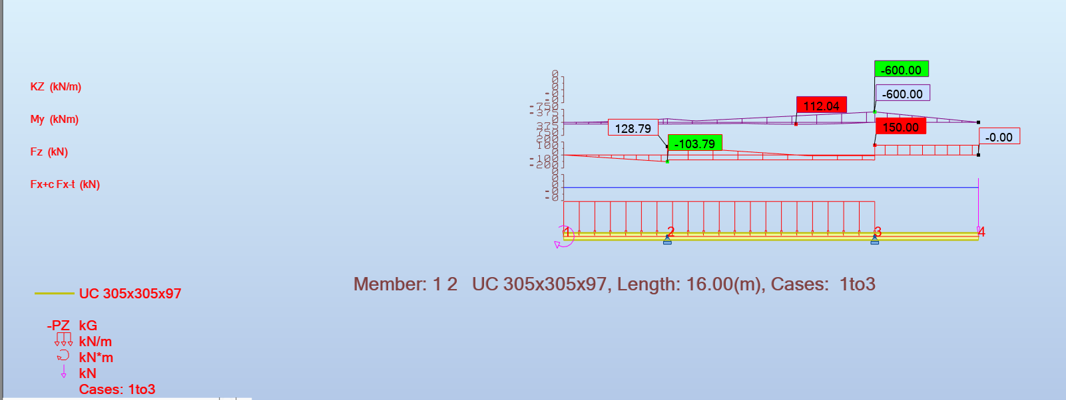

Question 3b Hand Calculations
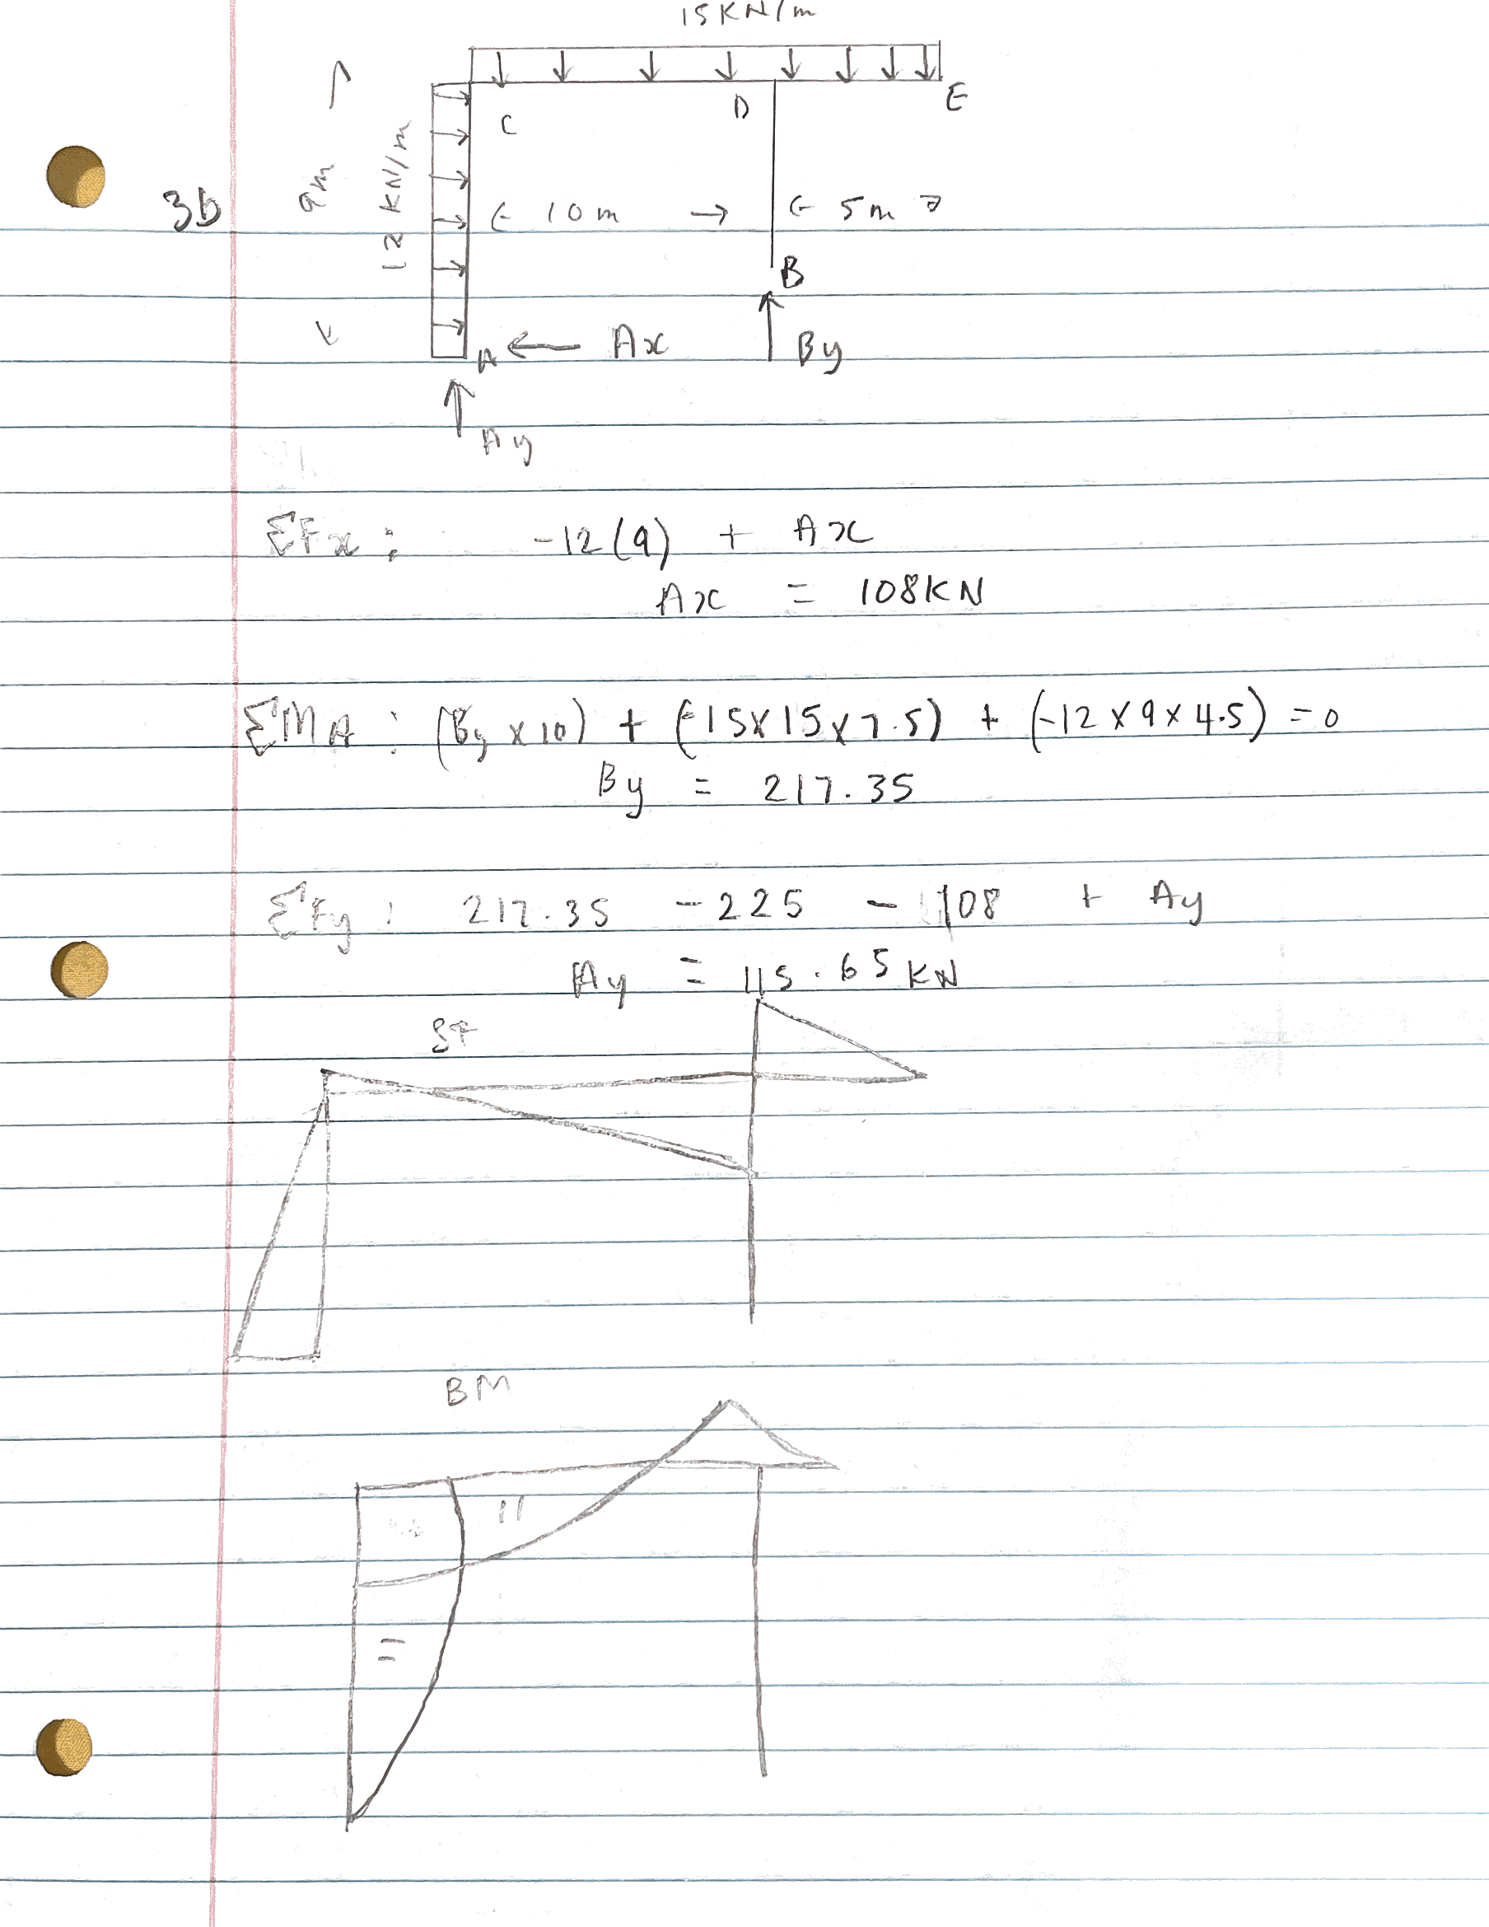

Question 3b Robot Structure
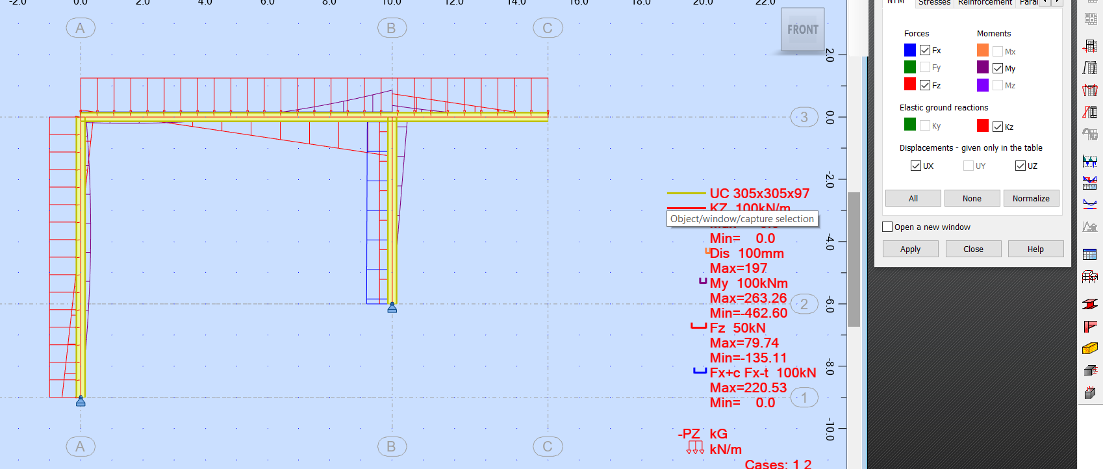

Question 4a Hand Calculations

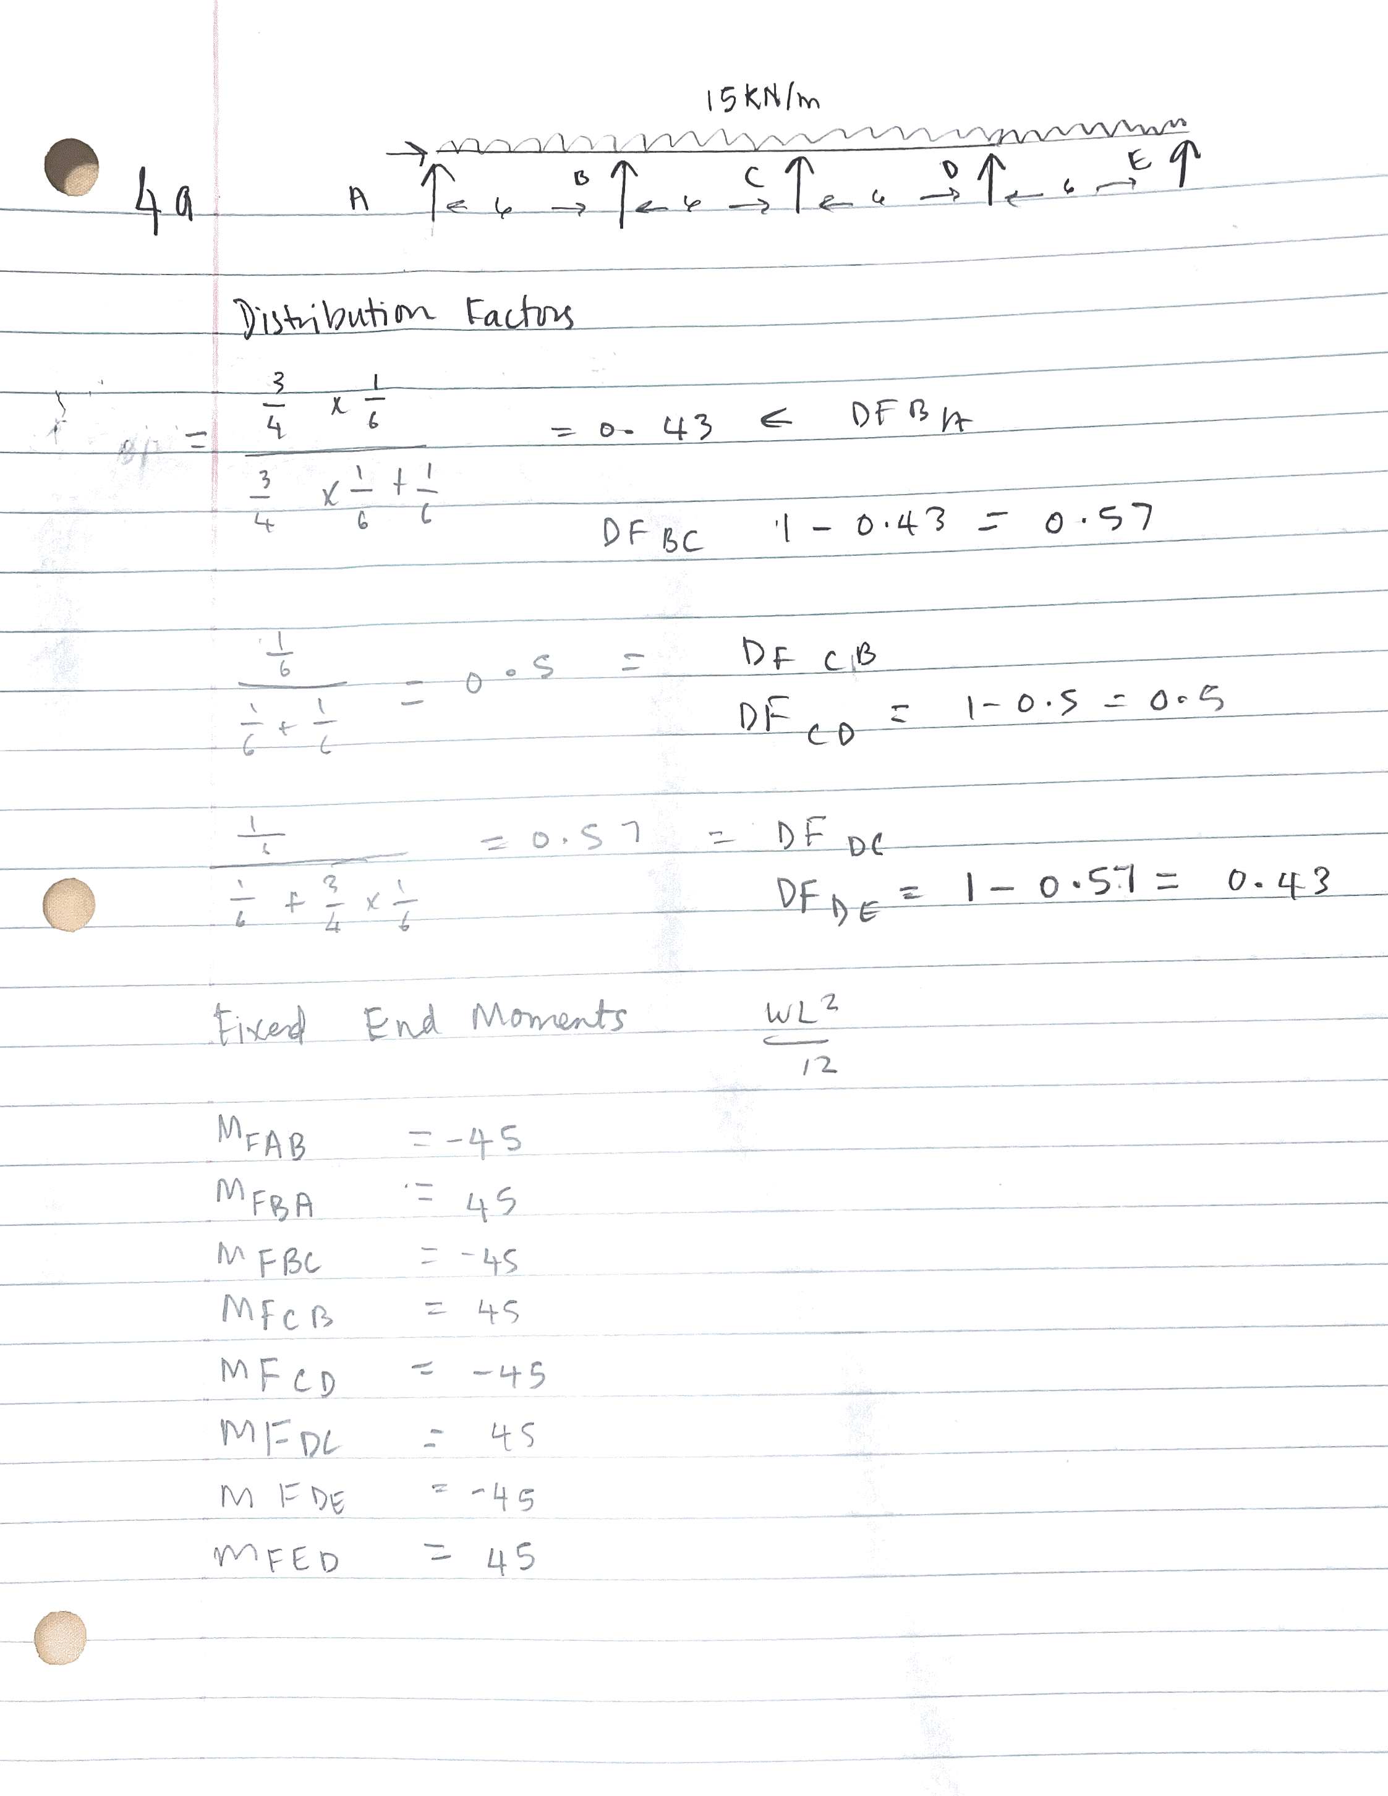
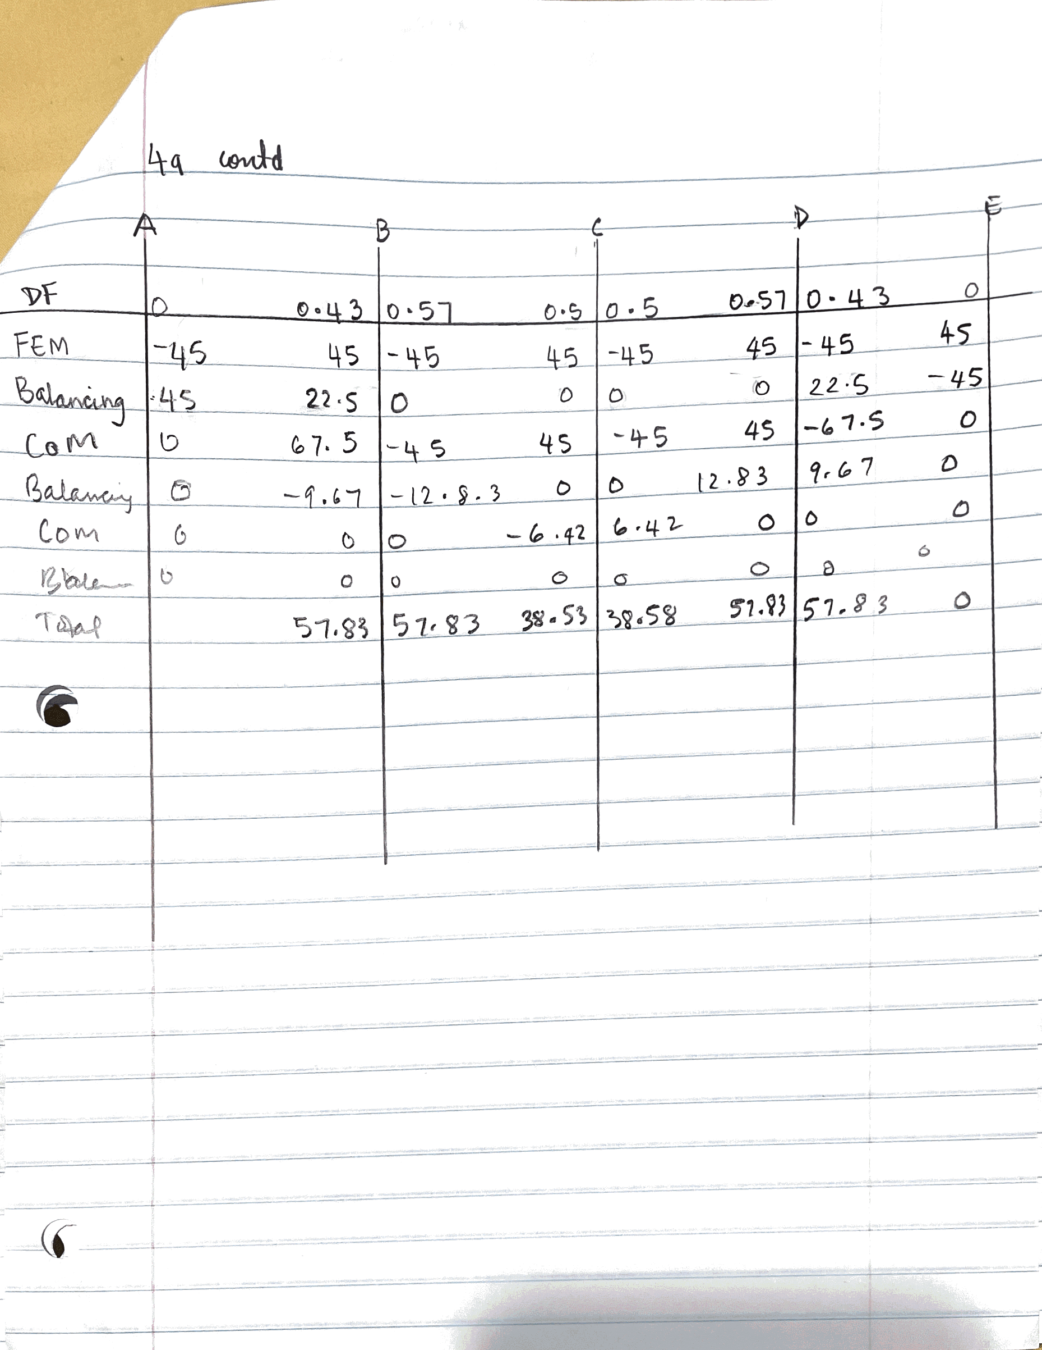

Question 4a Robot Structure
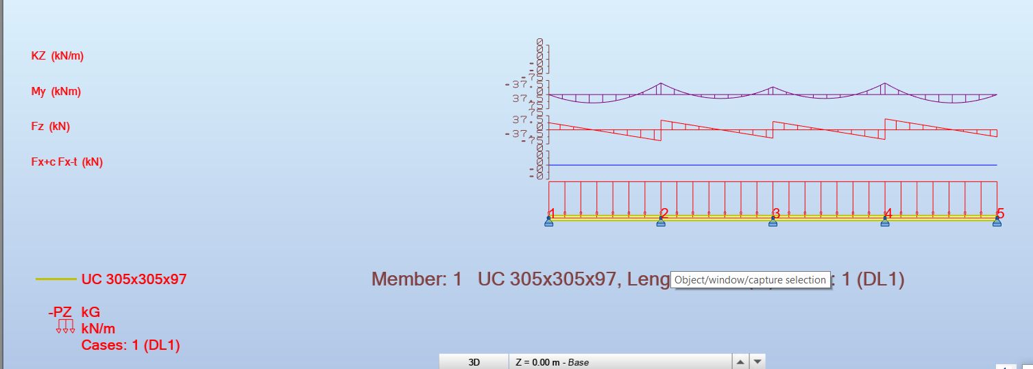

Question 4b Robot Structure


