Software Development
ACCA4017

Networking and Cyber Security BSc

Timothy Ferfers
1903054

Programming in C

Table of Contents

Solution Process 3
Exercise 1 3
Exercise 2 4
Exercise 3 6
Exercise 4 7
Appendix 8
Exercise 1 - Code Listings 8
Exercise 2 - Code Listings 12
Exercise 3 - Code Listings 19
Exercise 4 - Code Listings 20

Solution Process

Exercise 1
After reading through the description of Exercise 1, it became clear that the three variables needed to be different data types. Book titles would most likely only contain text; therefore the variable storing the users input book title must be ‘string’.
Measurements would be exclusively numbers so integer could apply, however as the example showed, some measurements go to a decimal point; therefore ‘double’ was the appropriate data type.
The quantity of items in a shopping basket must always be a whole number, as a retailer would not sell 0.5 of an item, etc. Since ‘integer’ data type can be calculated and does not allow decimal places it was used for amount of items.

Example use – no errors
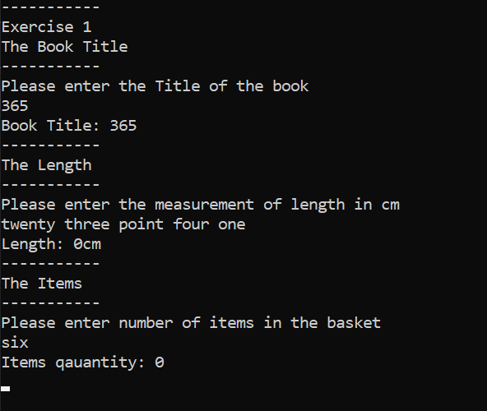
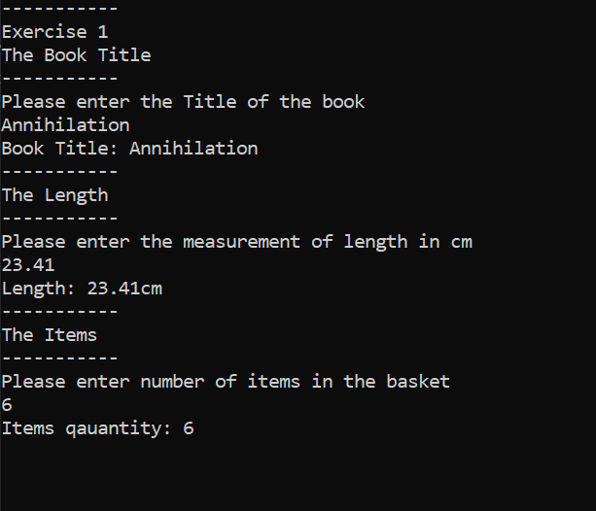
Example use- incorrect data type entry

Exercise 2
The brief on exercise 2 did not clarify how the inner dimensions of the shape should be calculated. After some deliberation on whether to incorporate a scaling circle and smaller square based on exterior width and height, a different method was adopted.
In this solution, the outline of the shape is referred to as “The Shape” and the smaller shape outlines are referred to as “Circle” and “Small Box”.
The user is prompted to enter values for The Shape’s height and width; following this the user must enter the dimensions for Small Box and Circle. Validation has been applied to both Small Box and Circle to ensure they cannot exceed The Shapes boundaries.
The validation for Small Box originally worked by taking the overall area value of Small Box and checking it was less than The Shape’s. However the realisation came that even if the area is less than The Shape, the user could still enter a height or width value exceeding The Shapes and still produce a smaller area. The original code was while (boxarea > initial area) after the area is calculated, instigating a warning and prompting the user to re-enter the measurements. Instead the new lines of code read while (boxheight > height) and while (boxwidth > width) enforcing validation under their respective user input sections.

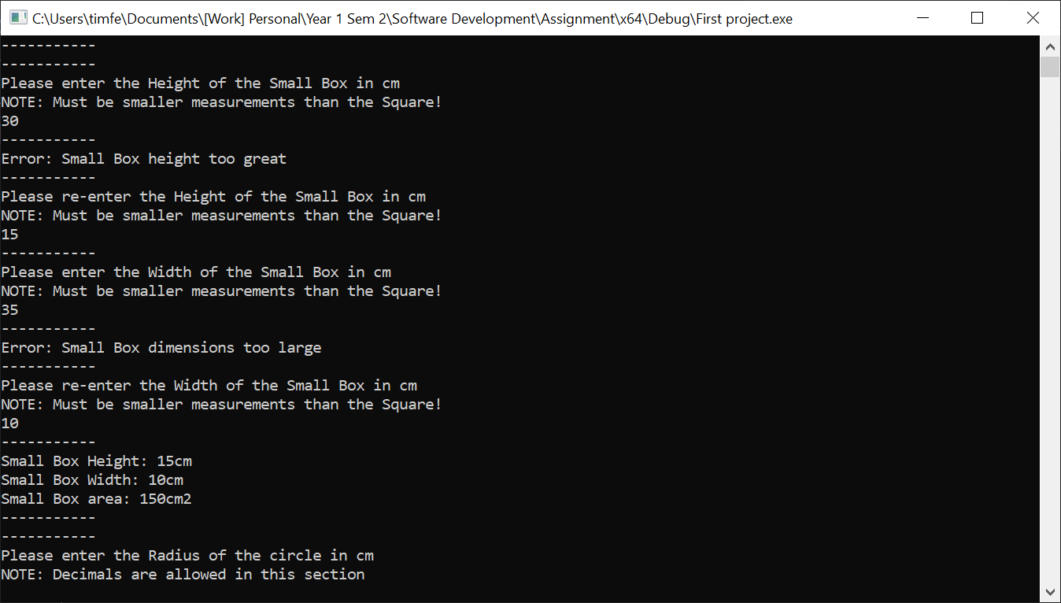
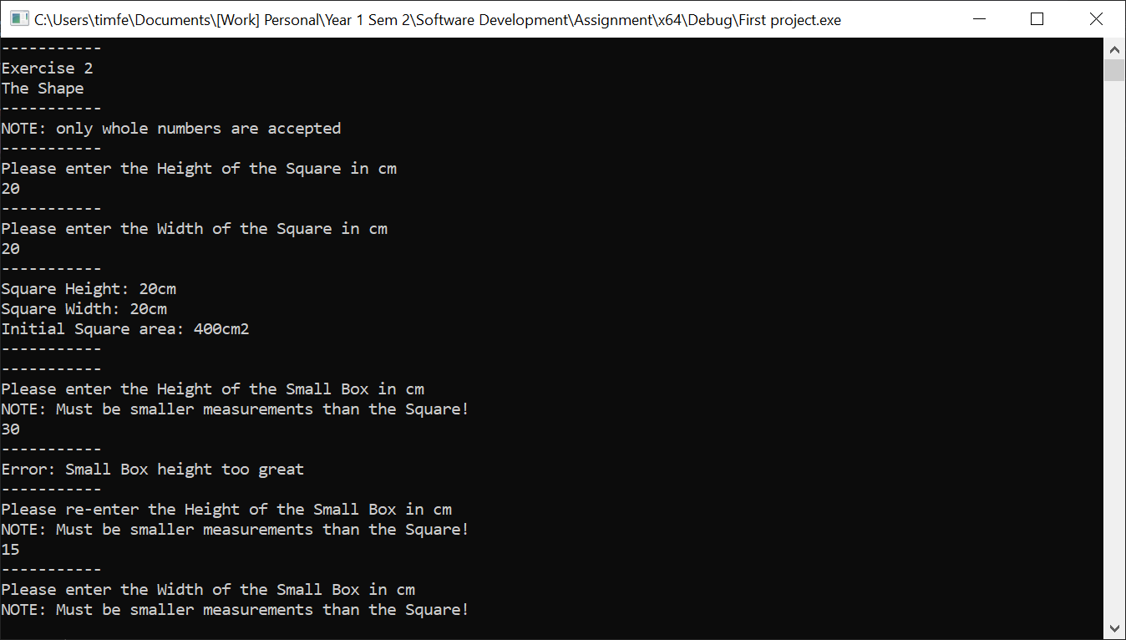
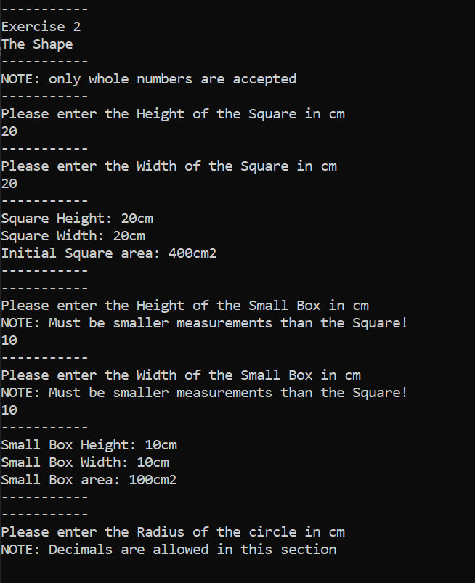
Example use – no errors
Example use – incorrect values entered

Incorporating and displaying the result of πr² in the code appeared tricky but was very simple in reality once a new variable was made to handle the value produced by the equation. The value used in the calculation for Pi had to be shortened to 3.14, due to the fact that greater values used in calculation caused the PC this work was completed on to struggle.
Validation has been put into place which prevents the Circle from having an area greater than The Shape, running a check after the radius input by a user is used to calculate the area. Double data type has been used in this section to ensure the measurement can support inevitable decimal points as a result of Pi calculations.

Example use – no errors
Example use – incorrect values entered

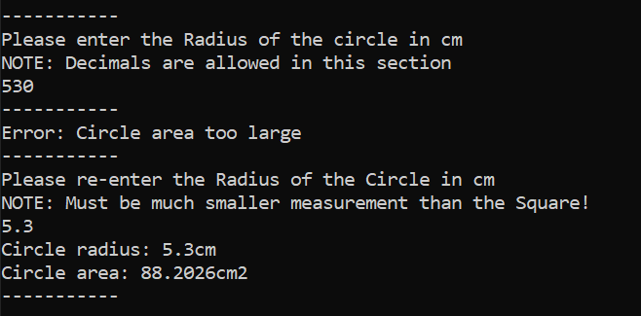
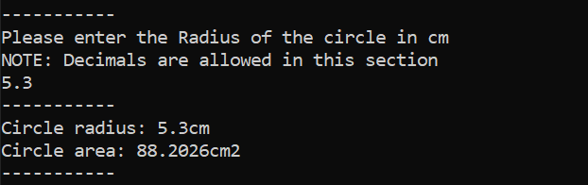

Extensive testing has revealed that the final area of The Shape can actually go into negative values. This is the result of an oversight in the validation for total area of the Circle and Small Box. Whist both calculated area values are checked against the initial area of The Shape, the inner areas are never checked for their combined value against the initial area of The Shape.
Attempts to put a fix into place have taken the form of asking users to recomplete the whole exercise if the combined end calculation is too great. However this is unsatisfactory as it would be more convenient to ask user to re-input their Small Box and Circle values straight after their input if necessary. Except there is no way to know that a Small Box value will be too great at the time of its input as Circle hasn’t been input yet and vice versa.
Two further potential fixes have been conceived: the first is to allocate both Circle and Small Box no more than 50 % of The Shapes initial area. The second idea is to run total remaining area calculation after Small Box’s size is validated and then simply put verification on Circle enforcing its size to be less than the remaining initial area after accounting for Small Box.

Example use – no errors
Example use – incorrect values entered
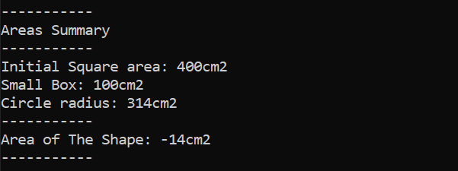
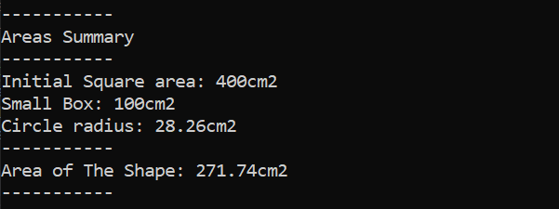

Exercise 3
The primary goal of exercise 3 was to convert user input values as GBP to an array and convert the sum to EUR. The first consideration was how the user could input value to an array since the previous exercises only made us of storing to stream.
Creating a basic array for this was simple, the input methods of previous exercises could be reused except users input was stored in specific array (e.g. streamcc.str(inputcc); streamcc >> gbpprices[2]; streamcc.clear(); )instead of storing to a single variable.
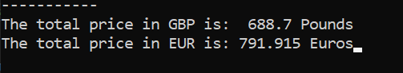
Following user input came the addition of the values together; again this was simple since they were stored as ‘double’. However the interesting part was when the values were multiplied by the GBP to EUR exchange rate, which at the time of creation was ‘1.14987’. Upon displaying the result of the calculation, the value often came to a 3rd or 4th decimal place due the exchange rates value, however in reality currency is always rounded to the 2nd decimal place. Shown here is the original state of the conversions:
After some experimenting and research, 2 more satisfactory methods of displaying the conversion were discovered, although only one has been implemented. The first method changes the line which displays the calculated values. Whereas the original line simply displayed the variables holding the value: cout << "The total price in EUR is: "<< eurtotal << " Euros";. The revised line of code displays the value but only to its 2nd decimal place: cout << "The total price in EUR is: "; printf("% .2f", eurtotal); cout << " Euros";.
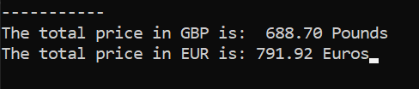
However the preferred and currently implemented method is to use cout << setprecision(2) << fixed; which is declared at the earlier lines of code. This method also requires #include <iomanip> in its head to function. This method allows more lines of calculations to be included without needing to re-write it as it covers them all, whereas the first method needs to be applied to every value display. The applied fix appears as follows:

Example use – no errors

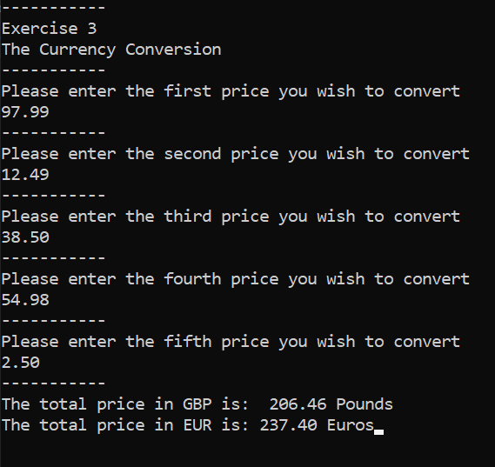

Exercise 4
In the description of the task for exercise 4, the crucial aspects are outlined: an interactive game where one player inputs a set of coordinates in the form of X and Y, adhering to an 8 by 8 grid. These coordinates serve to act as the location of hidden treasure and the second player must guess these locations, while their input updated the displayed grid with ‘X’ on successful guesses and ‘N’ on failed guesses. In addition the second player must have 3 ‘lives as acting as chances to continue playing after a failed guess, after all three are used up they lose the game.
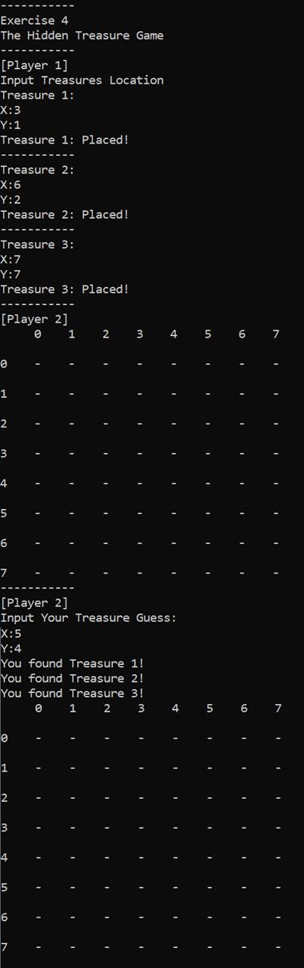
The produced game has made every effort to produce a desirable solution to the fullest. The solution has incorporated multiple arrays in order to produce a grid which acts as Player 2’ visual representation of the coordinates. However this grid is made with ‘cout’ lines and precise spacing producing the appearance of a grid on-screen. Every single number and dash (-) on the grid has a unique identifier in the form of their number in the array. Both axis and the inner grid are all made up of individual arrays of [8], strung together on-screen.
In order to allow users to input 2 coordinates to change 1 variable, some variables conversion takes places behind the scenes. This takes the form of an ‘if’ statement checking for specific user input for X, under each possible entry a subsidiary switch with 0-7 cases acts to interpret the input for Y. Once both an X and Y coordinate meet the case, the corresponding value in the array(s) will be stored under a new variable: ‘treasure1’. This same process is repeated for assigning values to treasure 2 and treasure 3 under respectively named variables.
However, an error in this build persists; in short the treasures location in an array can’t be properly recorded or retrieved while relating to the ‘grid’ used. This means that while the desired value of users input can be recorded, it can’t be correctly translated to change the grid, nor can the grids contents affect anything else. It seems part of the errors reason is the grids array contents are ‘char’ data type dashes (-). These data type are not directly recognised by many validation statements such as ‘if’.

Appendix

Exercise 1 - Code Listings
#include <string>
#include <iostream>
#include <sstream>

using namespace std;

int main(int argc, char* argv[])

{
//exercise 1
cout << "-----------" << endl;
cout << "Exercise 1" << endl;
cout << "The Book Title" << endl;
cout << "-----------" << endl;

string inputbt;
stringstream streambt;

string booktitle;

cout << "Please enter the Title of the book" << endl;
getline(cin, inputbt);

streambt.str(inputbt);
streambt >> booktitle;
streambt.clear();

cout << "Book Title: " << booktitle << endl;

streambt.str(inputbt);
streambt >> booktitle;
streambt.clear();

///

cout << "-----------" << endl;
cout << "The Length" << endl;
cout << "-----------" << endl;

string inputl;
stringstream streaml;

double length;

cout << "Please enter the measurement of length in cm" << endl;
getline(cin, inputl);

streaml.str(inputl);
streaml >> length;
streaml.clear();

cout << "Length: " << length << "cm" << endl;

streaml.str(inputl);
streaml >> length;
streaml.clear();

///

cout << "-----------" << endl;
cout << "The Items" << endl;
cout << "-----------" << endl;

string inputn;
stringstream streamn;

int number;

cout << "Please enter number of items in the basket" << endl;
getline(cin, inputn);

streamn.str(inputn);
streamn >> number;
streamn.clear();

cout << "Items qauantity: " << number << endl;

streamn.str(inputn);
streamn >> number;
streamn.clear();

//Pause
cin.get();

return 0;
}

Exercise 2 - Code Listings
#include <string>
#include <iostream>
#include <sstream>
#include <math.h>
#include <stdio.h>
using namespace std;

int main(int argc, char* argv[])

{
//exercise 2
cout << "-----------" << endl;
cout << "Exercise 2" << endl;
cout << "The Shape" << endl;
cout << "-----------" << endl;
cout << "NOTE: only whole numbers are accepted" << endl;
cout << "-----------" << endl;

string inputts;
stringstream streamts;

int height;
int width;

//user inputs square dimensions
cout << "Please enter the Height of the Square in cm" << endl;
getline(cin, inputts);

streamts.str(inputts);
streamts >> height;
streamts.clear();

cout << "-----------" << endl;

cout << "Please enter the Width of the Square in cm" << endl;
getline(cin, inputts);

streamts.str(inputts);
streamts >> width;
streamts.clear();

cout << "-----------" << endl;

//display Square input dimensions
cout << "Square Height: " << height <<"cm"<< endl;
cout << "Square Width: " << width << "cm" << endl;

//initial area of shape before circle/small sqaure areas subtracted
int initialarea = height*width;

cout <<"Initial Square area: " << initialarea << "cm2" << endl;

cout << "-----------" << endl;
cout << "-----------" << endl;

//user input Small Box dimensions
int boxheight;
int boxwidth;

cout << "Please enter the Height of the Small Box in cm" << endl;
cout << "NOTE: Must be smaller measurements than the Square!" << endl;
getline(cin, inputts);

streamts.str(inputts);
streamts >> boxheight;
streamts.clear();

//check small box height is small enough
while (boxheight > height)
{
cout << "-----------" << endl;
cout << "Error: Small Box height too great" << endl;
cout << "-----------" << endl;
cout << "Please re-enter the Height of the Small Box in cm" << endl;
cout << "NOTE: Must be smaller measurements than the Square!" << endl;
getline(cin, inputts);

streamts.str(inputts);
streamts >> boxheight;
streamts.clear();
}

cout << "-----------" << endl;
cout << "Please enter the Width of the Small Box in cm" << endl;
cout << "NOTE: Must be smaller measurements than the Square!" << endl;
getline(cin, inputts);

streamts.str(inputts);
streamts >> boxwidth;
streamts.clear();

//check small box width is small enough
while (boxwidth > width)
{
cout << "-----------" << endl;
cout << "Error: Small Box dimensions too large" << endl;
cout << "-----------" << endl;
cout << "Please re-enter the Width of the Small Box in cm" << endl;
cout << "NOTE: Must be smaller measurements than the Square!" << endl;
getline(cin, inputts);

streamts.str(inputts);
streamts >> boxwidth;
streamts.clear();
}

cout << "-----------" << endl;

//display Small Box input dimensions
cout << "Small Box Height: " << boxheight << "cm" << endl;
cout << "Small Box Width: " << boxwidth << "cm" << endl;

int boxarea = boxheight * boxwidth;

//display area of Small Box
cout << "Small Box area: " << boxarea << "cm2" << endl;
cout << "-----------" << endl;
cout << "-----------" << endl;

//user input Circle radius
double circleradius;

cout << "Please enter the Radius of the circle in cm" << endl;
cout << "NOTE: Decimals are allowed in this section" << endl;
getline(cin, inputts);

streamts.str(inputts);
streamts >> circleradius;
streamts.clear();

cout << "-----------" << endl;

//calculate circle area
double circlearea = (circleradius* circleradius* 3.14);

//Check Circle area is small enough
while (circlearea > initialarea)
{
cout << "Error: Circle area too large" << endl;
cout << "-----------" << endl;
cout << "Please re-enter the Radius of the Circle in cm" << endl;
cout << "NOTE: Must be much smaller measurement than the Square!" << endl;
getline(cin, inputts);

streamts.str(inputts);
streamts >> circleradius;
streamts.clear();

circlearea = 0;
//NOTE: Using more than 3.14 to represent Pi caused my system to struggle
circlearea = (circleradius * circleradius * 3.14);
}

//display circle radius
cout << "Circle radius: " << circleradius << "cm" << endl;
cout << "Circle area: " << circlearea << "cm2" << endl;
cout << "-----------" << endl;
cout << "-----------" << endl;

//calculate area of 'The Shape' by subtracting Circle and Small Box areas from Square
cout << "Areas Summary" << endl;
cout << "-----------" << endl;
cout << "Initial Square area: " << initialarea << "cm2" << endl;
cout << "Small Box: " << boxarea << "cm2" << endl;
cout << "Circle radius: " << circlearea << "cm2" << endl;
cout << "-----------" << endl;

//convert appropriate variables from int to double
double dboxarea = boxarea;
double dinitialarea = initialarea;
double totalarea = 0 ;

totalarea = (dinitialarea - dboxarea) + (-circlearea);

cout << "Area of The Shape: " << totalarea << "cm2" << endl;
cout << "-----------" << endl;

//Pause
cin.get();

return 0;
}

Exercise 3 - Code Listings
#include <string>
#include <iostream>
#include <sstream>
#include <time.h>
#include <iomanip>

using namespace std;

int main(int argc, char* argv[])

{
//exercise 3
cout << "-----------" << endl;
cout << "Exercise 3" << endl;
cout << "The Currency Conversion" << endl;
cout << "-----------" << endl;

//ensures outpus is set to 2 decimal places
cout << setprecision(2) << fixed;

string inputcc;
stringstream streamcc;

double gbpprices[5];
double gbptotal;

cout << "Please enter the first price you wish to convert" << endl;
getline(cin, inputcc);

streamcc.str(inputcc);
streamcc >> gbpprices[0];
streamcc.clear();

cout << "-----------" << endl;

cout << "Please enter the second price you wish to convert" << endl;
getline(cin, inputcc);

streamcc.str(inputcc);
streamcc >> gbpprices[1];
streamcc.clear();

cout << "-----------" << endl;

cout << "Please enter the third price you wish to convert" << endl;
getline(cin, inputcc);

streamcc.str(inputcc);
streamcc >> gbpprices[2];
streamcc.clear();

cout << "-----------" << endl;

cout << "Please enter the fourth price you wish to convert" << endl;
getline(cin, inputcc);

streamcc.str(inputcc);
streamcc >> gbpprices[3];
streamcc.clear();

cout << "-----------" << endl;

cout << "Please enter the fifth price you wish to convert" << endl;
getline(cin, inputcc);

streamcc.str(inputcc);
streamcc >> gbpprices[4];
streamcc.clear();

cout << "-----------" << endl;

//GBP total calculation
gbptotal = gbpprices[0] + gbpprices[1] + gbpprices[2] + gbpprices[3] + gbpprices[4];

cout << "The total price in GBP is: " << gbptotal << " Pounds" << endl;

//Total GBP conversion to Euro
double eurtotal = 0;
eurtotal = gbptotal * 1.14987;

//displaying and rounding coverted currency to 2 decimal places
cout << "The total price in EUR is: "<< eurtotal << " Euros";

//(ALT. METHOD) displaying and rounding coverted currency to 2 decimal places
//cout << "The total price in EUR is: "; printf("% .2f", eurtotal); cout << " Euros"

//Pause
cin.get();

return 0;
}

Exercise 4 - Code Listings

#include <string>
#include <iostream>
#include <sstream>

using namespace std;

int main(int argc, char* argv[])

{
//exercise 4
cout << "-----------" << endl;
cout << "Exercise 4" << endl;
cout << "The Hidden Treasure Game" << endl;
cout << "-----------" << endl;

string inputth;
stringstream streamth;

//player 1
int xchoice;
int ychoice;

int treasure1 = 0;
int treasure2 = 0;
int treasure3 = 0;

//player 2
int p2lives = 3;
int treasure1guess = 0;
int treasure2guess = 0;
int treasure3guess = 0;

//Grid variables creation
string blank1 = " ";
string blank = " ";

int dx[8]{ 0,1,2,3,4,5,6,7 };
int dy[8]{ 0,1,2,3,4,5,6,7 };

string value = "-" ;

//X columns
char xy0[8] = { '-', '-','-', '-', '-', '-', '-', '-' };
char xy1[8] = { '-', '-','-', '-', '-', '-', '-', '-' };
char xy2[8] = { '-', '-','-', '-', '-', '-', '-', '-' };
char xy3[8] = { '-', '-','-', '-', '-', '-', '-', '-' };
char xy4[8] = { '-', '-','-', '-', '-', '-', '-', '-' };
char xy5[8] = { '-', '-','-', '-', '-', '-', '-', '-' };
char xy6[8] = { '-', '-','-', '-', '-', '-', '-', '-' };
char xy7[8] = { '-', '-','-', '-', '-', '-', '-', '-' };

//Treasure Placement
//Treasure 1
cout << "[Player 1]" << endl;
cout << "Input Treasures Location" << endl;
cout << "Treasure 1:" << endl;
cout << "X:";
getline(cin, inputth);

streamth.str(inputth);
streamth >> xchoice;
streamth.clear();

//depending on players chosen X coord, Y choice becomes 0-7 of that column
cout << "Y:";
getline(cin, inputth);

streamth.str(inputth);
streamth >> ychoice;
streamth.clear();

if (xchoice == 0);
{
switch (ychoice)
{
case 0:
treasure1 = xy0[0];
case 1:
treasure1 = xy0[1];
case 2:
treasure1 = xy0[2];
case 3:
treasure1 = xy0[3];
case 4:
treasure1 = xy0[4];
case 5:
treasure1 = xy0[5];
case 6:
treasure1 = xy0[6];
case 7:
treasure1 = xy0[7];
}
}

if (xchoice == 1);
{
switch (ychoice)
{
case 0:
treasure1 = xy1[0];
case 1:
treasure1 = xy1[1];
case 2:
treasure1 = xy1[2];
case 3:
treasure1 = xy1[3];
case 4:
treasure1 = xy1[4];
case 5:
treasure1 = xy1[5];
case 6:
treasure1 = xy1[6];
case 7:
treasure1 = xy1[7];
}
}

if (xchoice == 2);
{
switch (ychoice)
{
case 0:
treasure1 = xy2[0];
case 1:
treasure1 = xy2[1];
case 2:
treasure1 = xy2[2];
case 3:
treasure1 = xy2[3];
case 4:
treasure1 = xy2[4];
case 5:
treasure1 = xy2[5];
case 6:
treasure1 = xy2[6];
case 7:
treasure1 = xy2[7];
}
}

if (xchoice == 3);
{
switch (ychoice)
{
case 0:
treasure1 = xy3[0];
case 1:
treasure1 = xy3[1];
case 2:
treasure1 = xy3[2];
case 3:
treasure1 = xy3[3];
case 4:
treasure1 = xy3[4];
case 5:
treasure1 = xy3[5];
case 6:
treasure1 = xy3[6];
case 7:
treasure1 = xy3[7];
}
}

if (xchoice == 4);
{
switch (ychoice)
{
case 0:
treasure1 = xy4[0];
case 1:
treasure1 = xy4[1];
case 2:
treasure1 = xy4[2];
case 3:
treasure1 = xy4[3];
case 4:
treasure1 = xy4[4];
case 5:
treasure1 = xy4[5];
case 6:
treasure1 = xy4[6];
case 7:
treasure1 = xy4[7];
}
}

if (xchoice == 5);
{
switch (ychoice)
{
case 0:
treasure1 = xy5[0];
case 1:
treasure1 = xy5[1];
case 2:
treasure1 = xy5[2];
case 3:
treasure1 = xy5[3];
case 4:
treasure1 = xy5[4];
case 5:
treasure1 = xy5[5];
case 6:
treasure1 = xy5[6];
case 7:
treasure1 = xy5[7];
}
}

if (xchoice == 6);
{
switch (ychoice)
{
case 0:
treasure1 = xy6[0];
case 1:
treasure1 = xy6[1];
case 2:
treasure1 = xy6[2];
case 3:
treasure1 = xy6[3];
case 4:
treasure1 = xy6[4];
case 5:
treasure1 = xy6[5];
case 6:
treasure1 = xy6[6];
case 7:
treasure1 = xy6[7];
}
}

if (xchoice == 7);
{
switch (ychoice)
{
case 0:
treasure1 = xy7[0];
case 1:
treasure1 = xy7[1];
case 2:
treasure1 = xy7[2];
case 3:
treasure1 = xy7[3];
case 4:
treasure1 = xy7[4];
case 5:
treasure1 = xy7[5];
case 6:
treasure1 = xy7[6];
case 7:
treasure1 = xy7[7];
}
}

cout << "Treasure 1: Placed!" << endl;
cout << "-----------" << endl;

xchoice = 0;
ychoice = 0;

//Treasure 2
cout << "Treasure 2:" << endl;
cout << "X:";
getline(cin, inputth);

streamth.str(inputth);
streamth >> xchoice;
streamth.clear();

//depending on players chosen X coord, Y choice becomes 0-7 of that column
cout << "Y:";
getline(cin, inputth);

streamth.str(inputth);
streamth >> ychoice;
streamth.clear();

if (xchoice == 0);
{
switch (ychoice)
{
case 0:
treasure2 = xy0[0];
case 1:
treasure2 = xy0[1];
case 2:
treasure2 = xy0[2];
case 3:
treasure2 = xy0[3];
case 4:
treasure2 = xy0[4];
case 5:
treasure2 = xy0[5];
case 6:
treasure2 = xy0[6];
case 7:
treasure2 = xy0[7];
}
}

if (xchoice == 1);
{
switch (ychoice)
{
case 0:
treasure2 = xy1[0];
case 1:
treasure2 = xy1[1];
case 2:
treasure2 = xy1[2];
case 3:
treasure2 = xy1[3];
case 4:
treasure2 = xy1[4];
case 5:
treasure2 = xy1[5];
case 6:
treasure2 = xy1[6];
case 7:
treasure2 = xy1[7];
}
}

if (xchoice == 2);
{
switch (ychoice)
{
case 0:
treasure2 = xy2[0];
case 1:
treasure2 = xy2[1];
case 2:
treasure2 = xy2[2];
case 3:
treasure2 = xy2[3];
case 4:
treasure2 = xy2[4];
case 5:
treasure2 = xy2[5];
case 6:
treasure2 = xy2[6];
case 7:
treasure2 = xy2[7];
}
}

if (xchoice == 3);
{
switch (ychoice)
{
case 0:
treasure2 = xy3[0];
case 1:
treasure2 = xy3[1];
case 2:
treasure2 = xy3[2];
case 3:
treasure2 = xy3[3];
case 4:
treasure2 = xy3[4];
case 5:
treasure2 = xy3[5];
case 6:
treasure2 = xy3[6];
case 7:
treasure2 = xy3[7];
}
}

if (xchoice == 4);
{
switch (ychoice)
{
case 0:
treasure2 = xy4[0];
case 1:
treasure2 = xy4[1];
case 2:
treasure2 = xy4[2];
case 3:
treasure2 = xy4[3];
case 4:
treasure2 = xy4[4];
case 5:
treasure2 = xy4[5];
case 6:
treasure2 = xy4[6];
case 7:
treasure2 = xy4[7];
}
}

if (xchoice == 5);
{
switch (ychoice)
{
case 0:
treasure2 = xy5[0];
case 1:
treasure2 = xy5[1];
case 2:
treasure2 = xy5[2];
case 3:
treasure2 = xy5[3];
case 4:
treasure2 = xy5[4];
case 5:
treasure2 = xy5[5];
case 6:
treasure2 = xy5[6];
case 7:
treasure2 = xy5[7];
}
}

if (xchoice == 6);
{
switch (ychoice)
{
case 0:
treasure2 = xy6[0];
case 1:
treasure2 = xy6[1];
case 2:
treasure2 = xy6[2];
case 3:
treasure2 = xy6[3];
case 4:
treasure2 = xy6[4];
case 5:
treasure2 = xy6[5];
case 6:
treasure2 = xy6[6];
case 7:
treasure2 = xy6[7];
}
}

if (xchoice == 7);
{
switch (ychoice)
{
case 0:
treasure2 = xy7[0];
case 1:
treasure2 = xy7[1];
case 2:
treasure2 = xy7[2];
case 3:
treasure2 = xy7[3];
case 4:
treasure2 = xy7[4];
case 5:
treasure2 = xy7[5];
case 6:
treasure2 = xy7[6];
case 7:
treasure2 = xy7[7];
}
}
cout << "Treasure 2: Placed!" << endl;
cout << "-----------" << endl;

xchoice = 0;
ychoice = 0;

//Treasure 3
cout << "Treasure 3:" << endl;
cout << "X:";
getline(cin, inputth);

streamth.str(inputth);
streamth >> xchoice;
streamth.clear();

//depending on players chosen X coord, Y choice becomes 0-7 of that column
cout << "Y:";
getline(cin, inputth);

streamth.str(inputth);
streamth >> ychoice;
streamth.clear();

if (xchoice == 0);
{
switch (ychoice)
{
case 0:
treasure3 = xy0[0];
case 1:
treasure3 = xy0[1];
case 2:
treasure3 = xy0[2];
case 3:
treasure3 = xy0[3];
case 4:
treasure3 = xy0[4];
case 5:
treasure3 = xy0[5];
case 6:
treasure3 = xy0[6];
case 7:
treasure3 = xy0[7];
}
}

if (xchoice == 1);
{
switch (ychoice)
{
case 0:
treasure3 = xy1[0];
case 1:
treasure3 = xy1[1];
case 2:
treasure3 = xy1[2];
case 3:
treasure3 = xy1[3];
case 4:
treasure3 = xy1[4];
case 5:
treasure3 = xy1[5];
case 6:
treasure3 = xy1[6];
case 7:
treasure3 = xy1[7];
}
}

if (xchoice == 2);
{
switch (ychoice)
{
case 0:
treasure3 = xy2[0];
case 1:
treasure3 = xy2[1];
case 2:
treasure3 = xy2[2];
case 3:
treasure3 = xy2[3];
case 4:
treasure3 = xy2[4];
case 5:
treasure3 = xy2[5];
case 6:
treasure3 = xy2[6];
case 7:
treasure3 = xy2[7];
}
}

if (xchoice == 3);
{
switch (ychoice)
{
case 0:
treasure3 = xy3[0];
case 1:
treasure3 = xy3[1];
case 2:
treasure3 = xy3[2];
case 3:
treasure3 = xy3[3];
case 4:
treasure3 = xy3[4];
case 5:
treasure3 = xy3[5];
case 6:
treasure3 = xy3[6];
case 7:
treasure3 = xy3[7];
}
}

if (xchoice == 4);
{
switch (ychoice)
{
case 0:
treasure3 = xy4[0];
case 1:
treasure3 = xy4[1];
case 2:
treasure3 = xy4[2];
case 3:
treasure3 = xy4[3];
case 4:
treasure3 = xy4[4];
case 5:
treasure3 = xy4[5];
case 6:
treasure3 = xy4[6];
case 7:
treasure3 = xy4[7];
}
}

if (xchoice == 5);
{
switch (ychoice)
{
case 0:
treasure3 = xy5[0];
case 1:
treasure3 = xy5[1];
case 2:
treasure3 = xy5[2];
case 3:
treasure3 = xy5[3];
case 4:
treasure3 = xy5[4];
case 5:
treasure3 = xy5[5];
case 6:
treasure3 = xy5[6];
case 7:
treasure3 = xy5[7];
}
}

if (xchoice == 6);
{
switch (ychoice)
{
case 0:
treasure3 = xy6[0];
case 1:
treasure3 = xy6[1];
case 2:
treasure3 = xy6[2];
case 3:
treasure3 = xy6[3];
case 4:
treasure3 = xy6[4];
case 5:
treasure3 = xy6[5];
case 6:
treasure3 = xy6[6];
case 7:
treasure3 = xy6[7];
}
}

if (xchoice == 7);
{
switch (ychoice)
{
case 0:
treasure3 = xy7[0];
case 1:
treasure3 = xy7[1];
case 2:
treasure3 = xy7[2];
case 3:
treasure3 = xy7[3];
case 4:
treasure3 = xy7[4];
case 5:
treasure3 = xy7[5];
case 6:
treasure3 = xy7[6];
case 7:
treasure3 = xy7[7];
}
}

cout << "Treasure 3: Placed!" << endl;
cout << "-----------" << endl;

cout << "[Player 2]" << endl;
//Grid display
cout << blank1 << dx[0] << blank << dx[1] << blank << dx[2] << blank << dx[3] << blank << dx[4] << blank << dx[5] << blank << dx[6] << blank << dx[7] << endl;
cout << blank << endl;
cout << dy[0] << blank << xy0[0] << blank << xy1[0] << blank << xy2[0] << blank << xy3[0] << blank << xy4[0] << blank << xy5[0] << blank << xy6[0] << blank << xy7[0] << endl;
cout << blank << endl;
cout << dy[1] << blank << xy0[1] << blank << xy1[1] << blank << xy2[1] << blank << xy3[1] << blank << xy4[1] << blank << xy5[1] << blank << xy6[1] << blank << xy7[1] << endl;
cout << blank << endl;
cout << dy[2] << blank << xy0[2] << blank << xy1[2] << blank << xy2[2] << blank << xy3[2] << blank << xy4[2] << blank << xy5[2] << blank << xy6[2] << blank << xy7[2] << endl;
cout << blank << endl;
cout << dy[3] << blank << xy0[3] << blank << xy1[3] << blank << xy2[3] << blank << xy3[3] << blank << xy4[3] << blank << xy5[3] << blank << xy6[3] << blank << xy7[3] << endl;
cout << blank << endl;
cout << dy[4] << blank << xy0[4] << blank << xy1[4] << blank << xy2[4] << blank << xy3[4] << blank << xy4[4] << blank << xy5[4] << blank << xy6[4] << blank << xy7[4] << endl;
cout << blank << endl;
cout << dy[5] << blank << xy0[5] << blank << xy1[5] << blank << xy2[5] << blank << xy3[5] << blank << xy4[5] << blank << xy5[5] << blank << xy6[5] << blank << xy7[5] << endl;
cout << blank << endl;
cout << dy[6] << blank << xy0[6] << blank << xy1[6] << blank << xy2[6] << blank << xy3[6] << blank << xy4[6] << blank << xy5[6] << blank << xy6[6] << blank << xy7[6] << endl;
cout << blank << endl;
cout << dy[7] << blank << xy0[7] << blank << xy1[7] << blank << xy2[7] << blank << xy3[7] << blank << xy4[7] << blank << xy5[7] << blank << xy6[7] << blank << xy7[7] << endl;

cout << "-----------" << endl;
cout << "[Player 2]" << endl;
cout << "Input Your Treasure Guess:" << endl;
cout << "X:";
getline(cin, inputth);

streamth.str(inputth);
streamth >> xchoice;
streamth.clear();

cout << "Y:";
getline(cin, inputth);

streamth.str(inputth);
streamth >> ychoice;
streamth.clear();

//treasure 1 check
if (xchoice == 0);
{
switch (ychoice)
{
case 0:
treasure1guess = xy0[0];
case 1:
treasure1guess = xy0[1];
case 2:
treasure1guess = xy0[2];
case 3:
treasure1guess = xy0[3];
case 4:
treasure1guess = xy0[4];
case 5:
treasure1guess = xy0[5];
case 6:
treasure1guess = xy0[6];
case 7:
treasure1guess = xy0[7];
}
}

if (xchoice == 1);
{
switch (ychoice)
{
case 0:
treasure1guess = xy1[0];
case 1:
treasure1guess = xy1[1];
case 2:
treasure1guess = xy1[2];
case 3:
treasure1guess = xy1[3];
case 4:
treasure1guess = xy1[4];
case 5:
treasure1guess = xy1[5];
case 6:
treasure1guess = xy1[6];
case 7:
treasure1guess = xy1[7];
}
}

if (xchoice == 2);
{
switch (ychoice)
{
case 0:
treasure1guess = xy2[0];
case 1:
treasure1guess = xy2[1];
case 2:
treasure1guess = xy2[2];
case 3:
treasure1guess = xy2[3];
case 4:
treasure1guess = xy2[4];
case 5:
treasure1guess = xy2[5];
case 6:
treasure1guess = xy2[6];
case 7:
treasure1guess = xy2[7];
}
}

if (xchoice == 3);
{
switch (ychoice)
{
case 0:
treasure1guess = xy3[0];
case 1:
treasure1guess = xy3[1];
case 2:
treasure1guess = xy3[2];
case 3:
treasure1guess = xy3[3];
case 4:
treasure1guess = xy3[4];
case 5:
treasure1guess = xy3[5];
case 6:
treasure1guess = xy3[6];
case 7:
treasure1guess = xy3[7];
}
}

if (xchoice == 4);
{
switch (ychoice)
{
case 0:
treasure1guess = xy4[0];
case 1:
treasure1guess = xy4[1];
case 2:
treasure1guess = xy4[2];
case 3:
treasure1guess = xy4[3];
case 4:
treasure1guess = xy4[4];
case 5:
treasure1guess = xy4[5];
case 6:
treasure1guess = xy4[6];
case 7:
treasure1guess = xy4[7];
}
}

if (xchoice == 5);
{
switch (ychoice)
{
case 0:
treasure1guess = xy5[0];
case 1:
treasure1guess = xy5[1];
case 2:
treasure1guess = xy5[2];
case 3:
treasure1guess = xy5[3];
case 4:
treasure1guess = xy5[4];
case 5:
treasure1guess = xy5[5];
case 6:
treasure1guess = xy5[6];
case 7:
treasure1guess = xy5[7];
}
}

if (xchoice == 6);
{
switch (ychoice)
{
case 0:
treasure1guess = xy6[0];
case 1:
treasure1guess = xy6[1];
case 2:
treasure1guess = xy6[2];
case 3:
treasure1guess = xy6[3];
case 4:
treasure1guess = xy6[4];
case 5:
treasure1guess = xy6[5];
case 6:
treasure1guess = xy6[6];
case 7:
treasure1guess = xy6[7];
}
}

if (xchoice == 7);
{
switch (ychoice)
{
case 0:
treasure1guess = xy7[0];
case 1:
treasure1guess = xy7[1];
case 2:
treasure1guess = xy7[2];
case 3:
treasure1guess = xy7[3];
case 4:
treasure1guess = xy7[4];
case 5:
treasure1guess = xy7[5];
case 6:
treasure1guess = xy7[6];
case 7:
treasure1guess = xy7[7];
}
}

//treasure 2 check
if (xchoice == 0);
{
switch (ychoice)
{
case 0:
treasure2guess = xy0[0];
case 1:
treasure2guess = xy0[1];
case 2:
treasure2guess = xy0[2];
case 3:
treasure2guess = xy0[3];
case 4:
treasure2guess = xy0[4];
case 5:
treasure2guess = xy0[5];
case 6:
treasure2guess = xy0[6];
case 7:
treasure2guess = xy0[7];
}
}

if (xchoice == 1);
{
switch (ychoice)
{
case 0:
treasure2guess = xy1[0];
case 1:
treasure2guess = xy1[1];
case 2:
treasure2guess = xy1[2];
case 3:
treasure2guess = xy1[3];
case 4:
treasure2guess = xy1[4];
case 5:
treasure2guess = xy1[5];
case 6:
treasure2guess = xy1[6];
case 7:
treasure2guess = xy1[7];
}
}

if (xchoice == 2);
{
switch (ychoice)
{
case 0:
treasure2guess = xy2[0];
case 1:
treasure2guess = xy2[1];
case 2:
treasure2guess = xy2[2];
case 3:
treasure2guess = xy2[3];
case 4:
treasure2guess = xy2[4];
case 5:
treasure2guess = xy2[5];
case 6:
treasure2guess = xy2[6];
case 7:
treasure2guess = xy2[7];
}
}

if (xchoice == 3);
{
switch (ychoice)
{
case 0:
treasure2guess = xy3[0];
case 1:
treasure2guess = xy3[1];
case 2:
treasure2guess = xy3[2];
case 3:
treasure2guess = xy3[3];
case 4:
treasure2guess = xy3[4];
case 5:
treasure2guess = xy3[5];
case 6:
treasure2guess = xy3[6];
case 7:
treasure2guess = xy3[7];
}
}

if (xchoice == 4);
{
switch (ychoice)
{
case 0:
treasure2guess = xy4[0];
case 1:
treasure2guess = xy4[1];
case 2:
treasure2guess = xy4[2];
case 3:
treasure2guess = xy4[3];
case 4:
treasure2guess = xy4[4];
case 5:
treasure2guess = xy4[5];
case 6:
treasure2guess = xy4[6];
case 7:
treasure2guess = xy4[7];
}
}

if (xchoice == 5);
{
switch (ychoice)
{
case 0:
treasure2guess = xy5[0];
case 1:
treasure2guess = xy5[1];
case 2:
treasure2guess = xy5[2];
case 3:
treasure2guess = xy5[3];
case 4:
treasure2guess = xy5[4];
case 5:
treasure2guess = xy5[5];
case 6:
treasure2guess = xy5[6];
case 7:
treasure2guess = xy5[7];
}
}

if (xchoice == 6);
{
switch (ychoice)
{
case 0:
treasure2guess = xy6[0];
case 1:
treasure2guess = xy6[1];
case 2:
treasure2guess = xy6[2];
case 3:
treasure2guess = xy6[3];
case 4:
treasure2guess = xy6[4];
case 5:
treasure2guess = xy6[5];
case 6:
treasure2guess = xy6[6];
case 7:
treasure2guess = xy6[7];
}
}

if (xchoice == 7);
{
switch (ychoice)
{
case 0:
treasure2guess = xy7[0];
case 1:
treasure2guess = xy7[1];
case 2:
treasure2guess = xy7[2];
case 3:
treasure2guess = xy7[3];
case 4:
treasure2guess = xy7[4];
case 5:
treasure2guess = xy7[5];
case 6:
treasure2guess = xy7[6];
case 7:
treasure2guess = xy7[7];
}
}
//treasure 3 check
if (xchoice == 0);
{
switch (ychoice)
{
case 0:
treasure3guess = xy0[0];
case 1:
treasure3guess = xy0[1];
case 2:
treasure3guess = xy0[2];
case 3:
treasure3guess = xy0[3];
case 4:
treasure3guess = xy0[4];
case 5:
treasure3guess = xy0[5];
case 6:
treasure3guess = xy0[6];
case 7:
treasure3guess = xy0[7];
}
}

if (xchoice == 1);
{
switch (ychoice)
{
case 0:
treasure3guess = xy1[0];
case 1:
treasure3guess = xy1[1];
case 2:
treasure3guess = xy1[2];
case 3:
treasure3guess = xy1[3];
case 4:
treasure3guess = xy1[4];
case 5:
treasure3guess = xy1[5];
case 6:
treasure3guess = xy1[6];
case 7:
treasure3guess = xy1[7];
}
}

if (xchoice == 2);
{
switch (ychoice)
{
case 0:
treasure3guess = xy2[0];
case 1:
treasure3guess = xy2[1];
case 2:
treasure3guess = xy2[2];
case 3:
treasure3guess = xy2[3];
case 4:
treasure3guess = xy2[4];
case 5:
treasure3guess = xy2[5];
case 6:
treasure3guess = xy2[6];
case 7:
treasure3guess = xy2[7];
}
}

if (xchoice == 3);
{
switch (ychoice)
{
case 0:
treasure3guess = xy3[0];
case 1:
treasure3guess = xy3[1];
case 2:
treasure3guess = xy3[2];
case 3:
treasure3guess = xy3[3];
case 4:
treasure3guess = xy3[4];
case 5:
treasure3guess = xy3[5];
case 6:
treasure3guess = xy3[6];
case 7:
treasure3guess = xy3[7];
}
}

if (xchoice == 4);
{
switch (ychoice)
{
case 0:
treasure3guess = xy4[0];
case 1:
treasure3guess = xy4[1];
case 2:
treasure3guess = xy4[2];
case 3:
treasure3guess = xy4[3];
case 4:
treasure3guess = xy4[4];
case 5:
treasure3guess = xy4[5];
case 6:
treasure3guess = xy4[6];
case 7:
treasure3guess = xy4[7];
}
}

if (xchoice == 5);
{
switch (ychoice)
{
case 0:
treasure3guess = xy5[0];
case 1:
treasure3guess = xy5[1];
case 2:
treasure3guess = xy5[2];
case 3:
treasure3guess = xy5[3];
case 4:
treasure3guess = xy5[4];
case 5:
treasure3guess = xy5[5];
case 6:
treasure3guess = xy5[6];
case 7:
treasure3guess = xy5[7];
}
}

if (xchoice == 6);
{
switch (ychoice)
{
case 0:
treasure3guess = xy6[0];
case 1:
treasure3guess = xy6[1];
case 2:
treasure3guess = xy6[2];
case 3:
treasure3guess = xy6[3];
case 4:
treasure3guess = xy6[4];
case 5:
treasure3guess = xy6[5];
case 6:
treasure3guess = xy6[6];
case 7:
treasure3guess = xy6[7];
}
}

if (xchoice == 7);
{
switch (ychoice)
{
case 0:
treasure3guess = xy7[0];
case 1:
treasure3guess = xy7[1];
case 2:
treasure3guess = xy7[2];
case 3:
treasure3guess = xy7[3];
case 4:
treasure3guess = xy7[4];
case 5:
treasure3guess = xy7[5];
case 6:
treasure3guess = xy7[6];
case 7:
treasure3guess = xy7[7];
}
}

//win conditions
if (treasure1guess = treasure1)
{
treasure1 = 'X';
cout << "You found Treasure 1!" << endl;
}
if (treasure2guess = treasure2)
{
treasure2 = 'X';
cout << "You found Treasure 2!" << endl;
}
if (treasure3guess = treasure3)
{
treasure3 = 'X';
cout << "You found Treasure 3!" << endl;
}

else
{
treasure1 = 'N';
cout << "You Found Nothing!" << endl;
cout << "lives remining: " << p2lives - 1 << endl;
}

//Grid display
cout << blank1 << dx[0] << blank << dx[1] << blank << dx[2] << blank << dx[3] << blank << dx[4] << blank << dx[5] << blank << dx[6] << blank << dx[7] << endl;
cout << blank << endl;
cout << dy[0] << blank << xy0[0] << blank << xy1[0] << blank << xy2[0] << blank << xy3[0] << blank << xy4[0] << blank << xy5[0] << blank << xy6[0] << blank << xy7[0] << endl;
cout << blank << endl;
cout << dy[1] << blank << xy0[1] << blank << xy1[1] << blank << xy2[1] << blank << xy3[1] << blank << xy4[1] << blank << xy5[1] << blank << xy6[1] << blank << xy7[1] << endl;
cout << blank << endl;
cout << dy[2] << blank << xy0[2] << blank << xy1[2] << blank << xy2[2] << blank << xy3[2] << blank << xy4[2] << blank << xy5[2] << blank << xy6[2] << blank << xy7[2] << endl;
cout << blank << endl;
cout << dy[3] << blank << xy0[3] << blank << xy1[3] << blank << xy2[3] << blank << xy3[3] << blank << xy4[3] << blank << xy5[3] << blank << xy6[3] << blank << xy7[3] << endl;
cout << blank << endl;
cout << dy[4] << blank << xy0[4] << blank << xy1[4] << blank << xy2[4] << blank << xy3[4] << blank << xy4[4] << blank << xy5[4] << blank << xy6[4] << blank << xy7[4] << endl;
cout << blank << endl;
cout << dy[5] << blank << xy0[5] << blank << xy1[5] << blank << xy2[5] << blank << xy3[5] << blank << xy4[5] << blank << xy5[5] << blank << xy6[5] << blank << xy7[5] << endl;
cout << blank << endl;
cout << dy[6] << blank << xy0[6] << blank << xy1[6] << blank << xy2[6] << blank << xy3[6] << blank << xy4[6] << blank << xy5[6] << blank << xy6[6] << blank << xy7[6] << endl;
cout << blank << endl;
cout << dy[7] << blank << xy0[7] << blank << xy1[7] << blank << xy2[7] << blank << xy3[7] << blank << xy4[7] << blank << xy5[7] << blank << xy6[7] << blank << xy7[7] << endl;

//Pause
cin.get();

return 0;
}

