ACADEMIC AND EMPLOYABILITY SKILLS,
Table of contents
- Introduction…………………………………………………………………………….... Sub-heading, I
-Employability skills………………………………………………………………. ….……. Sub-heading II
-Communication skills………………………………………………………………. ….. Sub-heading III
-Interpersonal skills ………………………………………………………………………………………………………………Article 1
-Graduates vs nongraduates…………………………………………………………………………………….... Article 2
-Personal skills-what do health professionals need?.......................................Article 3
-Adults lacking transferable skills…………………………………………………………………………Article 4
-Analysis of my own employability skills………………………………………………………………………………………. Heading
-Personal Goals…………………………………………………………………………………………. Sub-heading
-Conclusion………………………………………………………………………………………………………………………………………………………….. Heading
-References………………………………………………………………………………………………………………………………………………………….. Heading
-Appendix as follows………………………………………………………………………………………………………………………………A, B, C.
-In class work- appendix D and E……………………………………………………………………………………………………Thank you.

I .Introduction:
The aim of this report was to give all readers a better understanding upon the skills needed into a career, why are the skills important, how skills cholate with employability and if could be of any importance towards our academic and employability skills learning development. Information was gathered from different sources, such as articles published by different authors to make it more interesting and to prove its audacity through the same related subject. The purpose was to encourage all individuals, graduates, or undergraduates, to search for a job that matches their skills best and never be afraid to reflect upon the effectiveness their skills have when applying. Practicing your skills within the workplace, through training or by taking courses, has been the main key to start an academic path.
Another perspective was to prove how skills acquired from higher education and Universities can become certified and how important they are when trying to achieve a goal, follow your dream or simply earn more for your needs.
A description of my own employability skills analysis will be used to demonstrate preparation for an interview and SWOT analysis when targeting a career.
Finally, the satisfaction for your hard work, the commitment you had to go through, the self- improvement you have achieved and how your hard-earned skills may prove its benefits while continuing to study. In the end, conclusion will follow to determine understandings, findings, and motivation to use all skills accordingly.

II. Employability skills
“Employability skills are useful in most jobs, they can be transferable, and they develop an expertise, to determine your mindset and knowledge. These skills are often referred to as soft skills or foundational skills and they minimize your error margins, improve your performance and promote teamwork collaboration and efficiency.” (Anon-1, 2019)
Effective communication skills, problem-solving, organizational, teamwork, motivational leadership, adaptability, flexibility, computer, creativity, time management and willingness towards multi-tasking and perseveration skills, are only a few of the employability skills that may be looking attractive for the job contractors.
III. Communication skills:
The way you treat or speak to someone, the way you behave, the way you suggest things, your attitude and body-language are factors who define you as a person and reflect upon everyone you get in contact with.
Listening and personal appearance as part of the communication, contributes to all individual’s personal development and empowers the effect of your ability to speak-out and become a professional through your ability of understanding the employability demands.
Depending on your career job role or orientation to excel, you can learn more about the skills, knowledge, and other features that employers are seeking before offering a certain job.

Interpersonal skills

- ARTICLE 1.
UPDATED NOVEMBER 26, 2019
BY: ALISON DOYLE

“What are interpersonal skills, and why are they important in the workplace? Interpersonal skills, also known as people skills, soft skills, or emotional intelligence skills, are related to the way you communicate and interact with others.
When employers are hiring, interpersonal skills are one of the top criteria used to evaluate candidates. Regardless of the type of job you have, it’s important to be able to get along well with co-workers, managers, customers, and vendors.” (DOYLE, 2019)
Some examples of interpersonal skills, that are useful, when intending to make a good impression, when attending an interview or simply trying to discover new skills, are:

- Diplomacy
- Active listening
- Collaboration
- Caring
- Respect
- Motivation
- Patience
- Sympathy
- Tolerance
- Non-verbal communication/ body-language
- Encouraging
- Helping others
Skills, as part of our personality which represent our ability and competency to perform tasks are easily noticeable by the employers right at the very first interview. Employers know very well what their working requirements and criteria are, based on the position you have applied for. It is very essential that we search for the appropriate job and make sure we have the appropriate skills to undertake the job offer.
Graduates vs non-graduates in work

- Article 2.
JULLY TO SEPTEMBER 2017, UNITED KINGDOM
Source: LABOUR FORCE SURREY

Labour market graduates in United Kingdom: 2017
“14 million graduates from United Kingdom, in July to September 2017, were pursuing a steady growth over the past epoch. This summary looks at employment, unemployment, industry, skill level, pay, and evaluation of masculine and feminine graduates.” (Statistics, 2017)

“More than 40 percent of graduates worked in the education, administration and healthcare industry compared with 21 percent of non-graduates. In September 2017, the 21 % of non-graduates were employed within the same domains. (Figure 6, Please see appendix A).

Education, health industry and public administration are common for graduates and vary from an educational background to another. Jobs are made available in the area, due to the industries where graduates with degrees in education, dentistry and medicine related are highly looked for.” (Statistics, 2017)
(Please see appendix B).
According to the statistics, in 2017, more graduates were able to find a skilled job that is highly paid, than the non- graduates which could not find a job at all or been non-approved due to their lack of skills. However, a 20% out of all non-graduates had a chance for a job.
Graduates have a fresh outcome and are better seen by the employers. This does not necessarily mean they lack experience as many of them get a job as soon as they apply as a graduate. Comparing to a non-graduate, the number that get a job in well-payed industries and medicine related are nearly double.

PERSONAL SKILLS - WHAT DO HEALTHCARE PROFESSIONALS NEED?

- ARTICLE 3.
Reported by: The Training Hub

United Kingdom
Posted on August 27, 2017

“Tutor Care takes your personal development plan seriously and focuses on your professional development. The aim is to improve your personality skills. Your personal attributes (also known as soft skills, are used to bring you together with people and support the influence towards a better communication, related to family, colleagues, patients and friends.
In professional life, these skills are playing the most important role. They impact your career chances, your job performance, and other related activities. In addition to qualifications, the employers are highly interested into personality skills. Personal skills have become more valuable than specific technical skills which are left behind in some domains such as healthcare”. (Care, 2017)
Dealing with pressure, empathy, having a positive mental attitude, be self-confident, flexible, compassionate, and simply deal with criticism, are only a few personal skills, required in most healthcare domains to get a job. Basically, if you cannot have compassion or empathy skills in your nature, do not apply for a job in healthcare as you will not be accepted or risk to be eliminated if not able to adapt the requirement. However, you can take alternative learning solutions to improve your personal skills and improve them accordingly.
Many times, in life, people depend on their own skills and tend to rely on them without trying to become a professional. Even so, people do improve themselves, willingly, by practice and experience or by training from professionals.

“United Kingdom faces employability skills gap as nearly 60 percent of adults lack the complete set of basic transmissible skills” (GOVERNMENT, 2018)

- ARTICLE 4.
UNITED KINGDOM
OCTOBER 12, 2018
PUBLISHED BY: OPEN ACCESS GOVERNMENT
AUTHOR: ASHOK VASWANI

Ashok Vaswani, CEO of Barclays UK, said: “Today’s findings show the importance of lifelong learning, whatever your age or chosen career path. I firmly believe that education should not stop at the school gates – businesses, educators and the Government all have a role to play.
“We need to work together to agree a core set of transferable employability skills, giving people of all ages the tools needed to upskill and ultimately creating a competitive workforce that will support the UK economy.
“That is why Barclays is backing the UK by announcing the expansion of our Life Skills programme to all ages – by the end of 2022, we’re committing to helping 10 million adults build the employability skills they need to succeed in the future workplace.” (Vaswani, 2018)
Shortly said, Mr. Vaswani is exemplifying himself, offering opportunities to improve skills for all ages and gives guidance on how to do that.
There are very good employers that are looking for personal skills and looking to improve them to become a professional. The lack of skills can be a major impediment when applying for a career even if you have the required qualification.

Analysis of my own employability skills

SWOT ANALYSIS stand for: Strengths, Weakness, Opportunities, and Threats. (Appendix C).
My strengths are based on attachment and empathy towards people in general, and my ambitious ability to complete tasks successfully. I love working individually but also as a team, for all those that are struggling with their daily tasks, have certain physical disabilities or those that need support in their last moments of life such as terminal illnesses. I am a respectful and kind person, ready to give and support in time of need. I am loyal in general, devoted, and motivated to finish any given task. I have compassion towards anyone I get in contact with and I am known as a trustworthy person among my family and friends. I prefer to walk away rather than creating a fight and I always try to avoid conflictual altercations. At my current job, I perform multi-tasks easily and I am happy when I get a positive feedback from my superiors. Overall, I believe that I am a soft-hearted person, very communicative, tolerant, with positive attitude and supportive.
I consider weak the fact that I tend to take everything personal and find it hard to control my emotions when people are in agony due to pain and discomfort. I am also working on how to deal with people that have a very aggressive behaviour and looking for ways to calm them through speech therapy in a humoristic way. I have started going to University, because I wish to improve my competency within workplace and be trained by professionals on how to use my skills and find more that may be transferable. My weakness comes from the fact that I am lacking confidence and I need confirmation to make sure that I am on the right spot at the right time. Another weak point is that I lose concentration if I get disappointed and I can only accept criticism if is proved with facts. I lose trust when people lie to me or promise things they can not keep.
Considering the high demand of jobs, within healthcare system, I would like to take the opportunity of using my employability and personal skills to make my dream come true. As a social care worker, not only that I need qualification but also need to use skills every steps of my way, according to the laws and regulations applied by the conduct authorities. By respecting the boundaries and agreed ways of working, I commit myself to respect and be devoted to all individuals I may get in contact with, which can place me on top of the waiting list when applying for the job. I will make sure that the opportunity is in my favour and apply for my dream job as soon as I feel ready and qualified. Becoming a palliative nurse, for me is not just an opportunity to have a qualified job but also to spend my time with them as I would like to be spent with me when I get helpless. Is about giving and the enjoyment of offering rather than receiving.
Threats are not hard to find, graduate, non-graduate, skilled or less-skilled, competition will always exist and therefore we always have to focus and give our best, mostly in a work environment. (Please see appendix D).

Personal Goals:
- Improving and developing new skills
- Choosing my career path
- Going to the interview prepared for all questions and requirements
- Presenting my qualifications and prove my employability skills
- Willingness to undertake any additional training or courses that will improve my emotional intelligence skills.
- Be flexible and able to work individually but also as a team
- Focus on the job tasks with a patience and caring attitude
- Continue University studies and gain more experience, qualifications, and experience to enhance my levels and become a professional as a palliative nurse. (Please see appendix E).

CONCLUSION
If we resume just to United Kingdom, the conclusion is that our personal skills represent our ability to develop and improve employability skills, which usually may be enhanced by study and training from professionals, and therefore transferable.
Communication is the base of all skills either if is verbal or non-verbal such as body-language or active listening. Our appearance, attitude, and gestures reflect upon our personality and if they are all in good order, you may be looking attractive for employers.
It is important to acknowledge that graduates do get a job easier than the non-graduates and more than that will be very rewarding and worth as a life-time career.
People like MR. Vaswani, CEO of Barclays bank, which is willing to contribute and support over 10 million adults that are lacking experience and employability skills to succeed in future employability. Nothing is easy in life but if we are willing to improve and achieve more during our life, skills are the beginning to a new happy life in the career we choose to take part in.
“Everything is theoretically impossible, until it is done.” (Heinlein., 2019)

And finally, when skills are combined with education, the employability rates are growing significantly, and we become a target by employers who want to improve their organization with trustworthy and hard-working people.

References
Anon-1, 2019. Indeed Career guide. [Online]
Available at: https://www.indeed.com/career-advice/finding-a-job/employability-skills
[Accessed 16 07 2020].
Care, T., 2017. The Training Hub. [Online]
Available at: http://www.tutorcare.co.uk/traininghub/personal-skills-health-care-professionals
[Accessed 10 8 2020].
DOYLE, A., 2019. The balance careers. [Online]
Available at: https://www.thebalancecareers.com/interpersonal-skills-list-2063724
[Accessed 5 8 2020].
GOVERNMENT, O. A., 2018. OPEN ACCESS GOVERNMENT. [Online]
Available at: https://www.openaccessgovernment.org/uk-faces-employability-skills-gap/53192/
[Accessed 15 8 2020].
Heinlein., R. A., 2019. Hello bio. [Online]
Available at: https://www.hellobio.com/blog/25-of-the-best-motivational-quotes-from-scientists.html
[Accessed 17 8 2020].
Statistics, O. f. N., 2017. Office for National Statistics. [Online]
Available at: https://www.ons.gov.uk/employmentandlabourmarket/peopleinwork/employmentandemployeetypes/articles/graduatesintheuklabourmarket/2017
[Accessed 12 8 2020].
Vaswani, A., 2018. OPEN ACCESS GOVERNMENT. [Online]
Available at: https://www.openaccessgovernment.org/uk-faces-employability-skills-gap/53192/
[Accessed 15 8 2020].

Appendix A
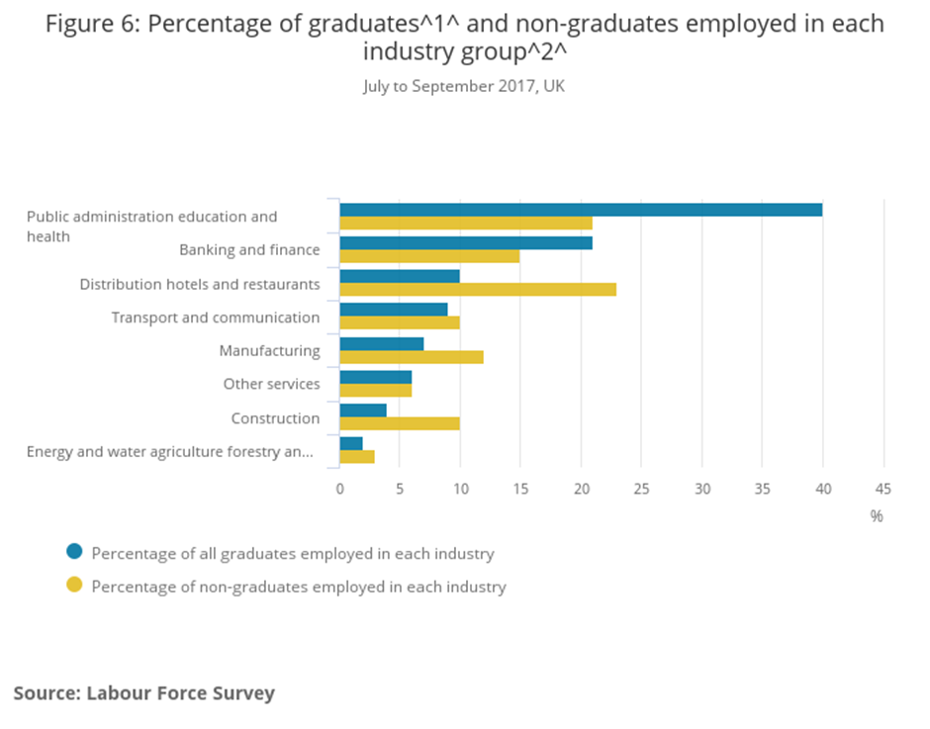
- Please scroll down

Appendix B - Photo of the article+ link to the page-https://www.ons.gov.uk/employmentandlabourmarket/peopleinwork/employmentandemployeetypes/articles/graduatesintheuklabourmarket/2017
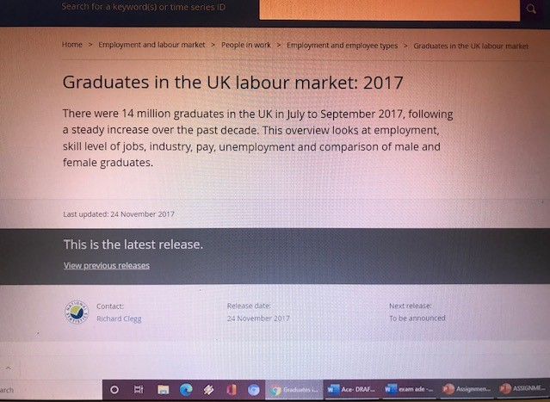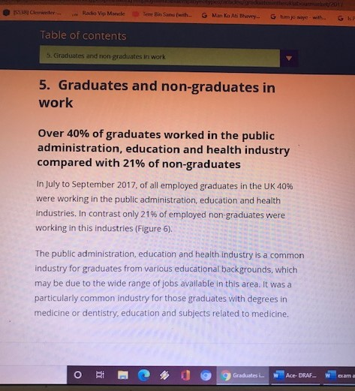
APPENDIX C

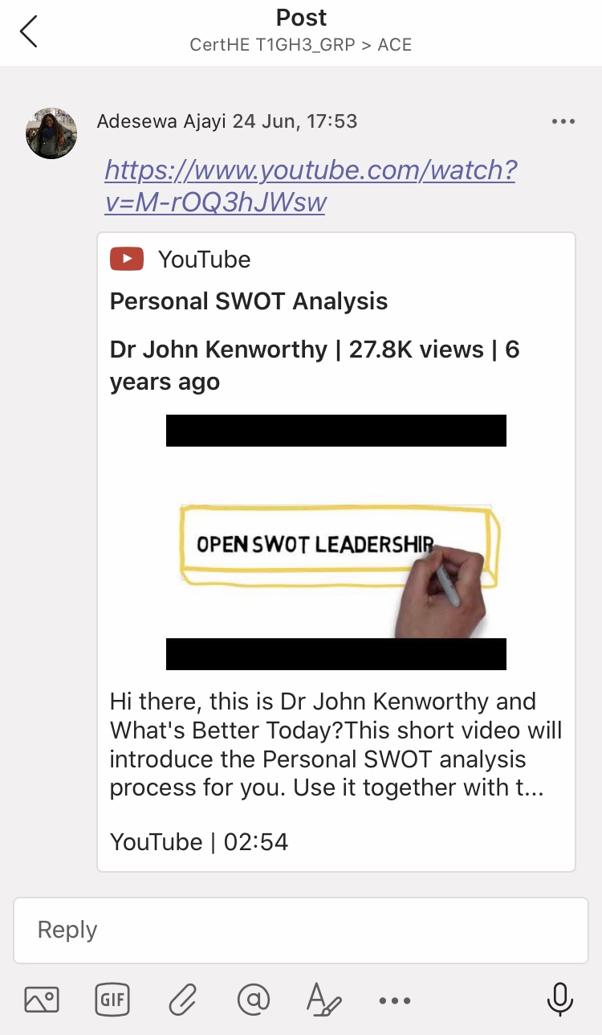

Appendix d

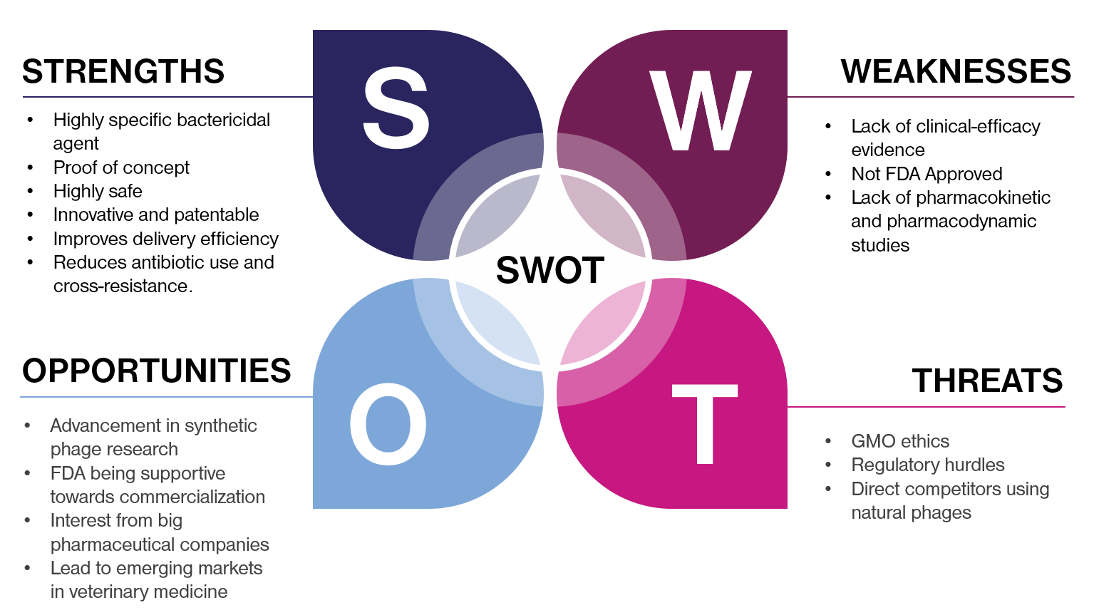
This Photo by Unknown Author is licensed under CC BY

- Please scroll down

Appendix e- In class work

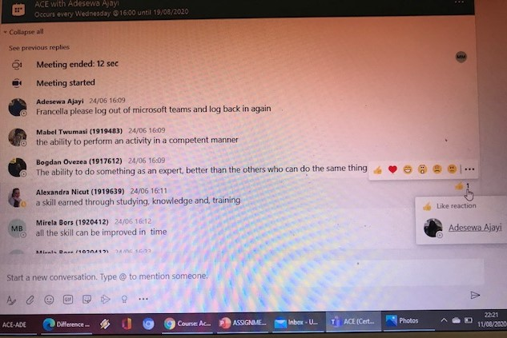
- Please scroll down

- Appendix E
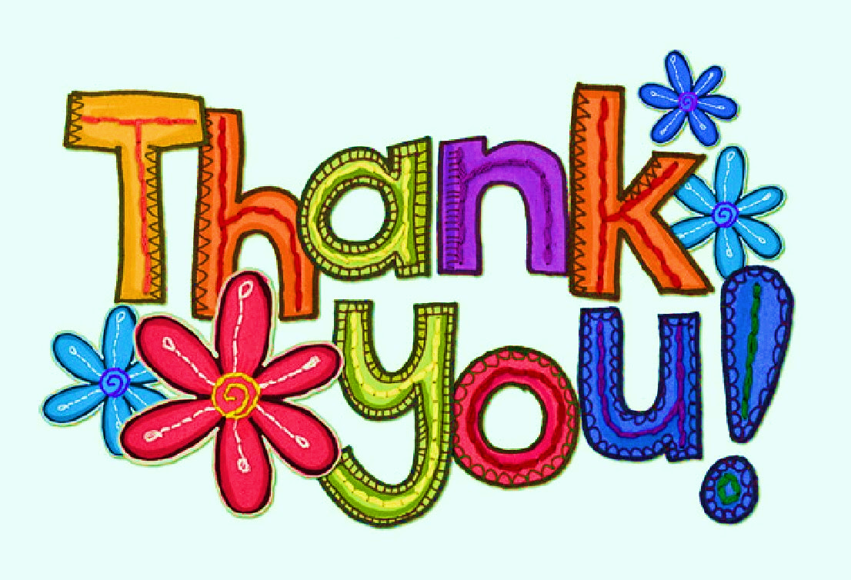
- Please note that I am taking this opportunity to say: “thank you” to my lecturer, Ms. Adesewa Ajayi for all the patience, knowledge, and all employability skills that she has shared with me within class
This Photo by Unknown Author is licensed under CC BY-NC-ND

