Sam Quinn
P148980
Word Count: 1840
Dissertation Proposal: Black

Using my keywords, Art, culture and psychology, I aim to explore the colour black. I aim to look at how the colour black is used what it symbolises. Black is an unusual colour due to it being a pure absence of pigment so my aim is to find out why black has such negative meanings across the world and history and how in some areas, it could even be something positive. As a colour that is argued to be the most used, the meaning and symbolism for it is something intriguing and fascinating.

Art
Black is used in many ways in art and is used very interestingly when used more abstractly. It appears in almost all forms of art and design and different practises use it different ways.
- Malevich created ‘The Black Square’ in 1915.
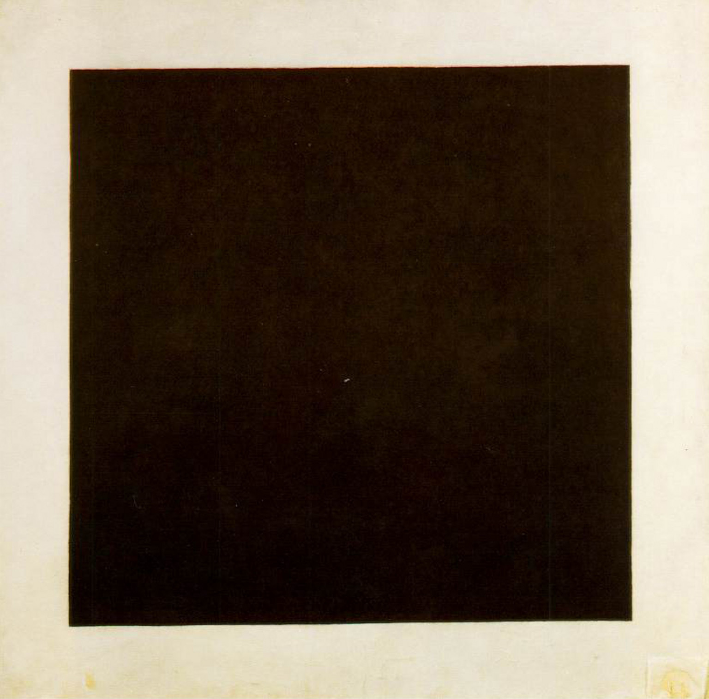
“Black Square is radically non-representational. The slab of black paint that dominates the canvas works as grand refusal, repudiating nature in favour of abstraction. As such, the painting may be read in terms of the Kantian theory of the sublime. Favouring flatness over depth, Black Square conveys, in the words of Kant’s ‘Analytic of the Sublime’ (1790), ‘the feeling of displeasure that arises from the imagination’s inadequacy’ in an estimation of ‘formlessness’ or ‘magnitude’.” (Shaw, 2018)
(Malevich, 1915)
- Anish Kapoor tried to copyright the ‘blackest black’ The pigment Ventablack is known as the darkest pigment and it absorbs 99.96% of light. Can a colour be copyrighted?
- It also has meaning with simplicity and modernity. Black is very sleek and modern as it fits with almost anything and works well with anything. A lot of branding that wants to have a modern look will have a largely black colour scheme and if not black, be quite dark in colour.
“Black is used by companies wishing to evoke a classic sophistication and simplicity. Black works well for brand wishing to promote luxury.” (Black, 2013)
- Black and White photography is a very popular thing to use in photoshoots. Although colour photography has been a thing for decades, people still go back to black and white photography as it’s seen as vintage and artistic. Many people have wedding photos in black and white.
“Black and White photography is a step away from reality adding authenticity and beauty. I’ve always advocated that I like to move away from reality as many steps as possible. My argumentation was that the more steps you move away from reality, the closer you will get to the essence of the artist and the more the expression will be an authentic representation of the subjective experience of the artist only. (Tjintjelaar, 2017)

- Many people put black with any other colour as black fits with everything. It also adds contrast between light and dark, therefore adding depth to a painting. This could also equate to the idea of death and emptiness being a part of life just around the corner that we can’t escape.
- In Film and TV, colour symbolism is a very important thing and usually black means death, evil and negativity. In contrast white represents purity, virginity and angelic in nature. This is another way that black is portrayed negatively in artistic expression.
- The art of abstraction may use black as a big way to portray emotion in their work. Many artists such as Georgia O’Keeffe and William Scott played around with this and created abstract works of art using black. Ad Reinhart even created an abstract work that was just blackness, similarly to Malevich.
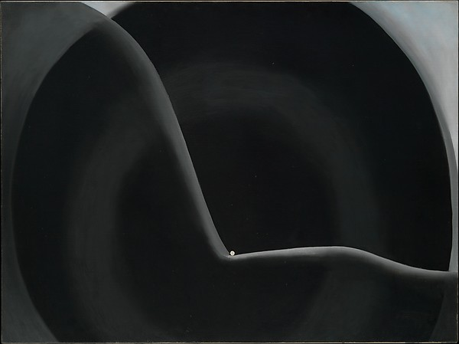
(O'Keeffe, 1927)
“Abstract Painting contains three distinct shades of black, which become visible only after prolonged looking. Reinhardt was intensely sensitive to such subtle variations. He explained, “There is a black which is old and a black which is fresh. Lustrous black and dull black, black in sunlight and black in shadow.” (Museum of Modern Art, 2018)
- Blackness has a complexity to it because with most paints, you can’t get it naturally as blackness is just a really dark version of any colour. It doesn’t appear on any artist colour wheels because in the art community it isn’t even seen as a colour, it is seen as the complete opposite. Can we really define black, because it is almost impossible to get complete black and even if we do, where does it fit in the definition of colour and in relation to all the colours we have?
- Toni Frissell used black and white photography to create surreal pieces of art. She also took pictures during World War II and eventually became the official photographer for the Women’s Army Corps. 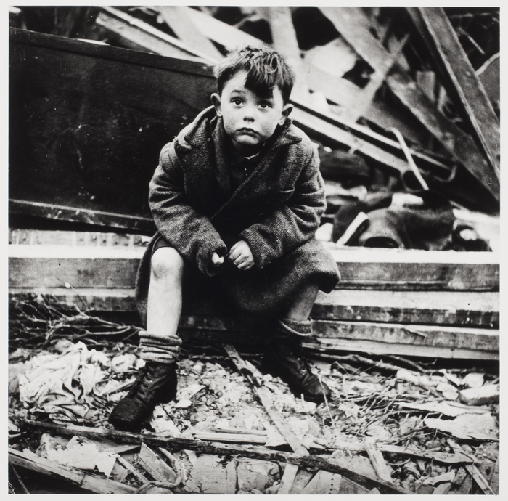
(Frissell, 1945)
Culture
Black appears a lot in many different parts of modern westernised culture, all with different meanings, some positive and some negative.
- Black has deep connections with death because people wear black at a funeral, people traditionally see the grim reaper as wearing a black cloak and black is symbolism for absence, so the absence of life. It could also relate to how in death, some people imagine it being dark and black.
“In Western industrial cultures, black is associated with death; mourners wear dark clothes and the body is transported in a black limousine. In ancient Egypt however, statues of Osiris were painted black to indicate the period of gestation when seeds are sprouting beneath the earth; black is associated with preparation for rebirthrather than an end of earthly life.” (Fisher, 1989)
- Black also has connections with professionalism and power. Most businessmen and women wear black suits, government officials wear black suits and in popular culture, FBI, CIA and other agents will wear black as a sign of importance and superiority.
- Black is usually negatively connotated, having terms such as ‘Black humour’ ‘Black death’ ‘Black listed’ etc. This shows that black has negative connotations usually related to fear, the unknown and things that should not be thought about.
- Black also has connections with space. Many things in space relate back to black, such as black holes, space itself, voids in space. All of this comes down to how black is so dark and full of nothing, just like space is.
- Goth culture is centred around black. Black clothing, black make up, vampires and death metal. These all give off a vibe of blackness and most people see goths as very depressing and scary which can be a misconception but it is all down to the fact that they wear black and wear it heavily. Some even go as far as believing they worship Satan.
“The culture relies on the principle of bricolage, borrowing from Victorian, pagan and occult iconographies, among many others… with mourning, decay, decadence and memento mori being prevalent
Back in the day, it was considered dangerous for young people to become too absorbed in such themes.” (Gander, 2017)
- Emo culture is very similar to goth culture however it is more edgy and less of an obsession around black. Whilst Gothic is more Victorian, Emo is more modern and punk with relations to spiked hair, studded clothing. However, black is a very common colour and they are seen the same as goths, threatening and scary.
- Racism is also a very big problem and comes down to the colour of your skin in most cases. Refer to as ‘Blacks’ people with darker skin are looked down on in a lot of modern day cultures by some people. This is purely down to their skin colour as originally blacks were treated as lesser humans. Why is the darkness of skin a reason to think people are lesser than others?
“A perfect life from perfect skin – but only for those of the right shade – is the message and mindset that’s being passed down. This has spawned a multibillion-dollar industry in cosmetic creams and invasive procedures such as skin bleaching, chemical peels, laser treatments, steroid cocktails, “whitening” pills and intravenous injections – all with varying effectiveness and health risks. It’s more than a bias, it’s a dangerous cultural obsession.” (Abraham, 2017)
- The area of Dudley in the UK is nicknamed the ‘Black Country’ this is down to their role in the industrial revolution. The West Midlands was the area where the industrial revolution began in the UK, and the ‘Black Country’ gained it’s title due to the smog that the area was covered in during this time. This gives black another meaning. Production and Manufacture.
“It's said that the Black Country gained its name in the mid-nineteenth century from the smoke from the many thousands of ironworking foundries and forges. Other theories mention the abundance of coal in the region.” (BBC, 2018)

Psychology
Black is a very prominent topic with psychology as it appears many times with fear and psychological issues.
- Many people are afraid of black. The fear of the dark, Nyctophobia, is essentially the fear of the unknown and most children have this fear as it’s a natural human response (Fight or Flight). Many adults also have this fear and this fear also carries over to the colour black.
“Loss of vision. Sight is our strongest sense and some of our natural predators, such as the big cats, had better night vision than our ancestors did. Our ancestors also had to watch out for enemy raids; even today, we may justifiably fear being burgled.
But our greatest fears come from our own minds. Many children, and some adults are terrified of the monster under the bed. This is called the ‘sense of presence’ and is often associated with sleep paralysis.” (Blackmore, 2016)
- Blackness can also symbolise illness and memory loss. It can mean a haziness and a loss of way and being unsure of who you are. People who have pasts that they wish to forget and have been troubled call it their ‘dark past’.
- Melanophobia is the phobia of the colour black. This could develop for many reasons but the commonly thought reasons are the associations with death, grieving, evilness and all other negative connotations.
- Thanatophobia is the fear of death. This all comes down to the fear of the unknown and darkness and loneliness.
- Depression is characterised as dark and black is usually associated with it. Depression creates self-loathing, lonliness and intense sadness. Many sufferers describe it as a fog of darkness coming over them that they can’t escape. This furthers the negative connotations with black.

Exploring the colour black has shown how truly negative the colour is in western society. Mainly looking into the UK along with some US contributions, the colour black in our country has deep connections will negativity. In art, culture and psychology it has only got a few positives and the negatives outweigh them. I want to explore further into why exactly these negative connotations exist with black and why they are so prominent is the developed country that the UK is today. As a colour or a pigment, why does black itself hold such an emotional connection and where did it come from?

In reference to Art and Society in the UK and US, why does black hold such a negative connection to us and where has that come from?

Bibliography
Abraham, M.-R., (2017). Dark is beautiful: The battle to end the world's obsession with lighter skin.. [Online]
Available at: https://www.theguardian.com/inequality/2017/sep/04/dark-is-beautiful-battle-to-end-worlds-obsession-with-lighter-skin
(Accessed 06 05 2018).
BBC, (2018). Black Country. [Online]
Available at: http://www.bbc.co.uk/blackcountry/content/articles/2005/03/15/where_is_the_black_country_feature.shtml
(Accessed 06 05 2018).
Black, J. L., (2013). Understanding color and the meaning of color. [Online]
Available at: https://www.blackbeardesign.com/understanding-color-the-meaning-of-color/
(Accessed 06 05 2018).
Blackmore, S., (2016). What makes people afraid of the dark?. [Online]
Available at: http://www.sciencefocus.com/article/mind/what-makes-people-afraid-of-dark
(Accessed 06 05 2018).
Melanski, Paul & Fisher, Mary P, (1989). Colour. 1 ed. London: The Herbert Press.
Gander, K., (2017). World Goth Day: Shedding some light on the darkness of a much-maligned subculture.. [Online]
Available at: https://www.independent.co.uk/life-style/world-goth-day-2017-pop-sub-culture-what-is-it-darkness-music-clothes-style-cure-dracula-tim-burton-a7038176.html
(Accessed 06 05 2018).
Malevich, K., (1915). Black Square. [Art] Tretyakov Gallery.
Museum of Modern Art, (2018). Ad Reinhardt: Abstract Painting. [Online]
Available at: https://www.moma.org/collection/works/78976
(Accessed 06 05 2018).
O'Keeffe, G., (1927). Black Abstraction. [Art] (Whitney Museum of American Art).
Shaw, P., (2018). Kasimir Malevich's Black Square. [Online]
Available at: http://www.tate.org.uk/art/research-publications/the-sublime/philip-shaw-kasimir-malevichs-black-square-r1141459
(Accessed 30th April 2018).
Tjintjelaar, J., (2017). IN DEFENSE OF BLACK AND WHITE PHOTOGRAPHY – GUIDE TO BLACK AND WHITE PHOTOGRAPHY. [Online]
Available at: http://www.bwvision.com/defense-black-white-photography/
(Accessed 06 05 2018).

