Research Proposal

To research, design and implement an educational application that encompasses interactive learning elements.

By: Kadmin Van Vuuren
MSc Software Engineering | DVLA
2019

Table of Contents

Table of Contents 1
Table of Figures 1
Introduction | Background 2
Research & Development Methods 5
Resources & Planning 11
References 14
Reading List 15

Table of Figures

Figure 1: Research Union 6
Figure 2: Positivism [9] 6
Figure 3: Positivism [9] 7
Figure 4: SDLC [11] 8
Figure 5: Project Planning Pt. 1 11
Figure 6: Project Planning Pt. 2 12
Figure 7: Project Planning Pt. 3 12

Introduction | Background

Introduction
The first topic of discussion for the proposed project will be to introduce the motivation behind and background of the research proposal. Furthermore, considerations towards existing research and literature pertaining to this project proposal will be made and finally, a clear and concise set of aims and objectives for the project will be outlined.
Proposed Project Title
The proposed title for this project will take the form of An Interactive Educational Learning Application for a Combined MSc & DVLA Degree Project.
Background
Educational learning applications are aplenty in an age where digital media and online learning dominate how we consume information. By allowing users who seek to consume and educate themselves on interested topics through a means by which we remove the need for bricks and mortar rooms of education, we allow them to study at times and places which ultimately suit them.
The above can further be described as e-learning. A more suitable definition for that of e-learning is that: E-learning is the use of electronic technologies to create learning experiences [1].
Development of eLearning is connected to development, technical improvement and also better affordability of computers [2]. It’s important for us to understand some of the more important parts of history surrounding e-learning: If one is to understand the need behind learning tools and what drove their early stage development, an understanding of at least some of its history is key.
We can see that during the late eighties and into the nineties of the last century Computer-Based Training or CBT was starting to take shape and it is this that is considered to be the cornerstone of e-learning [2]. It appears that this CBT was, of course, CD based multimedia and much like we can today; learning was capable of leaving the classroom and entering a learner’s private space. It’s interesting to point out, that in parallel with the development of CBT was the technology developed, that at the end lead into the rise of internet and creation of the web system [2]. Importantly, we also see other technologies be created for the above, such as the web browser and a means by which we can display content on computer screens. As such, this trend soon became popular among vast amounts of people across the world, allowing it to be an affordable interest for many of the population.
The above really sets a picture for where e-learning stemmed from and how it became such an important part in the education of learners as well as playing more and more of an important role in education since.

Today’s Landscape
Today, e-learning is a complex system with multiple forms and different level of interest of learner [3]. This is important, because until recently and still ongoing, there is debate as to exactly what e-learning is and what it encompasses. For the purposes of this research topic, e-learning will form a means, by which a learner can use an application, regardless of operating system or system setup, to educate themselves: Furthermore, the application will not be online facing and therefore remove the need for constant internet access.
Another important observation one can make is that many if not most of these e-learning materials reside on the internet and therefore require constant internet connection in order to access the material. There have been suggestions provided through literature that suggest a major problem behind that of e-learning is the application ease of access [3].
Content is readily available today. As such, there is a plethora of applications that exist which provide users with huge amounts of educational content. However, it is important to build an application that encompasses that of many different approaches to presenting material. This is evident as we can see that an article written by a Mr Little, states that after 90 interviews with UK-based executives involved in the e-learning sector, a key issue within that of e-learning is that of the contextualisation of learning materials [4]. This is often one problem that plagues that of learning materials, having to piece together information to contextualise something in which a user is trying to understand.
Proposal
As such the proposed application will look to produce content or at its MVP level, produce a framework that is capable of presenting information in many different ways to the learner: Such as Visual, Aural, Reading/Writing and Kinaesthetic as seen in VARK [6]. Furthermore, this application will look to provide learning through user interaction rather than simply explaining away educational topics. It is important that this proposal and application take the stance of catering for all types of learners as this mainly forms the premise of this proposal.
Learning styles and content variety will play an important part in this projects success. Many studies have been done in the subject area of Pedagogy and as such this project will look to expand upon this study to understand better how users learn.
Furthermore, the developed application will look to implement these best practice styles of learning in such a way that the application caters for all types of learners. One such study concluded that learning styles differ while attending online classes, further suggesting students prefer kinaesthetic as the most favourite learning style [6]. This is important, as it shows through scientific study, that learners can require information to be presented in a multitude of ways. Such studies only reinforce the idea of creating an application that caters for all styles and provides interaction.

Aim & Objectives
Importantly this project will ultimately look to develop, deploy and present and application that educates users on technological topics used and employed at the DVLA. However, it is important to point out that although an application with educational content is desired, an educational framework will look to be created as a base MVP or Minimal Viable Product. This will allow educational materials to be added, updated and/or removed as and when required. Furthermore, the application will look to encompass that of technologies such as Docker, providing a means by which the application can be used on any desktop, regardless of OS.
The above aims will looked to be broken down into an achievable set of objectives.
- Investigation of learning styles and in particular that of VARK.
- Investigation into design and implementation of interactive features.
- To design and build an application framework.
- Finally, to provide evaluation and analysis for the proposed application as well as provide recommendations for future enhancements to the application.
Expected Outcome
Once concluded, an application should exist that consists of educational material. As previously suggested, this material will encompass that of technologies that are used within the DVLA. Additionally and as previously suggested, an MVP will be created which will comprise of the application acting as a framework that can have material inserted and removed.
Additionally, the project will look to produce its own set of statistics which illustrate how best users learn and if they feel like the application supports their learning needs.
Conclusion
Throughout this section, an overview of the research that is required as part of this project proposal, as well as considering that of previous research performed in areas of e-learning and learning styles has been provided. Using this research one can look to develop and deploy an application that takes this into consideration.
Moving forward with our proposal, topics such as research methods and development methods will be provided.

Research & Development Methods

Introduction
Previously, an introduction was made into the field of e-learning, what it is and more importantly aspects that could be improved upon through the proposed application. Moving forward, a discussion surrounding the research and development methods that will need to be undertaken in order to achieve the projects desired outcome, will be provided.
Data such as how users learn best as seen in VARK [6] needs to be collected and analysed to determine the most suitable way of presenting information: We can see this as according to the VARK learning styles theory, every individual is predisposed to a preferred learning style, instinctively favouring one of the four styles that the theory describes [8]. As such this is an important research topic in the field of e-learning.
Furthermore, do users feel like ease of access to an application does present a problem and will a Docker based application rather than access to a website reduce that problem. To ensure that the correct research is performed and in a proper manner, Biggam [7] further suggests that there are a number of strands to a research methods chapter, typically including the following sub-sections:
- Introduction
- Research Strategy
- Data Collection
- Framework for data analysis
- Limitations and potential problems
The above further provides us with a means by which we can approach our project correctly.
Research Strategy
When thinking about what type of strategy to use for the proposed project, there are a number of different ways one can approach their research. A research strategy simply describes how we intend on implementing our own research study [7].
Philosophies
However, before we can begin our research we should decide upon a suitable research philosophy. Figure 1 illustrates the ‘Research Onion’ which was developed by Saunders et al in 2007. This is a useful tool as it helps researches understand what stages need to be applied whilst developing a methodology. This is helpful because depending on what type of research is being performed, this will directly influence your research philosophy.

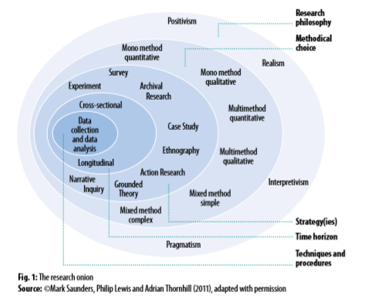
Figure 1: Research Union
The undertaking of this project is to ultimately build a piece of software. As such, it is suggested that the best philosophy for this type of work is that of Positivism. Another good indicator for positivism is the following diagram which helps illustrate the separate pieces of positivism:
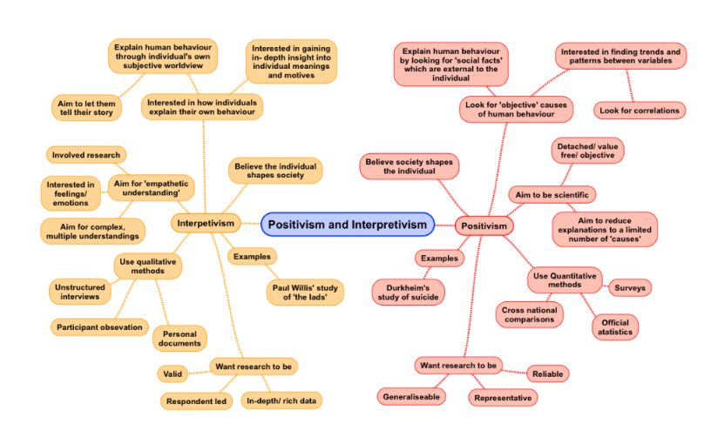
Figure 2: Positivism [9]
The Positivism philosophy takes a scientific approach to research. By basing itself upon observations, Positivism in turn, allows for the collection of data that is otherwise credible and quantifiable. Furthermore Positivism encapsulates that of both experimental and objectivist paradigms and otherwise suggests that research of its type, is based upon facts.

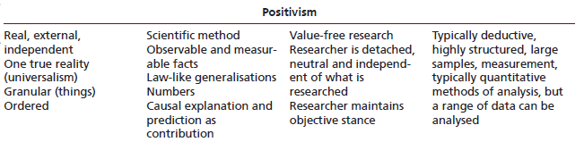
Figure 3: Positivism [9]
Furthermore, Saunders et al suggests that positivism is typically deductive, further allowing for the use of structured data analysis [9].Now that we have chosen a suitable philosophy, a research approach needs to be decided upon. Both of these approaches can be noted as inductive and deductive.
Research Strategy | Case Study
The research strategy taken by this research project will be that of a case study. These are well suited to that of software development projects as there is a need for multiple forms of data collection: Such as surveys, observation and structured interviews. By ensuring that multiple means of data collection methods are utilised we can ensure high data validity. Furthermore, a case study is well suited due to the research nature of the project, such as the research into application development, deployment, similar applications etc.
Finally, when making a consideration for that of the time horizon, cross-sectional will be used due to the projects relatively short life span as well as cross-sectional being limited to specific time frames.
Study Population | Sample
The population for the sample will consist of both students and potentially staff, both of which will be of the School of Applied Computing due to the nature of the project and its contents. Potentially staff at the DVLA may be used as a sample pool however this is yet to be decided.
Data Collections Methods
To gather requirements for the required system, staff will be consulted providing a good basis from which to start whilst providing any technical considerations that need to be made.
Once the application has been developed both staff and students will invited to complete anonymous questionnaire, ensuring that questionnaire sites such as Survey Monkey are used to ensure anonymity. Information collected will allow for the realisation of what the application should provide, how this information is presented and the general look and feel of the intended application.
Reliability & Validity
When collecting data we need to understand that there may be four threats to reliability [9]. Of which there are the following:
- Subject or participant error
- Subject or participant bias
- Observer error
- Observer bias
We should also consider that there may be threats to the validity. Validity is concerned with whether the findings are really about what they appear to be about [9]. It is suggested that there are six total threats to validity:
- History
- Testing
- Instrumentation
- Morality
- Maturation
- Ambiguity about casual direction
These are all valid reason that can potentially affect our results and are an inevitable part of data collection. However, due to multiple methods of data collection as well as both quantitative and qualitative forms of data, avoiding these, if not minimising the above impact should be possible.
Development Methods & Techniques
A system development methodology refers to the framework that is used to structure, plan, and control the process of developing an information system [12].
Furthermore, when considering what development methods and techniques to use for the creation of a piece of software, there are many choices one can look to utilise as seen in the SDLC or Software Development Lifecycle. Although considerations were made towards many types of SDLC a RAD or Rapid Application Development approach has been chosen: It’s also important to point out that there is no correct choice to be made during this consideration, most SDLC approaches would suffice.
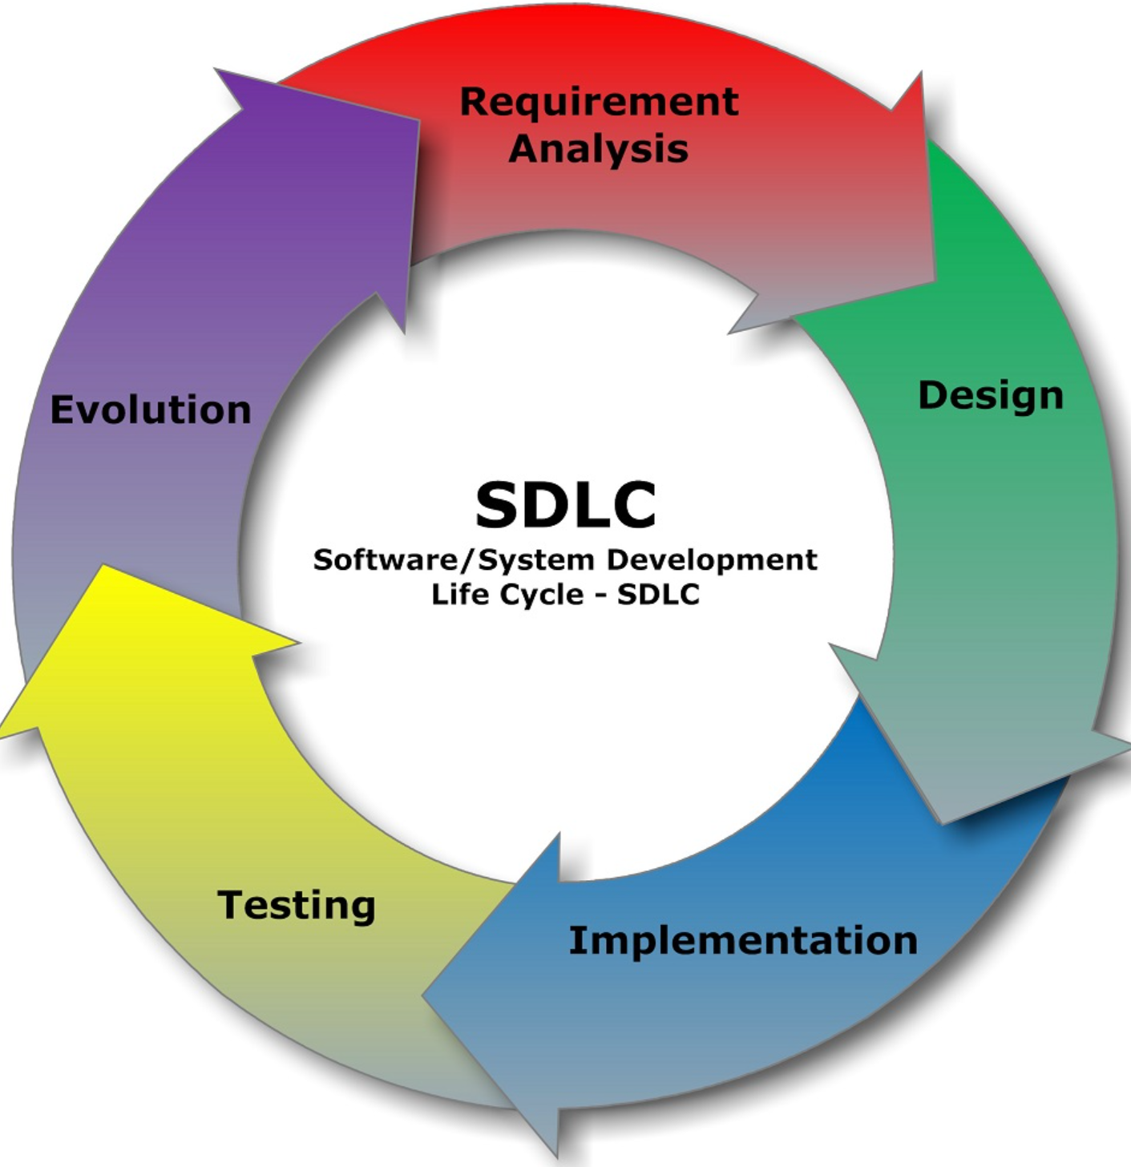
Figure 4: SDLC [11]
We further see RAD being suggested as appropriate where systems are being built with active user involvement and with development tools such as GUIs, RDBMS, Code Generators and Object-Oriented Techniques [12]. Furthermore we see that RAD provides a number or strengths, such as:
- Operational version of application is available much quicker than that of Waterfall, Incremental or Spiral Frameworks.
- Provides ability to rapidly change system design [12]
We also see suggestions of where RAD deployment may be appropriate, such as:
- Small-to-medium scale
- System functionality is clearly visible at the user interface [12]
Furthermore, UML or Unified Modelling Language will be utilised as it is well suited to the development of detailed diagrams to illustrate and better understand how the system works.
Identification of Risks | Limitations & Ethical | Legal Considerations
There are a number of considerations to make when looking to identify any potential issues that may arise with the project, its contents and fair use. These issues range from the significant such as ethical and legal ramifications, all the way to risks and/or limitations that might present a problem. Firstly let’s consider the ethical and legal issues:
- Legal | Considerations as to data collected from the users of the system
- Legal | Ensuring no personal information is taken as to adhere to the GDPR
- Legal | Anonymity of user data through sites such Survey Monkey
- Ethical | Ensuring that all work relating to the project is cited, if required
- Ethical | Any interviews with staff should also be appropriately named for contribution
- Ethical | Ensuring that the application is to industry standard
The above outlines potential considerations that will need to be made in the legal and ethical realms for the proposed project. Legally, we need to ensure that any data that is used by the application is not sensitive in any way. Furthermore, ensuring that as a professional of IT, ethical benchmarks are upheld is of the upmost importance: Such as ensuring work is cited and contributors named. There also ensuring that the application is suitable for the industry and is created with that in mind.
Furthermore, we need to consider the potential risks and/or limitations that may be faced during the project, such as:
- Poor time management
- Unsuitable research material and/or software used to build the application
- Not achieving initial requirements due to over compensation of goals/plans
- Poor time management
The above can be mitigated by ensuring firstly that a suitable Gantt is created: This should help to avoid issues surrounding poor time management and not reaching any goals that have been set. Furthermore, using a well-planned chart will ensure that a critical path through the project is identified. This also further allows us to weigh project items accordingly so to not under or overspend time on project work items.
Furthermore, we can ensure that we meet a suitable project target by the creation of an MVP or minimal viable product. This will be what is needed for the application to be suitable and fit for purpose: It’s important to understand that this does not constitute an application that is poorly implemented and presented, but rather an application that has met its base goal.
We also need to give some consideration to that of survey data. Ensuring that enough data points are collected is of the upmost importance. As such, slotted times whereby students and or staff can complete surveys may provide a solution to ensuring that enough data is collected. Additionally, one might have to ensure that enough time is allocated to finding participants.
Finally, an important consideration to that of limitations is that of not being able to develop the skillset needed in time to complete the project. However, this is why an approach such as Agile has been considered as it provides constant iteration on the project, further allowing for development and testing to be performed numerous times over a period of time.
Analysis & Evaluation
Once data has been collected for the proposed application, this will be analysed and will directly impact upon how the application looks, feels and how educational content is presented. The development process will be tested periodically, once a new feature has been implemented, this will be tested to ensure accuracy. Staff at the university will be consulted to perform user testing of the application once it has been completed: As well as staff at the DVLA, potentially.
Conclusion
Throughout this section of the proposal we have considered with justification, the research and development methods that are to be used during this project. Furthermore, risks, limitations, ethical and legal ramifications have also been considered while proposing mitigation to these potential problems.

Resources & Planning

Introduction
Now that we have given consideration towards research philosophies and strategies as well as development methodologies we can start to make considerations towards the resources required and project management planning.
Resource Identification
So that the project can be successfully completed a number of resources will be required, such as:
- PC | Laptop - Development machines to build application
- SQL Server | PostgreSQL - To house a number of application dependent resources
- Books | Online Resources - To provide further research into subject areas
- Students | Staff - To complete questionnaires/surveys
- Online Surveys - Survey Monkey
Project Planning
This project will take a considerable amount of time and effort. As such it is important to plan and organise your time effectively so to ensure targets are met as well as reduce any impact through time lost. As such, a Gantt chart will be constructed to organise time spent on project items.
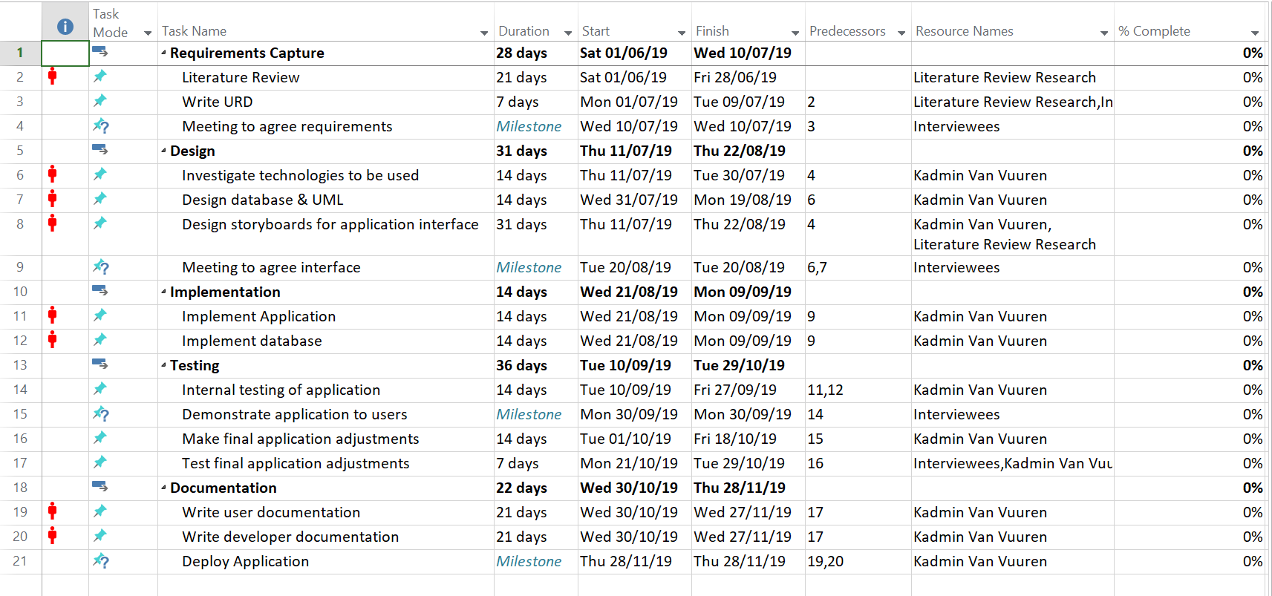
Figure 5: Project Planning Pt. 1

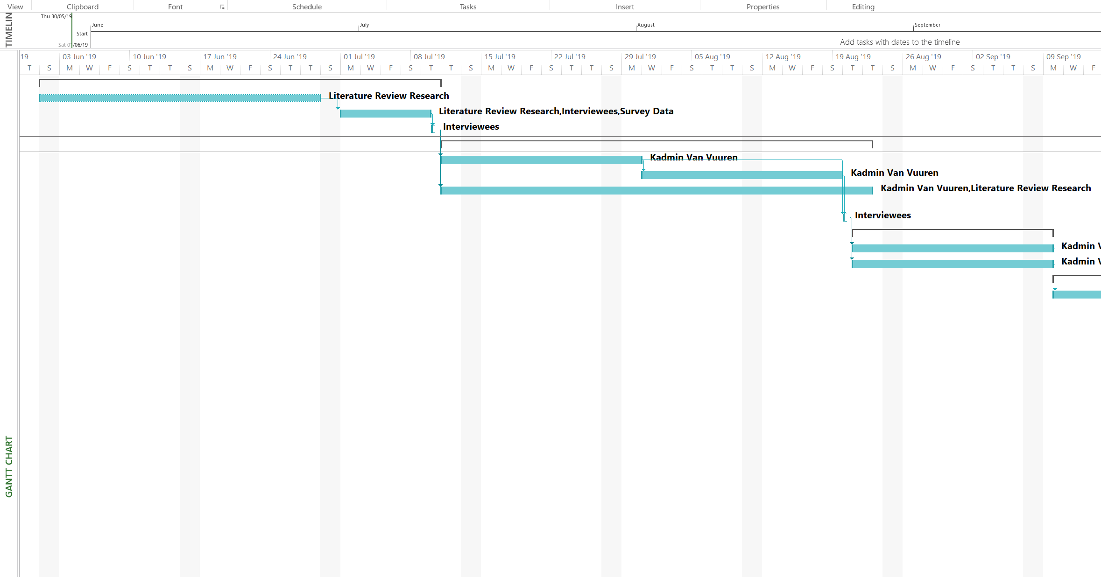
Figure 6: Project Planning Pt. 2

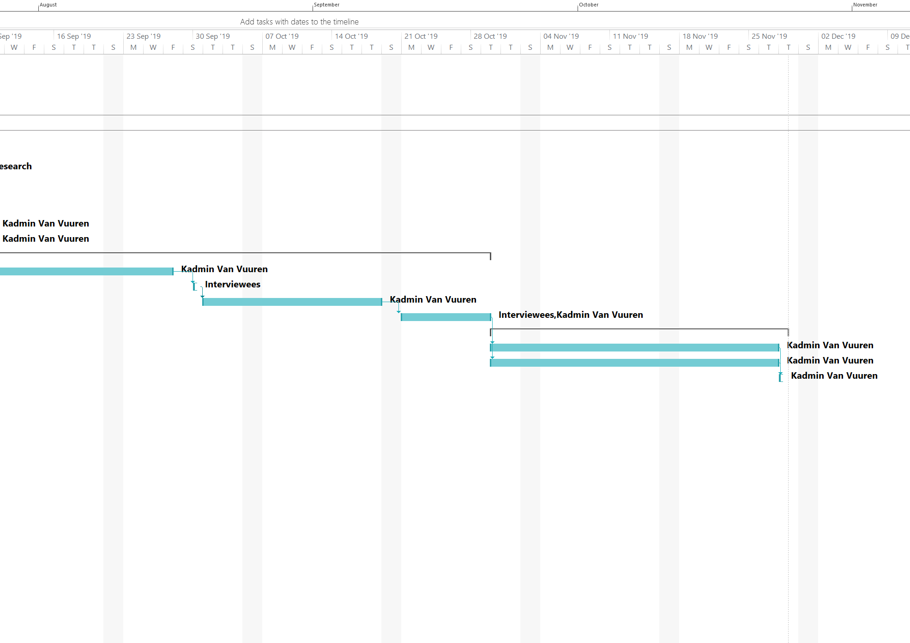
Figure 7: Project Planning Pt. 3
It should be noted that at this stage of the project this chart is likely to change somewhat, however it does provide us with a good basis from which to work.
Conclusion
This section allowed for thought to be given towards that of resources and planning required for the proposed project. Although every effort has been made to ensure accuracy, throughout the lifespan of the project some of these resources and or planning may change as there may be considerations that have yet to be thought of. Importantly, we must note that at this stage, areas such as planning are still somewhat construed. We will only be able to tell, once the project has become operational, if the planning was accurate: However, even if there are slight deviations, this can be corrected early in the projects lifecycle.

References

[1] W, Horton, E-Learning by Design, Second Edition, San Francisco: Pfeiffer, 2012.
[2] Hubackova, Sarka. (2015). History and Perspectives of Elearning. Procedia - Social and Behavioral Sciences. 191. 1187-1190. 10.1016/j.sbspro.2015.04.594.
[3] Rana, Hemant & , Rajiv & Lal, Manohar. (2014). E-learning: Issues and Challenges. International Journal of Computer Applications. 97. 20-24. 10.5120/17004-7154.
[4] B, Little, “Perspective on the e-learning industry” TJ Training Journal, Sep. 1, 2014. [Online]. Available: https://www.trainingjournal.com/articles/feature/perspective-e-learning-industry [Accessed May. 25, 2019].
[5] MUSEANU, Elena. "E-Learning and Its Pedagogical Challenges for Trainers." ELearning & Software for Education 1 (2018): 182-87. Web.
[6] Idrizi, Ermira & Filiposka, Sonja & Trajkovik, Vladimir. (2018). VARK Learning Styles and Online Education: Case Study.
[7] J, Biggam, Succeeding with your Master’s Dissertation, Glasgow: Open University Press, 2008.
[8] H. S, Alqunayeer, S, Zamir, “Identifying Learning Styles in EFL Classroom,” International Journal of Learning and Teaching, Vol. 1, No. 2, December 2015.
[9] M. Saunders, P. Lewis & A. Thornhill, Research Methods for Business Students, Fifth Edition, Harlow: Pearson, 2019.
[10] Tutorialspoint, SDLC. 2017. [E-book].
[11] Career Drill, “Software Development Lifecycle” Career Drill, 2019. [Online]. Available: http://careerdrill.com/blog/wp-content/uploads/2015/11/SDLC_-_Software_Development_Life_Cycle.jpg [Accessed: May. 30, 2019].
[12] CMS Gov, “Selecting Development Approach” CMS Gov, 2019. [Online]. Available: https://www.cms.gov/Research-Statistics-Data-and-Systems/CMS-Information-Technology/XLC/Downloads/SelectingDevelopmentApproach.pdf [Accessed: May. 26, 2019].

Reading List

Njoku, Mary Gloria. (2013). Teaching Styles. 10.13140/2.1.1178.1441.
Revise Sociology, “Positivism Interpretivism Sociology” Revise Sociology 2019. [Online]. Available: https://revisesociology.com/2015/05/18/positivism-interpretivism-sociology/ [Accessed: May. 21, 2019].

