Engineering Technical Report

Work Shope and Practice: ACHA4011

Oscar Davis
2410215

Submission: 10pm Sunday 1st December

Contents Page

Chapter 1 – Introduction…………………………………………...3

Chapter 2 – Health and Safety with Risk Assessments………..4

Chapter 3 – Engineering Role in Society………………………...6

Chapter 4 – Problem Solving……………………………………...7

Chapter 5 – Team Structure……………………………………..10

Chapter 6 – Personal Development…………………………….12

Chapter 7 – Conclusion…………………………………………..13

Chapter 1

Introduction

This document cover topics engineers have to be knowledgeable in to be successful, such as health and safety, team structures, and problem solving. Each topic will be discussed in detail with examples and references to real applications.

Chapter 2

Health and Safety with Risk Assessment

A lathe is a machine that conducts various types of cuts depending on the desired outcome. (Escudier & Atkins, 2019) It is an efficient machine when it comes to its primary purpose which is to remove material is a safe and effective way.
The lathe is set up with multiple all of which conduct different tasks to complete a finished product. One of the most important parts of the lathe is the chuck which can be defined as a cylindrical tool that rotates tools and work pieces to perform cuts. (Escudier & Atkins, 2019)
There are many hazardous risks when using a lathe that can very easily cause lethal and even fatal injuries if the machine is not used correctly. In the US alone there is estimated to be 3,400 metal lathe operators who sustain an array of injuries each year. (Etherton, et al., 1981)
The main hazards of using lathes include:
- Coming into contact with moving parts like the chuck or drive gears.
- Flying objects such as metal chips and swarf, as well as tools.
- Slipping on hydraulic liquid or coolant.
- Dropping equipment, tools, and work pieces.
These hazards commonly cause injuries like entanglement, broken bones, bruising, deep cuts, damaged eyes, strain on muscles and body parts, and loss of limbs. To avoid said injuries various PPE and control are in place in workshops.
Controls to avoid said injuries consist of not wearing any loose clothing, jewellery, gloves, tying back long hair. This will prevent entanglement and getting caught in the machine.
Aprons, overalls, and lab coats are often used to keep clothing away from moving parts and also to avoid being hit with any hot or sharp flying objects from coming in contact with the body.
The guard must be used to prevent contact with swarf, tools, etc. Check the work piece is securely fasted in the chuck before use to prevent any objects from flying off and harming the operator or anyone in close proximity.
Be aware of potential risks like unwanted items near any moving parts on the machine and any liquid on the floor or machine that may cause slipping or making a mistake whilst operating.
When putting your body in contact with the machine in any way always ensure that the machine will not turn by mistake by leaning or moving on any activation leavers or buttons.
When using machinery, wear safety goggles to stop things like swarf and fluids from getting in or around the eyes. Steel toe capped shoes must be worn in case sharp or heavy objects fall and cause major damage to the operators’ toes and feet.

Information from: - (www.worksafe.govt.nz, [W.G] 2017)

 | Negligible | Minor | Moderate | Significant | Severe
Very Likely | Contact with flying swarf to the body
Likely
Possible |  | Slipping on fluid | Dropping heavy object on foot | Dropping sharp object on foot
Unlikely |  |  | Contact with flying swarf to the eye | Contact with flying tool or workpiece
Very Unlikely |  |  |  |  | Body entanglement
Severity

Likelyhood

Chapter 3

Engineers Role in Society

An issue today within the motorsport engineering industry is the amount of pollution that comes with it. This pollution comes from the manufacturing of parts in workshops and factories as well as the transportation of resources, materials, teams, and equipment to from races and events. Sustainability is not always a factor leading to terrible outcomes on the environment.

At Mercedes Benz, they promote themselves to following the ‘4 R’ scheme. Rethink, Reduce, Repair and Recycle. By doing this they cut back on waste and are able to increase the life cycle of components and materials.
Examples:
They look to reduce the quantity of primary materials they use; this includes plastics, steel, and aluminium. Instead, they are using a greater number of recycled materials to avoid wastage and decrease CO2 emissions.
They are also using new materials such as CO2- reduced steel, planning to use more than 200,000 tons of it within the next decade. Reason being that the steel used on a production electric vehicle account for around 20% of the over carbon emissions.
Information from: - (Mercedes-Benz Group [MBG], 2024)

At Audi they aim to be ‘role models’ of conserving the environment. Each stage of a products lifespan, they take care in minimizing harmful effects on the environment and abide by all environmental laws and regulations.
Examples:
Applying optimal technologies, with no effect on the environment, when developing and manufacturing. Reducing their carbon emissions, improving sustainability, and governing the quantity of natural resources used in manufacturing. Their insight is to hold responsibility on being as sustainable as possible.
Optimizing resource as seen in their protocol when spotting leaking fluid in workshops; whomever is in charge is informed and attention to the problem is provided immediately. Stopping wastage and efficiently increasing the lifespan of a resource.
Information from: - (Audi.com [A], 2024)
Chapter 4

Problem Solving

For an issue found during development, the first step would be to identify the issue at hand, followed by troubleshooting possible solutions. The most effective way to troubleshoot is to start with most obvious solutions (i.e. turning it off and on). Next would be to brainstorm solutions, working as a team and identifying the best possible outcome considering, time, cost, effort, and other variables related to the issue. This should leave you with one or multiple answers. If not, find other ways of solving the problem, i.e. Google, asking external bodies who may know, and thinking creatively.
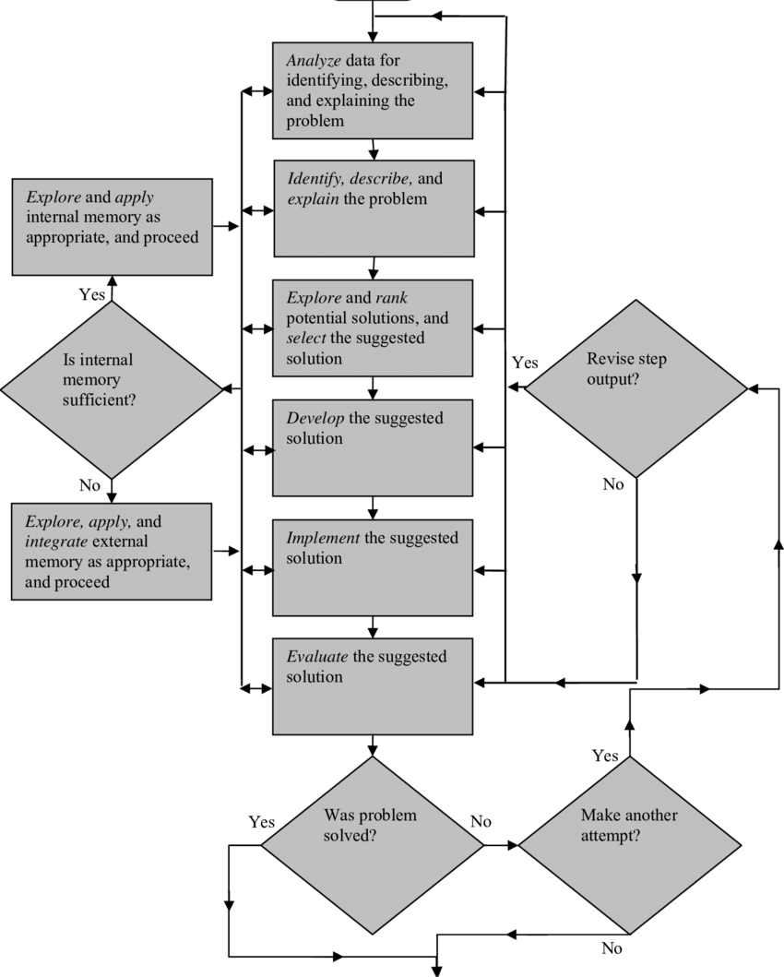

Figure 1
(www.researchgate.net [RG], N.A.)

If an issue is found within a product once its on the market, the first thing to do is take it off the market as to not sell any faulty products which would effect profitability of said product. The nect step would be to estabilsh the issues. The most efficitn way carry this out would to take feedback of the product into account. From there solutions will be easier to determine. A key way to get back on the market would be to research successful competitors selling a similar product and seeing how they’ve gone about producing their item.
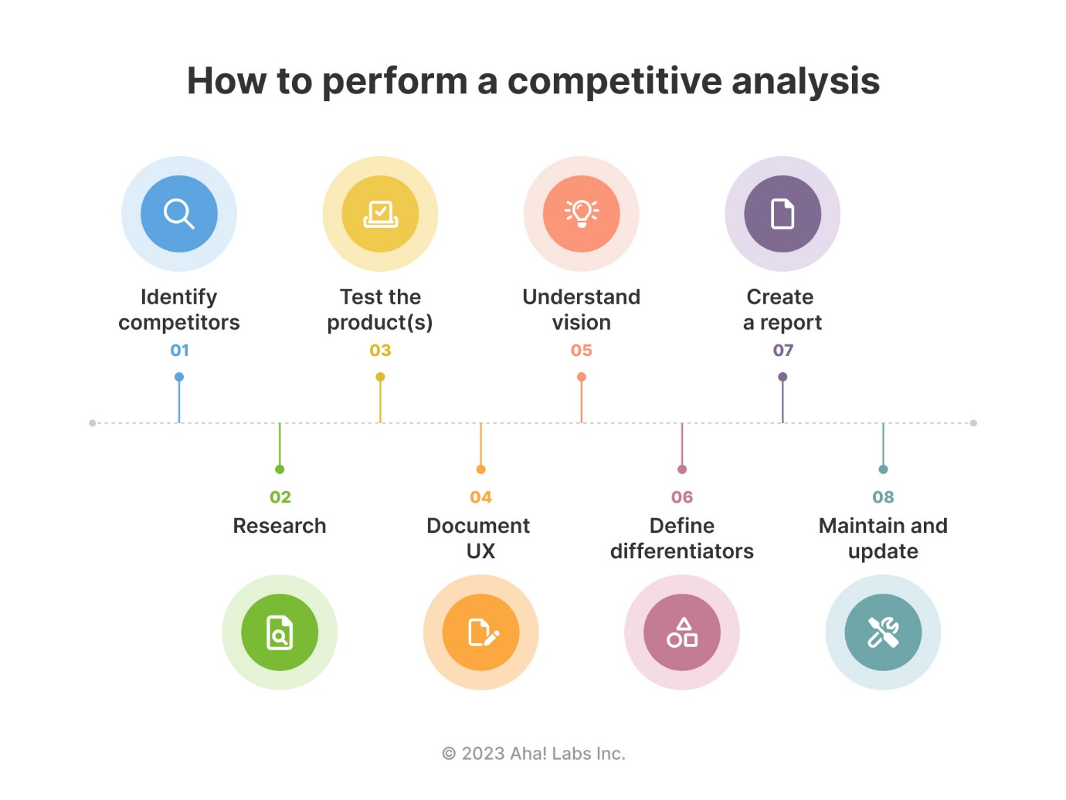
Figure 2
(www.aho.io, [A.I], 2023)

Supllier issues include, delays in delivery, and quality and hazardous issues. These major set backs companys should avoided by the using clear policy agreements, and preperation. Establishing poicies will mean that supplier has guildlines to adhere to that cannot be worked around, and process will run with less error margin. Preperation is key, for example if a material delivery is delayed, the company should have spare material to use. If not prodction and income could come to a hault.
Information from: - (Bit Rebels [BR], 2024)

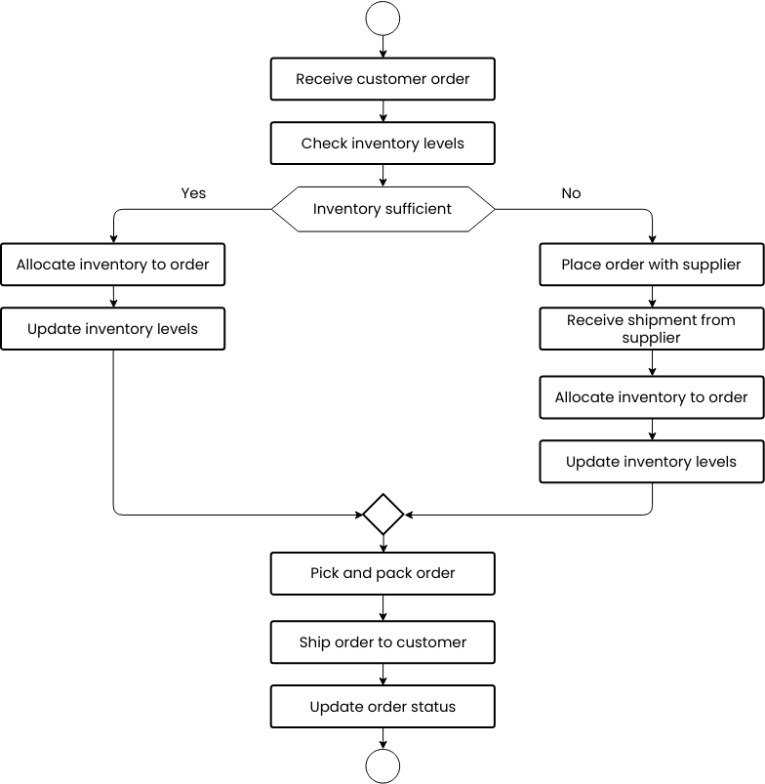

Figure 3
(online.visual-paradigm.com [VP], 2024)

Chapter 5

Team Structure
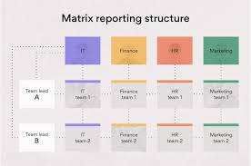
A time I have worked as a team was when my friends and I had to set up tents in the rain on a camping trip. To do this as efficiently as possible we used the matrix structure whereby, we had several ‘leaders’ who have more knowledge and experience of the tasks at hand. Each leader had a specific task that they were conduct with a small group.
Figure 4
(asana.com [A.C], 2024)
I was in charge of picking where the tents should be set up. I felt that the most suitable place would be a tight circle on the flattest part of ground on the hill side, thinking that a smaller circle will be easier to manage and quicker to set up. My team agreed with setting up on flat ground but one of them disagreed with my close circle idea. Instead, he suggested that we have a larger outer ring of tents with a communal area in the middle with chairs, table, etc. Sharing his idea would lead to a much better camp and overall holiday.
This was a benefit of using the matrix structure, being in small groups, each member has a fair input and has a chance to share ideas. It also meant that the other ‘leaders’ could share and compare knowledge, making decisions much easier to reach with few inputs rather than many, or just one which could either lead to a longer time to decide or make a biased decision. We could work a lot closer as a team and had few disagreements due to open conversation and feeling comfortable to share opinions to reach the best outcome. Using the matrix we also worked as separate roles depending on people’s skill set meaning everyone worked to their full potential.

A downside to this was laziness, when people would not want to work it would then put strain on the rest of us. To reduce this, rewards like beer, would be in place to motivate people into working harder. Another issue was competitiveness, group leaders arguing over the best ideas, which would be resolved by a mutual decision with other team members.

A team structure we could have used would be the flat structure, where each member has equal authority below the leader. Because of this there be a boost of team spirit as there would be no hierarchy. A downside would be that any poor decisions made that effect the rest of the equal team cannot be criticized as opposed to being in another team structure such as matrix or hierarchal.
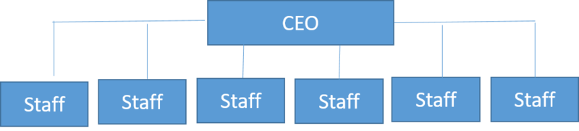
Figure 5
(CIO Wiki [CW], 2022)
A different team structure of relevance would be the functional structure. Which would split the team into multiple distinct groups to then focus on one target alone. This is highly effective as it means that each member only has a finite number of things to focus on. A downside of this, however: members skills would not be used to their full potential as their skills could be useful outside of their set task.
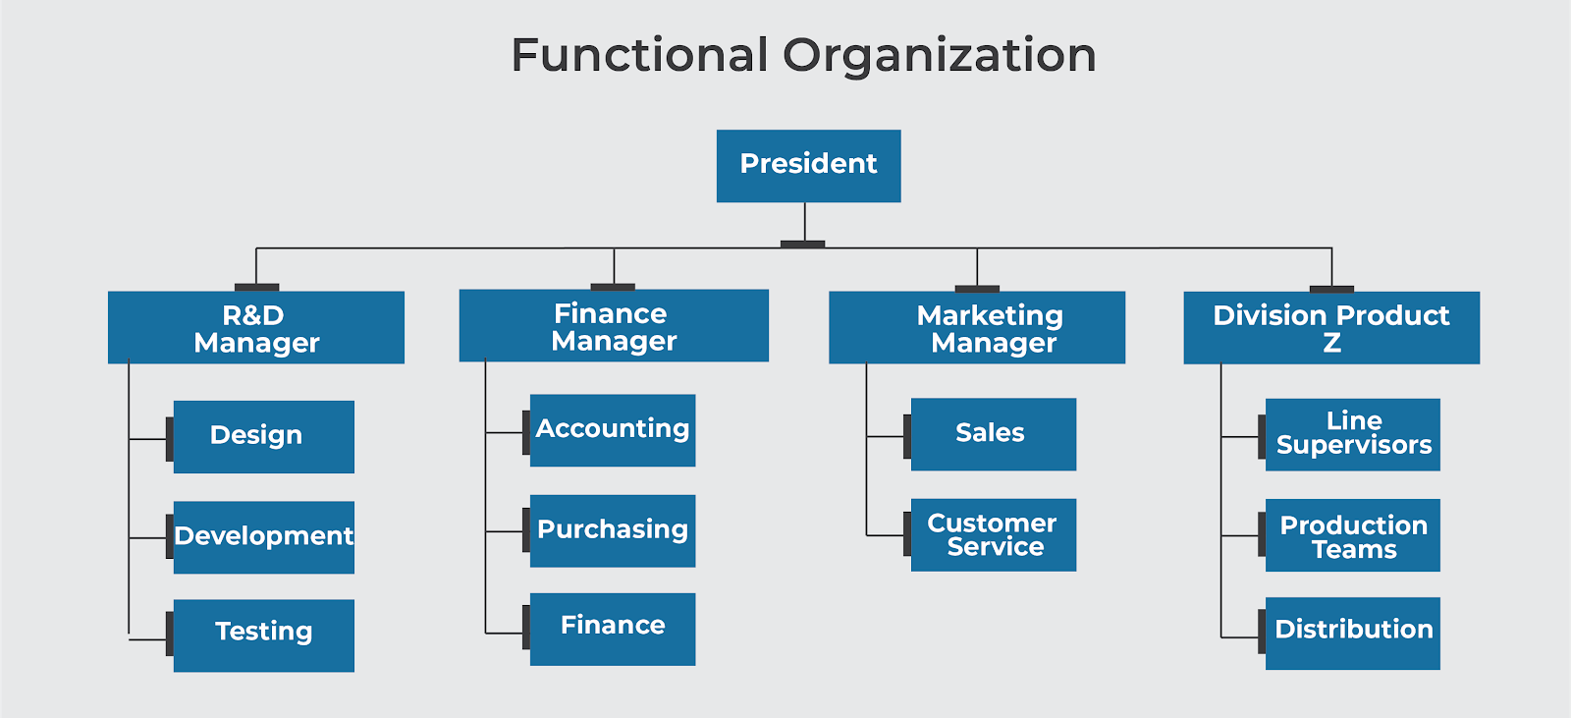
Figure 6
(Viquepedia [V], 2024)
Personal Development Plan

Name – Oscar Davis

Degree – Motorsport Engineering HND

Previous Qualifications – Engineering BTEC, 3D Design BTEC.

Previous Experience – School/university work with machinery and CAD.

Long Term Goals (5 to 10 years)
To work around the world dealing with sustainability related engineering in motorsport and renewable energy.
Short Term Goals (0 to 5 years)
Travel the world and experience as much as I can to decide what industry I would prefer to work in.

Goal | Objective | Resources Required | Measurement | Target Date
Work in WRC. | To become an on-site engineer. | An engineering degree | Comfortable working under difficult conditions. | 2030
Work for a sustainability company. | To collaborate with a company in recycling. | An engineering degree. | Become someone of value in the company. | 2037
Work for a renewable energy company. | To design ways of generating renewable energy. | Relevant experience and an engineering degree. | To have some authority in the company I work for. | 2040

Chater 7

Conclusion

Chapter 2. Care should be taken when operating machinery. Otherwise, accidents can occur. Avoid this by being aware of regulations, laws, and PPE that are in place for the safety of others.
Chapter 3. Engineers must think about the wellbeing of Earth. Demonstrating ways of creating a more sustainable present and a more environmentally friendly future.
Chapter 4, Problem Solving, demonstrates ways in which engineers are evaluated regularly against common issues that crop up. It shows how necessary it is for engineers to be prepared for the worst and understand that things rarely go to plan, but if your prepared for the worst then no issues will come of it.
Teams are especially important and work differently depending on the company and outcome desired. Working as a team will get the very most out of an engineer and the type of team structure used has a huge impact on the outcome of the team.
My personal development plan shows what I would to do with my life in the near future, in which I hope to be success in completing my goals.

Reference List
Chapter 2
Escudier, M., & Atkins, T. (2019). A Dictionary of Mechanical Engineering (2 ed.). Oxford University Press.
Etherton, J. R., Trump, T. R., Jensen, R. C. (1981). The determination of effective injury controls for metal-cutting lathe operators Scandinavian Journal of Work, Environment & Health, vol. 7 no. Suppl 4, pp. 115-119, 1981.
www.worksafe.govt.nz. (2017). Machinery: Metal turning lathes. Metal turning lathes | WorkSafe.

Chapter 3
Mercedes-Bez Group AG. (2024). New materials for new processes. | Mercedes-Benz Group > Sustainability > Resources & Circularity > Materials.
Mercedes-Benz Group AG. (2024). Recycling - on the road to the circular economy. | Mercedes-Benz Group > Sustainability > Resources & Circularity > Recycling.
Audi Code of Conduct. (2024). (version 3.1). Environmental protection. (section 4.9). Audi_CoC_3.1_EN.pdf.

Chapter 4
(Bit Rebels [BR], 2024) Bit Rebels. (2024). Common Supplier Issues And How to Avoid Them | Bit Rebels
Figure 1: research gate. (N.A.). A flowchart analysis: The general problem-solving process. | Download Scientific Diagram
Figure 2: aho.io. (2023). 9 Competitor Analysis Templates (With Example Data)
Figure 3: online.visual-paradigm. (2024). Supply Chain Management Flowchart | Flowchart Template

Chapter 5
Figure 4: Asana. (2024). What Is a Matrix Organization and How Does It Work? [2024] • Asana
Figure 5: CIO Wiki. (2022). File:Flat organization.png - CIO Wiki
Figure 6: Viquepedia. (2024). Functional Structure with Horizontal Linkages | Viquepedia

