BMIH5003
Cultural Awareness

Hotel Handbook for Intercultural Competence
The Ritz London

Rafique Ullah, 2118398
Executive Summary
For this report study, I have chosen one suitable hotel which is in London, UK named “The Ritz London”. The Ritz London is a luxury hotel renowned for its world-class service and opulence. The hotel management team at The Ritz understands the importance of cultural intelligence and sensitivity in the hospitality industry, and they have implemented various strategies to ensure that their guests from different cultures are treated with the utmost care and respect. Cultural intelligence is the ability to understand and appreciate different cultures, and it is an essential skill for hotel personnel, especially in a globalized world where guests from different cultures are likely to visit. Cross-cultural models such as Hofstede's cultural dimensions theory and Trompenaars' cultural dimensions model provide useful frameworks for understanding cultural differences and developing strategies for cross-cultural communication (Hurn & Tomalin, 2013).

Table of Contents
An Executive Summary 2
Introduction 4
Required Hotel Norms for International Guests 4
Summary 7
Do’s and Don’ts 7
Recommendations 7
Conclusion 8
References 9

Introduction
A Hotel Guidebook for Intercultural Competence helps hotels and staff improve cross-cultural communication and meet the demands of customers from diverse cultures. The manual covers communication styles, cultural practices, and beliefs (Ting-Toomey & Dorjee, 2019). It also advises on culturally sensitive staff training programs. Hotels can become world-class intercultural hotels by using the handbook's ideas to give personalized service to guests of all cultures (Kucukusta et al., 2014).

Evaluation
The hotel management team at The Ritz has developed training programs for staff to enhance their cultural intelligence and sensitivity. For example, staff members are trained to understand cultural differences in communication styles, non-verbal cues, and etiquette. They also provide translated materials such as menus, signs, and hotel information in different languages. The hotel management team recognizes the importance of guest service implications for international guests (Chen et al., 2013). They ensure that staff members have a good understanding of different cultures, including their customs, traditions, and beliefs (Fong & Tanaka, 2013). This enables staff members to provide personalized service that is tailored to the needs of the guest. For example, Muslim guests are provided with prayer mats and a Qibla direction, while Chinese guests are provided with tea sets and chopsticks (Haller et al., 2019). Finally, The Ritz London's hotel management has implemented various strategies to ensure that their guests from different cultures are treated with the utmost care and respect. The hotel management team recognizes the importance of cultural intelligence and sensitivity in the hospitality industry, and they have developed training programs for staff to enhance their cross-cultural communication skills. By focusing on guest service implications for international guests, The Ritz London has established itself as a world-class hotel that caters to the needs of guests from different cultures.

Required Hotel Norms for International Guests
To provide individualized service, hotels must adapt to visitors' cultural customs and preferences (Richard, 2017). All departments/functions must collaborate to create a seamless passenger experience throughout adaption. This essay will discuss how hotel departments/functions may need to alter their service delivery to fit guests' cultural conventions and requirements.
- Front Office
The front desk's first impression of the hotel is crucial. The front office employees should learn to adapt to guests' cultural communication and decorum. For example, Japanese guests are greeted by bowing, thus personnel should learn to do so. Western guests expect handshakes, so personnel should be trained to provide them.

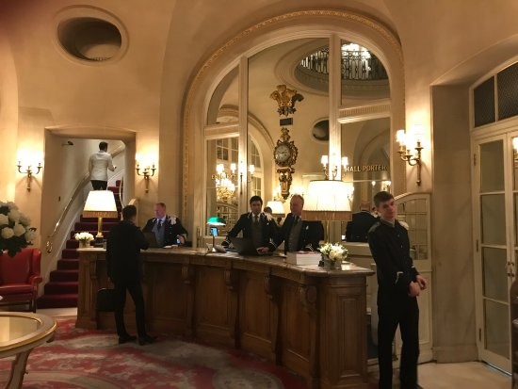

Fig 01: Reception of The Ritz London; Source: Google

- Housekeeping
Housekeeping must also satisfy guests' cultural conventions and requirements (Luo & Qu, 2016). Staff should give slip-on shoes to Muslim visitors who remove their shoes before entering a room. For visitors who cannot drink alcohol, hotels should offer alternatives.


Fig 02: Housekeeping co-ordinator at The Ritz London; Source: Harri Jobs

- Food and Beverage
Hotels should cater to visitors' cultural preferences when serving food and drink (Liu et al., 2017). Hotels must offer halal food for Muslims. Chinese guests prefer tea over coffee, thus hotels should offer tea sets and hot water instead of coffee makers in guest rooms.


Fig 03: Food and Beverage at The Ritz London; Source: Harri Jobs

- Concierge
. The concierge gives guests hotel and local information. The concierge should speak the guest's language to accommodate cultural conventions (Michelson, 2019). To accurately inform guests, they need to know cultural conventions. The concierge should be able to direct Chinese guests to Chinese medicine and food.
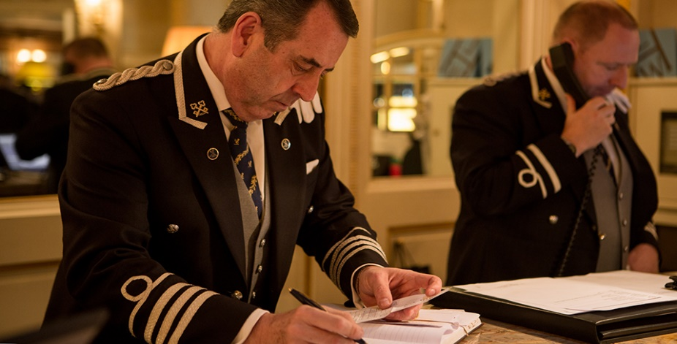

Fig 04: Concierge team at The Ritz London; Source: IPTC’2013

- Spa and Wellness:
The spa and wellness section should also cater to clients' cultural preferences. Hotels should provide separate amenities for men and women in Muslim culture (Alserhan et al., 2018). For customers who require modest dress, hotels should provide it.


Fig 05: Professional Spa and Wellness- The salon at The Ritz London; Source: Professional Beauty Group, London, UK

Do’s and Don’ts
Below is a table of ‘Do's and Don'ts' that can act as a briefing document to relevant staff in the hotel to adapt their service delivery to accommodate guests' specific cultural norms and requirements:
Departments/functions | Do's | Don'ts
Front Office | Adapt to guests' communication style/etiquette | Assume that all guests have the same norms
Housekeeping | Provide slip-on shoes for guests who require them | Assume that all guests wear shoes in the room
Food and Beverage | Offer halal-certified food options | Assume that all guests eat the same food
Concierge | Provide information in the guest's preferred language | Assume that all guests speak English
Spa and Wellness | Provide separate facilities for male and female guests | Assume that all guests use the same facilities

Summary
Overall, in order to provide personalised service, hotels are required to adapt their operations to the cultural norms and requirements of guests. To provide guests with an experience that is culturally sensitive, it is important that all departments and functions work together. If hotels take these steps, they can transform into intercultural hotels of the world-class calibre that welcome customers of a variety of cultural backgrounds.

Recommendations
Based on the discussion above, here are two recommendations for staff at The Ritz London:
- Provide training on cultural awareness and sensitivity: The hotel staff should undergo training to understand the cultural norms and practices of different international guests (Wen et al., 2018). This would enable them to provide personalized services that meet the needs and expectations of guests from different cultural backgrounds.
- Offer language support: The Ritz London staff should be able to communicate with guests in their preferred language, or at least provide a basic translation service (Buhalis & Amaranggana, 2014). This would help to improve communication and avoid misunderstandings, making the guest feel more comfortable and valued during their stay.

Conclusion
Guests from different cultures have distinct demands and expectations in the hospitality sector. Hotels must personalize and include these guests. Cultural expertise and sensitivity have helped the Ritz London serve foreign guests well. The Ritz London gives international guests a memorable experience by providing cultural awareness and sensitivity training and language help. Hotels must adapt to clients' cultural conventions to stay competitive and deliver exceptional service.

References
Alserhan, B.A. et al. (2018) “The Transparency of Islamic Hotels: ‘nice Islam and the ‘self-orientalizing’ of Muslims?,” International Journal of Tourism Research, 20(4), pp. 475–487. Available at: https://doi.org/10.1002/jtr.2197.
Buhalis, D. and Amaranggana, A. (2014) “Smart tourism destinations enhancing tourism experience through personalisation of services,” Information and Communication Technologies in Tourism 2015, pp. 377–389. Available at: https://doi.org/10.1007/978-3-319-14343-9_28.
Chen, K.-H., Liu, H.-H. and Chang, F.-H. (2013) “Essential Customer Service factors and the segmentation of older visitors within wellness tourism based on Hot Springs Hotels,” International Journal of Hospitality Management, 35, pp. 122–132. Available at: https://doi.org/10.1016/j.ijhm.2013.05.013.
Fong, E.H. and Tanaka, S. (2013) “Multicultural Alliance of Behavior Analysis Standards for cultural competence in behavior analysis.,” International Journal of Behavioral Consultation and Therapy, 8(2), pp. 17–19. Available at: https://doi.org/10.1037/h0100970.
Haller, P.M., Naegele, U. and Berger, S. (2019) “Cultures of our world,” Management for Professionals, pp. 75–226. Available at: https://doi.org/10.1007/978-3-030-17130-8_4.
Hurn, B.J. and Tomalin, B. (2013) “What is cross-cultural communication?,” Cross-Cultural Communication, pp. 1–19. Available at: https://doi.org/10.1057/9780230391147_1.
Jauhari, V. (2017) “Hospitality Marketing and consumer behavior.” Available at: https://doi.org/10.1201/9781315366227.
Kucukusta, D., Heung, V.C. and Hui, S. (2014) “Deploying self-service technology in luxury hotel brands: Perceptions of Business Travelers,” Journal of Travel & Tourism Marketing, 31(1), pp. 55–70. Available at: https://doi.org/10.1080/10548408.2014.861707.
Liu, Y. et al. (2017) “Big data for big insights: Investigating language-specific drivers of hotel satisfaction with 412,784 user-generated reviews,” Tourism Management, 59, pp. 554–563. Available at: https://doi.org/10.1016/j.tourman.2016.08.012.
Luo, Z. and Qu, H. (2016) “Guest-defined hotel service quality and its impacts on guest loyalty,” Journal of Quality Assurance in Hospitality & Tourism, pp. 1–22. Available at: https://doi.org/10.1080/1528008x.2015.1077185.
Michelson, K. (2019) “Global simulation as a mediating tool for teaching and learning language and culture as discourse,” Foreign Language Annals, 52(2), pp. 284–313. Available at: https://doi.org/10.1111/flan.12392.
N. Torres, E. and Kline, S. (2013) “From customer satisfaction to customer delight,” International Journal of Contemporary Hospitality Management, 25(5), pp. 642–659. Available at: https://doi.org/10.1108/ijchm-dec-2011-0228.
Richard, B. (2017) “Hotel Chains: Survival Strategies for a dynamic future,” Journal of Tourism Futures, 3(1), pp. 56–65. Available at: https://doi.org/10.1108/jtf-06-2016-0018.
Ting-Toomey, S. and Dorjee, T. (2019) Communicating across cultures. New York, US: The Guilford Press.
Wen, J., Hu, Y. and Kim, H.J. (2018) “Impact of individual cultural values on hotel guests’ positive emotions and positive ewom intention,” International Journal of Contemporary Hospitality Management, 30(3), pp. 1769–1787. Available at: https://doi.org/10.1108/ijchm-07-2017-0409.

