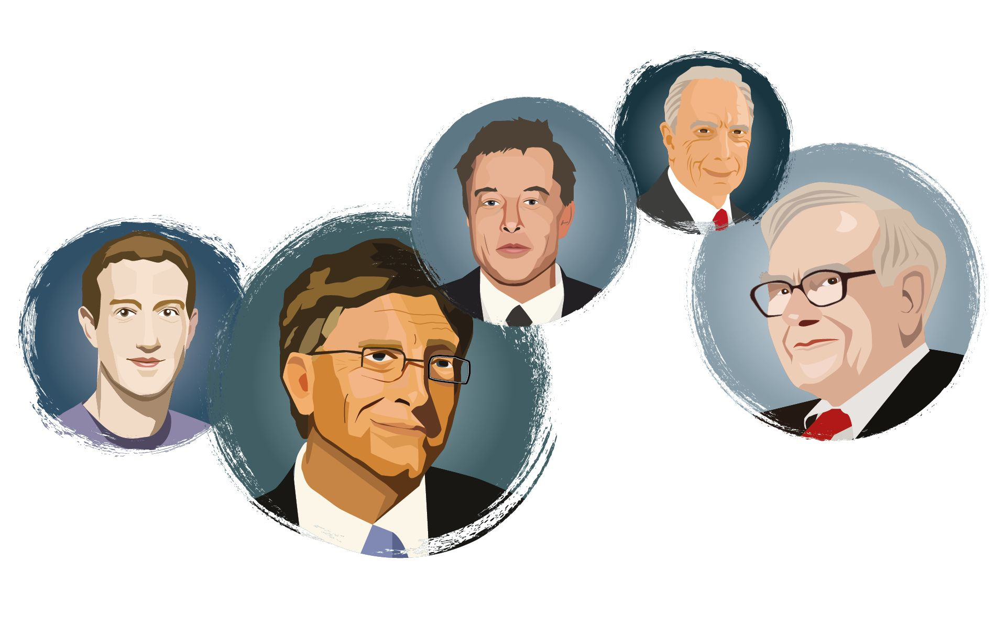
Student Name:SiQi Cai
Student No.1804421
Philanthropy,
Corporate Governance and Corporate Social Responsibility
Table of Contents
1. Introduction 1
2. Stakeholders 2
3. Governance 3
4. Robber Barons, Captain Industry or Philanthropist 6
5. Merits of the philanthropy 7
6. Oxfam Scandal and reflection 9
Reference List 11

- Introduction
The terminological origin of Philanthropy is the Greek work “Phil-anthropos”, meaning the love to humans. It is essentially representing the reallocation of social resources such as wealth through the charitable activities. In a globalized world, no enterprise can be standing-alone and only making profits for itself, which requires the enterprises to fulfil the public requirement to be social citizen and be actively dedicated to philanthropic activities. Philanthropy has a rather long history (Payton and Moody, 2008). Though UK has the earlies passed philanthropy law in the world, the promotion of philanthropic activities was more under the inspirations from American tycoons in the beginning of 20th century, which was later described as the golden era of US. It is however interesting that, the tycoons at that time were also described as Baron Robbers (Burlingame, 2004). It is thus enlightening for today’s philanthropic community to discuss the two most distinguishable philanthropists at that time, Andrew Carnegie and John Rockefeller.

- Stakeholders
Stakeholder defines any relevant individuals or groups that can affect or be affected by the activities of the enterprises. Stakeholder theory was not rising during that time. But one can still identify the key stakeholders as Early phase of worker union, employees, shareholders consumers, government and regulatory bodies (Crane, Matten and Moon, 2008). Worker union at that time was not mature and was not able to fight against, in fact they stand in line with the corporate owners most of the time, the managers and owners of the businesses. The employees and workers were the stakeholders criticizing people like Carnegie and Rockefeller being Baron Robbers since the working time regime at that time was harsh on the workers with minimal pay check (Landstrom, 2007). The government and regulatory bodies had mixed feelings on people like them. On one hand they were the harbingers of American industry and pushed the American economy to the top of the world. This is why they were also referred to as Captain industry. On the other hand, they were also running monopoly companies which disobey the free competition idea in the US constitution.

- Governance
Corporate governance in US only has one and half a century of history. Comparing to its two centuries of nation history, corporate governance is indeed through the history of the united states. Before the 1840s, the majority of the US corporates were rather classical and small in scale (Morck, 2007). The corporate governance was attached much importance at this time. In the late 19th century, the technological development such as assembly line technique and inclusive adoption of electricity brought about many large enterprises. The demand on new technology and new governance modes were demanding the business owners and operator to raise funds from any possible channel (Gordon and Ringe, 2018). It was during this time that the majority of legendary business tycoon rose from small businesses. The corporate governance at this time was focused on the power held by founders of the businesses and investment banks i.e. the shareholders. the public share of those large enterprises only accounted for a trivial amount of the entire share volume of the enterprises (van de Velde, 2018). With the progressing of industrialization process, the stock market at that time was overheated many times due to the imbalance between the needs from the investors and needs from the enterprises (Crawford, 2006). Accounting information at this time was not considered to be publicly accessible information even the enterprise was listed. The dominant ideology of the corporate governance was the liberalism i.e. minimal government intervention (Aras and Crowther, 2012). When the 20th century came, the US society and government were increasingly concerned with the large enterprises being the monopiles of the market and being able to influence even the legislation process. This is also called the progressive era, during which time the government set stricter regulation systems and forced many monopolies to be split into smaller businesses such as Standard Oil of Rockefeller (Geisst and Geisst, 2014). After this period the corporate governance in the US entered the era of owner-manager separation model with more corporate information being compulsory to be disclosed to the shareholders.
This owner-manger separation model has profound impact to the corporate governance in the world today. This model has generated the agency problem, that is the agent of the enterprises (such as managers) would only pursue the maximization of their own interests and ignore the interests of the shareholders i.e. the owners of the enterprises. The agent problem has led to many regulation reforms in the history of corporate governance in the US. However, till the latest financial crisis during which CEOs of the financial institutes were ignoring the systematic risks to cater the needs from the shareholders. it is ironic that this seems to be the solution to the agent problem that has been haunting the US enterprises for almost one century. However, this solution has led to one of the most severe financial crises and economic recession in modern history (Mendoza and Quadrini, 2010). It is the latest financial crisis that led to the rising of the stakeholder theory. The stakeholder theory demands the enterprises to account responsibility for stakeholders. For example, in the financial crisis, the managers should conduct riskier transactions over financial derivatives based on their interest (high bonus) and the interests from the shareholders (high pay-off by dividend or share price increase) (Colander et al., 2009). However, taking their corporate social responsibility and other stakeholders such as the customers or their retail banking businesses and robustness of the financial system in the US, they should inform the regulatory bodies on how these derivatives should be properly managed and be more prudent on the transactions. These seem to be impossible as even the public and the regulatory bodies, together with third party organizations such as ranking agencies were all included in the huge gamble before the financial crisis. It is hard to say that the shareholder theory or recent stakeholder theory is a blessing or curse to the corporates. The past financial and economic crises have fostered numerous reforms in corporate governance which have brought about new threats to the society and the economy. With the increasing level of the globalization, these threats are being more easily enlarged to the global level. It seems only rational that the stakeholders within the economy system should be responsible for each other. The responsibility should not be confined to only the corporates, even they are the majority of the business community.

- Robber Barons, Captain Industry or Philanthropist
In my onions they are the integration of all three roles. According to many of the Muckraker reports on the business tycoons during that time, many of them were pursuing maximized profits without consideration on the workers’ benefit and welfare. The weak worker union typically stood in line with the owners rathe than defending the workers’ interest. Considering the popularity of the Das Kapital, Rockefeller and Carnegie were almost executing the sins claimed by Carl Marx that capitalists naturally bear (Parmar, 2012). They were minimizing the worker benefit with prolonged working time. They were polluting the environment without considering the outcomes. To establish positive public images, many of the tycoons were joining the noble houses in EU with money via marriage or child adoption to become the original noble class in the US. However, considering the industrialization miracles in the US and their contributions to the innovation and advancement of the technologies and applications, they could definitely be viewed as Captain Industry. Both of them were the pioneers of the philanthropic activities in the US. The Rockefeller foundations have been investing in public researches even today. Carnegie set the example of donating all the wealth to the society. The Carnegie foundation and Carnegie Mellon university have contributed to many of the most profound researches in human history. They can definitely be viewed as philanthropists.

- Merits of the philanthropy
The purpose of philanthropic activities is to promote the well-being of the humanity and to promote the public interest by providing tangible property or intangible labor, expressing goodwill to others and making a meaningful contribution to society. Therefore, any education, arts, sports, health care, environmental protection, and social care related events for the community can be philanthropic activities. Corporate Philanthropy is "corporate sponsorship of philanthropic activities". Enterprises provides money, or labor and so on to participate in the activities with above characteristics. The motivation of enterprises to participate in public welfare activities can be divided into: short-term interest, long-term interest and social responsibility Short-term interest refers to the increase in product sales and tax reduction. Long-term interest refers the enhancement corporate public image, effective motivation of employees and establishment corporate culture (Godfrey, 2005). Different motives can exist at the same time, that is, when enterprises support a philanthropic activity, there are often multiple motivations. The motivations of enterprises to participate in philanthropic activities are different which affect the execution and implementation of the philanthropic activities.
There are four basic merits of corporate philanthropic activities:
1: To leverage the philanthropic activities as marketing tools. For example, during the refugee crisis in Europe, Ikea built a sample room same as one of the tents refugees built in Syria. After the event Ikea donated around 5 million Euros to the Red Cross. The entire event significantly improved the public image of Ikea after several quality issues exposed.
2: To use philanthropic activities as the tool to establish good public relationship. For example, in the case of McDonald in China, the company has been donating to the senior citizen and the handicap community to establish good public relations in China.
3: To promote the corporate culture and motivate the employees as to inform them their work is to benefit the public in general. For example, after the 2004 Indian Ocean tsunami, many companies were donating materials or money, or sending professional support to the victims of the disasters. It has been confirmed in many empirical researches that philanthropic activities in this disaster significantly enhanced the employees’ loyalty to the companies.
4: The philanthropic activities can be used for tax reduction or tax exemption. Many governments, in the hope of promoting corporate philanthropic activities, have set a series of regulations on how the philanthropic activities can be used for tax reduction.

- Oxfam Scandal and reflection
Oxfam is global non-government organization emphasizing on eliminating poverty. The organization is major organization in the charity community. It was founded in 1942 and is being operated in many of the major cities in the world. It aimed to address the issues in global poverty and starvation caused by structural inequality and social injustice. The organization has been a major player in the field, however it has also received many critics in terms of not being politically neutral and bureaucracy in managing the funds received (Khan, 2018). The organization was exposed on the severe scandal of prostitution using funds donated to the organization and using the charity resources to exchange for sex from females in their operation areas.
In the aftermath of the earthquake in Haiti in 2010, one member from the Oxfam was exposed to call for prostitutes during the rescue mission in Haiti. The internal inquiry conducted after the exposure under significant public pressure led to the resignation of the director in Haiti mission and other three employees of Oxfam (The BBC, 2018). They were not only using the charity fund to call prostitutes but also to exchange sexual services using resources in Oxfam such as volunteer job positions for local female. The Oxfam scandal, according to their own press release, is due to the loose recruitment screening process and their loose auditing process during the Haiti mission. However, after this exposure, some other scandals were also exposed with minor impact such as misuse of charity funds.
The Oxfam scandal shows the significance of promoting the stakeholder theory and corporate social responsibility not just among profitable organizations but also in the non-profitable organizations. In recent years many scandals such as UN Peacekeeping Force calling for prostitutes using public funds have been exposed. In this regard these organizations require stricter regulation on their execution of social responsibilities. As the charity groups are generally not being inspected as thoroughly as companies, and they have ben justifying this by claiming the difficulties in doing charity projects, the information disclosure of these organizations is now crucial to prevent such scandals to happen again. The effort they made to the society cannot be neglected, however, it is because they are doing the good things for other people, they should be inspected and regulated more thoroughly. One of such scandals can severely damage the image of the organization even the entire charity community. As in the example of Red Cross in China, one lady claiming to work for the organization was found to have luxury watches worth tens of thousand of pounds led to the donation the group decrease to almost zero.

Reference List
Aras, P. G. and Crowther, P. D. (2012) A Handbook of Corporate Governance and Social Responsibility. Ashgate Publishing Limited (Corporate Social Responsibility).
Burlingame, D. (2004) Philanthropy in America: A Comprehensive Historical Encyclopedia. ABC-CLIO (Philanthropy in America: A Comprehensive Historical Encyclopedia).
Colander, D. et al. (2009) ‘The financial crisis and the systemic failure of academic economics’, Univ. of Copenhagen Dept. of Economics Discussion Paper, (09–03).
Crane, A., Matten, D. and Moon, J. (2008) ‘Corporations and citizenship: Business, responsibility and society’, New York et al.
Crawford, C. J. (2006) Compliance & Conviction: The Evolution of Enlightened Corporate Governance. XCEO.
Geisst, A. C. G. P. F. C. R. and Geisst, C. R. (2014) Encyclopedia of American Business History. Facts On File, Incorporated (Facts on File Library of American History).
Godfrey, P. C. (2005) ‘The relationship between corporate philanthropy and shareholder wealth: A risk management perspective’, Academy of management review. Academy of Management Briarcliff Manor, NY 10510, 30(4), pp. 777–798.
Gordon, J. N. and Ringe, W. G. (2018) The Oxford Handbook of Corporate Law and Governance. OUP Oxford (Oxford Handbooks).
Khan, M. S. (2018) ‘Oxfam: sex scandal or governance failure?’, The Lancet, 391(10125), pp. 1019–1020. doi: 10.1016/s0140-6736(18)30476-8.
Landstrom, H. (2007) Pioneers in Entrepreneurship and Small Business Research. Springer US (International Studies in Entrepreneurship).
Mendoza, E. G. and Quadrini, V. (2010) ‘Financial globalization, financial crises and contagion’, Journal of monetary economics. Elsevier, 57(1), pp. 24–39.
Morck, R. K. (2007) A History of Corporate Governance around the World: Family Business Groups to Professional Managers. University of Chicago Press (National Bureau of Economic Research Conference Report).
Parmar, I. (2012) Foundations of the American century: The Ford, Carnegie, and Rockefeller Foundations in the rise of American power. Columbia University Press.
Payton, R. L. and Moody, M. P. (2008) Understanding Philanthropy: Its Meaning and Mission. Indiana University Press (Philanthropic and Nonprofit Studies).
The BBC (2018) Oxfam GB banned from Haiti after sex scandal - BBC News. Available at: https://www.bbc.co.uk/news/uk-44474211 (Accessed: 2 May 2019).
van de Velde, M. (2018) Beyond Shareholder Theory: Exploring Effective Business Models Balancing Profits and Purpose. University of Glasgow.

