Skills for the Workplace
Term 2

Student Name: Sorin-Nastase Gilmeanu
Student Number: 1605779
Module No: EMPL4012
Module Title: Researching and Analysing Data
Lecturer: Isaiah Oino

Executive summary
In the United Kingdom, the online businesses are booming by providing different facilities to its customers. The high street businesses are facing reduced profitability for the growth of online businesses and for different other reasons. The report has focused on different advantages and disadvantages of both, online and high street businesses conducting primary and secondary research.
Table of contents
Introduction 4
Research question 4
Secondary research 4
Analysis of primary data 6
Ethical implications 9
Conclusion 9
Reference list 10

Introduction
In the United Kingdom, the online businesses have been growing eventually from past few years and for this reason, the high street businesses are facing lack of profitability. A number of high street business are considering online platform for their business growth and some high street businesses are closing down their operations. However, different foreign online businesses are capturing the market of online business in the UK, which reduces the opportunities for the UK businesses. The report will focus on business opportunities for both online and high street businesses. A research question will be made and both primary and secondary research will be conducted in order to make a proper conclusion.
Research question
The research question of this research is following:
- Which type of business has higher opportunity in the market of the United Kingdom, online businesses or high street businesses?
Secondary research
The online businesses are becoming the most favourable for the shoppers in the United Kingdom in the present scenario. The high street businesses are facing huge problems for their decreasing profitability. A number of facilities are provided by the online businesses, which is helpful for them to attract more customers. However, both online and high street businesses have pros and cons, which affects their business growth.
According to Wrigley and Lambiri (2014), many online businesses are providing different facilities to its customers such as lesser price, free products and more. Apart from his, the customers can choose their desired product among a huge number of products by going through its review. This is helpful for the customers to choose the best products within their budget. The high street businesses cannot provide this kind of facilities. As argued by Hubbard (2017), the customers need to visit the shops and have to purchase the products, which is offered by the shops and based on the own knowledge and suggestion of the shop owners. Therefore, the choice is lower and sometimes customers need to pay higher price compared to the online shops.
John Lewis is one of the popular online businesses in the United Kingdom, which brings a unique facility for its customers. The business has collaborated with collect + stores, which enables the customers to order their desired products online and pick up those products from almost 1000 shops of the collect+ throughout south-west England, Scotland and Northern Ireland by paying a charge of £3. The customers need not wait for the delivery of the products and can get those as soon as possible. Apart from this, the customers can return those products to those stores free of cost if any problem arises related to those products. This type of facilities is enabling the customers to prefer online shopping more compared to traditional shopping. Apart from this, the payment methods are also user friendly and customers can pay by using debit or credit card or transferring money online (Bly et al. 2015). The cash on delivery option enables the customers to pay after receiving the products at their desired place.
As opined by Grant et al. (2014), the government of the United Kingdom is failed to reform the business rate for high street businesses and for this reason, the high street businesses need to pay higher amount as tax. Many high street businesses in the UK need to close several branches for decreasing the tax rate, which also reduces their profitability. The Kingfisher has planned to close a number of stores in the UK in order to reduce the expenditure of business rate. However, the business rate is not higher for the online businesses in the UK and for this reason, that business can take competitive advantages and provide the products at comparatively lesser price to the customers. However, in the UK, a number of foreign businesses such as Google,Ebay,Itunes, Amazon is capturing a huge market of online business. Those businesses are implementing excellent marketing strategies, which restrict the small online businesses to grow in the UK.
The online businesses consist of several threats, which need to be considered by the businesses in order to develop an online shop. The online businesses need to upgrade the security system of their website overtime or it can be hacked. According to Nagra and Gopal (2013), the online businesses need to install secure payment system for the customers because, the customers need to provide financial details in that and if the payment system is hacked, then the customers also can experience financial lose. The business will also face higher problem due to this and customers will avoid purchasing products from that online store. However, the high street businesses are safe in this context and customers can safely purchase their products from those stores. As opined by Wu et al. (2015) sometimes the customers can get damaged products from online stores and the customer service does not respond on time. A number of customers report that they have received used products from different online stores.
Customers can consider different factors in order to purchase the products safely from online stores. The customers need to consider only popular and secure online websites for purchasing their desired products. They need to go through review and history of an online website if possible before considering a new online store.

Analysis of primary data
Research method: In order to conduct the primary research, the researcher has developed a questionnaire that consists of 5 questions. The data collected through the primary research will be analysed by using pie charts to construct a proper conclusion.
Sampling: The simple random sampling is considered by the researcher in order to conduct the primary research. Researcher has randomly selected 10 people who have shopping experience in both online and high street stores.
Data analysis:
1. The online shopping is trustable
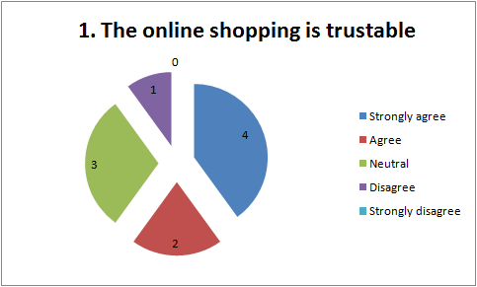
According to the survey, 4 people strongly agree with that the online shopping is trustable while 2 people agree with it and 3 people remain neutral. On the other hand, 1 people disagree with this fact. Therefore, the trustability is high in the online shopping because it provides better shopping experiences to the customers.
2. The online businesses provide higher facilities compared to high street businesses
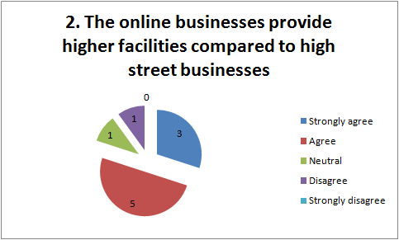
According to the survey, 3 people strongly agree with the fact that the online businesses provide higher facilities compared to high street businesses while 5 people agree with the fact. On the other hand, only 1 people remain neutral and 1 people disagree with this fact. Therefore, the number of facilities given by the online stores are high and for this reason, people prefer to shop online.
3. Payment in high street businesses is more secure in context of online stores
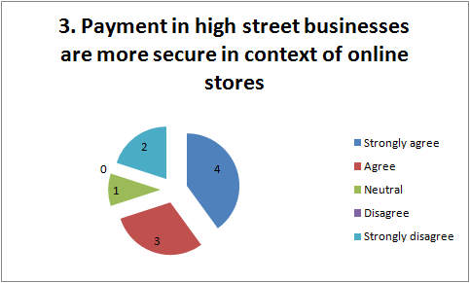
According to the survey, 4 people strongly agree with the fact that payment in high street businesses are more secure in context of online stores while 3 people agree with it. Only 1 people remain neutral and 2 people are strongly disagree with that fact. Therefore, the traditional payment system in high street businesses is more secure than the online payment methods because the chances of hacking are lower.
4. The product review is helpful to make purchase decisions in online shopping
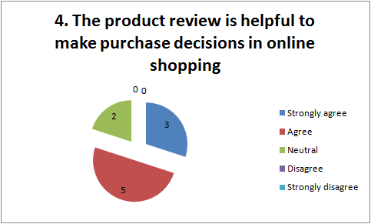
According to the survey, 3 people strongly agree with that the product review is helpful to make purchase decisions in online shopping while 5 people agree with it. Only 2 people remain neutral with the fact. Therefore, the review of the products helps the customers to choose their desired product efficiently.
5. Customer service is better for high street businesses compared to online businesses
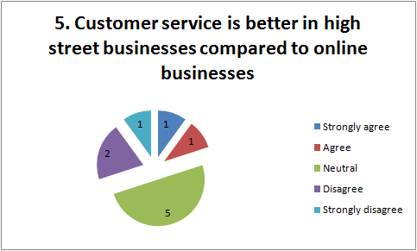
According to the survey, 1 people strongly agree with that the customer service is better in high street businesses compared to online businesses while 1 people agree with it. 5 people are neutral on this fact while 2 people disagree and 1 people is strongly disagree with it. Therefore, the customer service of high street businesses is somewhat same as online businesses.

Ethical implications
The researcher has considered a number ethical factor in order to conduct this research. The researcher has collected the details of the respondents. Which will not be disclosed by the researcher. The data collected from the primary research will not be used for commercial purpose.

Conclusion
In the United Kingdom, the online businesses are facing higher growth by providing different facilities to its customers. Many online stores provide less price to its customers along with different other facilities that enhance the shopping experience of the customers. On the other hand, the unreformed business rate and enhancement of online shopping have reduced the profitability of the high street businesses. However many people believe that the payment procedure is more secure n high street business compared to online. Sometimes, people get damaged products while shopping online, which reduce the credibility. Not all the online stores provide better customer service, which allows customers to prefer high street businesses more for shopping purpose. Both types of businesses have almost same opportunity to grow in the future market of UK and they need to use it properly.

Reference list
Bly, S., Gwozdz, W. and Reisch, L.A., 2015. Exit from the high street: an exploratory study of sustainable fashion consumption pioneers. International Journal of Consumer Studies, 39(2), pp.125-135.
Grant, K., Edgar, D., Sukumar, A. and Meyer, M., 2014. ‘Risky business’: Perceptions of e-business risk by UK small and medium sized enterprises (SMEs). International Journal of Information Management, 34(2), pp.99-122.
Hubbard, P., 2017. The ‘Death’of the High Street. In The Battle for the High Street (pp. 15-44). Palgrave Macmillan UK.
Nagra, G. and Gopal, R., 2013. An study of Factors Affecting on Online Shopping Behavior of Consumers. International Journal of Scientific and Research Publications, 3(6), pp.1-4.
Wrigley, N. and Lambiri, D., 2014. High street performance and evolution: A brief guide to the evidence. University of Southampton.
Wu, W.Y. and Ke, C.C., 2015. An online shopping behavior model integrating personality traits, perceived risk, and technology acceptance. Social Behavior and Personality: an internatio journal, 43(1), pp.85-97.

