LCBB4008
Introduction to Leadership and Management
Component 1: Coursework: Essay

Introduction
The term leadership refers to the ability of an individual to influence and thus guide the group of people in a right manner. Leadership is important because it provides directions, vision and thus motivates others to success. Leadership is the approach of influencing and guiding people belonging to a specific group to enhance their capacity to achieve the same goal collectively. Throughout the project, an explanatory analysis has been made to the selection transformational leadership and paternalistic leadership alongside with the advantage and disadvantage with the help of two examples.

Main Body

Choosing Organizations and Leadership Styles
As per the opinion of Virgiawan et al. (2021), the concept of a transformational style of leadership has emerged with the view of the requirement of team inspiration and motivation. This form of leadership behaviour is quite distinguishable from the contemporary authoritative style of leadership where the leaders exercise a command-and-control approach to guide their team. The ability to lead and guide a team are the main traits or attributes of any leader but the transformational approach of a leading project team is a little different as transformational leaders not only lead a team to achieve the goals and objectives of the organization but also inspire and motivate their project team to achieve beyond their organizational expectations.
Leadership Style of Amazon
Amazon INC is associated with the transformational leadership styles in which Jeff Bezos is able to develop the customer driven environment in the Amazon by splinting the entire workforce in the segmentation of tasks. This splitting process helps employees of Amazon to focus on the different tasks as well as improvement communication with the proper execution of transformational leadership approach. As articulated by Alkadash et al. (2020), the transformational approach of the leading team also provides adequate autonomy to the project team while managing the project team. Henceforth, it can be stated that with the increasing attention of the transformational leaders towards better project team management and managing team motivation and performance, leadership behaviour has adopted a more liberal and flexible approach with the transformational style of leadership.
Advantage and Disadvantage of Transformational Leadership
As suggested by Hawkins (2021), the adoption of a transformational approach in Amazon helps leader to manage project team active involvement which helps to manage projects smoothly as well. According to the research made by Asbari et al. (2020), the transformational leadership style helps inspire all the team members of Amazon to provide their effort with a shared vision and proper motivation in terms of gaining a specific job effectively. Based on the findings of Shafi et al. (2020), the transformational leadership style has been recognized as one of the leading mediators in Amazon by supporting organizational innovation and employee motivation and inspiration.
Knowledge and skill gaps among the team members are another potential challenge that may be faced by the leaders trying to implement this leadership style within their workplace (Afriyie et al. 2019). Maintaining Market dynamics and competition is another major challenge for leaders trying to implement a transformational leadership style within their business sector (Nauman et al. 2022).
Leadership Style of Ford Motor Company
Ford Motor company is associated with the Paternalistic Leadership style in which ford provides full authority as well as control over its different employees by providing strict rules as well as regulations in the workplace. As stated by Bedi (2020), with the help of paternalistic leadership approach, leader is directly associated to the need of the employees by fostering healthy relationship with the employees. On the other hand, it has been proposed by Hou et al. (2019) that considering individually to all the team members individually is another effective impact of having paternalistic leadership within a specific business sector. For example, it is seen that leaders having paternalistic leadership styles consider individual team members to improve their efforts while reducing their weaknesses and improving their strengths simultaneously.
Advantage and Disadvantage of Paternalistic Leadership
As per the opinion of Lau et al. (2019), clear vision and inspiration are some of the important impacts included by Paternalistic leadership in the context of Ford Company as it help to motivate team members to provide their effort as per the shared vision of Ford. The leaders also get to share long-term goals with the team members to provide a positive impact on the overall productivity of the Ford. In this case, it can be stated that the leader belonging to paternalistic leadership get the chance to improve their sense of commitment towards the organisation by enhancing their organisational success effectively.
Regulatory constraint is one of the major challenges of implementing a paternalistic leadership style as several business sectors constrain individual regulations of implementing their leadership styles. Leaders may face complex regulations of their organisation in implementing any leadership style other than the fixed leadership style proposed by the organization due to the lack of flexibility and innovation.

Describing Personal Experiences
As the role governed by me as a leader of Amazon, I experienced different types of challenges. The challenges were very prominent and thus I decided to follow a style that would have a positive impact in my work. The challenges include conflicts with team members and changing management. On the contrary, I also have some of the positive impacts where I felt supported, trustworthy, and a kind of psychological safety. This has helped me to bring an improvement in my performance and I was able to bring better opportunities to my career goals. As everyone was very supportive, I can easily solve my problems while working in teams and our tasks got executed within a short period of time. This is a significant impact on my job as there is productivity in my work.
Moreover, the rate of engagement is also much and due to this, I am able to face the tasks very smoothly. In a way, I use a coaching style of leadership, where my continuous aim is to cater to the needs of the customers. My basic strategy was to provide better products and services so that my customers are happy. Communication is one of my profound trends by which I am able to discuss all the types of issues that I face in my day to day life. Again, while I am selected for this role, I work in a team. The reason is that it helps to bring out a proper conclusion to the tasks which are difficult.
Thus, from my personal experiences as a leader, I am able to provide positive insights within the employees and gain their level of confidence. Also, I am able to bring a change within myself because of the experiences which I am learning from my role. I am confident now to solve any type of issues that are coming right now. The level of confidence has increased because of several experiences which I am learning right now.

Integrating Personal Experience with Theory
In this section, an evaluation has been made to my personal experience gain as a transformational leader. I understand that, Employee satisfaction is obtained by the leaders having this leadership style within the Amazon improving their overall growth and competitive advantages. In terms of providing instances, it can be stated that enhancing individual recognition of each of the employees and proper motivation for improving the effort of employees (Paais and Pattiruhu, 2020). Having this leadership style can motivate the team members of Amazon to remain in the same organisation while improving their employee retention capability at the same time.
In the transformational leadership theory, the main focus area of this leadership theory is to inspire to every employee in every evolving situation of business.
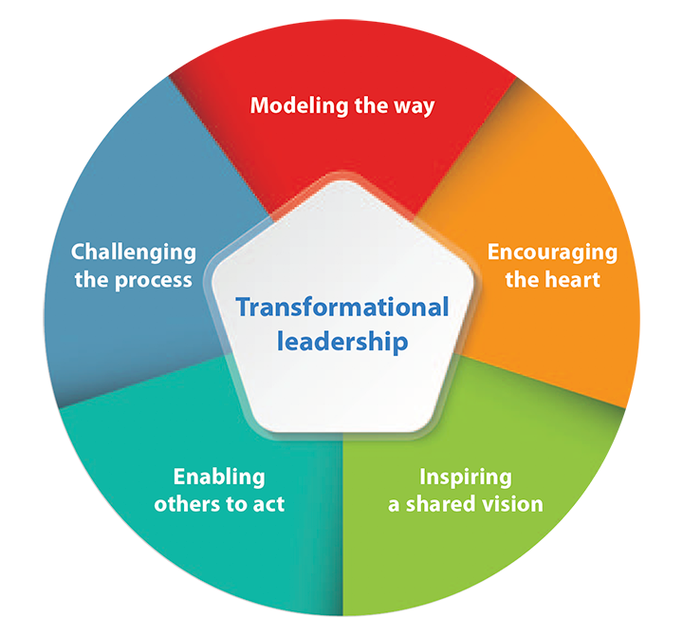
Figure 1: Transformational Leadership Framework
(Source: Li and Liu, 2022)
From the above picture, the transformational leadership Framework has been understood with the help of 5 phases of a transformational Leader. First of all, modelling the way is one of the important phases of this leadership style. The modelling of way is the development of the strategy of a particular business situation. Along with this encouraging the heart is another phase of this leadership style. In this stage, the leaders are always inspiring the team members of a particular organisation. After that inspiring a share division is another stage of the leadership framework. This means that the leaders are always open to sharing a shared vision and the strategy for the organisation's goal with their employees. The leaders are making a friendly situation to overcome all the problems for achieving these particular visions with the employees (Li and Liu, 2022). The last two stage of this Framework that has been identified from the above picture is enabling other to act and challenging the process. In a building other to act is the actual strategy of the leader to work according to the strategy.

Conclusion
Based on the above analysis, it has been stated that, transformational leadership style is able to recognise the individual efforts of the team members and motivate them to achieve their goals successfully. Leaders having this leadership style in business organization can incorporate proper ethical standards within the work environment by providing a major focus on the ethical behaviour of the team members while gaining proper sustainability within the work culture effectively. Transformational leadership helps in motivating all the employees by fostering a sense of purpose and commitment among the team members.

Reference List

Afriyie, S., Du, J. and Ibn Musah, A.A., (2019). Innovation and marketing performance of SME in an emerging economy: the moderating effect of transformational leadership. Journal of Global Entrepreneurship Research, 9, pp.1-25.
Alkadash, T.M., Almaamari, Q., Mohsen Al-Absy, M.S. and Raju, V., (2020). Theory of transformational leadership towards employee performance as sequence of supply chain model: the mediating effect of job autonomy in Palestine banks during Covid-19 pandemic. International Journal of Supply Chain Management (IJSCM)[ISSN 2050-7399 (Online), 2051-3771 (Print)].
Asbari, M., (2020). Is transformational leadership suitable for future organizational needs?. International Journal of Social, Policy and Law, 1(1), pp.51-55.
Bedi, A., (2020). A meta‐analytic review of paternalistic leadership. Applied Psychology, 69(3), pp.960-1008.
Hawkins, P., (2021). Leadership team coaching: Developing collective transformational leadership. Kogan Page Publishers.
Hou, B., Hong, J., Zhu, K. and Zhou, Y., (2019). Paternalistic leadership and innovation: the moderating effect of environmental dynamism. European Journal of Innovation Management, 22(3), pp.562-582.
Lau, W.K., Pham, L.N. and Nguyen, L.D., (2019). Remapping the construct of paternalistic leadership. Leadership & Organization Development Journal, 40(7), pp.764-776.
Li, L. and Liu, Y., (2022). An integrated model of principal transformational leadership and teacher leadership that is related to teacher self-efficacy and student academic performance. Asia Pacific Journal of Education, 42(4), pp.661-678.
Nauman, S., Musawir, A.U., Munir, H. and Rasheed, I., (2022). Enhancing the impact of transformational leadership and team-building on project success: The moderating role of empowerment climate. International Journal of Managing Projects in Business, 15(2), pp.423-447.
Paais, M. and Pattiruhu, J.R., (2020). Effect of motivation, leadership, and organizational culture on satisfaction and employee performance. The Journal of Asian Finance, Economics and Business, 7(8), pp.577-588.
Shafi, M., Lei, Z., Song, X. and Sarker, M.N.I., (2020). The effects of transformational leadership on employee creativity: Moderating role of intrinsic motivation. Asia Pacific Management Review, 25(3), pp.166-176.
Virgiawan, A.R., Riyanto, S. and Endri, E., (2021). Organizational culture as a mediator motivation and transformational leadership on employee performance. Academic Journal of Interdisciplinary Studies, 10(3), pp.67-79.

