

Feasibility Plan Presentation
for “Winter Story on the Ice Rink” in Chelmsford

Student Name: VICTORIA CHILIANU
Student ID Number: 2208500
The Module Title: International Meetings Management for the Hotel Industry (BMIH6007)
Lecturer’s Name: KATHRYN FLYNN

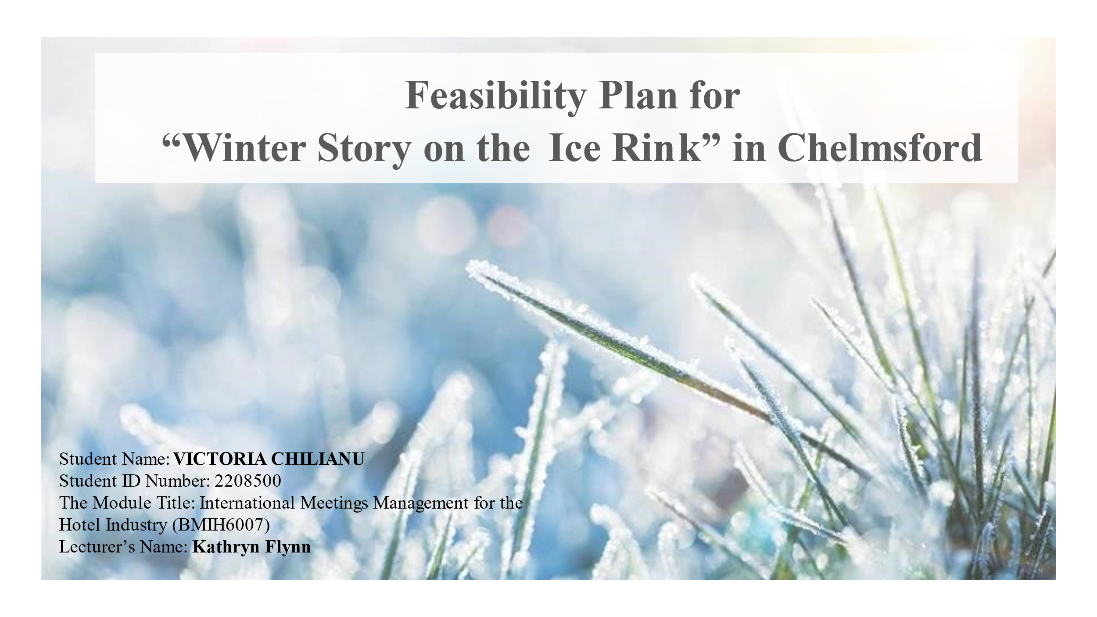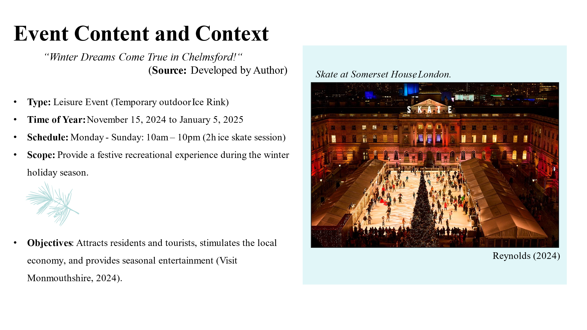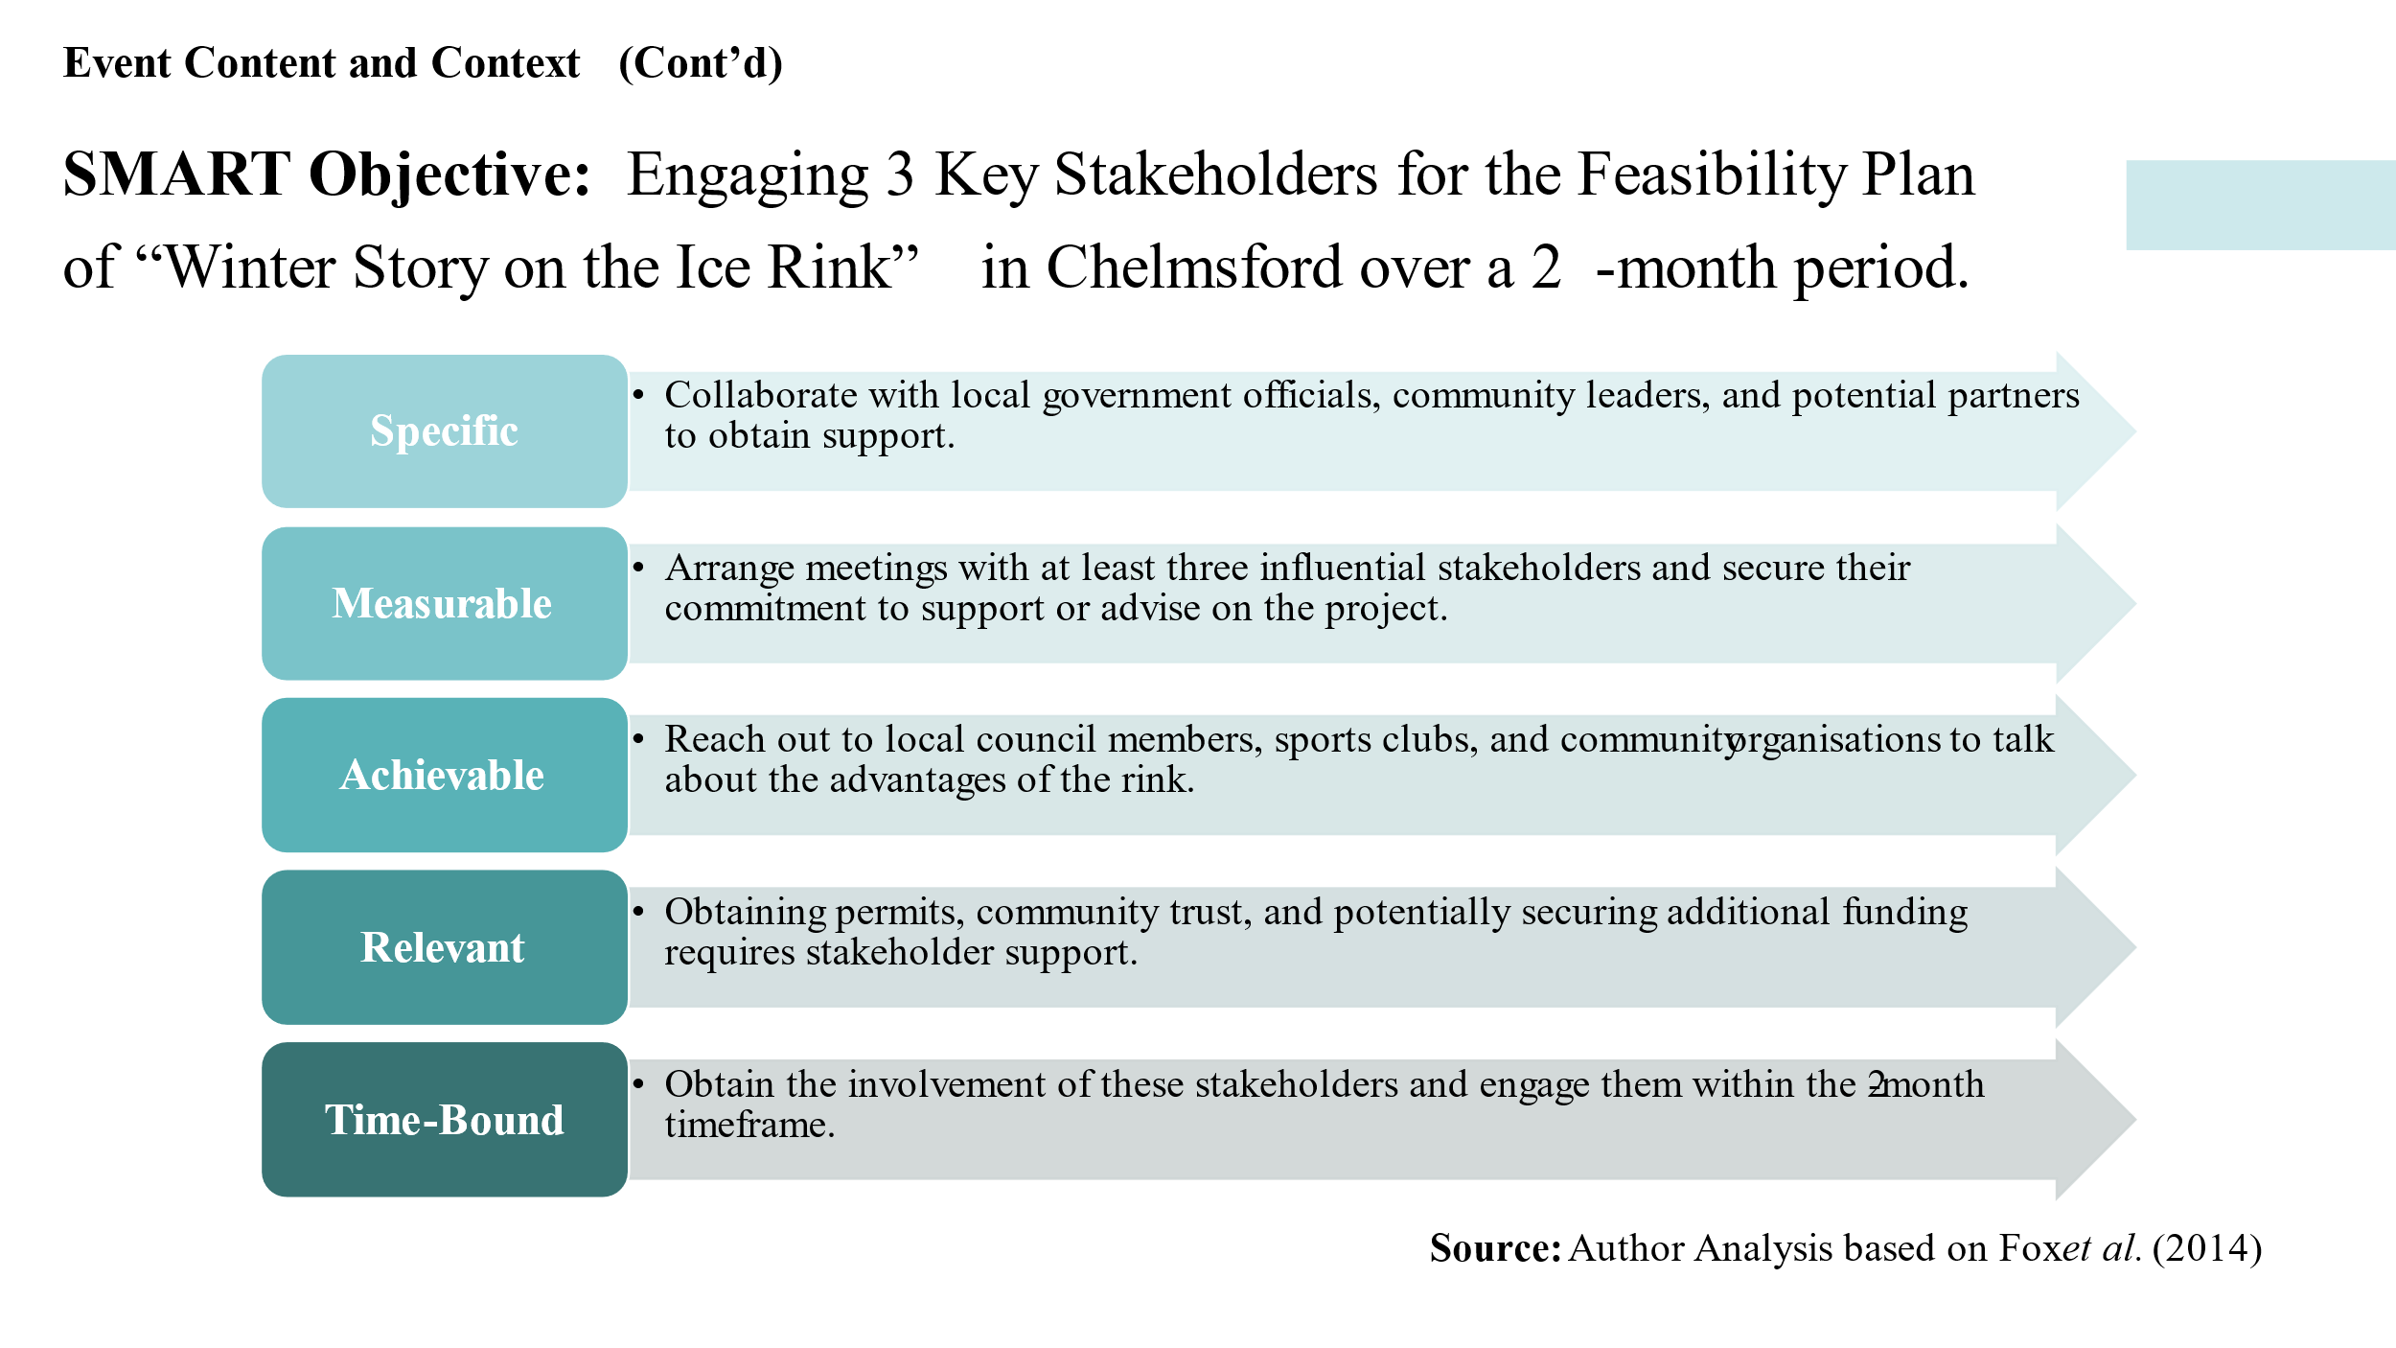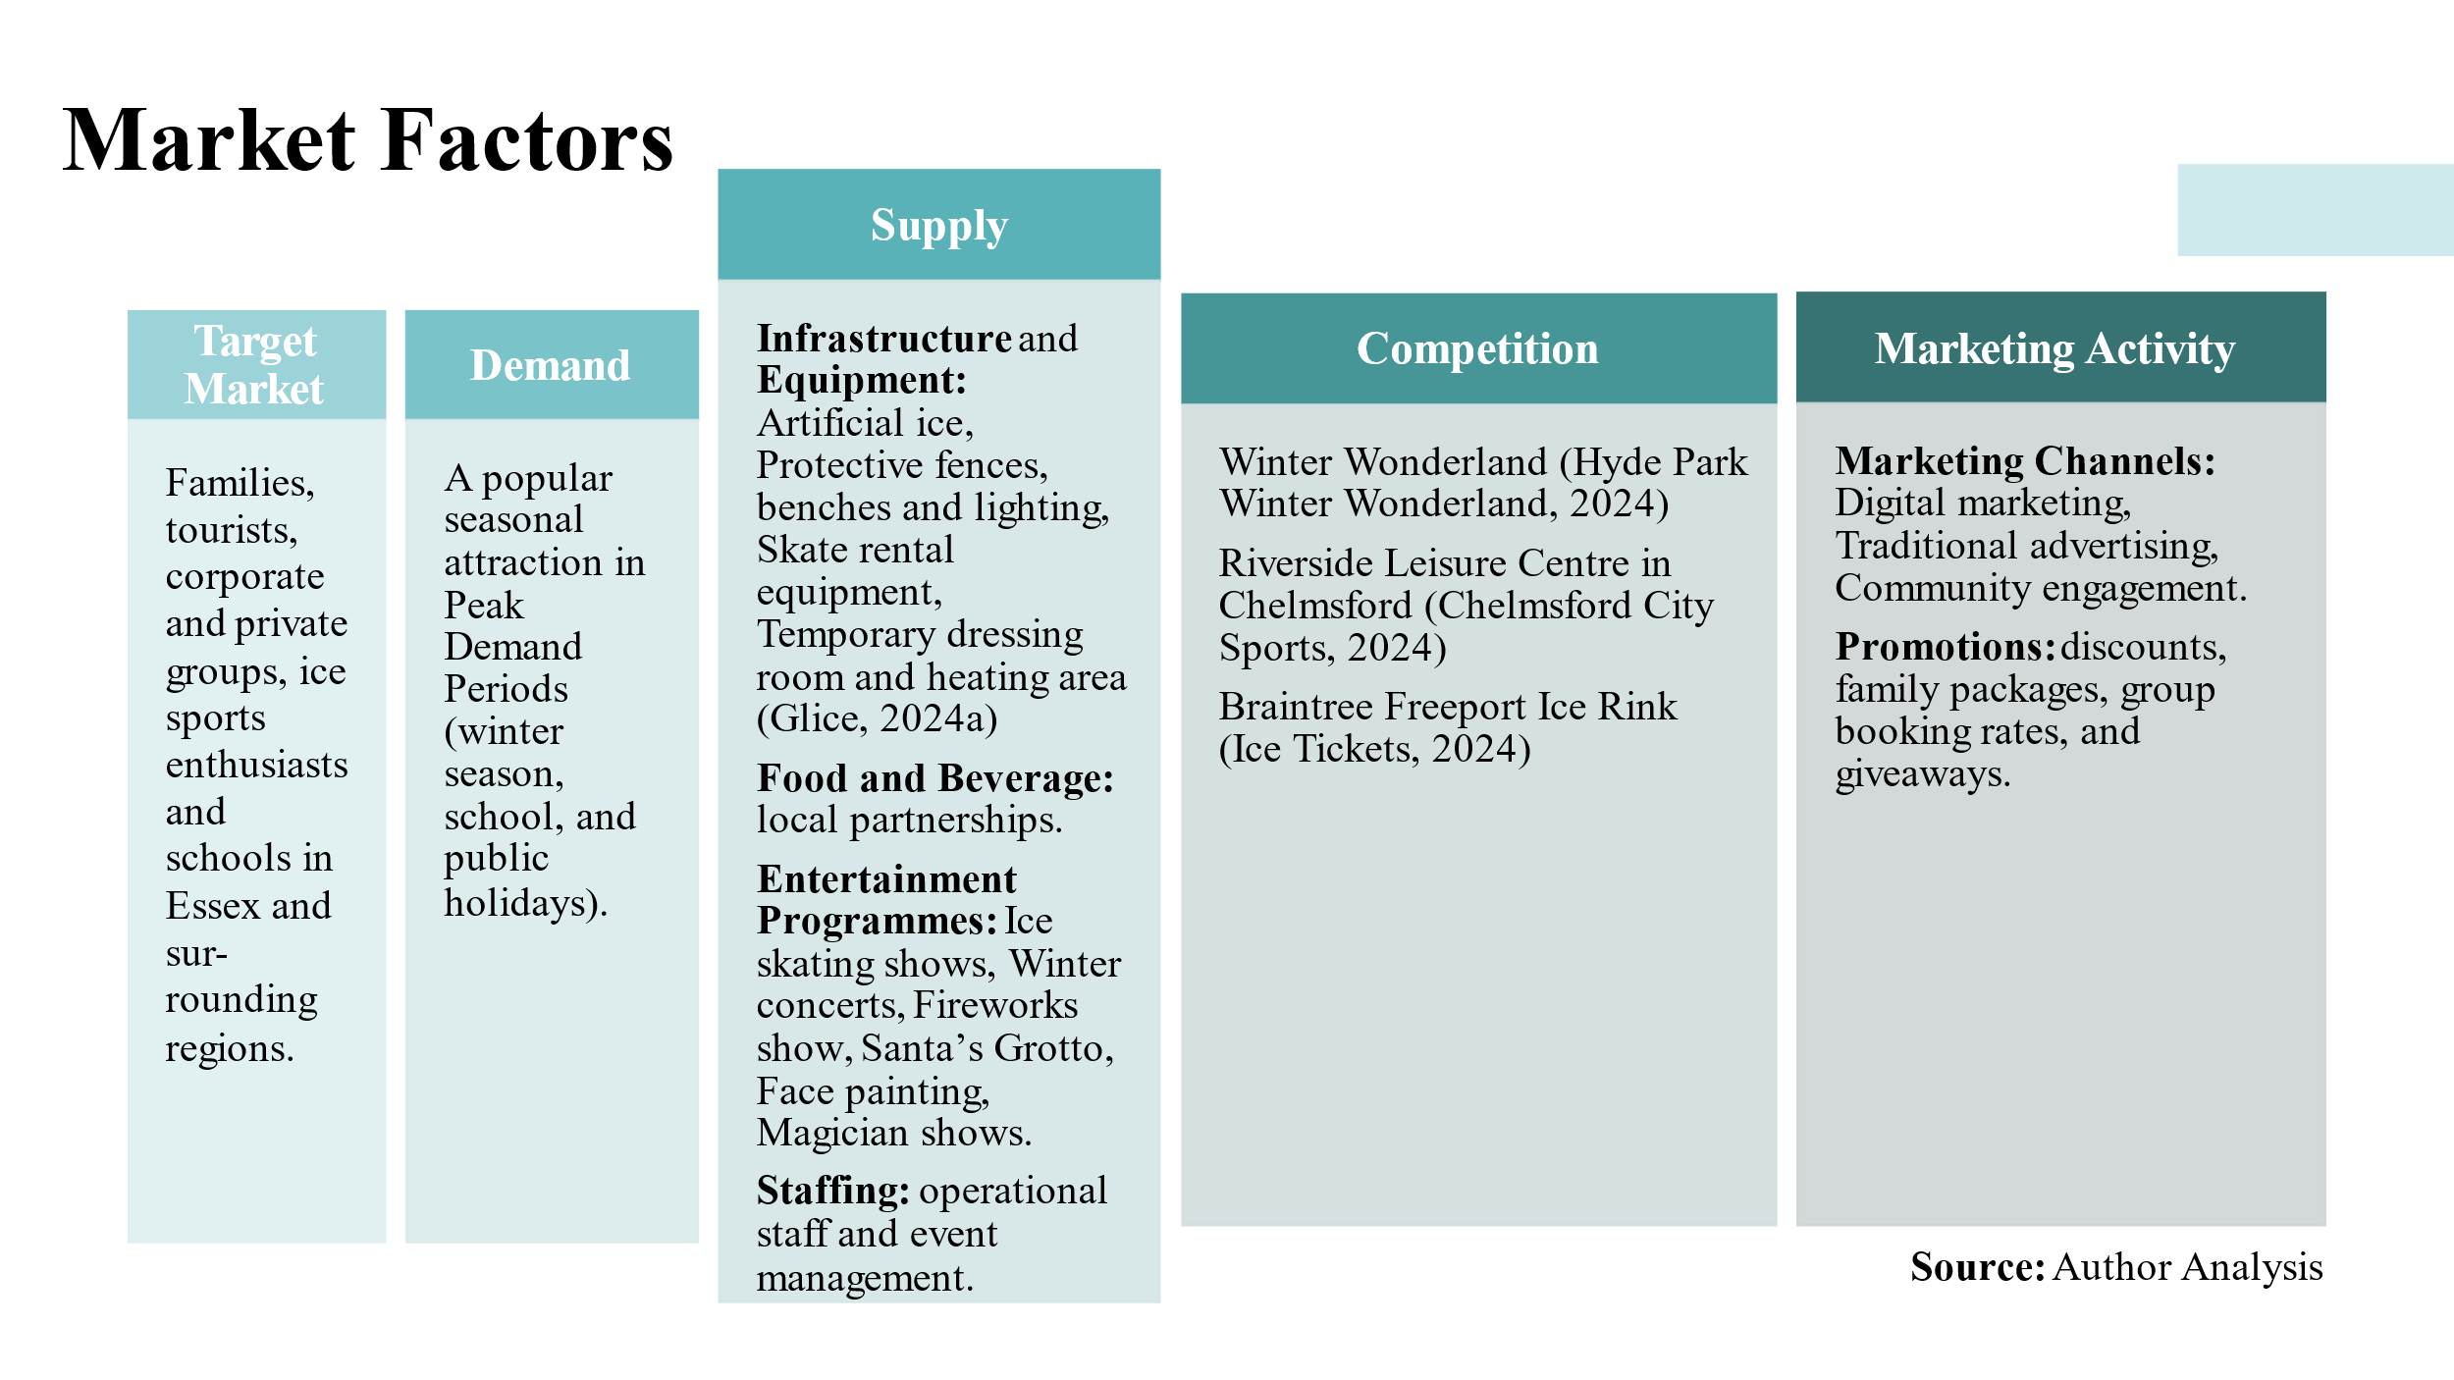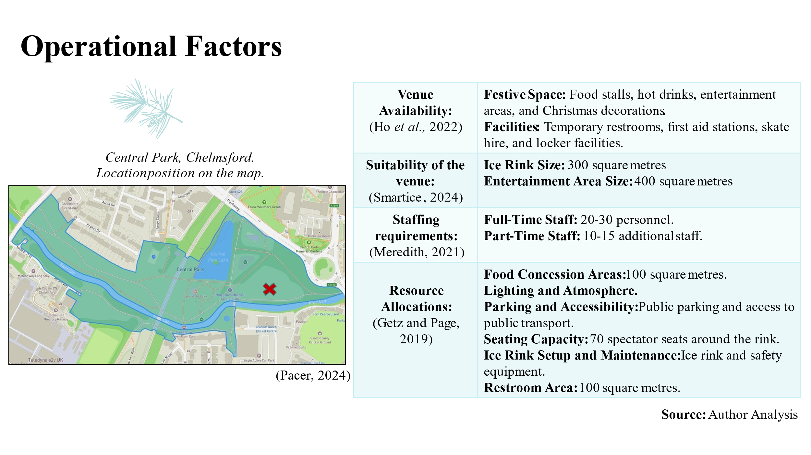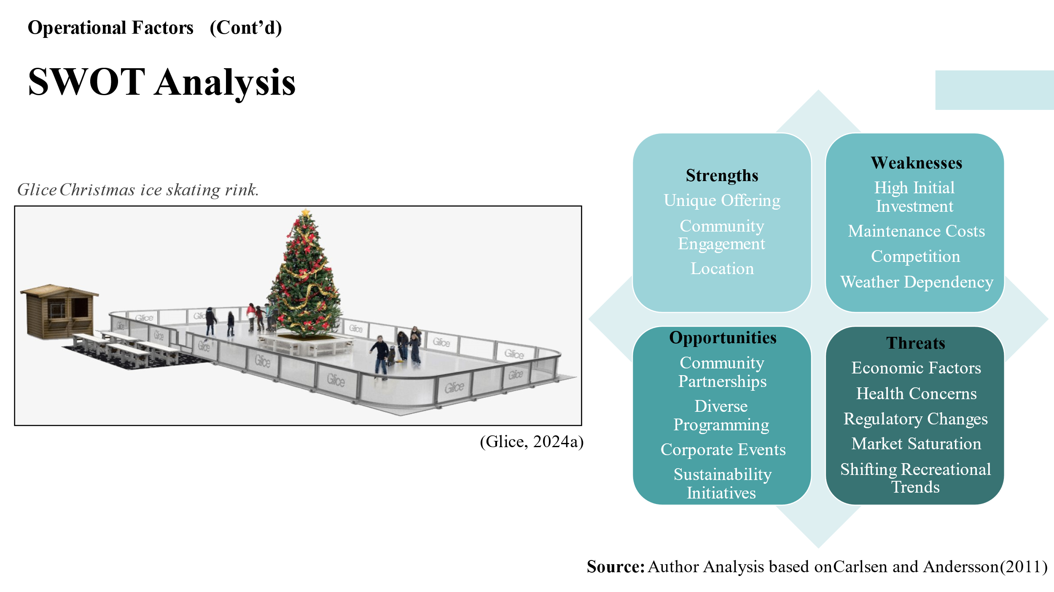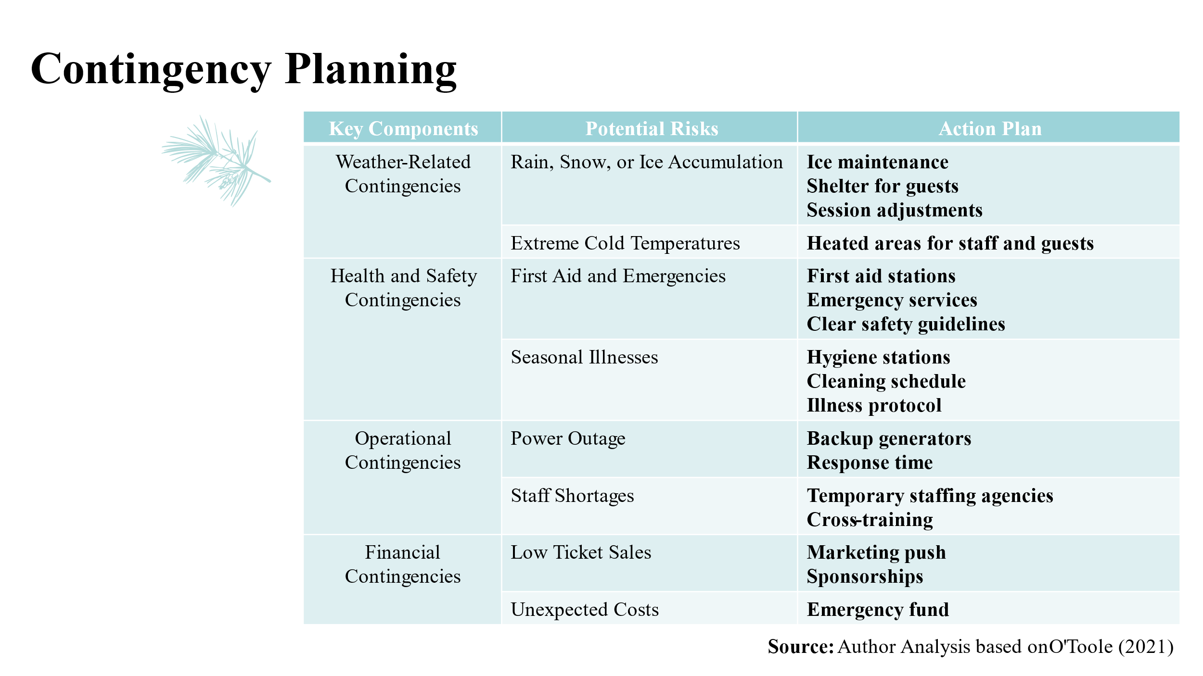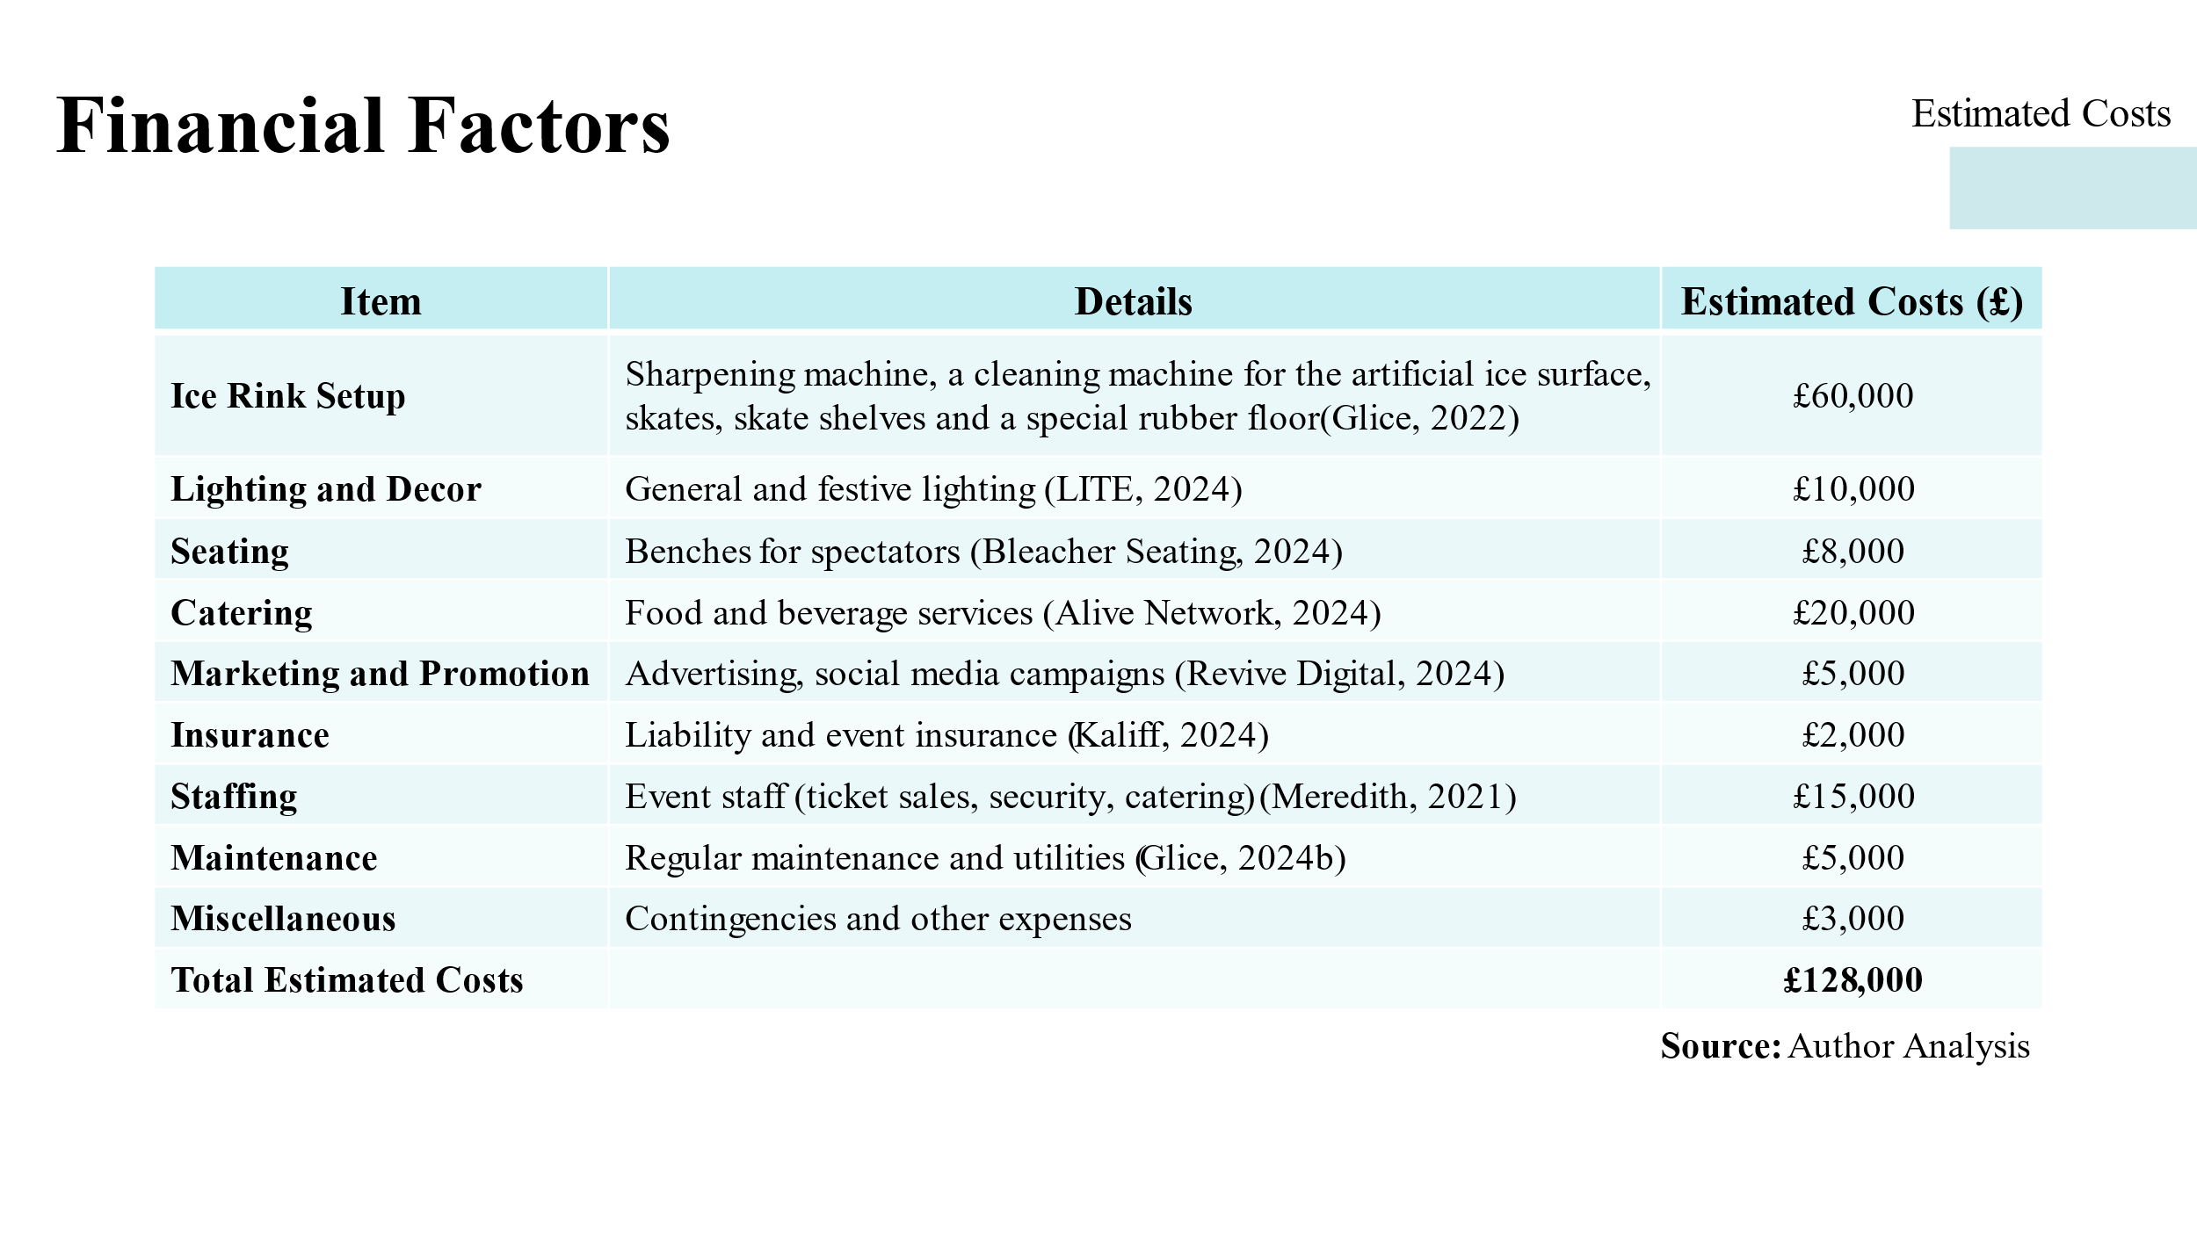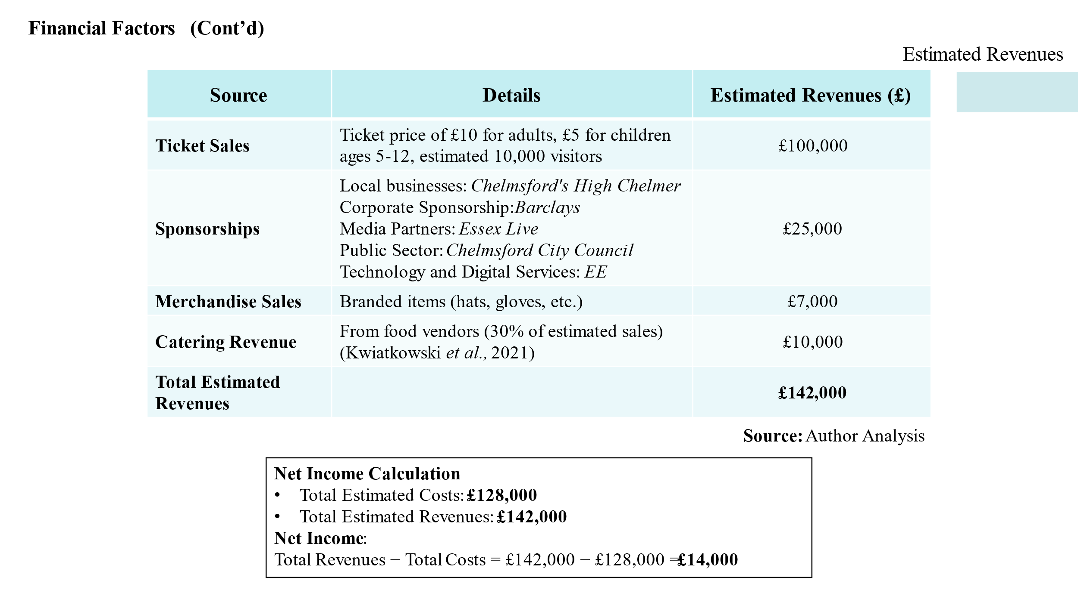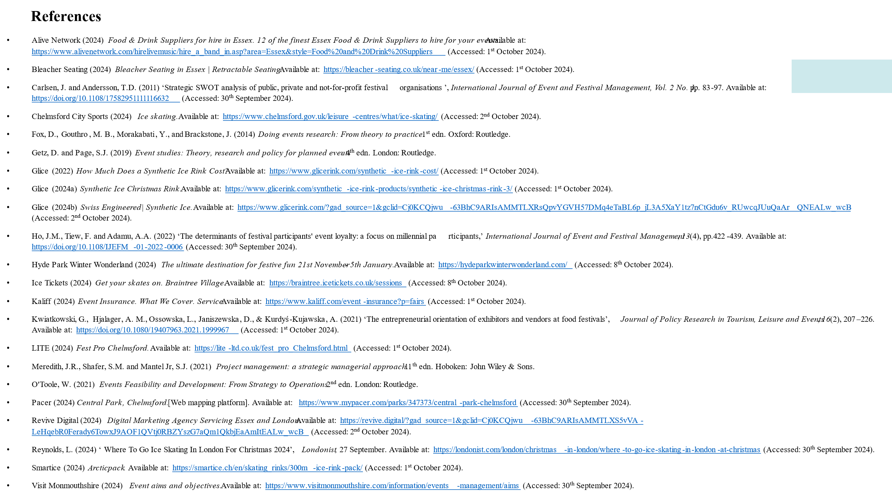

References
Alive Network (2024) Food & Drink Suppliers for hire in Essex. 12 of the finest Essex Food & Drink Suppliers to hire for your events. Available at: https://www.alivenetwork.com/hirelivemusic/hire_a_band_in.asp?area=Essex&style=Food%20and%20Drink%20Suppliers (Accessed: 1st October 2024).
Bleacher Seating (2024) Bleacher Seating in Essex | Retractable Seating. Available at: https://bleacher-seating.co.uk/near-me/essex/ (Accessed: 1st October 2024).
Carlsen, J. and Andersson, T.D. (2011) ‘Strategic SWOT analysis of public, private and not‐for‐profit festival organisations’, International Journal of Event and Festival Management, Vol. 2 No. 1, pp. 83-97. Available at: https://doi.org/10.1108/17582951111116632 (Accessed: 30th September 2024).
Chelmsford City Sports (2024) Ice skating. Available at: https://www.chelmsford.gov.uk/leisure-centres/what/ice-skating/ (Accessed: 2nd October 2024).
Fox, D., Gouthro, M. B., Morakabati, Y., and Brackstone, J. (2014) Doing events research: From theory to practice. 1st edn. Oxford: Routledge.
Getz, D. and Page, S.J. (2019) Event studies: Theory, research and policy for planned events. 4th edn. London: Routledge.
Glice (2022) How Much Does a Synthetic Ice Rink Cost? Available at: https://www.glicerink.com/synthetic-ice-rink-cost/ (Accessed: 1st October 2024).
Glice (2024a) Synthetic Ice Christmas Rink. Available at: https://www.glicerink.com/synthetic-ice-rink-products/synthetic-ice-christmas-rink-3/ (Accessed: 1st October 2024).
Glice (2024b) Swiss Engineered | Synthetic Ice. Available at: https://www.glicerink.com/?gad_source=1&gclid=Cj0KCQjwu-63BhC9ARIsAMMTLXRsQpvYGVH57DMq4eTaBL6p_jL3A5XaY1tz7nCtGdu6v_RUwcqJUuQaArQNEALw_wcB (Accessed: 2nd October 2024).

Ho, J.M., Tiew, F. and Adamu, A.A. (2022) ‘The determinants of festival participants' event loyalty: a focus on millennial participants,’ International Journal of Event and Festival Management, 13(4), pp.422-439. Available at: https://doi.org/10.1108/IJEFM-01-2022-0006 (Accessed: 30th September 2024).
Hyde Park Winter Wonderland (2024) The ultimate destination for festive fun 21st November - 5th January. Available at: https://hydeparkwinterwonderland.com/ (Accessed: 8th October 2024).
Ice Tickets (2024) Get your skates on. Braintree Village. Available at: https://braintree.icetickets.co.uk/sessions (Accessed: 8th October 2024).
Kaliff (2024) Event Insurance. What We Cover. Service. Available at: https://www.kaliff.com/event-insurance?p=fairs (Accessed: 1st October 2024).
Kwiatkowski, G., Hjalager, A. M., Ossowska, L., Janiszewska, D., & Kurdyś-Kujawska, A. (2021) ‘The entrepreneurial orientation of exhibitors and vendors at food festivals’, Journal of Policy Research in Tourism, Leisure and Events, 16(2), 207–226. Available at: https://doi.org/10.1080/19407963.2021.1999967 (Accessed: 1st October 2024).
LITE (2024) Fest Pro Chelmsford. Available at: https://lite-ltd.co.uk/fest_pro_Chelmsford.html (Accessed: 1st October 2024).
Meredith, J.R., Shafer, S.M. and Mantel Jr, S.J. (2021) Project management: a strategic managerial approach. 11th edn. Hoboken: John Wiley & Sons.
O'Toole, W. (2021) Events Feasibility and Development: From Strategy to Operations. 2nd edn. London: Routledge.
Pacer (2024) Central Park, Chelmsford. [Web mapping platform]. Available at: https://www.mypacer.com/parks/347373/central-park-chelmsford (Accessed: 30th September 2024).
Revive Digital (2024) Digital Marketing Agency Servicing Essex and London. Available at: https://revive.digital/?gad_source=1&gclid=Cj0KCQjwu-63BhC9ARIsAMMTLXS5vVA-LeHqebR0Ferady6TowxJ9AOF1QVtj0RBZYszG7aQm1QkbjEaAmItEALw_wcB (Accessed: 2nd October 2024).
Reynolds, L. (2024) ‘Where To Go Ice Skating In London For Christmas 2024’, Londonist, 27 September. Available at: https://londonist.com/london/christmas-in-london/where-to-go-ice-skating-in-london-at-christmas (Accessed: 30th September 2024).
Smartice (2024) Arcticpack. Available at: https://smartice.ch/en/skating_rinks/300m-ice-rink-pack/ (Accessed: 1st October 2024).
Visit Monmouthshire (2024) Event aims and objectives. Available at: https://www.visitmonmouthshire.com/information/events-management/aims (Accessed: 30th September 2024).

