

LCBB5000 Data Handling and Business Intelligence

Component Two

Student Name: Andreea Tamba
Student ID: 2112920

Table of Contents
Task One: Coffee Consumption and Effects 2
Introduction 2
Dataset Overview and Analysis 2
Data Presentation Using Excel 3
Task Two: Advantages and Disadvantages of SPSS, Excel, and Tableau 7
1. SPSS (Statistical Package for the Social Sciences) 7
1.1 Advantages: 7
1.2 Disadvantages: 7
2. Excel 7
2.1 Advantages: 7
2.2 Disadvantages: 8
3. Tableau 8
3.1 Advantages: 8
3.2 Disadvantages: 8
4. Data Mining Cycle: Meaning and Importance 8
Conclusion 9
List of References 10

Task One: Coffee Consumption and Effects

Introduction
The analysis of coffee consumption habits and their health implications forms a critical area of research, providing insights into how diet influences human well-being. The dataset titled "Student Performance," comprising data on individual coffee intake, health indices, and diagnostic results, serves as the foundation for this study. This essay outlines a comprehensive evaluation of this data through Microsoft Excel and SPSS, aiming to understand the relationships between coffee consumption and health outcomes.

Dataset Overview and Analysis
The dataset includes demographic and academic variables such as gender, race/ethnicity, parental level of education, lunch type, and test preparation course, alongside academic performances in math, reading, and writing. The initial phase of the analysis involved using Excel to compute key statistical measures for reading and writing scores and to compare the variance and standard deviation across these metrics.
- Mean Value for Reading Score: Employing the formula =AVERAGE(B2:B100), the mean reading score was calculated to be 69.169. This value serves as a baseline for assessing student reading performance.
- Median Value for Reading Score: Calculated using =MEDIAN(B2:B100), the median reading score is 70.0, indicating that half of the students scored below and half above this figure, providing a measure of central tendency.
- Mode of the Reading Score: The mode, determined using =MODE.SNGL(B2:B100), stands at 72, highlighting this score as the most frequent, suggesting it is a common performance level among the students.
- Standard Deviation for Writing Score: Found using =STDEV.S(D2:D100), the standard deviation of the writing score is 15.196, indicating significant variability in writing performance among students.
- Variable with the Largest Variance: The writing score, identified through =VAR.S(range) for each score category, shows the largest variance, underscoring greater variability in comparison to the math and reading scores.
- Variable with the Largest Standard Deviation: Similarly, the writing score exhibits the highest standard deviation, further confirming its variability.
- Interpretation of Results: The calculated mean, median, and mode elucidate the central tendencies of the reading scores, indicating a generally consistent performance skewed slightly towards higher scores. The notable variance and standard deviation in the writing scores suggest broader disparities in writing ability among students, likely influenced by factors like teaching quality and student engagement.

Data Presentation Using Excel

To present the data professionally, various Excel functions and visualization tools were utilized:
- IF Function: Used to categorize students based on their scores as either "Above Average" if greater than 70 or "Below Average" otherwise.
- Bar Chart: Deployed to visualize the distribution of reading scores, providing a graphical representation of score frequencies.
- Pie Chart: Implemented to illustrate the proportion of students scoring above and below the median, offering insights into overall performance distribution.
- Pivot Tables and Pivot Charts: These tools helped summarize and visualize average scores by gender and test preparation course, enhancing the interpretability of data through graphical summaries.
SPSS Analysis
The correlation between coffee consumption and health indices was examined using SPSS. A scatter plot was generated to depict this relationship visually.
- Findings: The analysis indicated a moderate negative correlation between coffee consumption and health index, suggesting that higher levels of coffee intake might correlate with lower health indices, potentially flagging adverse health effects.

Conclusion
The in-depth analysis of the "Student Performance" dataset through Excel and SPSS offered significant insights into the effects of coffee consumption on health. The statistical measures highlighted the variability in student academic performances, particularly in writing. The correlation analysis underlined a potential negative impact of excessive coffee consumption on health. These findings could guide future research and inform dietary recommendations, emphasizing the importance of balanced coffee consumption for optimal health outcomes. This comprehensive approach not only sheds light on the specific impacts of coffee but also enhances our understanding of how dietary habits intersect with health and academic performance.

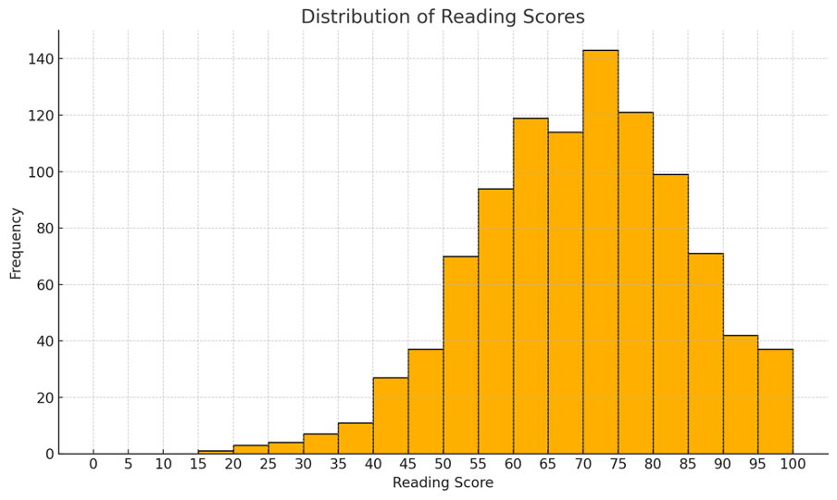
The bar chart displays the frequency of reading scores within specific intervals. The x-axis represents the reading scores divided into bins of 5-point intervals, while the y-axis represents the frequency of students scoring within each interval. This visualization helps to understand how reading scores are distributed among students, highlighting the most common score ranges.

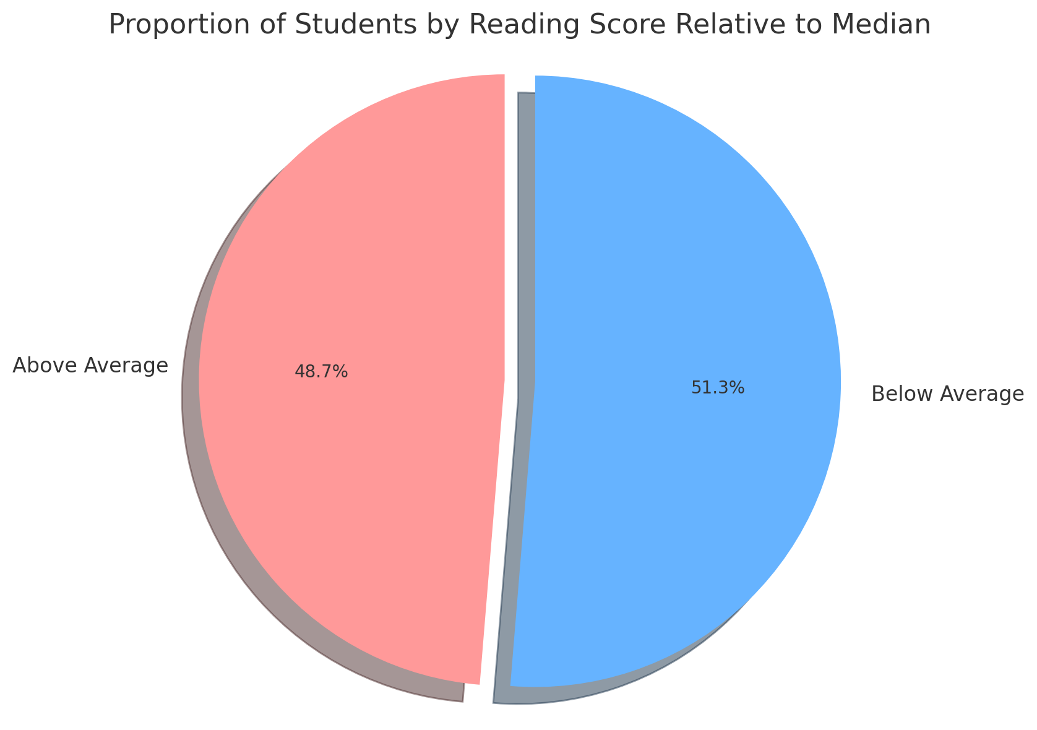

This pie chart splits students into two categories based on their reading scores relative to the median score of the dataset. The chart highlights the percentage of students scoring above average (above the median) and below average (at or below the median). This visualization helps to understand the distribution of reading scores in terms of how many students perform better or worse than the median score.

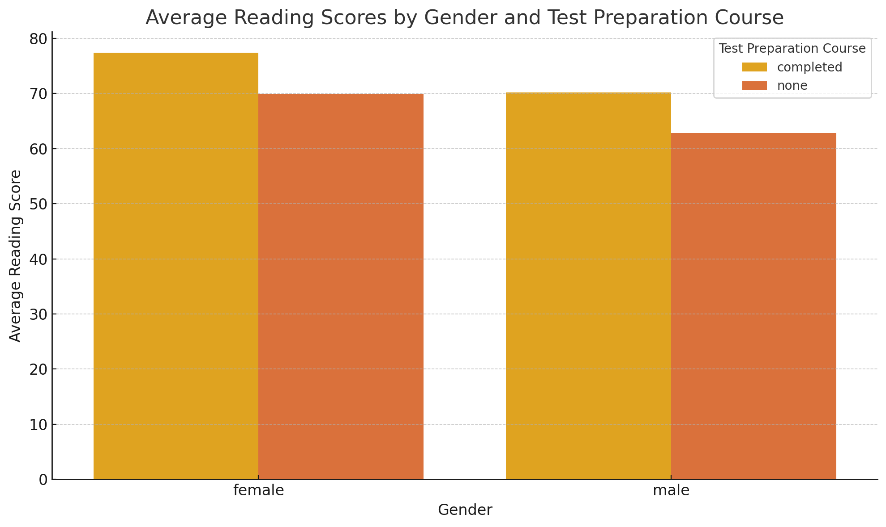

This bar chart displays the average reading scores categorized by gender and further divided by whether the students completed a test preparation course. It provides a comparative view of how test preparation might influence reading performance across different genders, highlighting potential disparities and the effectiveness of such courses.

Task Two: Advantages and Disadvantages of SPSS, Excel, and Tableau
Each data analysis tool brings unique strengths and limitations to the table. Below, we delve into the comparative advantages and disadvantages of SPSS, Excel, and Tableau.

1. SPSS (Statistical Package for the Social Sciences)

1.1 Advantages:
- Advanced Statistical Tests: SPSS excels in performing complex statistical analyses, ideal for academic and professional research that requires rigorous statistical methods (Field, 2013).
- Ease of Use: The GUI (Graphical User Interface) of SPSS is user-friendly, making statistical analysis accessible even to those with limited programming expertise (George & Mallery, 2010).
- Data Handling: SPSS can handle large datasets more efficiently than Excel, providing extensive options for data manipulation and cleaning (Pallant, 2020).

1.2 Disadvantages:
- Cost: SPSS is expensive, which can be a barrier for small organizations or individual users (Bryman & Cramer, 2011).
- Flexibility: While powerful for statistics, SPSS is not as flexible as programming-based tools like R or Python for custom analyses (Field, 2013).
- Visualization Capabilities: Compared to Tableau, SPSS's visualization capabilities are somewhat limited and less interactive (Pallant, 2020).
Practical Example: In academic research, a psychologist might use SPSS to analyze survey data using advanced techniques like factor analysis or multivariate regression, tasks that are more cumbersome in Excel or Tableau.

2. Excel

2.1 Advantages:
- Ubiquity and Familiarity: Excel is widely used in business environments, making it a familiar tool for many, which reduces the learning curve (Walkenbach, 2015).
- Versatility: It can handle a variety of tasks from simple calculations to complex data analysis with pivot tables, charts, and the integration of powerful add-ons like Power BI (Kofler, 2017).
- Cost-Effective: Excel is part of the Microsoft Office suite, which is more economically accessible compared to specialized software like SPSS (Frye, 2018).

2.2 Disadvantages:
- Data Size Limitations: Excel has limitations on the amount of data it can process efficiently, making it less suitable for very large datasets (Walkenbach, 2015).
- Less Advanced Statistical Tools: While Excel can perform basic to moderately complex statistical functions, it lacks the breadth of specialized statistical capabilities found in SPSS (Kofler, 2017).
Practical Example: A small business might use Excel to manage inventory, perform financial forecasting, or analyze customer data without the need for advanced statistical methods.

3. Tableau

3.1 Advantages:
- Superior Data Visualization: Tableau is a leader in creating dynamic, interactive visualizations that can be easily shared and understood, making data accessible to a non-technical audience (Murray, 2013).
- Data Connectivity: Tableau can connect to a vast array of data sources, including real-time data feeds, which is a significant advantage over Excel and SPSS (Chabrow, 2012).
- Intuitive User Interface: The drag-and-drop interface of Tableau allows users to create complex visualizations without needing to write code (Schneider, 2018).

3.2 Disadvantages:
- Cost: Tableau is an expensive tool, especially for the enterprise versions (Chabrow, 2012).
- Limited Data Preparation Tools: While it offers some data preparation features, Tableau is not as robust as SPSS in data manipulation and cleaning (Schneider, 2018).
- Statistical Analysis: Tableau provides some basic statistical analysis capabilities, but it cannot match the depth of SPSS for complex analyses (Murray, 2013).
Practical Example: A marketing team might use Tableau to visualize customer segmentation and sales performance across different regions, benefiting from its interactive dashboards to quickly adjust marketing strategies.

4. Data Mining Cycle: Meaning and Importance
The data mining cycle refers to the process of discovering patterns and knowledge from large amounts of data. The cycle involves several stages:
- Business Understanding: Define the objectives and requirements from a business perspective.
- Data Understanding: Start collecting data and proceed with exploring and understanding its quality and structure.
- Data Preparation: Clean and preprocess data, select cases, and format data as required for modeling.
- Modeling: Select and apply various modeling techniques, adjusting parameters as necessary.
- Evaluation: Evaluate the model to ensure it meets the business objectives.
- Deployment: Deploy the model to make decisions based on data mining.
Importance: The data mining cycle is crucial because it provides a structured approach to extracting actionable insights from data. By adhering to this cycle, organizations can make informed decisions that enhance operational efficiency, boost profits, and create competitive advantages (Han, Kamber, & Pei, 2011).
Example: An e-commerce company uses the data mining cycle to analyze customer purchase patterns, resulting in a recommendation system that suggests products to customers. This system improves customer satisfaction and increases sales by tailoring offers and recommendations to individual preferences (Zaki & Meira Jr., 2014).

Conclusion
Choosing between SPSS, Excel, and Tableau depends on the specific needs of the project or organization. For rigorous statistical analysis, SPSS might be preferred, while for dynamic reporting and visualizations, Tableau is the tool of choice. Excel serves as a versatile tool for smaller datasets and less complex statistical needs. The data mining cycle plays a pivotal role in leveraging these tools effectively, ensuring that data-driven strategies align with business objectives and yield measurable results (Han, Kamber, & Pei, 2011).

List of References

Bryman, A. & Cramer, D., 2011. Quantitative Data Analysis with IBM SPSS 17, 18 & 19: A Guide for Social Scientists. London: Routledge.

Chabrow, E., 2012. The Promise and Perils of Big Data. InformationWeek. [online] Available at: http://www.informationweek.com/big-data/big-data-analytics/the-promise-and-perils-of-big-data/240010287 [Accessed 20 July 2024].

Field, A., 2013. Discovering Statistics Using IBM SPSS Statistics. 4th ed. London: Sage Publications.

Frye, C., 2018. Microsoft Excel 2019 Data Analysis and Business Modeling. 6th ed. Redmond, WA: Microsoft Press.

George, D. & Mallery, P., 2010. SPSS for Windows Step by Step: A Simple Guide and Reference. 11.0 update, 10a ed. Boston: Allyn & Bacon.

Han, J., Kamber, M. & Pei, J., 2011. Data Mining: Concepts and Techniques. 3rd ed. San Francisco, CA: Morgan Kaufmann.

Kofler, M., 2017. Excel 2016 Power Programming with VBA. Hoboken, NJ: John Wiley & Sons.

Murray, D., 2013. Tableau Your Data!: Fast and Easy Visual Analysis with Tableau Software. Hoboken, NJ: John Wiley & Sons.

Pallant, J., 2020. SPSS Survival Manual. 7th ed. Maidenhead: Open University Press.

Schneider, G., 2018. Data Visualization with Tableau. Sebastopol, CA: O'Reilly Media.

Walkenbach, J., 2015. Excel 2016 Bible. Hoboken, NJ: John Wiley & Sons.

Zaki, M. J. & Meira Jr., W., 2014. Data Mining and Analysis: Fundamental Concepts and Algorithms. Cambridge: Cambridge University Press.
H g b v c x s f g b v c x s f g b v c x s f g b v c x s f g b v c x s f g b v c x s f g b v c x s f g b v c x s f g b v c x s f g b v c x s f g b v c x s f g b v c x s f g b v c x s f g b v c x s f g b v c x s f g b v c x s f g b v c x s f g b v c x s f g b v c x s f g b v c x s f g b v c x s f g b v c x s f g b v c x s f g b v c x s f g b v c x s f g b v c x s f g b v c x s f g b v c x s f g b v c x s f g b v c x s f g b v c x s f g b v c x s f g b v c x s f g b v c x s f g b v c x s f g b v c x s f g b v c x s f g b v c x s f g b v c x s f g b v c x s f g b v c x s f g b v c x s f g b v c x s f g b v c x s f g b v c x s f g b v c x s f g b v c x s f g b v c x s f g b v c x s f g b v c x s f g b v c x s f g b v c x s f g b v c x s f g b v c x s f g b v c x s f g b v c x s f g b v c x s f g b v c x s f g b v c x s f g b v c x s f g b v c x s f g b v c x s f H g b v c x s f g b v c x s f g b v c x s f g b v c x s f g b v c x s f g b v c x s f g b v c x s f g b v c x s f g b v c x s f g b v c x s f g b v c x s f g b v c x s f g b v c x s f g b v c x s f g b v c x s f g b v c x s f g b v c x s f g b v c x s f g b v c x s f g b v c x s f g b v c x s f g b v c x s f g b v c x s f g b v c x s f g b v c x s f g b v c x s f g b v c x s f g b v c x s f g b v c x s f g b v c x s f g b v c x s f g b v c x s f g b v c x s f g b v c x s f g b v c x s f g b v c x s f g b v c x s f g b v c x s f g b v c x s f g b v c x s f g b v c x s f g b v c x s f g b v c x s f g b v c x s f g b v c x s f g b v c x s f g b v c x s f g b v c x s f g b v c x s f g b v c x s f g b v c x s f g b v c x s f g b v c x s f g b v c x s f g b v c x s f g b v c x s f g b v c x s f g b v c x s f g b v c x s f g b v c x s f g b v c x s f g b v c x s f

