Networking operating systems and services

Worksheet 4 – Module code: ACCA5023
  - Samuel Richards – Student number 1901717

Table of Contents
Task 1 Utilising ARP and Routing Tables 2
Task 2 Deploy Core Services (FTP Server) 3
On to Client 2 7
Task 3 Installing and Configuring the Routing and Remote Access Service 9
Task 4 IP Packet Filtering 13
Client 1 Ping 14
Filter 2 14
Client 1 Ping 15
Task 5 Failover Clustering for High Availability Systems/Services 16
Task 6 Observational Tasks 16

Task 1 Utilising ARP and Routing Tables
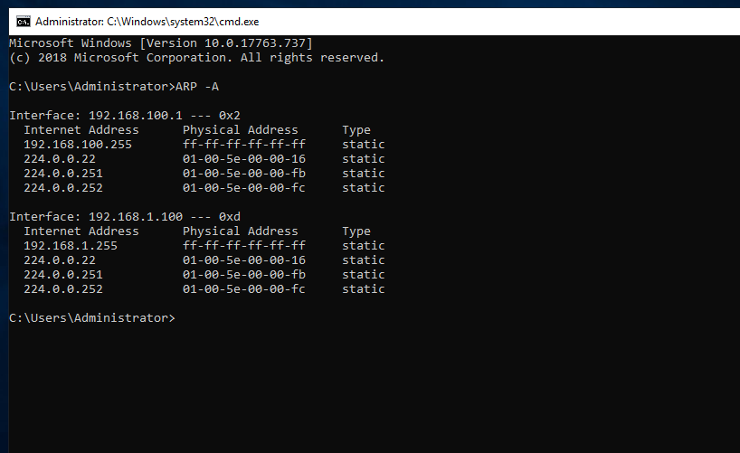
First instruction was to log on to server 1, run command prompt and then run the command “ARP -A”.
What came back from the request is the interface NIC’s and the physical addresses.

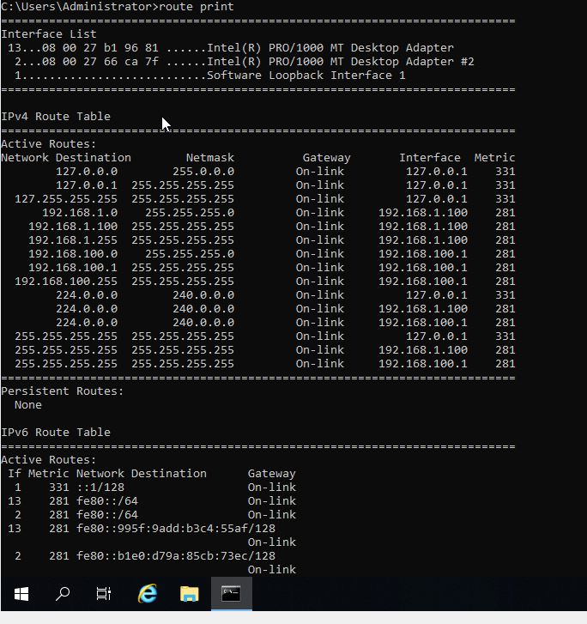

Next step was to run the command prompt again and run a command “route print” this command brings back a lot of information such as the netmask, Gateways, interfaces, and metrics of which is being run in the background of the workstation.

Task 2 Deploy Core Services (FTP Server)
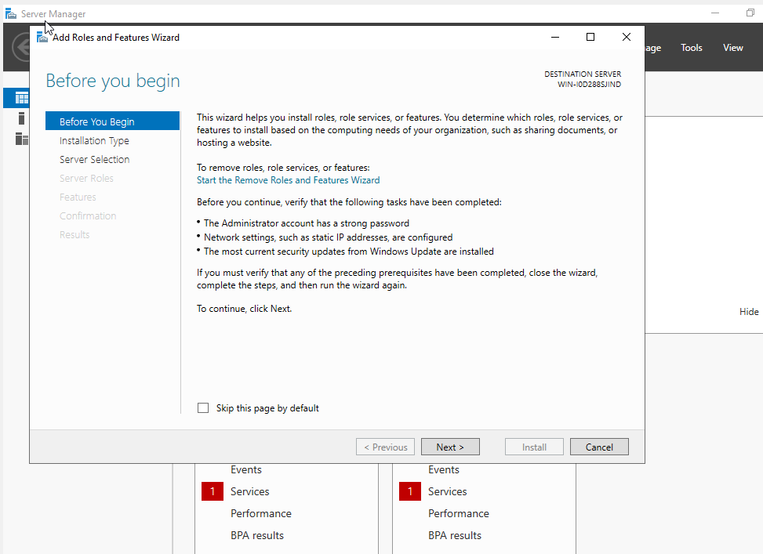
Firstly, step 1 was to start up server 2 and launch the server manager and start the process with “Add roles and features”.

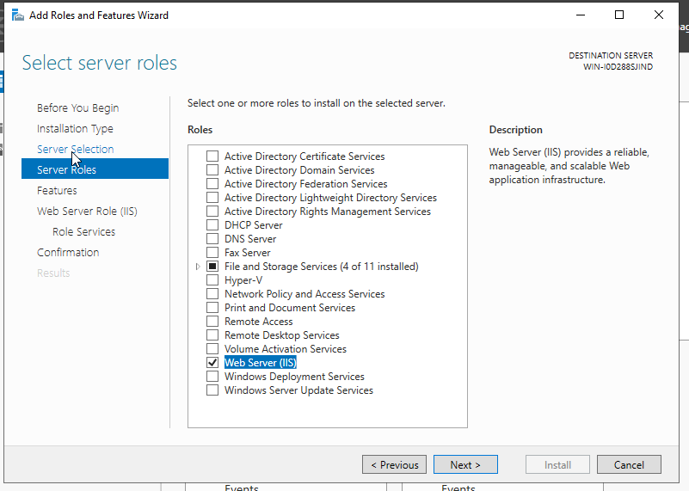

Going through the settings, ensuring that the right server is being used, as well as checking the correct boxes adding features.

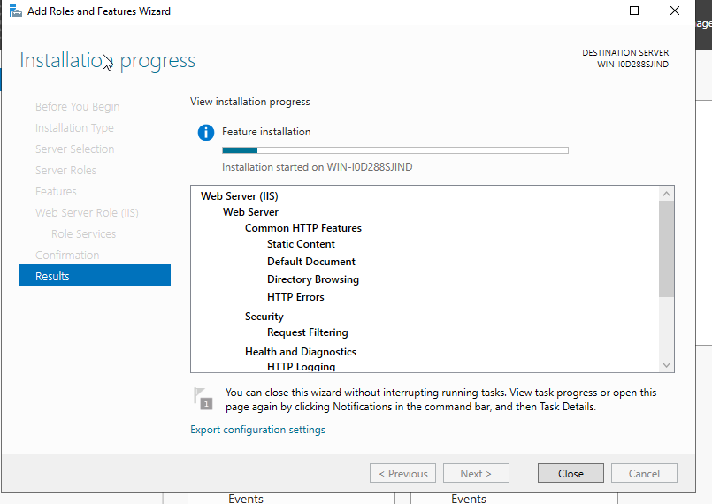
Came to the end of the process and started the install like instructed.

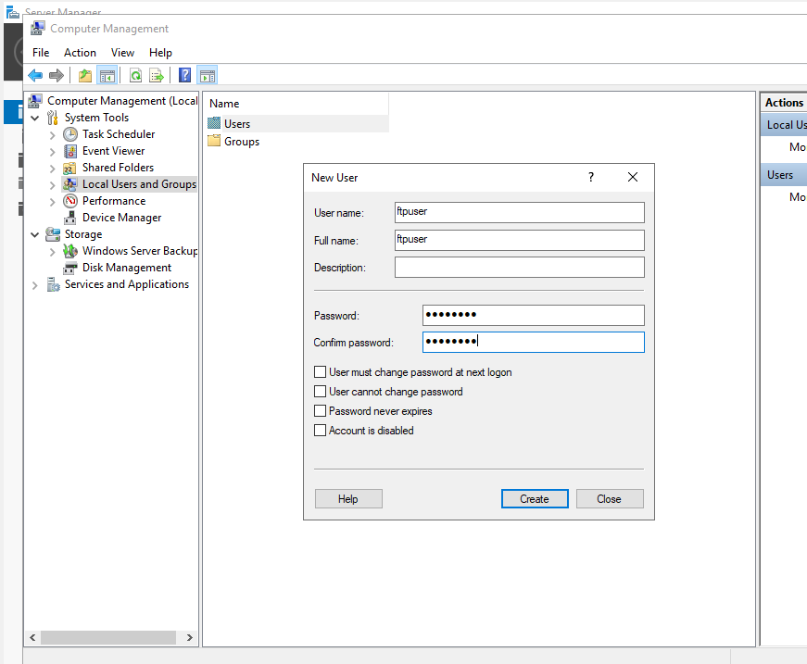

After the install was completed, the next step would be open tools and enter “Computer Management” and create a new user under “Local Users and groups”. Next, I ENSURED that I turned off/checked off “user must change password at next logon” and filled in the relevant fields.

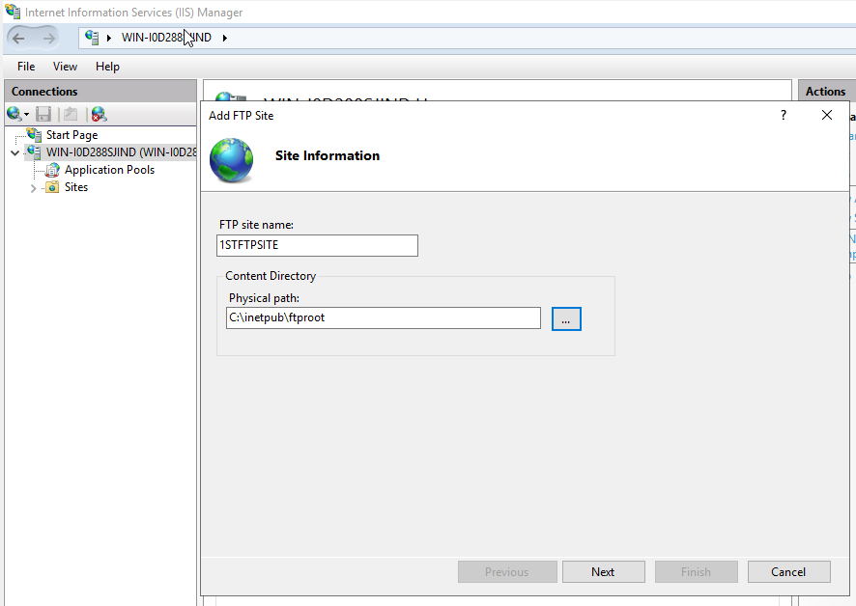
The next step was to go back to server manager open up tools again and choose “internet information services (IIS) Manager” and then navigate to this point on the left-hand side. Next was to fill in the relevant information.

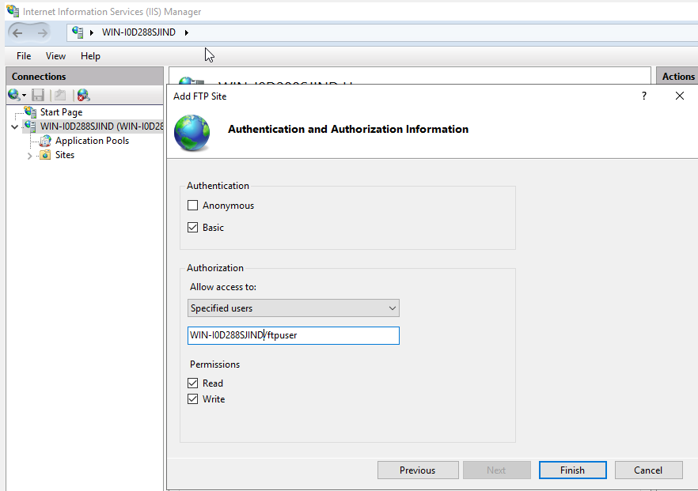
Again, followed through with the steps, when it came to the name, I double checked by using command prompt command “Hostname” in which came back with “WIN-I0D288SJIND”.

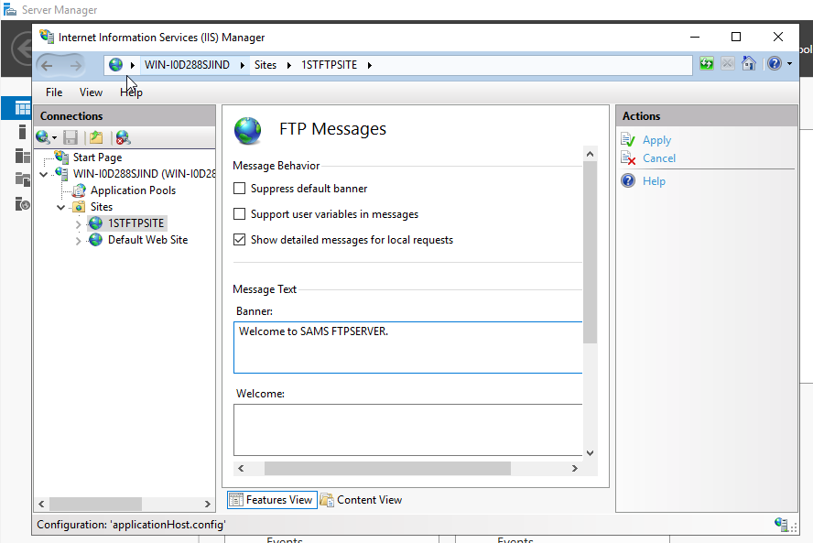
The next step was to set up a banner for the serve created, naviagted through the setting such as tools and IIS Manager and eventually set up the banner for the server.

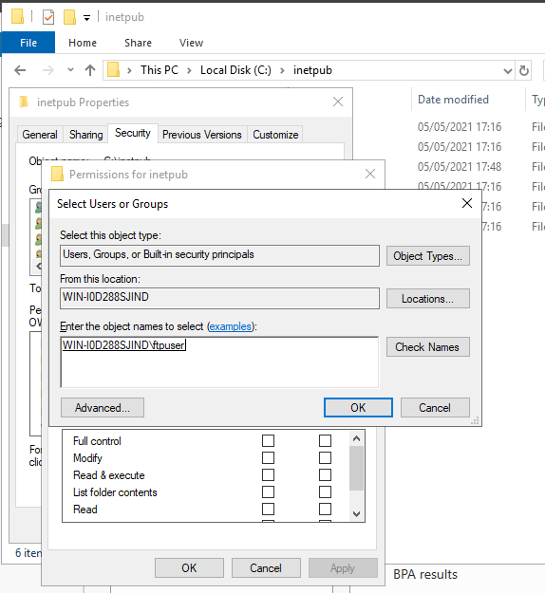

The next step was to ensure that we can use the FTPService, which meant checking on one last permission in the file system.
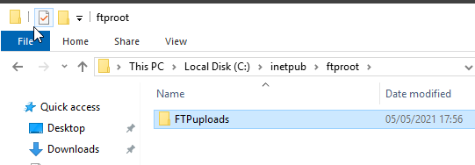

Also, was instructed to create a folder within ftproot folder name it “FTPuploads”.

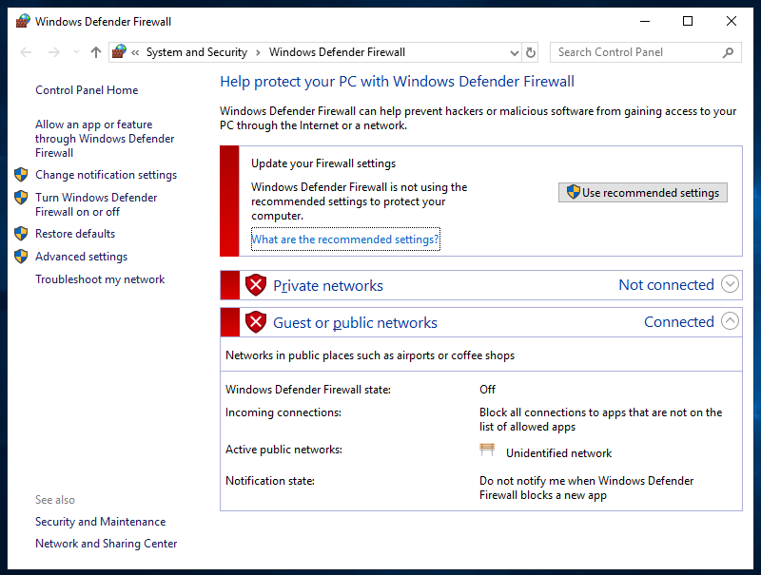
Final step on server 2 was to ensure that all firewalls were tuned off.

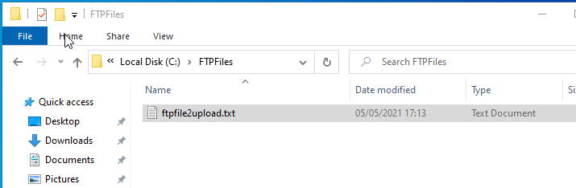
On to Client 2

Logged on to client 2, was instructed to create a new folder in the C: Directory and to name that folder a specific name which was done, but then was then asked to create a new text file within that folder, and again was instructed to name it “ftpfile2upload.txt”.

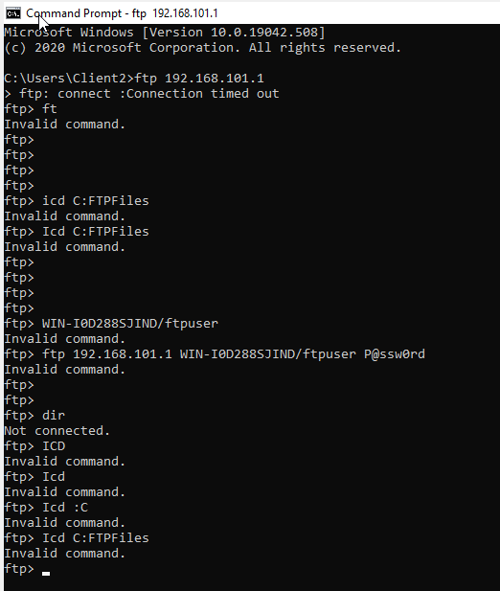
Was then instructed to go to command prompt and enter specific lines of command, which did not work, as you can see, many of them which came out as “Invalid Command”.

Task 3 Installing and Configuring the Routing and Remote Access Service
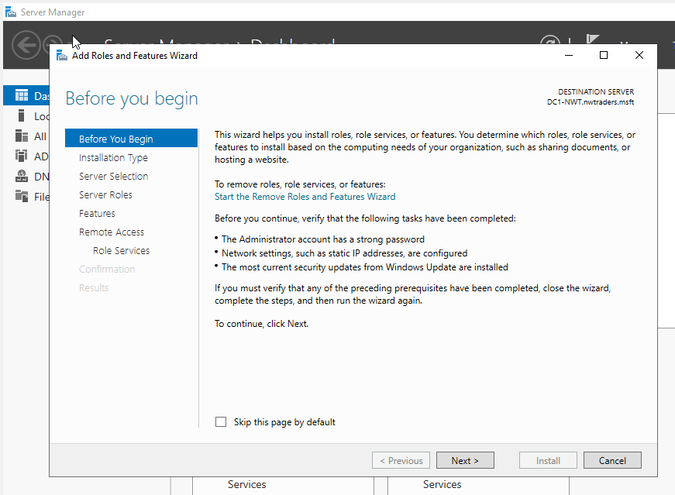

To begin with this task, it begins with starting up server manager and starting the process of “add roles and features”

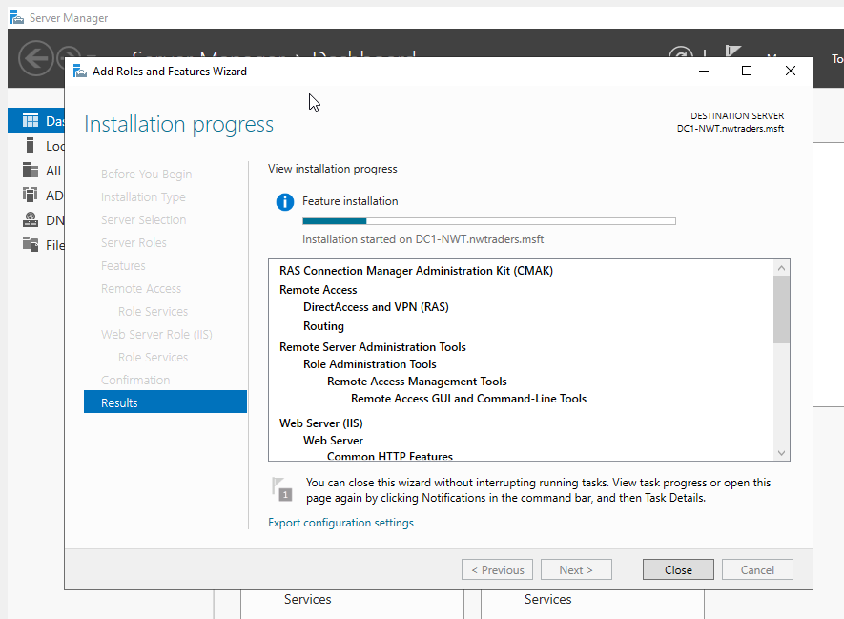

Gone through the whole processes and checked relevant features on, such as remote access.

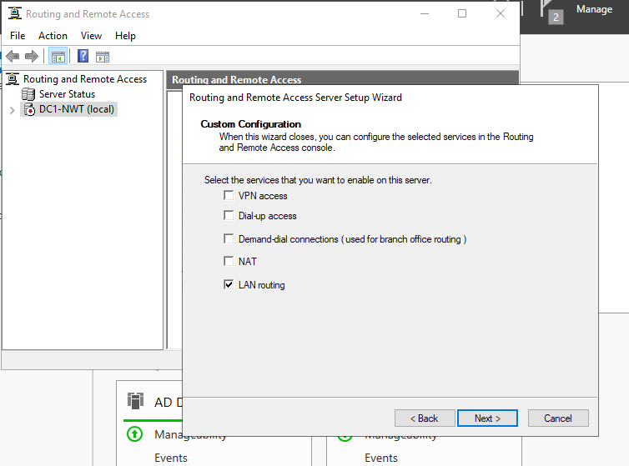
After the installation, next was to presume through the “Getting started wizard”.

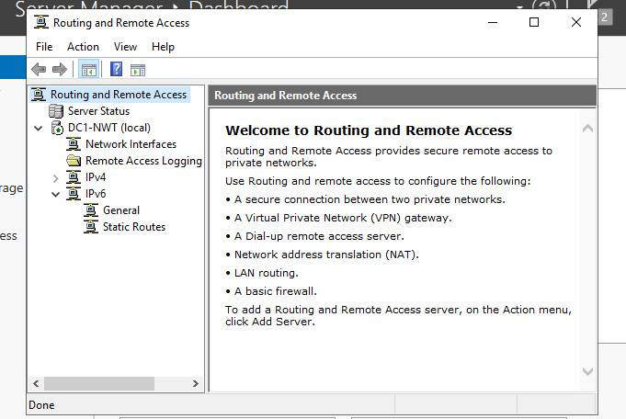
After finishing the installation, the service started running, as you can see from the green arrow next to the server’s name on the left-hand side.

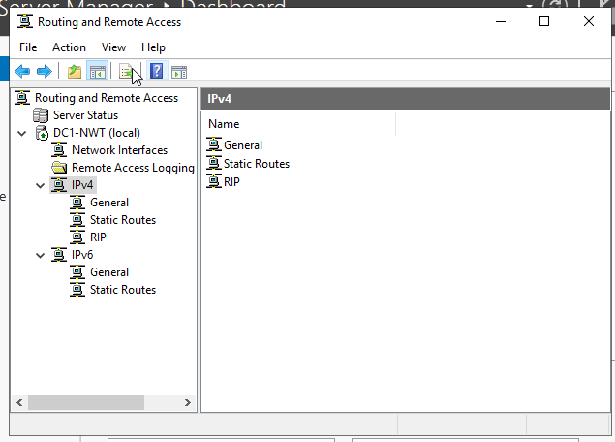
Afterwards was to presume to the IPV4 on within the server and chose a new “Routing Protocol” in which is the RIP as you can see from the image on the left-hand side.

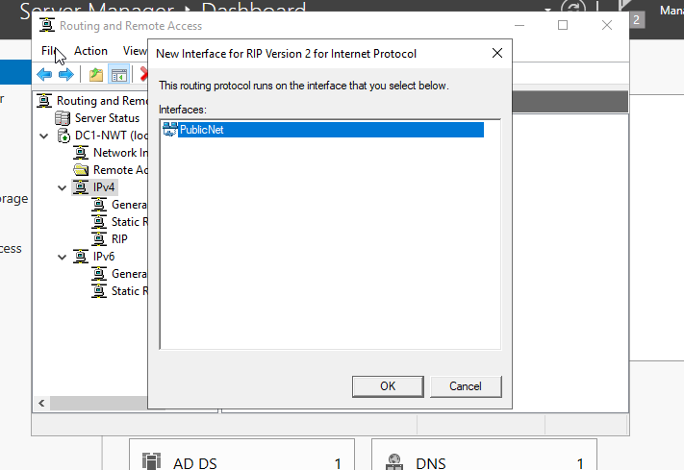
Next was to head into the new “RIP protocol” and add in the two new interfaces, only one is shown in the image because one has been done already.

The previous steps would be repeated for Server 2 as well.

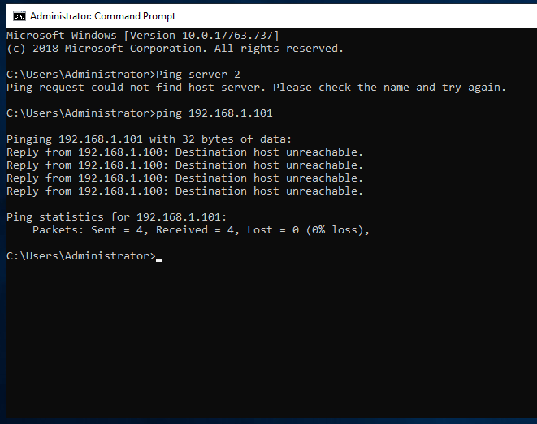
The next step was log back on to server 1, and attempt pinging server 2 through the “PublicNet” IP Address. Which as you can see from the left-hand side image was a success.

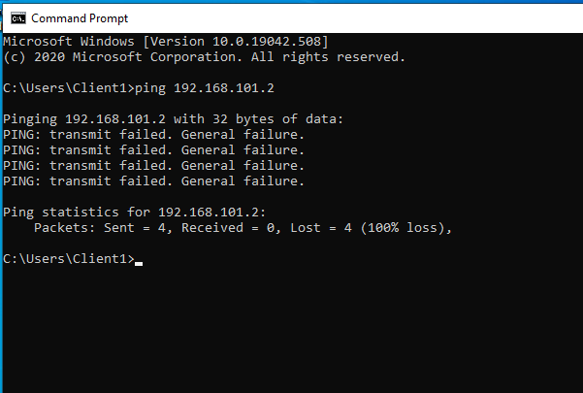

Repeated the steps for the Client 1 pining to client with the “PrivateNet2” IP Address, in which as you can see was a complete failure.

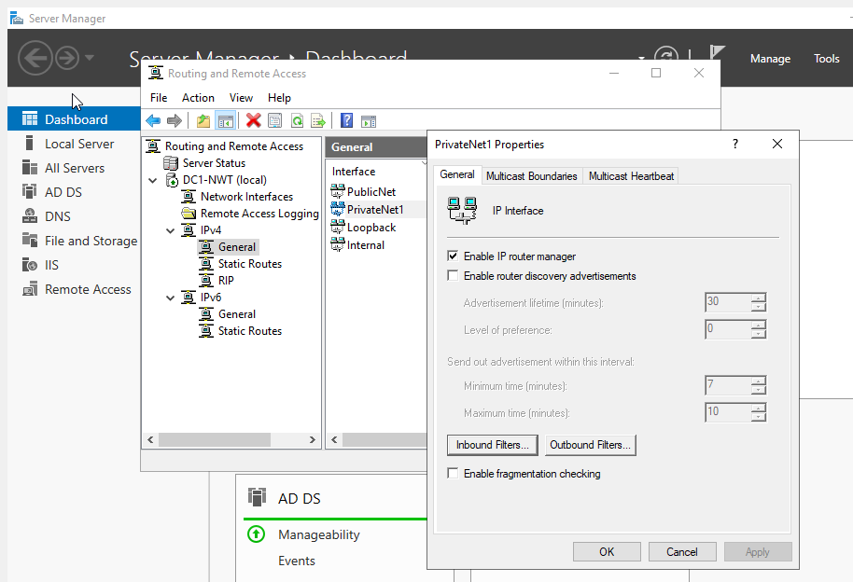
Task 4 IP Packet Filtering

Task 4 begins with logging on to server 1 and starting up the server manager as well as the “Routing and Remote Access”.

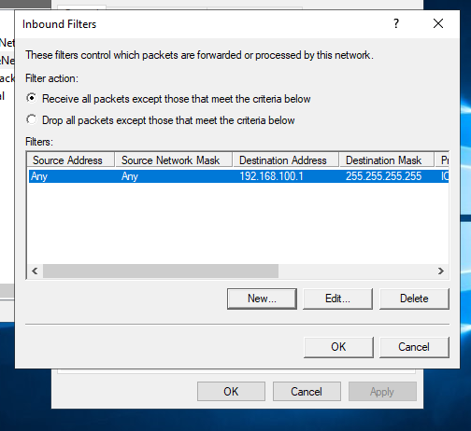

This stage is the finishing up, the step was to fill in the information prior to the screenshot which involved filling in the IP Address and the subnet mask. Then this screenshot was ensuring that the right option was selected.

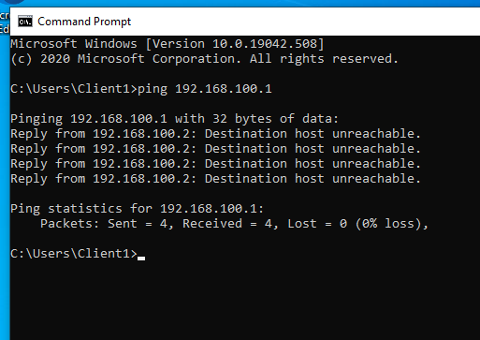

Client 1 Ping
With client 1, a ping approach to 192.168.100.1 was done and was successful.

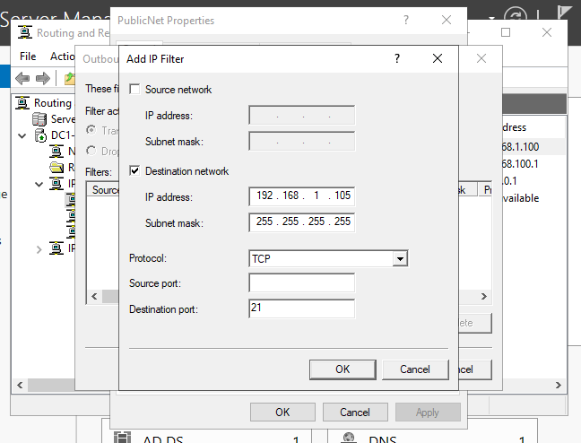
Filter 2
Same thing as of start-up, server 1 then start up the server manager, then go through the tools and click on routing and remote access and then navigate to this page and fill out the relevant information.
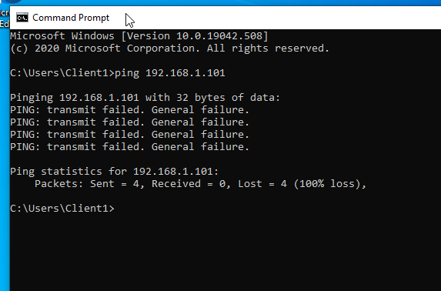

Client 1 Ping
With client 1, a ping approach to 192.168.1.101 was done and was failure.

Task 5 Failover Clustering for High Availability Systems/Services
Firstly, a Failover cluster is a feature in which you would add/check on to the set up of a local server when you are in the server manager application. The Failover cluster would help to protect the virtual machines. However, it is a separate application to the virtual machine [1]. But all in all, Failover cluster is a set of computer servers working together to provide either a High-Availability (HA) or a Continuous-Availability (CA). It is also known as a back up feature, because if one of the servers does go down [2], then another in the cluster can take on its workload with no downtime taken on.

Task 6 Observational Tasks
The policy that has been created will apply to all who uses this server/network. Firstly, Password security – Every user would have the responsibility to strengthen their password but there will be safeguards in motion, such as Passwords would have to be at least 8 characters long, involve upper and lower case as well as numbers and special characters. Another safeguard would be the password expire; the password would have to be changed every few months. But one of the most important safeguards is that the password must not be disclosed to anyone, if there is any suspicion then the authorised user must change it immediately.
System privileges – which is limiting system access to people who need it. When it comes to people/ users having access to certain areas on the server is because they are authorised to do so. This policy is to allow people to have those access rights to that area such as HR having access to employee’s information, they are allowed because it is part of their job, no one else would be able to have access to that.
Protection – All users have the responsibility for keeping their workstations up to date with the anti-virus software updates and so on. The anti-virus software must be used to conduct searches/scans daily to ensure that the workstation is kept safe and clean from harmful viruses.
Data BACK UP - Users are again responsible for backing up any information stored on the workstation. The reason why they must do this is because the admin oversees making any monthly or even weekly back ups which must be conducted, in order of keeping the workstation up to scratch.

References

[1] | “How to set up and manage a Hyper-V Failover Cluster, Step by step,” ALTARO, [Online]. Available: https://www.altaro.com/hyper-v/failover-cluster-manager/. [Accessed 03 05 2021].
[2] | J. Emigh, “What is Failover Clustering?,” ServerWatch, 15 05 2019. [Online]. Available: https://www.serverwatch.com/server-news/failover-cluster/. [Accessed 06 05 2021].

