Homework sheet
- practise your handwriting
jī
chicken
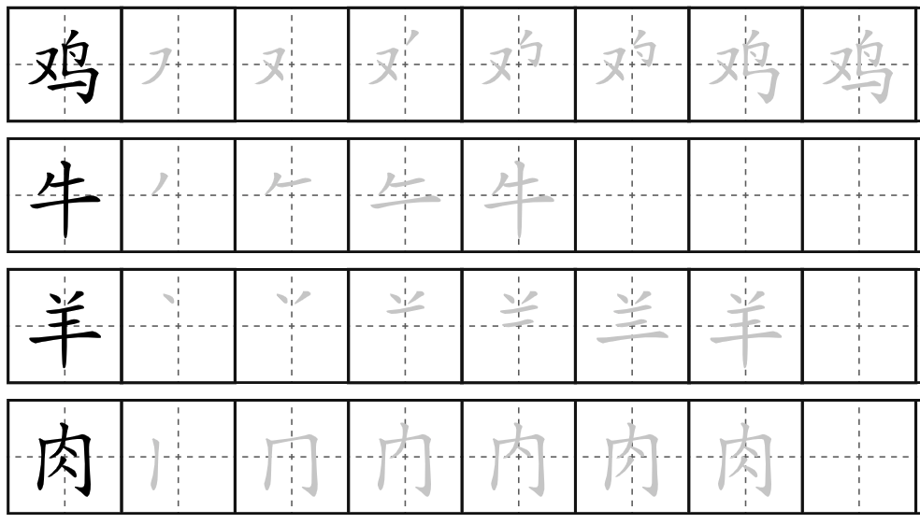
ròu
meat
niú
cow
yáng
sheep
lamb

- Answer the following questions
- Q: 你要吃什么?
A: 我要吃牛肉炒面。(Dw i eisiau bwyta nwdls cig eidion wedi’i ffrio.)
- Q: 你要喝什么?
A: 我要喝红茶。(Dw i eisiau yfed te coch.)
- Q: 妈妈要吃什么?
A: 她要吃羊肉炒饭。(Mae hi eisiau bwyta reis cig oen wedi’i ffrio.)
- Q: 爸爸要喝什么?
A: 他要喝奶茶。(Mae e eisiau yfed te gyda llaeth.)

- Translate the following sentences
- Mae coffi yn blasus iawn! 咖啡太好喝了
- Dydy te du ddim yn flasus. 茶不好喝
- Mae nwdls wedi’i ffrio yn blasus. 炒面很好吃
- Dydy reis wedi’i ffrio ddim yn blasus. 炒饭不好吃
- Mae nwdls cig eidion mor blasus. 牛肉面太好吃了
- Describe whether the food or the drink in the picture is delicious or not.
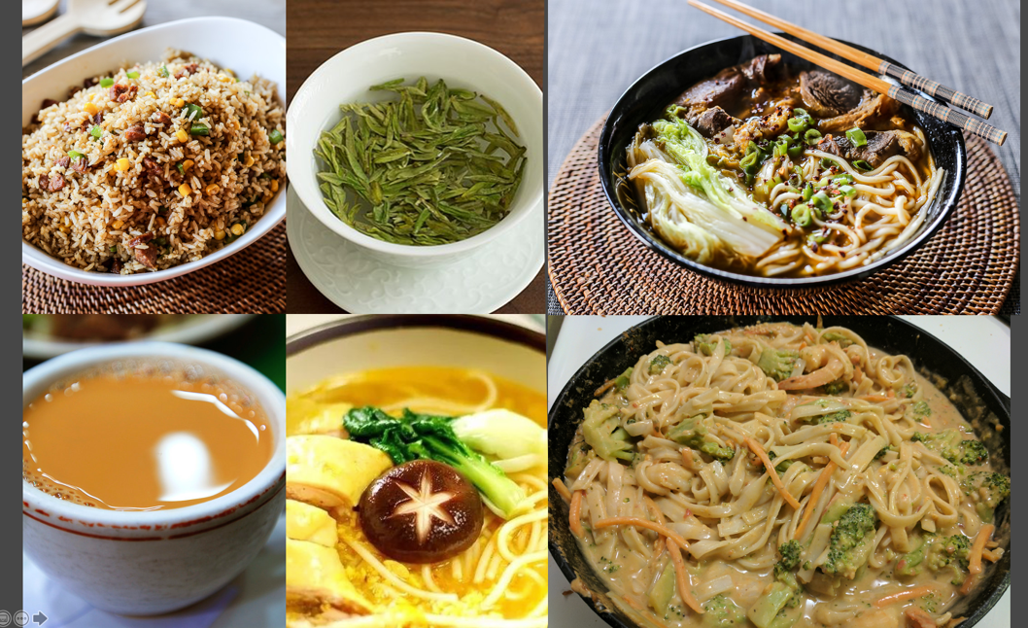

我觉得炒饭太好吃了
我觉得绿茶很好喝
我觉得面和肉太好吃了
我觉得奶茶很好喝
我觉得面和鸡蛋很好吃
我觉得菜面很好吃

- Type a paragraph to introduce yourself and your family. Then recording yourself reading it afterwards. (Please feel free to look up the words you are not sure about, e.g.: jobs and adjectives that are not included in our lesson. I will give you some feedback on that afterwards.)
you can talk about:
- your name
- your nationality
- your age and birthday
- your job and location
- the subject you teach
- people in your family (What are they like? What are their jobs?)
- your pet
- Chinese food you want to eat
- Chinese tea that you would like to drink

我叫茉莉。 我是威尔士人。我二十二岁。我的生日是九月二号。我是英语老师。我在法国工作。我家有四口人。我的爸爸是医生。我的妈妈是公务员。我的父母在威尔士工作。我有一个弟弟。他是中学生。我有两只宠物。我有一只狗。我的狗叫 Lola。Lola 又(yòu)聪明又漂亮。我有一只仓鼠。我的仓鼠叫Oreo。Oreo又小又可爱。我爱炒饭。我要吃牛肉炒面和海鲜炒面。我要上中餐厅(shàng zhōng cāntīng)。 我要喝绿茶和红茶。

6. Cultural study
Recording:
https://us02web.zoom.us/rec/share/3Q5InxPg979mi-d1NIXfzO31Z1y9KY9vM3Ju_Oj7hQmKxkySqaEFiOE69-nEVuKv.uYWnJ9ZJdKr_UZep
Passcode: X&g7YBeR
Assignment:
1. Feasibility report for developing a Chinese Tea House in Wales
Or
2. Promotion plan for attracting Welsh tourists travelling to the tea village of China

