Fatma Diana Abd Al Kerim 1803845
  - [Document subtitle]

Table of Contents
Introduction 2
Key Sensors and Motors 2
BPM Diagrams 2
Check Iteration BPM Diagram 2
Kite BPM Diagram 3
Five-Pointed Star 3
Collection of Triangles 3
Triangle in circle 3
Obstructions 4
Red Tape Obstruction 4
Blue Tape Obstruction 4
Key program structures and techniques 5
Benefits and Complications 5
Testing 5

Introduction
Blah – leave it to the end

Key Sensors and Motors

- EV3 Brick
This is the main unit of the Lego Mindstorms robot
- Large Motors
The wheels will be attacked to the motors to drive the robot
- Colour Sensor
The colour sensor will detect obstruction

What key sensors and motors you would plan to implement your design with a brief description of each

BPM Diagrams
Definition of bpm diagrams with citation
- how the diagrams will help you in the construction of your code

Check Iteration BPM Diagram
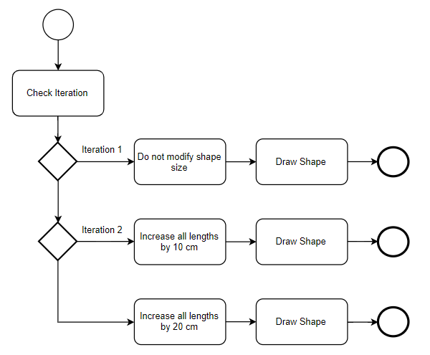

Kite BPM Diagram
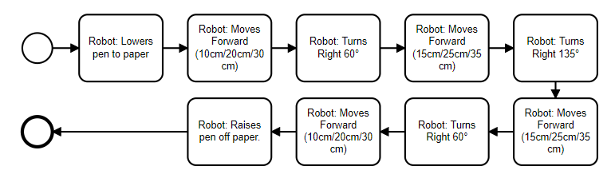

Five-Pointed Star
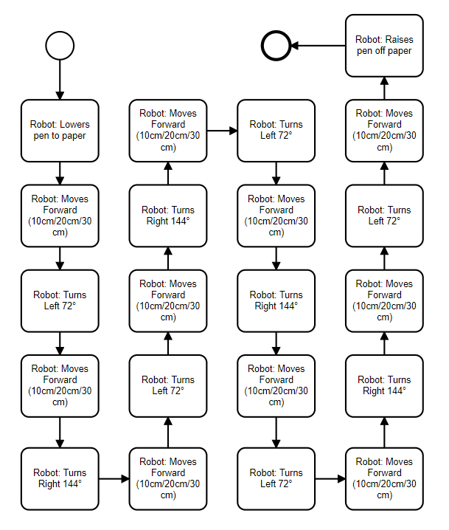

Collection of Triangles

Triangle in circle

Obstructions
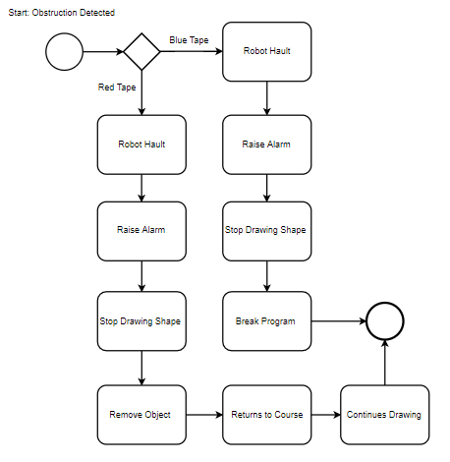

Red Tape Obstruction
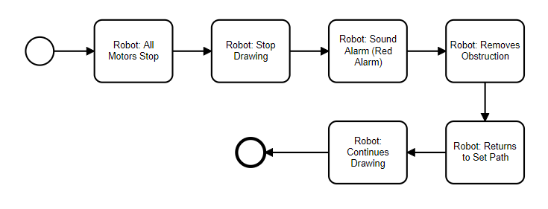

Blue Tape Obstruction
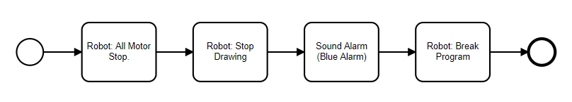

Key program structures and techniques
blah
- some of the key program structures and techniques that can be used in Lego Mindstorms

Benefits and Complications
Blah – cite something
- And benefits or problems that you believe you would encounter using the Lego kits for your solution

Testing
- How you would plan to test your solution after and during implementation

