FIELD REPORT: MEDIEVAL LAMPETER

Evan Davies

Doing Archaeology: The Past in Practice HPAR4011
Ros Coard, Quentin Drew
University of Wales Trinity Saint David
Feb 11, 2024

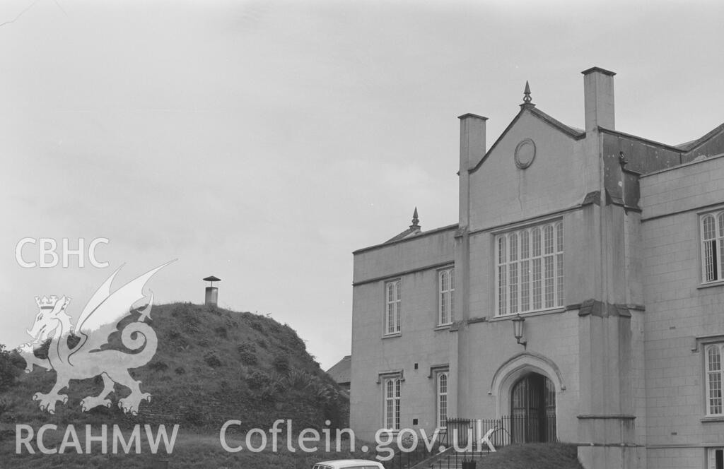
In this essay landscape Archaeology will be utilised to investigate the past of Lampeter as a Medieval location. The main points of interest that raise this curiosity are things such as the roads, and the motte. Sources such as Archwilio and Coflein are going to be used to gathered information on Medieval Lampeter. The Dyfed Archaeological Trust will also be used extensively. Other key locations in Lampeter that are Medieval would be Ffynnon Bedr, St Thomas’ Chapel, Stephen’s Castle (Lampeter Castle), Pont Faen Stone, and lastly Lampeter Parish Church. A look into the etymology of Lampeter (Llanbedr Pont Steffan) will be made in the essay, as this has significance to the Medieval origins of the town.

Figure 1, The mound and the Old Building (Chater, 1968)
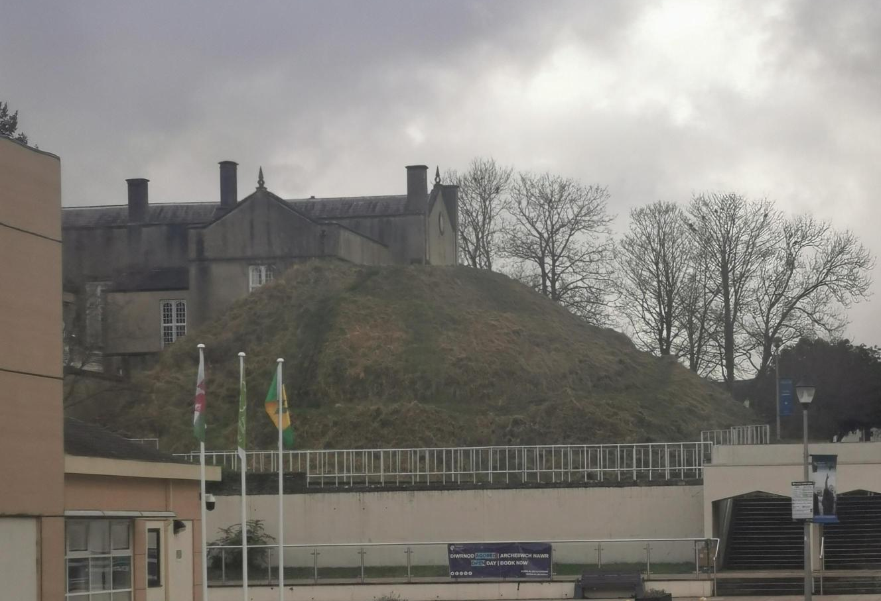
Figure 2, Modern photograph of the mound (Davies, 2024)
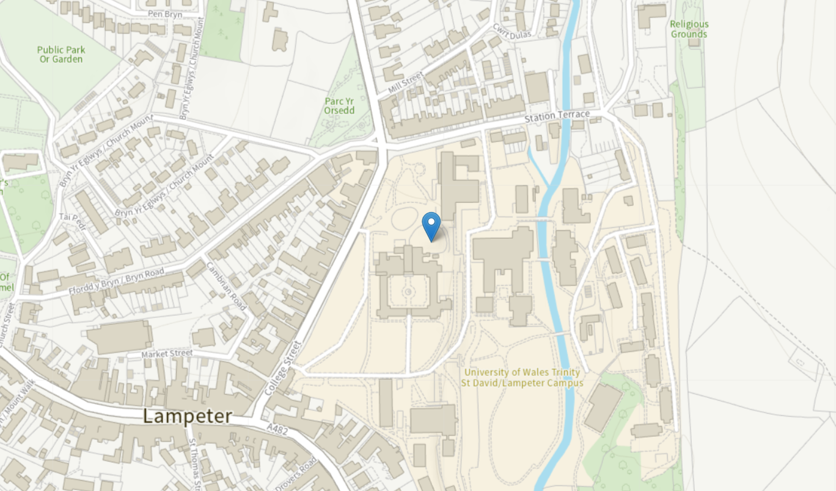
Figure 3, Map of Lampeter (Coflein, 2024)
Firstly, the most well-known Medieval feature in Lampeter is the mound Stephen’s Castle, which is also known as Lampeter Castle (see fig 1) (Castell Llanbedr in the Welsh language). Stephen’s Castle (see fig 1) is situated on the University of Wales Trinity Saint David (UWTSD) Campus in Lampeter by the Old Building (see fig 3). The Castle itself was built during the Norman invasion of Wales between 1115 and 1137 (Murphy, 2021, pp. 1). The motte has a height of 10m (Dyfed Archaeological Trust). The castle was captured by Cadell ap Gruffydd in 1147, a prince of Deheubarth (Pryce, 2005, pp. 166). Today, the only remains of the castle are the mound, which is the motte. The university building called the Old Building was built besides the mound. This could have been because of the significance of the castle in Lampeter. Perhaps the planners decided to build the Old Building next to the mound because it is a sign of power in Lampeter as it overlooks the town. The suggestion that helps this narrative is due to the mound still being at its original place, not completely manipulated by the modern landscape. Therefore, suggesting they purposefully avoided to destroy it.
There is an early medieval inscribed stone in Lampeter. The name of the stone is ‘Pont Faen Stone’. The inscribed stone is possibly dated to the 7th to 11th century (Dyfed Archaeological Trust). The stone was discovered in the year 1878, that was being used as a gatepost at the corner of the Pont-faen Cottage just outside of Lampeter (Dyfed Archaeological Trust). There is truly little information on the inscribed stone. However, it is known to be a cross-carved stone. Using this evidence, a narrative can be made based on other cross-carved stones found in Wales. The stone must have had religious context as it may have been medieval (Prior, 2020). If this is the case then the stone is very unlikely to have been around during the 7th century, as they firstly went out of fashion, and beforehand would mostly be used to record information such as recording the kin of the remembered individual (Prior, 2020). The inscribed stones past is hugely different to how it was utilised in the present day. Firstly, the stone may have had religious affiliation, maybe it was used as a gravestone or something familiar to honour a saint or someone. However, in the present the use of the stone was as a gatepost, diminishing its meaning (Dyfed Archaeological Trust). Then once being recognised by archaeologist its significance came back to educate people on the past of Lampeter and Medieval Wales in general.
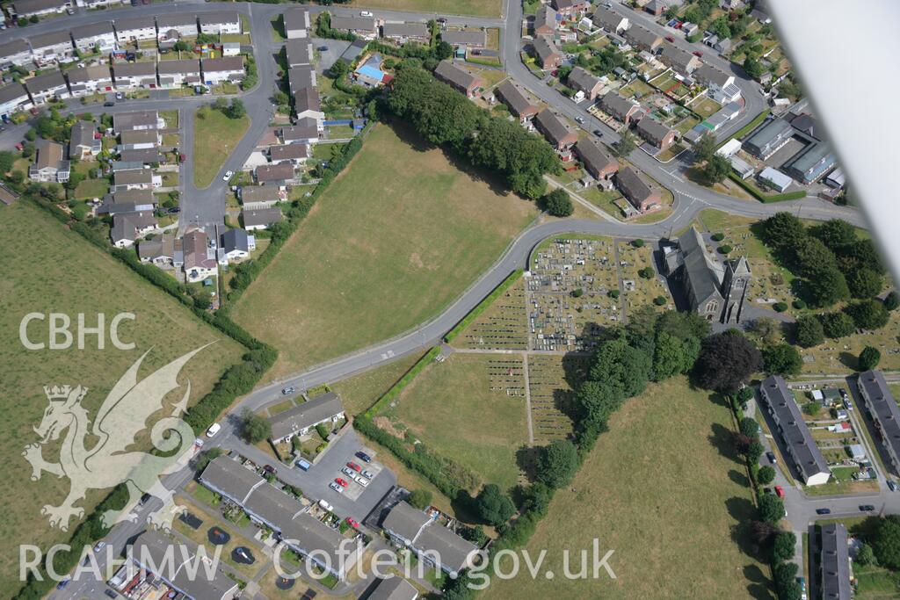
Figure 4, Lampeter Parish Church (Driver, 2006)
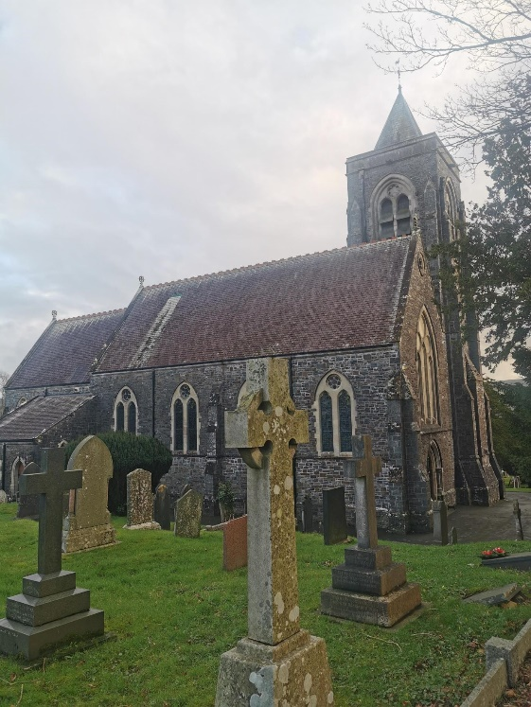
Figure 5, Lampeter Parish Church (Davies, 2024)
Another Medieval feature in Lampeter would be the Lampeter Parish Church (see fig 4). The site here could have had an early Medieval origin (Ludlow, 2004, pp. 93). In the Taxation of 1291 the church was first mentioned, suggesting that it is of Medieval origin (Coflein, 2024). Cadell ap Gruffydd would grant the church to Totnes Priory in the years 1100-1135, it had may of already existed then or was built anew during this time (Ludlow, 2004, pp. 93). The church was then rebuilt entirely in 1868 to 1870, rather than being abandoned (Dyfed Archaeological Trust). When walking around the area one can almost feel the hymns of the Medieval worshippers, chanting in Middle Welsh praying to God. Today, the church is still an important part of Lampeter’s Christian community. It has remained an important aspect of the community since its creation. Making it much easier to feel like one is walking back in time to the Medieval period as it has remained consistent through the ages.
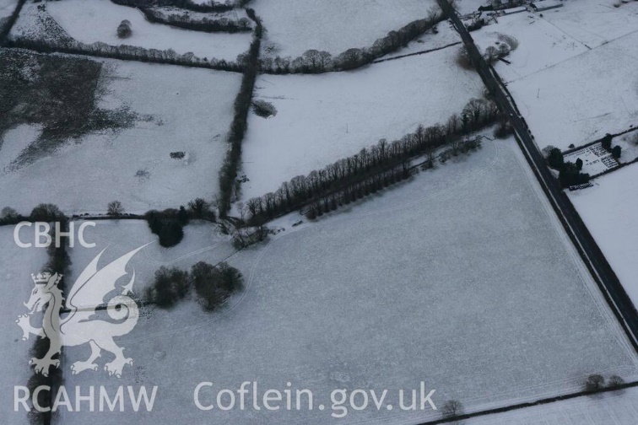
Figure 6, Aerial photograph of location of Peterwell house (Driver, 2010)
The photograph shown above was created by Toby G. Driver of the RCAHMW in 2010. It is the country house garden under the snow. A less known Medieval aspect of Lampeter would be Ffynnon Bedr (known as Peter’s Well in English). It is a Medieval Holy Well with very little information on it. The most that has been gathered from the site is that it is thought to be located near the ruins of Peterwell House (see fig 6). Which is a medieval/post-Medieval gentry house (Dyfed Archaeological Trust). Despite no exact indication of a well being in the location of the site, it is inferred from the boggy ground marked by the reeds, and cartographic evidence (Ings, 2012, pp. 93). Ffynnon Bedr is also depicted in the Ordnance Survey maps in 1889 on the Cardiganshire sheet and in 1905, the 2nd edition of the Cardiganshire sheet. As a Medieval part of Lampeter there is not much of an influence in the modern age. Despite some manipulation to the landscape where it may have been. However, during the period where it was used, it must have been a vital part of the community in Lampeter. Therefore, despite not being here in the modern age, is still significant to Lampeter as it may have allowed the town to grow.
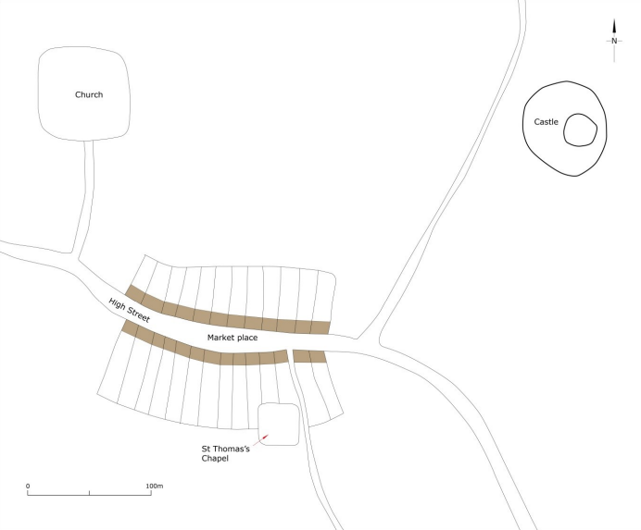
Figure 7, Map of Medieval Lampeter in c. 1320 (Murphy, 2021, pp. 14)
The name Lampeter pushes the Medieval narrative of the town. The name itself suggests the presence and existence of it being a Medieval town. In the Welsh language it is known as ‘Llanbedr Pont Steffan’, and ‘Llambed’ colloquially (Mills, 2003). The etymology of the town means ‘Peter’s church at Stephen’s bridge’ (Mills, 2003). Which shows the significance of the church and castle mound in the town. Which are both Medieval, the castle mound is by the University Old Building, and the church is in town. We can get a suggestion from the name that it has not changed throughout the town’s history. Despite Lampeter being home to a magnificent bridge, the bridge is different from the one currently standing today (Murphy, 2021, pp. 2). One thing that is assumed is that it was at the south of the town and crossed the river Teifi (Murphy, 2021, pp. 2). The bridge was constructed in 1188 when Giraldus Cambrensis would call Lampeter ‘Pons Stephani’ (Murphy, 2021, pp. 2). The name of the bridge and church is said to be in dedication to the Saint Peter (Murphy, 2021, pp. 2).
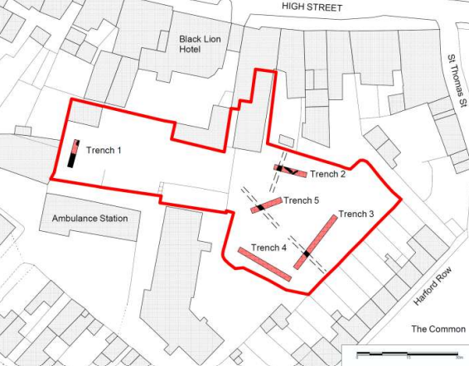
Figure 8, Map of the location of trenches being dug for the St Thomas Chapel (Kemp, 2015, pp. 16)
St Thomas’ Chapel is no longer standing in Lampeter town. However, the placename of ‘Mynwent Twmas’ is the marker of the Chapel in the area (Dyfed Archaeological Trust). The first time the site was mentioned was in the 14th century (Kemp, 2015, pp. 8). The coffins are said to be from the Chapel’s grounds were frequently dug up, the site is now a car park and evidence of an early Medieval date is no where to be seen (Dyfed Archaeological Trust). There would be efforts to dig trenches to find evidence of the Medieval Chapel behind the Black Lion Hotel in 2015 (see fig 8) (Kemp, 2015, pp. 16). The Chapel would have been near the market of the town and would have stood around the same period as the Parish Church and the Castle (see fig 7) (Murphy, 2021, pp. 14). Today the only remnants of the chapel consist of evidence of burgage slots (Kemp, 2015, pp. 37). Burgage slots have origins from the Medieval period, these are the urban rental properties that were owned by kings or lords (Kemp, 2015, pp. 37).
Overall Lampeter has a deep history of being a Medieval town. The presence of the Castles found within the boundaries of the town, the church and the chapel point to it being a significant area for religion in West Wales and a political important area. Due to the presence of a castle, as castle will suggests that powers are using the area for land control. The Normans built the Stephens castle, but it had seen many faces be in control of it. The name ‘Llanbedr Pont Steffan’ is also an important piece of evidence to help understand Medieval Lampeter. The inscribed stone is also an important indicator of Medieval Lampeter and is interesting, unfortunately photographs of the object cannot be added as there is no evidence of the stone in the records. Despite the Ordnance Survey maps. Lastly, the well that has been suggested is also mentioned in the essay. Evidence of the existence of the well comes form Ordnance Survey maps and the landscapes manipulation.
Reference List:
Chater, A, O. (1968). Figure 1, The mound and the Old Building. [photograph]. (Accessed 09 Feb 2024).
Coflein. (2024). Stephen’s Castle, Lampeter;Lampeter Motte. [map]. (Accessed 09 Feb 2024).
Davies, E. (2024). Figure 5, Lampeter Parish Church. [photograph]. (Accessed: 11 Feb 2024).
Davies, E. (2024). Figure 2, Modern photograph of the mound. [photograph]. (Accessed: 11 Feb 2024).
Dyfed Archaeological Trust. (2024). Ffynnon Bedr. Available at: https://archwilio.org.uk/her/chi3/report/page.php?watprn=DAT785&dbname=dat&tb name=core&sessid=CHI3lcou482&queryid=Q143800001707492320 (Accessed: 08 Feb 2024).
Dyfed Archaeological Trust. (2024). St Thomas’ Chapel. Available at: https://archwilio.org.uk/her/chi3/report/page.php?watprn=DAT9559&dbname=dat&t bname=core&sessid=CHI3lcou482&queryid=Q143800001707492320 (Accessed: 08 Feb 2024).
Dyfed Archaeological Trust. (2024). Lampeter Parish Church. Available at: https://archwilio.org.uk/her/chi3/report/page.php?watprn=DAT49328&dbname=dat& tbname=core&sessid=CHI3lcou482&queryid=Q928579001707491674 (Accessed: 08 Feb 2024).
Dyfed Archaeological Trust. (2024). Pont Faen Inscribed Stone. Available at: https://archwilio.org.uk/her/chi3/report/page.php?watprn=DAT752&dbname=dat&tb name=core&sessid=CHI3lcou482&queryid=Q928579001707491674 (Accessed: 08 Feb 2024).
Driver, T, G. (2006). Figure 4, Lampeter Parish Church. [photograph]. (Accessed: 09 Feb 2024).
Driver, T, G. (2010). Figure 6, Aerial photograph of location of Peterwell house. [photograph]. (Accessed: 10 Feb 2024).
Ings, M. (2012). Medieval and Early Post-Medieval Holy Wells: A Threat-Related Assessment 2011. Dyfed Archaeological Trust. Available at: https://coflein.gov.uk/media/85/953/dat21_04.pdf (Accessed: 10 Feb 2024).
Kemp, Rh. (2015). The Black Lion Hotel, Lampeter, Ceredigion: Archaeological Evaluation. Dyfed Archaeological Trust. Available at: https://www.walesher1974.org/herumd.php?group=DAT&level=3&docid=30136937 2. (Accessed: 10 Feb 2024).
Ludlow, N. (2004). Early Medieval Ecclesiastical Sites Project. Cambria Archaeology. Available at: https://www.walesher1974.org/herumd.php?group=DAT&level=3&docid=30136960 3. (Accessed: 09 Feb 2024).
Murphy, K. (2021). The Archaeology of the Medieval Towns of Southwest Wales, Lampeter. Dyfed Archaeological Trust. Available at: https://www.dyfedarchaeology.org.uk/wp/wp-content/uploads/historic-towns- 2020/EPRN_125663_LAMPETER.pdf (Accessed: 09 Feb 2024).
Prior, N. (2020). ‘What do Medieval carved stones and Celtic crosses in Wales symbolise?’, BBC News, 18th July. Available at: https://www.bbc.co.uk/news/uk-wales-53435217 (Accessed: 09 Feb 2024).

