
JO&JOE Hotel
Assignment Title: MARKETING PLAN
Module Title: Marketing Essentials BMIH4005
Lecturer’s Name: Gayathri Senanayake Mudiyanselge
SYED AHSAN ALI
Student ID: 2126965


Table of Contents
Introduction: 2
Situation Analysis: 2
SWOT Analysis: 2
Segmentation and Targeting: 3
Competitors 3
Perceptual Positioning Map: 3
Bowman's Strategy Clock: 3
Collaborators: 3
Climate (PESTLE Analysis): 4
Marketing Mix: 4
Objectives: 5
Strategy: 5
Changes to the Marketing Mix: 5
Tactics: 5
Reach: 6
Act: 6
Convert: 6
Engage: 7
Control: 7
Conclusion: 7
Appendix: 9
References 16

Introduction:
The study shows that JO&JOE Hotel understands the importance of strengthening the brand and increasing the market share. This marketing plan is meant to give a road map for enhancing productivity and income through well-executed marketing activities to the marketing staff and any interested parties. In order to better identify the target audience and fine-tune the marketing plan, the JO&JOE will undertake a SWOT analysis to assess the relative strengths, weaknesses, opportunities, and threats. The goal is to elevate JO&JOE Hotel to market leader position by using a range of strategic approaches.

Situation Analysis:

SWOT Analysis:
Strengths:
- The provision of exceptional quality in all facets of customer service.
- Hotel that is strategically located in popular destinations.
Weaknesses:
- Being dependent on an industry that operates on a seasonal basis.
- Insufficient brand recognition exists in foreign markets. (Schooley, 2023).
Opportunities:
- There has been a notable increase in the demand for hotels that prioritise environmental sustainability.
- The process of establishing a foothold in previously untapped markets.
Threats:
- The prevalence of larger hotels poses a significant challenge in terms of competition.
- The tourism industry has experienced the impacts of economic instability (Profitco, 2023).

Segmentation and Targeting:

Segmentation:
- Demographics such as age and socioeconomic status can be identified as potential targets for marketing efforts.
- The practise of psychographic segmentation endeavours to tailor advertising initiatives based on the personality traits and interests of consumers.

Targeting:
- The convenience and comfort of business travellers should be taken into consideration.
- It is advisable for families vacationing with children to prioritise lodging and recreational options that cater to the needs and preferences of the younger members of the family.

Competitors

Perceptual Positioning Map:
- The JO&JOE offers exceptional amenities in esteemed locations, accompanied by unparalleled hospitality (Wirtz, 2018).

Bowman's Strategy Clock:
- The principal aim of JO&JOE is to furnish a distinctive proposition at a cost that is competitive. (Smarter, 2023).

Collaborators:
- Local travel agencies and tour operators have the potential to offer pre-planned travel schedules to tourists. Reliable partners and service providers are available to support sustainable green initiatives and undertakings of JO&JOE.

Climate (PESTLE Analysis):
Political:
- The government enforces travel restrictions.
- Low-risk markets for political instability.
Economic:
- Currency fluctuations have an effect on profitability.
- The economy influences the demand for vacation travel.
Social:
- Travel interests and trends are changing.
- Environmental preservation and ecotourism are acquiring popularity (Mathews, 2016).
Technological:
- The creation of sophisticated online reservation systems.
- Integrating intelligent technologies into the hospitality experience.
Environmental:
- Environmental sustainability programmes and regulations.
- Changes in the weather influence how people travel.
Legal:
- Compliance with all applicable domestic and international laws.
- Protection for a brand's assets in the form of intellectual property (Edrawmax, 2023).

Marketing Mix:
- Product: Extraordinary accommodations that position you in the heart of the activity and a wide range of amenities and provisions are available.
- Price: The pricing strategy is designed to cater to the target audience's budgetary constraints. Price adjustments based on seasonal and promotional sales are offered.
- Place: Hotel that is strategically located in popular destinations having a web-based reservation system that is user-friendly.
- Promotion: JO&JOE is establishing partnerships and doing collaborations with individuals of significant influence.
- People: The paramount consideration should be directed towards the requirements and preferences of the clientele (Carniel, 2023).

Objectives:
To meet its business goals, JO&JOE created SMART targets. Strategic marketing that clearly communicates the USP is our main goal. Over the next six months, the hotel wants to boost direct reservations on the JO&JOE website by 20%. The hotel also strives for a review site average of 4.5 or above to improve client satisfaction. It wants to join three more overseas markets with high growth potential within two years. It has a 15% revenue growth objective by the end of the fiscal year to show the dedication to financial success. JO&JOE will survive the hospitality sector with these SMART goals (Accor, 2023).

Strategy:
The objective of JO&JOE is to offer unique and unforgettable lodging experiences in sought-after locations, target specific segments of the potential clientele, and prioritise amicable and supportive customer service. The hotel’s objective is to establish JO&JOE as a prominent brand in the hospitality industry by distinguishing ourselves from its competitors through unique and inventive approaches, as well as prioritising the satisfaction of our clientele (Cascade, 2023).

Changes to the Marketing Mix:
JO&JOE intends to enhance its market standing through modifications to its marketing mix. To appeal to environmentally aware tourists, enterprises can enhance their promotional strategies by implementing personalised amenities and services, optimising digital platforms to target particular demographics, creating more sophisticated pricing structures for diverse customer segments, establishing stronger relationships with community influencers, and intensifying their emphasis on sustainable practises (MTCT, 2023).

RACE:
The JO&JOE Hotel intends to utilise the RACE model in relation to the communications mix as a means of surmounting obstacles and improving communication.

Reach:
- Increase JO&JOE brand's social media following.
- Partner with key opinion leaders to enhance its reach (Chaffey, 2022).

Act:
- Check the website and reservation system.
- Contests and other incentives can boost the sales (Trip, 2023).

Convert:
- Increase walk-up reservations with targeted advertising.
- Use of exclusive discounts and conversion incentives (Huang & Hsu, 2019).

Engage:
- Participate and share to grow JO&JOE’s online community.
- For client retention and online acclaim, it should provide excellent service (Tripadvisor, 2023).

SOSTAC

Situation Analysis
- Conduct a comprehensive analysis of the present state of the market, the competitive environment, and customer input.
- It is imperative to undertake a SWOT analysis of JO&JOE, taking into account the company's strengths, weaknesses, opportunities, and threats.

Objectives
- Formulate SMART goals that are aligned with the research findings to facilitate the attainment of objectives pertaining to brand awareness, revenue expansion, and customer contentment.

Strategy
- Formulate a comprehensive marketing strategy that delineates the principal methodologies and metrics to be implemented in order to attain the desired goals.
- Identify its market segment, distinctive advantage, and strategic approach to competition.

Tactic:
- Implement promotional tactics, including digital and social media marketing, collaborations with influencers, and focused sales efforts.
- Augment the guests' experience by providing unique amenities, exceptional infrastructure, and eco-friendly protocols.

Action
- Execute the marketing plan through the allocation of responsibilities, establishment of timelines, and provision of sufficient resources.
- It is advisable to closely monitor the statistical data and subsequently make necessary adjustments in accordance with the feedback provided by the consumers.

Control:
- It is advisable to monitor the efficacy of one's marketing endeavours in relation to the predetermined objectives and make necessary adjustments accordingly.
- To optimise the effectiveness of your marketing endeavours, it is recommended to employ Key Performance Indicators (KPIs) to monitor its advancement, steer your strategic choices, and furnish substantiation of accomplishments.

Conclusion:
JO&JOE Hotels has developed a comprehensive marketing strategy with the aim of enhancing its market position and augmenting brand recognition. JO&JOE aims to enhance its financial performance by utilising strategic tools such as SWOT analysis, market segmentation and targeting, optimisation of the marketing mix, and the incorporation of frameworks such as the RACE model. JO&JOE has established itself as a promising contender in the highly competitive hotel industry by placing utmost importance on customer satisfaction, crafting exceptional guest experiences, and demonstrating a strong commitment towards environmental sustainability. In light of the results and suggestions, it is advisable for Jo&JOE Hotels to give precedence to augmenting its online presence through deliberate online advertising and partnerships with prominent personalities. The implementation of environmentally sustainable practises and personalised customer service will differentiate the organisation from its rivals and attract environmentally conscious tourists.

Appendix:
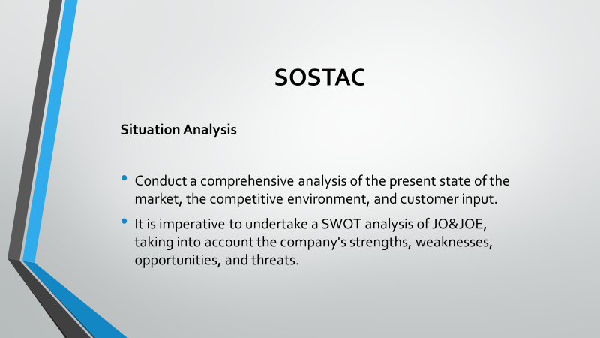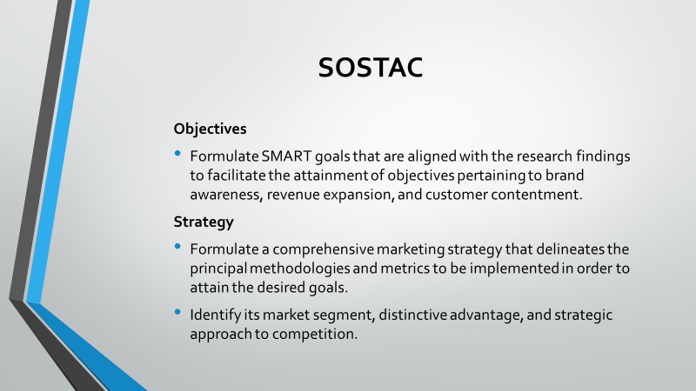
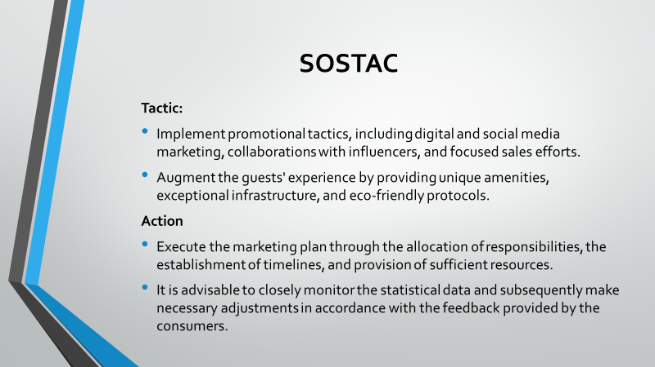
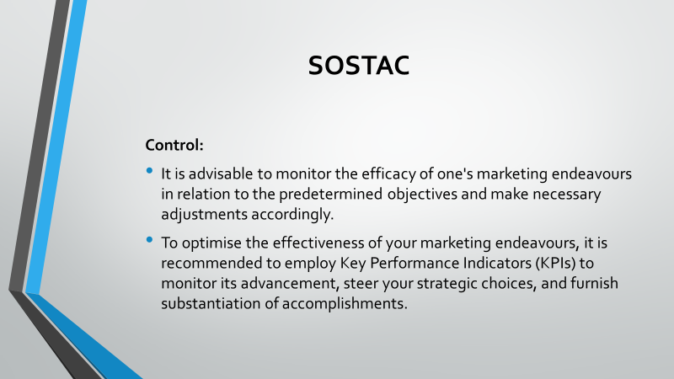
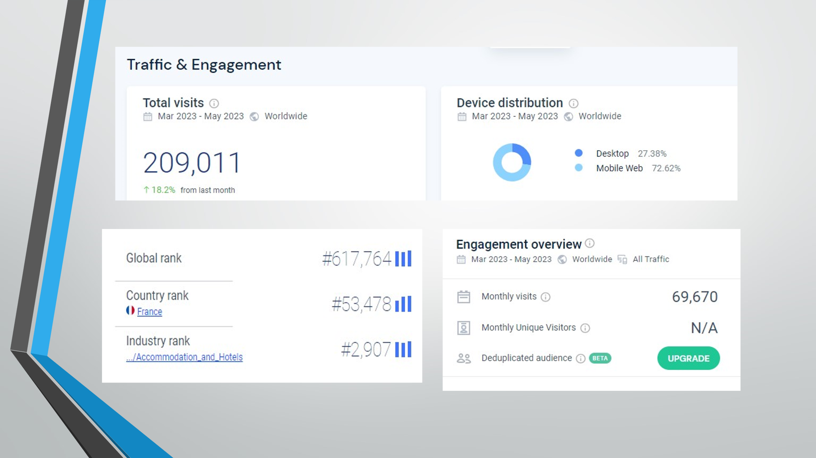
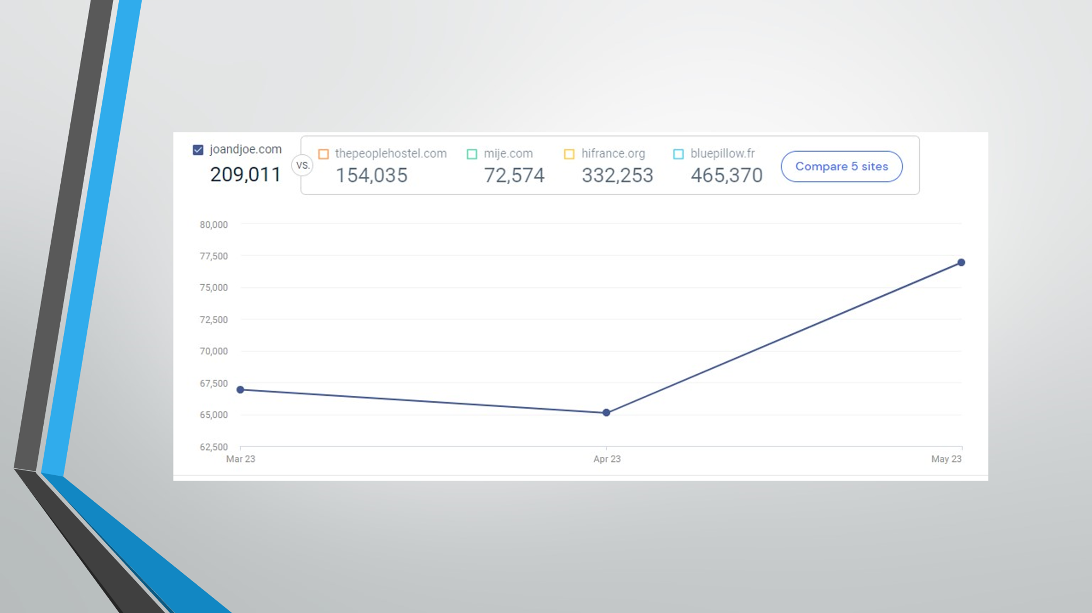
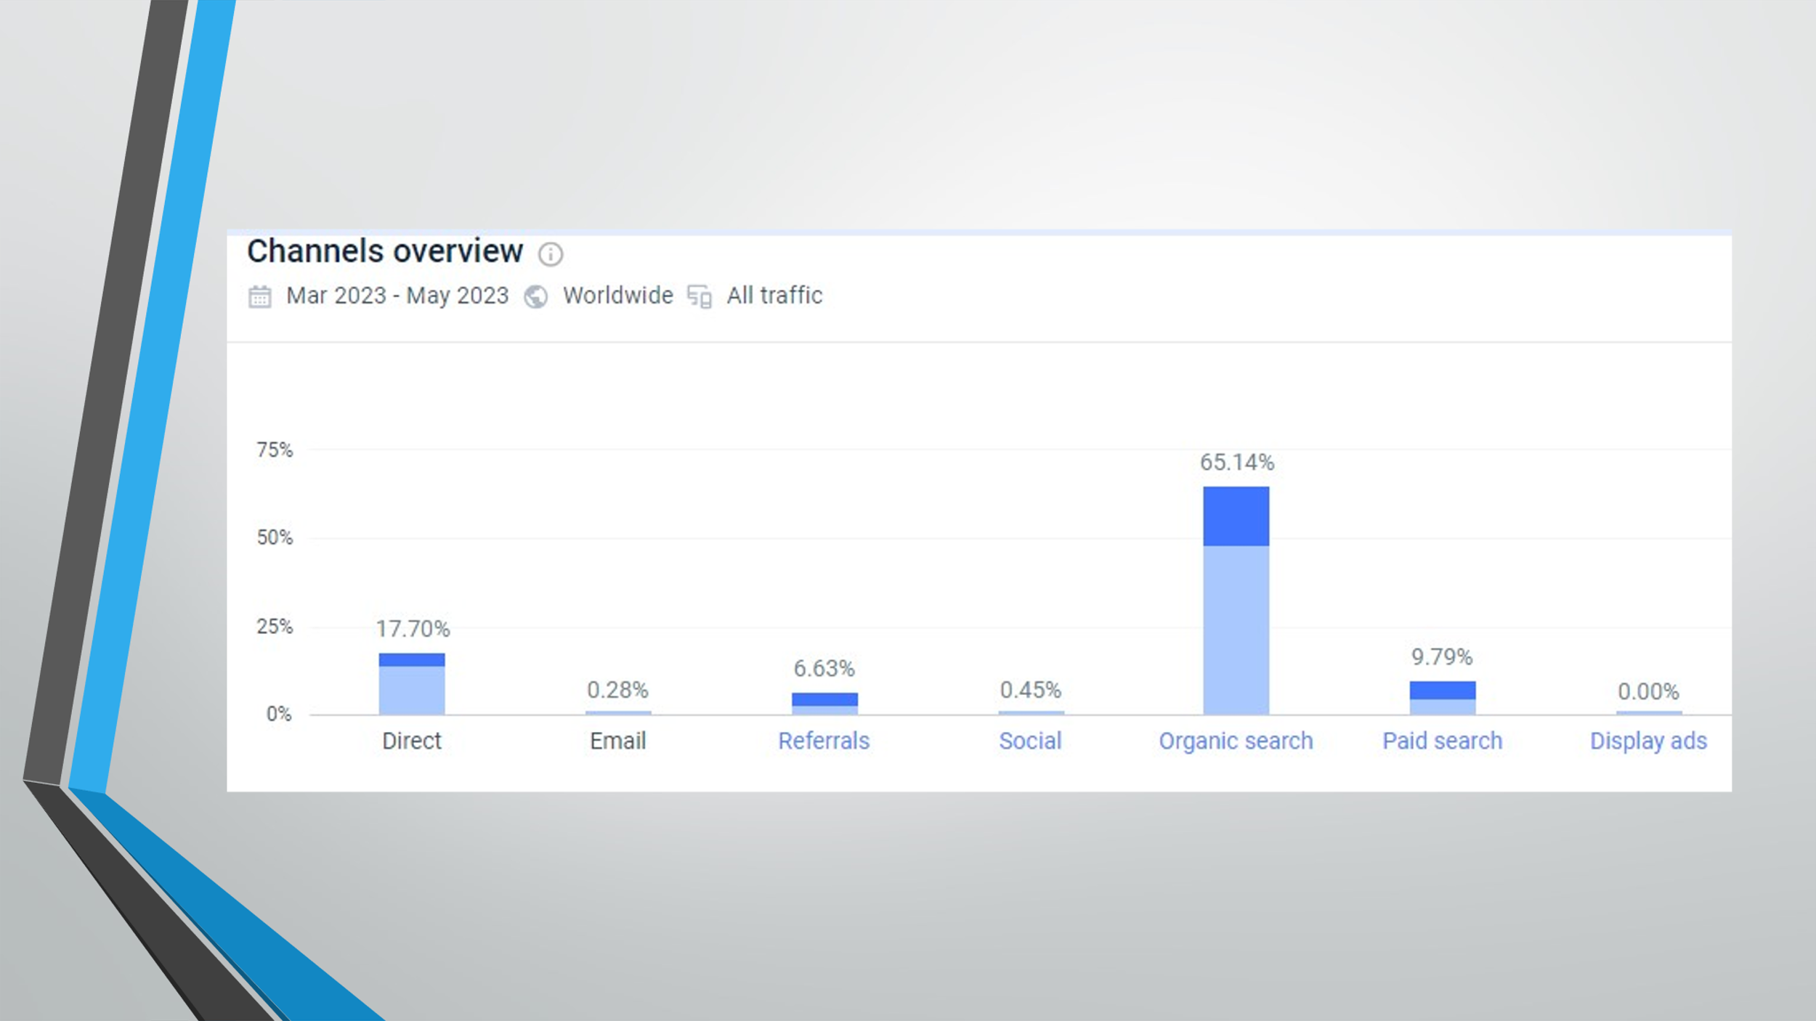
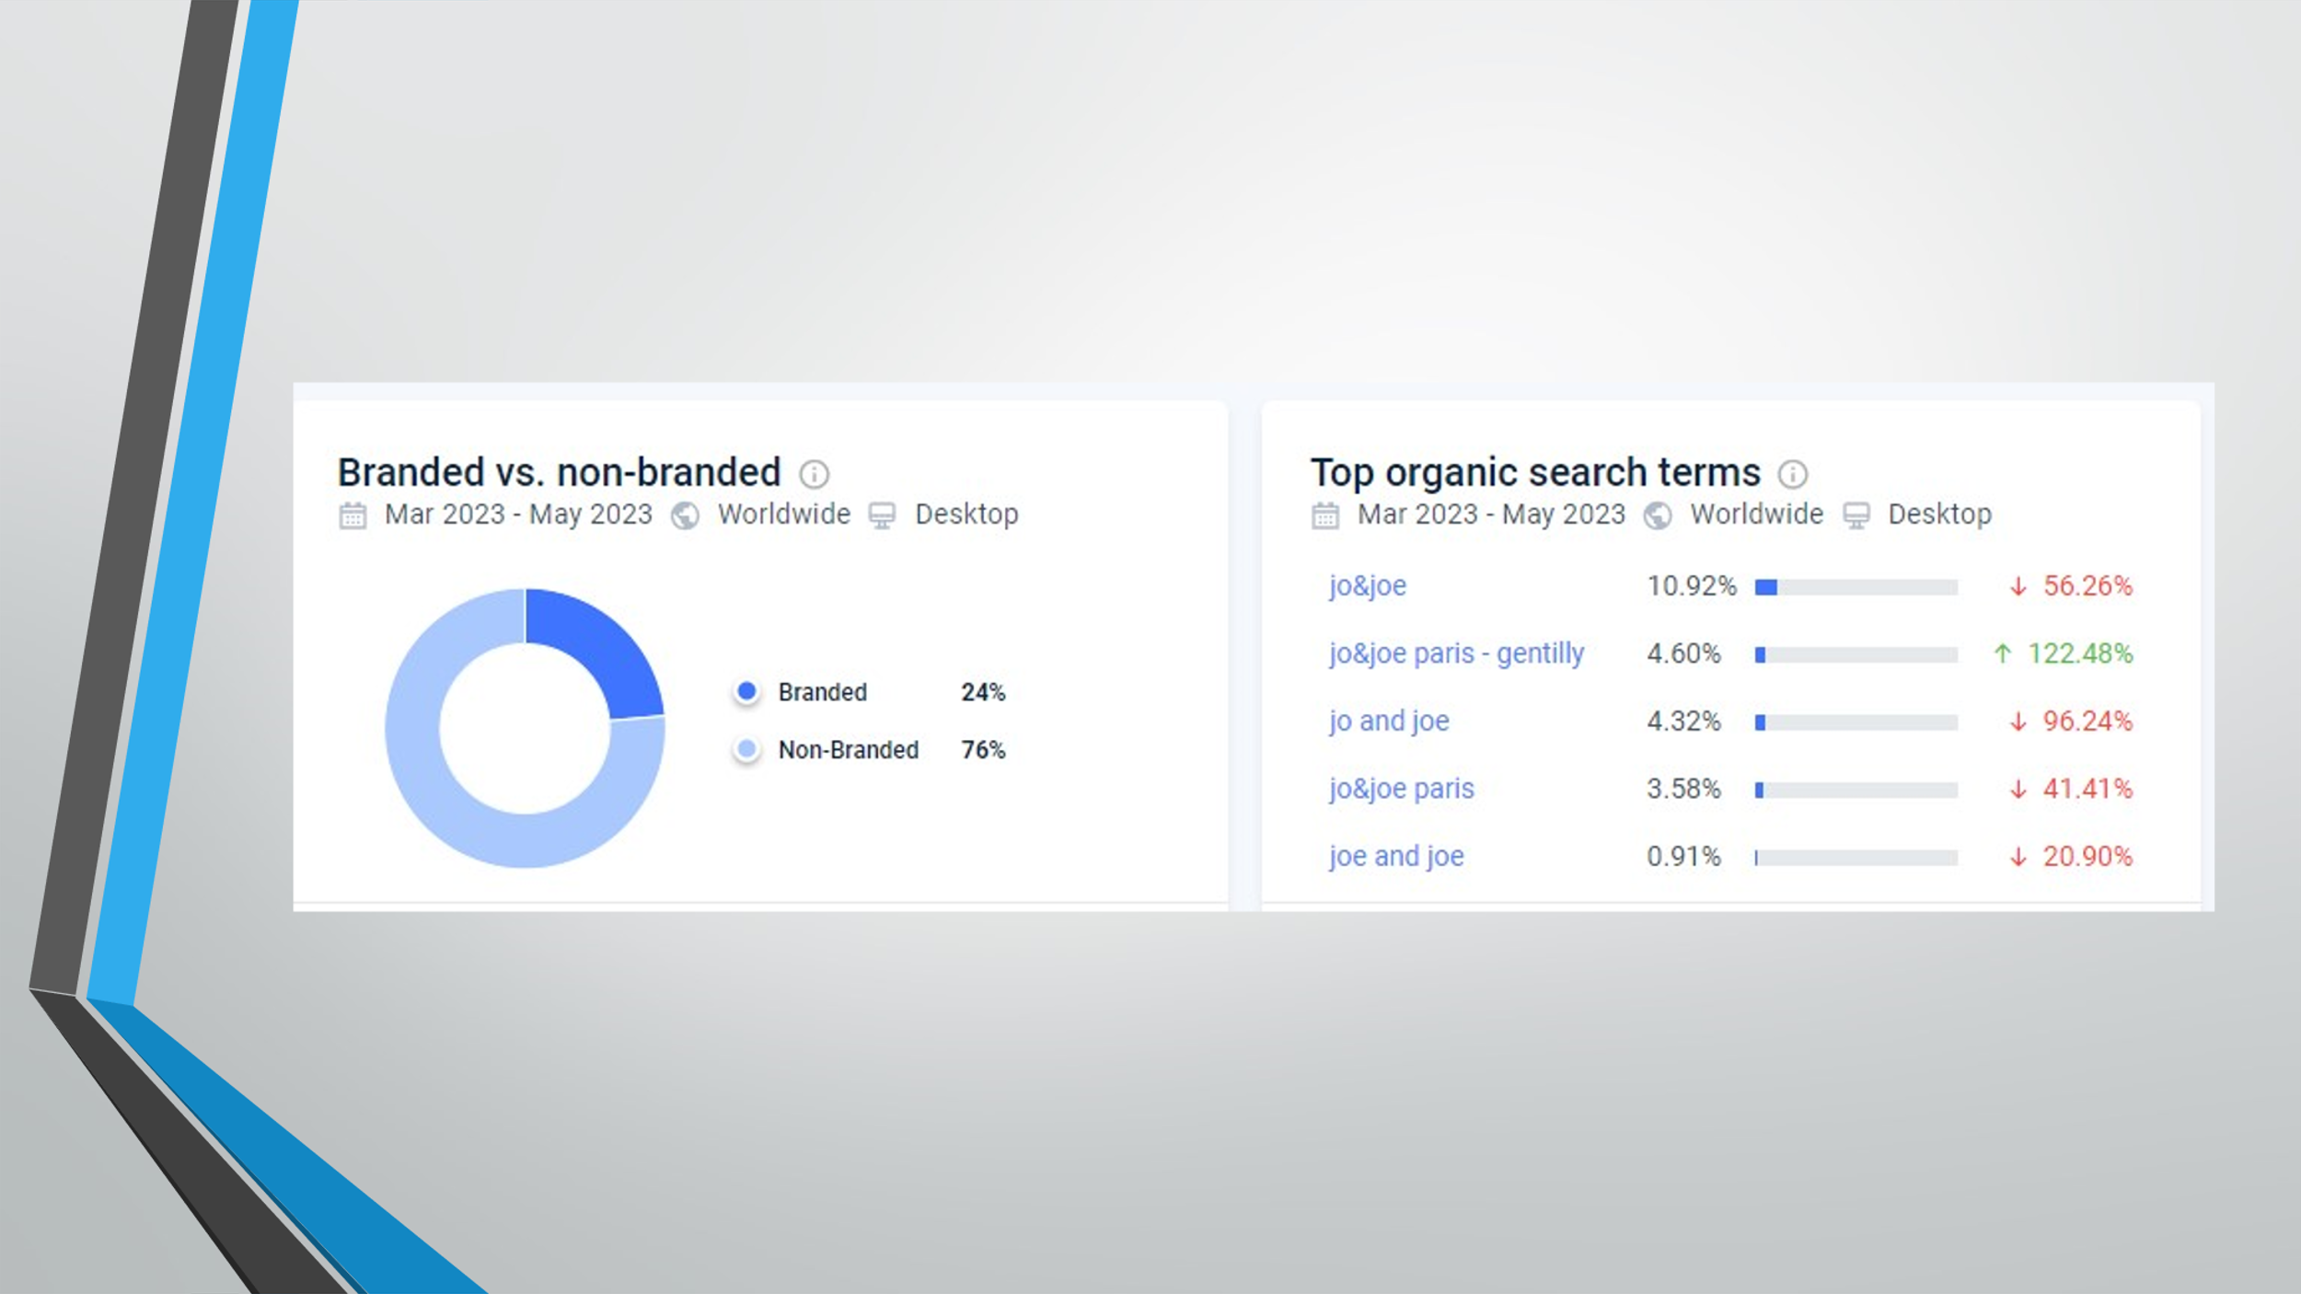
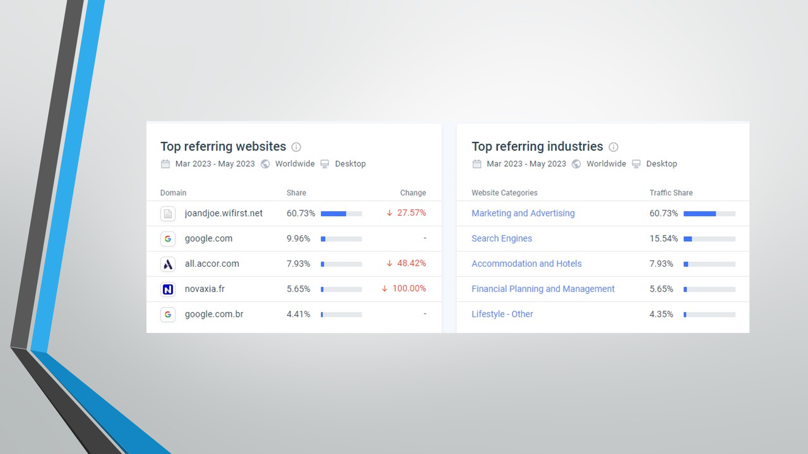
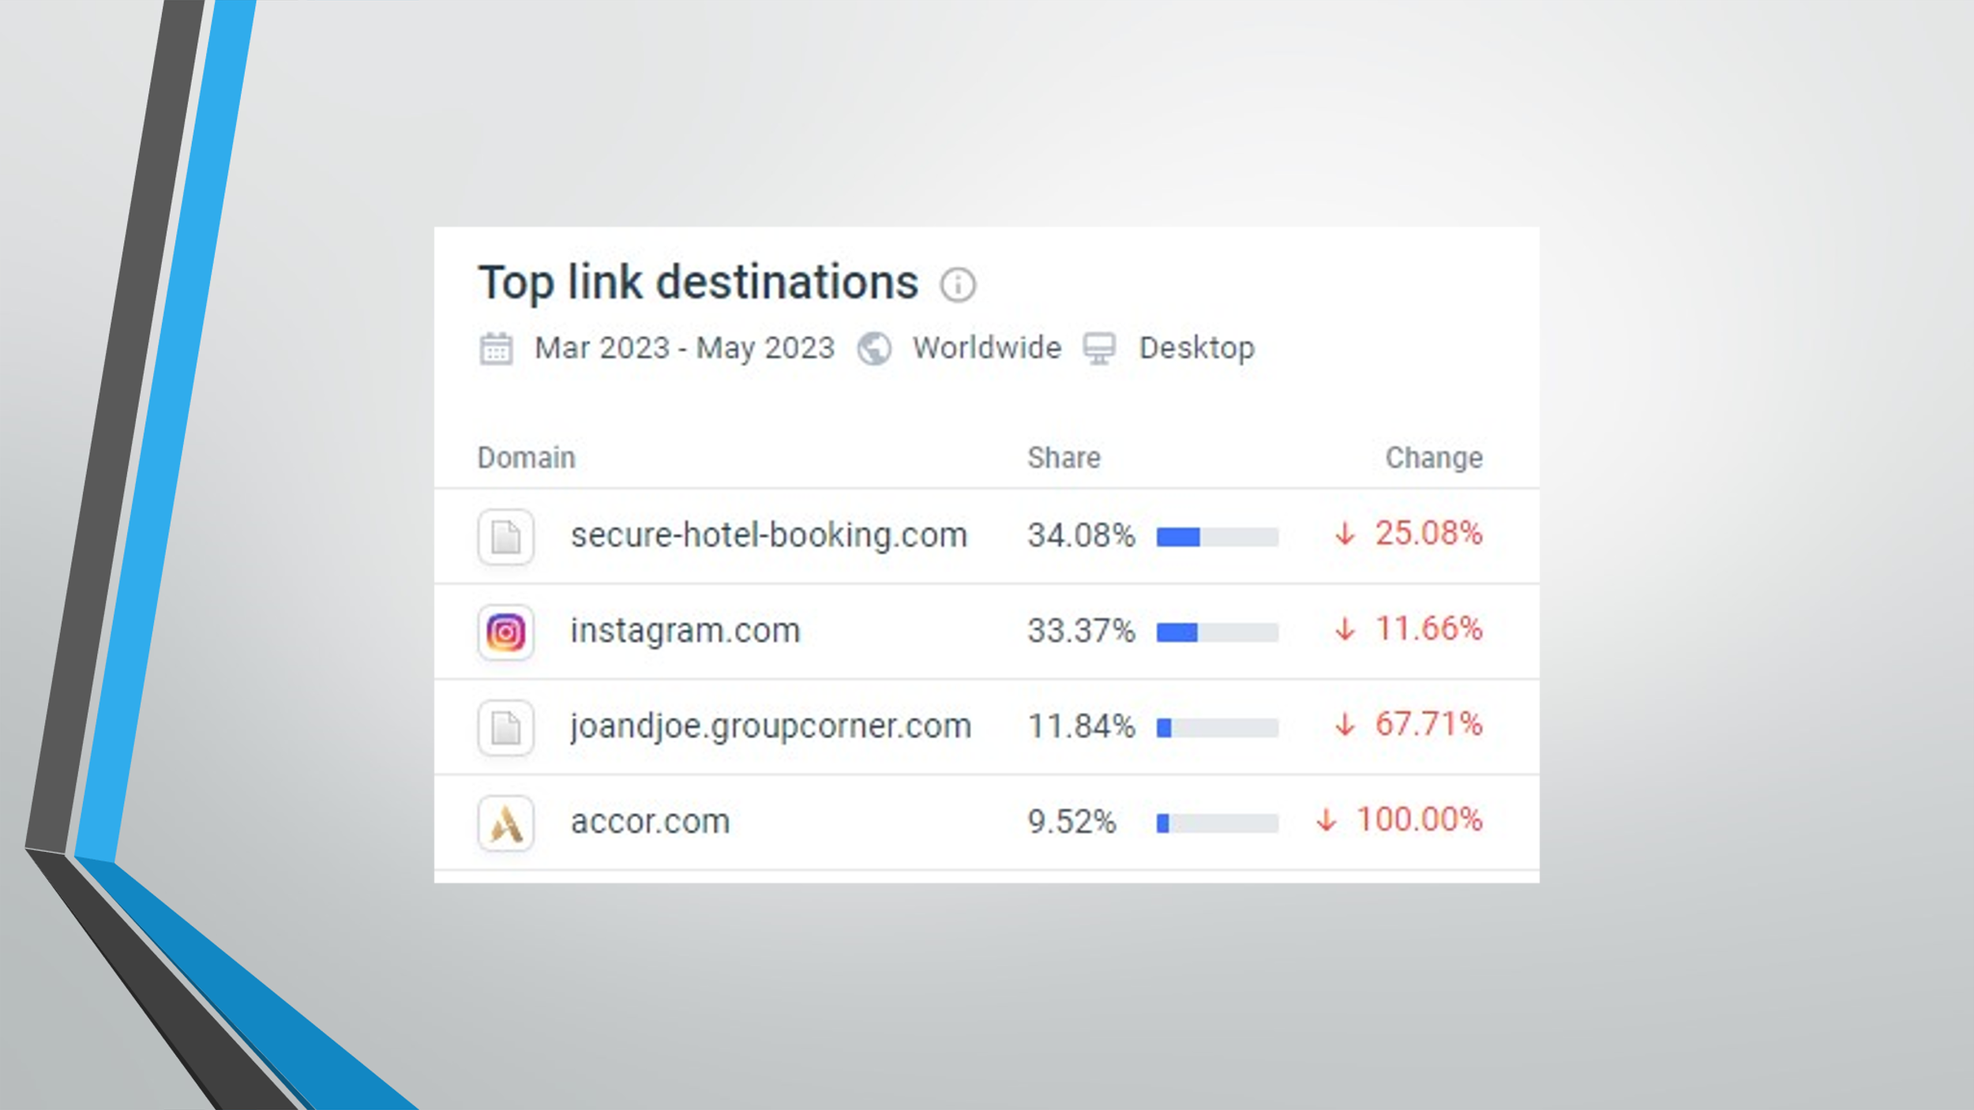
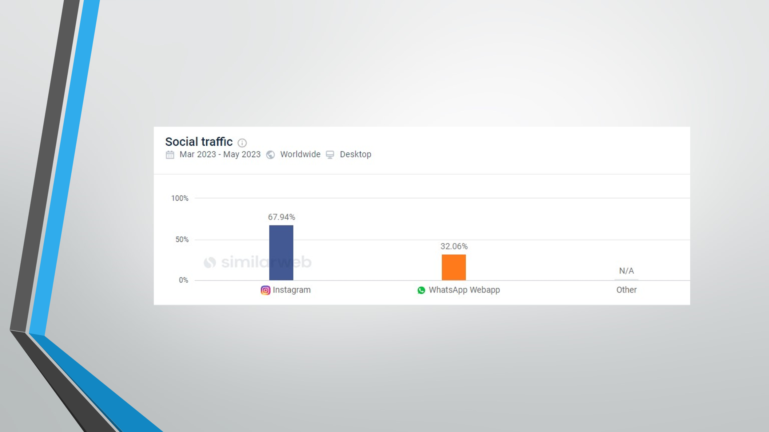
Similarweb (Similarweb, 2023)
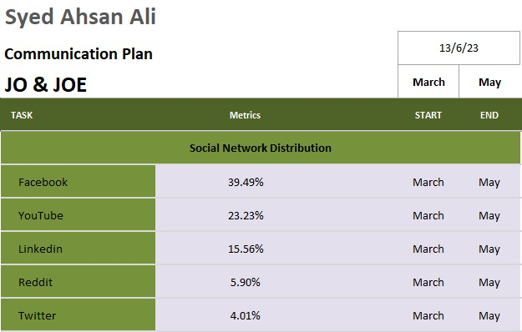
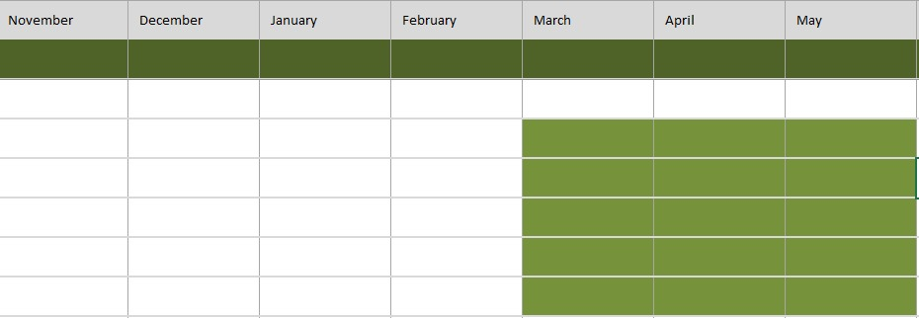
Gantt Chart (Similarweb, 2023)
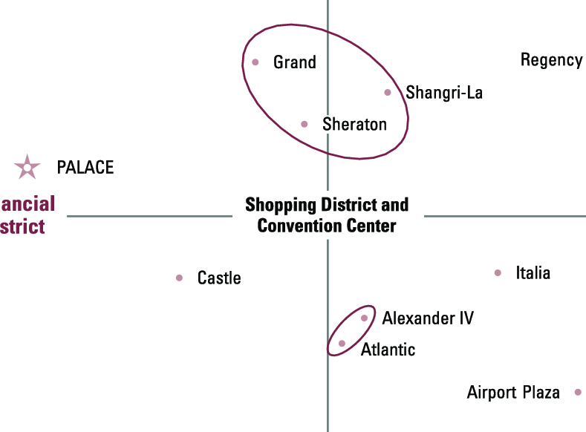
(Wirtz, 2018)
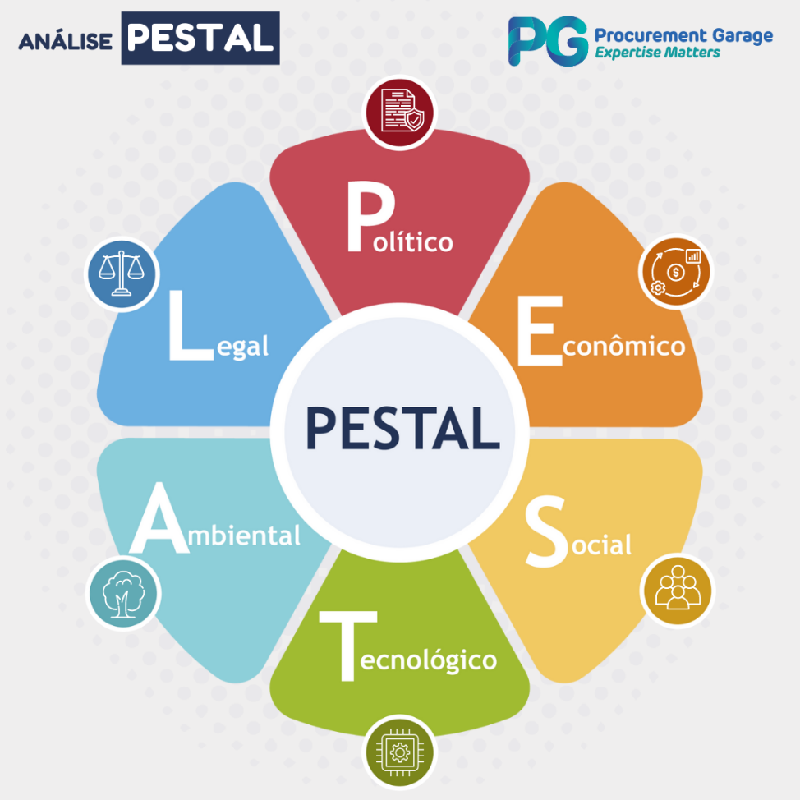
(Práticas, 2023)

References
Accor, 2023. Bringing travellers together. [Online]
Available at: https://all.accor.com/brands/joandjoe.en.shtml
Carniel, A., 2023. The ultimate guide to marketing mix: 4Ps, 7Ps, 8Ps, 4Cs, 7Cs. [Online]
Available at: https://www.albertocarniel.com/post/marketing-mix
Cascade, 2023. The Ansoff Matrix: 4 Growth Strategies Explained (With Examples). [Online]
Available at: https://www.cascade.app/blog/the-ansoff-matrix-helps-organizations-grow
Chaffey, D., 2022. Introducing The RACE Growth System and RACE Planning Framework: practical tools to improve your digital marketing. [Online]
Available at: https://www.smartinsights.com/digital-marketing-strategy/race-a-practical-framework-to-improve-your-digital-marketing/
Edrawmax, 2023. Detailed PESTEL Analysis of Hotel Industry. [Online]
Available at: https://www.edrawmax.com/article/hotel-industry-pestel-analysis.html
Huang, S. & Hsu, C. H., 2019. Application of importance-performance analysis in determining critical factors of hotel services: A study of a hot spring hotel in Taiwan. Journal of Quality Assurance in Hospitality & Tourism, pp. 1-19.
Mathews, V., 2016. Competition in the international hotel industry. International Journal of Contemporary Hospitality Management, pp. 114-118.
MTCT, 2023. The Marketing Mix and the 4Ps of Marketing. [Online]
Available at: https://www.mindtools.com/akksnwa/themarketingmixandthe4ps
Práticas, M., 2023. As 6 Forças do PESTAL: o que é, para o que serve e como deve ser aplicada. [Online]
Available at: https://blognagarage.com.br/melhores-praticas/analise-pestal-6-forcas/
Profitco, 2023. How to Utilize a SWOT Analysis For Your Business. [Online]
Available at: https://www.profit.co/blog/okr-university/how-to-utilize-a-swot-analysis-for-your-business/
Schooley, S., 2023. What is a SWOT Analysis? (And When To Use It). [Online]
Available at: https://www.businessnewsdaily.com/4245-swot-analysis.html
Similarweb, 2023. Jo&Jo Website Performance. [Online]
Available at: https://pro.similarweb.com/#/digitalsuite/websiteanalysis/overview/website-performance/*/999/3m?webSource=Total&key=joandjoe.com
Smarter, S., 2023. Bowmans Strategic Clock. [Online]
Available at: https://www.studysmarter.co.uk/explanations/business-studies/strategic-direction/bowmans-strategic-clock/
Trip, 2023. JO&Joe Paris - Gentilly Hotel - Hostel Map, Address, Transportation & Nearest Stations and Airport. [Online]
Available at: https://www.trip.com/hot/hotel-map/jo%26joe-paris---gentilly-hotel---hostel-map.html
Tripadvisor, 2023. JO&JOE Paris Gentilly Hotel. [Online]
Available at: https://www.tripadvisor.com/Hotel_Review-g227892-d16700988-Reviews-JO_JOE_Paris_Gentilly_Hotel-Gentilly_Val_de_Marne_Ile_de_France.html
Wirtz, J., 2018. Winning in Service Markets Series, Vol. 2: Positioning Services in Competitive Markets. [Online]
Available at: https://www.researchgate.net/figure/Positioning-map-of-Bellevilles-principal-business-hotels-Location-versus-Physical-Luxury_fig7_318672547

