

Module Title and Module Code: Personnel Resourcing and Development - BMIH5005

Project Proposal Title - Analyse the Impacts of Socio-Economic Force on Employees’ Performance Management and Monitoring in Different Work Modes: Hospitality HR’s Perspective
Lecturer’s Name: Helen Lee
Student name: Sidonia Bianca Mihu
Student ID:2231047
Table of Contents

- Introduction and Background 3
  - JW Marriott 3
- Discussion/Literature 3
  - PESTLE Analysis 3
    - Political Factor 3
    - Economic Factor 4
    - Social Factor 6
    - Technological Factor 7
    - Legal Factor 7
    - Environmental Factor 8
  - Socio-Economic Analysis 8
  - Industry Trend 8
  - Emergence of Work Modes 11
- Evaluation and Conclusion 12
- References 13

- Introduction and Background
The main goal of this research is the identification, analysis, and establishment of the link of the socio-economic factors to employee performance management in the hospitality sector, particularly the JW Marriott. this analysis will explore the intricate, PESTLE factors at play and the industry trends including occupancy rates and retention and turnover rates. Furthermore, it will also cover a brief history of how labour modes have evolved in the hospitality sector over the past five years, specifically, industry examples from these leaders.

JW Marriott
JW Marriott is an internationally recognized hotel company, which is the pioneer in luxury hotel accommodation and outstanding service. In this dynamic market competition, the level of performance of employees is the key driver for upholding client trust and securing a competitive advantage. Within the portfolio of Marriott International is the upscale brand JW Marriott. It is present in more than 35 countries and territories, with more than 100 hotels and resorts. The brand bears the name of JW Marriott, the man who founded the Marriott Corporation and was initially unveiled in 1984 with the inauguration of the first hotel company in Washington, D.C. The experiences offered by JW Marriott are intended to leave visitors with a sense of physical fulfilment, spiritual renewal, and mental presence (JW Marriott, 2024). The company provides informed and eco-friendly vacation plans that include stops in cities, beaches, deserts, and safaris. Stay in the moment is JW Marriott's tagline. The company wants to make people feel entire, and mindfulness is what drives it.
- Discussion/Literature

PESTLE Analysis

Political Factor
- The government impose travel restrictions during times of crisis or political instability, which is detrimental to the hotel sector.
- This is true because businesses that operate hotels depend on travellers searching for short-term lodging (Holloway and Humphreys, 2022).
- Staycations suffer due to political unrest making people less likely to go out to eat and enjoy leisure activities.

Economic Factor
- The hotel sector employed 3.0 million people indirectly and 3.5 million people directly in the UK in 2022, making it the third largest employer in the country.
- Directly and indirectly, the sector contributed about £93 billion in gross value added to the UK economy.
- In 2023, the gross domestic output of the UK was valued at 2.274 trillion British pounds, a little rise over the 2.27 trillion pounds it was the year before.
- The COVID-19 pandemic and the ensuing lockdowns caused severe losses for many businesses, especially in the service sector, which is highly dependent on the UK economy.
- This resulted in a decline in GDP from 2019 to 2020.
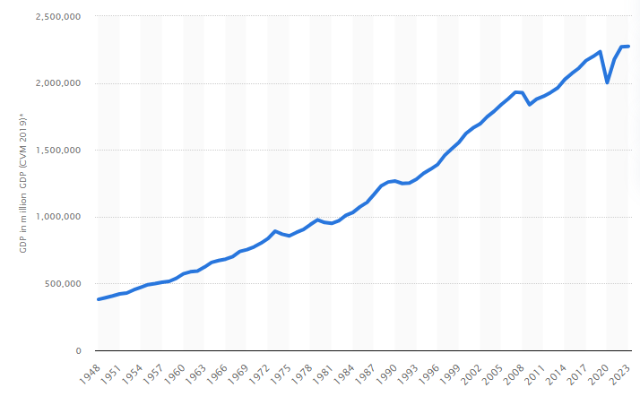
Figure 1: GDP of the UK 1948-2023
Source: Statista, 2024a
- In January 2024, the inflation rate of the UK didn't change from the previous month at 4%.
- The UK saw seven months of double-digit inflation between September 2022 and March 2023, with a high of 11.1 per cent in October 2022.
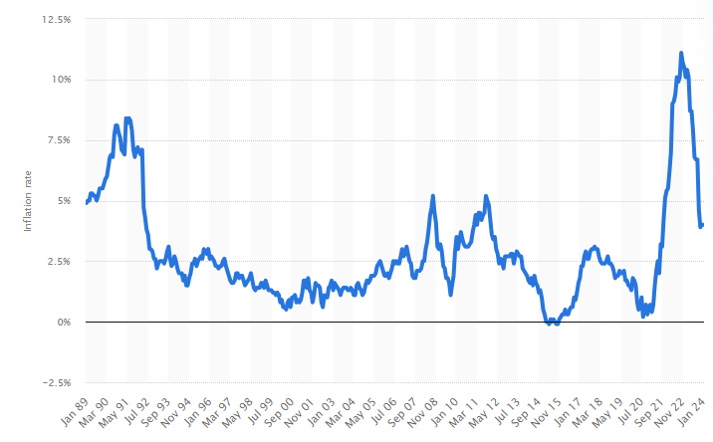
Figure 2: Inflation rate in the UK 1989-2024
Source: Statista, 2024b
- The fourth quarter of 2023 saw a 32% rise in consumer prices in the UK, according to the Consumer Price Index, which was 132 in the first quarter of 2015.
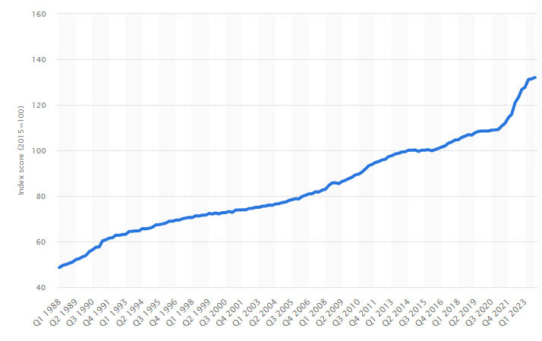
Figure 3: CPI in the UK 1988-2023
Source: Statista, 2024c

Social Factor
- In the UK, expenditure on dining establishments and lodging fell precipitously in 2020 relative to 2019.
- By this time last year, consumer expenditure had dropped to 77.45 billion British pounds, a 42 per cent decline.
- The coronavirus (COVID-19) pandemic had a major effect on UK consumer expenditure on dining out and lodging, leading to nationwide stay-at-home laws designed to slow the spread of the virus.
- Consumer expenditure topped 117 billion dollars in 2021.
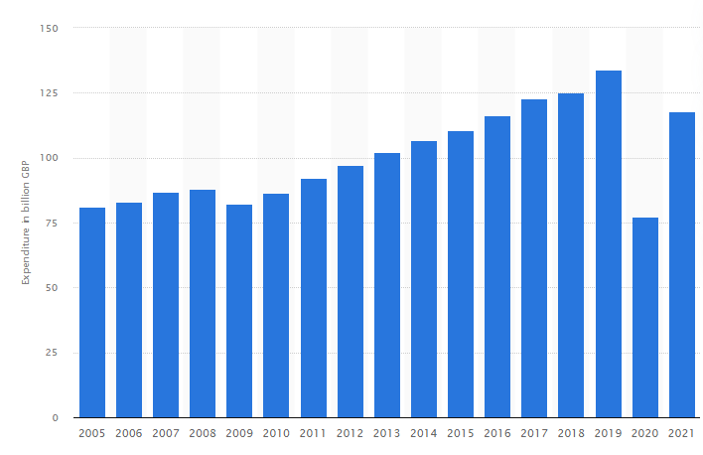
Figure 4: Consumer expenditure on restaurants and hotels in the United Kingdom (UK) 2005-2021
Source: Statista, 2023a
- Customer satisfaction increased in 2022 across most businesses, including the apparel and hotel sectors among many others (Statista, 2022).

Technological Factor
- The food, entertainment, and hospitality sectors of the UK are expected to spend over 185 million US dollars on software in 2021.
- It is estimated that the sector will spend $346.32 million on software by 2024 (Statista, 2022).

Legal Factor
- The framework of consumer law in the UK strives to guarantee that clients, particularly those in the hospitality industry, get equitable treatment when transacting with businesses.
- The GDPR applies to hotels in the country in the UK (Sharma, 2019)
- Taxes have a big effect on a hotel's total income in the hospitality industry.

Environmental Factor
- The hotel sector is significantly impacted by environmental problems.
- The effects of global warming are extremely dangerous for the hotel sector.
- Air pollution is a major problem in certain areas.
- Due to health concerns, those who suffer from asthma or other respiratory illnesses choose to stay away from these places completely (Steinemann, 2018).

Socio-Economic Analysis
In the context of economic factors, visible indicators such as the GDP, inflation rates, and consumer spending, significantly define the ocean of the hotel environment operation. This additional noise to the revenue streams of JW Marriott creates challenges regarding performance metrics and targets of employees, as well as efficient planning of resources and cost management. The COVID-19 pandemic crisis immensely magnified the situation, leading to a workforce shortage, reduced demand from customers and financial constraints. Therefore, JW Marriott needs to be prepared for the challenge. This entails devising appropriate performance management strategies factoring in these uncertainties (DeNisi and Murphy, 2017). These strategies are agile, cost-efficient, and employee-morale friendly.
The social dimension of the revenue and the satisfaction of the customers are affected through switching of spending patterns on dining and lodging straight to JW Marriott's income streams. Though customer satisfaction showed growth setting in 2022, the cumulative effect of the influence of the pandemic on the market persists to be gradual (Harb et al., 2022). JW Marriott has to have its performance management processes adjusted to the fast-changing nature of the customer expectations, which highlight personalization, individualized approach and flexible customer service.

Industry Trend
The UK Hotel industry has gone through an interesting story of trends in 2023 with characteristic features like resilience, innovative developments, IT advancement, and changing consumer preferences. The hospitality sector managed to overcome challenges caused by the COVID crisis and further enhanced the key performance indicators, despite some setbacks which have happened (Varelas and Apostolopoulos, 2020). This support has been seen more explicitly from JW Marriott where adaptability and manoeuvrability were the main driving forces of choosing strategies, coping with unstable conditions, and keeping top performance. The resilience of this sector has not only boosted the morale of workers but also given the staff more confidence, which resulted in a lower rate of moving on through the company. In addition, such development plans coupled with new projects in London, offer JW Marriott a chance to increase the number of its hotels and introduce a new list of services. The office-to-hotel conversions reveal a strategic action to accommodate different stakeholders' needs and preferences, which leads to generating new employment positions and ways forward for job seekers (Quirke, 2017). Nevertheless, the leadership of JW Marriott modernised its performance management procedure to become current with the organization's goals and objectives in addition to creating a stimulating and collaborative environment that that nurtures innovation within the workforce. Artificial Intelligence (AI) is the latest game changer in the hospitality sector, as it completely transforms guest experience with personalized recommendations and consistent service delivery (Buhalis and Moldavska, 2022). Over the projected period of 2024–2029, the UK hospitality industry is predicted to increase at a compound annual growth rate (CAGR) of 2.53%, from USD 24.81 billion in 2024 to USD 28.11 billion by 2029.
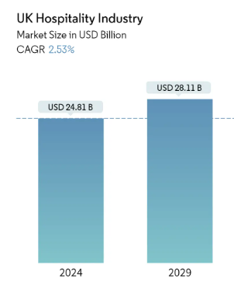
Figure 5: Market Size
Source: Mordor Intelligence, 2024
In JW Marriot, the AI automated systems, and solutions can ease operations, economize resource distribution and improve service quality. Nevertheless, the employment of AI calls for the implementation of upskilling and reskilling strategies that include the digital training of employees to the new skills as new technology is on-boarded and smooth operations as the system integrates with existing work modes. In addition to creating a positive impression on their guests, JW Marriott's wellness initiatives make the employees feel valued and as if they matter thereby promoting employee gratification (Forbes, 2020). Through the implementation and provision of wellness amenities services and programs, the JW Marriott fosters an ideal work environment suited for productivity, innovation, and creativity.
Guest care and convenience issues resulted in the development of contactless technology among many other sectors as learning of the pandemic. JW Marriott's adoption of No-touch technology stands out with its focus on automating guest interactions, trimming down operational complexity, and lessening physical contact. Besides using contactless technology, JW Marriott can design work process flow easily and quickly which presents restaurant staff the chance to offer the best services to the customers and, thus, can adapt to growing guest expectations easily (Reilly, 2018). Also, the main point of giving the tourist an idea of what the local culture is is indeed an expression of the commitment of JW Marriott to deliver personalized and immersive guest experiences. JW Marriott embraces and leverages local culture and heritage to empower employees and improve guest satisfaction through increased staff pride and competitive position in markets as a result.

Emergence of Work Modes
Over the last five years, a conclusion can be drawn that the Hospitality industry as a driver of the different modes of work is ruled by technical development, changing consumer styles and operational needs to be flexible (Kojo and Nenonen, 2017). JW Marriott is one of the hotel chains which pioneer in bearing different operational environments that in turn boost employee satisfaction, productivity, and overall operational efficiency. One of the most pronounced changes in the employment landscape is the adoption of hybrid work models, which provides the chance to be remote for a few days as well as to come to the office for some time. An example of collaborative and flexible work models is the Work Anywhere program that Marriott International introduced. Likewise, InterContinental Hotels Group (IHG) has come up with a Flexible Work initiative which allows employees to decide their time of work and places where they work based on the needs of the business (IHG, 2022). This way allows staff members to have improved productivity with the incorporation of family-oriented dimensions, as a result, this is translated into higher work satisfaction and retention rates. For instance, the Radisson Hotel Group has altered the traditional work; such as an Agile Working concept that highlights partnership, change, and flexibility. Radisson achieved this through the provision of cross-functional teamwork and empowered individual workers to customize the environment they work in. This in turn caused a culture of creativity and agility. It then enabled the company to respond rapidly to the dynamism of the market and guests' preferences. Means of communication through the sharing of desks, co-working offices, and virtual collaboration tools make teamwork, and knowledge-sharing across the globe workforce possible in the hotel industry (Akhavan and Mariotti, 2023). Moreover, the Remote Concierge service utilized technology to contribute to delivering personalized services for guests abroad. It's a sign of JW Marriott's compatibility in adjusting itself to all future consumer preferences and operational needs.
- Evaluation and Conclusion
In a nutshell, it can be summarized that the report findings have revealed complex relations between social-economic factors and handling of employee performance in the hospitality industry mainly based on JW Marriott examples. A figure of various economic trends including GDP trends and consumer behavior patterns shows preparations to deal with crises that seem inevitable in the future. Hence, projections of social tender such as new community taste and technology are more challenges than they are opportunities, to boost employee productivity and guest happiness.
Henceforth, JW Marriott needs to build upon these insights while implementing a more effective performance management system that gives a helpful scheme for monitoring and engaging the employees. To ensure employee satisfaction, introduce work flexibility in the form of hybrid and remote work which will in the long run improve staff retention. Additionally, adopting technology as the advancement of AI and contactless technology will aid in operations as well as improve service delivery. Moreover, employee wellness programs as well as the authentic local influence will play a significant role in increasing JW Marriott's competitiveness and reinforcing its promise of providing quality customer service experiences.

- References
Akhavan, M. and Mariotti, I., 2023. Coworking spaces and well-being: an empirical investigation of coworkers in Italy. Journal of Urban Technology, 30(1), pp.95-109.
Buhalis, D. and Moldavska, I., 2022. Voice assistants in hospitality: using artificial intelligence for customer service. Journal of Hospitality and Tourism Technology, 13(3), pp.386-403.
DeNisi, A.S. and Murphy, K.R., 2017. Performance appraisal and performance management: 100 years of progress?. Journal of applied psychology, 102(3), p.421.
Forbes 2020. 3 Things You Can Learn From Marriott About Taking Care Of Employees. [Online] Available at https://www.forbes.com/sites/serenitygibbons/2020/04/30/3-things-you-can-learn-from-marriott-about-taking-care-of-employees/?sh=37a436bf2bca [Accessed on 24 February 2024]
Harb, A., Thoumy, M. and Yazbeck, M., 2022. Customer satisfaction with digital banking channels in times of uncertainty. Banks and Bank Systems, 17(3), pp.27-37.
Holloway, J.C. and Humphreys, C., 2022. The business of tourism. Sage.
IHG 2022. Pressure is on employers to adopt flexible working conditions and blended travel to attract and retain talent. [Online] Available at https://www.ihgplc.com/en/news-and-media/news-releases/2022/pressure-is-on-employers-to-adopt-flexible-working-conditions [Accessed on 24 February 2024]
JW Marriott 2024. MAKE 7 DAYS OF WELL-BEING A PERSONAL JOURNEY. [Online] Available at https://jw-marriott.marriott.com/7-days-of-well-being/ [Accessed on 24 February 2024]
Kojo, I. and Nenonen, S., 2017. Evolution of co-working places: drivers and possibilities. Intelligent buildings international, 9(3), pp.164-175.
Mordor Intelligence 2024. UK Hospitality Industry Market Size. [Online] Available at https://www.mordorintelligence.com/industry-reports/hospitality-industry-in-the-united-kingdom/market-size [Accessed on 24 February 2024]
Quirke, B., 2017. Making the connections: Using internal communication to turn strategy into action. Routledge.
Reilly, P., 2018. Building customer centricity in the hospitality sector: the role of talent management. Worldwide Hospitality and Tourism Themes, 10(1), pp.42-56.
Sharma, S., 2019. Data privacy and GDPR handbook. John Wiley & Sons.
Statista 2022. Customer satisfaction with industry sectors in the United Kingdom (UK) in 2021 and 2022. [Online] Available at https://www.statista.com/statistics/879013/customer-satisfaction-by-industry-sector-united-kingdom-uk/ [Accessed on 24 February 2024]
Statista 2022b. Total software spending in accommodations, restaurants and nightlife industry in the United Kingdom from 2018 to 2024(in million U.S. dollars). [Online] Available at https://www.statista.com/statistics/1275146/uk-software-spending-industry-accommodation-restaurants-nightlife/ [Accessed on 24 February 2024]
Statista 2023a. Consumer spending on restaurants and hotels in the United Kingdom (UK) from 2005 to 2021(in billion GBP). [Online] Available at https://www.statista.com/statistics/476625/restaurant-and-hotels-consumer-spending-uk/ [Accessed on 24 February 2024]
Statista 2024a. Gross domestic product of the United Kingdom from 1948 to 2023(in million GBP). [Online] Available at https://www.statista.com/statistics/281744/gdp-of-the-united-kingdom/ [Accessed on 24 February 2024]
Statista 2024b. Inflation rate for the Consumer Price Index (CPI) in the United Kingdom from January 1989 to January 2024. [Online] Available at https://www.statista.com/statistics/306648/inflation-rate-consumer-price-index-cpi-united-kingdom-uk/ [Accessed on 24 February 2024]
Steinemann, A., 2018. Fragranced consumer products: effects on asthmatics. Air Quality, Atmosphere & Health, 11, pp.3-9.
Varelas, S. and Apostolopoulos, N., 2020. The implementation of strategic management in Greek hospitality businesses in times of crisis. Sustainability, 12(17), p.7211.

