Bartosz Galantowicz
1700994
Artificial Intelligence & Machine Learning
ACCA6011
Gordon Dickers
“Search”

Table of Contents
2 Abstract 3
3 Introduction 3
4 Task 1 4
4.1 Depth-First Search Algorithm 6
4.2 User Guide 9
4.3 Program Listing 13
4.3.1 ReadMe.txt 13
4.3.2 main.cpp 14
4.3.3 cNode.h 24
4.3.4 cNode.cpp 25
4.3.5 cItem.h 27
4.3.6 cItem.cpp 28
4.4 Test Schedule 29
5 Task 2 35
5.1 Algorithm for Simple Hill Climbing 37
5.2 Algorithm for Steepest-Ascent Hill Climbing 37
5.3 Discussion 38
6 Task 3 40
6.1 Discussion 43
7 Task 4 44
8 References 48

Abstract
The aim of the given assignment is to show knowledge and understanding of the algorithms, data structures, and AI concepts that can be implemented in programming. Also, in this document, the assessment of the used search methods is provided to analyse the advantages of the incorporated algorithms.

Introduction
This report is focused on research and practical implementation of search algorithms in the field of Artificial Intelligence and Machine Learning. For the given tasks requiring to develop an application, C/C++ programming language has been used. The IDE for the developed program was Visual Studio 2017. The theoretical tasks have been solved and described in more detail in the particular sections.

Task 1
The objective of Task 1 was to implement a Depth-first Search algorithm for the given scenario. Namely, the created application is a simulation of an AI agent searching for objects in a medical storage facility. A name of the searching item is provided by a user, and then the examination of a storage area map is started to locate the position of that object on the map.
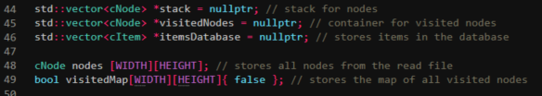
Fig 1. The data containers for storing nodes, items, and the visited map.
cNode is a class developed to hold a node and its characteristics such as position or a character value which is an id. Hence, the created vectors and an array are designated to keep the required information about nodes from the loaded file.
cItem class is a class designed to initialise the objects of medical items which can be possibly contained in a medical facility (e.g., Paracetamol, Naproxen).

std::vector<cNode> *stack - this is a container for the stack of nodes used during the depth-first search.

std::vector<cNode> *visitedNodes - this is a container for storing the already visited nodes during the depth-first search.
std::vector<cItem> *itemsDatabase - this is a container for a list of items, which can be found in a medical storage facility.

cNode nodes [WIDTH][HEIGHT] - this is an array of nodes saved from a read file (conversion the characters from a .txt file to related nodes).

bool visitedMap[WIDTH][HEIGHT]{ false - this is an array, which stores the map of visited nodes as booleans.

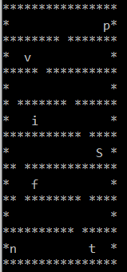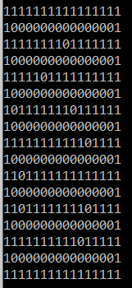

Fig 2. The examples of a medical storage facility map and an initial visited nodes map.
Figure 2 is showing the displayed maps of a medical storage facility in two versions. The first one is presenting the look of the storage facility to users, whereas the second one is a net of all nodes saved as visited or not. Moreover, the character “*” is a symbol indicating a “wall” or a “shelf” in the storage. Accordingly, each wall and shelf is set as visited (true) on the visited map in regard to their original coordinates. This is due to the requirement of keeping the search algorithm within the boundaries of the storage area map.
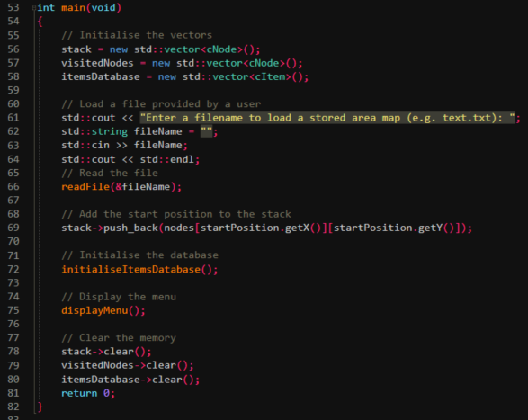
Fig 3. The main function.
At the beginning of the application, a user is asked to load a .txt file containing a stored area map. Next, a provided file is read by the program, and each position from the area map is saved to the array called nodes. Then the list of items is initialised. Due to the testing purpose, the list is made of predefined names of medicaments. Also, an id in the form of a single character is added to each unique item.

Depth-First Search Algorithm
Depth-first Search is a technique used in computer programming to traverse a graph or tree. The algorithm is begun by adding a start node to the stack and then exploring the adjacent nodes of the current node. The process of finding adjacent nodes is repeated until a node with no children nodes is encountered. Once the node with no children is reached, the DFS is starting to backtrack to one of the previously visited nodes, which other adjacent nodes have not been yet processed [1] [2].
DFS steps:
- Insert the start node in the stack.
- Pop the top item from the stack and allocate it to the visited list.
- Find all the adjacent nodes of the currently visited node, and add them to the stack if they have not been encountered.
- Repeat steps 2 and 3 until the stack is empty.
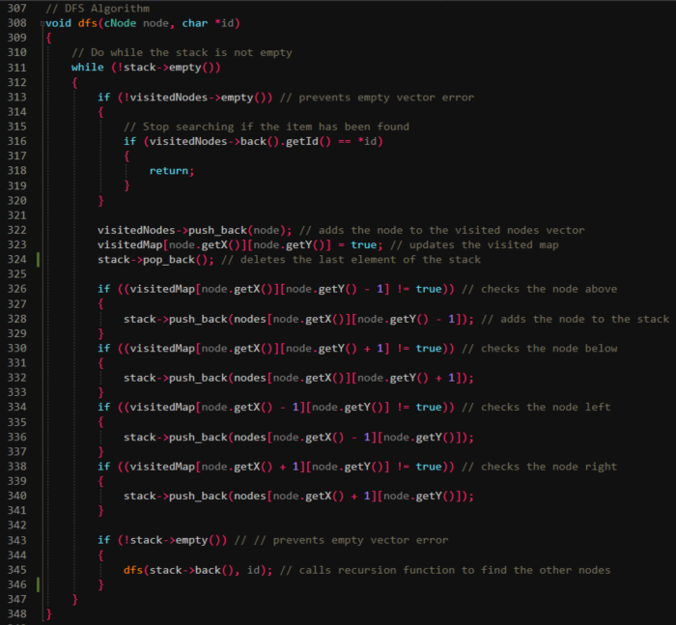
Fig 4. The presented function is responsible for processing the depth-first search algorithm.
Accordingly, to find the required item within an uploaded storage map, the function responsible for using DFS has been implemented. A node object and id of the item to find are passed to that function. Next, the currently analysed node is set as visited, the visited map is updated, and the algorithm removes the last element from the stack. Subsequently, the adjacent nodes are checked basing on the visited map if they are present and has not been already encountered. If yes, they are added to the stack, if not they are omitted. Finally, the function is called recursively, and all the processed steps are repeated until the final item id is found or all nodes are checked.
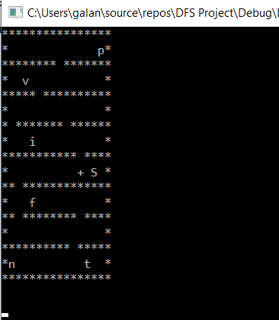
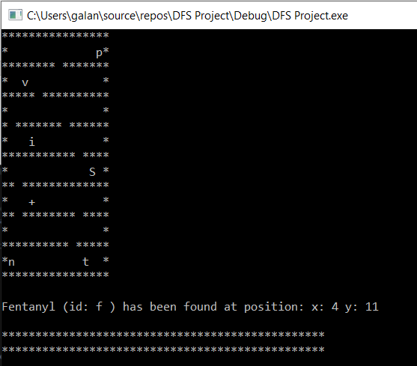
Fig 5. The example of search execution and its result.
The search execution is printed in the console window in the form of the storage area map, where the current position of the AI agent traversing the nodes is indicating by “+” character. Moreover, the console is refreshed every few nanoseconds, so the search is visible step by step in a smooth manner.

User Guide
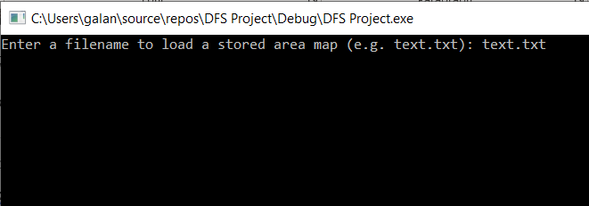
- User is asked to provide the .txt file name of a storage area map (e.g. text.txt) – type text.txt to proceed.
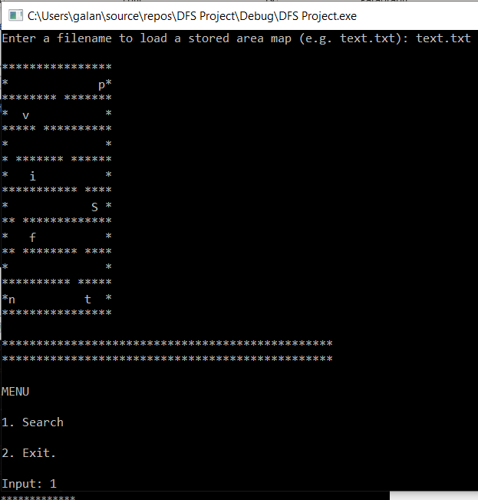
- The storage area map is read and displayed in the console window – type “1” to run a search.
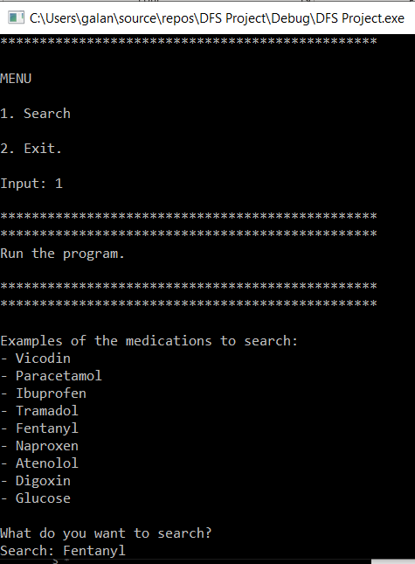
- The list of example medicaments is displayed – type one of the items from the list to find its position in the storage area map.
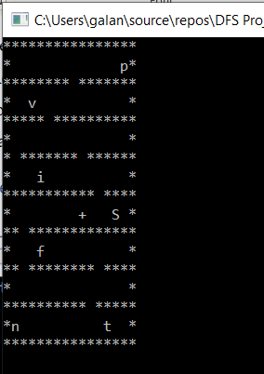

- Search is executed until the item is found or all elements of the storage area map are visited. Each step of searching is printed in the console window, where “+” character indicates the updated position of the AI agent.
- The name and the stored position of the searched item are displayed in the console window.
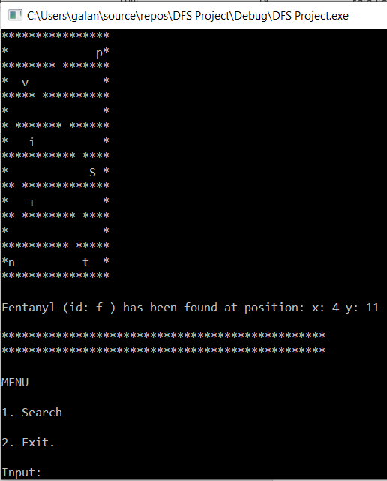
- The main menu is displayed again to allow another search or to exit the application.
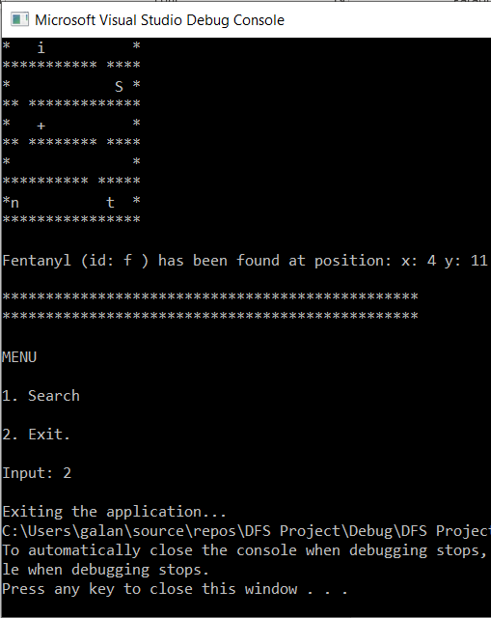
- Exiting the application is possible after input “2” in the console window.

Program Listing

ReadMe.txt

========================================================================================================
DFS Project
Bartosz Galantowicz
01/12/2020
========================================================================================================

This application is an example of the implementation of the Depth First Search algorithm.
Moreover, the DFS was used to simulate searching the medical storage area map.
A user can find the position of the searching item by providing the item’s name.
Basing on that input the AI agent is starting to looking for the item.
Each step of searching is displayed on the console window as the search is executed.

========================================================================================================
HOW TO USE THE APPLICATION
========================================================================================================
1. User is asked to provide the .txt file name of a storage area map (e.g. text.txt).
2. The storage area map is read and displayed in the console window.
3. The list of example medicaments is displayed.
4. User is asked to input the name of the searched item (e.g. Paracetamol).
5. Searching is executed until the item is found or all elements of the storage area map are visited.
6. Each step of searching is printed in the console window, where "+" character indicates the position of the AI agent.
7. The name and the stored position of the searched item are displayed in the console window.

main.cpp

#define WIDTH 16
#define HEIGHT 17

#include <iostream>
#include <fstream>
#include <string>
#include <vector>
#include <chrono>
#include <thread>

#include "cNode.h"
#include "cItem.h"

// This function is responsible for reading a .txt file containg storage area map
void readFile(std::string *fileName);

// This function initialise an example of items database
void initialiseItemsDatabase();

// This function return an id for the searched item
char findItemId(std::string itemName);

//This testing function displays the storage area map
void displayStorage();

//This testing function displays the visited storage area map
void displayVisitedMap();

// This function displays an updated search operation
void displaySearch(char *id, std::string *searchedItem);

// This function displays the menu
void displayMenu();

// This function is responsible for menu options proceeding
void choseMenuOptions(int userChoice);

// This function is responsible for searching an item
void search();

// DFS Algorithm
void dfs(cNode node, char *id);

std::vector<cNode> *stack = nullptr; // stack for nodes
std::vector<cNode> *visitedNodes = nullptr; // container for visited nodes
std::vector<cItem> *itemsDatabase = nullptr; // stores items in the database

cNode nodes [WIDTH][HEIGHT]; // stores all nodes from the read file
bool visitedMap[WIDTH][HEIGHT]{ false }; // stores the map of all visited nodes

cNode startPosition; // stores the start position

int main(void)
{
// Initialise the vectors
stack = new std::vector<cNode>();
visitedNodes = new std::vector<cNode>();
itemsDatabase = new std::vector<cItem>();

// Load a file provided by a user
std::cout << "Enter a filename to load a stored area map (e.g. text.txt): ";
std::string fileName = "";
std::cin >> fileName;
std::cout << std::endl;
// Read the file
readFile(&fileName);

// Add the start position to the stack
stack->push_back(nodes[startPosition.getX()][startPosition.getY()]);

// Initialise the database
initialiseItemsDatabase();

// Display the menu
displayMenu();

// Clear the memory
stack->clear();
visitedNodes->clear();
itemsDatabase->clear();
return 0;
}

// This function is responsible for menu options proceeding
void choseMenuOptions(int userChoice)
{

switch (userChoice)
{
case 1: // Display the program instructions
{
std::cout << "\n" << "************************************************" << "\n" << "************************************************" << std::endl;

std::cout << "Run the program." << std::endl;

std::cout << "\n" << "************************************************" << "\n" << "************************************************" << std::endl;

// Start searching
search();

// Back to the menu
displayMenu();

break;
}
// Exit the application
case 2:
{
std::cout << std::endl;
std::cout << "Exiting the application...";
exit(0);
break;
}
default:
std::cout << "Error: Invalid input!" << std::endl;
//exit(0);
}
}

void displayMenu()
{
int userChoice = 0; // stores a user's choice

// Display the menu of the program in the console windows
do
{
std::cout << "\n" << "************************************************" << "\n" << "************************************************" << std::endl;
std::cout << "\n" << "MENU" << std::endl;

std::cout << "\n" << "1. Search" << std::endl;
std::cout << "\n" << "2. Exit." << std::endl;

std::cout << "\n" << "Input: ";

std::cin >> userChoice; // gets a user's input
choseMenuOptions(userChoice); // proceeds with a chosen operation

} while (userChoice != 1 && !std::cin.fail());

}

// This function is responsible for reading a .txt file containg storage area map
void readFile(std::string *fileName)
{
char text[WIDTH * HEIGHT];
std::string line;
std::ifstream myfile(*fileName);
// Start reading the file
if (myfile.is_open())
{
int count = 0;
while (std::getline(myfile, line))
{
line.copy(&text[WIDTH * count], WIDTH, 0);
count++;
}
myfile.close();
}
else
{
std::cout << "Unable to open file!" << std::endl;
exit(0);
}

// Save the characters to the nodes
for (int y = 0; y < HEIGHT; y++)
{
for (int x = 0; x < WIDTH; x++)
{
// Get teh start position
if (text[WIDTH * y + x] == 'S')
{
startPosition.setX(x);
startPosition.setY(y);
}

// Set the "walls" of the storage map as visited to prevent searching at these positions
if (text[WIDTH * y + x] == '*')
{
visitedMap[x][y] = true;
}

// Create and save the nodes
cNode newNode;
newNode.setX(x);
newNode.setY(y);
newNode.setId(text[WIDTH * y + x]);

nodes[x][y] = newNode;

// Display the storage area map
std::cout << text[WIDTH * y + x];
}
std::cout << std::endl;
}

}

// This function initialise an example of items database
void initialiseItemsDatabase()
{
// These items are the example samples for the testing purposes
// Providing an available item from the text.txt file will start the search
// Providing a not available item from the text.txt file will result in not finding the desired item
itemsDatabase->push_back(cItem("Vicodin", 'v')); // available
itemsDatabase->push_back(cItem("Paracetamol", 'p')); // available
itemsDatabase->push_back(cItem("Ibuprofen", 'i')); // available
itemsDatabase->push_back(cItem("Tramadol", 't')); // available
itemsDatabase->push_back(cItem("Fentanyl", 'f')); // available
itemsDatabase->push_back(cItem("Naproxen", 'n')); // available
itemsDatabase->push_back(cItem("Atenolol", 'a')); // not available
itemsDatabase->push_back(cItem("Digoxin", 'd')); // not available
itemsDatabase->push_back(cItem("Glucose", 'g')); // not available
}

// This function return an id for the searched item
char findItemId(std::string itemName)
{
char id = ' ';

// Find the id of the searched item
for (unsigned int i = 0; i < itemsDatabase->size(); i++)
{
if (itemName == itemsDatabase->at(i).getItemName())
{
id = itemsDatabase->at(i).getID();
}
}

return id;
}

//This testing function displays the storage area map
void displayStorage()
{
for (int y = 0; y < HEIGHT; y++)
{
for (int x = 0; x < WIDTH; x++)
{
std::cout << nodes[x][y].getId();
}
std::cout << std::endl;
}
}

//This testing function displays the visited storage area map
void displayVisitedMap()
{
for (int y = 0; y < HEIGHT; y++)
{
for (int x = 0; x < WIDTH; x++)
{
std::cout << visitedMap[x][y];
}
std::cout << std::endl;
}
}

// This function displays an updated search operation
void displaySearch(char *id, std::string *searchedItem)
{
using namespace std::this_thread; // sleep_for, sleep_until
using namespace std::chrono; // nanoseconds, system_clock, seconds

// The search is not successful If the last visited node does not contain the searched item
if (visitedNodes->back().getId() != *id)
{
std::cout << "Item not found!" << std::endl;
return; // prevent displaying search if the item is not found
}

// Display the search steps if the item has been found
for (unsigned int i = 0; i < visitedNodes->size(); i++)
{
system("cls"); // refresh the console window each update of steps

// Get a visited node's coordinates
int nodeX = visitedNodes->at(i).getX();
int nodeY = visitedNodes->at(i).getY();

for (int y = 0; y < HEIGHT; y++)
{
for (int x = 0; x < WIDTH; x++)
{
if (nodeX == x && nodeY == y)
{
std::cout << "+"; // represents an AI agent
}
else
{
std::cout << nodes[x][y].getId(); // displays the rest of the storage area map
}
}
std::cout << std::endl;
}
std::cout << std::endl;
sleep_for(nanoseconds(10)); // wait before the next step
sleep_until(system_clock::now() + seconds(1));
}

// Inform a user where the item is placed
std::cout << *searchedItem << " (id: " << *id << " )" << " has been found at position: " << "x: " << visitedNodes->back().getX() << " y: " << visitedNodes->back().getY() << std::endl;
}

// DFS Algorithm
void dfs(cNode node, char *id)
{
// Do while the stack is not empty
while (!stack->empty())
{
if (!visitedNodes->empty()) // prevents empty vector error
{
// Stop searching if the item has been found
if (visitedNodes->back().getId() == *id)
{
return;
}
}

visitedNodes->push_back(node); // adds the node to the visited nodes vector
visitedMap[node.getX()][node.getY()] = true; // updates the visited map
stack->pop_back(); // deletes the last element of the stack

if ((visitedMap[node.getX()][node.getY() - 1] != true)) // checks the node above
{
stack->push_back(nodes[node.getX()][node.getY() - 1]); // adds the node to the stack
}
if ((visitedMap[node.getX()][node.getY() + 1] != true)) // checks the node below
{
stack->push_back(nodes[node.getX()][node.getY() + 1]);
}
if ((visitedMap[node.getX() - 1][node.getY()] != true)) // checks the node left
{
stack->push_back(nodes[node.getX() - 1][node.getY()]);
}
if ((visitedMap[node.getX() + 1][node.getY()] != true)) // checks the node right
{
stack->push_back(nodes[node.getX() + 1][node.getY()]);
}

if (!stack->empty()) // // prevents empty vector error
{
dfs(stack->back(), id); // calls recursion function to find the other nodes
}
}
}

// This function is responsible for searching an item
void search()
{
// Present the examples of items to input
std::cout << "\n" << "Examples of the medications to search:" << std::endl;

for (unsigned int i = 0; i < itemsDatabase->size(); i++)
{
std::cout << "- " << itemsDatabase->at(i).getItemName() << std::endl;
}

// Ask user about the searching item
std::cout << "\n" << "What do you want to search?" << std::endl;
std::string searchedItem = "";
std::cout << "Search: ";
std::cin >> searchedItem; // gets input from a user
char id = findItemId(searchedItem); // gets the id of the searching item

// Check if the searched id is not space
if ((id != ' '))
{
// Call DFS algorithm
// Pass the starting node and the desired id
dfs(stack->back(), &id);
// Display the search
displaySearch(&id, &searchedItem);
}
else
{
std::cout << "Item not found";
}
}

cNode.h

#pragma once
#include<vector>

// This class represents a node which can store the characteristics of one element from the storage area map
class cNode
{
private:
// The coordinates of the node
int x = 0;
int y = 0;

char id = ‘/’; // stores the id of the node, which is a character from the storage area map at position (x,y)
public:

//Constructors for the cNode
cNode();
cNode(int x, int y, char id, bool visited);

int getX(); // returns the x coordinate
void setX(int x); // sets the x coordinate
int getY(); // returns the y coordinate
void setY(int y); // sets the y coordinate

char getId(); // returns the id
void setId(char id); // sets the id
};

cNode.cpp

#include "cNode.h"

cNode::cNode()
{
}

cNode::cNode(int x, int y, char id, bool visited)
{
this->x = x;
this->y = y;
this->id = id;
}

int cNode::getX()
{
return x;
}

void cNode::setX(int x)
{
this->x = x;
}

int cNode::getY()
{
return y;
}

void cNode::setY(int y)
{
this->y = y;
}

char cNode::getId()
{
return id;
}

void cNode::setId(char id)
{
this->id = id;
}

cItem.h

#pragma once
#include<vector>

// This class represents a node which can store the characteristics of one element from the storage area map
class cNode
{
private:
// The coordinates of the node
int x = 0;
int y = 0;

char id = ‘/’; // stores the id of the node, which is a character from the storage area map at position (x,y)
public:

//Constructors for the cNode
cNode();
cNode(int x, int y, char id, bool visited);

int getX(); // returns the x coordinate
void setX(int x); // sets the x coordinate
int getY(); // returns the y coordinate
void setY(int y); // sets the y coordinate

char getId(); // returns the id
void setId(char id); // sets the id
};

cItem.cpp

#include "cItem.h"

cItem::cItem(std::string newItemName, char newId)
{
itemName = newItemName;
id = newId;
}

char cItem::getID()
{
return id;
}

std::string cItem::getItemName()
{
return itemName;
}

cItem::~cItem()
{
}

Test Schedule
Test Case Id:  FileLoader1 |  | Test Purpose: To check if the storage data can be loaded from the console window.
Environment:
Windows 10 Pro
Microsoft Visual Studio Community 2017 v.15.9.15
Preconditions: The program has been started.
Test Case Steps: 3
Step No | Procedure |  | Response | Pass/Fail
1 | Press “CTRL” + “F5” buttons to run the debug mode. |  | 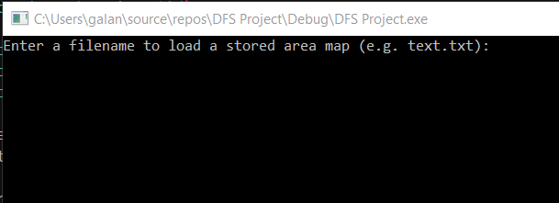  The console program is open, and it is asking for input. | Pass
2 | Provide an example input “text.txt”. |  | 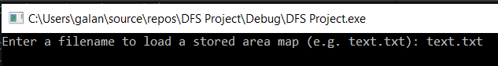  The application window is displayed. The “text.txt” is provided. | Pass
3 | Press enter key. |  | 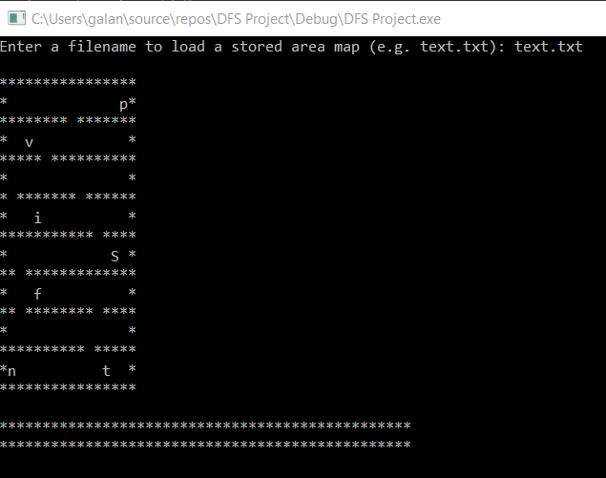  The storage map is displayed in the console window. | Pass
Comments:
All steps passed.
Related Tests: FileLoader2
Author: Bartosz Galantowicz

Test Case Id:  FileLoader2 |  | Test Purpose: To check if the incorrect storage data cannot be loaded from the console window.
Environment:
Windows 10 Pro
Microsoft Visual Studio Community 2017 v.15.9.15
Preconditions: The program has been started.
Test Case Steps: 3
Step No | Procedure |  | Response | Pass/Fail
1 | Press “CTRL” + “F5” buttons to run the debug mode. |  | The console program is open, and it is asking for input. | Pass
2 | Provide an example input “scriptum.txt”. |  | 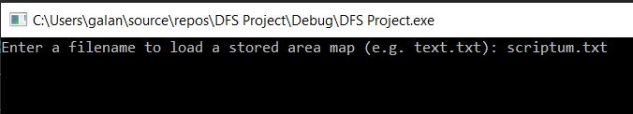  The application window is displayed. The “scriptum.txt” is provided. | Pass
3 | Press enter key. |  | 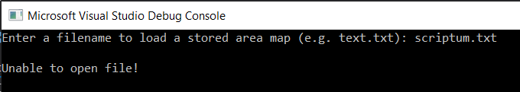  The information that the file is unable to be opened is displayed in the console window. | Pass
Comments:
All steps passed.
Related Tests: FileLoader1
Author: Bartosz Galantowicz

Test Case Id:  Search1 |  | Test Purpose: To check if an item can be found in the provided storage area map.
Environment:
Windows 10 Pro
Microsoft Visual Studio Community 2017 v.15.9.15
Preconditions: The program has been started.
Test Case Steps: 4
Step No | Procedure |  | Response | Pass/Fail
1 | Press “CTRL” + “F5” buttons to run the debug mode. Provide an example input “text.txt” and press enter. |  | 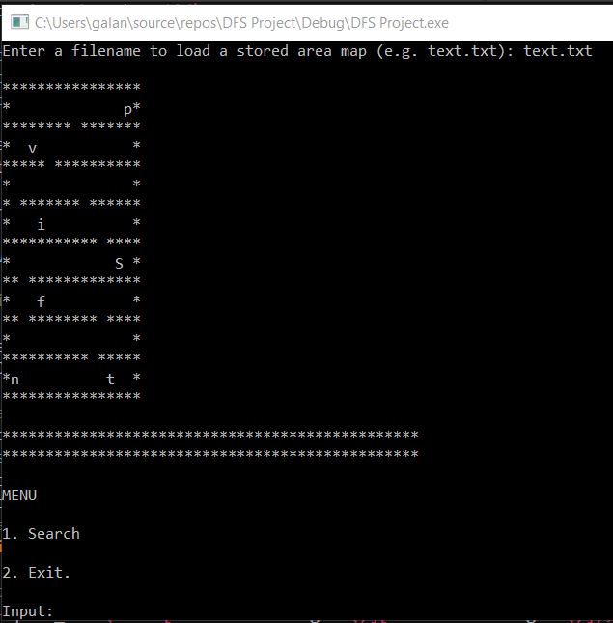  The storage map and the menu are displayed in the console window. | Pass
2 | Press “1” to start searching. |  | 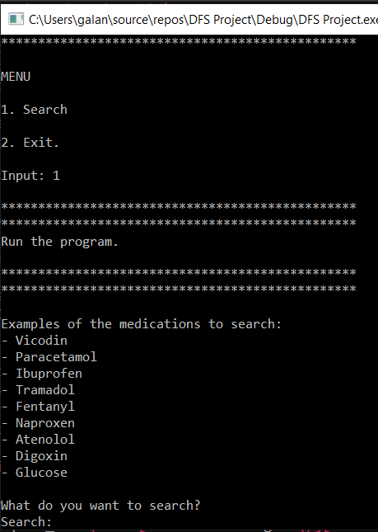  The list of example items is printed. The program is asking for the name of a searching item. | Pass
3 | Enter “Fentanyl” to find it in the storage and press enter key. |  | 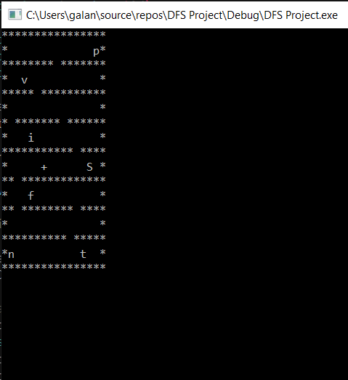  The console window is cleared, and the search simulation is rendered. | Pass
4 | Wait until the search is ended. |  | 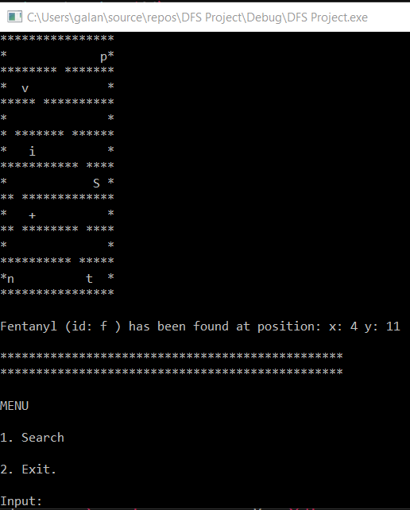  The position of the found item is displayed on the storage map. The crucial data about the item is presented in the console window. The menu is printed again. | Pass
Comments:
All steps passed.
Related Tests: FileLoader1, FileLoader2, Search2
Author: Bartosz Galantowicz

Test Case Id:  Search2 |  | Test Purpose: To check if a not existed item can be found in the provided storage area map.
Environment:
Windows 10 Pro
Microsoft Visual Studio Community 2017 v.15.9.15
Preconditions: The program has been started.
Test Case Steps:
Step No | Procedure |  | Response | Pass/Fail
1 | Press “CTRL” + “F5” buttons to run the debug mode. Provide an example input “text.txt” and press enter. |  | The storage map and the menu are displayed in the console window. | Pass
2 | Press “1” to start searching. |  | The list of example items is printed. The program is asking for the name of a searching item. | Pass
3 | Enter “Glucose” to find it in the storage and press enter key. |  | 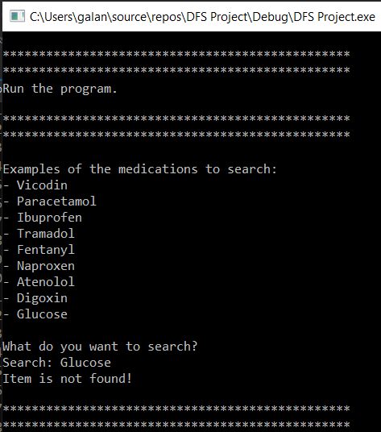  The information that the item is not found is printed in the console window. The menu is printed again. | Pass
Comments:
All steps passed.
Related Tests: FileLoader1, FileLoader2, Search2
Author: Bartosz Galantowicz

Task 2

Hill Climbing is a search algorithm which is used for mathematical optimisation of the issues in the field of Artificial Intelligence. Namely, its work logic is based on taking a sub-optimal solution, which is continuously moved in the direction of increasing its optimal value. The termination occurs when a peak value is reached, and its neighbour values are not higher. The well-known example of implementation of the hill-climbing algorithm is Traveling-salesman problem, which aim is to minimise the distance travelled by the salesman. Also, the algorithm is called greedy local search as when the first optimal value is found, the search is stopped, despite that the better solution may exist [3] [4].
A node in the hill-climbing algorithm is made of two components which represent state and value. Accordingly, it is not necessary to maintain and handle the search graph or tree. The only required variable to follow is a single current state. Hence, the algorithm is mostly used when a good heuristic is available [3] [4].
Features of Hill Climbing:
- Generate and Test variant – the method is used to generate feedback which is a reference to decide which direction to move in the search space.
- Greedy approach – the moves of the search are taken in the direction which costs are optimised.
- No backtracking – the search space is not backtracked, so the previous state is not remembered.
The graphical representation of the hill-climbing algorithm is the state-space landscape. The various states of the algorithm are compared to its cost/objective function. These relationships can be presented as a diagram.
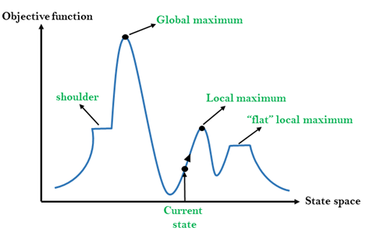
Fig 5. The graphical representation of the hill-climbing algorithm (https://static.javatpoint.com/tutorial/ai/images/hill-climbing-algorithm-in-ai.png).
The functions which can be an objective function or cost function are described on the y-axis, whereas state-space is presented on the x-axis. Therefore, if the y-axis is cost, then, the aim is to find the local minimum and global minimum. Otherwise, if the y-axis is the objective function, the objective to achieve is to find local maximum and global maximum.
- Local Maximum – is a state that values are higher than its neighbour states; however, there is a state which is higher than it.
- Global Maximum – is the best possible solution in the space landscape as its value is the highest.
- Current state – is the position in the landscape diagram currently occupied by AI agent.
- Shoulder – is a “flat” region which one or both its edges are uphill edges.

Algorithm for Simple Hill Climbing
The hill-climbing algorithm can be implemented using various approaches. The most simple one is just called a simple hill climbing. Its logic is based on evaluating only one the neighbour state at a time and selecting the first one that is optimising current cost. Accordingly, the newly selected node is set as a current state and so on. The main features of this approach are: saving searching time, finding less optimal solution and the rule that solution is not guaranteed [3] [5].
- Step 1: Evaluation of the initial state and if it is a goal state, then stop the execution.
- Step 2: Looping until a solution is found, or there is no new operator to apply.
- Step 3: Selecting and applying an operator to the current state.
- Step 4: Checking the new condition:
  - If it is goal state, then success is returned, and the algorithm is quite.
  - Else if the new state is more optimal than the current state then assign new state as a current state
  - Else if the new state is less optimal than the current state then return to step 2.
- Step 5: Exit.

Algorithm for Steepest-Ascent Hill Climbing
The other variation of the high climbing algorithm is steepest-ascent hill climbing. In this technique, all neighbour nodes of the current state are examined. Then, a node which is the closest to the goal state is selected [5].
- Step 1: Evaluation of the initial state and if it is a goal state, then stop the execution.
- Step 2: Looping until a solution is found or the current state is not changed.
  - Let S be a state such that any neighbouring nodes of the current state will be better than it.
  - For each operator that the current state is applied:
    - A new operator is applied.
    - A new state is generated.
    - If it is a goal state, then the state is returned, else compare it to the S.
    - If it is better than S, then the new state is set to S.
    - If S is better than the current state, then the current state is set to S.
- Step 3: Exit.

Discussion
Hill climbing algorithm is one of the most popular solutions for local searches. However, it is not perfect, and its limitations and specific problems come with it. Nevertheless, in some particular examples, there are solutions to these issues .
Firstly, local maximum, which is a peak state in the landscape, might be a good solution, but in the same state landscape, a better result exists. In that case, the fact that a better solution exists is omitted due to using a greedy approach by the algorithm [3]. Hence, the search is stopped when the successors of the current node are less valuable than their parent. However, a backtracking technique can be utilised to maintain a list of visited states and consequently to overcome this problem. If an undesirable state is reached, it can be backtracked to the previous configuration, and then a new path can be explored [5].
Another problem in a different region in hill climbing is the shoulder region. On the shoulder region values for all neighbour states are the same. Therefore, it is impossible to choose the best direction. However, this issue can be overcome by making a jump and randomly select a state which is spaced further than the current state. The chance of choosing a state in the non-shoulder region is increased due to using this operation [5].
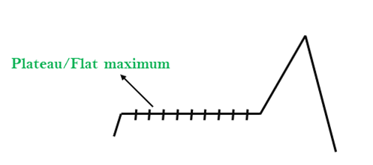
Fig 6. The example of the shoulder region (https://static.javatpoint.com/tutorial/ai/images/hill-climbing-algorithm-in-ai4.png).
The last issue regarding the hill-climbing algorithm to discuss is ridge region, which is a special form of the local maximum. Its area is higher than in the surrounding areas. Hence, a slope is contained in the ridge region, which cannot be reached in a single move. Improvement for solving this problem can be the implementation of additional checking rules before testing. Namely, the search will proceed in different directions to eliminate the issue [3] [5].
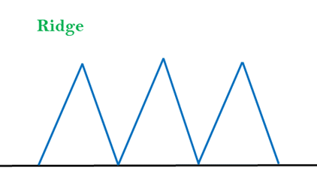
Fig 7. The example of the ridge region (https://static.javatpoint.com/tutorial/ai/images/hill-climbing-algorithm-in-ai2.png).
The discussed solutions are enhancements for the hill-climbing algorithm, which can improve its execution process.

Task 3
The Eight Tiles problem is a puzzle which is consisted of an area divided into a grid. In the given case, it is three by three grid for the eight puzzle. Eight from nine grid squares are tiles. One grid square is remained empty to allow moving the tiles. A tile that is the closest tile to the empty grid can be moved into the empty space. The aim is to solve the puzzle starting from the given initial state and find a goal state [6] [7].
The moves can be taken in four directions
- Right
- Left
- Up
- Down
1 | 2 | 5
 | 3 | 4
6 | 7 | 8
Fig 8. The initial state of the given puzzle.
 | 1 | 2
3 | 4 | 5
6 | 7 | 8
Fig 9. The goal state for the given puzzle.
The simple heuristic function for determining the goal is the method which returns the number of misplaced tiles and keeps the best outcome. Hence the best solution is chosen by the algorithm and set as the current state. Namely, the current state is compared to each possible move in regard to the goal [6] [7].

h(n) = number of misplaced tiles
The search is executing as follow:
1 | 2 | 5
 | 3 | 4
6 | 7 | 8
 | 2 | 5
1 | 3 | 4
6 | 7 | 8
1 | 2 | 5
3 |  | 4
6 | 7 | 8
h(n) = 5

h(n)= 4
h(n) = 5

1 | 2 | 5
3 | 4
6 | 7 | 8

1 |  | 5
3 | 2 | 4
6 | 7 | 8

h(n)= 3
h(n)= 4

1 | 2
3 | 4 | 5
6 | 7 | 8

h(n)= 2
1 |  | 2
3 | 4 | 5
6 | 7 | 8

h(n)= 1

 | 1 | 2
3 | 4 | 5
6 | 7 | 8

h(n)= 0

The goal has been achieved as all nodes are placed at the correct positions.

Discussion
Implementing a hill-climbing algorithm to solve the 8-puzzle problem might be the right approach for simple examples of the puzzle. Moreover, this is fast in execution. However, reaching the goal can be more tricky for complicated puzzles. The solution is not guaranteed because using a heuristic function. In hill-climbing, if the values of neighbour states are “worst” than the current state, the execution is stopped. Therefore, the final goal of for 8-tile puzzle can be unreached if neighbour nodes are bigger than the current one. Also, the algorithm is vulnerable to infinite loops if the rules of searching are not specified appropriately [6] [7] [8].
Furthermore, only one variable is taken into consideration by the heuristic function, which is based on the number of misplaced tiles. The value of this variable is false if a tile is misplaced or true if it is not. In this case, the meaning of how far away a tile is from being correct is not essential. Thereby, a tile which is one square away from its objective position is evaluated the same way as a tile that is far away from its destination. Lack of such information can make the algorithm less precise [6] [7] [8].
On the other hand, there are heuristic functions which use additional data to calibrate the search. The good examples can be incorporating Manhattan Distances or Euclidean Distances to the method.

Task 4
Another method to find a solution for the eight puzzle problem is implementing Manhattan Distance function, which returns the distance between two points measured along axes at right angles. In this case, the length will be the number of moves required to achieve the goal state for a particular grid square [7] [8].
5
5

Fig 10. For example, the Manhattan Distance for 5 is 1, as only one move is required to place it in the right position.
Due to solving the given problem the sum of Manhattan Distances of each misplaced node is used to assess all possible moves and then to chose the most efficient one, which leads to a new termination with even fewer moves to make. The process is ended if the solution is found, if there is an infinite loop found or if a new sum of Manhattan Distances is bigger than the current sum of Manhattan Distances. Moreover, the nodes which are placed on the correct position in the grid are omitted in search [7] [8].

Let say that there is a function returning Manhattan Distance for each grid square as can be seen below. One position is reserved as a blank tile.
P(1) | P(2) | P(5)
blank | P(3) | P(4)
P(6) | P(7) | P(8)

The heuristic function which is applied to reach the goal is based on the number of misplaced tiles and the sum of Manhattan Distances.
h(n) = P(1) + P(2) + P(3) + P(4) + P(5) + P(6) + P(7) + P(8)
n - is the number of misplaced nodes
For example:
h(5) = 1 + 1 + 1 + 1 + 1 + 0 + 0 + 0
h(5) = 5

The search is executing as follow:
1 | 2 | 5
 | 3 | 4
6 | 7 | 8
 | 2 | 5
1 | 3 | 4
6 | 7 | 8
1 | 2 | 5
3 |  | 4
6 | 7 | 8
h(n) = 1+1+1+1+1+0+0+0+0
h(n)= 5

h(n) = 1+1+0+1+1+0+0+0+0
h(n)= 4
h(n) = 2+1+1+1+1+0+0+0+0
h(n)= 6

1 | 2 | 5
3 | 4
6 | 7 | 8

1 |  | 5
3 | 2 | 4
6 | 7 | 8

h(n) = 1+1+0+0+1+0+0+0+0
h(n)= 3
h(n) = 1+2+0+1+1+0+0+0+0
h(n)= 5

1 | 2
3 | 4 | 5
6 | 7 | 8

h(n) = 1+1+0+0+0+0+0+0+0
h(n)= 2
1 |  | 2
3 | 4 | 5
6 | 7 | 8

h(n) = 1+0+0+0+0+0+0+0+0
h(n)= 1

 | 1 | 2
3 | 4 | 5
6 | 7 | 8

h(n) = 0+0+0+0+0+0+0+0+0
h(n)= 0

The goal has been achieved as all nodes are placed at the correct positions.

References

[1] | P. N. Stuart Russell, Artificial Intelligence A Modern Approach, 3rd ed., New Jersey: Pearson, 2010, pp. 85-90.
[2] | P. S. Kurt Mehlhorn, Algorithms and Data Structures The Basic Toolbox, Berlin: Springer, 2010, pp. 178-187.
[3] | P. N. Stuart Russell, Artificial Intelligence A Modern Approach, 3rd ed., New Jersey: Pearson, 2010, pp. 122-126.
[4] | S. Skiena, The Algorithm Design Manual, 2nd ed., London: Springer, 2012, pp. 251-258.
[5] | java T point, “Hill Climbing Algorithm in Artificial Intelligence,” java T point, [Online]. Available: https://www.javatpoint.com/hill-climbing-algorithm-in-ai. [Accessed 11 2020].
[6] | P. N. Stuart Russell, Artificial Intelligence A Modern Approach, 3rd ed., New Jersey: Pearson, 2010, pp. 102-107.
[7] | M. d. C. R. D. Tim Finin, “Artificial Intelligence Informed Search,” [Online]. Available: https://cs.brynmawr.edu/Courses/cs372/spring2012/slides/05_OptimizationGAs.pdf. [Accessed 11 2020].
[8] | D. Nayak, “Analysis and Implementation of Admissible Heuristics in 8 Puzzle Problem,” Rourkela, 2014.
[9] | J. F. Ian Millington, Artificial Intelligence for Games, 2nd ed., CRC Press, 2009.

