CHANGEMAKERS:
CREATIVITY and VALUE CREATION
BMHP5014
Dr AZORA HURD
TASKS 1 & 2
GHEORGHE ADRIAN COT
1913213

TASK 1-MIND MAP ON COVID-19 LOCKDOWN AND THE IMPACT ON ELDERLY SINGLE PEOPLE
The Covid-19 cases first appeared in the end of 2019 in Wuhan, China. Since then, the disease has reach to a variety of states around the globe, becoming a pandemic
1 COVID-19

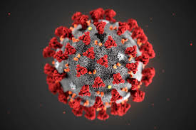
Illustration of the ultrastructure of the Covid-19 virus


People are being advised to stay at home. People should only leave home to shop for basic needs, go to work, offer voluntary services or seek medical assistance.

2 NHS Governmental Advice

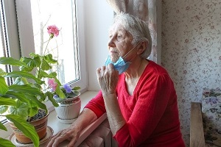
Emerging data shows that Covid-19 is a specific danger to older persons. The pandemic puts older persons at a greater risk of prejudice and loneliness. In order to reach aged human beings through digital equipment, we require better social support and smarter efforts. Loneliness can affect aged human beings health causing hearth problems, depression, higher stress, drug abuse and many more. Loneliness is the key markers of social well-being (Cacioppo, Patrick, 2008).

3 Impact on older people

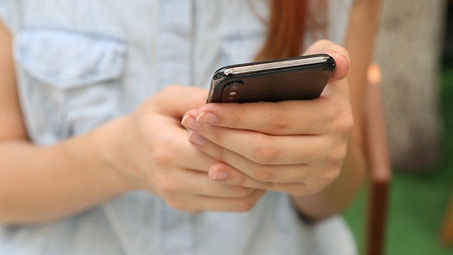
The person you are supporting is going to reap health benefits. A quick phone call could make a difference.
According to Smith (2006), in the past the superiority of technology was not as much as to make the distance feel intensified.

4 Implementing a helpline

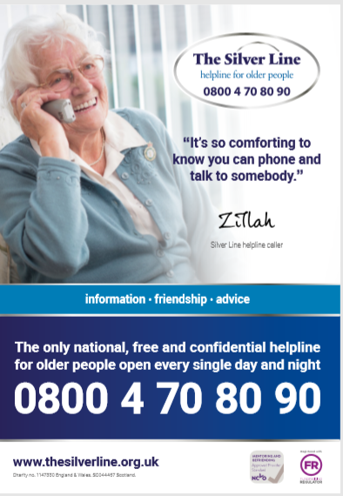
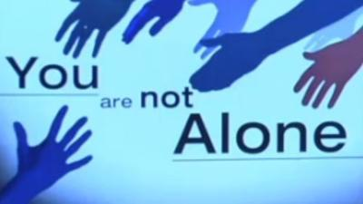
Being socially linked not only has an effect on emotional well-being, but also has an important and positive impact on physical well-being and longevity. the sense of belonging, the relation minimizes the factors that contribute to depression (Firestone, nd).

5 Outcomes

REFERENCES

Birmingham City council, (2021) National lockdown announced for England. Available at: https://www.birmingham.gov.uk/news/article/787/national_lockdown_announced_for_england (Accessed: 12 February 2021).
Cacioppo T., Patrick W., (2008). Loneliness: Human Nature and the Need for Social Connection Available at https://books.google.co.uk/books?hl=en&lr=&id=w8pWZ2AGI4MC&oi=fnd&pg=PR9&ots=lG7K4Eq22V&sig=44_xCFpYfy7XpSwYlH2xFzEtK3o&redir_esc=y#v=onepage&q&f=false (Accessed: 15 February 2021).
Firestone L., (nd). Psychalive ISOLATION AND LONELINESS, SELF DEVELOPMENT Available at: https://www.psychalive.org/being-alone/ (Accessed: 15 February 2021).
HSBA, (2020). National Safeguarding Adults Week 2020- Loneliness and Social Isolation. Available at: https://www.hampshiresab.org.uk/safeguarding-adults-week-2020-loneliness-and-isolation/ (Accessed: 12 February 2021).
Itv, (2020). Loneliness helplines. Available at: https://www.itv.com/thismorning/articles/loneliness-helplines (Accessed: 12 February 2021).
Medical Industry Ltd, (nd) Government Guidance and Advice. Available at: https://www.medicalindustry.co.uk/resources/covid-19-industry-support-tracker/government-guidance-and-advice/ (Accessed: 12 February 2021).
Newscientist, (2020) Illustration of the ultrastructure of the Covid-19 virus. Available at: https://www.newscientist.com/term/covid-19/ (Accessed: 12 February 2021).
UNECE, (2020). The impact of the COVID-19 pandemic on older persons. Available at: https://unece.org/population/news/impact-covid-19-pandemic-older-persons (Accessed: 12 February 2021).
William B., Applegate MD., (2020). Covid-19 Presents High Risk to Older People. JOURNAL OF THE AMERICAN GERIATRICS SOCIETY. Available at: https://agsjournals.onlinelibrary.wiley.com/doi/full/10.1111/jgs.16426 (Accessed: 12 February 2021).

TASK 2- BLOG
“Many aspects of the Covid-19 pandemic and the public health response to it will undoubtedly contribute to
widespread emotional distress and increased risk for psychiatric illness…”
“Socialization is an important part of the healthy aging process, but natural changes in the lifestyle and
health of older people increased risk of loneliness...”
Perlman D., Peplau L. A., (1982) Loneliness, Encyclopedia of Mental Health Volume
TACKLING LONELINESS

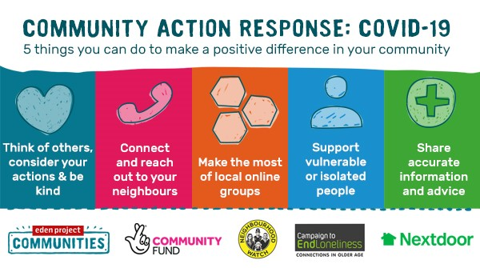

For a better view click the link below:
https://peplau.psych.ucla.edu/wp-content/uploads/sites/141/2017/07/Perlman-Peplau-98.pdf
I want to present you how loneliness caused by the pandemic could affect anyone around you and the impact you could have in someone’s life.
Peplau and Perlman’s (1982) work suggests that social loneliness is the kind of solitude that take place when a human being lacks the sense of social inclusion or group participation that a network of friends, neighbours may provide. Some individuals may be more at risk than others to the psychosocial consequences of the pandemic. Psychological effect, involving stress, depression, anxiety, uncertainty, rage, are related to isolation.
Most people who feel lonely are not seeking medical support. Anyone who feels lonely can access the helpline. Professionals will review every person in the database to make sure every person is stable.
Just pick up the phone and reach out to anyone you know. I found that being active in the community it is very satisfying. By helping others, we help ourselves.
There are several governmental agencies as well as charities and NGOs that, along with community engagement, could make a significant difference in this difficult time and not only. Taking part as a volunteer could lead us to meet and know new human beings and to build lifelong relationships.
In the Analysis of loneliness in Great Britain during the Covid-19 pandemic suggests that people in younger age groups were more likely to experience loneliness, whereas those in older age groups were less likely to report loneliness (Office for National Statistics, 2020).
However, the suggestions from the study make me wonder whether older people are used to be lonely and just assuming that this is natural, or whether the analysis is not valid.

References
Bandari, Razieh et al., 2019. Defining loneliness in older adults: protocol for a systematic review. Systematic reviews, 8(1), p.26. Available at:
https://browzine.com/libraries/1422/journals/194/issues/205764822?showArticleInContext=doi%3A10.1186%2Fs13643-018-0935-y (Accessed: 16 February 2021).
Campaign to EndLoneliness, (2020), Coronavirus and social isolation Available at: https://www.campaigntoendloneliness.org/blog/coronavirus-and-social-isolation/ (Accessed: 16 February 2021).
NORTH, C.S., 2020. Mental Health and the Covid-19 Pandemic. The New England journal of medicine, 383(6), pp. 510-512. DOI:10.1056/NEJMp2008017 (Accessed: 16 February 2021).
Perlman D., Peplau L. A., (1982) Loneliness, Encyclopedia of Mental Health Volume Available at: https://peplau.psych.ucla.edu/wp-content/uploads/sites/141/2017/07/Perlman-Peplau-98.pdf (Accessed: 15 February 2021).

