LCHS4002
Component 2
Research Report

Student Number:2213991
Matthew Brian

Digital Skills and Research Methods: Which digital technology is most commonly used for collaboration at UWTSD?

Table of Contents
Introduction 3
Rationale and historical context of research 3
Aim of research 4
Research objectives 4
Importance of research 4
Research design 4
Research questions 4
Research questions 5
Research Methodology 5
Tools for Academic Study 5
Ethical and moral considerations 7
Findings of the research 7
Discussion 10
Conclusion 11
References 12
Appendix 1: Questionnaire 13

Introduction

Rationale and historical context of research
The usage of online resources for group work is on the rise in classrooms (Zohrabi, 2018). Increased convenience in communication and activity directly results from technological progress. Yet, throughout the digital realm, wandering is also happening. Under the guidance of their educator, learners freely explore their online collaborative instruments.
Students use technology tools to develop their skills as thinkers and creators, improve their teamwork and individual performance, and increase their exposure to new ideas and perspectives. Unfortunately, instructors and learners are finding that instructional programs are becoming increasingly ineffective in this phase of learning dominated by cell phones, social networks, and technologies. The curriculum has moved to the student's cellphone, even though many educators still ban their use in class (Busse & Weidner, 2022). Today's students are more accustomed to technology because they use it as their main mode of communication, share and play computer games, and spread information on educational work. With technological resources, learners can share resources, mice can have their study area with the instructor, and children can have fun studying by contributing their ideas and perspectives.
The use of online platforms that facilitate teamwork is on the rise (Busse & Weidner, 2022). Numerous studies have shown that virtually all kids today use a little form of digital technology for group work and sharing ideas with their peers and instructors. They would rather use digital resources to get data than interact personally with the subject matter. The COVID-19 crisis has prompted educators to use digital resources more in the classroom. In the epidemic's early stages, it was physically challenging to continue with regular school activities. Institutions of higher learning back then often employed interactive web technologies to run their classes (Busse & Weidner, 2022). The primary goal of digital resources is to improve the student experience by making learning more convenient, interesting, and pleasurable. Learners or people worldwide can work together to study using digital resources.
This research aimed to examine the popular means of group work among UWTSD undergraduates. Data collection from a subset of undergrads has been used to conclude the efficacy of digital resources. Data analysis and the software's impacts on academic' learning are described in the report. As the prevalence of learners' usage of digital technologies grows, so does this research's significance, as it directly affects how people learn.

Aim of research
The primary goal of this research is to determine the most popular resource among UWTSD undergraduates.

Research objectives
The objective is the way of reaching the desired goal. This study aims to understand-
- How people are putting digital resources to work together.
- To recognize the implications of online technologies on cooperation.
- Determine how pupils are negatively affected by using digital resources.
- To mitigate the harmful effects of the instruments, proper guidance must be provided.

Importance of research
Educators are now using digital technology for cooperation, and that number is close to 100%. COVID-19 has caused substantial growth in clients during the past couple of years. The report's overarching goal is to establish the most prevalent collaborative learning method (A., 2016). Educational leaders will benefit from this research and its conclusions since it will allow them to better understand students ' behaviour and devise a set that caters to their needs.

Research design

Research questions
In scientific investigation, research questionnaires are inquiries about the topic at hand that are posed to the respondents (B.S, 2017). The very first step in conducting an investigation is developing a research question. A questionnaire is designed to gauge learners' thoughts on the efficacy of utilizing a digital resource in the classroom. Learners at UWTSD will be able to share their thoughts on the benefits and drawbacks of various digital technologies by filling out this survey. Researchers have utilized both descriptive and analytical inquiry formats to design surveys (B.S, 2017). As a result, the survey has many open-ended, hypothetical, and analytical inquiries.

Research questions
- The research will contain some queries. Those seem to be:
- How can pupils embrace digital technology in learning?
- Could the virus have altered how learners feel about the use of technology?
- To what extent do they rely on this methodical device?
- Do the instruments used in the investigation produce reliable and accurate results?
- Are they ever use a digital device to interact with those around them?
- How comfortable are the educators with the latest tech?
- Is there any evidence that this resource has had a detrimental effect on the learners?
These queries will result in a range of replies along with the learners' viewpoint on utilizing the digital technology; what tool is typically utilized by the UWTSD learners, they are pleased to utilize the device.

Research Methodology

Tools for Academic Study
Techniques in the study refer to the plans, procedures, and tools used to gather information for studies, as well as the processes and tools used to investigate and interpret that information (Bordens & Abbott, 2014). Investigators can improve their studies' credibility and credibility with the aid of a solid research design. Data gathering, population, sample, sampling procedure, research design, tools, and ethical concerns are all part of the research methodology. There seem to be detailed descriptions of the research methodologies that were employed.
The techniques are:
1. Sample and population
Collecting information about a team's whole membership is called a population study while studying a subset of that community is called a sampling study (Thomson et al., 2020). In this study, the population consists of all UWTSD participants, while the sample consists of 30 individuals chosen at random. Data collection is most effective when the study participants engage investigators. It's challenging and expensive to gather information from everyone in the organization. Expenses associated with data collection will increase proportionally with the research sample size. Population-based research necessitates a larger sample size, more in-depth surveys, longer discussions, and much more expensive travel (Thomson et al., 2020). For this study, we employ a sampling strategy to gather information. Thirty students were selected randomly to complete the survey and provide statistics on their use of technological resources for group work.
2. Sampling methods
Methods for identifying a representative sample of the population and collecting information from that sample The most trustworthy information for this study will be gathered by a random sampling method. Samples can be skewed if they're taken from a population subset (Thomson et al., 2020). Using a random sampling method eliminates the potential for biased information and ensures the credibility of the study's findings. Thirty volunteers will be randomly picked to participate in this study and provide information.
3. Research Approach
The research approach includes data collection, processing, and experimentation methods, including surveying, as well as the overarching research paradigm (Lovewell, 2017). The research approach lays out in detail what needs to be done and how it will be done. Investigators employ a hybrid approach combining qualitative and quantitative methods. Qualitative research allows investigators to delve deeply into a topic, and respondents might use their own phrases to describe their experiences (Lovewell, 2017). Quantitative studies are conducted to demonstrate numerical results. The study integrates qualitative and quantitative data with descriptive approaches to arrive at a complete picture of the topic at hand.
4. Research tools
Data collection instruments are the equipment used for information gathering, analysis, measurement, and interpretation. Most commonly, research tools are utilized in social, medical technology, and academic research (A., 2016). You can research with tools like focus group discussions, quasi-conversations, and focused and informal discussions. Investigators at UWTSD will interview random respondents to collect the data, with numerical analysis being the preferred information to gather. Each study's respondents will be given the very same question to fill out. The following questions of the respondents will be quantitative.
5. Research philosophy
The term “research philosophy” is used to explain the condition of where and how information is gathered, the character of the approach, and its evolution. Metaphysics, epistemological, and axiology are the three philosophical frameworks utilized by investigators (Eisend & Kuss, 2019). As well as using positivism and interpretivism, qualitative research also employs humanistic and naturalistic approaches. Using numbers, researchers may see if their study makes sense. Here, information is gathered from learners utilizing online resources to work together.

Ethical and moral considerations
The research group views moral considerations as being the most delicate. When doing their research, scientists must consider several ethical concerns. The ethical concerns include respondent confidentiality and informed consent, conflict resolution, and unintended consequences. Some examples of such methods include introspective inquiries intended to elicit strong feelings from the person in the investigation (Redeem, 2017). There were no leading or emotionally fraught queries used in this study. The investigators were told to simply probe for meaning in their responses. Investigation questions were focused exclusively on how and why digital technologies are used. Respondents give their consent to be studied before any data is collected. Subjects were not subjected to any sensitive questions.

Findings of the research
Thirty UWTSD undergraduates are taking part in this research. Due to the high volume of students at the University and the associated difficulties in conducting interviews (e.g., schedule and financial constraints), this research only includes 30 randomly chosen from the University campus. As a result, people are asked a large number of math questions. Most of the MS group's time is spent collaborating via digital technologies, as demonstrated by the example research.
Question 1:
Is academic achievement affected by your use of technological resources for collaborative efforts?

All undergraduates regularly engage in group work through online resources at the University of Washington, Tacoma, and San Diego (UWTSD).
Question 2:
What’s your preferred method of group communication?
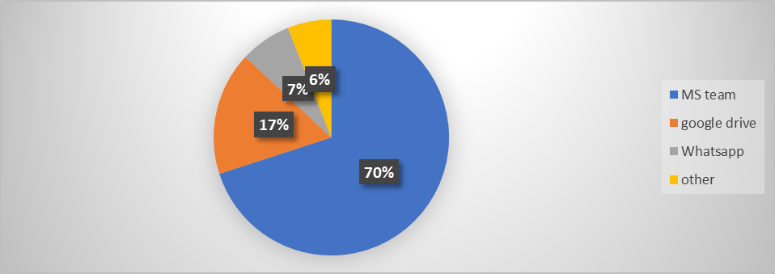
The highest proportion of students enrolled is in the MS group, at 70%. And even at 17%, Google Drive is the second most common option. The percentage of pupils who use Whatsapp is 7%, while 6% use other forms of technology.
Question 3:
Place your proficiency with these programs for working with others into a ranking.
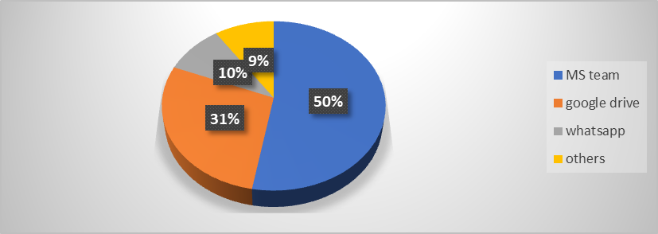
Around half, or 50%, of the student population, considers the MS team the worst possible collaborator. We find Google Drive and Whatsapp in the following two spots.
Question: 4
Would you know what to do if you were tasked with collaborating with others to develop a single file?
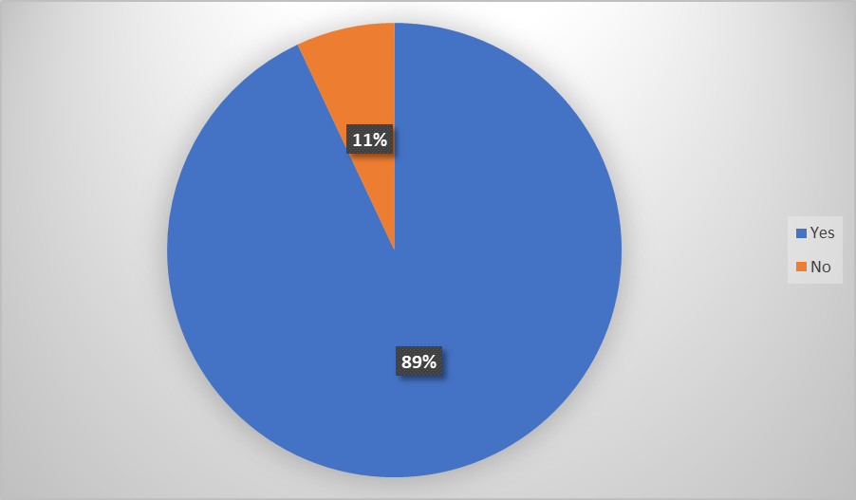
Around 89% per cent of UWTSD students can work together to produce a document. And the remainder of them; 11%is making progress, too.

Discussion
Study participants’ propensity to use digital collaboration tools is uncovered. Whatsapp, Google Drive, and One Drive are utilized to solicit feedback from users about the efficacy of alternative collaboration alternatives to Microsoft Teams. Respondents' responses indicate that all tools are in use, with the MS team using more than its fair share. The MS group relies on the instructors' preparations for the assigned work (Austin, 2013). When writing their projects, most students turn to Microsoft Word. Microsoft PowerPoint is used for slideshows and layouts, and Microsoft Excel is used for many tasks.
In most cases, learners employ a combination of collaborative tools. The MS group is the most widely used group project platform at UWTSD (Austin, 2013). In addition, learners utilize various applications besides the MS group's own, including WhatsApp, Slack, ProofHub, and Trello. The study's findings indicated that the instruments have had a tangible effect on UWTSD learners and that the student body has routinely used them.

Conclusion
There has been a dramatic increase in the usage of online technologies for student participation in recent years. In terms of online tools for teamwork, the MS group is by far the most popular amongst UWTSD undergraduates. The employment of these aids is preferred because it makes their work simpler and clarifies it for those who might be learning from it (Busse & Weidner, 2022). UWTSD undergraduates participate in this study by giving feedback on the effectiveness of various digital resources. Quantitative data analysis methods have been employed to conclude this study. As part of the research, students were allowed to share their thoughts and experiences using technological resources. The ethical implications of this study are thoughtfully considered. When filling out the survey, neither of the respondents felt that they were targeted in any way.

References
A., D.V.D. (2016) Research design. London: SAGE.
Austin, J.T. (2013) “Reporting research findings,” Management [Preprint]. Available at: https://doi.org/10.1093/obo/9780199846740-0032.
B.S, R. (2017) “Research question formulation,” The SAGE Encyclopedia of Communication Research Methods [Preprint]. Available at: https://doi.org/10.4135/9781483381411.n506.
Bordens, K.S. and Abbott, B.B. (2014) Research design and methods: A process approach. New York, NY: McGraw-Hill Education.
Busse, R. and Weidner, G. (2022) “A qualitative investigation on combined effects of distant leadership, organisational agility and digital collaboration on perceived employee engagement,” Leadership & Organization Development Journal, 41(4), pp. 535–550. Available at: https://doi.org/10.1108/lodj-05-2019-0224.
C., B.J.A. and Lampel, J. (2014) The Globalization of Research Strategy. Bingley: Emerald.
Eisend, M. and Kuss, A. (2019) “The Philosophy of Science Viewpoint: Scientific realism,” Research Methodology in Marketing, pp. 59–81. Available at: https://doi.org/10.1007/978-3-030-10794-9_3.
Lovewell, E.C. (2017) “Research approaches,” Encyclopedia of Educational Philosophy and Theory, pp. 2032–2032. Available at: https://doi.org/10.1007/978-981-287-588-4_100912.
Redeem, A. (2017) “Ethical considerations in research projects,” Projects in Linguistics and Language Studies, pp. 196–198. Available at: https://doi.org/10.4324/9780203768990-23.
Thomson, D.R. et al. (2020) “Gridded Population Survey Sampling: A review of the field and strategic research agenda.” Available at: https://doi.org/10.20944/preprints201911.0072.v2.
Wandersee, J.H. (2020) “Using concept mapping as a knowledge mapping tool in research,” Science & Technology Education Library, pp. 127–142. Available at: https://doi.org/10.1007/0-306-47225-2_9.
Zohrabi, M. (2018) “Mixed method research: Instruments, validity, reliability and reporting findings,” Theory and Practice in Language Studies, 3(2). Available at: https://doi.org/10.4304/tpls.3.2.254-262.

Appendix 1: Questionnaire
1. When working with others, do you make use of digital tools? What effect, if any, do you think it has on students' success in the classroom?
A. Yes
B. NO
2. Please rate your proficiency with using these programs to interact with other people in accordance with the scale provided (Most competent at the top).
A) Google Drive
B) WhatsApp
C) MS Word
D) Moodle.
E) MS Teams
3. When working together, what is your preferred method of communication and collaboration?
--------------------------------------------------------------------------------------------------------------------
4. Would you know what to do if you were tasked with creating a paper with other co-workers?
A. Yes
B. No

