

CREATIVITY & VALUE CREATION

NAME: EHIS TESSY MASADEY

STUDENT NUMBER: 2244813

MODULE TITLE: CREATIVITY& VALUE CREATION

MODULE CODE: BMHP5014

LECTURER: ALICE CLAYTON

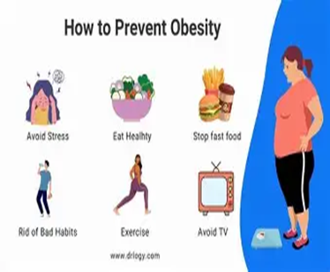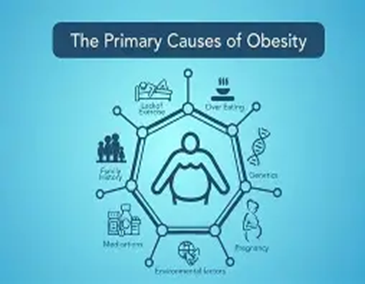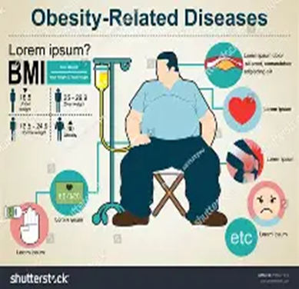


OBESITY: A Holistic View. The basics:

Obesity is excessive body fat. Obesity is considered one of the major public health issues globally due to its increasing spread and detrimental effects on health, mortality and healthcare systems. This paper overviews obesity, as well as its causes, effects, prevention, and treatment of obesity. Obesity is a major public health issue globally, affecting over 650 million adults worldwide (World Health Organisation, 2021).
Fit Buddy: A Focused Health Coach Platform for Obesity Management.
Innovation Overview
Fit Buddy is a new digital health platform that provides personalised health coaching to combat the ever-increasing obesity epidemic and a range of physical and mental health challenges worldwide. It's an exclusive combination of AI and certified health coach skills, providing personalised nutrition and fitness plans, learning resources, and user support integrated within a straightforward mobile application. Food and exercise recommendations are aligned with established health standards, including those from the American Heart Association (American Heart Association, 2018). Augmented by human assistance technology, this twin-sided approach design allows users to receive personalised advice on how to properly manage their overweight and obesity, enabling consumers to develop healthier behaviours. Tackling the Problem and Current Gaps in Health & Social Care. Obesity is a challenging health issue and a public health priority that is rapidly escalating in worldwide reach. Studies reveal that close to 70% of individuals with obesity lack adequate support for sustained weight loss (Lin et al., 2018). The World Health Organisation reports that there are more than 650 million adults with obesity. Fit Buddy’s compliance with data protection laws like HIPAA and GDPR ensures secure handling of health information (U.S. Department of Health and Human Services, 1996; Regulation (EU) 2016/679) Obesity has consequences for more than just personal health, putting great pressure on health care systems due to a wide range of obesity-related complications like diabetes, cardiovascular diseases, cancers and other diseases. A 2022 study found that a gap in the management of obesity has become glaring: nearly 70% of individuals living with obesity feel unsupported in their efforts to achieve and maintain weight loss. Wearable device integration supports real-time data collection essential for personalised interventions (Jakicic & Davis, 2011). Conventional approaches to weight management, many of which are already available in traditional form, such as programmes and mobile apps, mostly have in excess of 30% of patients and do not have, on average, support in terms of tailoring personalised services, but have poor adherence to support, with limited reach for the patients. Many current solutions are disconnected from other users, do not evolve with their specific needs in the long term, as well as do not offer ongoing motivational support. This results in high dropout rates and poor health outcomes. Fit Buddy is focused specifically on the segment, the combination of technology and a personal coach of ongoing personalised assistance. Integrating AI with human coaching can improve personalised treatment and long-term adherence (Tolver et al., 2021). Using this approach will provide users with actionable plans as they progress, and certified coaches come in to help offer the type of accountability and encouragement that is rarely found in digital spaces alone. Target Audience and Impact Key Demographic:
Fit Buddy works mainly with adults 18 to 60 who have a Body Mass Index (BMI) of 30 or higher. The model focuses on targeting low socioeconomic individuals who do not have the same access to standard health services. Impact Fit Buddy aims to improve the health status and well-being of its users by providing personalised coaching supported by a mixture of AI-driven insights and human support. With tailored meal and exercise plans (including a simple guide to nutrition regimes), ongoing motivational support, and accountability mechanisms in place, users are making long-term lifestyle changes that contribute to successful obesity management. There is evidence that those who receive a personalised supportive environment are more likely to attain long-term weight loss. Conventional weight management programs often show poor adherence rates, partly due to lack of personalised approaches (Burke, Wang, & Sevick, 2011). Reducing obesity related health risks both to individuals and to the community through improved adherence and motivation to participate in Fit Buddy. Moreover, the platform creates a community with users which promotes social harmony that raises users´ commitment and well-being, and that is a social improvement that serves the public interest. Implementation Strategy

Where: Fit Buddy will be rolled out mainly to community health centres, gyms and online. Such accessible, trusting settings are also great places to introduce the intervention to potential beneficiaries.

By Whom: The team behind the program is a consortium of registered dietitians and trained health coaches with AI support tools supporting expert advice and personalised help.

How: Workshops. Fit Buddy’s features and benefits will be introduced to users via workshops and presentations at community health centres to engage with users at earlier stages in the program.
Mobile App: The central delivery system is an intuitive mobile app to help users monitor nutrition, physical activity, and general growth. It promotes engaging with coaches and friends and offers access to a robust resource of specialised educational resources.
Community Elements: Fit Buddy encourages peer support, evidence suggests that peer encouragement can significantly influence behaviour change via the app, and through community challenges and social groups, there are a host of support systems in place in the app. Develop and Rollout Timeline
- Phase 1 (Months 1-3): Research and Development. Refine app design and core functions based on user feedback for the final phase.

- Phase 2 (Months 4-6): Pilot Testing. Release a beta product to select users. Gather data and qualitative feedback to make the most of the platform's functionality and the users' experience.
- Phase 3 (Months 7-9): Full Launch. Create awareness campaigns with targeted marketing campaigns. Initiate full service in selected community health centres and partner gyms.

- Phase 4 (Months 10-12): Evaluation and Adjustment. Monitor user engagement metrics, health outcomes, and satisfaction surveys. Perform improvements based on evaluation results to improve effectiveness and reduce user churn. Regulatory and Development Compliance
Fit Buddy’s design and construction should be compliant with applicable healthcare regulations to maintain ethical usage of sensitive personal health data and comply with health standards. Health Care Regulations: The Health Insurance Portability and Accountability Act (HIPAA) in the United States ensures that users' information is safeguarded from unauthorised access. Data protection: Fit Buddy in Europe is governed by the General Data Protection Regulation (GDPR), providing regulations for the protection of user privacy and data integrity, with implications for global personal data protection. Health Standards: Any dietary or exercise recommendations made by Fit Buddy adhere to guidelines from recognised associations such as the American Heart Association. This results in advice that is based on accurate scientific evidence and is safe at best. Not only does Fit Buddy protect its users well, but it also wins respect and credibility in healthcare and communities.

Technology Integration in Fit Buddy
Mobile App Core Functions: At its core, fit Buddy is an interactive mobile application built to provide support for daily health practices that is easy on the eyes and body. Users can log meals, work out, monitor progress, and establish measurable goals for themselves. Curated educational content gives users access to educating users on their condition and helps them actively manage it. AI (Artificial Intelligence):
Fit Buddy optimally utilises AI algorithms, dynamically analysing user data. This enables the platform to create tailored meal suggestions, personalised workout programs and motivational feedback which would match each behaviour pattern and preference of each user perfectly. The AI evolves by understanding how the user interacts to break through the 'game-changer' mentality to overcome peaks and make lifestyle plans for adaptation by taking notes from the users (to adapt them as the behaviour alters). Device integration: The platform can easily be made to work with various wearables: Fitbit, Apple Watch or Fitbit as the popular digital fitness monitor integration. In this way, fit Buddy gets real-time information regarding activity, heart rate, and quality of sleep and the entire world of lifestyle. These findings provide a more direct and personalised coaching experience and help users stay conscious of their health.
Secure User Profiles:
Fit Buddy uses sophisticated encryption algorithms, as well as secure login methods, to guarantee you will never see your health details being shared. The system supports the secure sharing of information with healthcare professionals for enabling evidence-based clinical decisions and integrated care. Increased Efficiency Through Technology: Technology (AI/ wearables) + coaching (humans) adds additional value to an app. Personalised user feedback and real-time tracking increase user interaction with the app. Timely changes in behaviour supported by secure, cooperative dialogue with health practitioners make Fit Buddy an innovative and comprehensive approach to obesity management.
Spread and Recommendation Mechanism
In order to enhance the reach, uptake and adoption of Fit Buddy, a multi-faceted distribution model has been developed for healthcare professionals, the public and community organisations. The promotion and message aims to create awareness of the technology by the health sector and support the community and reduce risks. Media Communications: Introduce full-blast campaigns on TV, radio, & social media. Include compelling stories of positive fit and the positive impact fit Buddy could have on both people's outlook (what the world wants and how they want it) to promote better public awareness and buy-in. Digital Marketing: Create an engaging website full of educational resources. Sustain active social media engagement creating blogs, infographics, videos and testimonials. Partner with health and wellness influencers for wider reach. We will hold workshops, webinars and health fairs using other health fairs, work with community health groups to engage with community health initiatives. Incentivize participants in this way by offering trial memberships or bonuses, for instance discounted rates and incentives to encourage early users. Healthcare Providers’ Partnerships: The integration of Fit Buddy is a complementary approach to obesity medicine. Train health authorities and professionals accordingly. You're encouraged to give referrals. Healthcare workers are responsible for putting the platform forward to patients. Promotional Material: Brochures & flyers in clinics, centres and colleges, gyms and schools. Use QR codes for easy downloads and for instant app interaction.

Conclusion
Fit Buddy is an unprecedented way of managing obesity using cutting-edge technology, partnered with expert human coaching to provide users with a personalised, responsive, and supportive solution to improving their health. By building out one mobile application, AI insights integration, wearable measurements, and secure, collaborative conversations, Fit Buddy uniquely enables individuals by breaking down obstacles that often occur in weight management programs. Given that obesity rates are steadily on the rise worldwide and there is an undeniable need for accessible and personalised interventions, the demand for solutions like Fit Buddy has never been higher. Fit Buddy provides data to fill gaps in current services and reach a range of stakeholders through an integrated communication plan within its implementation to allow different actors, both health professionals and the general public, to share their data to make a difference in the context of the obesity epidemic.
Fit Buddy’s innovation is now perfectly positioned to contribute to solving this problem by bridging the knowledge gap with the people from all around us, using data, technology, and human empathy to make a positive impact on sustainable change. The successful integration of technology, customised coaching, and community action sets fit Buddy up as a powerful, evidence-based approach ready to make positive strides in obesity management and population health.

References

American Heart Association. (2018). Dietary Recommendations for Healthy Children: An Overview. *Circulation*, 138(9), e513-e533.

Apovian, C. M. (2016). The clinical and economic consequences of obesity. *American Journal of Managed Care*, 22(7 Suppl), s219-s228.

Burke, L. E., Wang, J., & Sevick, M. A. (2011). Self-monitoring in weight loss: a systematic review of the literature. *Journal of the American Dietetic Association*, 111(1), 92-102. 2010.10.008

Hruby, A., & Hu, F. B. (2015). The epidemiology of obesity: a big picture.

Jakicic, J. M., & Davis, K. K. (2011). Obesity and physical activity. *Psychiatr Clinics of North America*, 34(4), 829-840.

Lin, J.S., O’Connor, E., Whitlock, E. P., Beil, T. L., & O’Connor, E. A. (2018). Behavioural Weight Loss Interventions to Prevent Obesity-Related Morbidity and Mortality in Adults: A Systematic Review for the US Preventive Services Task Force. JAMA, 320(11), 1174-1185. 2018.

Regulation (EU) 2016/679 of the European Parliament and of the Council. (2016). General Data Protection Regulation (GDPR). Official Journal of the European Union.

Tolver, A., Fink, P., Holmberg, T., & Sørensen, J. M. (2021). Effectiveness of mobile health apps on obesity management: A systematic review and meta-analysis. *Obesity Reviews*, 22(6), e13129.
U.S. Department of Health and Human Services. (1996). Health Insurance Portability and Accountability Act (HIPAA).

World Health Organisation. (2021). Obesity and overweight.

