
Applied Leadership and Management in the Workplace
Module Assignment Submission
Student Name: | Mica Davies
Student Number: | 2313850
Module No: | BMSK4011
Module Title: | Continuous Professional Development

Statement of Confirmation of Authenticity
By the act of making this submission, the student declares that this is the work of the student named above. The work has not, in whole or in part, been knowingly presented elsewhere for assessment, or where assessment has been built on a previous assessment, this has been identified. Where materials have been used from other sources it has been properly acknowledged. If this statement is untrue, the student acknowledges that an assessment offence has been committed.
Attention is drawn to the plagiarism and unfair practice policies of both the University and of ILM.
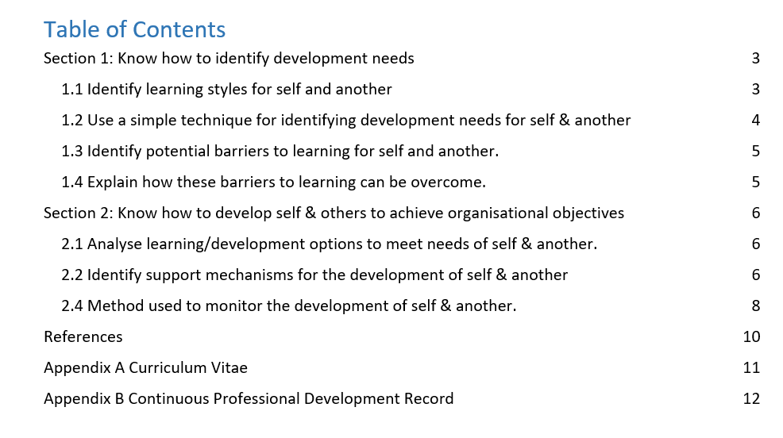
In this assignment I will discuss learning styles, results for both myself and a colleague, our development needs/how to identify them. Potential barriers to learning and how we can overcome them. Development options, support mechanisms and create Personal development Plans to achieve our goals and to improve ourselves in a professional and personal manner.
1.1 Knowing how to identify developmental needs is important as we can maximize our abilities along with leadership and management skills. Learning more in depth about ourselves we can be more self-aware which helps us to improve our judgement and identify opportunities for our own professional development and personal growth. To develop professionally I started to investigate my learning styles and what methods work best for myself and did this by using the Honey, P. and Mumford, A. (1986a) method which was based on the Kolb learning cycle. These styles are broken down into four sections: Activist, Pragmatist, Theorist, Reflector. I found that the result of my learning style wasn’t a singular result as my personality traits fit into the categories of a Reflector, Activist and Theorist. I went on to complete this with a colleague to understand the way in which they learn best as this is important to manage a Team in a professional setting.
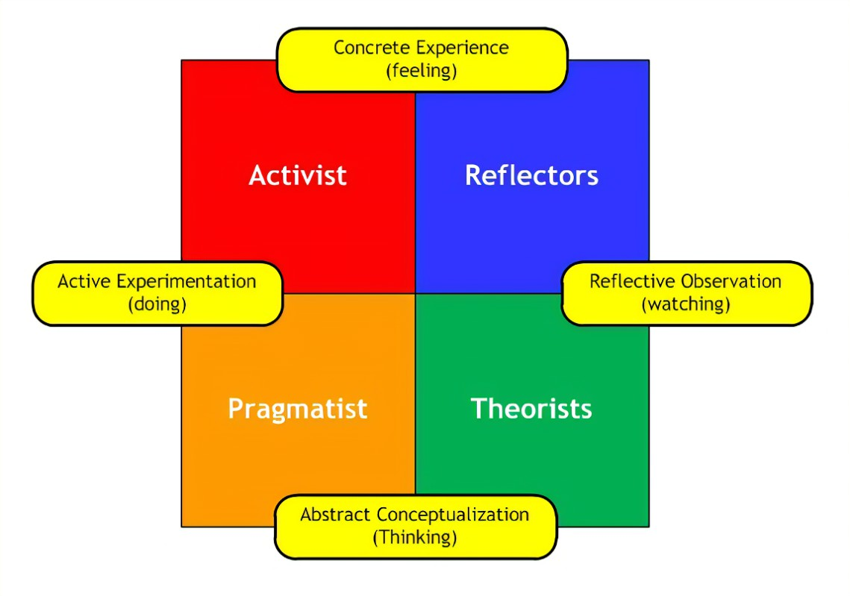
I used the same method on a colleague and the reason for doing this is so that I am then able to adapt my skills around the staff team on a person-centred focus. This will help run the team better to ensure that everybody is having what they need within the workplace. Through completing this learning style method with my colleague Paige, her results noted that she has different traits in her personality that would fit the description of both a Pragmatist and a Reflector.
1.2
SWOT on Myself

STRENGTHS  -- I work very well independently as well as with others. I am able to mix with a variety of different personalities.  - I have a very good ability to find solutions regardless of the situation that I am confronted with.  - The ability to reassure and put people at ease when in times of distress.  -Good at listening to others along with empathetic and understanding.  -Not a judgemental person as I have the ability to have a very open mind and am able to put myself into the mindset of other people and their circumstances.  - As a person I can be quite resilient and adapt to change very well. | WEAKNESSES  -- I need to develop the mindset of less procrastination and be more active with completing goals.  - I’m not a person who is very good with controlling finances along with saving money and budgeting.  - I within my personality struggle with boundaries at times and find it difficult to say No.  -I can appear as uncomfortable or shy in certain environments or around some other personalities.  - I am not a person who can stick to a time frame as easily as others. Poor Punctuality.
OPPORTUNITIES  -To further my higher education is that it will open more doors for myself in the future.  - Enables me to apply for higher paid qualified jobs in a chosen career path.  - It is for my own self to develop as a person and will help improve my confidence in my personal and professional life.  - The opportunity to complete a higher education degree will improve the way I view myself and will encourage me to continuously improve my self-awareness. | THREATS  -- I do not have very good Quantitative skills and am unable to understand these subjects.  - I struggle with my Mental health at times which can be a barrier in my personal/professional growth and development.  - The confidence that I lack is something that would be a threat within my professional growth.  - Poor punctuality acts as it doesn’t appear professional to others.  - Others could have more knowledge and understanding than myself around particular subjects.

SWOT analysis on colleague, Paige.

STRENGTHS  - Paige is extremely good at problem solving as she is a mature person. This enables her to have a practical outlook on situations.  - Confident when speaking to people and dealing with barriers. This colleague can suggest realistic solutions to barriers within a working environment.  - This individual is excellent at following instruction with minor to no faults, is adaptable with working methods and uses great initiative when working as part of a structure or plan.  - This colleague has the excellent ability to listen thoroughly and be understanding and empathetic to many situations.  -Paige is positive/bubbly person and this works well for her professionally as it gives this colleague a very approachable appearance. | WEAKNESSES  -- Paige is aware they struggle to be punctual within a working environment and this can appear as lack of professionalism.  - Paige struggles to ask for help when they need it. They at times see it as a sign of weakness and prefer to solve the barrier alone before asking another colleague for guidance/assistance.  - Paige can appear quiet and does not push to speak up or put forward ideas in group discussions. This is due to lack of confidence rather than knowledge.  - Paige can be overly emotional/personally invested and struggle to keep their personal lives out of their professional lives.
OPPORTUNITIES  -Paige furthering her education will lead to new opportunities arising future. Which will enable her to apply for higher paid/qualified jobs.  - To complete a higher education degree for Paige would act as an opportunity as it would improve her self-confidence massively and her perceived abilities.  -To improve her professional skills and to acquire knowledge on management skills to help her succeed in the future. | THREATS  -A threat to Paige could potentially be her level of concentration/motivation, as she does not challenge herself to further her knowledge.  -Paige tends to self-doubt herself and this could act as a potential barrier due to feeling like she is uncapable and does not believe she could complete a higher education degree.  -A potential threat for Paige could be the factor that she struggles with Anxiety and prefers to stay within her comfort zone. Paige doesn’t adapt too well to new environments or experiences. This could prevent her from pushing herself to be the best version of herself.
Gap Analysis on Myself.
To have a better understanding of myself, who I want to become and what is currently holding me back; I used Graham Gibbs Model of Reflection (1998). This allowed me to break down into a more basic structure so that I can complete a plan to achieve these goals. This method can be used in both a personal and professional setting.
What? | So what? | Now what?
Improving/Managing Mental Health. | I am aware that my mental health could act as a negative factor. Through working with the relevant services, I can improve this over time. | Focus my mind on a positive outlook, accept help that is offered and learn to understand that I can communicate my feelings with others when needing support.
Lack of punctuality | I struggle to be punctual in situations as I struggle with what can be described as ‘Time Blindness’. This is something I’ve discussed with my doctor and could be a potential sign of ADHD. | Now I plan to follow a different routine to learn to become punctual. I will do this by waking up earlier/going to sleep earlier and reminding myself that lateness can appear extremely unprofessional.
Lack of self confidence | I am aware that my low confidence is a factor that holds me back in my professional and personal life. I have a false sense of perceived abilities within myself. | I need to focus on things I have already achieved in life and remind myself that I am capable. I will focus on putting myself more out of my comfort zone so that I can experience more and re-create a new sense of self confidence.
This same method was also used using my colleague Paige and she was able to identify her Barriers to allow her to put a plan in place.
What? | So what? | Now what?
Lack of concentration/motivation. | Paige is aware that she lacks both motivations to further her education and concentration when committing to situations. | Paige is aware that she needs to seek information to find out what career/topic she is interested in. To build a plan of where she would like to be in 5 years’ time and ask herself her reason for wanting to achieve these goals.
Ask for Help | Paige is someone who shy’s away from asking for help due to feeling incompetent. This is something that she wants to work on by reaching out to more qualified people. | To be aware that the lecturers and student support are there to help and to use them as a guidance when needed.
Self-confidence & Mental health. | Paige can keep herself in her comfort zone and this can put barriers in the way of opportunities for her. She can struggle with her mental health at times and does not always reach out to the correct people. | To challenge herself to put herself into more unfamiliar surroundings to build up the confidence to where it does not cause her Anxiety. To maintain a healthy management plan with her GP.
1.3
My external Barriers | My Internal Barriers
-Working a full-time job could act as potential barrier as it means structuring my working hours and studying to fit alongside each other for me to successfully complete the course. | -My levels of self-confidence could act as a potential barrier as my outlook on myself can be negative due to lack of self-belief in my abilities.
-At times I have had technical problems with my car, and it has not functioned properly and therefore that could be a potential barrier if I am unable to attend lectures. | -The stability of my mental health could act as a potential barrier to learning. The reason this could be a barrier is that it at times can be worse than others.
Paige’s External Barriers | Paige’s Internal Barriers
-A potential barrier for Paige is that not holding a driving licence could restrict her furthering her education. Public transport isn’t always reliable or there are sometimes limited bus routes that she could take. | --A potential barrier that could occur is Paige’s lack of motivation to improve herself professionally and personally. Aswell as poor concentration.
-A potential barrier could be that 1 year ago, Paige was diagnosed with dyslexia and has yet to seek support for this. | - Paige is a person who struggles with feeling anxious when she is in any environment that is out of her comfort zone or that she feels intimidated in.
1.4
My External Barriers | My Internal Barriers
To through speaking to My Boss and explain my commitments based around university and to attempt to create a healthy work balance that will allow me to continue with both. | low self-confidence and negative perceived abilities, I would need to communicate my worries and struggles with my lecturer and be committed to studying and broadening my knowledge in the subjects that make me self-doubt. To work on perceived abilities, due to the feeling being an internal factor I could investigate positive self-affirmations to create a happier/healthier outlook on what I am capable of.
Put a plan together to have my car regularly serviced/checked to avoid emergency repairs. By checking the car regularly, it allows me to attend all lectures and continue to further my education. | Mental Health conditions/management, I will work closely with my GP, Psychiatrist to continue with my mental health plan, to comply with taking the medication that is helpful with my conditions and to accept the help/resources that are offered to me

Paige’s External Barriers | Paige’s Internal Barriers
Paige wants to commit time to revising for her theory test and will need to arrange driving lessons with an instructor so that she is able to travel to attend lectures. Until then there is multiple forms of public transport and routes can be planned based on where she will need to travel to and prepare for any traffic disruptions. | To look at where Paige would like to be in 1-5 years’ time and find what motivates her as a person and what she would like to achieve. To improve her concentration, she needs to find topics that she enjoys and has an interest in developing her skills in. To attempt to increase her levels of concentration, Paige could focus her mind to learn a skill such as meditation.
Dyslexia she would need to access the right services to prevent it interrupting her learning and developing her career. Paige is aware that there are resources that she can access such as Student Support Services and can discuss this with her GP. | Challenge herself in new environments that feel out of her comfort zone. By setting challenges and then achieving them it will gain her confidence and her Anxiety will decrease over time through continuing to push herself in a professional and personal setting.
- 2.1 There are always ways in which we can improve our knowledge and develop ourselves further. There are lots of educational opportunities available which are easily accessible. There are courses that can be completed Online based around full time jobs. There are multiple resources to turn to such as books and regular training.

2.2. My support Mechanisms for myself would be a collection of different people ranging from my professional and personal life. To explain this, I have used the Gilbert, A., & Chakravorty, I. (2002) Go Mad about Coaching. Go Make a difference.
Attend all lectures. Be on time to university. Submit assignments on time. Stay focus. Ask for help if needed.
My reasons are to prove it to myself that I am capable. To open more opportunities in the future and to be successful in a higher qualified job.
This is rated as a 10 on a scale of Achievability. If I am focused and dedicated, I will achieve these goals.
My support networks will be made up of: My lecturer, Student support, My sister, My parents, and other Students on the course.
I am 100% responsible and accountable for achieving this.
The belief I have in myself that I am capable ranging on a 1-10 scale is a score of 7.
Start October 2023.
Attend and Complete on time.
Complete in 2024.
2.3 To help structure a clear plan I have used the method S.M.A.R.T objectives created by George T. Doran (1981) to achieve the results that I am aiming for.
S – Specific
M- Measurable
A- Achievable
T- Time bound
I have looked at the exact goals I want to achieve, how meaningful they are to me and my reasons as to why. How achievable they are and my likelihood for success and the length of time I am looking to do this in which will help me stay focused.
What do I want to learn? | What do I have to do? | What support and resources will I need? | How will I measure success? | Target Date for Review
Decide what career I want to focus on. | To be dedicated and stay focused. | -lecturer and student support if necessary. | Complete assignments/tasks on time and by completing the course to my highest ability. | Completion of course.
Complete the course to the best of my ability. | access resources given to me and be dedicated to the course. | I will need support from my lecturer/support services and family/friends. | Ask for regular feedback and reviews through the university and communicate with family/friends. | November 2024
To gain self confidence | Challenges to be out of my comfort zone and to set personal goals. | Self-belief and the support of my family and friends. | Track what goals I have achieved and how long they took to complete. | Yearly.

My Personal Objectives
Short Term Goals (next 12 months)
-Complete higher education course

Medium Term Goals (2-3 years)
-Complete a degree in a profession that I am truly interested in. Stay focused
-Look into opening my own business.

Long Term Goals (3-5 years)
-Work within a chosen profession that I love and continuously be improving myself.
-To have multiple qualifications.
-Run and Own my own business.
What does Paige want to learn? | What does Paige have to do? | What support and resources will Paige need? | How will Paige measure success? | Target Date for Review
To have more confidence. | Challenge herself to be in unfamiliar surroundings. Sign up for new courses/experiences. | To join groups where she knows she will have to socialise. Speak to Friends about trying new experiences. | Setting goals or a ‘bucket list’ and ticking them off when successful. | Yearly.
Support for Dyslexia | To contact the GP to request more information and to access all resources given to her and be dedicated to the course. | Lecturer/support services and family/friends. | To ask for regular feedback and reviews through the university. | Yearly.
To find motivation to improve herself professionally and personally. | To find a topic that she is really interested in and become a part of something that makes her happy. | To do own research on the type of topics she loves. Speak to Family/Friends. Find out what options and opportunities are available. | By seeing what achievements have been made. | Yearly.
Paige’s short-term Goals (next 12 months)
To have found a career that I want to study in.
To have been promoted to a higher qualified/paid job.
To have gained confidence in myself.

Medium Term Goals (2-3 years)
To have completed a degree.
To look at continuing my education and constantly improve my knowledge.

Long Term Goals (3-5 years)
To be working in my chosen profession.
To have my mental health fully under control and manageable.
2.4 The methods that I will use to monitor my development and of others will be multiple resources. To maintain a routine of regular feedback and meetings to review the situation is vitally important as it keeps all work-related issues up to date. Regular feedback can improve your critical thinking and help make you more self-aware. By using an up-to-date personal development plan and performance reviews it can be monitored your development closely which will improve your professional and personal lives. Through online training, research and by asking for regular feedback from my boss and other colleagues.
To conclude this assignment over the course of the next 12 months I will be continuously looking into how I can Improve myself through the learning styles that are best suited for myself and other colleagues. What barriers are potentially going to arise and how I can overcome them. By finding out this information it has given me a better understanding of who I am and the person I want to become. I will continue to use this throughout my course and throughout my personal life.

References:
Honey and Mumford Model - Search Images (bing.com)
The Nature of Good Goals: SMART Goal Setting
Gilbert, A., & Chakravorty, I.(2002) Go Mad about Coaching. Go Make a difference.
Graham Gibbs’ model of Reflection (1988)
David and Kolb and Ron Fry (1975)

Mica Davies CV
micadavies68@gmail.com
Port Talbot.
07463188114
I am an enthusiastic, hard working person who always strives to the best of my ability. I like to challenge myself with new experiences and enjoy a fast-paced environment. I want to improve myself in my professional development and I work excellently as part of a team as well as competently alone. I am looking to further my qualifications through higher education and be working in a Health Care profession that I am passionate about.
Skills:
- Hard working individual
- Uses own initiative
- Is able to critically think about my actions.
-Follows instructions well and is a good listening.
-A open minded person who is not judgemental.
I have over the last 9 years worked as a Health Care Assistant and have worked in a wide range of different settings. From domiciliary health care to working in nursing homes and hospices. I have over the last 2 years worked mainly within Support Work and have been working with individuals that suffer with mental health and learning difficulties.
I have also had experience in jobs out of health care such as working in Admiral as a Sales Assistant and as a dispensing assistant in Pharmacies.
I like to take part in activities such as swimming, walking and going to the gym.
Education:
English Literature – B
English language- B
Welsh- B
Drama-C
Textiles-B
RS-C
Maths-D
IT-B
Problem Solving Skills
Key Skills
First Aid training
Manual Handling
References:
Admiral Group Insurance 03301343208
Well Pharmacy 01639883524

